Style Guidelines for Final Year Project ReportsAI Meeting Knowledge Orchestrator

Final Year Project Proposal

Session Fall 2025

A 4th Year Student

BSc. (Hons.)BS in CS



Department of CS
Fast School of Computing
FAST National University, Karachi Campus
22 September 2025

Project Registration
Project ID (for office use)
Type of project |  |  | [ ] Traditional [ x ] Industrial [ ] Continuing
Nature of project |  |  | [ ] Development [ x ] Research & Development [ ] Research
Sustainable Development Goals(SDGs) |  |  | [ ] Good Health and Well-Being [ ] Quality Education  [ ] Industry, Innovation, and Infrastructure [ ] Gender Equality  [ ] Decent Work and Economic Growth [ ] Climate Action
Area of specialization |  |  | [ x ] Artificial Intelligence (AI) [ ] Data Science and Analytics  [ ] Internet of Things (IoT) [ ] Blockchain  [ ] Mobile App Development [ x ] Web Development [ ] Cybersecurity  [ ] Game Development [ ] Natural Language Processing (NLP)  [ ] Other
Project Group Members
Sr.# | Reg. # | Student Name |  | CGPA | Email ID | Phone # | Signature
(i) | 22K-4535 | Saiyed Asim Majeed |  | 3.62 | k224535@nu.edu.pk | +92 3362462248
(ii) | 22K-4267 | Muhammad Muzammil |  | 2.36 | k224267@nu.edu.pk | +92 3332439881
(iii) | 22K-4367 | Ayan Hasan |  | 2.91 | k224367@nu.edu.pk | +92 3306860349
Declaration: FYP group members have cleared all prerequisite courses For FYP-I as per their degree requirements.

Project Abstract
The modern business environment, particularly in multilingual regions such as Pakistan, is characterized by meetings where participants frequently code-switch between English and Urdu. Existing meeting assistants (e.g., Otter.ai, Zoom AI) struggle with this linguistic complexity, providing only superficial transcription and summarization without structuring the knowledge generated. This project proposes the development of an AI Meeting Knowledge Orchestrator, a system that transforms meetings into structured, queryable knowledge.
The core innovation is a robust Automated Speech Recognition (ASR) pipeline leveraging WhisperX[3], or any more effective alternative discovered (e.g., Soniox, AssemblyAI), for accurate, diarized transcription of Urdu-English code-switched speech. The transcript will then be processed by a Large Language Model (LLM) for extraction of structured knowledge (decisions, tasks, owners, deadlines), which will be persistently stored and interconnected in a Neo4j knowledge graph. This architecture provides a holistic organizational memory, enabling teams to query past decisions, track dependencies, and proactively surface conflicts.
The MVP will be implemented as a containerized web application deployable on a local RTX 3050 GPU for privacy and sovereignty, but with scalability considerations for future cloud deployment. Importantly, the team commits to evolving the technology stack if scalability or accuracy issues emerge, ensuring the system remains practical and commercially viable. Future exploration may extend to Graph Neural Networks (GNNs) for advanced reasoning over meeting graphs.
This project thus aims to bridge the gap between raw multilingual transcription and actionable knowledge management, addressing a major unmet need in multilingual professional settings.

Introduction
Meetings are an essential medium for decision-making, planning, and collaboration in organizations. However, valuable insights, action items, and decisions are often lost due to ineffective documentation. Traditional transcription tools focus mainly on English monolingual speech and provide limited functionality beyond transcripts. In multilingual contexts such as Pakistan, where English and Urdu are frequently code-switched within the same sentence, existing solutions often fail to capture meaning accurately. Commercial tools provide transcripts but lack robust code‑switch handling (Urdu-English) and cross‑meeting orchestration (persistent knowledge linking). This project addresses that gap by building an ASR + extraction + knowledge graph pipeline optimized for code‑switched speech and organizational memory.
Objectives
- Build a pipeline that transcribes English/Urdu code‑switched meetings with speaker diarization.
- Extract structured entities: decisions, tasks, owners, deadlines, and link them into a Neo4j knowledge graph.
- Demonstrate a working dashboard for search, playback, and task follow‑ups.
- Evaluate the pipeline on accuracy (WER, code-switch recall), extraction precision, and usability.
Main sub‑tasks and methods
- ASR (Automatic Speech Recognition): WhisperX alignment, or commercial APIs (e.g., Soniox) or another approach deemed fit if they prove superior or feasible.
- Diarization: per speaker segmentation.
- Extraction: LLM-based structured JSON generation with schema validation and rule-based fallback.
- Knowledge storage: Neo4j schema design with provenance metadata and relationships for traceability.
Criteria for evaluation and evidence
- WER / code‑switched recall on Urdu and English tokens.
- Precision/recall for extracted action items and decisions.
- Usability metrics from pilot teams and demonstration.

Success Criterion
The project will be considered successful if it demonstrates tangible progress across the ASR, extraction, and knowledge orchestration components, while satisfying supervisor evaluation. Success is defined in layered terms to ensure feasibility and room for exceeding the baseline:
- ASR Performance:
  - Minimum success: Demonstrates measurable improvement in Urdu token recall compared to baseline Whisper runs.
  - Strong success: Achieves consistent transcription quality across ≥10 meeting recordings with stable diarization.
- Information Extraction:
  - Minimum success: Achieves ≥60% precision/recall for action items and decisions on a curated test set.
  - Strong success: Maintains accuracy with varied meeting domains and speakers.
- System Integration:
  - Minimum success: Functional dashboard processes at least 10 meeting recordings into a persistent knowledge graph with basic search and playback.
  - Strong success: Supports additional features such as summarization or natural queries.
- Practical and Verifiable Outcomes:
  - Annotated evaluation dataset, reproducible deployment instructions, and pilot study results are produced.
  - Supervisor acceptance (and pilot user satisfaction where applicable) is treated as the final marker of success.

Related work
Commercial tools like Otter.ai, Fireflies.ai, and Zoom AI provide summarization but perform poorly in multilingual scenarios. Microsoft Copilot and Google Gemini integrate with ecosystems but lack robust code-switch support.
Our research has explored Urdu-English ASR using Kaldi CNN-TDNN hybrids [1], but public models are scarce. Google Cloud STT and AssemblyAI support multilingual recognition, but struggle with intra-sentence mixing. Soniox, a commercial API, shows strong performance for code-switched speech though its methodology is undisclosed.
Open-source progress includes Whisper and its extension WhisperX with forced alignment for multilingual transcription [2][3]. Pyannote-audio provides state-of-the-art diarization pipelines [4]. Knowledge graph approaches have been used in decision support systems, and recent works suggest extending these with GNNs for advanced reasoning.

Project Rationale
This project is chosen for its practical impact (better meeting memory in bilingual workplaces), technical novelty (first Urdu-English knowledge orchestration pipeline), and achievable scope (prototype feasible on consumer hardware).

Aims and Objectives
- Aim: Convert meetings into a structured, queryable organizational memory system.
- Objectives: Develop ASR/diarization, structured extraction, Neo4j knowledge graph, and dashboard interface.

Scope of the Project
- In scope: Offline audio uploads, diarization, bilingual ASR, LLM extraction, KG population, dashboard MVP, evaluation.
- Out of scope: Real-time conferencing integration, enterprise deployment, user identity linking.

Proposed Methodology and Architecture
The methodology of this project follows a research–prototype–validation cycle, in which alternative methods are investigated, implemented at baseline, and then validated against evaluation metrics such as Word Error Rate (WER) and extraction accuracy.

Methodological Approach
- Baseline Establishment
  - Begin with established open-source tools such as Whisper for ASR and Pyannote for diarization.
  - Evaluation of baseline accuracy will provide a reference point for subsequent improvements.
- Experimental Enhancements
  - Explore double-pass ASR strategies (e.g., running Whisper twice with different language biases and merging via alignment heuristics).
  - Test commercial APIs (Soniox, AssemblyAI, Google STT) to benchmark against open-source performance.
  - Investigate schema validation + fallback rules in LLM extraction to reduce hallucinations.
- Knowledge Graph Construction
  - Define a schema for tasks, decisions, and participants.
  - Insert extracted entities into Neo4j with provenance and confidence scores.
  - This stage allows later exploration of Graph Neural Networks (GNNs) for reasoning across multiple meetings.
- Dashboard and Usability Layer
  - Develop a minimal dashboard enabling search, playback, and structured queries.
  - This step validates the system’s usability in practical workflows, not just raw accuracy.

Architecture Overview
The envisioned pipeline is modular to allow substitution of methods based on validation outcomes:
- Audio Ingestion
- Preprocessing (silence trimming, normalization)
- Speaker Diarization (Pyannote/SpeechBrain)
- ASR (WhisperX, Soniox, or alternative under test)
- Alignment & Merge (baseline: single-pass; experimental: double-pass)
- LLM Extraction (schema validation + fallback rules)
- Knowledge Graph Upsert (Neo4j)
- Dashboard Interface (search, playback, queries).
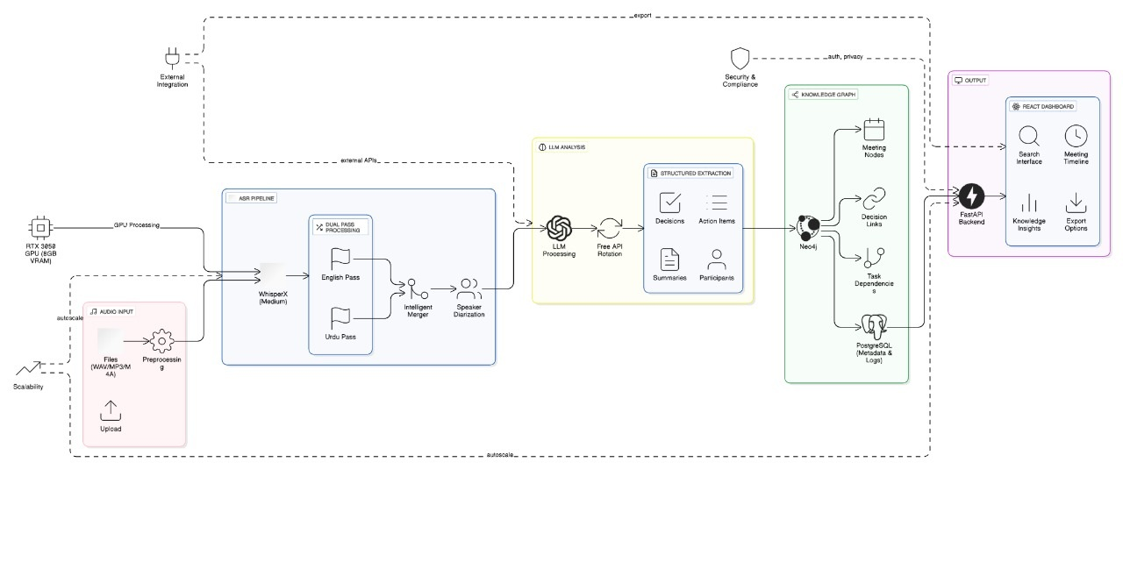
Figure 1 System Diagram

Individual Tasks
Team Member | Activity | Tentative Date
Asim Majeed | Research & benchmarking ASR approaches (WhisperX, Soniox, AssemblyAI) | Aug 19 – Sep 15, 2025
 | Implement baseline ASR + diarization pipeline (WhisperX + Pyannote) | Sep 16 – Oct 6, 2025
 | Integrate forced alignment, optimize Urdu-English code-switch handling on RTX 3050 | Oct 7 – Oct 20, 2025
 | Evaluate ASR (WER, recall) + fallback API integration | Oct 21 – Nov 10, 2025
 | Final runtime optimizations, GPU profiling & Docker deployment (MVP demo) | Nov 18 – Dec 1, 2025
 | Refine ASR (forced alignment + heuristics), explore alternative APIs (Google, AssemblyAI) | Jan 6 – Feb 2, 2026
 | Explore runtime scaling (Docker/K8s), GPU throughput optimization | Apr 14 – May 4, 2026
Muhammad Muzammil | Dashboard design (UI wireframes, React + FastAPI setup) | Sep 30 – Oct 13, 2025
 | Build minimal dashboard MVP (transcript view + search) | Oct 14 – Oct 27, 2025
 | LLM model survey: compare GPT, LLaMA, Mistral, others for structured extraction | Oct 21 – Nov 10, 2025
 | Prototype LLM integration + prompt engineering | Nov 11 – Dec 1, 2025
 | LLM fine-tuning (if needed) on transcript dataset (LoRA or adapters) | Jan 6 – Feb 23, 2026
 | Expand dashboard: playback, task follow-ups, query interface | Feb 24 – Mar 23, 2026
 | Final dashboard polish, usability testing, integration with KG + LLM | Apr 21 – May 11, 2026
Ayan Hasan | Design Neo4j schema for meeting entities (decisions, owners, deadlines) | Oct 7 – Oct 20, 2025
 | Prototype LLM prompts, schema validation, fallback rules | Oct 21 – Nov 10, 2025
 | Insert structured entities into Neo4j + demo query pipeline | Nov 11 – Dec 1, 2025
 | Extend KG with provenance metadata & richer relationships | Jan 20 – Feb 23, 2026
 | Implement natural query → Cypher pipeline (LLM-assisted querying) | Mar 3 – Apr 6, 2026
 | Lead evaluation of extraction precision/recall | Apr 14 – May 11, 2025

Gantt Chart
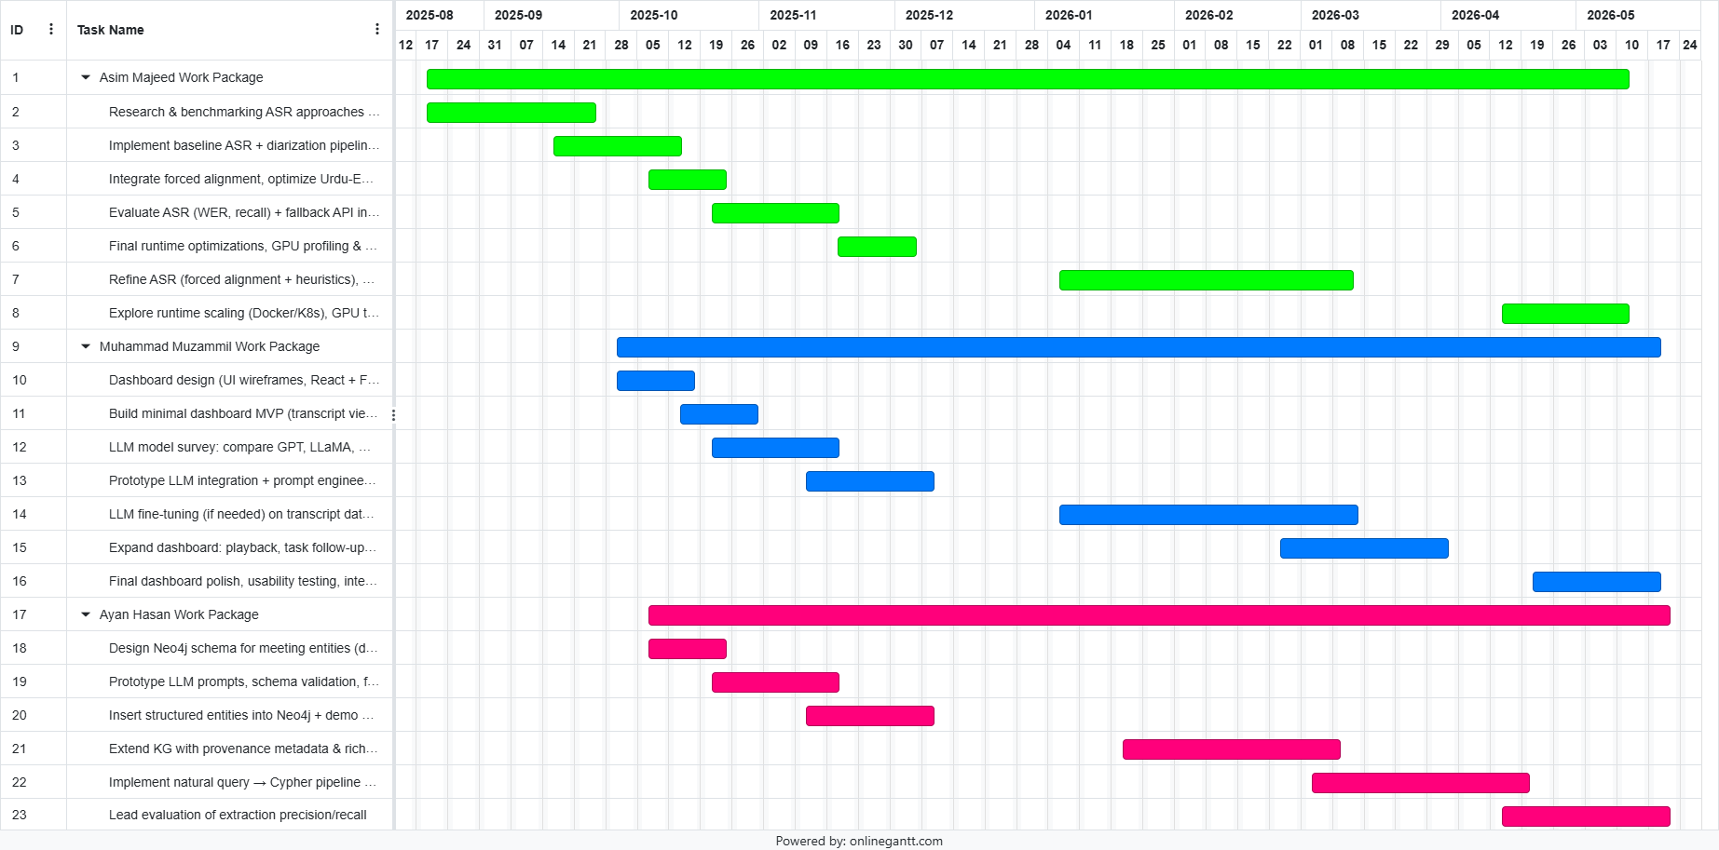
Figure 2 Gantt Chart

Tools and Technologies
The project will employ a modern and adaptable technology stack, selected for both immediate feasibility and long-term maintainability. The group acknowledges that the field of speech recognition and language modeling is evolving rapidly; therefore, the stack may be updated during the project if superior alternatives emerge, ensuring the system remains state-of-the-art.
- Languages & Frameworks: Python for backend (FastAPI/Flask), React for frontend, containerization with Docker.
- ASR: OpenAI Whisper / WhisperX for initial prototypes; commercial APIs such as Soniox or AssemblyAI will be evaluated if they demonstrate higher accuracy on Urdu-English code-switched speech.
- Diarization: Pyannote (baseline) or SpeechBrain for speaker segmentation.
- LLM & Extraction: Hugging Face Transformers, with LLaMA or Mistral as the primary models; LoRA/PEFT for lightweight fine-tuning where required.
- Graph Database: Neo4j (Dockerized) for structured storage of meetings, tasks, and decisions.
- Optional Future Exploration: Graph Neural Networks (PyTorch Geometric or DGL) for reasoning over knowledge graph relationships.
- Storage & Logs: S3/MinIO for audio data; PostgreSQL for metadata and audit logs.
- Deployment: Docker Compose for the MVP; Kubernetes considered in later scaling phases.

References
- M. D. Khan, R. Ali, and A. Aziz, “Code-Switched Urdu ASR for Noisy Telephonic Environment Using Data-Centric Approach with Hybrid HMM and CNN-TDNN,” arXiv preprint arXiv:2306.08912, 2023.
- A. Ahmed, S. Shams, and M. Z. Afzal, “WER We Stand: Benchmarking Urdu ASR Models,” arXiv preprint arXiv:2402.01988, 2024.
- M. Bain et al., “WhisperX: Time-Accurate Speech Transcription with Whisper,” GitHub repository, 2023.
- H. Bredin et al., “pyannote.audio: Neural Building Blocks for Speaker Diarization,” in ICASSP 2020 – IEEE International Conference on Acoustics, Speech and Signal Processing, 2020.
- D. Povey et al., “The Kaldi Speech Recognition Toolkit,” in IEEE ASRU Workshop, 2011.
- C. Shang et al., “A Survey of Graph Neural Networks for Knowledge Graph Completion,” IEEE Transactions on Neural Networks and Learning Systems, vol. 34, no. 1, pp. 1–21, 2023.

