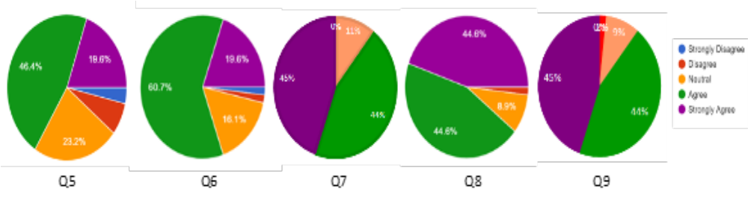

Figure 1. Results of Likert scale questions given in Table 2.

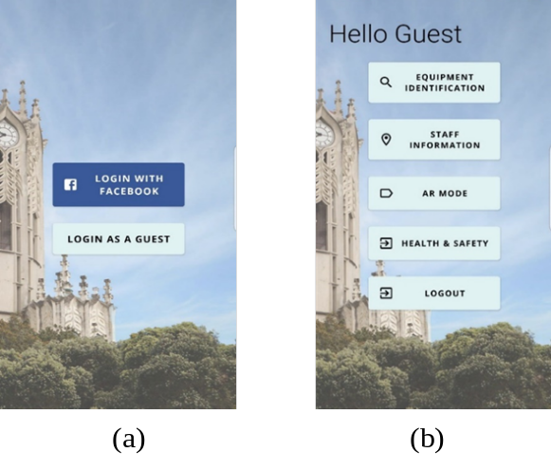

Figure 2. Log in and main screen

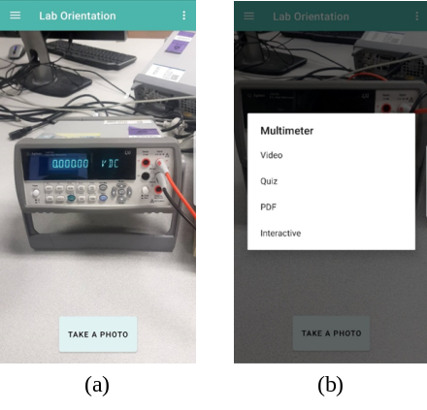

Figure 3. Equipment identification (a) equipment image acquisition (b) information dialogue box

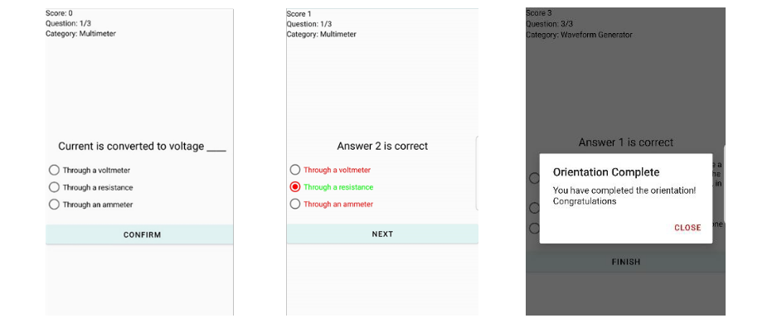

Figure 4. Quiz Activity

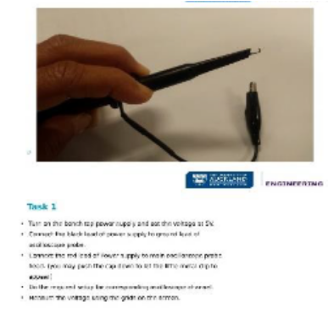

Figure 5. Pdf activity
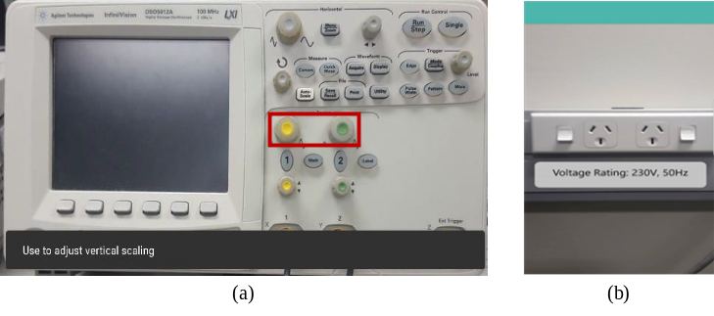

Figure 6. (a) Interactive Equipment (b) Power socket in AR Mode

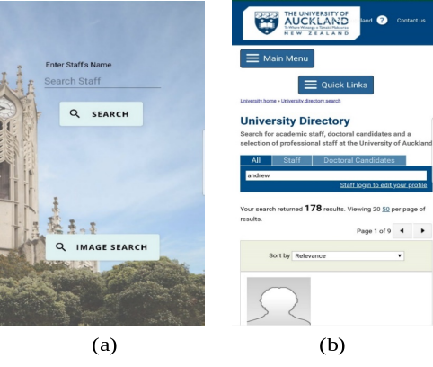

Figure 7. Staff Information (a) query screen (b) university directory page

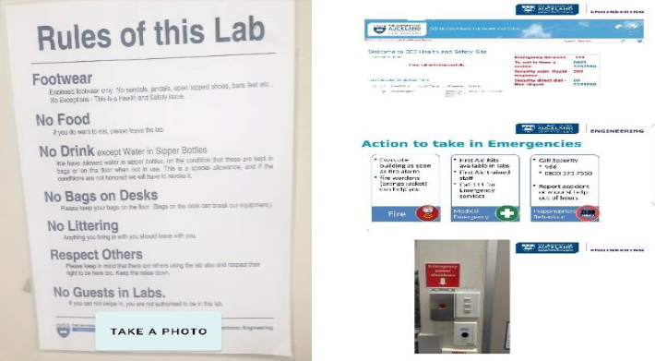

Figure 8. Health and Safety

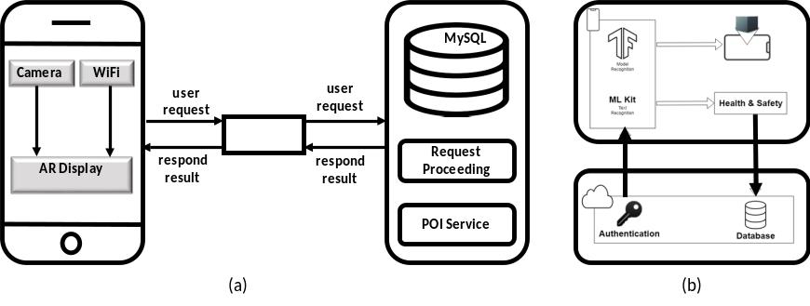
Figure 9. System Architecture

