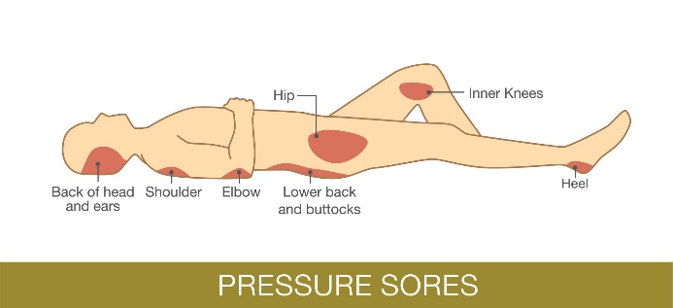

**Fig. 1** Pressure Sore Face Up [12]



**Fig. 2** System Architecture

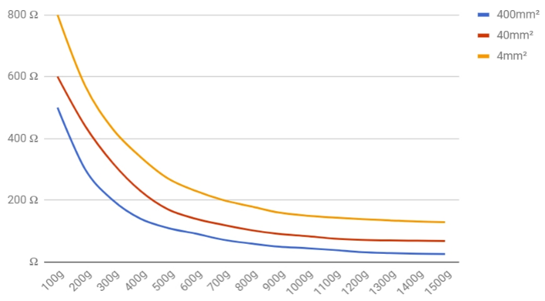

**Fig. 3** Velostat Resistance vs Pressure Graph



**Fig. 4** Three layered FSR design



**Fig. 5** Sensor topology with heat map



**Fig. 6** Mat construction



**Fig. 7** Connection diagram



Figure 8: Bread-boarding and final PCB

**Fig. 8** Bread boarding and PCB

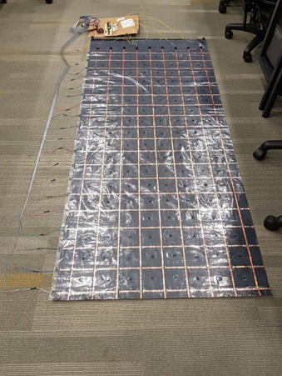

**Fig. 9** PressureSensor mat prototype

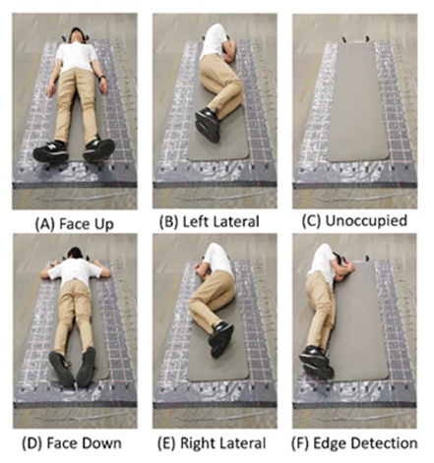

**Fig. 10** Identifiable sleep postures

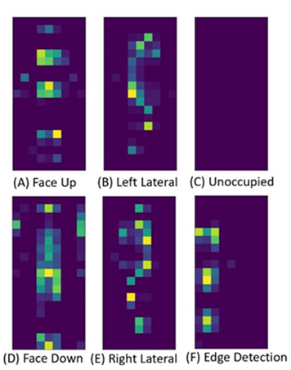

**Fig. 11** Categorical heat map images generated from the pressure readings.



**Fig. 12** CNN process in TensorFlow

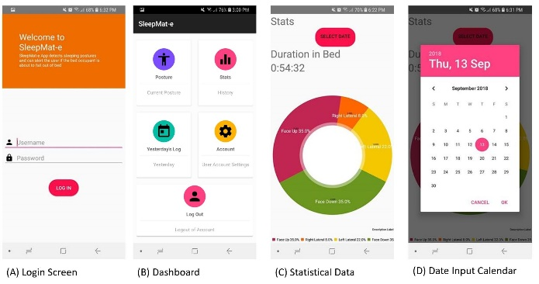

**Fig. 13** Mobile application user interface



**Fig 14** (a) Live posture image (b) fall alert