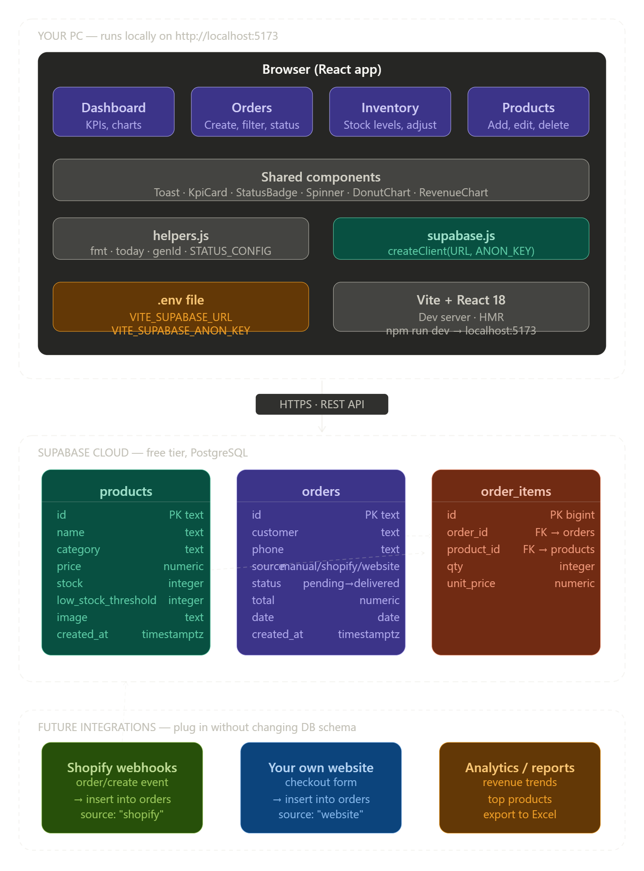
Here's the full picture. You can click any box to ask about that part. Here's the summary in plain terms:

What you built — 3 layers
The app runs entirely on your PC. Vite serves it as a local website at localhost:5173. React handles all the UI. When you open it, it reads your .env file to get the Supabase credentials, then fetches all data from the cloud DB on startup.
Every action (add order, adjust stock, edit product) sends an HTTPS request directly from your browser to Supabase's REST API — no server in the middle. Supabase handles the database and returns the result.
The 3 database tables
products — your catalog. orders — every order with its status and source tag. order_items — the line items inside each order, linked to both tables via foreign keys. This 3-table design is what lets you attach multiple products to one order cleanly.
The source field is your integration key
Right now every order you create manually gets source: "manual". When Shopify sends a webhook later, that order gets source: "shopify". Your own website gets source: "website". Nothing else in the schema changes — the dashboard and filters already handle all three.
File structure
src/lib/supabase.js — the DB connection. src/lib/helpers.js — shared formatting and constants. src/components/UI.jsx — reusable components used across all pages. src/pages/ — one file per screen (Dashboard, Orders, Inventory, Products). App.jsx — loads all data on startup and handles routing between pages.

