1. List all running processes
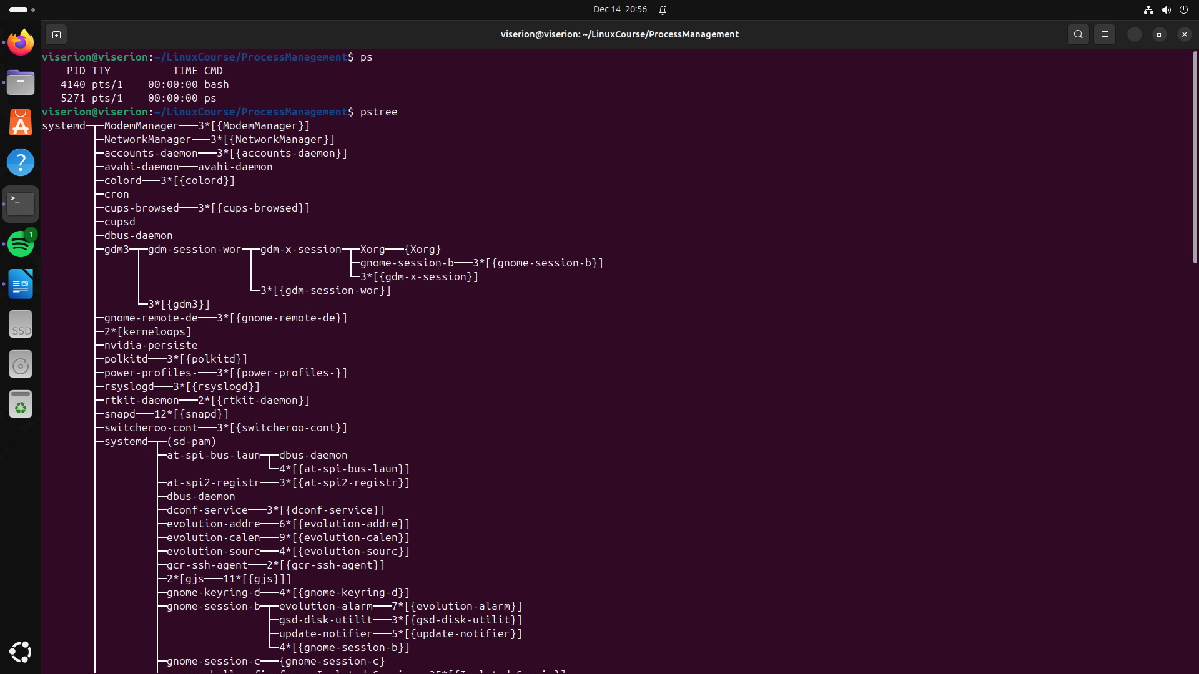

2. Monitor system processes in real-time
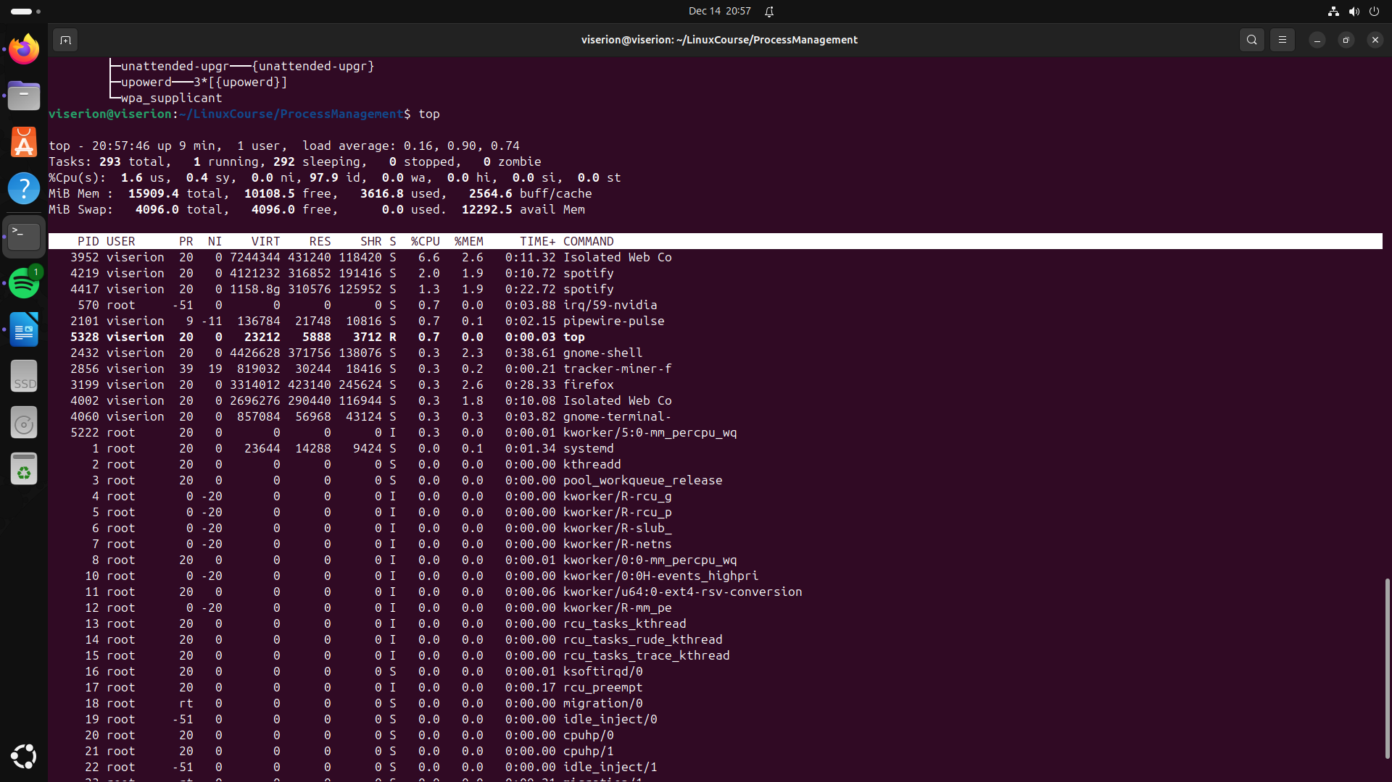
3. Start a background process
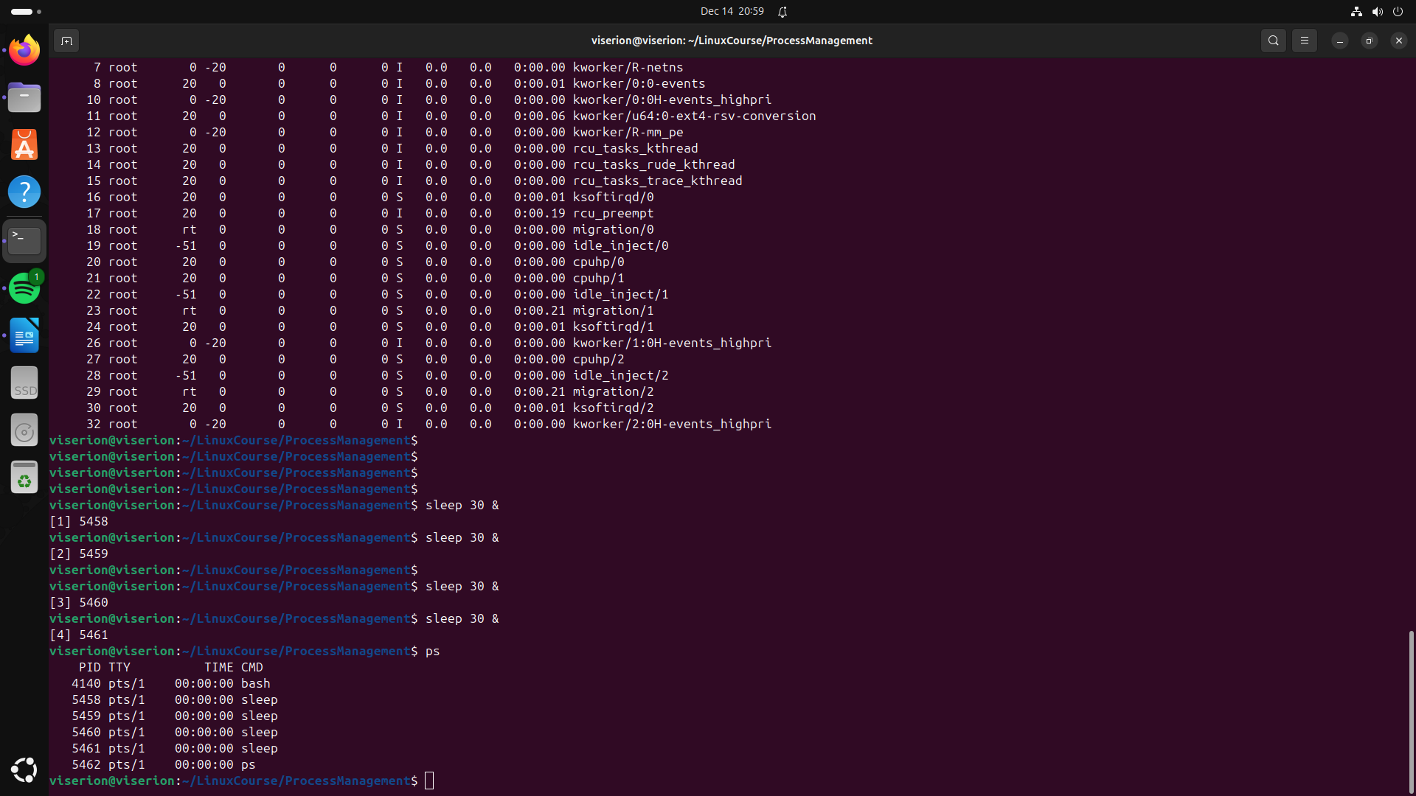
4. Bring a background process to the foreground
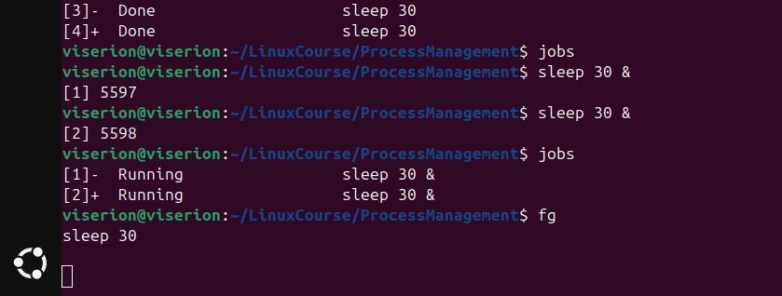
5. Suspend and resume a process

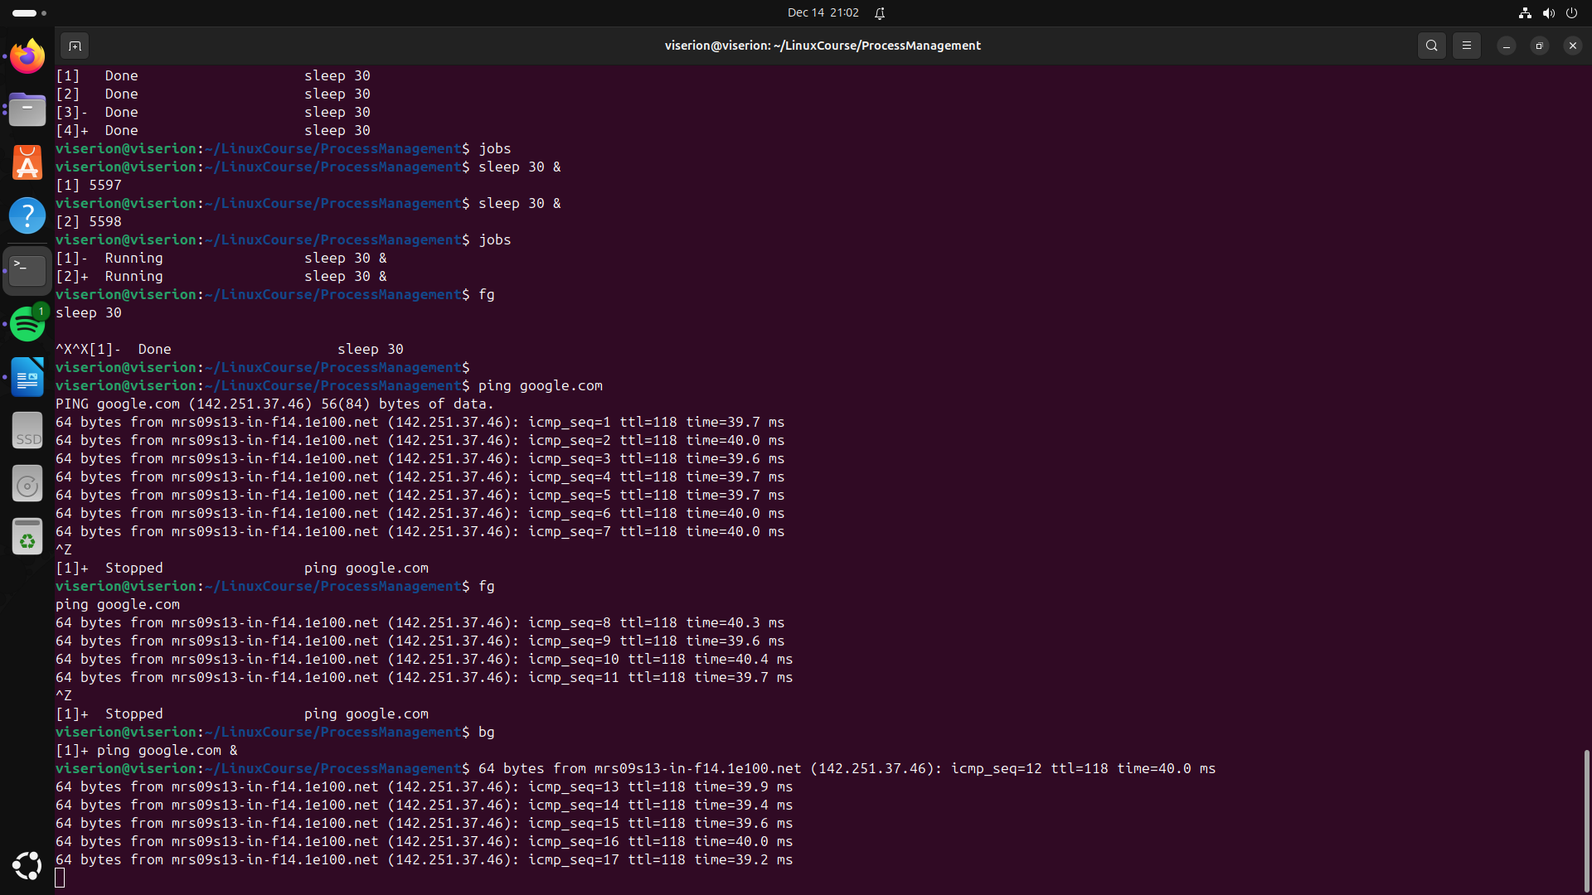

------------------------------------------------------------------------------------------------------------------------

6. Kill a process by PID
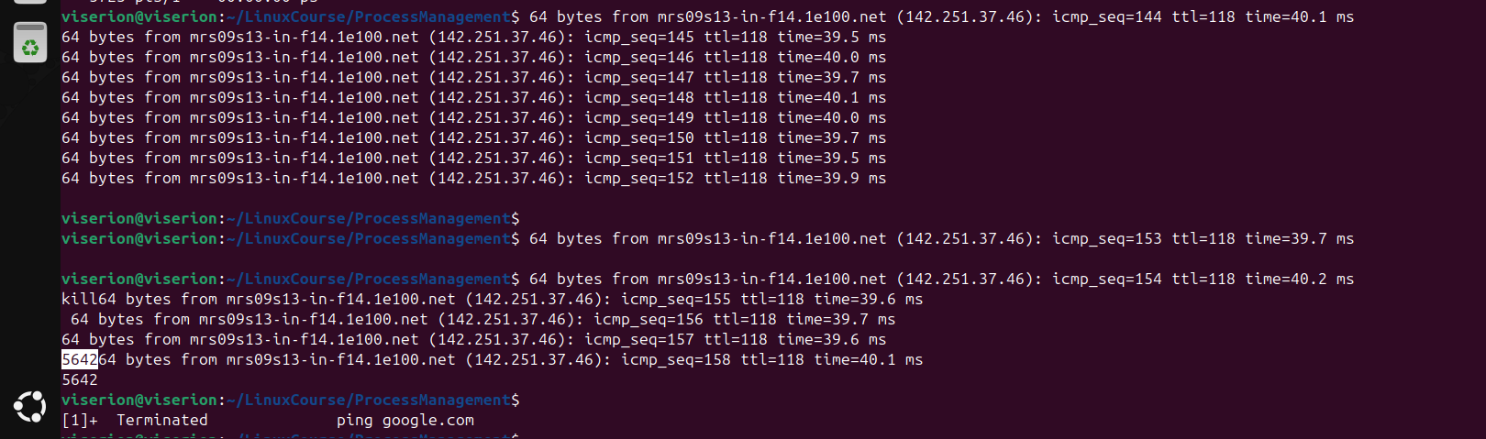
7. Terminate multiple processes
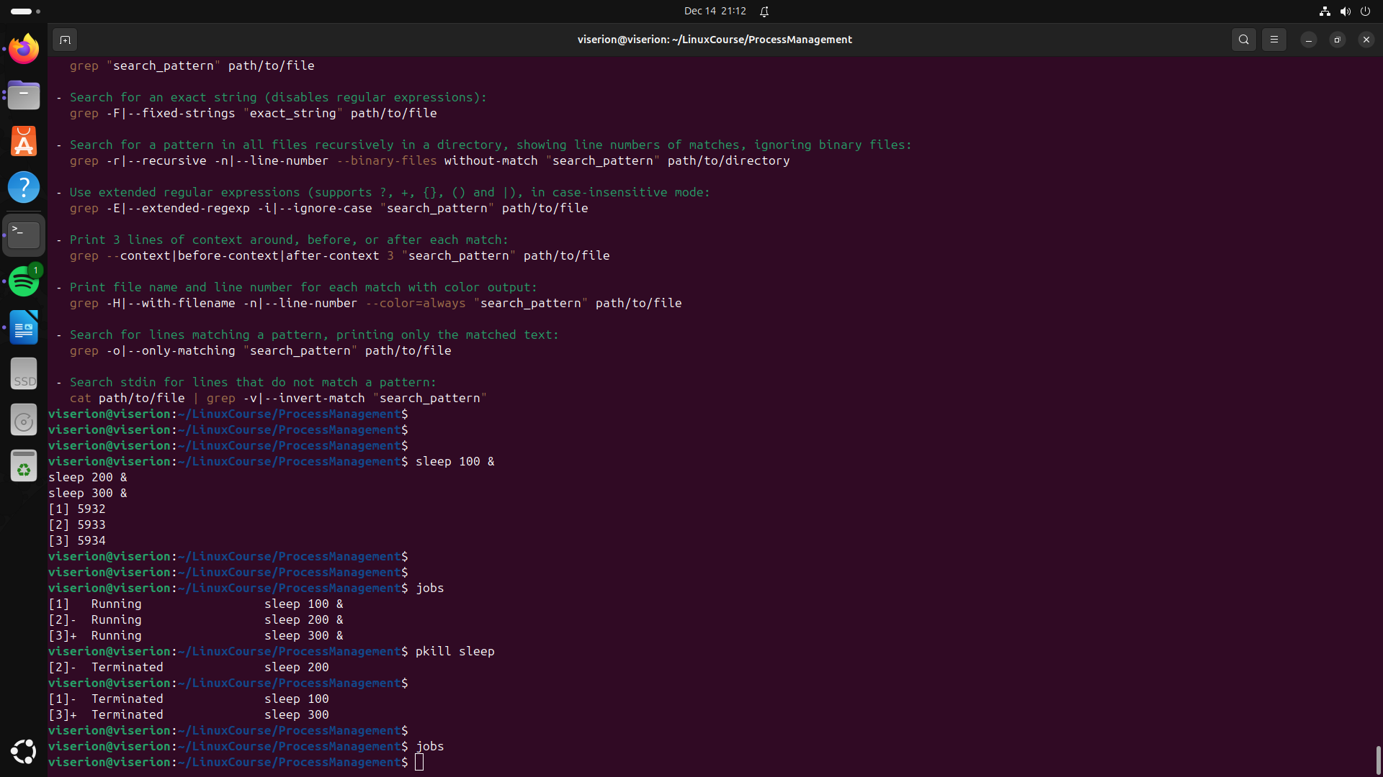
8. Niceness levels
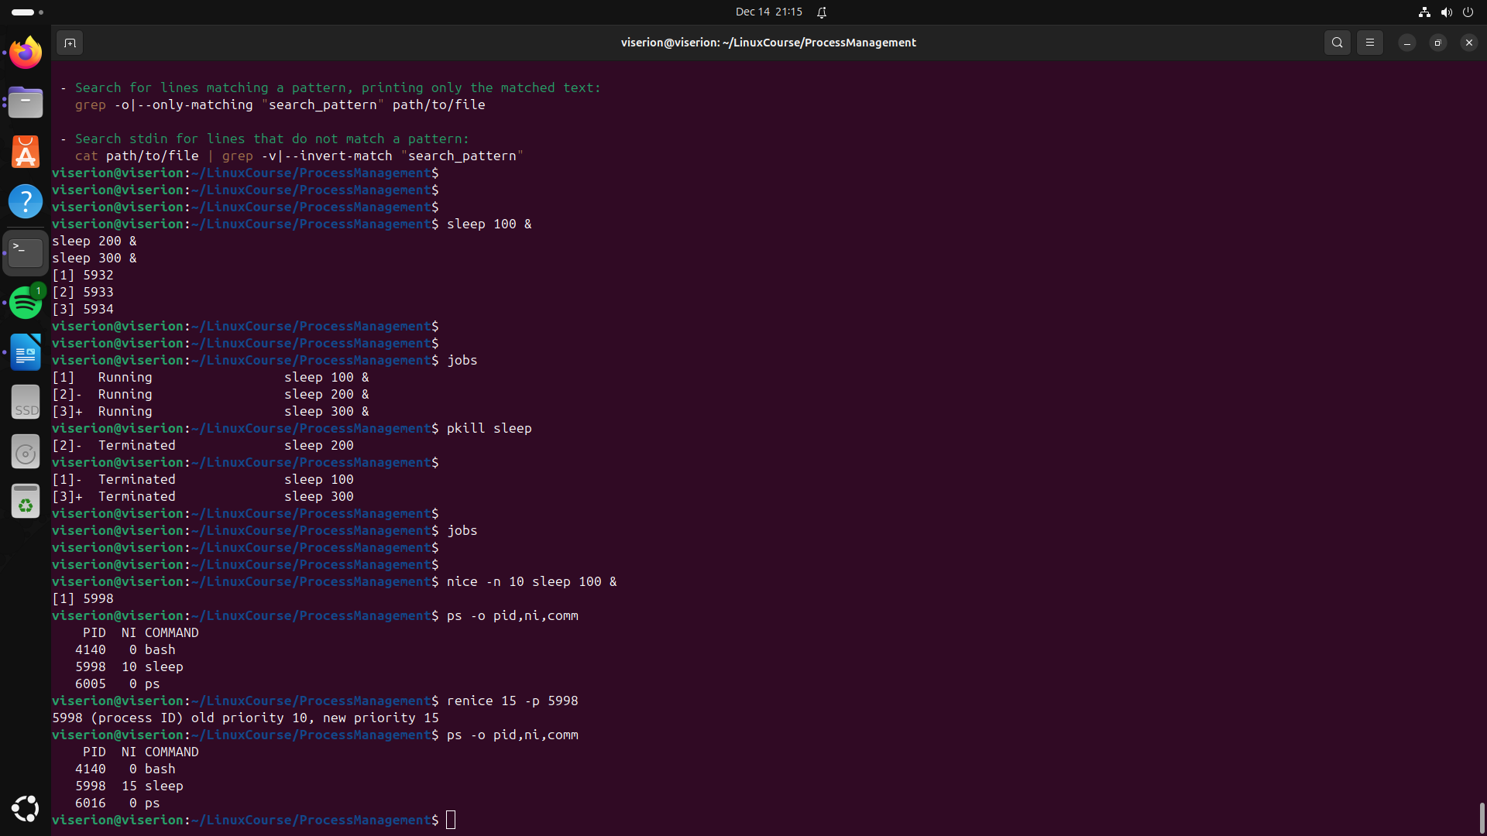
9. View process hierarchy
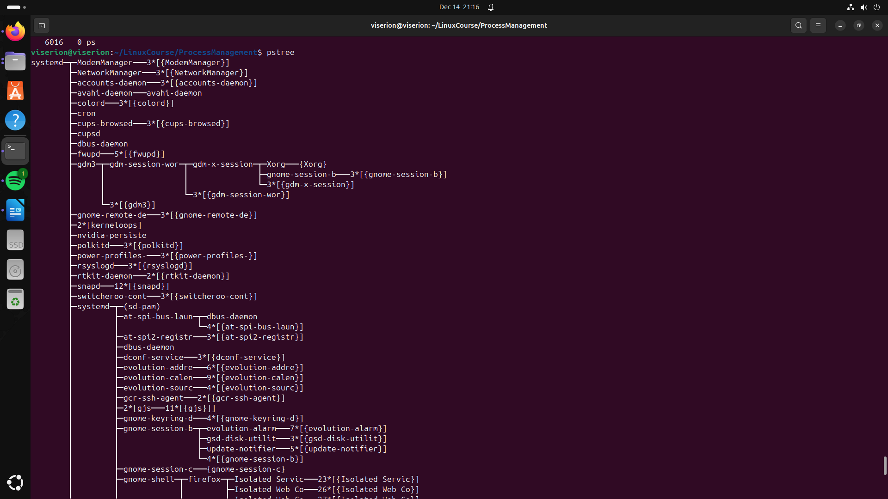
10. Redirect process output
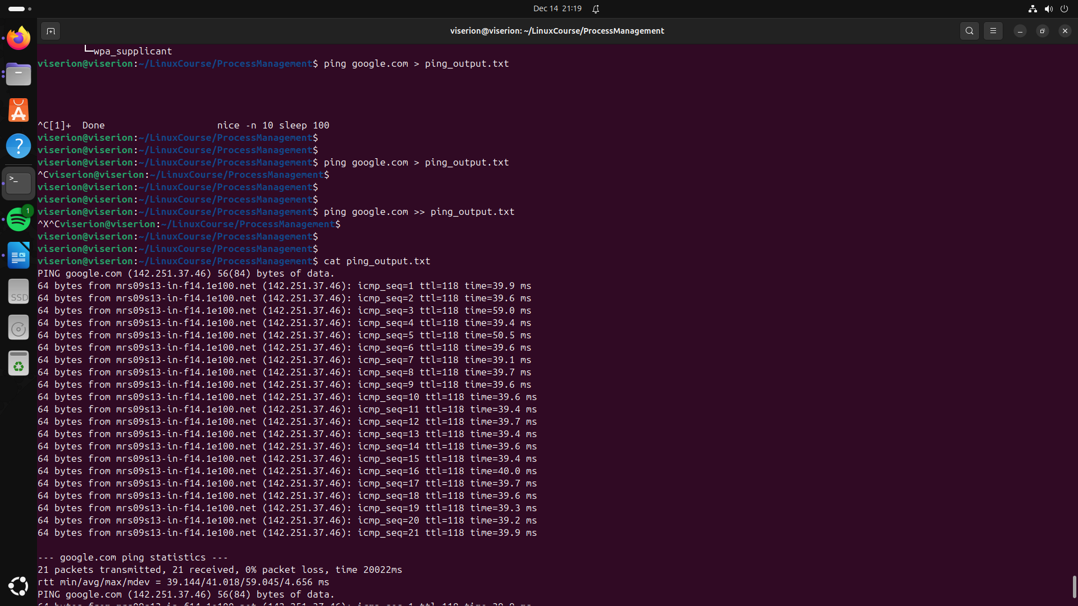

------------------------------------------------------------------------------------------------------------------------

11. Track system calls of a process
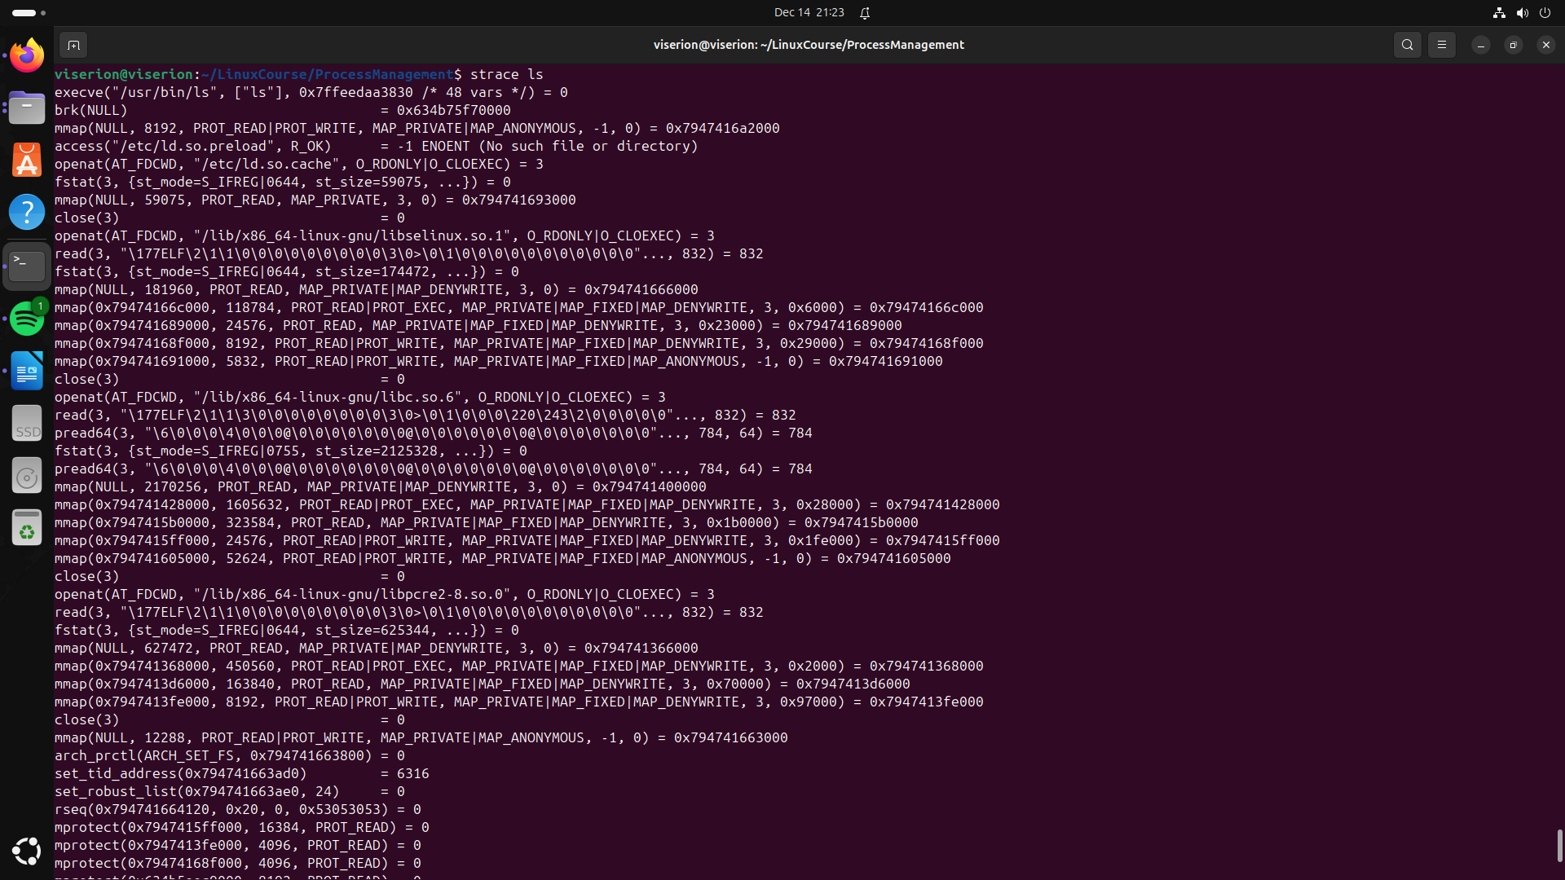
12. Monitor file descriptors
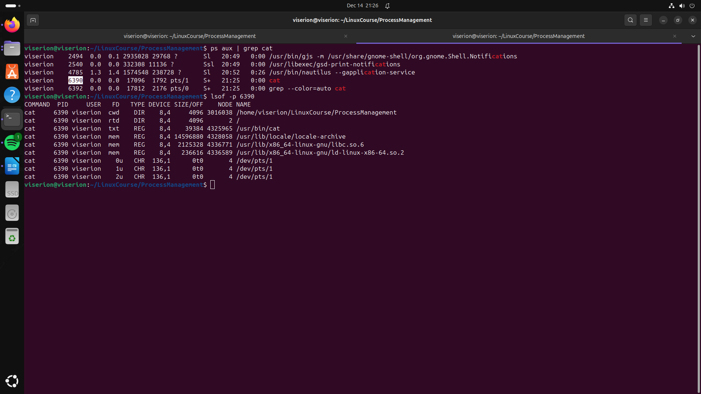
13. Process scheduling policies

14. Create and terminate a zombie process
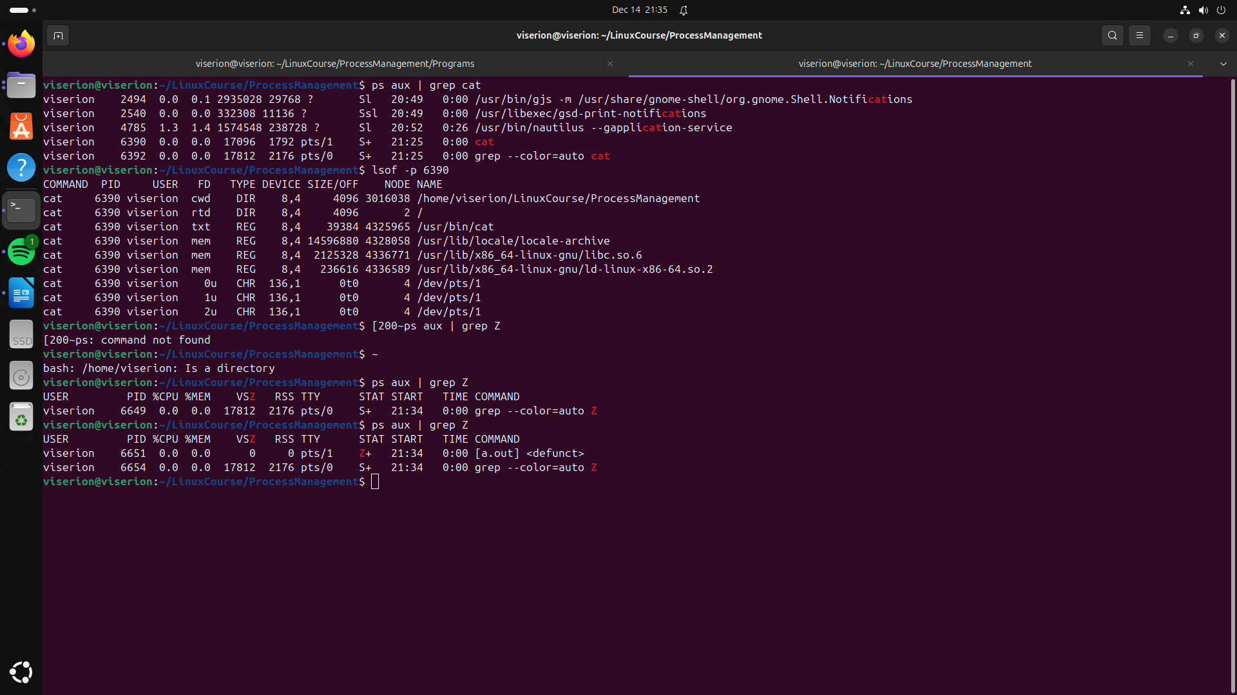
15. Limit resource usage

