- Check how many cores do you have using top command.
nproc


- Create number of cores + 2 processes dd if=/dev/zero of=/dev/null run in background.
for i in {1..6}; do dd if=/dev/zero of=/dev/null & done

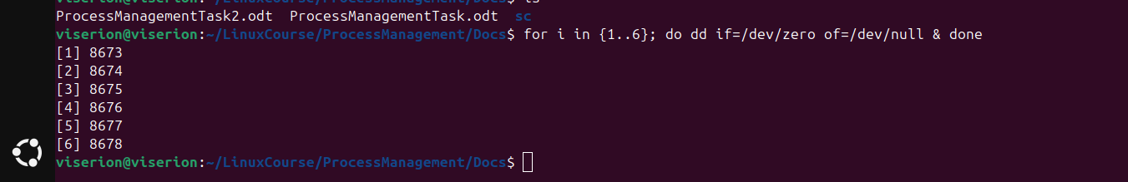
- Change priority for them:
  - -20, -10, 0, .. , 19

ps aux | grep dd
sudo renice -n -20 -p PID1
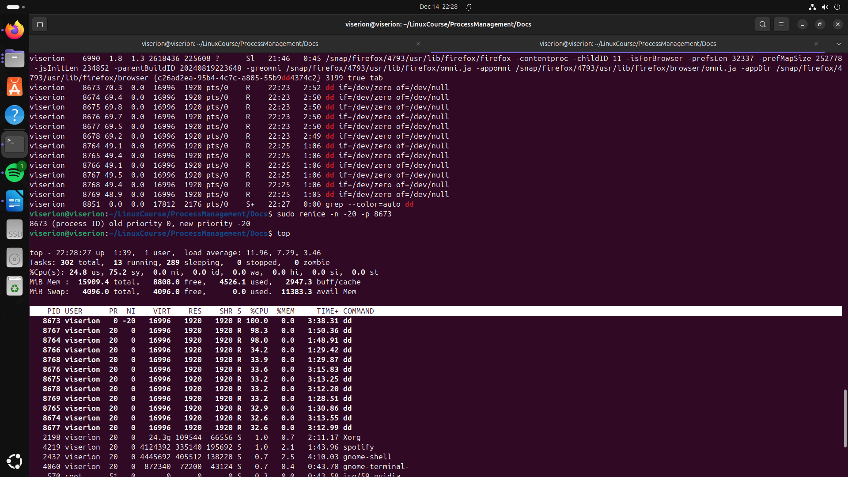
top

- Monitor them using top command, did you notice any change ?

- Kill them all using killall command.
killall dd
