-1st you should install python on your local machine, then install fastAPI

- Pip install fastapi uvicorn
- Pip show fastapi
Then use the following command to init the server:
Uvicorn main:app –reload
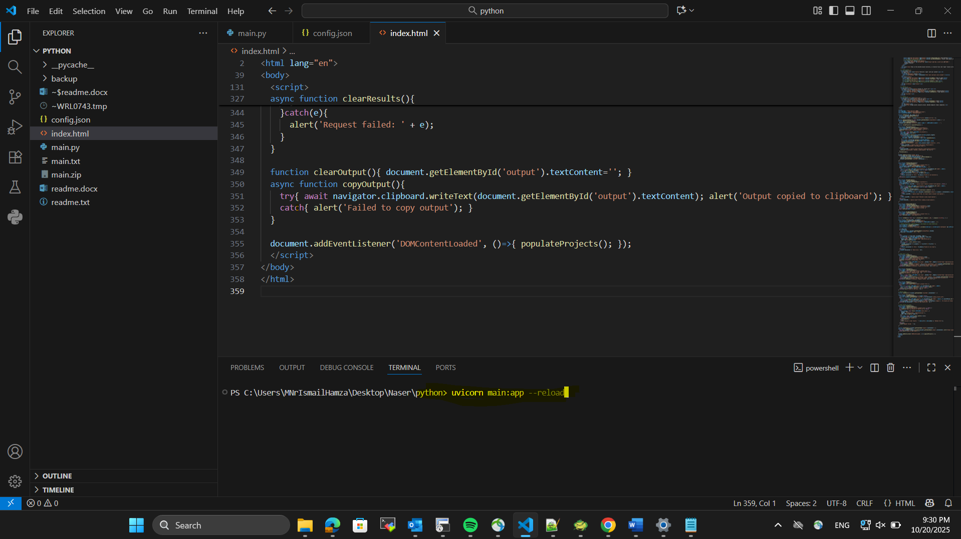

Then open index.html file on your browser and you will open the below frontend:
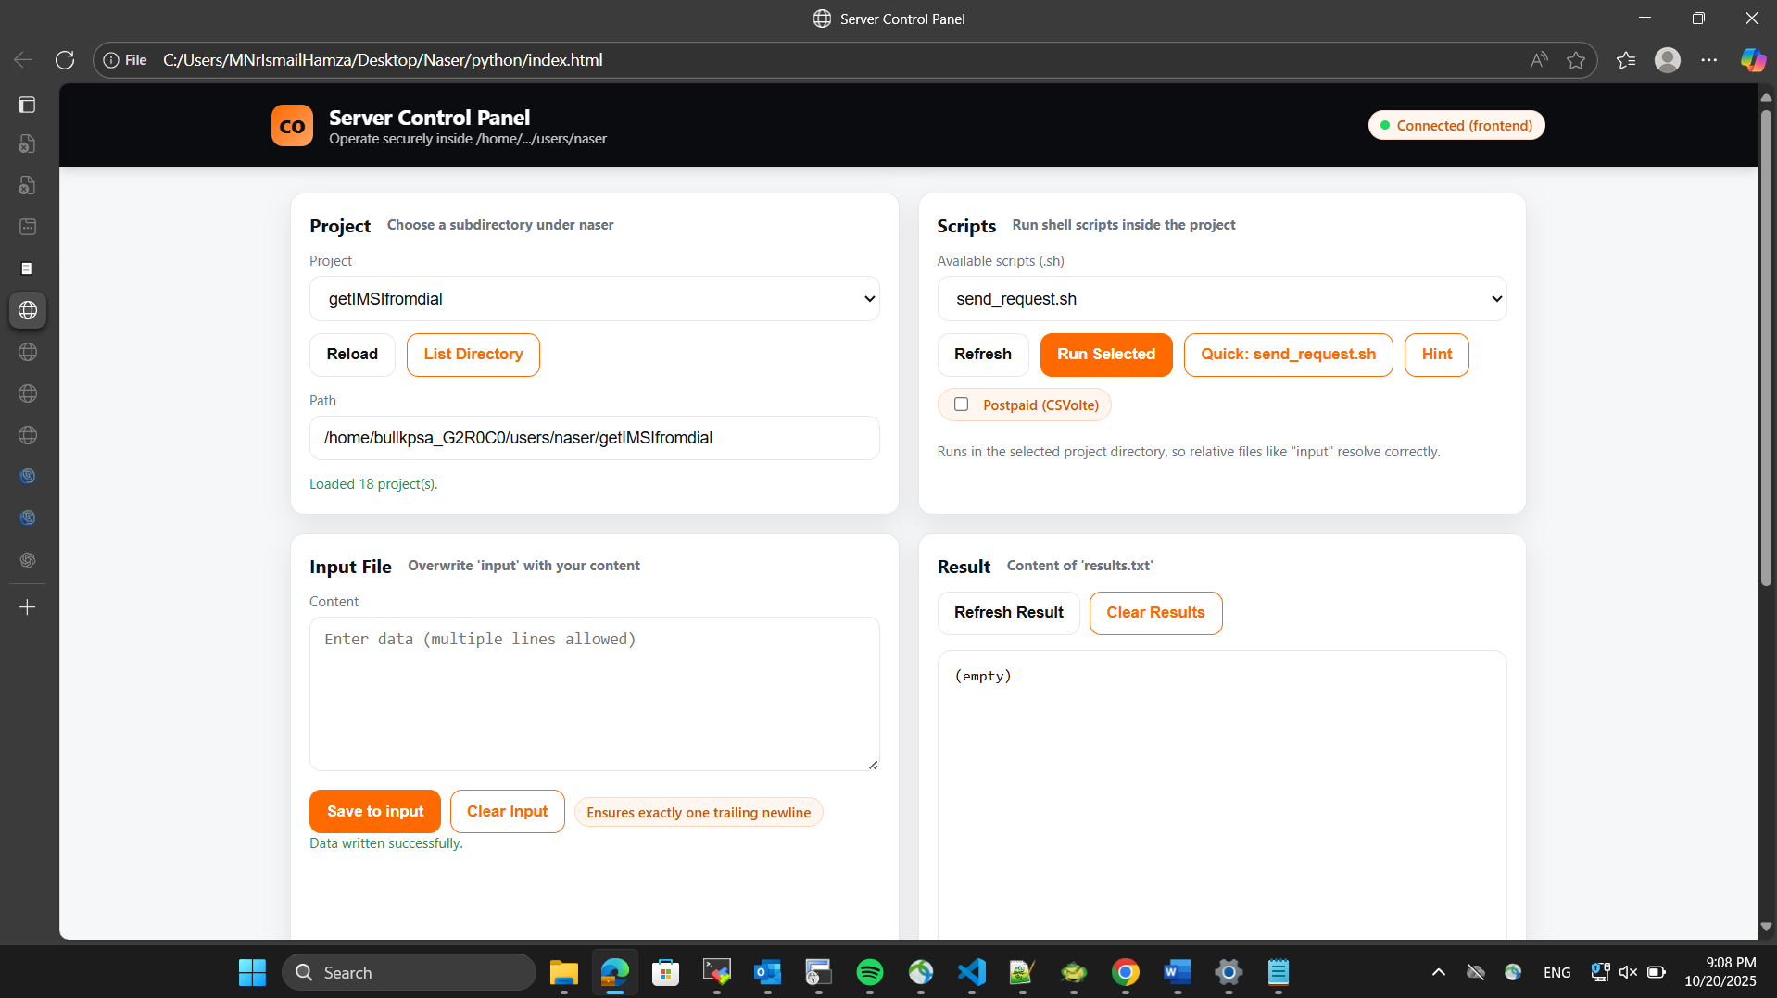

How to use the tool:
- Project view:
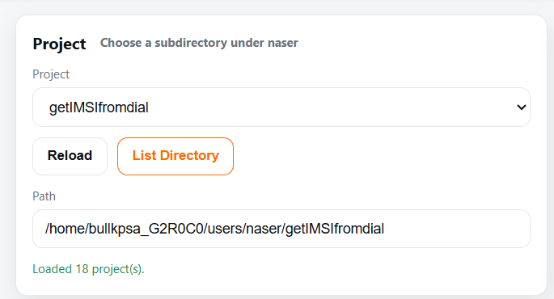
- You can chose any script you want to run from the above drop down menu,
- List directory button will list all the files inside the directory,

- Scripts :
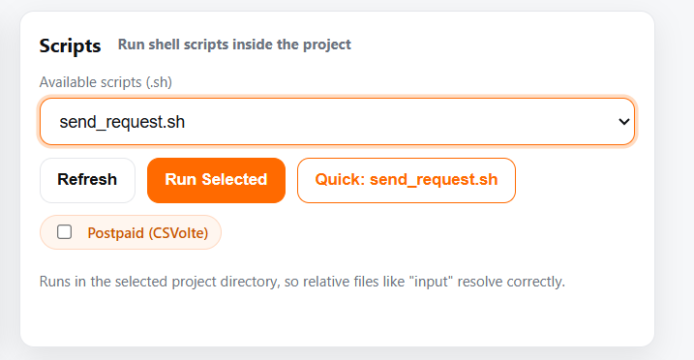
This field will let you run any bash script placed into the directory you choose before,
You can press Run Selected to run the script ,
Note: the check button (Postpaid) is a special treatment for a specific script (CSVolteDelete) don’t mark it until you need to run the script on a postpaid dial,
- Input :
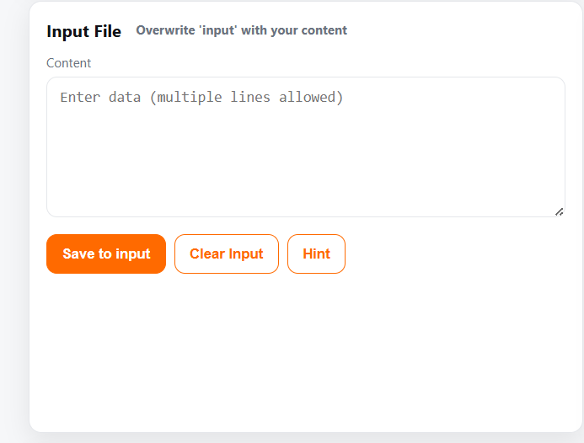

Insert any input you need then press save to input ,
Hint button will show you a simple guide the learn you how to use the script,

- Output:
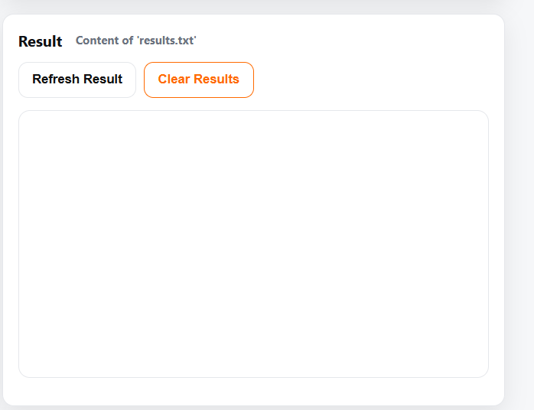

This field will show you the results of any script you run if it returns output,
Ex: get imsi from dial ……

- Logs
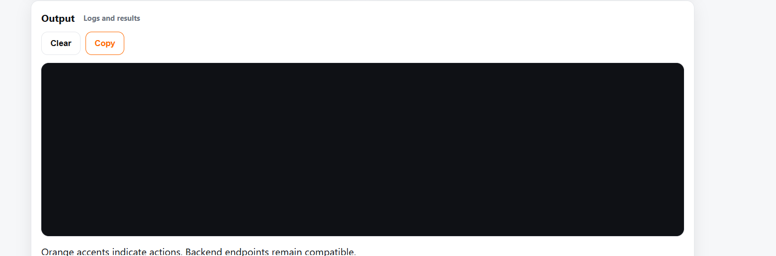

This field will show the logs and the terminal,
(it’s not interactive so you cant write any commands on it ),

