My name is Muhammad Nidal

I am the React js is using is front-end and backend is a Asp.net core

Developer and using database is sql

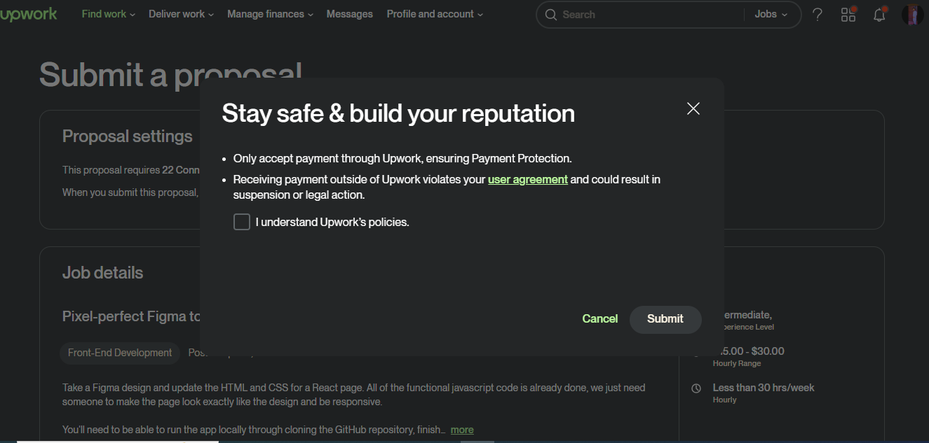

Certainly! Here are three questions you might ask your client on Upwork related to a React.js and ASP.NET Core developer position:

1. Can you provide more details about the specific projects or tasks I'll be working on with React.js and ASP.NET Core? Understanding the scope and requirements will help me assess my fit for the role.
2. What technologies or frameworks are currently in use within your development environment? This will help me gauge how my skills align with your tech stack and any potential learning curves.
3. Are there any particular challenges or goals you're aiming to address with the React.js and ASP.NET Core development? Knowing the project objectives can guide me in showcasing relevant experience and suggesting effective solutions.

Top of Form

Bottom of Form

I am excited to apply for the React.js and ASP.NET Core developer position you have available. With over two years of hands-on experience in HTML, CSS, JavaScript, React.js, and ASP.NET Core, I am confident in my ability to contribute effectively to your projects.

Having discussed the job requirements with you, I am eager to leverage my expertise to tackle the tasks and projects you have outlined. My experience includes developing responsive and user-friendly web applications using React.js and integrating them seamlessly with ASP.NET Core backend services. I am adept at translating design mockups into high-quality, pixel-perfect front-end code while ensuring optimal performance and accessibility standards.

I am committed to delivering results that exceed your expectations and am keen on collaborating closely with your team to achieve project objectives efficiently. My proactive approach, attention to detail, and ability to troubleshoot and solve complex problems make me a valuable asset to any development team.

Regarding the hourly rate, as discussed, I propose a rate of $7 per hour for my services. I believe this rate is fair and competitive given the level of expertise and dedication I bring to the table.

Thank you for considering my application. I am eager to further discuss how I can contribute to your projects and address any questions or concerns you may have. I look forward to the opportunity to work together and contribute to your team's success.