

Python

LAB # 02



October 3, 2022

MUHAMMAD nOMAN

35152-BSCS

**PRACTISE:**

# Indentation  
if 3 > 5:  
 print('Five is greater than Three')  
else:  
 print('Five is less than Three')  
  
# variable  
x = 5  
y = 'string'  
print(x, " because x is a type of integer")  
print(y, " because y is a type of string")  
  
# overwrite  
a = 4  
a = "sally"  
print(a)  
  
x = int(3)  
y = str(4)  
z = float(33.0)  
  
print(x)  
print(y)  
print(z)  
# describing type of variable  
z = 3  
print(type(z))

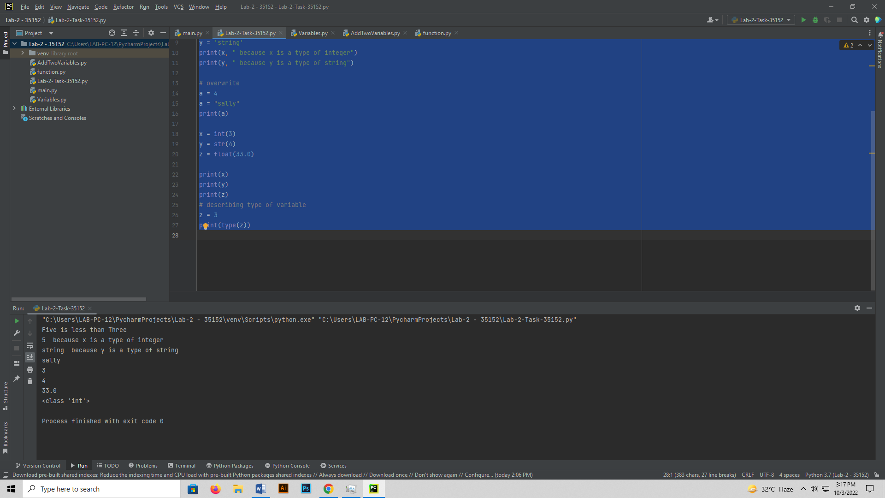

print(" Different Types of Variables")  
# Camel Case  
myName = "camel Case Variable"  
print(myName)  
# Pascal Case  
MyName = "Pascal Case Variable"  
print(MyName)  
# Snake Case  
my_name = "snake_case_variable"  
print(my_name)  
  
print(" Multiple Variables in one Line ")  
  
# Multiple Variables in One Line  
  
x, y, z = ["Orange", "Bannana", "Cherry"]  
print(x)  
print(y)  
print(z)  
  
print(" one value to Multiple variables ")  
# one value to Multiple variables  
x = y = z = "Orange"  
print(x)  
print(y)  
print(z)

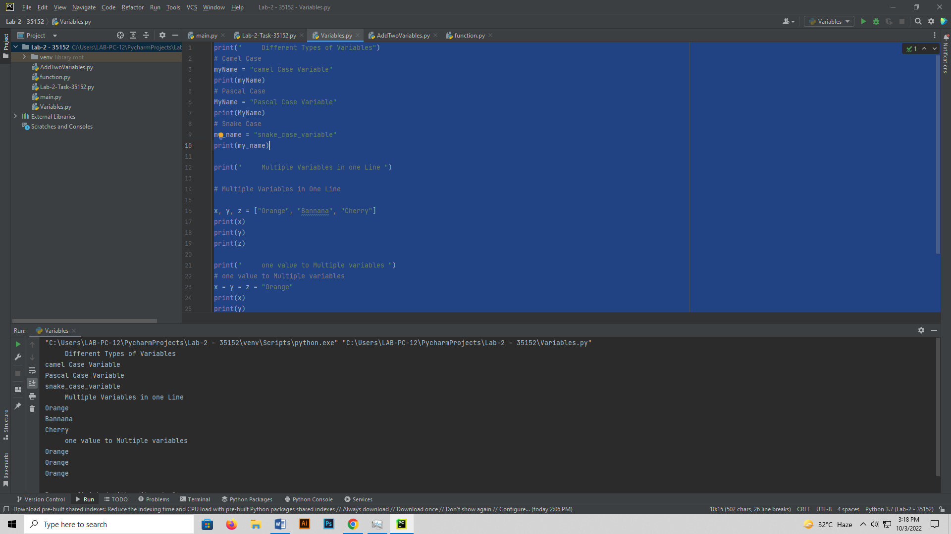

x = "awesome "  
print("Python is " + x)  
x = "Python is "  
y = "awesome"  
z = x + y  
print(z)  
  
x = 5  
y = "john"  
print(str(x) + y)

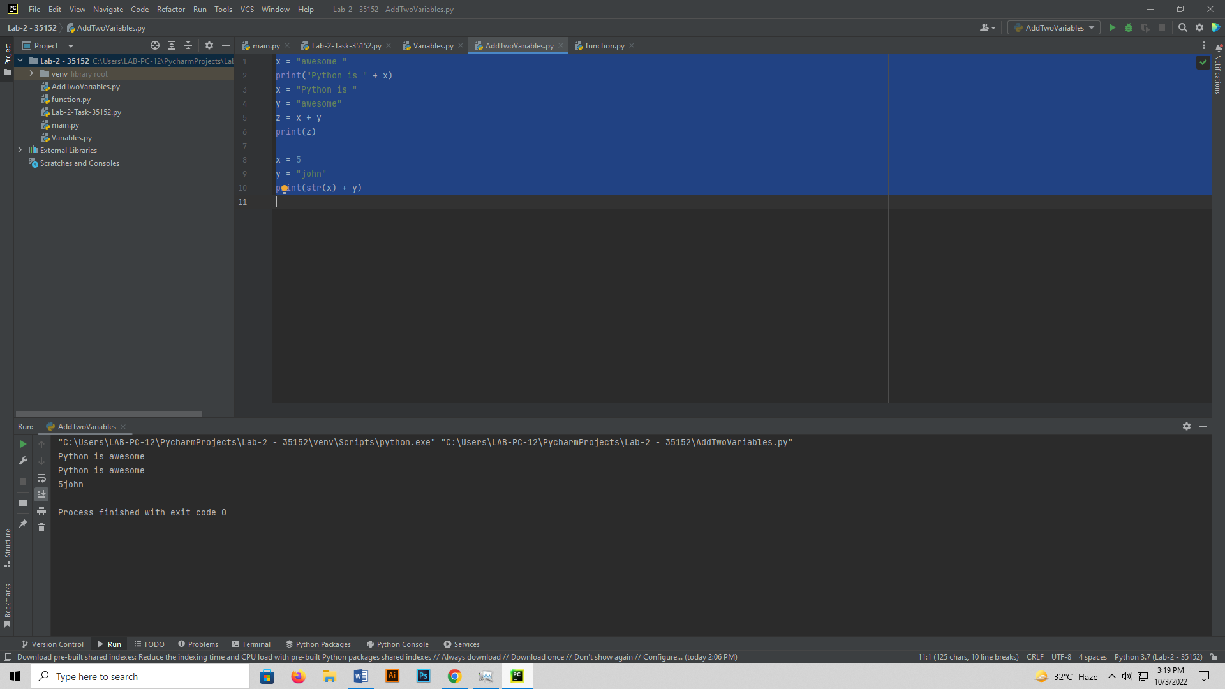

# Function  
print(" Functions ")  
x = "awesome"  
  
  
def myfunc():  
 print("Python is " + x)  
  
  
myfunc()  
  
  
# Local Variable in a function  
  
def myfunc():  
 global x  
 x = "fantastic"  
  
  
myfunc()  
  
print("Python is " + x)

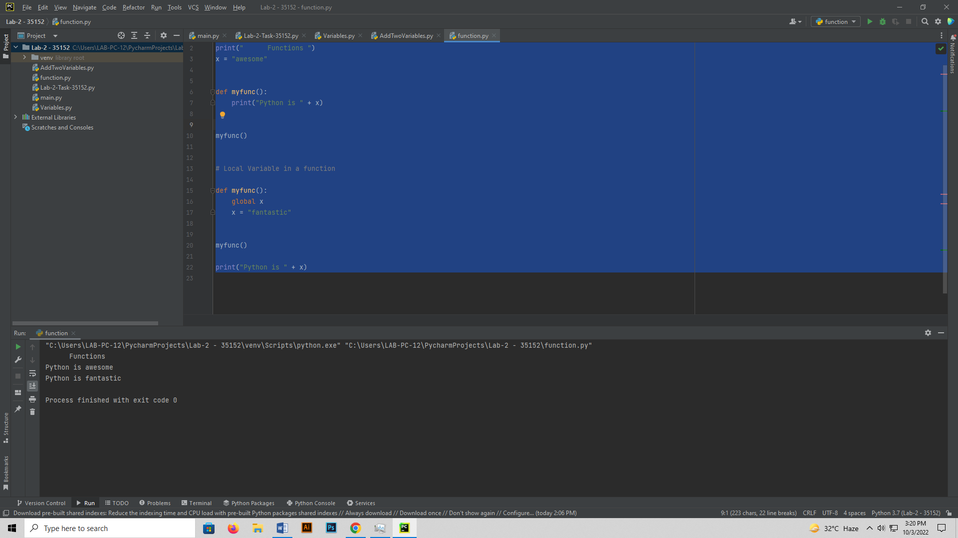

**TASK 1**

def myInformation():  
 global semester, age  
 name = "Muhammad Noman"  
 age = 21  
 semester = "5th"  
 print("Name : ", name)  
  
  
myInformation()  
print("age : ", age)  
print("Semester :", semester)

