Software Requirements Specification

Agentic Accessibility Auditor (Axion)

for Android Mobile Application UIs
Field | Value
Document version | 2.10
Status | Draft for SDS handoff
Prepared by | Ayesha Naveed + Salar (primary authors); Muhammad Noor (Lead — review, integration, API/report sections)
Institution | National University of Computer and Emerging Sciences (FAST-NUCES)
Internship duration | 8 weeks (Summer 2026)
Standards basis | IEEE 830-style SRS structure
Supersedes | SRS v1.0 documents (Axion + Agentic)

Document history
Version | Date | Author | Changes
1.0 (Axion) | 2026 | Ayesha Naveed | Initial Axion UI-focused SRS with G01–G30, R01–R30, Figma screen specs
1.0 (Agentic) | 2026 | Team | Module-based SRS with Docker, R1–R10 core, stretch goals
2.0 | 2026 | Ayesha + Salar | Unified SRS; Muhammad Noor reviewed and merged for SDS handoff
2.1 | 2026-07-13 | Noor | Figma screenshots restored from formatted DOCX into docs/assets/figma/; team ownership alignment
2.2 | 2026-07-14 | Noor | POST /api/v1/audit requires paired screenshot + XML; pair validation aligned with Axion Upload
2.3 | 2026-07-15 | Noor | Week 6 status: JWT auth + Records API implemented on noor; FR-AUTH/FR-REC/FR-UI.40–45 marked Done; eval sheet started
2.4 | 2026-07-16 | Noor | Week 6 close-out: OTP/forgot/reset + Gmail SMTP; Google OAuth (GOOGLE_CLIENT_ID); any-domain emails (Yahoo/edu/…); 40/40 eval notes; HTML/PDF export fix; FR-AUTH/FR-EV updated Done
2.5 | 2026-07-16 | Noor | Align §4.9 / §9 with live mounts (/auth, /records); FR-REC.5 DELETE Done; FR-IN.2 pair validation Done
2.6 | 2026-07-20 | Noor | Week 7 QA: rule-wise + guideline-wise summaries on MASC 40-screen sample (docs/week7/); Rico holdout eval deferred; team priority fixes for Salar/Ayesha
2.7 | 2026-07-27 | Noor | Post–Week 7 YOLO track: new FR-CV.4–FR-CV.7 screenshot-only UI-element detector fallback requirement (§4.4); F13 product function; Appendix B traceability updated; Progress Report v1.23 comprehensive embedded visualizations + outputs inventory (§15D–15F)
2.8–2.9 | 2026-07-29 | Noor | Rule-accuracy fixes verified against real MASC (7,068 screens) and Rico holdout (1,698 screens) data, not just fixtures: FR-RU.7 (R07) and FR-RU.8 (R08) false-positive sources eliminated (R08 -43.2% on Rico holdout); R30 collapses repeated list/grid-row icon instances; R20 unblocked from a parser bug (0 → 749 hits), which also corrected an R05 false-positive pattern (2,117 → 717). §4.4 renamed and expanded: FR-CV.8–9 added (crop classifier is multi-label across R09/R04/R17/R10/R28/R08, MASC-only training — the actual implementation is broader than FR-CV.3's original R09-only framing); F10 (§2.2) updated from "optional CV contrast + CNN signal" to the trained crop classifier; status paragraphs added for both the crop classifier (val macro-F1 0.265) and YOLO detector, correcting a stale claim that src/yolo_ui_detector.py was scaffolded (it does not exist). Appendix B: FR-EV.5 (Rico holdout) updated Done, no longer deferred. Progress Report v1.24–1.25 / SDS v2.12–2.13 sync.
2.10 | 2026-07-30 | Noor | Teammate Salar independently completed the full 60-epoch YOLO training run and the Rico holdout zero-shot-vs-fine-tuned evaluation on the salar branch; his finished checkpoint (models/yolo_ui_detector_best.pt, 51.2 MB) and exported src/yolo_ui_detector.py were merged into noor, correcting the 29 Jul claim that the module does not exist — it now exists but remains deliberately not wired into the backend (Stretch requirement, integration explicitly deferred by team decision, not started). Crop classifier: Rico holdout generalization eval also run (9,343 crops, all 1,698 holdout screens, weighted F1 0.43 vs. 0.63 on MASC test) — same not-wired, deliberately-deferred status. §4.4 status paragraphs and Appendix B (FR-CV.4–9) updated accordingly. Progress Report v1.26 / SDS v2.14 sync. Filename bumped from v2.8 to v2.10 to match content version (previous filename had drifted behind the 2.8–2.9 combined content update).

| Note on UI specifications: Screen layouts, branding, and interaction flows in Section 3.1 and Appendix F are derived from Ayesha Naveed's Figma designs shared in #tem-all-dynamo Slack. Reference screenshots are embedded in Appendix F (docs/assets/figma/). Screens covered: Sign Up, Log In, Forgot Password, OTP Verify, Reset Password, Upload (all states), Audit Complete modal, Dashboard, Issue Detail drawer, Audit Report, Generate Report modal, and Records (Reports) page.

Table of contents
- [Introduction](#1-introduction)
- [Overall description](#2-overall-description)
- [External interface requirements](#3-external-interface-requirements)
- [System features and functional requirements](#4-system-features-and-functional-requirements)
- [Non-functional requirements](#5-non-functional-requirements)
- [Data collection and storage](#6-data-collection-and-storage)
- [Accessibility guidelines and detection rules](#7-accessibility-guidelines-and-detection-rules)
- [JSON schema contracts](#8-json-schema-contracts)
- [REST API requirements](#9-rest-api-requirements)
- [Module-level acceptance criteria](#10-module-level-acceptance-criteria)
- [Evaluation plan](#11-evaluation-plan)
- [Deliverables](#12-deliverables)
- [Other requirements](#13-other-requirements)
- [Appendix A: Use cases](#appendix-a-use-cases)
- [Appendix B: Requirements traceability matrix](#appendix-b-requirements-traceability-matrix)
- [Appendix C: Glossary](#appendix-c-glossary)
- [Appendix D: TBD list](#appendix-d-tbd-list)
- [Appendix E: Docker and deployment](#appendix-e-docker-and-deployment)
- [Appendix F: Axion UI screen specifications (Figma / Slack)](#appendix-f-axion-ui-screen-specifications-figma--slack)

1. Introduction

1.1 Purpose
This Software Requirements Specification (SRS) defines the functional and non-functional requirements for the Agentic Accessibility Auditor — a two-month summer internship prototype developed at FAST-NUCES.
The system accepts an Android UI screenshot and a UIAutomator XML hierarchy dump, detects accessibility violations against WCAG 2.2 AA–aligned guidelines using a deterministic rule engine, generates AI-powered explanations and developer fix recommendations via an agentic LLM layer, and produces structured HTML/PDF audit reports through a React web dashboard branded Axion.
This document is the single authoritative requirements reference for:
- Development and testing by the three-intern team
- Integration against agreed JSON data contracts
- Supervisor evaluation and SDS (Software Design Specification) authoring
- Acceptance criteria at module and system level
What this document specifies: what the system must do.
What the SDS specifies: how modules are designed, class diagrams, algorithms, and normative schema validation rules.

1.2 Document conventions
This document follows IEEE 830-style SRS conventions:
Convention | Meaning
shall | Mandatory requirement
should | Desirable requirement; may be deferred to stretch if schedule requires
Stretch | Explicitly lower priority; not required for minimum prototype acceptance
FR-<MODULE>.<n> | Functional requirement ID (module-grouped, from Agentic SRS)
FR-AAA-<nn> | Legacy functional requirement ID (from Axion SRS; mapped in Appendix B)
NFR-<n> | Non-functional requirement ID
G01–G30 | Accessibility guideline identifiers
R01–R30 | Detection rule identifiers
Must Have | Required for internship sign-off
Should Have | Expected if schedule permits
Stretch | Optional enhancement
TBD-xx | Open item; see Appendix D

Higher-level requirement priority propagates to sub-requirements unless stated otherwise.

1.3 Intended audience and reading suggestions
Audience | Focus sections
Salar (Intern 1) — Parser, rules, Docker, datasets | §4.2, §4.3, §6, §7, §8, Appendix E
Ayesha (Intern 2) — Figma, React dashboard, SRS co-author | §3.1, §4.1, Appendix F
Muhammad Noor (Lead, Intern 3) — SDS, backend API, agent, reports, JSON contracts, QA, evaluation | §4.4–§4.6, §8–§9, §11–§12
Supervisor / Evaluator | All sections; §10–§12 for acceptance
Future maintainers | §2, §7, §8, §9, Appendix C

All readers should begin with Section 2 (Overall Description) before detailed requirements.

1.4 Product scope

1.4.1 In scope
The Agentic Accessibility Auditor is a standalone prototype tool targeting Android mobile UI accessibility evaluation. The system shall:
- Accept paired inputs: one Android UI screenshot (PNG/JPG) and one UIAutomator XML hierarchy file
- Parse XML to extract structured component attributes (class, bounds, text, content-desc, clickable, enabled, focusable, resource-id)
- Run deterministic rule-based accessibility checks mapped to guidelines G01–G30 and rules R01–R30
- Use an agentic LLM layer to generate human-readable explanations, impact descriptions, and developer fix suggestions per violation already detected by the rule engine
- Generate developer-facing HTML/PDF audit reports with severity scores, guideline mappings, annotated screenshots, and recommendations
- Provide a React-based web frontend (Axion) for file upload, issues dashboard, and report download
- Deploy via Docker Compose with documented single-command startup
- Evaluate on MASC (development/tuning) and Rico holdout (unseen final evaluation) datasets

1.4.2 Priority tiers (merged resolution)
Tier | Scope
Must Have (MVP) | Parser → R01–R10 rule engine → LLM explanations → HTML/PDF report → Axion Upload + Issues + Report screens → Auth + Records → Docker Compose → evaluation on 25–40 screens
Should Have | R11–R20 rules; Issues dashboard filtering; batch CLI/API; annotated screenshot regions in UI; Figma-approved Axion branding
Stretch | R21–R30 rules; CV contrast (R09) — trained via the crop classifier (§4.4), not yet pipeline-wired; interactive click-to-highlight in HTML report; benchmark dataset export

1.4.3 Out of scope
The following are explicitly excluded from this prototype:
- Automated APK or Play Store crawling
- Full WCAG conformance certification or legal compliance audit
- Clinical disability studies or user testing with disabled participants
- Real-device ADB integration for automated capture at runtime (manual/offline collection only)
- iOS, web, or desktop UI hierarchy support
- Production-grade SSO, enterprise IAM, or HIPAA-grade user management (prototype uses JWT + local/SQLite store)
- Lab pathology / NDA-covered code, data, or infrastructure reuse

1.4.4 Scope clarifications (resolving prior SRS conflicts)
Topic | Axion SRS said | Agentic SRS said | Merged decision
Rule count MVP | R1–R10 required; R11–R20 stretch; doc also lists R01–R30 | R1–R10 only | R01–R10 Must; R11–R20 Should; R21–R30 Stretch
Contrast (R09) | Required in rules table; also "advanced contrast out of scope" | Optional CV stretch | R09 Stretch — requires screenshot crop + contrast computation
Auth / OTP UI | Required | Not mentioned | Must Have — Figma-approved Sign Up, Log In, Forgot Password, OTP, Reset Password (Appendix F)
Records page | Not in v1 | Not mentioned | Must Have — per-user audit history on sidebar Reports nav
Dataset | Rico only | Rico / public sources | MASC primary (7,068 screens); Rico holdout for unseen eval; Rico source corpus in final_rico/
Docker | Not required | Required | Required
CNN classifier | Not mentioned | Stretch | Stretch — supplementary signal only; never overrides rule engine

1.5 Definitions, acronyms, and abbreviations
See Appendix C: Glossary.

1.6 References
# | Reference
R1 | Agentic Accessibility Auditor Internship Plan, Version 1.0, FAST-NUCES, 2026
R2 | Agentic Accessibility Auditor Internship Plan & Final Report Template (8-week plan: Docker, React/Tailwind, Figma, CNN)
R3 | GitHub Repository: [MuhammadNoor7/agentic-accessibility-auditor](https://github.com/MuhammadNoor7/agentic-accessibility-auditor)
R4 | WCAG 2.2 AA Guidelines — W3C Web Accessibility Initiative (WAI)
R5 | MASC Dataset — Mobile App Dataset for Building Classification Applications ([Google Drive](https://drive.google.com/file/d/1kx8qRbOtdQbbewZgfBTeCIj7lNvabFTF/view?usp=sharing))
R6 | Rico Dataset — Android UI screenshots and view hierarchies
R7 | UIAutomator2 Documentation — Android Developers
R8 | IEEE Std 830-1998 — Recommended Practice for Software Requirements Specifications
R9 | FastAPI Documentation — https://fastapi.tiangolo.com
R10 | React 18 + Vite + Tailwind CSS Documentation
R11 | Project docs: docs/json_schemas.md, docs/accessibility_guidelines_report.md, docs/qa_test_plan.md
R12 | Ayesha Naveed — Axion Figma designs (shared via #tem-all-dynamo Slack)

2. Overall description

2.1 Product perspective
The Agentic Accessibility Auditor is an independent prototype system, not a sub-module of a larger existing platform. It is developed as an 8-week internship deliverable under team-lead supervision.
The system is structured as a six-layer pipeline:
Input Layer → Parsing Layer → Rule Checker (+ optional CV/CNN) → Agentic Layer → Report Layer → Evaluation Layer
Each layer produces a structured JSON artefact consumed by the next, enabling the three interns to develop independently against agreed data contracts.
The frontend (Axion) interacts with the backend pipeline via a FastAPI REST API. The React frontend serves as both the user-facing demo tool and the primary deliverable for the UI intern.
High-level data flow:
Screenshot + UIAutomator XML
→ XML Parser (components.json)
→ Rule Engine + optional CV/CNN (violations.json)
→ Agentic Explanation Layer (report.json / recommendations.json)
→ Report Generator (audit_report.html / .pdf)
→ React Dashboard (Axion) + Evaluation summary
All stages are orchestrated behind Docker-managed backend services (Appendix E).

2.2 Product functions
# | Function | Priority
F1 | File upload — Accept paired PNG/JPG screenshot and UIAutomator XML via web interface | Must
F2 | Pair validation — Verify screenshot and XML share matching screen IDs before analysis | Must
F3 | XML parsing — Extract UI component attributes into structured components.json | Must
F4 | Rule-based checking — Detect violations across R01–R30 (R01–R10 minimum) | Must (R01–R10)
F5 | Agentic explanation — LLM generates per-violation explanation, impact, and fix | Must
F6 | Audit report generation — HTML/PDF with scores, severity, annotated screenshots | Must
F7 | Issues dashboard — Filterable violation table in web UI | Must
F8 | Report download — PDF and HTML from interface | Must
F9 | Batch evaluation — Run pipeline across curated dataset screens | Should
F10 | Crop-level pixel classifier — Multi-label CV signal (R09/R04/R17/R10/R28/R08) supplementing the XML rule checker on rendered pixels | Stretch — trained, not pipeline-wired
F11 | User authentication (Axion) — Sign up, login, forgot password + OTP reset flow | Must
F12 | Records page — Per-user audit history; store and retrieve reports against authenticated account | Must
F13 | Screenshot-only fallback detection (YOLO) — Detect UI elements directly from the screenshot pixels when no (or a malformed) XML hierarchy is available | Stretch — trained, not pipeline-wired

2.3 User classes and characteristics
User class | Description | Technical level | Primary functions
Android Developer | Developer integrating accessibility into their Android app | Medium–High | Upload files, review violations, apply fix suggestions
QA / Accessibility Tester | Tester running audits on multiple screens | Medium | Batch uploads, download reports, review severity breakdown
Intern / Developer | Team member building or testing the pipeline | High | All functions; backend debugging; rule authoring
Supervisor / Evaluator | Team lead or academic evaluator reviewing outputs | Low–Medium | View reports; assess output quality and rule correctness

2.4 Operating environment
Component | Requirement
Client | Modern desktop browser (Chrome, Firefox, Edge); JavaScript enabled
Frontend | React 18 + Vite + Tailwind CSS; dev server localhost:5173
Backend | Python 3.11+ with FastAPI
Deployment | Docker + Docker Compose on Linux/macOS/Windows (Docker Desktop)
Database | No persistent database for prototype; file-system JSON storage per audit run
LLM | OpenAI API (GPT-4o or equivalent) via HTTPS; API key in environment variables only
Datasets (local) | MASC (data/data-masc/), Rico holdout (data/data-rico-holdout/), generic uploads (data/xml/, data/screenshots/)
Offline capture | Android emulator or physical device with ADB + UIAutomator (dataset collection only)

2.5 Design and implementation constraints
# | Constraint
C1 | Prototype must be completed within 8 weeks
C2 | Team size is three interns; each owns a primary module (see §2.6)
C3 | All code shall be pushed to GitHub at least 3 times per week
C4 | Only open-source tools except OpenAI API (team-provisioned)
C5 | The LLM agent shall not invent violations; it only explains rule-detected issues
C6 | All inter-module communication uses structured JSON following agreed schemas (§8)
C7 | Rule engine output shall be deterministic — identical input → identical violations.json
C8 | CNN outputs (if used) shall never silently override rule-based results
C9 | Axion UI shall follow approved Figma designs (Appendix F)
C10 | Lab computational pathology / NDA-covered assets are out of scope

2.6 Team responsibilities (module ownership)
Intern | Branch | Primary ownership
Salar | salar | MASC data integration (with Noor); hybrid XML parser (with Noor); rule engine (src/rules.py, with Noor + Ayesha); components.json pipeline; Docker; batch scripts; tests (with Noor)
Ayesha | ayesha | Rico holdout dataset; Figma + React/Tailwind Axion frontend; SRS co-author (with Salar); rules (with Salar + Noor, esp. R11–R12)
Muhammad Noor (Lead) | noor | Backend/FastAPI audit API; JSON structure + docs/json_schemas.md + auditor_schema.json; SDS author; SRS review; agent layer + report template (report.json, HTML/PDF); rules (with Salar + Ayesha); violations.json pipeline; MASC data (with Salar); parser extensions (with Salar); tests (with Salar); coordination

2.6.1 Artifact ownership (pipeline JSON + docs)
Artifact / deliverable | Primary author(s) | Notes
Data collection (team) | All | Shared internship dataset effort
MASC dataset (7,068 screens) | Salar + Noor | Parsed outputs on noor
Rico holdout (1,698 screens) | Ayesha | Manifest + holdout strategy
components.json | Salar | Via src/parser.py (Noor: R13–R20 fields, visibility)
violations.json | Salar + Noor + Ayesha | src/rules.py R01–R30; reviewed by all
report.json + HTML/PDF template | Noor | src/agent.py, src/report.py, src/templates/
JSON schema contracts | Noor | docs/json_schemas.md, docs/schemas/auditor_schema.json
SRS v2.0 | Ayesha + Salar | Noor: review, merge, traceability
SDS v2.2 | Noor | Implementation reference from SRS
Backend API | Noor | backend/routers/audit.py, backend/main.py
Frontend (Axion) | Ayesha | frontend/; API wiring on Upload/Dashboard/Report
pytest suite | Salar + Noor | Parser, rules, agent, audit, report tests

2.7 User documentation
The following documentation shall be maintained:
Document | Location | Owner
README with setup, folder structure, module descriptions | Repository root | All
FastAPI Swagger UI / audit API | /docs, backend/ | Noor
Windows setup guide | docs/windows_setup.md | All
JSON schemas | docs/json_schemas.md, docs/schemas/auditor_schema.json | Noor
Accessibility guidelines report | docs/accessibility_guidelines_report.md | Noor (team review)
QA test plan | docs/qa_test_plan.md | Noor
SRS v2.0 | srs/ | Ayesha + Salar (Noor review)
SDS v2.2 | sds/ | Noor
Weekly progress notes | docs/progress/ | Each intern
Final internship report | docs/ | All

2.8 Assumptions and dependencies
Assumptions:
- Users supply valid, matching screenshot/XML pairs with consistent screen IDs in filenames
- OpenAI API is accessible with a valid team API key for the project duration
- MASC and Rico holdout datasets are downloaded and stored in the agreed folder structure
- All three interns develop modules concurrently and integrate against agreed JSON schemas
- Figma designs in #tem-all-dynamo represent the approved Axion UI baseline
Dependencies:
Dependency | Purpose
MASC Dataset | Primary development and tuning corpus (7,068 paired screens)
Rico holdout | Unseen final evaluation (1,698 screens, MASC-disjoint)
OpenAI GPT-4o API | Agentic explanation and fix suggestion layer
Jinja2 + Playwright | HTML report templates + HTML-to-PDF conversion
PIL / OpenCV | Screenshot annotation and bounding box rendering
lxml / xml.etree | XML hierarchy parsing
Docker / Docker Compose | Containerized deployment
Legacy CNN classifier (Stretch) | Optional supplementary visual signal

3. External interface requirements

3.1 User interfaces — Axion web dashboard
The system shall provide a React-based web interface (Axion) designed in Figma and implemented to match approved designs. Full per-screen specifications are in Appendix F.

3.1.1 Global UI requirements
ID | Requirement | Priority
FR-UI.1 | All authenticated screens shall display consistent Axion branding: sunburst-ring logo, AXION wordmark, AI ACCESSIBILITY AUDITOR subtitle, WCAG AA Engine badge | Must
FR-UI.2 | Color theme: dark navy background #0b1929; primary action teal #1bc99a; white card surfaces for forms and content panels | Must
FR-UI.3 | All primary action buttons shall use fill color #1bc99a and remain always visible (not hover-dependent) — consistent with accessibility best practice for the auditor's own UI | Must
FR-UI.4 | Layout shall include a persistent sidebar with: Axion logo, Workspace / New Audit header, navigation links (Upload, Dashboard, Reports), WCAG AA Engine badge at bottom; top header shows search bar ("Search audits…") and user profile avatar (initials) | Must
FR-UI.5 | Responsive design targeting desktop browsers; reference width 1440px | Must
FR-UI.6 | Dashboard UI shall be designed in Figma first and implemented to match approved design before final delivery | Must
FR-UI.7 | UI shall meet basic keyboard navigability and sufficient contrast on primary controls | Should

3.1.2 Screen inventory
Screen | Description | Priority
Sign Up | Email + password; password strength hint; Continue with Google | Must
Log In | Email + password; Forgot password link; Continue with Google | Must
Forgot Password | Email → 6-digit OTP → Set password → Success confirmation | Must
Upload | Sequential screenshot/XML upload, validation panel, Files Matched modal, Start Audit | Must
Audit Complete modal | Pipeline step checklist; View issues dashboard → | Must
Dashboard | Score gauge, severity summary cards, issues-by-priority bar, violations table, Issue Detail drawer | Must
Audit Report | Score, guideline breakdown, top priority issues, Generate Report action | Must
Generate Report modal | PDF and HTML download options | Must
Records (Reports) | Per-user table of past audits with score, date, severity summary; open/download past reports | Must

3.1.3 Upload screen (Must Have)
ID | Requirement
FR-UI.10 | Sequential upload flow in a unified drop zone: first select PNG/JPG screenshot, then select matching UIAutomator XML (.xml); show progress at 0% → 50% → 100%
FR-UI.11 | Display selected filenames; show screenshot preview thumbnail/link when image selected
FR-UI.12 | Validation Status panel with four real-time checks: (1) screenshot detected, (2) XML detected, (3) valid pair detected, (4) ready for analysis
FR-UI.13 | Files Matched success modal when pair validates; lists both filenames with OK badges; dismiss to show validated state with Replace files action
FR-UI.14 | Floating bottom bar with "Start Audit →" button (teal); disabled until all four validation checks pass
FR-UI.15 | Display upload progress, helper text, and error/loading states (invalid file type, oversized file, parsing failure)
FR-UI.16 | Reject mismatched pairs with clear error message
FR-UI.17 | Audit Complete modal after pipeline finishes: checklist of seven pipeline steps with checkmarks; primary action View issues dashboard →

3.1.4 Dashboard (Must Have)
ID | Requirement
FR-UI.20 | Page title Issues Dashboard with screen filename, component count, and audit timestamp
FR-UI.21 | Accessibility Score circular gauge (0–100) and summary cards: Critical, Serious, Moderate/Minor counts
FR-UI.22 | Issues by Priority horizontal segmented bar (percentage by severity)
FR-UI.23 | Violations table columns: Rule, Issue & Component, Severity, Guideline, Action (View)
FR-UI.24 | Severity badges: Critical / Serious / Moderate / Minor (colour-coded per Figma)
FR-UI.25 | Re-run Audit action in header
FR-UI.26 | Clicking View opens Issue Detail drawer (right overlay) with: WHAT THE ISSUE IS, WHY IT MATTERS, HOW TO FIX IT (code block), RECOMMENDATION panel
FR-UI.27 | Floating bottom bar: Generate Report → (teal, always visible)

3.1.5 Audit Report screen (Must Have)
ID | Requirement
FR-UI.30 | Display Accessibility Score, total issues, severity breakdown, Issues by Guideline Category
FR-UI.31 | Top Priority Issues list: rule ID, severity badge, component path, issue title, WCAG guideline
FR-UI.32 | Per-violation detail blocks with AI explanation, why it matters, developer fix code block (as in exported PDF layout)
FR-UI.33 | Floating bottom bar "Generate Report →" (teal, always visible)
FR-UI.34 | Clicking Generate Report opens modal with Download as PDF, Download as HTML, and Cancel
FR-UI.35 | Exported PDF shall match Figma layout: header metadata (screen ID, total issues, schema version, severity summary), screenshot, XML snippet, violation blocks with fix highlights

3.1.6 Records page — Reports (Must Have)
Each authenticated user shall have a Records page (sidebar nav: Reports) listing all audits completed under their account.
ID | Requirement
FR-UI.40 | Records page shall display a table/list of past audits for the logged-in user only
FR-UI.41 | Each record row: screen ID / filename, audit date, accessibility score, total issues, severity summary (Critical / Serious / Moderate / Minor counts)
FR-UI.42 | User shall open a past record to view Audit Report or re-download PDF/HTML
FR-UI.43 | Empty state when user has no saved audits with CTA to Upload new audit
FR-UI.44 | Search/filter audits by screen ID or date (uses header search bar)
FR-UI.45 | Records UI shall follow same Axion design system as Dashboard (sidebar, header, teal CTAs)

3.2 Hardware interfaces
The system does not directly interface with hardware at runtime.
Assumption | Detail
Client devices | Modern web browser with JavaScript
Server | Sufficient RAM for LLM API calls and optional CV processing
Android device | Used offline only during dataset collection via ADB; not required for deployed prototype

3.3 Software interfaces
Component | Version | Purpose | Interface type
React + Vite + Tailwind | 18+ / 5+ | Frontend UI | Internal
FastAPI | 0.110+ | Backend REST API | Internal
Python | 3.11+ | Core pipeline | Internal
lxml / xml.etree | 5+ / stdlib | XML parsing | Internal
PIL / OpenCV | 10+ / 4+ | Screenshot annotation | Internal
OpenAI API (GPT-4o) | v1 | Agentic layer | REST HTTPS
Jinja2 + Playwright | Latest | HTML templates + HTML → PDF | Internal
Docker / Compose | Latest | Deployment | Internal
MASC / Rico datasets | — | Evaluation data | File system
Legacy CNN (Stretch) | TBD | Visual supplementary signal | Internal model file

Inter-module JSON contracts:
Producer | Consumer | Artifact
XML Parser | Rule Engine | components.json
Rule Engine | Agentic Layer | violations.json
Agentic Layer | Report Generator / UI | report.json
Report Generator | UI / user | audit_report.html, audit_report.pdf

3.4 Communications interfaces
ID | Requirement
FR-COM.1 | Client-server communication shall use HTTP/HTTPS
FR-COM.2 | FastAPI endpoints shall return JSON responses (except file downloads)
FR-COM.3 | Frontend communicates via fetch/axios to FastAPI
FR-COM.4 | OpenAI API called server-side only; API key never exposed to client
FR-COM.5 | CORS configured for frontend origin (localhost:5173 in development)
FR-COM.6 | Standard HTTP status codes: 200, 201, 400, 422, 500
FR-COM.7 | Docker internal network for frontend ↔ backend ↔ auditor service (Appendix E)

4. System features and functional requirements
Requirements are grouped by module. Legacy FR-AAA-xx IDs from the Axion SRS are mapped in Appendix B.

4.1 Input layer — file upload and pair validation
Description: Accept paired screenshot and XML through Axion; validate matching screen IDs before analysis.
Priority: High — all downstream features depend on this.
Owner: Ayesha (UI) + Salar (backend validation)
Stimulus/response:
- User navigates to Upload screen → system displays upload drop zone and Validation Status panel
- User selects PNG/JPG → filename shown; progress 50%; prompt to select XML
- User selects XML → filenames shown; pair validation runs
- Valid pair → Files Matched modal; Validation Status all green; progress 100%
- All checks pass → Start Audit → activates in bottom bar
- User clicks Start Audit → pipeline runs → Audit Complete modal → navigate to Dashboard
ID | Requirement | Priority | Maps to
FR-IN.1 | Web UI allowing upload of screenshot (.png/.jpg) and matching UIAutomator XML (.xml) | Must | FR-AAA-01, 02, 26
FR-IN.2 | Validate matching screen identifier; reject mismatched pairs with clear error | Must | FR-AAA-03, 05
FR-IN.3 | Validation Status panel: screenshot detected, XML detected, valid pair, ready for analysis | Must | FR-AAA-04, 27
FR-IN.4 | Screenshot preview on image selection | Must | FR-AAA-06
FR-IN.5 | Display upload progress and error/loading states | Should | —
FR-IN.6 | Trigger full pipeline (parse → rules → agent → report) with single user action | Must | —
FR-IN.7 | Enforce max file size 20 MB per file | Must | NFR-10

Pairing convention: Screenshot and XML for the same screen share the same stem, e.g. chat/49879.jpg + chat/49879.xml, or screen_001.png + window_001.xml.

4.2 Parsing layer — XML component extraction
Description: Parse UIAutomator XML hierarchy; produce components.json.
Priority: High.
Owner: Salar
Supported XML formats (hybrid parser):
Format | Recognition
UIAutomator | <node class="…" bounds="[l,t][r,b]">
MASC | UIAutomator nodes + <wrapper> numeric bounds
Rico | Widget tags + space-separated bounds
Generic upload | Any element with class/widget tag + bounds

ID | Requirement | Priority | Maps to
FR-PS.1 | Extract for every node: class, text, content-desc, resource-id, clickable, enabled, focusable, bounds | Must | FR-AAA-07
FR-PS.2 | Assign unique component_id (e.g. c_001) to each component | Must | FR-AAA-08
FR-PS.3 | Convert bounds to integer array [left, top, right, bottom] | Must | FR-AAA-09
FR-PS.4 | Handle missing attributes gracefully ("" or false defaults) | Must | FR-AAA-10
FR-PS.5 | Output components.json conforming to §8 schema | Must | FR-AAA-11
FR-PS.6 | Process nested hierarchies of arbitrary depth | Must | FR-AAA-12
FR-PS.7 | Link component bounds to paired screenshot region for annotation | Should | —
FR-PS.8 | Handle malformed/incomplete XML gracefully; report parsing error, do not crash pipeline | Must | —
FR-PS.9 | Strip null bytes before parse; TC-01: missing bounds → [0,0,0,0] or skip per tag rules | Must | TC-01

Output path convention:
Input | Output
data/xml/{screen}.xml | data/parsed/{screen}_components.json
data/data-masc/xml/{cat}/{id}.xml | data/data-masc/parsed/{cat}/{id}_components.json
data/data-rico-holdout/xml/{cat}/{id}.xml | data/data-rico-holdout/parsed/{cat}/{id}_components.json

4.3 Rule checker — accessibility violation detection
Description: Apply deterministic rules to parsed components; produce violations.json.
Priority: High.
Owner: Salar
ID | Requirement | Priority
FR-RU.1 | Detect R01 — missing accessible label: clickable + empty text + empty content-desc | Must
FR-RU.2 | Detect R02 — image button without description | Must
FR-RU.3 | Detect R03 — duplicate labels | Must
FR-RU.4 | Detect R04 — small touch target (< 48dp width or height) | Must
FR-RU.5 | Detect R05 — unlabeled input field | Must
FR-RU.6 | Detect R06 — disabled important control | Must
FR-RU.7 | Detect R07 — invisible/zero-size component | Must
FR-RU.8 | Detect R08 — layout overlap (>50% of smaller element) | Must
FR-RU.9 | Detect R09 — low contrast via screenshot crop (Stretch) | Stretch
FR-RU.10 | Detect R10 — text overflow / clipping | Must
FR-RU.11 | Implement R11–R20 as Should Have stretch within internship | Should
FR-RU.12 | Implement R21–R30 as Stretch | Stretch
FR-RU.13 | Each violation includes: rule_id, issue, component_id, class, bounds, guideline, severity, recommendation | Must
FR-RU.14 | Include related_component for pair rules R03, R08, R17 | Must
FR-RU.15 | Rule engine runs independently of agent; deterministic output for identical input | Must
FR-RU.16 | No false positives on components satisfying rule conditions (within defined limits) | Must
FR-RU.17 | Apply 48dp threshold using screen density metadata when available (ADB wm density or dataset metadata) | Must
FR-RU.18 | Output violations.json conforming to §8; total_violations === violations.length | Must

Full rule logic: Section 7.

4.4 Computer vision, crop classifier, and YOLO UI-detector module (Stretch)
ID | Requirement | Priority
FR-CV.1 | Run a supplementary pixel-level classifier on screenshot crops as a secondary signal alongside the XML rule checker | Stretch
FR-CV.2 | Classifier outputs clearly distinguished from rule violations; never silently override rule results | Stretch
FR-CV.3 | R09 contrast: crop screenshot using XML bounds; compute WCAG-style ratio (< 4.5:1 text, < 3:1 large/icons) | Stretch
FR-CV.4 | System should run a screenshot-only YOLO UI-element detector as a fallback when the paired XML is missing, malformed, or fails to parse, producing a components.json-compatible component list from pixel detections alone | Stretch
FR-CV.5 | YOLO detector shall be trained and validated only on MASC (train/val/test); Rico holdout shall never be used for training — reserved strictly for generalization evaluation, consistent with BR-4/BR-5 | Stretch
FR-CV.6 | Detected classes limited to a fixed 9-class taxonomy: text, image, icon, button_labeled, button_icon_only, input_field, checkbox_toggle, tab_item, list_item | Stretch
FR-CV.7 | YOLO fallback outputs shall be clearly flagged as pixel-inferred (not XML-derived) in components.json so downstream rule confidence can be adjusted accordingly | Stretch
FR-CV.8 | Crop classifier shall cover R09, R04, R17, R10, R28, and R08 as a multi-label problem (one crop can trigger more than one rule at once, e.g. a control that is both too small and too close to its neighbor) — not single-label limited to R09 contrast alone | Stretch
FR-CV.9 | Crop classifier shall be trained on MASC only, same stratified splits as the parser/rule pipeline, consistent with BR-4/BR-5 | Stretch

Status — YOLO detector (30 Jul 2026): MASC-only training completed the full 60/60 epochs (on teammate Salar's salar branch, merged into noor) — final precision 0.535, recall 0.447, mAP50 0.434, mAP50-95 0.322 on the MASC val split (see Supplementary Progress Report §15C.7 for full run results; supersedes the earlier 1-epoch interim figures). Best checkpoint exported (models/yolo_ui_detector_best.pt, 51.2 MB). `src/yolo_ui_detector.py` now exists (ported from Salar's branch 30 Jul — corrects the 29 Jul claim that it did not exist), exposing detect_ui(image_path). Rico holdout generalization eval done: zero-shot mAP50 0.0258 → fine-tuned mAP50 0.2546 (§15C.9). Still not wired into the audit pipeline — deliberately deferred, as this remains a Stretch requirement. See SDS §3.6 for design detail.
Status — Crop classifier / FR-CV.1–3, FR-CV.8–9 (30 Jul 2026): MobileNetV3-Small trained for 20 epochs on MASC (25,202/5,558/5,541 train/val/test crops), best val macro-F1 0.265 at epoch 17. Test-set F1: R08 0.70, R17 0.47, R04 0.36; R09/R10/R28 have zero positive test examples in the current MASC corpus (no declared color/text-size signal — a data-coverage gap, not a code gap). Rico holdout generalization eval done (30 Jul): 9,343 crops from all 1,698 holdout screens, weighted F1 0.43 (vs. 0.63 on MASC test) — confirms real generalization, not pure memorization, with the expected accuracy drop on unseen apps (§15G.7). src/crop_violation_classifier.py's classify_crop() is real, imports and runs — but nothing in backend/ calls it yet (FR-CV.1's "supplementary signal" is trained and evaluated but not connected to the live pipeline, deliberately deferred as a Stretch requirement). See SDS §3.7 and Supplementary Progress Report §15G for full design and results.

4.5 Agentic layer — LLM explanation and fix generation
Description: Generate human-readable content for each rule-detected violation.
Priority: High.
Owner: Muhammad Noor
Flow: Agent receives violations.json + components.json → structured prompt per violation → LLM response merged into report.
ID | Requirement | Priority | Maps to
FR-AG.1 | Generate agent_explanation — plain-English issue description (1–2 sentences) | Must | FR-AAA-19
FR-AG.2 | Generate agent_why_it_matters — impact on users with disabilities (1–2 sentences) | Must | FR-AAA-20
FR-AG.3 | Generate agent_developer_fix — concrete Android XML/code fix (1–3 lines) | Must | FR-AAA-21
FR-AG.4 | Shall not invent violations beyond those in violations.json | Must | FR-AAA-22
FR-AG.5 | Include schema_version in output | Must | FR-AAA-23
FR-AG.6 | Handle API timeouts/errors gracefully; fallback to template explanation | Must | FR-AAA-24
FR-AG.7 | System prompt explicitly instructs: do not fabricate violations | Must | FR-AAA-25
FR-AG.8 | Store output in report.json / recommendations.json linked by violation and component IDs | Must | —

4.6 Report layer — HTML/PDF audit report generation
Description: Produce developer-friendly reports from enriched violation data.
Priority: High.
Owner: Muhammad Noor
ID | Requirement | Priority | Maps to
FR-RP.1 | HTML report: project header, screen ID, accessibility score, issue summary, per-issue detail, annotated screenshots | Must | FR-AAA-36
FR-RP.2 | PDF version of same report (Jinja2 HTML + Playwright) | Must | FR-AAA-37
FR-RP.3 | Violations grouped by severity (Critical/High first) | Must | FR-AAA-38
FR-RP.4 | Each section: rule ID, WCAG reference, severity, component ID, explanation, why it matters, developer fix | Must | FR-AAA-39
FR-RP.5 | Cover section: audit date, screen filename, total violation count | Should | FR-AAA-40
FR-RP.6 | Report traceable to screen_id, image_path, xml_path | Must | —
FR-RP.7 | Clickable issue → highlight bounding box on screenshot (Stretch) | Stretch | —

4.7 Containerization and orchestration
Owner: Salar
ID | Requirement | Priority
FR-DK.1 | All backend components deployable as Docker containers | Must
FR-DK.2 | Docker Compose config: frontend, backend, auditor/batch service on internal network | Must
FR-DK.3 | System starts via single documented command on clean Docker-enabled host | Must
FR-DK.4 | FastAPI health endpoint at /health (port 8000) | Must
FR-DK.5 | Auditor service runs batch parser against MASC by default (test_run.py) | Should

4.8 Evaluation and benchmark dataset
Owner: Muhammad Noor (coordination); all interns contribute
ID | Requirement | Priority
FR-EV.1 | End-to-end test on 25–40 distinct Android screens minimum | Must
FR-EV.2 | Manual review: label each violation Correct / False Positive / Missed | Must
FR-EV.3 | Support batch pipeline across dataset folder | Should
FR-EV.4 | Compile validated outputs into labeled benchmark dataset (screenshot, XML, violations) | Stretch
FR-EV.5 | Final evaluation on Rico holdout (unseen, never used for tuning) | Must
FR-EV.6 | Controlled XML test cases (10–15) with known R01–R05 violations | Must

4.9 User accounts, authentication, and Records storage
Owner: Ayesha (UI + API integration); Salar (backend persistence)
ID | Requirement | Priority
FR-AUTH.1 | Sign Up with email + password (min 8 characters, letter+digit) and optional Continue with Google; email may be any valid domain (Gmail, Yahoo, Outlook, university/education, etc.) | Must
FR-AUTH.2 | Log In with email + password; issue JWT session token; return display name for UI initials | Must
FR-AUTH.3 | Forgot Password flow: email → 6-digit OTP (TTL + resend) delivered by SMTP → set new password → success screen | Must
FR-AUTH.4 | Password fields masked; strength indicator on sign-up and reset | Must
FR-AUTH.5 | Protected routes require valid JWT; unauthenticated users redirected to Log In | Must
FR-AUTH.6 | Google Sign-In (OAuth): verify ID token server-side using configured GOOGLE_CLIENT_ID; create or link user | Must
FR-AUTH.7 | OTP emails sent via configured SMTP (prototype: Gmail App Password); AUTH_DEV_SHOW_OTP may expose debug code only in development | Should
FR-REC.1 | Associate each completed audit with authenticated user_id | Must
FR-REC.2 | Persist audit metadata and report artifacts for Records page retrieval | Must
FR-REC.3 | User shall only access their own records (no cross-user visibility) | Must
FR-REC.4 | API: GET /records (list) and GET /records/{record_id} (detail) scoped to current user; list includes screenshot/XML names + accessibility score | Must
FR-REC.5 | DELETE /records/{record_id} removes the user's record | Must

Auth API (Must) — implemented on `noor` (Week 6). Note: auth and records are mounted at root (/auth, /records); only the audit pipeline uses the /api/v1 prefix.
Endpoint | Method | Purpose
/auth/register | POST | Register account (UI route /signup calls this)
/auth/login | POST | Login → JWT
/auth/me | GET | Current user profile
/auth/forgot-password | POST | Send OTP email (SMTP)
/auth/resend-otp | POST | Resend OTP
/auth/verify-otp | POST | Verify 6-digit code
/auth/reset-password | POST | Set new password
/auth/google | POST | Google OAuth ID-token exchange
/auth/config | GET | Public auth config (e.g. whether Google client is configured)

Configuration (local `.env`, see `.env.example`): JWT_SECRET, GOOGLE_CLIENT_ID, SMTP_HOST / SMTP_PORT / SMTP_USER / SMTP_FROM / SMTP_PASSWORD, AUTH_DEV_SHOW_OTP. SMTP sender is the project Gmail; recipients are not restricted to Gmail. Never commit App Passwords.

5. Non-functional requirements
ID | Category | Requirement | Priority
NFR-1 | Performance | Full report pipeline (parse → rules → agent → report) for single screen (~200 components) within 30 seconds, excluding LLM API latency | Must
NFR-2 | Performance | XML parser: standard file (up to 2,000 nodes) within 5 seconds | Must
NFR-3 | Performance | Rule checker R01–R10 on parsed file within 3 seconds | Must
NFR-4 | Performance | Backend upload/status API within 2 seconds (excluding LLM) | Must
NFR-5 | Performance | React frontend Lighthouse performance score ≥ 80 on desktop | Should
NFR-6 | Usability | New user uploads pair and obtains report in ≤ 5 user actions without reading docs | Must
NFR-7 | Reliability | Rule engine produces identical violations.json for identical input across runs | Must
NFR-8 | Explainability | Agent produces zero hallucinated violations in manual review | Must
NFR-9 | Maintainability | Each module README documents input/output schema; functions have short docstrings | Must
NFR-10 | Security | OpenAI API key never exposed to client browser | Must
NFR-11 | Security | Validate MIME type before processing; reject non-image/non-XML | Must
NFR-12 | Security | HTTPS in production; XXE-safe XML parsing | Must
NFR-13 | Security | Max upload 20 MB per file | Must
NFR-14 | Portability | Runs on Docker-enabled Linux/macOS/Windows without host-specific config | Must
NFR-15 | Portability | Frontend renders on Chrome, Firefox, Edge (latest) | Must
NFR-16 | Scalability | Architecture supports batch processing without structural changes | Should
NFR-17 | Interoperability | All inter-module exchange via versioned JSON schemas (§8) | Must
NFR-18 | Auditability | Every report violation traces to rule ID + component ID; every recommendation traces to violation | Must
NFR-19 | Code quality | External datasets/APIs documented with source and license | Must
NFR-20 | Data retention | Uploaded files not retained beyond session unless saved to dataset folder | Must

5.1 Business rules
# | Rule
BR-1 | LLM agent explains only rule-detected violations
BR-2 | Each intern owns one primary pipeline layer; cross-layer changes require lead agreement
BR-3 | GitHub push ≥ 3× per week; weekly demos mandatory
BR-4 | Evaluation dataset: ≥ 25–40 paired screens; Rico holdout reserved for final unseen eval
BR-5 | MASC train+val used for development; MASC test for internal regression only

6. Data collection and storage

6.1 Dataset strategy
Dataset | Path | Size | Split | Purpose
MASC | data/data-masc/ | 7,068 pairs | 70% train / 15% val / 15% test | Development, parser tuning, rule development
Rico holdout | data/data-rico-holdout/ | 1,698 pairs | 100% held out | Final unseen evaluation — no tuning
final_rico | data/final_rico/ | Source corpus | — | Build holdout only; not for direct eval
Uploads | data/xml/, data/screenshots/ | Ad hoc | — | New/unknown apps via dashboard

Regenerate splits: python scripts/split_masc_dataset.py
Build holdout: python scripts/build_rico_holdout.py

6.2 Real-device collection (offline)
For supplementary collection via Android emulator or device:
adb devices
adb exec-out screencap -p > data/screenshots/screen_001.png
adb shell uiautomator dump /sdcard/window_001.xml
adb pull /sdcard/window_001.xml data/xml/window_001.xml
adb shell wm size
adb shell wm density

6.3 Folder structure
Folder | Contents
data/screenshots/ | PNG/JPG screenshots
data/xml/ | Matching UIAutomator XML
data/parsed/ | Generic parser output
data/data-masc/xml/, screenshots/, parsed/, splits/ | MASC dataset tree
data/data-rico-holdout/ | Holdout xml, screenshots, parsed, manifest
outputs/violations/ | Rule checker JSON
outputs/reports/ | HTML/PDF reports
docs/examples/ | Sample JSON per pipeline stage
docs/progress/ | Weekly intern notes

6.4 Git policy
Commit: source, docs, scripts, Docker, requirements, parser artifacts on salar, splits, holdout manifest metadata
Do not commit: .venv/, .env, raw xml/screenshots/json trees, large binary datasets

7. Accessibility guidelines and detection rules
Canonical reference: docs/accessibility_guidelines_report.md. Summary below.

7.1 Guidelines G01–G30
ID | Issue | User group | WCAG
G01 | Missing accessible label | Blind / Low Vision | 4.1.2
G02 | Image button without description | Blind | 1.1.1
G03 | Duplicate labels | Blind / Cognitive | 4.1.2
G04 | Small touch target | Motor / Elderly | 2.5.5
G05 | Unlabeled input field | Blind / Cognitive | 1.3.1
G06 | Disabled important control | All | 2.1.1
G07 | Invisible or zero-size component | All / Blind | 1.3.1
G08 | Possible layout overlap | All / Blind | 1.3.2
G09 | Low contrast | Low Vision / Color Blind | 1.4.3
G10 | Text overflow | Low Vision / Cognitive | 1.4.4
G11 | Information by color alone | Color Blind | 1.4.1
G12 | Missing captions on video | Deaf / HoH | 1.2.2
G13 | Audio-only without transcript | Deaf / HoH | 1.2.1
G14 | Notification audio only | Deaf / HoH | 1.3.3
G15 | Logical focus / reading order | Blind / Motor | 1.3.2 / 2.4.3
G16 | Non-interactive in focus tree | Blind | 1.3.1
G17 | Insufficient touch target spacing | Motor | 2.5.5
G18 | Multi-finger gesture required | Motor | 2.1.1
G19 | No confirmation for destructive action | Motor / Cognitive | 3.3.4
G20 | Input label disappears on focus | Cognitive | 3.3.2
G21 | Vague or missing error messages | Cognitive / Blind | 3.3.1 / 3.3.3
G22 | Password lacks show/hide toggle | Cognitive / Motor | 3.3.1
G23 | Navigation control not labeled | Blind | 2.4.6
G24 | Screen has no descriptive title | Blind / Cognitive | 2.4.2
G25 | Uncontrolled auto-updating content | Cognitive / ADHD | 2.2.2
G26 | Session timeout without warning | Cognitive | 2.2.1
G27 | Complex or jargon-heavy labels | Cognitive / Low Literacy | 3.1.5
G28 | Text does not scale with system font | Low Vision / Elderly | 1.4.4
G29 | All-caps body content | Cognitive / Dyslexia | 3.1.5
G30 | Icon-only button no text alternative | Blind / Low Literacy | 1.1.1

7.2 Detection rules R01–R30
Rule | Detection logic | Severity | Guidelines | MVP
R01 | clickable + empty text + empty content-desc → Missing Label | High | G01,G02,G30 | Must
R02 | ImageButton/clickable ImageView + empty content-desc → No Image Desc | High | G02,G30 | Must
R03 | 2+ clickable share identical text/content-desc → Duplicate Label | Medium | G03 | Must
R04 | clickable + (width or height < 48dp) → Small Touch Target | High | G04,G17 | Must
R05 | EditText + empty hint/text/content-desc → Unlabeled Input | High | G05,G20 | Must
R06 | clickable + enabled=false + no explanation → Disabled Control | Medium | G06,G26 | Must
R07 | zero/invalid bounds → Zero-Size Element | Medium | G07,G25 | Must
R08 | overlap >50% smaller area → Layout Overlap | Medium | G08,G15 | Must
R09 | contrast < 4.5:1 (text) or < 3:1 (icons) → Low Contrast | Medium | G09,G11 | Stretch
R10 | TextView bounds < estimated text height → Text Overflow | Low/Med | G10,G28,G29 | Must
R11 | state change color-only → Color-Only Info | High | G11 | Should
R12 | VideoView + no caption toggle → Missing Captions | High | G12 | Should
R13 | audio-only + no transcript → No Transcript | High | G13 | Should
R14 | alert + no visible icon → Audio-Only Notification | Medium | G14 | Should
R15 | focus order ≠ visual order → Bad Focus Order | Medium | G15,G16 | Should
R16 | decorative + focusable → Decorative In Focus Tree | Low | G16 | Should
R17 | gap between clickables < 8dp → Insufficient Spacing | Medium | G17 | Should
R18 | multi-touch only → Multi-Gesture Only | High | G18 | Should
R19 | destructive button + no confirm → No Confirmation | Medium | G19 | Should
R20 | EditText hint-only → Hint-Only Label | Medium | G05,G20 | Should
R21–R30 | See docs/accessibility_guidelines_report.md | Various | Various | Stretch

7.3 User group coverage
Group | Primary rules
Blind / Screen Reader | R01,R02,R03,R15,R16,R23,R24,R30
Low Vision | R09,R10,R28
Color Blind | R09,R11
Deaf / HoH | R12,R13,R14
Motor Impaired | R04,R06,R17,R18,R19
Cognitive | R03,R20,R21,R22,R27
All Users | R06,R07,R08

8. JSON schema contracts
Normative detail: docs/json_schemas.md and docs/schemas/auditor_schema.json. Summary:

8.1 components.json (Parser output)
Field | Required | Type
schema_version | Recommended | string "1.0"
screen_id | Yes | string
image_path | Yes | string
xml_path | Yes | string
components | Yes | array

Per component: component_id, class, text, content_desc, resource_id, clickable, enabled, focusable, bounds[4]

8.2 violations.json (Rule engine output)
Screen level: schema_version, screen_id, image_path, xml_path, total_violations, violations[]
Per violation: rule_id, issue, component_id, class, bounds, guideline, severity (Critical|High|Medium|Low), recommendation, optional related_component

8.3 report.json (Agent + report output)
Adds to violations: summary (counts by severity), agent_explanation, agent_why_it_matters, agent_developer_fix
Example files: docs/examples/components.json, violations.json, report.json

9. REST API requirements
Minimum API contract for Axion ↔ FastAPI (normative OpenAPI in SDS):
Method | Endpoint | Description
GET | /health | Health check
POST | /api/v1/audit | Upload screenshot + XML pair (multipart: screenshot, xml); validates matching filenames; returns { audit_id, status } (implemented; optional use_llm query)
GET | /api/v1/audit/{audit_id}/status | Pipeline status: pending, parsing, checking, explaining, complete, error
GET | /api/v1/audit/{audit_id}/violations | Returns violations JSON (Week 3 implemented)
GET | /api/v1/audit/{audit_id}/report | Returns report JSON with score + agent fields (Week 4 implemented; template or live LLM)
GET | `/api/v1/audit/{audit_id}/report/download?format=html\ | pdf`
POST | /api/v1/audit/batch | Batch run over server-side dataset path (Should)
POST | /auth/register | Register account (Must — UI /signup)
POST | /auth/login | Login → JWT (Must)
GET | /auth/me | Current user (Must)
POST | /auth/forgot-password | Send OTP email via SMTP (Must)
POST | /auth/resend-otp | Resend OTP (Must)
POST | /auth/verify-otp | Verify 6-digit code (Must)
POST | /auth/reset-password | Set new password (Must)
POST | /auth/google | Google OAuth ID-token exchange (Must)
GET | /auth/config | Public auth config (Must)
POST | /records | Create audit history row (Must)
GET | /records | List authenticated user's audit history (Must)
GET | /records/{record_id} | Fetch one saved audit record (Must)
GET | /records/{record_id}/report | Re-open persisted report JSON (Must)
DELETE | /records/{record_id} | Delete own record (Must)

Error responses: JSON body with detail message; 400 invalid pair; 422 validation; 500 pipeline failure.

10. Module-level acceptance criteria
Module | Minimum acceptance | Owner
XML Parser | Extracts all required fields for MASC/Rico/UIAutomator formats; TC-01 pass; outputs valid components.json | Salar
Rule Checker | R01–R30 on controlled fixtures; outputs valid violations.json | Salar + Noor + Ayesha (reviewed by all)
Guideline mapping | Every violation has WCAG guideline reference, severity, detection note | Salar + Noor + Ayesha
Agentic layer | Generates all three agent fields per violation; zero fabricated violations | Noor
UI Dashboard (Axion) | Upload, validation panel, issues table, report view, PDF/HTML download | Ayesha
Report generator | Readable HTML/PDF with score, summary, per-violation detail, fixes | Noor
Docker | docker-compose up --build starts backend + auditor; /health responds | Salar
Evaluation | Week 6: 40 stratified screens + 40/40 assisted FP/miss notes (docs/week6/); Week 7: rule/guideline QA summaries + cross-check (docs/week7/); Rico holdout batch deferred (Week 8) | All

11. Evaluation plan
Aspect | How measured
Rule correctness | 10–15 controlled XML examples; precision/recall for R01–R10
Screen-level testing | Full pipeline on 25–40 screens (MASC val/test)
Unseen generalization | Rico holdout — never used during tuning
Manual validation | Classify each finding: Correct / Incorrect / Uncertain
Report quality | LLM explanations understandable to developer unfamiliar with WCAG
Usability | ≤ 5 actions to report without documentation
LLM faithfulness | No violations in output absent from violations.json
Parser regression | MASC train split batch parse without fatal errors

Sign-off aligns with docs/qa_test_plan.md (TC-01–TC-06).

12. Deliverables
Deliverable | Description | Owner
Working prototype | End-to-end: upload → parse → rules → agent → report | All
Code repository | Clean GitHub repo with README, requirements, module docs | All
Sample dataset outputs | 25–40 screens with pipeline artifacts | Salar
Rule documentation | R01–R10 (min) implemented rules, logic, limitations | Salar
Agent & report docs | Prompt templates, sample reports, limitations | Noor
Axion UI | Figma + implemented React dashboard | Ayesha
JSON schemas | Documented + validated examples | Noor
Evaluation summary | Manual validation + Rico holdout results | Noor
Final internship report | Problem, method, implementation, results, future work | All
Final demo | 5–7 min live demo: problem → architecture → audit → report | All
Benchmark dataset (Stretch) | Labeled screenshot/XML/violation triples | All

13. Other requirements
Topic | Requirement
Localization | English only; i18n not required
Versioning | All JSON outputs include schema_version
Legal | No clinical testing; production data-protection compliance out of scope
Streamlit | Streamlit demo (app.py) permitted for parser dev; Axion React is production UI target

Appendix A: Use cases

UC-1: Upload and audit a single screen
Field | Value
Actor | Android Developer / QA
Preconditions | User logged in; matching screenshot + XML pair
Main flow | Log in → Upload → validate pair → Start Audit → Audit Complete modal → Dashboard → Generate Report → audit saved to Records
Postconditions | HTML/PDF report available; record visible on Reports page
Alternate | Mismatched or malformed files → error message; pipeline does not proceed

UC-2: Batch evaluation
Field | Value
Actor | Intern developer
Preconditions | Curated 25–40+ pairs in dataset folder
Main flow | Run batch pipeline → report per screen → manual review Correct/FP/Missed
Postconditions | Evaluation summary; optional benchmark dataset

UC-3: Review report and apply fix
Field | Value
Actor | Android Developer
Preconditions | Report generated for a screen
Main flow | Open report → select issue → view highlight (Stretch) → read explanation and fix
Postconditions | Actionable guidance for layout/attribute changes

UC-4: Authenticate to Axion (Must)
Field | Value
Actor | Any user
Main flow | Sign Up or Log In → optional Forgot Password OTP flow → access Workspace
Postconditions | Authenticated session; JWT stored client-side

UC-5: View past audits on Records page (Must)
Field | Value
Actor | Authenticated user
Preconditions | User has completed ≥ 1 audit
Main flow | Open Reports in sidebar → browse audit list → open record → view report or download PDF/HTML
Postconditions | Past audit retrieved without re-running pipeline

Appendix B: Requirements traceability matrix
Req ID | Description | Priority | Feature | Owner | Status
FR-IN.1 | Accept screenshot + XML | Must | §4.1 | Ayesha | Done (paired upload + validation; API enforces pair)
FR-IN.2 | Validate pair screen ID | Must | §4.1 | Noor | Done (frontend filesMatch + API pair check)
FR-PS.1 | Extract XML attributes | Must | §4.2 | Salar | Done
FR-RU.1–10 | Rules R01–R10 | Must | §4.3 | Salar | Done
FR-RU.11–30 | Rules R11–R30 | Should/Stretch | §4.3 | Team | Done (R09/R28 limited without colors/text-size)
FR-AG.1–7 | Agent explanations | Must | §4.5 | Noor | Done (API-wired; template + LLM)
FR-RP.1–2 | HTML/PDF reports | Must | §4.6 | Noor | Done (src/report.py + download API)
FR-UI.10–17 | Upload + modals | Must | §3.1 | Ayesha | Done (wired to POST /audit)
FR-UI.20–27 | Dashboard + drawer | Must | §3.1 | Ayesha | Done (wired to GET …/report)
FR-UI.30–35 | Report screen + modal + PDF | Must | §3.1 | Ayesha | Done (report view + GET …/report/download)
FR-UI.40–45 | Records page | Must | §3.1 | Ayesha / Salar | Done (live GET /records)
FR-AUTH.1–7 | Authentication | Must | §4.9 | Ayesha / Salar / Noor (OTP+SMTP+OAuth) | Done (JWT register/login/me; forgot/OTP/reset; Google Sign-In; any-domain email)
FR-REC.1–4 | Records storage | Must | §4.9 | Salar / Ayesha / Noor | Done (flat JSON store + score/filename fields + report reopen)
FR-DK.1–3 | Docker Compose | Must | §4.7 | Salar | Done (synced to noor)
FR-RU.5/7/8/20/30 | R05/R07/R08/R20/R30 detection accuracy | Must/Stretch | §4.3 | Noor | Fixed 29 Jul — R07/R08/R30 false-positive sources eliminated (_is_a11y_relevant, _is_ancestor, _dedupe_repeated); R20 unblocked from a parser bug (0 → 749 hits); R05 corrected as a side effect (2,117 → 717). Verified on full MASC (7,068) + Rico holdout (1,698)
FR-EV.1–6 | Evaluation | Must | §4.8 | Noor | Week 6 done (40 stratified-random + 40/40 assisted notes). Week 7 (Noor): rule-wise R01–R30 + G01–G30 coverage reports on same sample (docs/week7/, outputs/week7_eval/). Rico holdout (FR-EV.5) done — 1,698 screens, 0 failures, re-run post rule-fix 29 Jul; no longer deferred
FR-CV.1–3, FR-CV.8–9 | Crop classifier (multi-label R09/R04/R17/R10/R28/R08) | Stretch | §4.4 | Noor | Trained + Rico-evaluated, not wired — MobileNetV3-Small, 20 epochs, best val macro-F1 0.265 (epoch 17); Rico holdout weighted F1 0.43; classify_crop() real and working; not called from backend/ — deliberately deferred
FR-CV.4–7 | Screenshot-only YOLO UI-detector fallback | Stretch | §4.4 | Noor (+ Salar notebook/train/eval) | Trained + Rico-evaluated, not wired — full 60-epoch MASC training run (mAP50-95 0.322); best.pt exported (51.2 MB); Rico holdout mAP50 0.0258 → 0.2546; src/yolo_ui_detector.py exists (corrected 30 Jul); not called from backend/ — deliberately deferred
FR-AAA-01 … 40 | Legacy IDs | — | Mapped above | — | —

Appendix C: Glossary
Term | Definition
AAA | Agentic Accessibility Auditor
Axion | Brand name and React frontend for the auditor
ADB | Android Debug Bridge
Agentic Layer | LLM module explaining rule-detected violations only
bounds | [left, top, right, bottom] pixel coordinates
content-desc | Android contentDescription for screen readers
dp | Density-independent pixels (48dp min touch target)
MASC | Mobile App Screens Classification dataset (primary)
Rico holdout | MASC-disjoint Rico subset for unseen evaluation
Rule Engine | Deterministic non-AI violation detector
schema_version | Version field in all JSON pipeline outputs
UIAutomator XML | Android UI hierarchy dump
WCAG | Web Content Accessibility Guidelines
Violation | Rule-detected issue on a specific component

Appendix D: TBD list
ID | Description | Expected resolution
TBD-01 | Final LLM model / provider (cost vs quality) | Week 4 — Open (Noor + Ayesha; resolve via prompt experiments)
TBD-02 | Accessibility score formula (0–100) | Week 2 / SDS
TBD-03 | dp/density strategy for R04 on static XML without ADB metadata | Week 2
TBD-04 | Screenshot storage for deployed demo (local vs cloud) | Week 2
TBD-05 | Severity mapping: rule High/Medium/Low → UI Critical/Serious/Moderate/Minor | Week 2
TBD-06 | Auth flow in or out of MVP | Resolved — Must Have (SRS §4.9, Appendix F; see §9 auth endpoints)
TBD-07 | schema_version numbering convention | Week 1
TBD-08 | OpenAPI spec publication path | SDS

Appendix E: Docker and deployment
Services (`docker-compose.yml`):
Service | Role | Port
backend | FastAPI API | 8000
auditor | Batch parser (test_run.py) against MASC | internal
frontend (planned) | React Axion dashboard | 5173

Startup:
docker-compose up --build
# Health: http://localhost:8000/health
Environment: DATASET_ROOT=/app/data/data-masc, PARSER_MAX_FILES=0 (full batch)

Appendix F: Axion UI screen specifications (Figma)
| Source: Ayesha Naveed's Figma designs (shared in #tem-all-dynamo Slack). All screens below are Must Have unless marked otherwise. Embedded screenshots are stored in docs/assets/figma/ (restored from the legacy formatted DOCX export, 13 Jul 2026).

F.1 Design system
Token | Value | Usage
Background | #0b1929 | Page background (dark navy)
Primary action | #1bc99a | Buttons, CTAs, active nav (teal)
Surface | #FFFFFF | Cards, forms, modals
Text primary | White on dark; dark on white cards
Logo | Sunburst-ring icon + AXION wordmark
Subtitle | AI ACCESSIBILITY AUDITOR
Badge | WCAG AA Engine (sidebar footer)
Sidebar nav | Upload · Dashboard · Reports
Header | Breadcrumb, search ("Search audits…"), user avatar (initials)

Accessibility of Axion itself: Primary buttons must not rely on hover-only visibility; focus states required for keyboard users.

F.2 Sign Up and Log In (Must Have)
Sign Up and Log In screens — Axion Figma
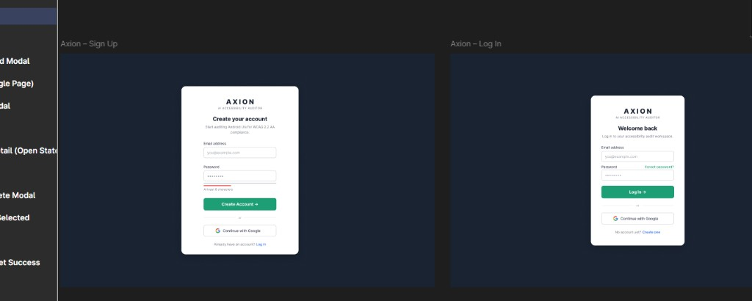
Screen | Elements
Sign Up | Title "Create your account"; Email; Password (min 8 chars + strength hint); Create Account →; Continue with Google; link to Log In
Log In | Title "Welcome back"; Email; Password; Forgot password? link; Log In →; Continue with Google; link to Sign Up

F.3 Forgot Password and OTP Verify (Must Have)
Forgot Password and Verify Code screens
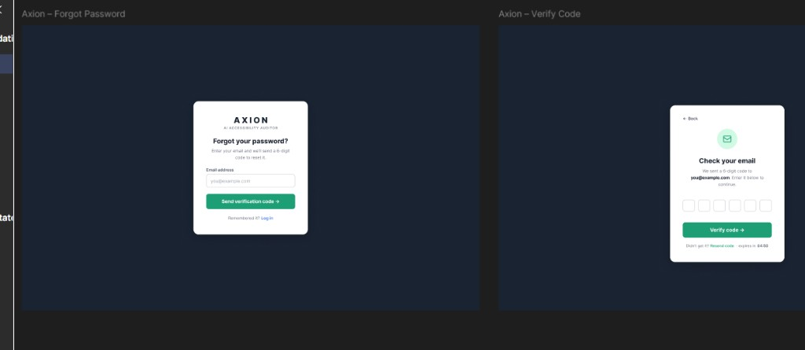
Step | Elements
Forgot Password | "Forgot your password?"; email field; Send verification code →; "Remembered it? Log in"
Verify Code | ← Back; envelope icon; "Check your email"; six OTP digit boxes; Verify code →; resend timer (e.g. expires in 04:50)

F.4 Set Password and Reset Success (Must Have)
Set Password and Password Reset Success
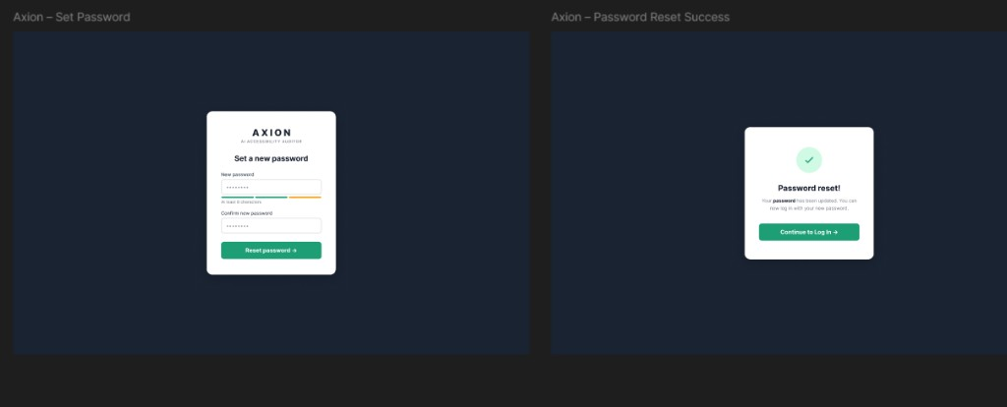
Step | Elements
Set Password | New password + confirm; strength meter; Reset password →
Success | Green checkmark; "Password reset!"; Continue to Log In →

F.5 Upload — progress states (Must Have)
Upload screen — initial and screenshot-uploaded states
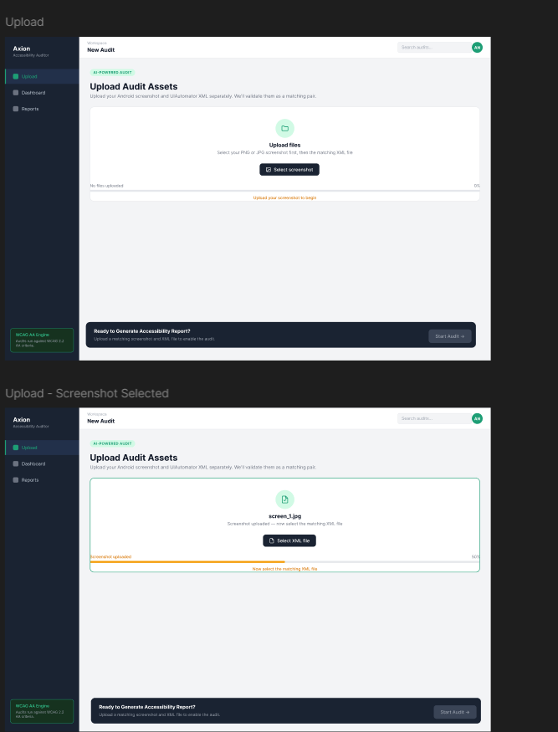
- AI-POWERED AUDIT badge; title Upload Audit Assets
- Unified drop zone: Select screenshot → then Select XML file
- Progress bar: 0% → 50% → 100% with helper text
- Bottom bar: disabled Start Audit → until pair validated

F.6 Upload — Files Matched (Must Have)
Files Matched modal and validated state
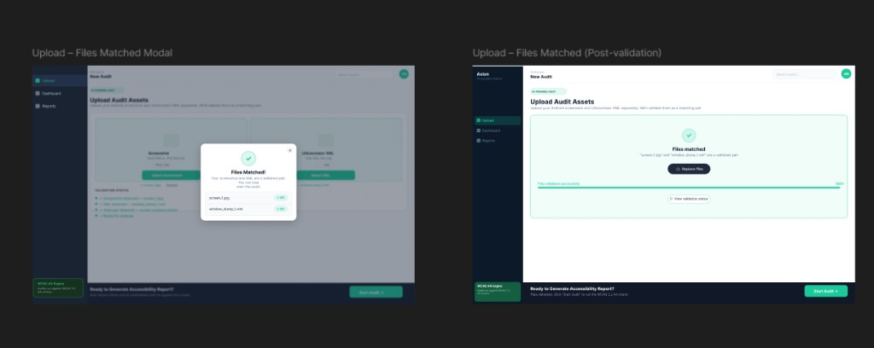
- Files Matched! modal lists screen_1.jpg + window_dump_1.xml with OK badges
- Post-dismiss: green validated panel, Replace files, 100% progress, View validation status
- Validation Status checklist (all four green) visible in background

F.7 Audit Complete modal and Dashboard (Must Have)
Audit Complete modal and Issues Dashboard
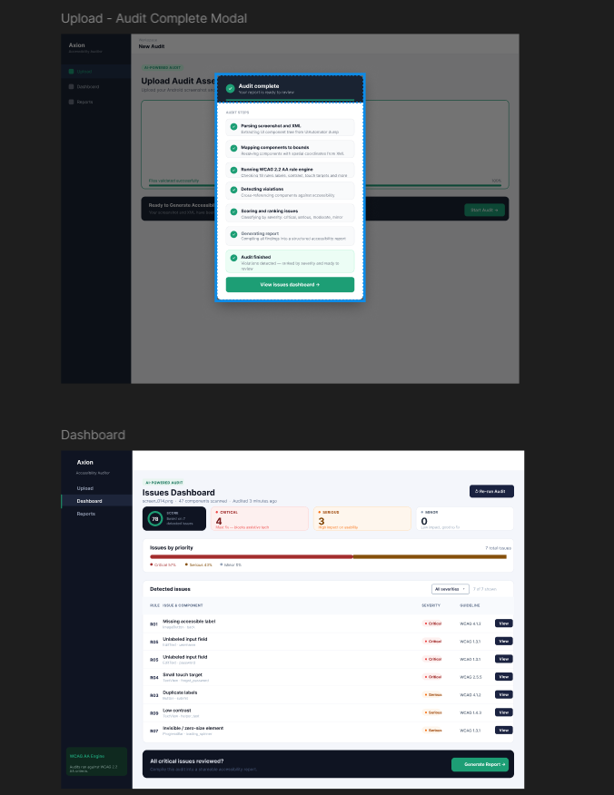
Audit Complete modal: seven pipeline steps with checkmarks; View issues dashboard →
Dashboard: score gauge (0–100); Critical / Serious / Minor cards; Issues by Priority bar; violations table (Rule, Issue & Component, Severity, Guideline, View); bottom Generate Report →

F.8 Dashboard Issue Detail and Audit Report (Must Have)
Issue Detail drawer and Audit Report page
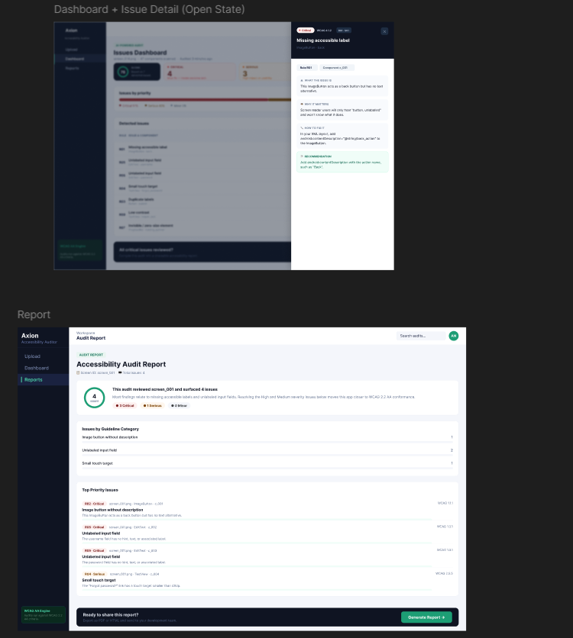
Issue Detail drawer: Critical badge; WHAT THE ISSUE IS / WHY IT MATTERS / HOW TO FIX IT / RECOMMENDATION; tabs Rule + Component
Audit Report: score summary; Issues by Guideline Category; Top Priority Issues with WCAG refs; Generate Report footer

F.9 Generate Report modal and PDF layout (Must Have)
Generate Report modal and PDF single-page layout
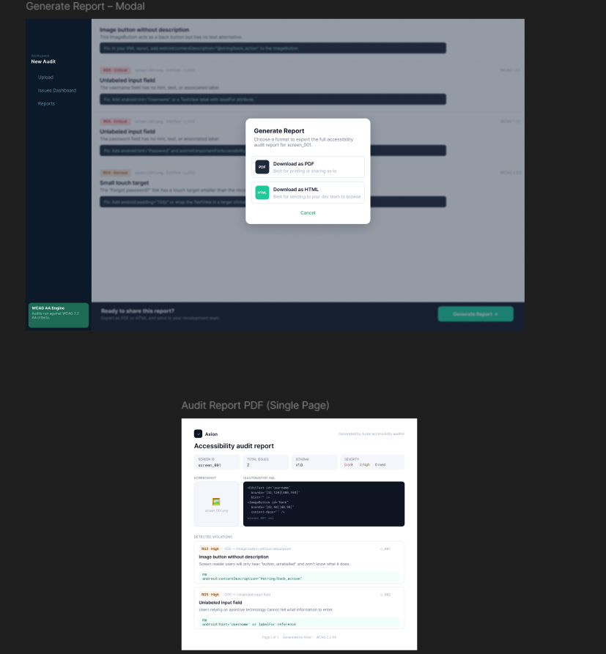
Modal: Download as PDF (print/share); Download as HTML (dev team); Cancel
PDF: Axion header; metadata boxes (Screen ID, Total Issues, Schema, Severity); screenshot + XML snippet; violation blocks with green fix highlights

F.10 Records page — Reports (Must Have)
No Figma screenshot was provided for Records; implement using the same design system as Dashboard:
Element | Specification
Route | Sidebar Reports → /records
Table columns | Screen ID, Date, Score, Total issues, Critical, Serious, Moderate, Minor
Row action | Open report view or download PDF/HTML
Empty state | Illustration + "No audits yet" + Start new audit → link to Upload
Scope | Show logged-in user's audits only (FR-REC.3)

F.11 Navigation map
[Sign Up] ←→ [Log In] → [Forgot Password → OTP → Reset → Success]
↓
[Upload] → [Files Matched] → [Start Audit] → [Audit Complete modal]
↓
[Dashboard] → [Issue Detail drawer] → [Audit Report] → [Generate Report Modal]
↓
[Records / Reports] (saved audits list)
— End of Software Requirements Specification v2.0 —

