Supplementary Progress Report

Agentic Accessibility Auditor (Axion)
Practical work completed — Weeks 1–8 + post–Week 7 YOLO track + Aug backend integration (baseline 1 July 2026; updated 05 August 2026)
Living document — see §15 / §15B / §15C / §15J for team updates; §12–§13 for literature + rule ownership
Field | Value
Report type | Empirical / progress (not theoretical SRS/SDS)
Prepared by | Muhammad Noor (Lead)
Team | Salar (parser, MASC data, rules, tests, YOLO notebook, full YOLO train + Rico eval); Ayesha (Rico holdout, frontend, SRS, rules, prompt experiments); Noor (backend, JSON schemas, SDS, agent, reports, rules, SRS review, tests, QA, Colab YOLO training, 33-backbone crop-classifier sweep, both models' backend integration, Docker fixes)
Repository | [MuhammadNoor7/agentic-accessibility-auditor](https://github.com/MuhammadNoor7/agentic-accessibility-auditor)
Canonical specs | In repo: srs/ · sds/ · updated_plan.md
Report version | v1.27 (05 Aug 2026)

1. Purpose of this report
This document gathers what has actually been built, run, and produced so far. It is intentionally different from the SRS and SDS, which describe what the system must do and how it should be designed. Here we record:
- Real file outputs and counts
- Sign-off test results
- Dataset preparation numbers
- Repository and folder structure as it exists today
- Gaps between plan and implementation

2. Executive summary
| Note: Baseline below is as of 1 July 2026. For current status after team pushes, see §15 Team weekly updates.
Area | Result (27 Jul on noor)
Parser (Stage 1) | Complete — hybrid XML parser; MASC <wrapper> + bounds fixes; visibility field; R13–R20 extended fields
Rule engine (Stage 2) | R01–R30 implemented — 57 XML pass/fail fixtures; 146 pytest collected
Agent layer (Stage 3) | Wired — src/explainer.py + src/agent.py (build_audit_report); LLM or template fallback; API-wired
Report generator (Stage 4) | Done — src/report.py (Jinja2 HTML + PIL + Playwright PDF); screenshot/XML persisted for export; GET …/report/download
Axion React UI | Complete for Week 6 MVP — Upload/Dashboard/Report/Records + Sign Up/Log In/Forgot/OTP/Reset + Google Sign-In + profile initials
FastAPI audit API | Done — paired POST /api/v1/audit, violations, report, download
Auth + Records | Done on `noor` — JWT + OTP/SMTP + Google OAuth + per-user /records (score/filename fields)
Docker | Synced — compose services backend + auditor (frontend via local Vite)
Documentation | SRS v2.7, SDS v2.11, progress report v1.20, plan updated 27 Jul
Screenshot-only YOLO detector | Functional Prototype — MASC fine-tuned YOLO11s UI Element detector, full 60-epoch run; best.pt exported (51.2 MB); Rico holdout evaluated (mAP50 0.2546); detect_ui() inference module ready but not backend-wired

Bottom line (30 Jul): Week 6–8 complete on noor. Post–Week 7 (YOLO Track): Salar's YOLO UI-element training notebook merged and implemented; full 60-epoch training completed on Google Colab T4 using MASC (7,068 screens) — final mAP50-95 0.3217 (val), superseding the earlier 1-epoch interim figure of 0.2846. Best weights exported to models/yolo_ui_detector_best.pt (51.2 MB). Inference module src/yolo_ui_detector.py created and present to support screenshot-only auditing. Rico holdout generalization eval done (§15C.9): zero-shot mAP50 0.0258 → fine-tuned 0.2546. Crop-violation classifier also Rico-evaluated (§15G.7): weighted F1 0.43 vs. 0.63 on the MASC test split. ~~Next Steps: integrate both models as backend fallback/confirmation paths (deliberately deferred — Stretch requirement, not started)~~ — Done, 05 Aug (see §15J); research specialized models for R09 (contrast) and visual clipping (R10/R28) per docs/user_coverage_for_training.md remains open.

2.1 Team contributions & artifact ownership (12 Jul 2026)
| Credit map for supervisor review — reflects who built each major deliverable on branch noor.
Area | Primary contributor(s) | Evidence
Data collection | All interns | Shared dataset effort
MASC dataset (7,068 screens) | Salar + Noor | data/data-masc/; full re-parse sign-off
Rico holdout (1,698 screens) | Ayesha | data/data-rico-holdout/; manifest
Parser → components.json | Salar + Noor | src/parser.py (Noor: R13–R20 fields, visibility, MASC wrapper fix)
Rules → violations.json | Salar + Noor + Ayesha (reviewed by all) | src/rules.py R01–R30; 57 XML fixtures; R11–R12 sign-off
Agent → report.json | Noor | src/agent.py, src/explainer.py, score formula
Report template (HTML/PDF) | Noor | src/report.py, src/templates/audit_report.html.j2
Backend / FastAPI | Noor (audit) + Salar (auth/records base) + Noor (OTP/SMTP/OAuth) | backend/routers/audit.py; auth.py, otp_store.py, email_service.py, auth_router.py, records_router.py
Frontend (Axion) | Ayesha (+ Salar/Noor auth wiring) | frontend/; Upload/Dashboard/Report/Records + full auth
JSON structure + schema docs | Noor | docs/json_schemas.md, docs/schemas/auditor_schema.json, src/schema_documents.py
SRS / SDS | Ayesha+Salar (SRS) / Noor (SDS + Week 6 sync) | srs/ · sds/
Tests (pytest) | Salar + Noor | tests/ + backend/tests/ — 146 collected (16 Jul)

3. Pipeline status (actual vs planned)
Stage | Owner | Output artefact | Status (16 Jul) | Evidence
1 — Parser | Salar / Noor | *_components.json | Done | data/data-masc/parsed/ (7,068; sign-off PASS)
2 — Rules | Salar + Noor + Ayesha | violations.json | Done R01–R30 | src/rules.py; 57 XML fixtures
3 — Agent | Noor | enriched report.json | Done | GET /api/v1/audit/{id}/report
4 — Report | Noor | HTML/PDF | Done | download API; screenshot/XML persist + autoescape
UI — Axion | Ayesha / Noor | React app | Done (Week 6 MVP) | Upload/Dashboard/Report/Records + full auth flows
API — Audit | Noor | FastAPI | Done | /api/v1/audit/*
Auth / Records | Salar + Noor | JWT + OTP/SMTP/OAuth + history | Done | /auth/*, /records/*; 146 pytest collected
Week 6 eval | Noor | 40-screen sheet | Done | docs/week6/ + validation logs
Week 7 QA | Noor | Rule/guideline summaries | Done (holdout deferred) | docs/week7/ · outputs/week7_eval/
YOLO UI detector | Salar (notebook + full train + Rico eval) + Noor (Colab train, merge) | best.pt / last.pt (51.2 MB) | Trained + Rico-evaluated (not backend-wired — deferred) | notebooks/train_yolo_ui_detector.ipynb · src/yolo_ui_detector.py
Crop-violation classifier | Noor | crop_violation_classifier_best.pt | Trained + Rico-evaluated (not backend-wired — deferred) | notebooks/train_crop_violation_classifier.ipynb · src/crop_violation_classifier.py

4. Project folder structure (repository root)
| As of 05 August 2026 on branch noor — canonical repo: [agentic-accessibility-auditor](https://github.com/MuhammadNoor7/agentic-accessibility-auditor). Supersedes the 12 Jul 2026 tree (Week 3–5 snapshot, collapsed below) — kept as a version-history reference, not deleted, per §16.
agentic-accessibility-auditor/ ← repo root (clone / _noor_push locally)
│
├── src/ ← Stage 1–3 Python core + CV modules
│ ├── parser.py ← XML → components.json (Stage 1; R13–R20 fields + visibility)
│ ├── rules.py ← R01–R30 rule checker (Stage 2)
│ ├── agent.py ← Score + build_audit_report (Stage 3; API-wired)
│ ├── report.py ← Jinja2 HTML + Playwright PDF (Stage 4)
│ ├── templates/
│ │ └── audit_report.html.j2 ← Standalone HTML report template
│ ├── explainer.py ← Live LLM recommendations (batched; anti-hallucination)
│ ├── guidelines.py ← G01–G30 + R→G mapping for explainer
│ ├── llm_providers.py ← Anthropic / OpenAI / Gemini / Groq (default: Groq, TBD-01)
│ ├── schema_documents.py ← JSON envelope builders
│ ├── crop_violation_classifier.py ← Swin-Tiny crop classifier (classify_crop, confirm_violations) — wired into backend
│ └── yolo_ui_detector.py ← YOLO screenshot-only fallback (detect_ui, detections_to_components) — wired into backend
│
├── backend/ ← FastAPI gateway
│ ├── main.py ← App entry + CORS + routers
│ ├── requirements.txt ← now includes torch/torchvision/timm/ultralytics (05 Aug fix)
│ ├── Dockerfile ← now installs libgl1/libglib2.0-0/libsm6/libxext6/libxrender1 (05 Aug fix)
│ ├── auth.py, otp_store.py, email_service.py
│ ├── models/
│ │ └── audit.py ← Pydantic audit response models
│ └── routers/
│ ├── audit.py ← POST /api/v1/audit (xml optional), GET …/violations, …/report, …/report/download
│ ├── auth_router.py ← JWT register/login/me, OTP forgot/reset, Google Sign-In
│ └── records_router.py ← Per-user audit history CRUD
│
├── frontend/ ← Axion React UI (Ayesha, synced to noor)
│ ├── Dockerfile ← new (05 Aug): node:20-slim, npm run dev -- --host, port 5173
│ ├── package.json ← Vite 8 + React 19 + Tailwind 4
│ ├── vite.config.js
│ ├── public/ ← favicon, icons
│ └── src/
│ ├── App.jsx ← Routes (auth + Upload/Dashboard/Report/Records)
│ ├── main.jsx, index.css
│ ├── state/auditFiles.js ← Upload file state (wired to POST /audit)
│ ├── components/
│ │ ├── Sidebar.jsx
│ │ ├── layout/ ← AuthLayout, MainLayout
│ │ └── ui/ ← Button, TextField, OtpInput, FileDropzone, …
│ └── pages/
│ ├── auth/ ← Login, SignUp, ForgotPassword, VerifyCode, …
│ ├── Upload.jsx, Dashboard.jsx, Report.jsx, Records.jsx
│ └── main/Placeholder.jsx
│
├── tests/ + backend/tests/ ← pytest suite (**155/155** passed on `noor`)
│ ├── test_parser.py, test_rules.py, test_agent.py, test_report.py, test_explainer.py
│ ├── test_audit.py ← FastAPI violations/report/download + CV wiring + YOLO fallback tests
│ ├── fixtures/rules/ ← 61 controlled XML screens (R01–R30)
│ └── backend/tests/test_auth.py ← JWT/OTP/OAuth suite (22 tests)
│
├── data/ ← datasets + local uploads
│ ├── data-masc/ ← 7,068 screens + parsed outputs + splits
│ ├── data-rico-holdout/ ← 1,698-screen holdout + manifest + parsed/ (125MB, mirrors data-masc/parsed)
│ ├── xml/, parsed/, screenshots/ ← generic upload drops
│
├── models/ ← trained checkpoints (gitignored, .pt only)
│ ├── crop_violation_classifier_best.pt ← swin_tiny_patch4_window7_224, epoch 8
│ └── yolo_ui_detector_best.pt ← 60-epoch run, 51.2 MB
│
├── runs/ ← training artefacts (tracked in git, except .pt)
│ ├── notebooks/ ← executed copies with saved outputs (incl. 26 backbone-sweep notebooks)
│ ├── crop_violation_classifier/
│ │ ├── crops/, rico_crops/, manifests/, rico_manifest/, export/
│ │ └── crop_classifier/ ← new (05 Aug): 9 PNGs — confusion matrices, PR/P/R/F1 curves, sample crops/predictions
│ └── runs/yolo_ui_detector/ ← args.yaml, results.csv, plots, export/best.pt
│
├── outputs/ ← pipeline artefacts
│ ├── violations/, reports/
│ ├── week7_holdout/ ← per_screen_results.csv, rule_summary.csv, guideline_summary.csv, run_summary.json
│ └── validation_logs/ ← noor_week1–8 {summary.md, validation_log.txt} (append-only)
│
├── notebooks/
│ ├── masc_dataset_analysis.ipynb
│ ├── train_crop_violation_classifier.ipynb ← §9 Rico holdout generalization check
│ └── train_yolo_ui_detector.ipynb
│
├── docs/ ← project documentation
│ ├── progress/
│ │ ├── Supplementary_Progress_Report_v1.27.md ← this report
│ │ └── assets/ ← figma/, week6/week7 UI refs (crop_classifier/ and logs/ copies removed 05 Aug — redundant with runs/ and outputs/validation_logs/)
│ ├── schemas/auditor_schema.json ← cv_confidence, inferred fields added (05 Aug)
│ ├── week6/, week7/ ← evaluation sheets, QA summaries
│ ├── crop_classifier_comparison_findings.md ← new: full 33-backbone sweep results
│ ├── crop_classifier_model_reference.md ← new: architecture/year/paper for all 33
│ ├── TBD-01-decision.md ← new: Groq default-provider decision record
│ └── examples/, assets/ ← sample JSON, Figma exports (SRS Appendix F)
│
├── scripts/ ← batch + validation + sweep utilities
│ ├── noor_week3–8_validate.py, validate_output.py, masc_parse_signoff.py
│ ├── run_rico_holdout_eval.py, run_week7_eval_analysis.py
│ ├── run_backbone_sweep.py, overnight_sweep.py, eval_masc_test.py, extract_notebook_results.py ← new: 33-backbone sweep tooling
│ ├── plot_crop_classifier_curves.py ← new: confusion matrices + PR/P/R/F1 curves for the crop classifier
│ ├── split_masc_dataset.py, build_rico_holdout.py, md_to_docx.py
│
├── srs/ ← SRS v2.11 (md + docx*)
├── sds/ ← SDS v2.15 (md + docx*) *docx exports pending regen
│
├── app.py ← Streamlit dev UI (parse + violations preview)
├── test_run.py ← CLI batch / single-file parser + rules (auditor Docker service entrypoint)
├── Dockerfile ← auditor service (python:3.11-slim)
├── docker-compose.yml ← frontend + backend + auditor (frontend added 05 Aug; backend loads .env via env_file)
├── requirements.txt ← root Python deps (+ torch/torchvision/timm/ultralytics)
├── updated_plan.md ← 8-week team plan
├── conftest.py
└── README.md
<details>
<summary>12 Jul 2026 snapshot (superseded — kept for version-history reference, not live)</summary>
agentic-accessibility-auditor/ ← repo root (clone / _noor_push locally)
│
├── src/ ← Stage 1–3 Python core
│ ├── parser.py ← XML → components.json (Stage 1; R13–R20 fields + visibility)
│ ├── rules.py ← R01–R30 rule checker (Stage 2)
│ ├── agent.py ← Score + build_audit_report (Stage 3; API-wired)
│ ├── report.py ← Jinja2 HTML + Playwright PDF (Stage 4)
│ ├── templates/
│ │ └── audit_report.html.j2 ← Standalone HTML report template
│ ├── explainer.py ← Live LLM recommendations (batched; anti-hallucination)
│ ├── guidelines.py ← G01–G30 + R→G mapping for explainer
│ ├── llm_providers.py ← Anthropic / OpenAI / Gemini / Groq
│ └── schema_documents.py ← JSON envelope builders
│
├── backend/ ← FastAPI gateway
│ ├── main.py ← App entry + CORS + routers
│ ├── requirements.txt
│ ├── models/
│ │ └── audit.py ← Pydantic audit response models
│ └── routers/
│ └── audit.py ← POST /audit, GET …/violations, GET …/report, GET …/report/download
│
├── frontend/ ← Axion React UI (Ayesha, synced to noor)
│ ├── package.json ← Vite 8 + React 19 + Tailwind 4
│ ├── vite.config.js
│ ├── public/ ← favicon, icons
│ └── src/
│ ├── App.jsx ← Routes (auth + Upload/Dashboard/Report/Records)
│ ├── main.jsx, index.css
│ ├── state/auditFiles.js ← Upload file state (wired to POST /audit)
│ ├── components/
│ │ ├── Sidebar.jsx
│ │ ├── layout/ ← AuthLayout, MainLayout
│ │ └── ui/ ← Button, TextField, OtpInput, FileDropzone, …
│ └── pages/
│ ├── auth/ ← Login, SignUp, ForgotPassword, VerifyCode, …
│ ├── Upload.jsx, Dashboard.jsx, Report.jsx, Records.jsx
│ └── main/Placeholder.jsx
│
├── tests/ ← pytest suite (**120** passed on `noor`)
│ ├── test_parser.py
│ ├── test_rules.py ← R01–R30 pass/fail XML fixtures (78 tests)
│ ├── test_agent.py ← score + template report
│ ├── test_audit.py ← FastAPI violations + report + download
│ ├── test_report.py ← HTML/PDF export (Week 5)
│ ├── test_explainer.py ← anti-hallucination / batching (mocked LLM)
│ └── fixtures/rules/ ← 57 controlled XML screens (R01–R30)
│
├── data/ ← datasets + local uploads
│ ├── data-masc/
│ │ ├── parsed/ ← 7,068 MASC components.json
│ │ │ ├── masc_parse_signoff_report.json
│ │ │ └── batch_parse_masc_full.log
│ │ └── splits/ ← train / val / test split JSON
│ ├── data-rico-holdout/ ← 1,698-screen holdout + manifest
│ ├── xml/ ← generic upload XML drops
│ ├── parsed/ ← generic parsed output
│ └── screenshots/ ← screenshot uploads (paired with XML for POST /audit)
│
├── outputs/ ← pipeline artefacts
│ ├── violations/ ← *_violations.json (Stage 2; generated locally)
│ ├── reports/ ← *_report.json, .html, .pdf (Stages 3–4)
│ └── validation_logs/
│ ├── noor_week1–4 summaries + logs
│ ├── noor_week5_summary.md
│ └── noor_week5_validation_log.txt
│
├── notebooks/
│ └── masc_dataset_analysis.ipynb ← Salar MASC analysis (synced Week 4)
│
├── docs/ ← project documentation
│ ├── progress/
│ │ └── Supplementary_Progress_Report_v1.0.md ← this report
│ ├── schemas/auditor_schema.json
│ ├── examples/ ← sample components / violations / report JSON
│ ├── assets/ ← Figma exports (SRS Appendix F)
│ ├── r11_r12_design.md
│ ├── qa_test_plan.md
│ └── updated_plan_v2.0.docx
│
├── scripts/ ← batch + validation utilities
│ ├── validate_output.py
│ ├── noor_week3_validate.py
│ ├── noor_week4_validate.py
│ ├── noor_week5_validate.py
│ ├── masc_parse_signoff.py
│ ├── run_explainer_sample.py ← Stage 3 LLM sample runner
│ ├── compare_visibility_filter_impact.py
│ ├── split_masc_dataset.py
│ └── build_rico_holdout.py
│
├── srs/ ← SRS v2.0 (md + docx)
├── sds/ ← SDS v2.2 (md + docx)
│
├── app.py ← Streamlit dev UI (parse + violations preview)
├── test_run.py ← CLI batch / single-file parser + rules
├── .env.example ← LLM_PROVIDER + API key template
├── requirements.txt ← root Python deps (+ anthropic/openai/groq)
├── updated_plan.md ← 8-week team plan
├── conftest.py
└── README.md
</details>

Key paths by pipeline stage
Stage | Primary code | Output location
1 — Parser | src/parser.py, test_run.py, app.py | data/**/parsed/*_components.json
2 — Rules | src/rules.py | outputs/violations/*_violations.json
3 — Agent | src/agent.py, src/explainer.py | outputs/reports/*_report.json
4 — Report | src/report.py | outputs/reports/*_report.html / .pdf + download API
API | backend/routers/audit.py | in-memory job → violations + report JSON + file download
UI | frontend/ | browser at :5173 (Upload/Dashboard/Report wired; Records mock)

Local workspace (optional clones)
Team members may keep additional working copies beside the canonical clone:
d:\internship\
├── agentic-accessibility-auditor\ ← main local copy
├── _noor_push\ ← Noor's push branch working copy
├── _salar_pull\ ← Salar sync copy
└── updated_plan.md ← local plan copy (also in repo root)
Important: Treat the GitHub repo root layout above as the single source of truth for code and folder conventions.

5. Parser deliverables (Salar)

5.1 Sign-off result (re-parse 6 July 2026)
Metric | Value
Dataset | MASC
Total screens | 7,068
Categories | 10
Components parsed | 640,563
Violations (R01–R20) | 462,542
Extended parser fields | 0 missing (all 13 R13–R20 fields)
Parse OK | 7,068
Parse errors | 0
Sign-off | PASS

Source: data/data-masc/parsed/masc_parse_signoff_report.json
Scripts: python test_run.py --dataset masc · python scripts/masc_parse_signoff.py
Commit: f7bcac9 on branch noor
Parser fix (Jul 2026): MASC widgets nest inside <wrapper> nodes; depth-first walk now descends into wrappers (previously ~1 component/screen).

5.2 MASC train / val / test split
Split | Screens | Ratio
Train | 4,943 | 70%
Val | 1,056 | 15%
Test | 1,069 | 15%
Total | 7,068 | 100%

Config: data/data-masc/splits/split_summary.json

5.3 Supported XML formats
src/parser.py handles UIAutomator, MASC, Rico, and generic upload formats.

6. Dataset work

6.1 MASC (primary development corpus)
- Screens: 7,068 paired screenshot + XML
- Parsed output: data/data-masc/parsed/{category}/{id}_components.json
- Splits: data/data-masc/splits/

6.2 Rico holdout (unseen final evaluation)
- Selected screens: 1,698 (after removing 302 MASC-overlapping screens)
- Overlap verification: 0 hash collisions
- Manifest: data/data-rico-holdout/manifest/selection_report.json
- Parsed at baseline: 4 screens (holdout batch not yet run at scale)

7. Code and infrastructure delivered (updated 12 Jul)
Path | Purpose | Owner
src/parser.py | Hybrid XML → components.json | Salar / Noor
src/schema_documents.py | JSON envelope builders | Noor
src/rules.py | R01–R30 rule checker → violations.json | Salar + Noor + Ayesha (reviewed by all)
src/agent.py, src/explainer.py | Agent layer → report.json | Noor
src/report.py, src/templates/ | HTML/PDF report export | Noor
backend/routers/audit.py | FastAPI audit + download API | Noor
test_run.py | CLI batch / single / --fixtures | Salar / Noor
tests/ | pytest suite (146 collected, 16 Jul) | Salar / Noor
app.py | Streamlit dev UI | Salar
scripts/validate_output.py | JSON schema validation | Noor / Salar
docker-compose.yml | Backend + auditor services | Salar

8. Documentation delivered
Document | Author(s) | Status
SRS v2.0 | Ayesha + Salar (Noor review) | Complete
SDS v2.2 | Noor | Complete
JSON schemas + auditor_schema.json | Noor | Complete
Accessibility guidelines (G01–G30, R01–R30) | Team (Noor lead doc) | Complete
QA test plan (TC-01–TC-06) | Noor | Complete
Figma UI specs (SRS Appendix F) | Ayesha | Documented
Updated 8-week plan | Noor | Complete

9. Per-person contribution summary (updated 12 Jul)

Salar — Parser, rules, MASC data, Agent, Docker, tests, JWT/records
Done: Hybrid parser (with Noor); R01–R30 rules (with Noor + Ayesha; reviewed by all); MASC integration + batch scripts; Docker Compose; components.json pipeline; pytest (with Noor); JWT auth + records API (synced to noor Week 6)
Pending: Branch rename azeem → salar (if still open); rule FP tuning (Week 7)

Ayesha — Rico holdout, frontend, SRS, rules,
Done: Rico holdout build; Figma designs; React Axion UI (incl. auth screens); SRS co-author; frontend ↔ API wiring; Records on live API; rules (with Salar + Noor; R11–R12 sign-off); Groq prompt experiments (TBD-01)
Pending: UI polish / prompt comparison notes (Week 7)

Noor (Lead) — Parser, MASC data, Backend, Frontend Review, schemas, SDS, agent, reports, rules, SRS review, tests, QA, Week 6 auth stretch
Done: FastAPI audit API; JSON schemas; SDS; SRS review; agent + report template (JSON/HTML/PDF + export fix); parser extensions; rules (with Salar + Ayesha); Week 1–6 validation; OTP + Gmail SMTP + Google OAuth; any-domain signup emails; profile initials; 40/40 eval sheet + R26–R30 design; docs/plan alignment
Pending: Rico holdout evaluation (Week 8); Friday demo rehearsal

10. Week 2 completion checklist (baseline)
Task | Done?
MASC dataset integrated locally | Yes
Parser handles MASC/Rico/UIAutomator formats | Yes
7,068 components.json files generated | Yes
Parser sign-off PASS | Yes
Train/val/test split created | Yes
Rico holdout built (1,698 disjoint screens) | Yes
JSON schemas documented + validated | Yes
SRS + SDS v2.0 written | Yes
Docker backend runs (health only) | Yes
Rule engine R01–R10 | No (at baseline)
React UI started | No

Week 2 status: ~75% complete at baseline.

11. Key output file locations
What | Where
Parsed MASC components | data/data-masc/parsed/
Parser sign-off report | data/data-masc/parsed/masc_parse_signoff_report.json
Split summary | data/data-masc/splits/split_summary.json
Rico holdout manifest | data/data-rico-holdout/manifest/selection_report.json
JSON schema | docs/schemas/auditor_schema.json
Example outputs | docs/examples/components.json, violations.json, report.json

12. Literature insights (Chen et al., IEEE TSE 2021)
Paper: Accessible or Not? An Empirical Investigation of Android App Accessibility (Chen et al., 2021, DOI [10.1109/TSE.2021.3108162](https://doi.org/10.1109/TSE.2021.3108162))
Why it matters for Axion: The paper studies 86,767 issue-level findings from 2,270 Android apps using automated exploration (tool: Xbot). This validates our approach of rule-based, violation-level auditing rather than only screen-level pass/fail.

Top real-world issue types (literature + full MASC validation, Jul 2026)
Rank | Issue type (literature) | Our rule(s) | MASC evidence (7,068 screens)
1 | Missing label / content description | R01, R02, R30 | R01: 60,112 violations / 6,185 screens
2 | Layout / focus order issues | R07, R08, R15 | R07: 266,393; R15: 3,860 screens
3 | Small touch target / spacing | R04, R17 | R17: 9,327 violations / 1,697 screens
4 | Multi-gesture only | R18 | R18: 13,529 violations / 3,945 screens
5 | Unlabeled input | R05, R20 | R05: 3,797; R20: 0 (no hint-only inputs in MASC)
6 | Low contrast | R09 | 0 — needs screenshot CV

Findings we apply directly
- Prioritize R01–R05 in MVP — highest frequency in literature and in our MASC sample.
- R07 remains dominant on full MASC — review false-positive rate (bounds fallback).
- R13–R20 are active on real data after parser re-parse (audio, focus order, spacing, gestures).
- Issue-level JSON enables severity stats and guideline mapping per Chen et al.
Sources: outputs/validation_logs/noor_week3_summary.md · data/data-masc/parsed/masc_parse_signoff_report.json

13. Rule & guideline ownership checklist (R01–R30)
| All 30 rules and 30 guidelines are team-owned. "Lead" implements; "Reviewers" must approve PRs. Canonical G↔R mapping: docs/accessibility_guidelines_report.md §3–§4.

Block leads (from `updated_plan.md`)
Block | Rule lead | Guideline validation | Reviewers
R01–R10 / G01–G10 | Salar | Noor | Ayesha
R11–R12 / G11–G12 | Ayesha | Salar | Noor
R13–R20 / G13–G20 | Noor | Salar | Ayesha
R21–R30 / G21–G30 | Noor | Ayesha | Salar

Per-rule tracker
Rule | Guideline(s) | Lead | Status | Notes
R01 | G01, G02, G30 | Salar | ✅ Done | High frequency in validation
R02 | G02, G30 | Salar | ✅ Done
R03 | G03 | Salar | ✅ Done
R04 | G04, G17 | Salar | ✅ Done | DPI-aware (Week 3 fix)
R05 | G05, G20 | Salar | ✅ Done | hint field + INPUT_CLASSES
R06 | G06, G26 | Salar | ✅ Done
R07 | G07, G25 | Salar | ✅ Done | Review false-positive rate
R08 | G08, G15 | Salar | ✅ Done | Zero-area guard added
R09 | G09, G11 | Salar | 🟡 Partial | Needs declared colors / screenshot contrast
R10 | G10, G28, G29 | Salar | ✅ Done
R11 | G11 | Ayesha | ✅ Done | Implemented by Salar; reviewed by Ayesha + Noor
R12 | G12 | Ayesha | ✅ Done | media_type + caption heuristics; Ayesha review sign-off
R13 | G13 | Noor | ✅ Done | 1,055 violations / 118 MASC screens
R14 | G14 | Noor | ✅ Done | 1,873 / 667 screens
R15 | G15, G16 | Noor | ✅ Done | 3,860 / 3,860 screens
R16 | G16 | Noor | ✅ Done | 130 / 115 screens
R17 | G17 | Noor | ✅ Done | related_component; 9,327 / 1,697
R18 | G18 | Noor | ✅ Done | 13,529 / 3,945 screens
R19 | G19 | Noor | ✅ Done | 758 / 416 screens
R20 | G05, G20 | Noor | ✅ Done | Unit tests pass; 0 MASC hits
R21 | G21 | Noor | ✅ Done | Vague error message (Salar sync Week 4)
R22 | G22 | Noor | ✅ Done | No password toggle
R23 | G01, G23 | Noor | ✅ Done | Unlabeled nav control
R24 | G24 | Noor | ✅ Done | Missing screen title
R25 | G25 | Noor | ✅ Done | Uncontrolled animation
R26 | G06, G26 | Noor | ✅ Done | No timeout warning
R27 | G27 | Noor | ✅ Done | Complex label language
R28 | G10, G28 | Noor | ✅ Done | Font scale overflow (needs declared text size)
R29 | G29 | Noor | ✅ Done | All-caps body text
R30 | G01, G30 | Noor | ✅ Done | Icon-only, no label

Legend: ✅ implemented + tests · 🟡 stub/partial · ⬜ not started

14. Recommended next steps (updated 15 July 2026)
- Noor: Fill ≥25 manual rows on docs/week6/evaluation_sheet_40_screens.csv (FP / missed notes)
- All: Friday demo — login → upload screenshot+XML → dashboard → report HTML/PDF → Records list
- Noor (stretch): Map guidelines for CV training on MASC train → tune on val → test on test; never train on Rico holdout
- Ayesha: Continue prompt experiments; polish auth/records UX if needed
- Salar: Keep JWT secret configured for demos; continue rule FP tuning
- Team: Friday demo path — signup/login → upload pair → report → Records

15. Team weekly updates
| Instructions: Each intern adds a dated entry after pushing work. Newest week at the top. Keep entries factual — file names, test counts, branch commits.

Week 8 — Noor (rule-accuracy fixes + Rico holdout + crop classifier, 28–29 Jul 2026)
Pushed by: Muhammad Noor
Date: 28–29 July 2026 (commits 7918113f rule fixes/data, 7a1e6a4f docs)
Completed:
- Rico holdout batch eval (1,698 screens, 0 failures) — deferred from Week 7, now done: mean violations/screen 51.7 → 31.7 post-fix, mean score 26.3 → 32.0 (§15I.2)
- R07/R08/R30/R20/R05 fixes — _is_a11y_relevant (R07), _is_ancestor (R08, -43.2% on Rico), _dedupe_repeated (R30), text-hint alias unblocking R20 (0 → 749 hits) and fixing R05 (2,117 → 717) — full detail §15I.4
- Crop-violation classifier trained (MobileNetV3-Small, 20 epochs, best val macro-F1 0.265) and Rico-evaluated (weighted F1 0.43 vs. 0.63 MASC test) — §15G
- Validation: pytest 152 collected/passed (rules 82, parser 12, auth 22, audit 9, +27 elsewhere); full MASC re-parse + re-check (7,068 screens, 0 failures)
→ outputs/validation_logs/noor_week8_validation_log.txt + noor_week8_summary.md (§15I.3)
- `.gitignore` fixes — dead blanket outputs/data rule, models/*.pt/ trailing-slash typo, .claude/ added, oversized Rico zip excluded, runs/ policy changed to only-exclude-.pt
- Docs: SRS v2.8→v2.10 · SDS v2.12→v2.14 · Progress Report v1.24→v1.26 · README + updated_plan.md fully synced to current project structure
Pending:
- Wire classify_crop() and detect_ui() into backend/ — both trained + Rico-evaluated, deliberately deferred (Stretch requirement)
- Final internship report + 5–7 min demo
Blockers: None

Week 7 — Noor (QA analysis, rule/guideline coverage, 20 Jul 2026)
Pushed by: Muhammad Noor
Date: 20 July 2026
Completed:
- MASC 40-screen stratified QA (seed 20260715): rule-wise R01–R30 + guideline-wise G01–G30 coverage reports — mean 64.3 violations/screen, mean score 6.8, R07 the dominant false-positive cluster (1,127 hits, 100% of screens) — this analysis is what led directly into the Week 8 R07/R08/R30 fixes
- Manual QA notes: 32 mostly_agree, 3 agree_clean, 2 over_flagging, 3 mixed_r30_noise (40/40 screens reviewed)
- Team priority handoff to Salar/Ayesha: P0 R07/R08 nesting FP suppression, P0 R30 overlap tolerance, P1 UI polish, P2 Rico holdout (deferred to Week 8)
- Validation: scripts/noor_week7_validate.py PASS
→ outputs/validation_logs/noor_week7_validation_log.txt + noor_week7_summary.md (§15B.3)
Pending:
- Rico holdout batch — explicitly deferred to Week 8 (scripts/run_rico_holdout_eval.py ready, not yet run at this point)
Blockers: None

Week 6 close-out — Noor (`noor` / `995f6d31`, 16 Jul 2026)
Pushed by: Muhammad Noor
Date: 16 July 2026
Completed (auth / mail / OAuth / eval / export):
- Sign Up / Log In — JWT register/login; password policy (letter+digit); optional name; UserAvatar initials
- Forgot → OTP → Reset — forgot-password, resend-otp, verify-otp, reset-password wired end-to-end
- SMTP — Gmail App Password via .env (SMTP_HOST, SMTP_USER, SMTP_FROM, SMTP_PASSWORD); real OTP emails verified; AUTH_DEV_SHOW_OTP=0 when mail works
- Recipient domains — any valid email (Yahoo, Outlook, university/education, …); sender remains Gmail
- Google OAuth — GIS + POST /auth/google; GOOGLE_CLIENT_ID in .env / .env.example
- Other settings — JWT_SECRET; load_dotenv(override=True); frontend VITE_API_BASE
- Report export fix — persist screenshot/XML for HTML/PDF; Jinja autoescape (123fbde4)
- Eval — 40/40 assisted FP/miss notes on stratified sheet; evaluation_sheet.md / .docx + method note
- Docs — SRS v2.4 · SDS v2.8 · updated_plan.md · this progress report
- Validation (16 Jul live): auth 22 passed · audit 9 passed · R26–R30 8 passed · eval integrity 40/40
→ outputs/validation_logs/noor_week6_validation_log.txt + noor_week6_summary.md
Pending:
- Friday demo rehearsal
- Rico holdout batch (Week 8)
Blockers: None
Secrets: App Passwords / JWT_SECRET stay local (gitignored). Document env names only in .env.example.

Week 6 — Noor (`noor` branch — Salar + Ayesha sync + eval, 15 Jul 2026)
Pushed by: Muhammad Noor (integration) — sources: Salar 198936146, Ayesha 3d4fa82eb
Date: 15 July 2026
Completed:
- Synced Salar JWT + records into _noor_push / noor — backend/auth.py, auth_router.py, records_router.py, test_auth.py, Docker/compose, Login/SignUp, frontend/src/utils/auth.js
- Synced Ayesha — docs/agent_prompt_experiments.md (larger Groq sample); Dashboard.jsx re-run popup layout
- Noor UI polish — Report score ring (accessibility_score); Records Screenshot/XML + Score columns; Upload saves record when logged in
- Eval sheet — docs/week6/evaluation_sheet_40_screens.csv — stratified random 4×10 MASC categories (seed 20260715); R26–R30 design DOCX
- `.gitignore` — synced from Salar (data/ + outputs/ + validation/samples exceptions)
- Validation — scripts/noor_week6_validate.py → outputs/validation_logs/noor_week6_summary.md + noor_week6_validation_log.txt
- auth tests: 12 passed (expanded to 22 on 16 Jul — see close-out entry above)
- audit tests: 8 passed, 1 skipped (PDF included on 16 Jul re-run)
- R26–R30: 8 passed
- Auth/Records API smoke: PASS
Pending (resolved 16 Jul):
- ~~≥25 manual eval verdicts on the CSV~~ → 40/40 done
- Rico holdout batch evaluation (Week 8)
- ~~OTP / SMTP stretch~~ → Done
Blockers: None on sync scope

Upload validation fix — Ayesha + Noor (`ayesha` `052a976` → merged on `noor`, 14 Jul 2026)
Pushed by: Ayesha Naveed (frontend) + Muhammad Noor (backend/docs)
Date: 14 July 2026
Completed (handoff doc — 4 issues):
- Issue 1 — XML without screenshot shows error popup (not silent) — Upload.jsx
- Issue 2 — createAudit(screenshot, xml) sends both files — api.js
- Issue 3 — Backend requires screenshot + XML; 400 on pair mismatch — backend/routers/audit.py
- Issue 4 — filesMatch() stem/prefix logic rejects false-positive digit matches — Upload.jsx
- Tests — tests/test_audit.py updated; missing-screenshot + mismatched-pair cases; validation scripts aligned
Pending: Records + auth (Week 6)
Blockers: None

Week 5 — Noor (`noor` branch, commit `4ce430feb` — pushed 12 Jul 2026)
Pushed by: Muhammad Noor
Date: 12 July 2026
Completed:
- `src/report.py` — Jinja2 template (src/templates/audit_report.html.j2), PIL screenshot bounding-box annotation, Playwright PDF export
- Download API — GET /api/v1/audit/{id}/report/download?format=html|pdf (sync handler for Playwright)
- Frontend — downloadAuditReport() in api.js; Report.jsx real HTML/PDF download after processing animation
- Rule fixtures — 21 new R09–R20 pass/fail XML files; test_run.py --fixtures batch mode; fixture path fix (no MASC root collision)
- Tests — tests/test_report.py; extended tests/test_audit.py + tests/test_rules.py; 120 pytest passed
- Validation — scripts/noor_week5_validate.py + validation logs
- Docs — SRS/SDS/README/updated_plan/progress report aligned; WeasyPrint → Jinja2 + Playwright
Pending:
- Records + auth (Week 6)
- Rico holdout batch evaluation
Blockers: None

Week 4 — Ayesha
Pushed by: Ayesha Naveed
Date: 11 July 2026
Completed:
- R11–R12 review sign-off: reviewed src/rules.py implementations of check_color_only_info (R11) and check_missing_captions (R12) against docs/r11_r12_design.md. Confirmed both rules moved past their original Week 3 stub design — R11 now flags checkable-state widgets (CheckBox/Switch/ToggleButton/RadioButton) with no text/content_desc; R12 now uses parent_id sibling adjacency plus bounds-proximity fallback, not just a blanket VideoView flag. Ran pytest tests/test_rules.py -k "r11 or r12" — all 5 relevant tests passed (fixture pass/fail cases, non-checkable-widget exclusion, sibling-vs-bounds-distance priority, non-media stub behavior).
- Frontend ↔ API wiring (Priority 1): Upload, Dashboard, and Report pages now call the live backend (POST /api/v1/audit, GET /report) instead of mock data. Tested end-to-end with a real XML fixture and Groq — confirmed full pipeline works (upload → audit → dashboard → report).
- Agent prompt experiments (TBD-01): ran scripts/run_explainer_sample.py — Groq tested successfully (15/15 violations explained, good quality, no hallucination observed). Anthropic/OpenAI blocked by paid billing requirements; Gemini blocked by a Google-side free-tier quota bug (429, limit 0) even after Noor's SDK fix resolved the original key-format issue. Documented in docs/agent_prompt_experiments.md and docs/TBD-01-decision.md; TBD-01 marked Resolved (Groq as default) in this doc's Open Decisions table.
Pending:
- Full 4-provider comparison once Anthropic/OpenAI credits are available and Gemini's quota issue is resolved
- Records/Audit History page — blocked on backend (no list endpoint, no persistence yet)
- Auth pages (login/signup/etc.) — blocked on backend (no auth router implemented yet)
Blockers: None on my own tasks; Records + Auth wiring blocked on backend work not yet scoped.

Week 4 — Noor (`noor` branch, commits `98efd2fe0` → `0144b1af3`)
Pushed by: Muhammad Noor
Date: 9 July 2026
Completed:
- Salar sync (98efd2fe0): Stage 3 LLM layer — src/explainer.py, src/guidelines.py, src/llm_providers.py; rules R01–R30 + visibility filter; parser bounds/visibility fixes; R11 + R21–R30 fixtures; scripts/run_explainer_sample.py, compare_visibility_filter_impact.py; .env.example
- Notebook sync (20c96fd07): notebooks/masc_dataset_analysis.ipynb
- Ayesha frontend sync (2d8356066): Report/Sidebar/Dashboard/Records/Upload updates + frontend/src/state/auditFiles.js
- Agent API wiring (0144b1af3): build_audit_report() in src/agent.py merges explainer + score formula (TBD-02); GET /api/v1/audit/{id}/report; pipeline statuses include explaining; template fallback when no API key (FR-AG.6); reports → outputs/reports/
- Tests: 94 pytest passed (parser, rules R01–R30, agent, audit, explainer)
- Week 4 demo goal met: XML upload → violations → agent-enriched report.json (template mode without live LLM)
Pending:
- Ayesha: frontend ↔ API wiring; prompt experiments + TBD-01 model choice
- src/report.py HTML/PDF (Week 5)
- Formal R11–R15 review sign-off documentation
- Rico holdout batch evaluation
- Auth + Records API
Blockers: None (API ready for Ayesha)

Week 3+ — Noor (`noor` branch, commit `f7bcac9`)
Pushed by: Muhammad Noor
Date: 6 July 2026
Completed:
- Parser R13–R20 extension — 13 new component fields (focus_order, parent_id, media_type, etc.)
- MASC `<wrapper>` fix — full widget extraction (640,563 components vs ~1/screen before)
- Rules R13–R20 wired in check(); 31 rule tests + 3 parser tests (38 total with agent/audit)
- Full MASC re-parse — 7,068 XML → data/data-masc/parsed/; 462,542 violations
- `scripts/noor_week3_validate.py` — re-parse + pytest + random 20-screen MASC sample + schema check
- `scripts/masc_parse_signoff.py` — extended-field validation + R13–R20 aggregate counts
- SDS v2.1 — R01–R20 parser/rules design, validation artefact paths
- `auditor_schema.json` — optional R13–R20 component fields
- Validation logs: noor_week3_summary.md, noor_week3_validation_log.txt, masc_reparse_log.txt
- Sign-off: masc_parse_signoff_report.json → PASS (0 extended-field misses)
Pending:
- Wire live LLM into agent (Week 4)
- Connect frontend to FastAPI
- src/report.py HTML/PDF generation
- Auth + Records API
Blockers: None

Week 3 — Salar (`salar` branch, commits `c46b4da` → `712dbd8`)
Pushed by: Muhammad Salar Khan
Latest: 712dbd8 — violations outputs + Week 3 validation logs
Completed:
- R01–R10 rule checker + 23 pytest tests
- R04/R05/R08 fixes (real DPI, hint, overlap zero-area guard)
- app.py wired to Stage 2 (violations table + download)
- outputs/violations/ — 69 files (MASC + fixtures)
- outputs/validation_logs/week3_summary.md — 20/20 schema pass
- docs/r11_r12_design.md shared with Ayesha
Blockers: None

Week 3 — Ayesha (`ayesha` branch)
Pushed by: Ayesha Naveed
Completed:
- Set up React frontend project (Vite + Tailwind CSS) under frontend/
- Built folder structure: pages/, components/, layout wrapper, reusable UI components (Button, Input, Divider, Logo)
- Implemented 6 auth screens matching Figma designs: Sign Up, Log In, Forgot Password, Verify Code, Set Password, Password Reset Success
- Corrected route paths to match SDS §9.3 (/verify-otp, /reset-password, /dashboard/:auditId, /report/:auditId, added /records)
- Pulled src/rules.py from salar branch; added R11 (Color-Only Info) and R12 (Missing Captions) detection stub functions
- Opened PR #3 "Add R11/R12 detection stubs"
- Updated frontend/ folder — synced onto noor branch by Noor (3 Jul, 38 files)
Pending:
- Agent/model prompt experiment session with Noor — not yet scheduled
- Wire frontend pages to FastAPI (POST /api/v1/audit, violations fetch) — Week 4
- Making necessary changes to frontend (Ayesha)
Blockers:None

Week 3 — Noor (`noor` branch)
Pushed by: Muhammad Noor
Date: 3 July 2026
Completed:
- Synced Salar Week 3 code + violations to noor branch (fd6036b)
- Added §12 Literature insights and §13 Rule ownership checklist (this report)
- Scaffolded `src/agent.py` — score formula (TBD-02), template enrichment (unit tests; not API-wired yet)
- Added `backend/routers/audit.py` — violations-only API (POST /api/v1/audit → parse → rules → GET .../violations)
- Added `tests/test_agent.py` (2 tests), `tests/test_audit.py` (2 tests)
- Frontend sync (Ayesha → `noor`): pulled frontend/ from ayesha branch (7a591b0) — 38 files
- Stack: React 19, Vite 8, Tailwind 4, React Router 7
- Auth: SignUp, Login, ForgotPassword, VerifyCode, SetPassword, ResetSuccess
- App pages: Upload, Dashboard, Report, Records (+ shared Sidebar, layouts, UI kit)
- Run: cd frontend && npm ci && npm run dev → http://localhost:5173
- Status: UI scaffold only — no live calls to FastAPI yet
- Validation logs (Noor Week 3): same pattern as Salar's week3_summary.md / week3_validation_log.txt
- outputs/validation_logs/noor_week3_summary.md — scope, 27 pytest pass, CLI↔API parity, schema pass
- outputs/validation_logs/noor_week3_validation_log.txt — full terminal log (8 steps)
- Re-run: python scripts/noor_week3_validate.py
- SRS cleanup: auth endpoints in §9 table; TBD-06 marked resolved; §1.4.2 auth moved to Must Have
Pending:
- Wire live LLM into agent (Week 4)
- Connect frontend to FastAPI
- src/report.py HTML/PDF generation
- Auth + Records API implementation
Blockers: None

15A. Week 6 evidence pack (logs, tables, UI references)
| Embedded for supervisor review. Canonical path: outputs/validation_logs/noor_week6_validation_log.txt

15A.1 Validation result tables (16 Jul 2026)
Check | 15 Jul baseline | 16 Jul live | Status
pytest backend/tests/test_auth.py | 12 passed | 22 passed | PASS (+ OTP / reset / Google)
pytest tests/test_audit.py | 8 passed, 1 skipped | 9 passed | PASS (PDF included)
R26–R30 rules | 8 passed | 8 passed | PASS
Eval sheet manual columns | blank | 40/40 | PASS
Auth + Records smoke | PASS | (covered by auth suite) | PASS
Pytest collection (repo) | — | 146 tests | —

Eval sheet verdict mix (40/40)
Verdict | Count
mostly_agree | 32
agree_clean | 3
mixed_r30_noise | 3
over_flagging | 2

Stratified sample (seed `20260715`)
Category | Screens sampled
chat, home, list, login, maps, menu, profile, search, settings, welcome | 4 each (40 total)

Working auth / mail / OAuth configuration (names only)
Setting | Role
JWT_SECRET | JWT signing
GOOGLE_CLIENT_ID | Google Sign-In Web client ID
SMTP_HOST / SMTP_PORT / SMTP_TLS | Gmail SMTP (smtp.gmail.com:587)
SMTP_USER / SMTP_FROM | Sender Gmail
SMTP_PASSWORD | Gmail App Password (local `.env` only)
AUTH_DEV_SHOW_OTP | 0 when real mail works
Email domains accepted | Any valid (Yahoo, Outlook, university/education, …)

15A.2 Excerpt — `noor_week6_validation_log.txt` (15 Jul + 16 Jul)
##################################################################
# RE-RUN 2026-07-15
##################################################################
STEP 0: Regenerate eval sheet — stratified RANDOM (4/category, seed=20260715)
Wrote 40 rows -> docs\week6\evaluation_sheet_40_screens.csv
STEP 1: pytest backend/tests/test_auth.py → 12 passed, 2 warnings in 7.96s
STEP 2: pytest tests/test_audit.py → 8 passed, 1 skipped, 2 warnings in 2.13s
STEP 3: pytest R26–R30 rules → 8 passed, 70 deselected in 0.14s
STEP 4: API smoke — POST /auth/register 200; POST /records 200; GET /records 200
Auth + Records smoke: PASS
##################################################################
# RE-RUN 2026-07-16 — recent session work (report/auth/eval)
# Branch: noor HEAD: 995f6d31
##################################################################
CHANGESET:
123fbde4 fix(report): persist upload screenshot/XML for HTML/PDF export
995f6d31 feat(auth): implement OTP email verify, password reset, and Google Sign-In
STEP A: pytest backend/tests/test_auth.py → 22 passed, 2 warnings in 9.50s
STEP B: pytest tests/test_audit.py → 9 passed, 1 warning in 2.65s
STEP C: pytest R26-R30 rules → 8 passed, 116 deselected in 0.81s
STEP D: eval sheet integrity → rows=40 manual_complete=40
SUMMARY (2026-07-16 live): Overall PASS
Full log file:
- outputs/validation_logs/noor_week6_validation_log.txt
- Summary: outputs/validation_logs/noor_week6_summary.md

15A.3 UI reference images (Figma → Axion)
Sign Up and Log In
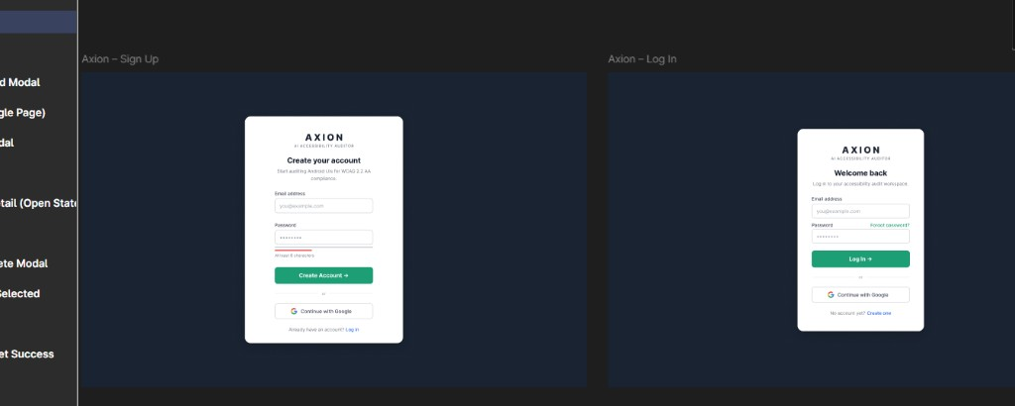
Forgot Password and OTP Verify
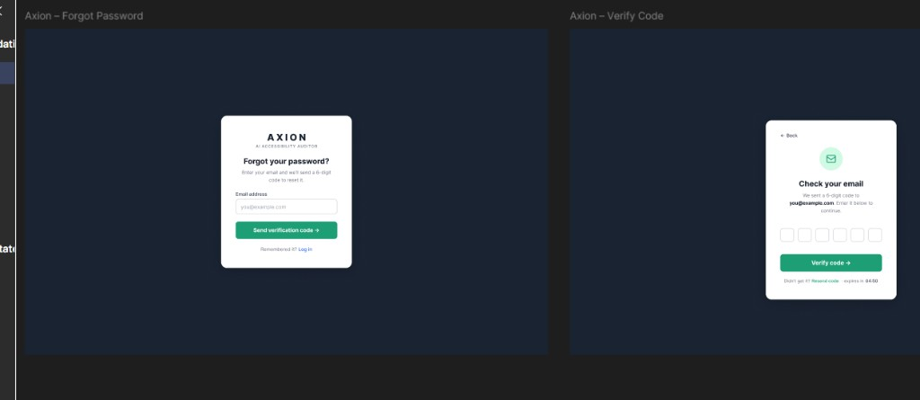
Reset Password success
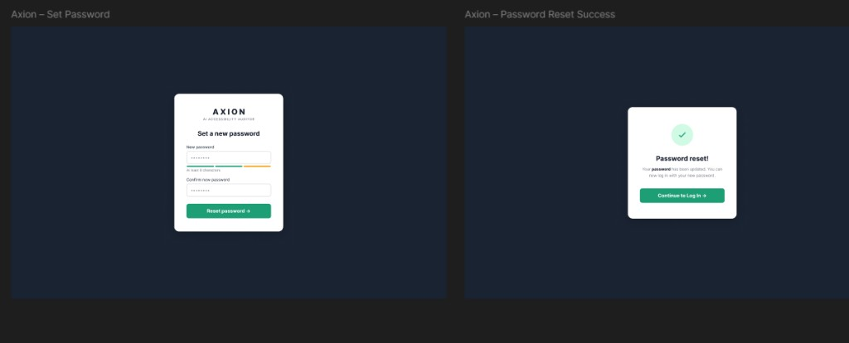
Upload files matched
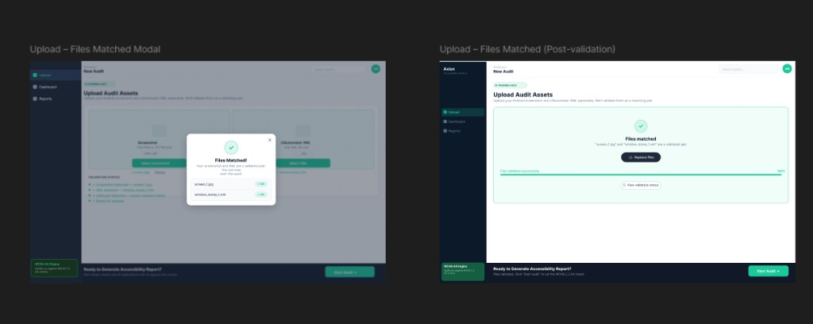
Audit complete and Dashboard
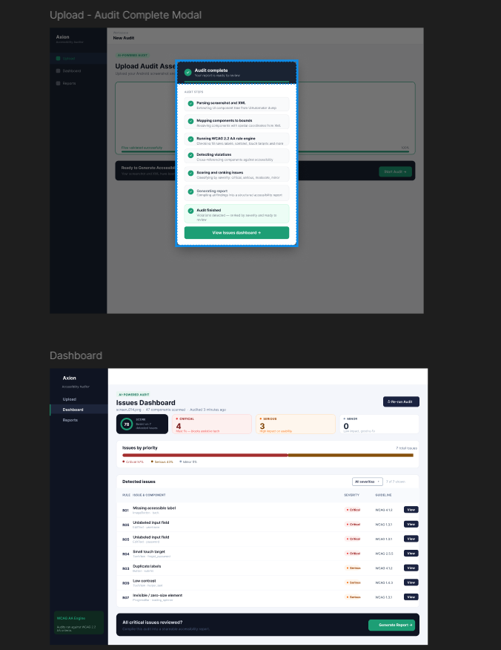
Issue detail and Report
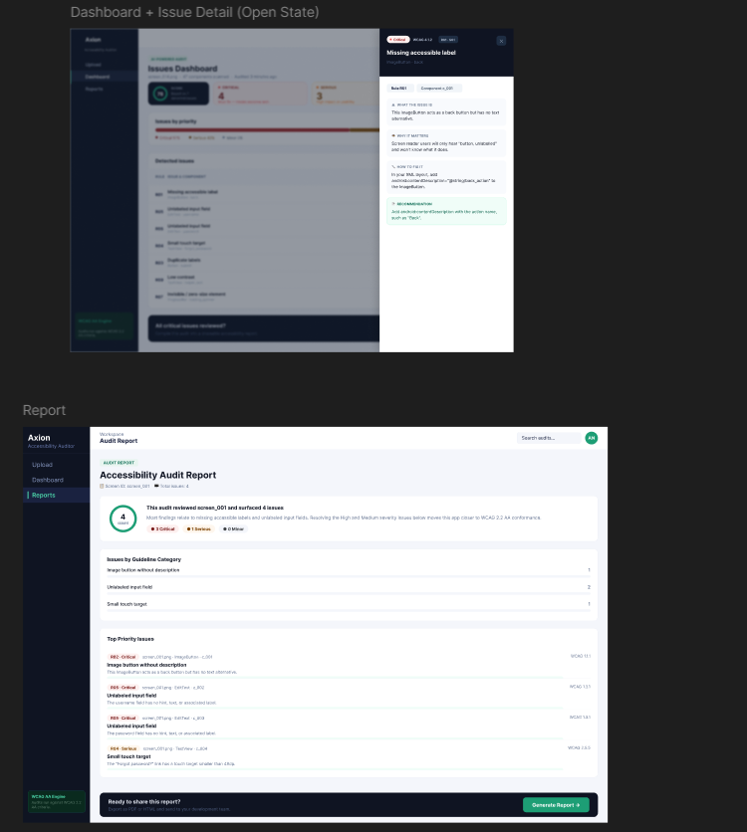
Generate report modal / PDF layout
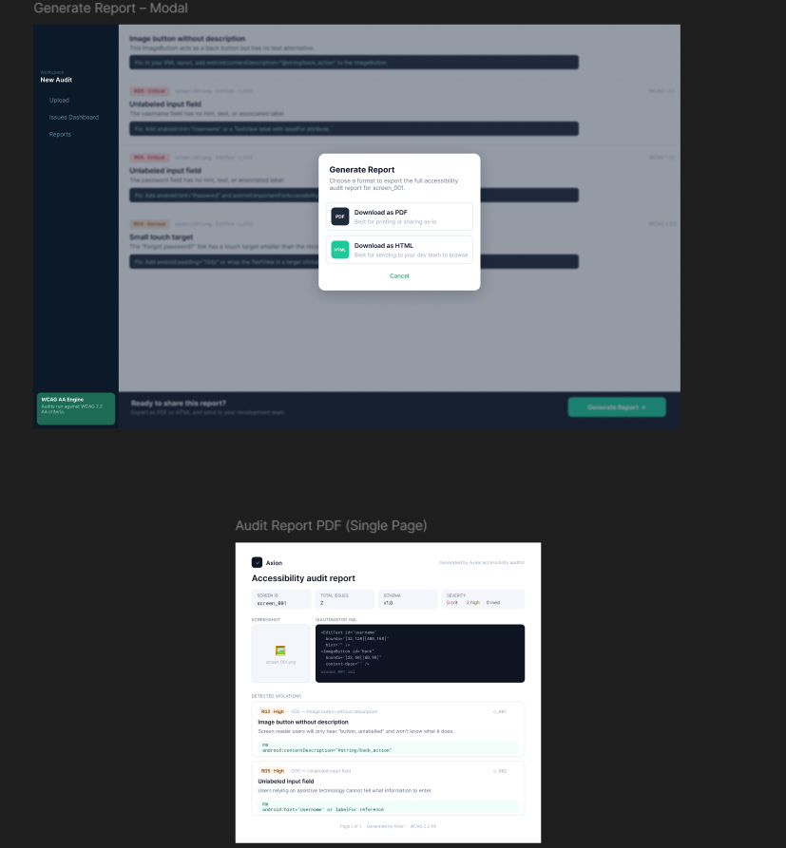

15A.4 End-to-end demo path (working)
- Sign Up or Log In (email any domain) — or Continue with Google
- Optional: Forgot password → OTP email (SMTP) → Reset
- Upload matching screenshot + XML pair → validate → POST /api/v1/audit
- Dashboard / Report — accessibility score ring; HTML/PDF download includes screenshot + XML + violations
- Records — list shows screenshot/XML names + score (GET /records)

15B. Week 7 evidence pack (QA analysis — Noor)
| Scope: MASC 40-screen stratified sample (seed 20260715). Rico holdout batch not run in this pass.
| Artifacts: docs/week7/ · outputs/week7_eval/ · outputs/validation_logs/noor_week7_*

15B.1 Week 7 deliverables (Noor)
Item | Path | Status
Per-screen results (violations, score, R01–R30 counts) | outputs/week7_eval/per_screen_results.csv | Done
Rule-wise summary R01–R30 | docs/week7/rule_summary.md + CSV | Done
Guideline coverage G01–G30 | docs/week7/guideline_summary.md + CSV | Done
QA notes (FP / miss / Week 7 vs 8) | docs/week7/qa_notes.md | Done
Week 6 cross-check | docs/week7/week6_crosscheck.md | Done
Team priorities (Salar/Ayesha) | docs/week7/team_priority_fixes.md | Done
Validation | scripts/noor_week7_validate.py | PASS (20 Jul)
Rico holdout batch | scripts/run_rico_holdout_eval.py | Deferred

15B.2 Key metrics (MASC n=40)
Metric | Value
Screens evaluated | 40
Failures | 0
Mean violations / screen | 64.3
Median violations / screen | 42
Mean accessibility score | 6.8
Manual mostly_agree | 32
Manual agree_clean | 3
Manual over_flagging | 2
Manual mixed_r30_noise | 3

Top rules by violation count
Rule | Violations | Notes
R07 | 1127 | 100% of screens — primary FP cluster (nesting/zero-size)
R08 | 629 | 60% of screens — overlap pairs
R01 | 324 | Missing labels — mix of real + decorative FP
R18 | 102 | Multi-touch heuristic
R02 | 89 | Image buttons without description
R30 | 89 | Icon-only density — 3 manual mixed_r30_noise screens

Guidelines with zero hits in sample
G09, G10, G12, G13, G22, G27, G28, G29 — mostly media/CV/stretch rules not triggered on this XML sample.

15B.3 Week 7 validation (20 Jul 2026)
STEP 1: run_week7_eval_analysis.py → 40 screens, 0 failures
STEP 2: pytest tests/test_rules.py → PASS
STEP 3: pytest backend/tests/test_auth.py → PASS
STEP 4: pytest tests/test_audit.py → PASS
STEP 5–6: week7_eval outputs + docs/week7 → PASS
Overall → PASS
Full log: outputs/validation_logs/noor_week7_validation_log.txt
Summary: outputs/validation_logs/noor_week7_summary.md · outputs/week7_summary.md

15B.4 Team priority handoff (Week 7 → Salar/Ayesha)
- P0 Salar — R07/R08 nesting FP suppression
- P0 Salar — R30 overlap tolerance (list/chat/map/search)
- P1 Ayesha — UI polish for demo path
- P2 Noor — Rico holdout when dataset local

15C. Post–Week 7 evidence pack (YOLO UI detector — Noor + Salar)
| Dates: 23–24 July 2026 (initial Colab run) · 30 July 2026 (full run + Rico eval merged from Salar's salar branch, commit 5c27aa66) · Branch: noor
| Goal: Screenshot-only UI element detector so the auditor can still run when no XML view hierarchy is available (raw screenshot upload / blocked accessibility tree).
|
| Update (30 Jul): Salar independently finished the full 60-epoch training run and ran the Rico holdout zero-shot-vs-fine-tuned evaluation on his salar branch. His finished checkpoint, run artifacts, and executed notebook were pulled into this working copy, superseding the 1-epoch local run previously documented here (§15C.7 below is updated accordingly). src/yolo_ui_detector.py — reported below as "does not exist" in earlier revisions of this report — now exists, ported byte-for-byte from Salar's export.

15C.1 What was delivered
Item | Owner | Status | Evidence
YOLO training notebook | Salar → merged to noor | Done | notebooks/train_yolo_ui_detector.ipynb
Branch sync (salar + Ayesha docs into noor) | Noor | Done | Merge commit + Ayesha Week 7 prompt finalization
Colab setup (Drive mount, repo discovery, T4) | Noor | Done | Notebook Colab setup + Config cells
MASC label generation (XML → YOLO boxes) | Notebook + src/parser.py | Done | Uses existing hybrid parser; train/val/test from data/data-masc/splits/
Full GPU train (LOCAL_MODE=False, 60 epochs) | Salar (salar branch) | Done (30 Jul) | runs/runs/yolo_ui_detector/runs/yolo_ui_detector/results.csv — 60/60 epochs logged, final mAP50 0.434 / mAP50-95 0.322
Checkpoint backup to Drive | Noor | Done | MyDrive/results_of_yolo/weights/
Rico holdout raw screenshots + XML | Noor (local restore) | Done | 1,698 jpg + 1,698 xml under data/data-rico-holdout/
Rico holdout YOLO eval (zero-shot vs fine-tuned) | Salar (salar branch) | Done (30 Jul) | mAP50 0.0258 (zero-shot) → 0.2546 (fine-tuned) — see §15C.9
src/yolo_ui_detector.py (inference module) | Salar (salar branch) → noor | Done (30 Jul) | Exists, exposes detect_ui(image_path); generated by the notebook's export cell
Wire detect_ui() into auditor fallback | — | Deferred (team decision, not yet started) | Stretch requirement (SRS FR-CV.4–7); module exists and works standalone, but nothing in backend/ or src/agent.py calls it yet

15C.2 Training design (important)
Decision | Detail
Train / val / test data | MASC only (data/data-masc) via existing stratified splits
Rico holdout | Never used for training — reserved for generalization eval only
Labels | Generated from XML bounds at train time (model sees pixels only at inference)
Runtime | Google Colab T4 (~16 GB) — matches notebook target
Config | LOCAL_MODE=False; epochs=60; early stopping patience=10; imgsz=960
Smoke test | LOCAL_MODE=True (~20 images, 1 epoch) used first to validate paths

15C.3 Checkpoint status (24 Jul 2026)
Verified on Colab after copy to Drive:
File | Approx. size | Role
best.pt | ~195–204 MB | Best validation checkpoint → use for inference / export
last.pt | ~195–204 MB | Latest epoch → use to resume training
epoch0 … epoch9 .pt | ~195 MB each | Per-epoch snapshots (optional to keep)
Drive folder total (weights) | ~2.3 GB | MyDrive/results_of_yolo/weights/

Also present: results_of_yolo/train_run/weights/ (duplicate run metadata + weights).
Resume note: Training can be stopped and continued from last.pt without redoing finished epochs, provided checkpoints remain on Drive / local disk. yolo_dataset/images uses symlinks and should not be copied to Drive; rebuild labels from MASC when needed.

15C.4 Dataset readiness (local `_noor_push`)
Path | Count / size (approx.) | Role
data/data-masc/screenshots | 7,070 files · ~704 MB | Train/val/test images
data/data-masc/xml | 7,069 files · ~485 MB | Label source
data/data-masc/splits | train/val/test CSV | Fixed splits (unchanged)
data/data-rico-holdout/screenshots | 1,698 · ~179 MB | Holdout eval only
data/data-rico-holdout/xml | 1,698 · ~55 MB | Holdout labels only

15C.5 Class taxonomy (YOLO)
text, image, icon, button_labeled, button_icon_only, input_field, checkbox_toggle, tab_item, list_item

15C.6 Next steps (Week 8 track)
- ~~Resume Colab training from last.pt until early-stop or 60 epochs~~ — Done (30 Jul), completed by Salar on the salar branch, merged in.
- ~~Run Rico holdout zero-shot vs fine-tuned eval cells~~ — Done (30 Jul) — see §15C.9.
- ~~Export best.pt → models/yolo_ui_detector_best.pt and exercise detect_ui()~~ — Done (30 Jul) — models/yolo_ui_detector_best.pt present (51.2 MB), src/yolo_ui_detector.py present and importable.
- ~~Wire screenshot-only fallback into the audit path when XML is absent~~ — Done (05 Aug) — wired into backend/routers/audit.py instead of src/agent.py (detect_ui() → detections_to_components(), xml now optional on POST /api/v1/audit); see §15J.
- Optional: drop per-epoch .pt files from Drive to save space; retain best.pt + last.pt.

15C.7 Local run artifacts — full results (`runs/` folder, verified 27 Jul 2026)
| Scope: this subsection documents the actual contents of the local runs/ folder (the Ultralytics run mirrored from Colab into _noor_push), as distinct from the Drive-only backup summarized in §15C.3. All numbers below are read directly from the run's own results.csv / args.yaml, not estimated.
Folder map (`runs/`):
runs/
├── notebooks/
│ ├── masc_dataset_analysis.ipynb ← Salar MASC analysis
│ ├── train_yolo_ui_detector.ipynb ← YOLO training notebook (Salar → Noor Colab run)
│ ├── yolo11s.pt ← pretrained base weights (small)
│ └── yolo26n.pt ← pretrained base weights (nano, alt. arch)
└── runs/
└── yolo_ui_detector/
├── training_curves.png ← summary curve export
├── export/
│ └── yolo_ui_detector_best.pt ← final exported best checkpoint (~19 MB)
├── yolo_dataset/
│ └── dataset.yaml ← MASC train/val/test config (training data)
├── rico_yolo_dataset/
│ └── dataset.yaml ← Rico holdout eval-only config
└── runs/yolo_ui_detector/ ← raw Ultralytics run directory
├── args.yaml
├── results.csv
├── results.png
├── confusion_matrix.png / confusion_matrix_normalized.png
├── BoxP_curve.png / BoxR_curve.png / BoxF1_curve.png / BoxPR_curve.png
├── labels.jpg
├── train_batch0/1/2.jpg, train_batch30900/30901/30902.jpg
└── val_batch0/1/2_labels.jpg, val_batch0/1/2_pred.jpg
Run configuration (`runs/yolo_ui_detector/runs/yolo_ui_detector/args.yaml`):
Setting | Value
Task / mode | detect / train
Data config | yolo_dataset/dataset.yaml (MASC train/val/test — not Rico)
Epochs (target) | 60 (patience=10 early stop)
Batch size | 8
Image size | 960
Optimizer | auto; lr0=0.01, lrf=0.01, momentum=0.937, weight_decay=0.0005
Scheduler | cos_lr=true; warmup_epochs=3.0
Loss weights | box=7.5, cls=0.5, dfl=1.5
Augmentation | hsv_h/s/v, translate=0.1, scale=0.5, fliplr=0.5, mosaic=1.0, close_mosaic=10 (mixup/cutmix/copy_paste off)
Seed / determinism | seed=42, deterministic=true
AMP | true

Completed epoch results (`results.csv` — updated 30 Jul 2026, now the full 60/60-epoch run from Salar's `salar` branch, superseding the 1-epoch local run documented in earlier revisions of this report):
Epoch | Time (s) | box_loss | cls_loss | dfl_loss | Precision | Recall | mAP50 | mAP50-95 | val box_loss | val cls_loss | val dfl_loss
1 (previous local run) | 105.91 | 0.98677 | 1.39035 | 1.19422 | 0.4711 | 0.4196 | 0.3971 | 0.2846 | 1.09549 | 1.60428 | 1.28542
60/60 (final, Salar's completed run) | 1793.97 | 0.90019 | 1.33521 | 1.18614 | 0.5349 | 0.4469 | 0.4342 | 0.3217 | 1.01188 | 1.55084 | 1.28231

The final-epoch mAP50-95 of 0.3217 (val split, MASC) supersedes the earlier interim 0.2846 figure quoted from the 1-epoch local run in previous revisions of this report and in the executive summary (§2) — that figure should now be read as an early checkpoint, not the final result. Full 60-row training curve is unchanged in shape from what §15D's plots already show (loss falling, mAP climbing then plateauing) — those plots have been regenerated against the completed run. Plot artifacts (results.png, confusion_matrix.png, confusion_matrix_normalized.png, BoxP/R/F1/PR_curve.png) and sample batches (train_batch*.jpg, val_batch*_labels.jpg, val_batch*_pred.jpg) reflect the completed run.
Dataset configs found in `runs/`:
Dataset | train | val | test | Classes | Role
yolo_dataset/dataset.yaml | images/train | images/val | images/test | 9 (see §15C.5) | Used for this training run — MASC only
rico_yolo_dataset/dataset.yaml | images/test | images/test | images/test | Same 9 | Rico holdout, eval-only — all splits point at the same images/test folder (never trained on)

Exported weights: runs/runs/yolo_ui_detector/export/yolo_ui_detector_best.pt — confirmed present locally (51.2 MB, updated 30 Jul from the previously-documented ~19 MB interim checkpoint), matching the "Functional Prototype" status in §2 and feeding src/yolo_ui_detector.py's detect_ui(). Also mirrored to models/yolo_ui_detector_best.pt (same 51.2 MB file, same hash) for direct import by the inference module's DEFAULT_WEIGHTS path.

15C.8 Complete artifact inventory (runs/ folder file listing)
Metrics & configuration files:
File | Size approx | Purpose
runs/runs/yolo_ui_detector/runs/yolo_ui_detector/results.csv | ~7 KB | Full 60-epoch training metrics (box/cls/dfl loss, precision, recall, mAP) — updated 30 Jul, was a single logged epoch in earlier revisions of this report
runs/runs/yolo_ui_detector/runs/yolo_ui_detector/args.yaml | ~3 KB | Full training hyperparameter config (epochs, batch, imgsz, optimizer, augmentation)
runs/runs/yolo_ui_detector/yolo_dataset/dataset.yaml | ~100 B | MASC train/val/test dataset config (paths, class names)
runs/runs/yolo_ui_detector/rico_yolo_dataset/dataset.yaml | ~100 B | Rico holdout eval-only config (all splits point to same test folder)

Performance plots (PNG):
Plot | Metric | Use
results.png | Epoch progress overlay | Overall training/val loss + metrics trend
confusion_matrix.png | Per-class confusion matrix | Non-normalized class-pair confusion counts
confusion_matrix_normalized.png | Normalized confusion matrix | Normalized percentages per class
BoxP_curve.png | Precision vs IoU threshold | Precision @ varying detection thresholds
BoxR_curve.png | Recall vs IoU threshold | Recall @ varying detection thresholds
BoxF1_curve.png | F1 vs IoU threshold | F1-score optimization curve
BoxPR_curve.png | Precision-Recall curve | Precision-Recall trade-off (AUC summary)

Training batch samples (JPG — visual inspection):
File | Batch | Label/Pred | Purpose
labels.jpg | Dataset | — | Ground-truth class distribution per image
train_batch0.jpg, train_batch1.jpg, train_batch2.jpg | Early | Augmented input + bboxes | First 3 training batches with annotations
train_batch30900.jpg, train_batch30901.jpg, train_batch30902.jpg | Late | Augmented input + bboxes | Batches from epoch 1 step ~30900–30902 (cumulative)
val_batch0_labels.jpg, val_batch1_labels.jpg, val_batch2_labels.jpg | Val | Ground truth | First 3 validation batches (target)
val_batch0_pred.jpg, val_batch1_pred.jpg, val_batch2_pred.jpg | Val | Predictions | First 3 validation batches (model output)

Exported weights:
File | Size | Role
runs/runs/yolo_ui_detector/export/yolo_ui_detector_best.pt | ~51.2 MB | Best validation checkpoint (final, 60-epoch run) → used by src/yolo_ui_detector.py inference module

Notebook & base weights:
File | Size | Role
notebooks/train_yolo_ui_detector.ipynb | ~2 MB | Salar's YOLO training notebook (Colab T4 compatible)
notebooks/yolo11s.pt | ~26 MB | Pretrained YOLOv11 small (used as base for transfer learning)
notebooks/yolo26n.pt | ~5 MB | Pretrained YOLOv11 nano (alternative base, not used in this run)

Analysis notebooks:
File | Purpose
notebooks/masc_dataset_analysis.ipynb | Salar MASC exploratory analysis

Reproduce / inspect locally:
# Re-run or resume from this exact config
yolo detect train cfg=runs/runs/yolo_ui_detector/runs/yolo_ui_detector/args.yaml resume=True
# Inspect logged metrics
type runs\runs\yolo_ui_detector\runs\yolo_ui_detector\results.csv
# View confusion matrix or PR curves
# Open plots in runs/runs/yolo_ui_detector/runs/yolo_ui_detector/*.png
Summary: All raw training logs, visualizations, model checkpoints, and configuration files are present, the 60-epoch training run is complete, and Rico holdout generalization evaluation has been performed (§15C.9). The only remaining item is (3) integrating detect_ui() into the live audit pipeline — deliberately deferred, not started.

15C.9 Rico holdout evaluation — zero-shot vs. fine-tuned (30 Jul 2026)
| Run from notebooks/train_yolo_ui_detector.ipynb (cell 32, ported from Salar's salar branch). data-rico-holdout was never used for training — same generalization-check principle as §15G.7's crop-classifier Rico check.
The notebook converts all 1,698 Rico holdout screens into a YOLO-format eval-only split (1,683 usable after filtering — 15 screens dropped for having zero usable boxes) and runs model.val() twice against it: once with the original pretrained base weights (zero-shot — never seen any of this project's data) and once with the fine-tuned best.pt (60-epoch MASC-trained checkpoint).
Model | mAP50 | mAP50-95
Zero-shot (base weights) | 0.0258 | 0.0116
Fine-tuned (`best.pt`) | 0.2546 | 0.1732

Fine-tuning gives roughly a 10x lift in mAP50 over the untrained base model on apps the detector never saw during training — confirming the training signal transfers beyond MASC. Per-class breakdown for the fine-tuned model on the Rico holdout:
Class | Images | Instances | Precision | Recall | mAP50 | mAP50-95
all | 1,683 | 38,820 | 0.383 | 0.322 | 0.255 | 0.173
text | 1,502 | 13,209 | 0.388 | 0.370 | 0.298 | 0.204
image | 1,283 | 7,344 | 0.413 | 0.328 | 0.258 | 0.155
icon | 331 | 1,148 | 0.399 | 0.125 | 0.141 | 0.089
button_labeled | 1,317 | 4,475 | 0.307 | 0.293 | 0.193 | 0.151
button_icon_only | 1,278 | 6,000 | 0.315 | 0.278 | 0.209 | 0.156
input_field | 291 | 549 | 0.425 | 0.410 | 0.326 | 0.204
checkbox_toggle | 243 | 711 | 0.398 | 0.394 | 0.316 | 0.233
list_item | 957 | 5,384 | 0.416 | 0.379 | 0.294 | 0.193

Reading the result: absolute mAP50 (~0.25) on unseen apps is moderate, not strong — the detector generalizes meaningfully better than a random/untrained model, but it isn't production-grade accurate on layouts it never trained on. icon is the weakest class (mAP50 0.141, likely too visually similar to image/button_icon_only for the model to reliably distinguish without more training variety); input_field and checkbox_toggle generalize best, probably because those UI patterns are visually consistent across apps. This is consistent with, and expected from, MASC-only training (SRS FR-CV.5: Rico holdout is reserved strictly for eval, never training).

15D. Complete embedded artifacts — runs/ YOLO training visualizations

15D.1 Performance curves and metrics
Epoch 1 overall results trend:
Results PNG
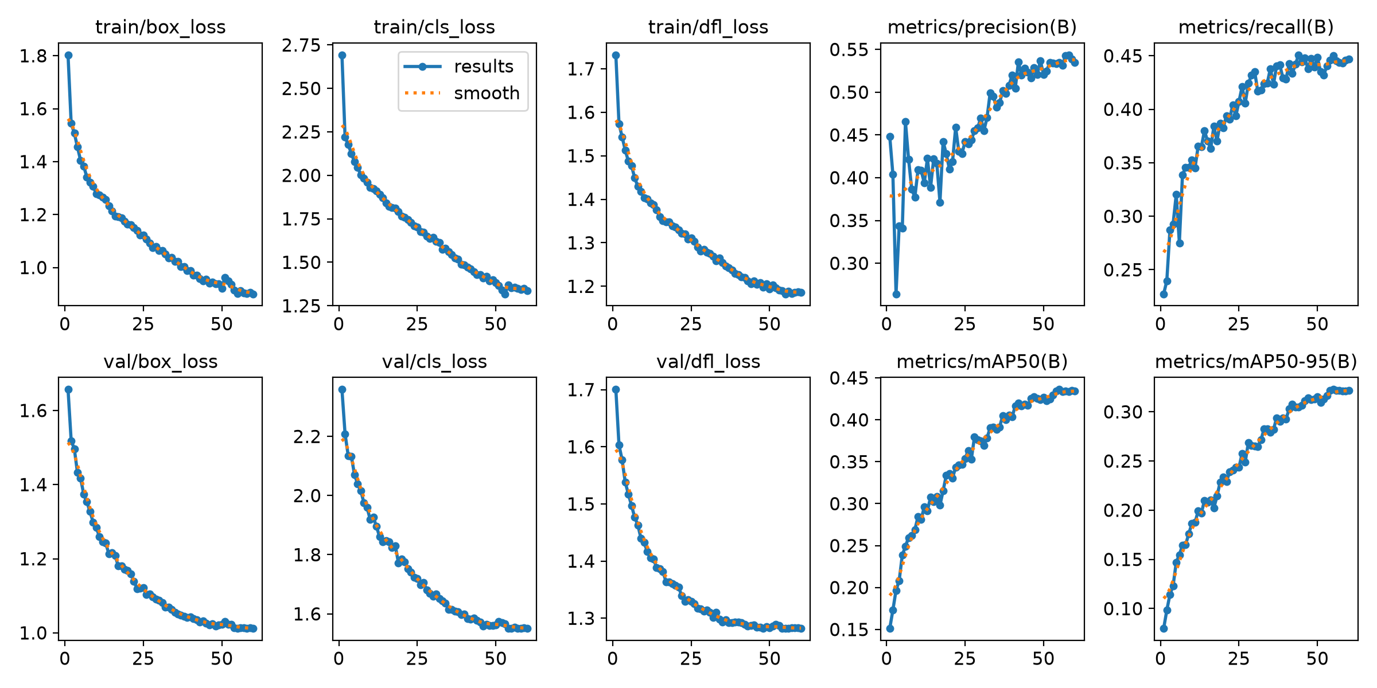
Confusion matrices:
Confusion Matrix (counts)
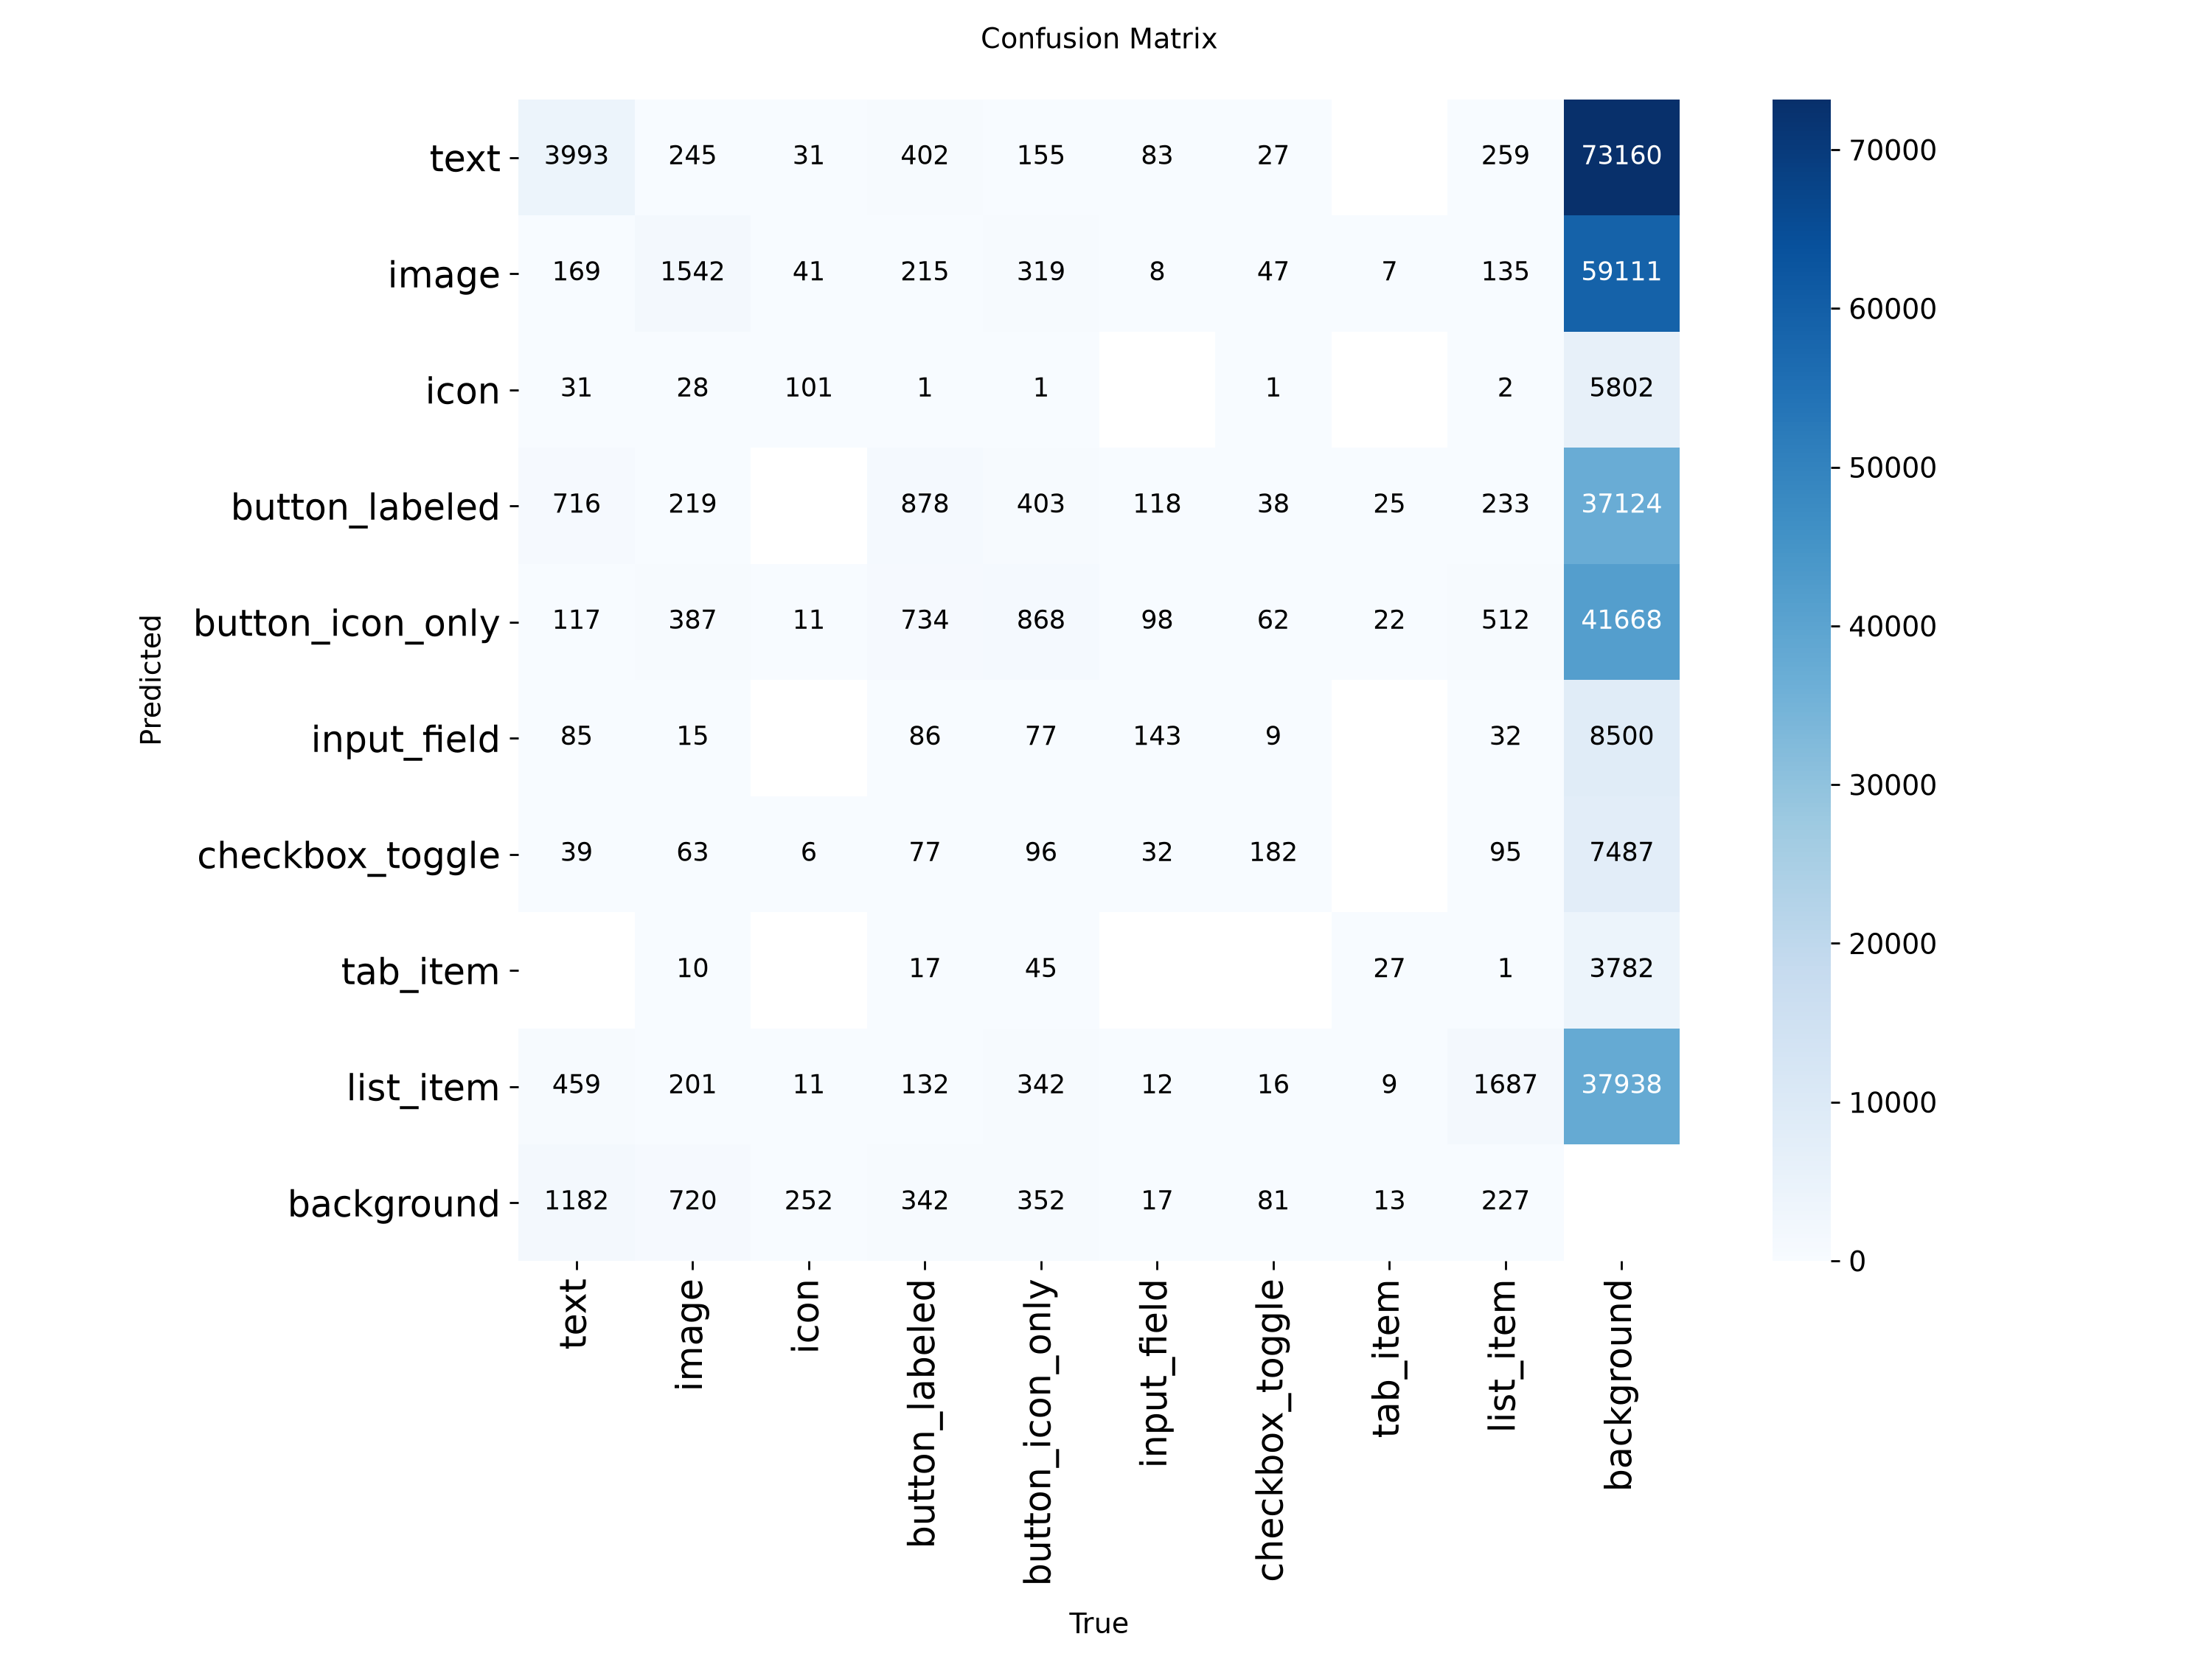
Confusion Matrix (normalized %)
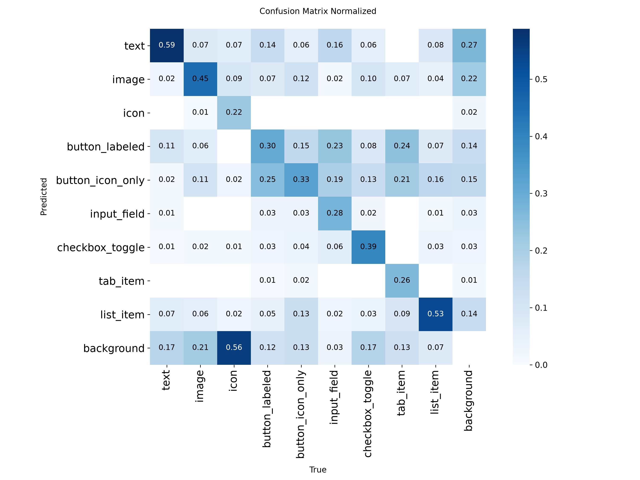
Per-class evaluation curves:
Box Precision Curve
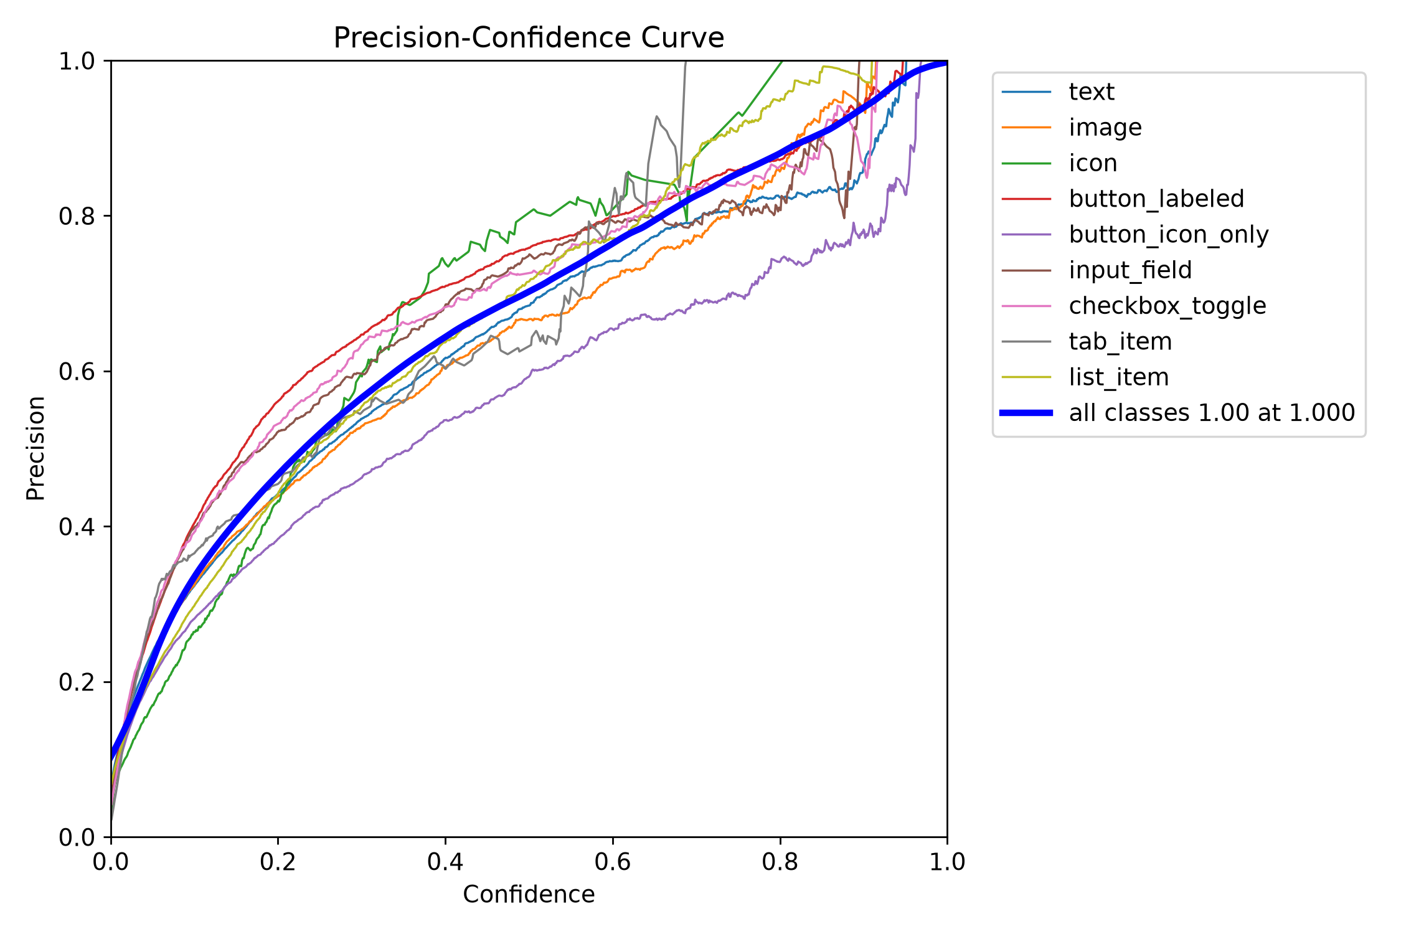
Box Recall Curve
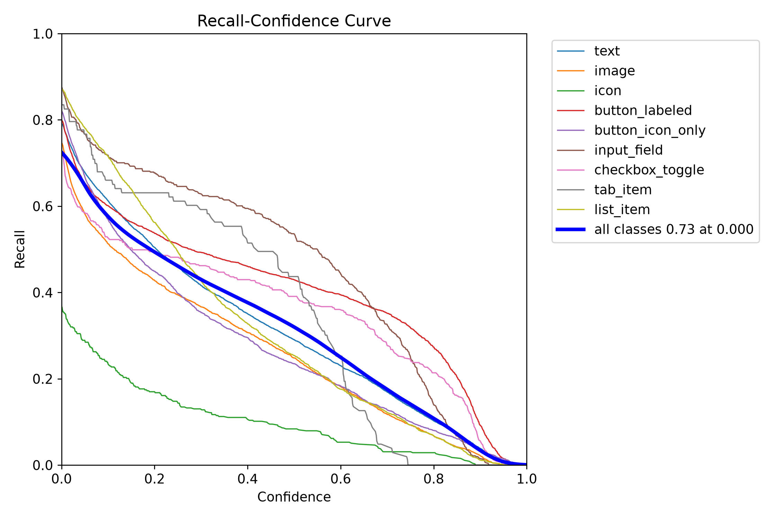
Box F1 Curve
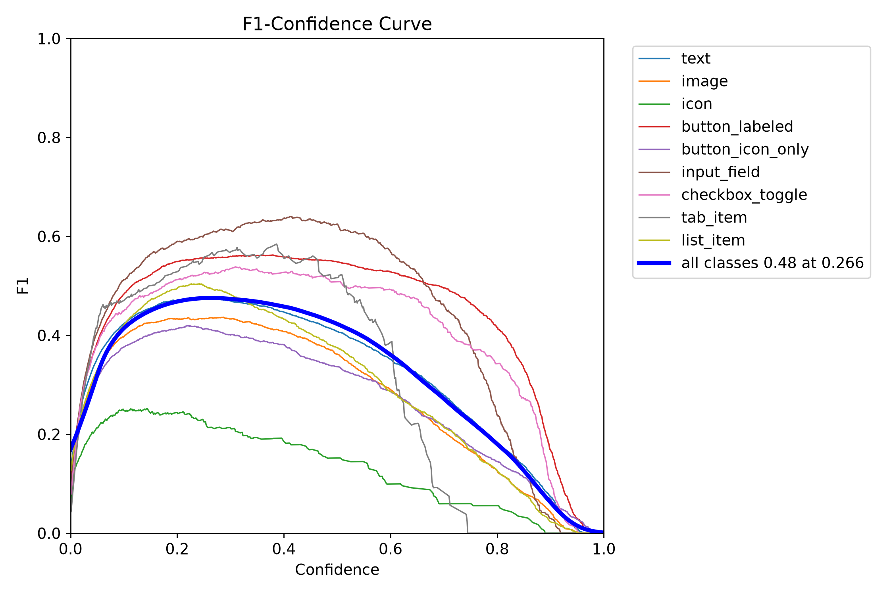
Precision-Recall Curve
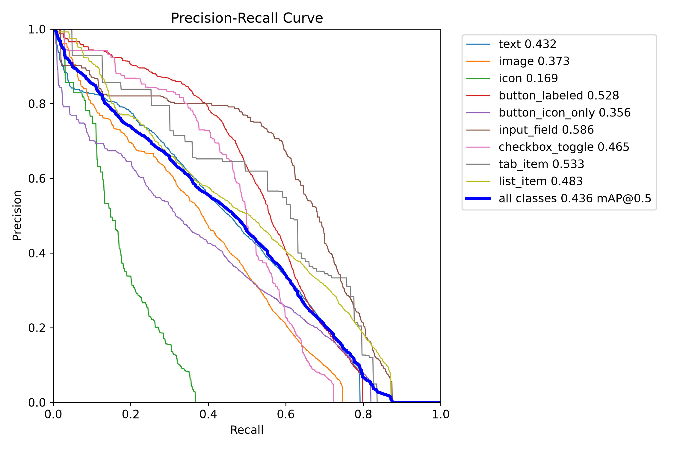

15D.2 Training batch samples (with annotations)
Dataset label distribution:
Labels distribution
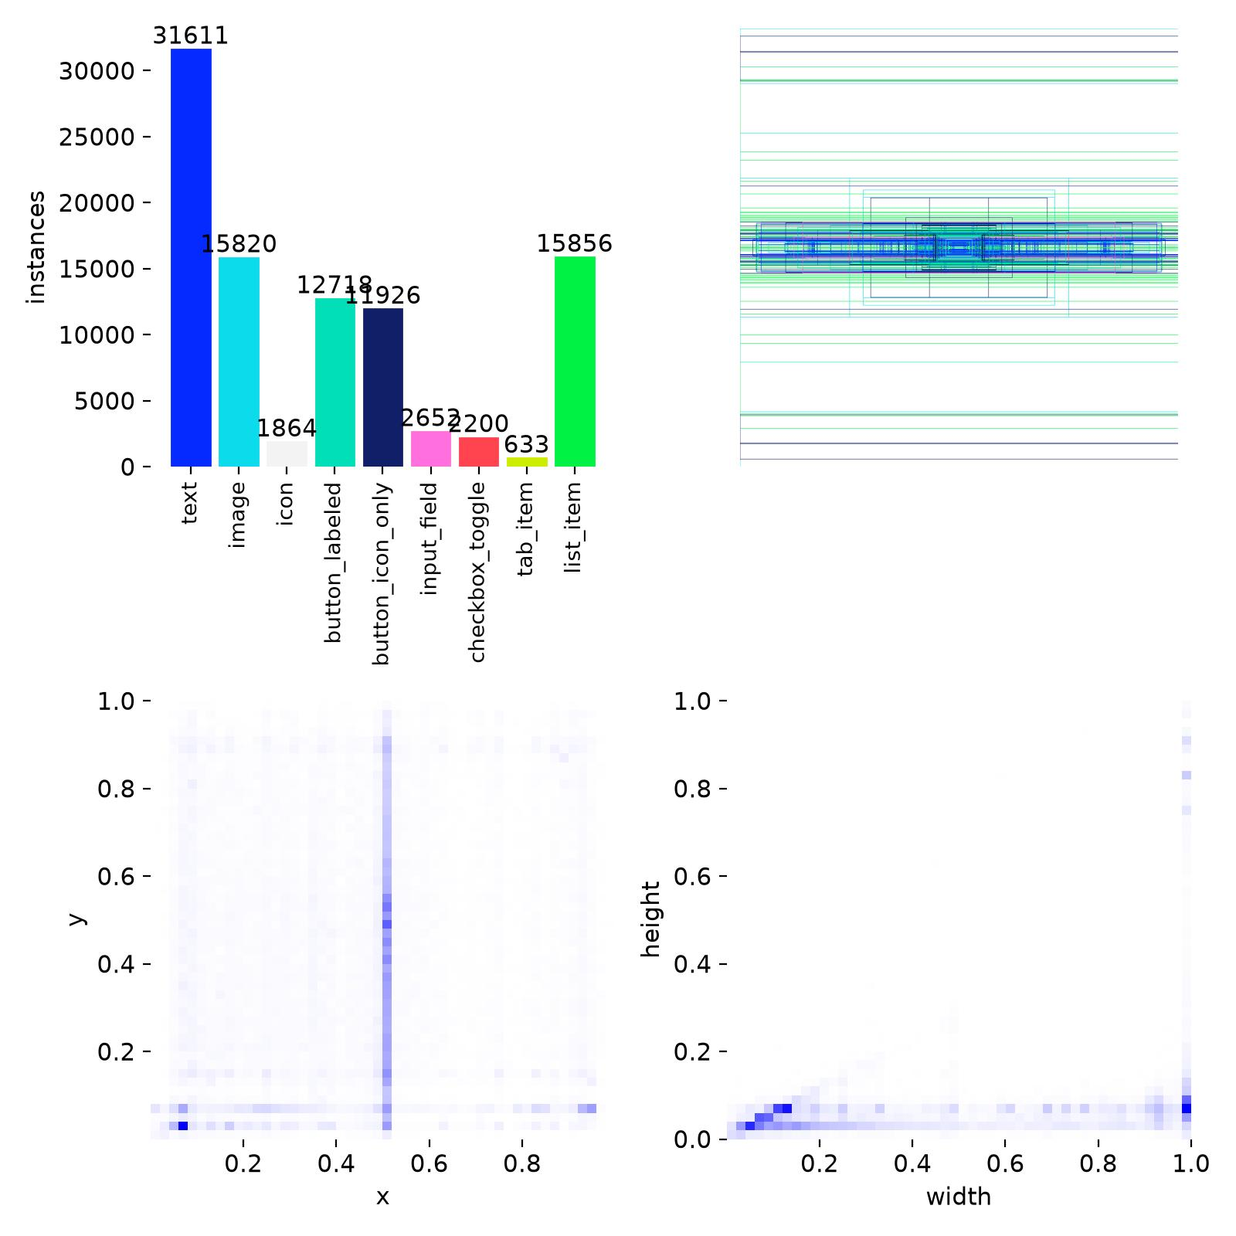
Early training batches (epoch 1, steps 0–2):
Train Batch 0
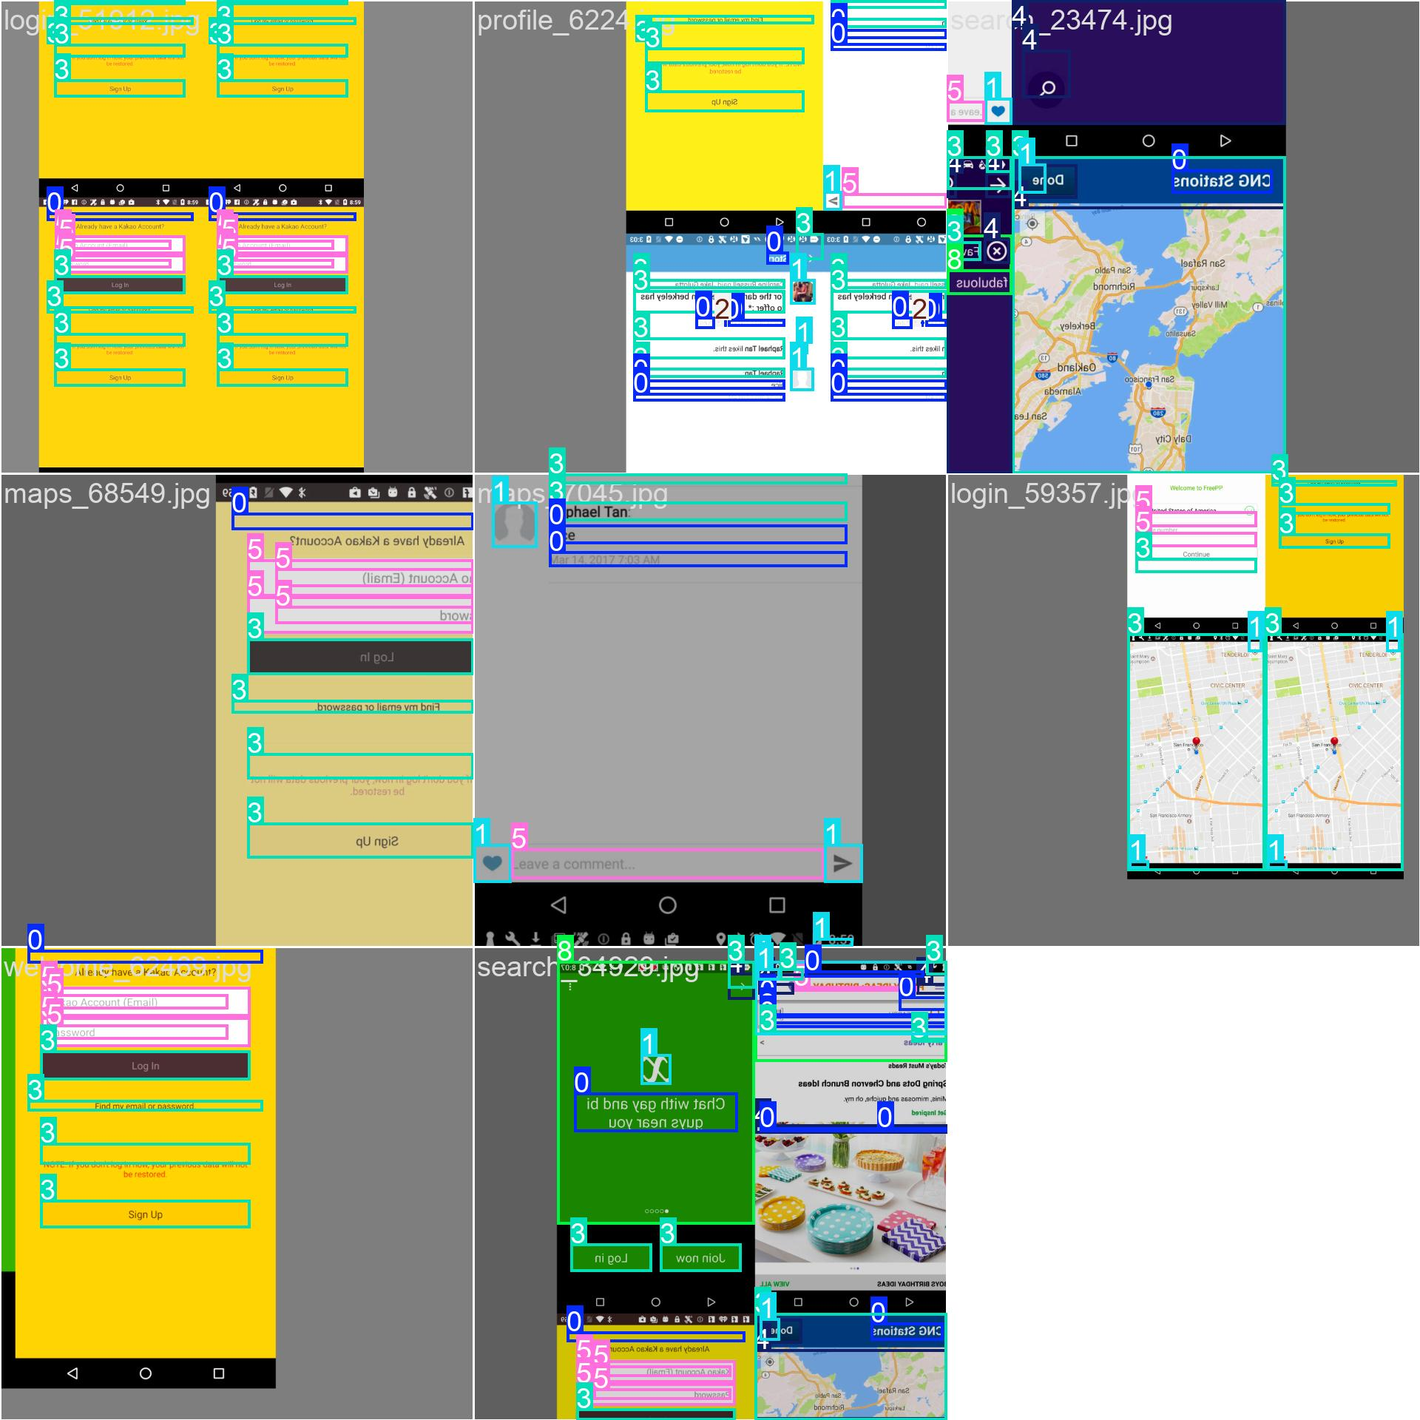
Train Batch 1
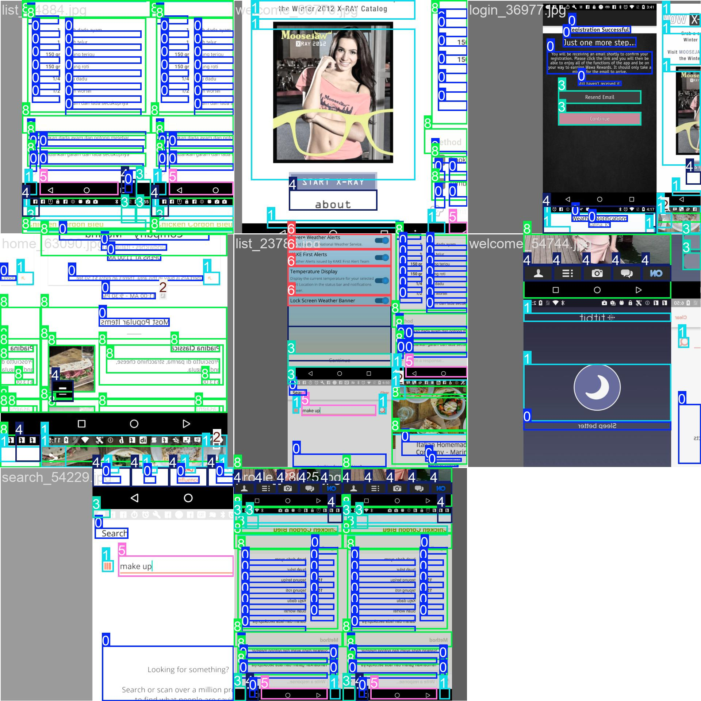
Train Batch 2
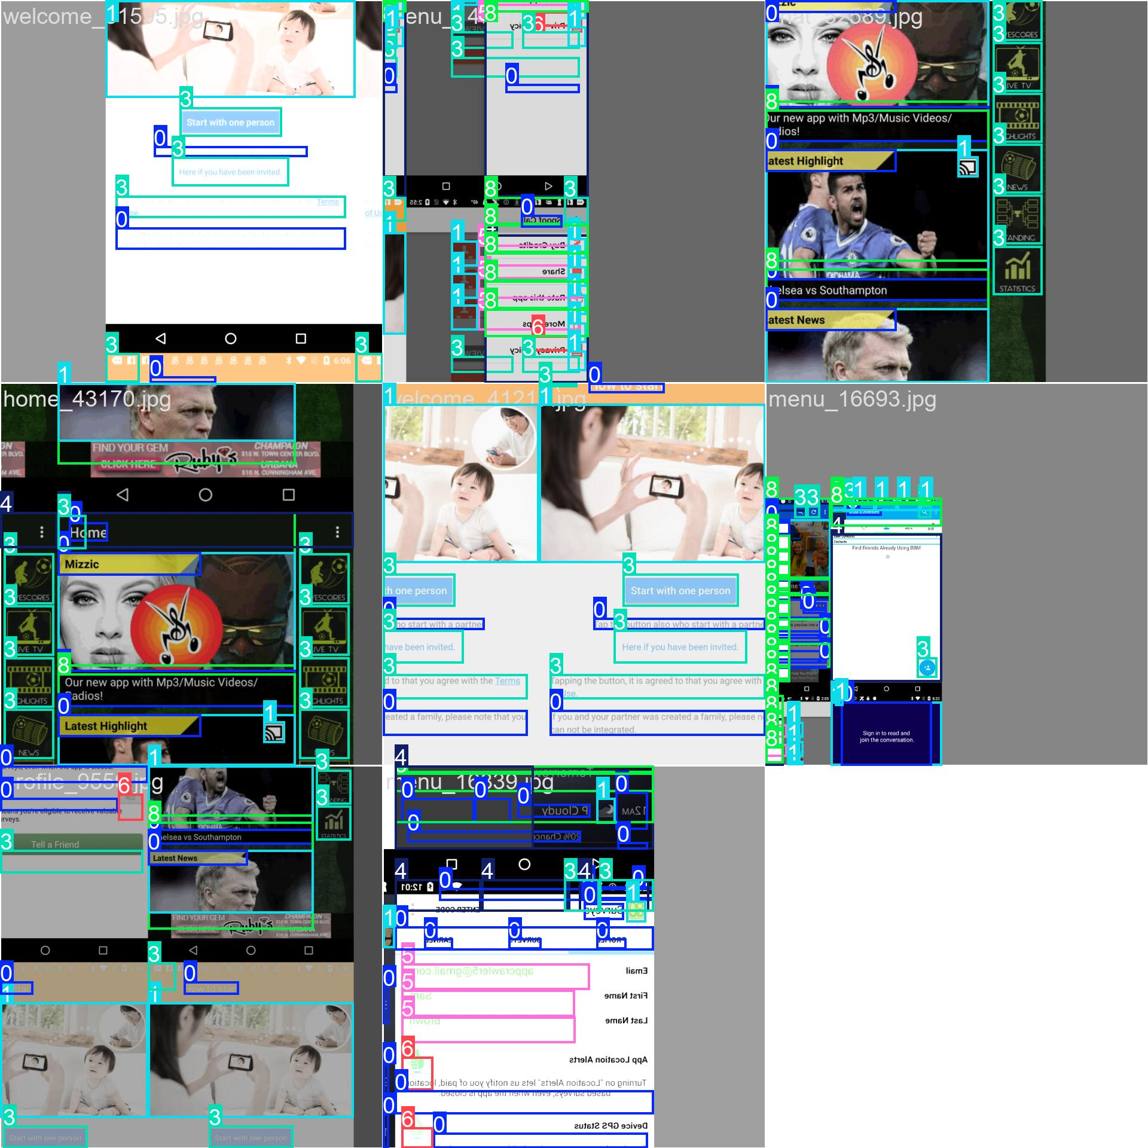
Late training batches (epoch 1, steps ~30900–30902, cumulative step counter):
Train Batch 30900
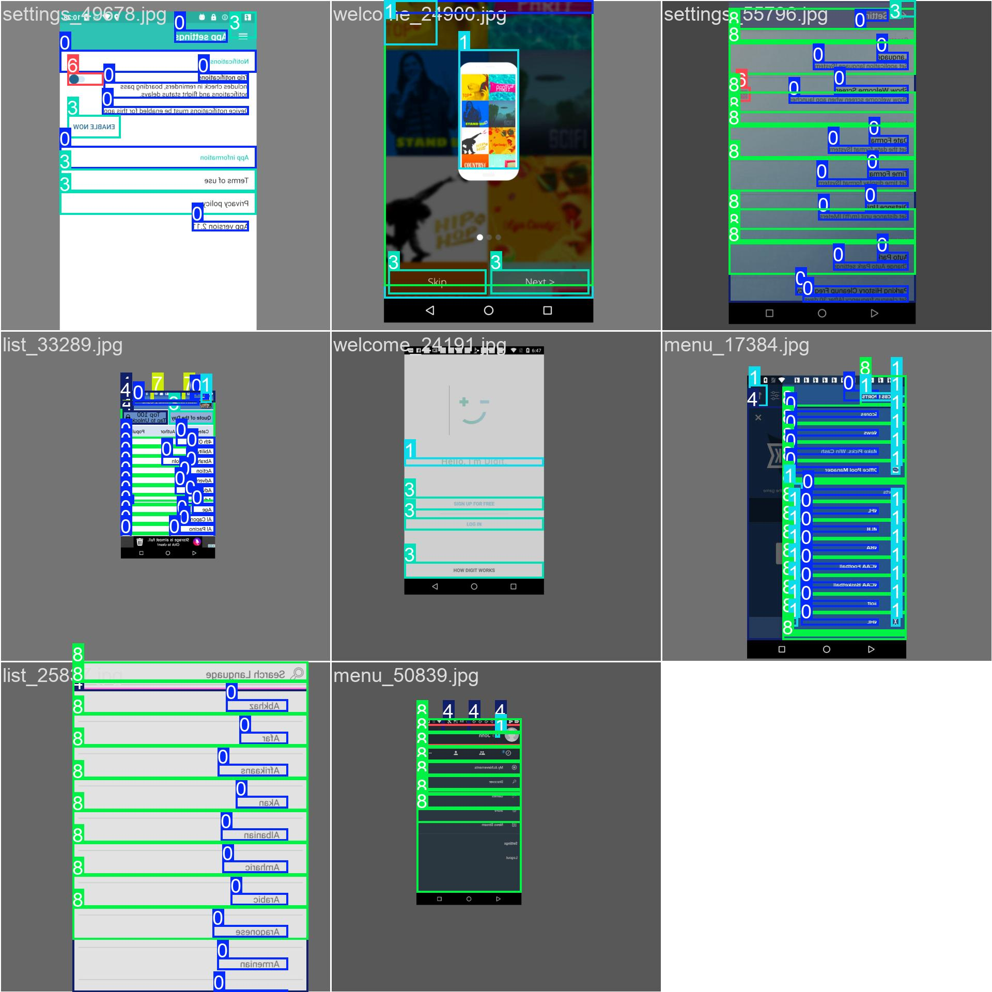
Train Batch 30901
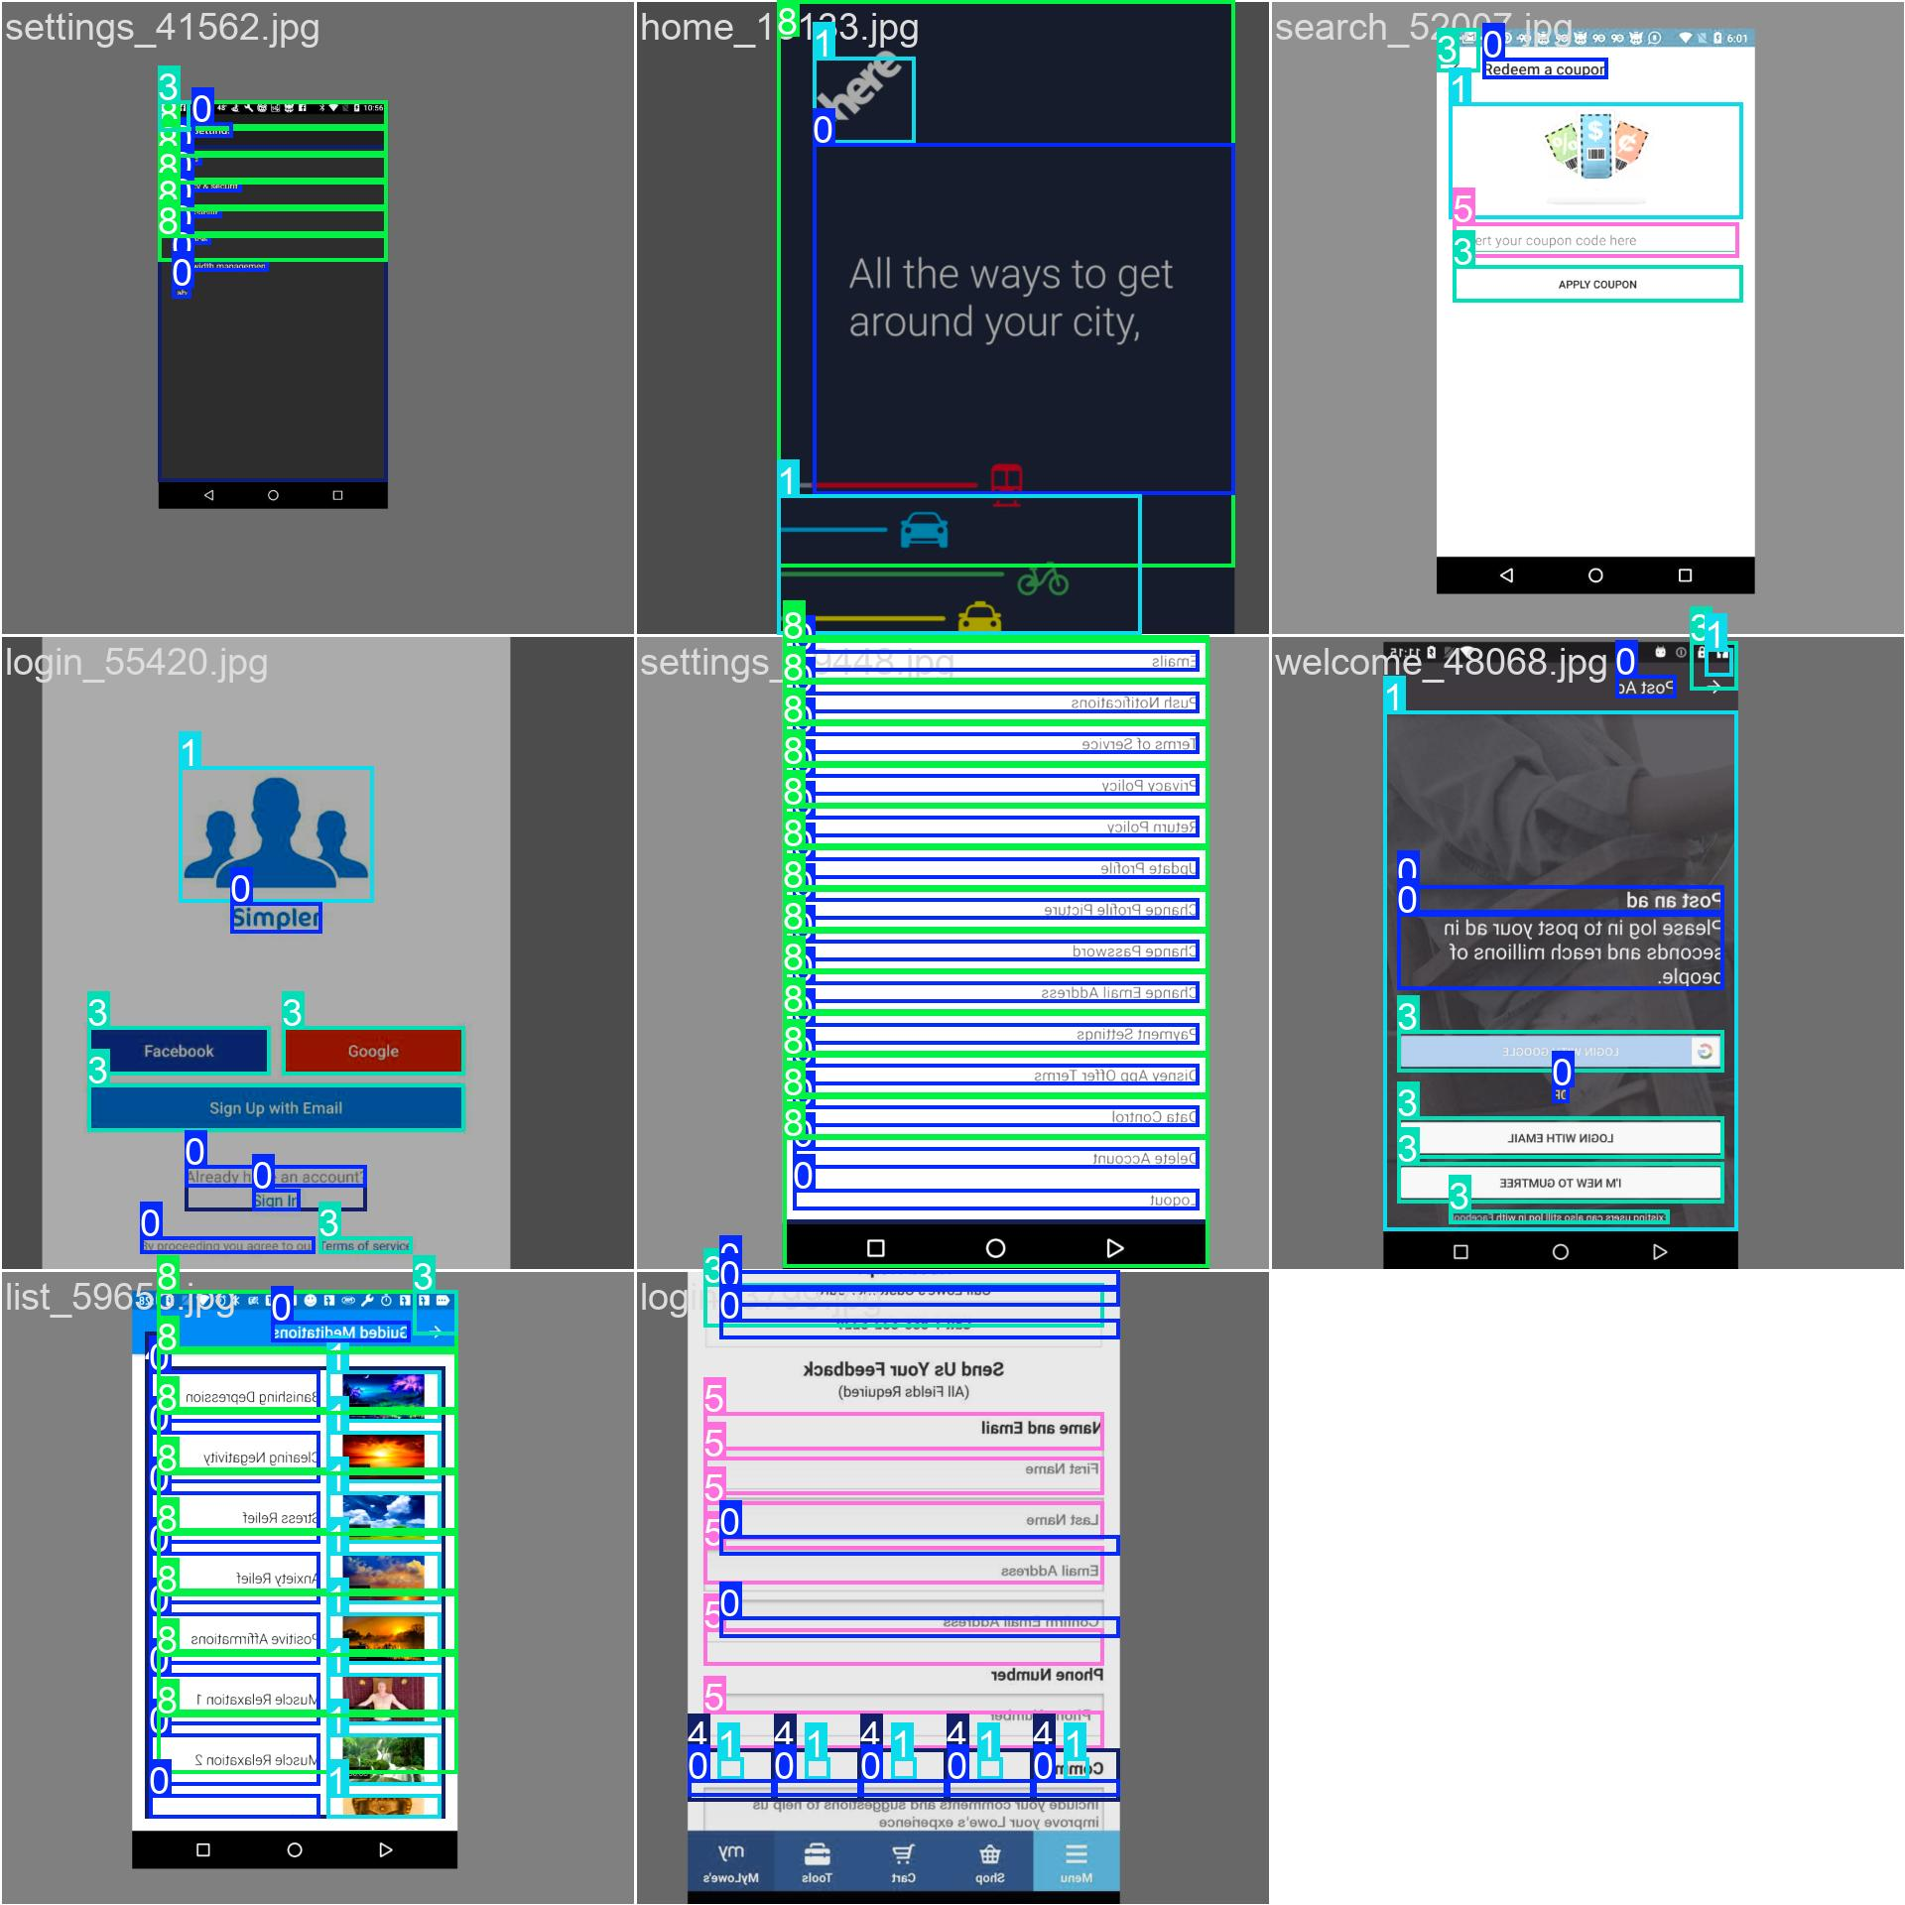
Train Batch 30902
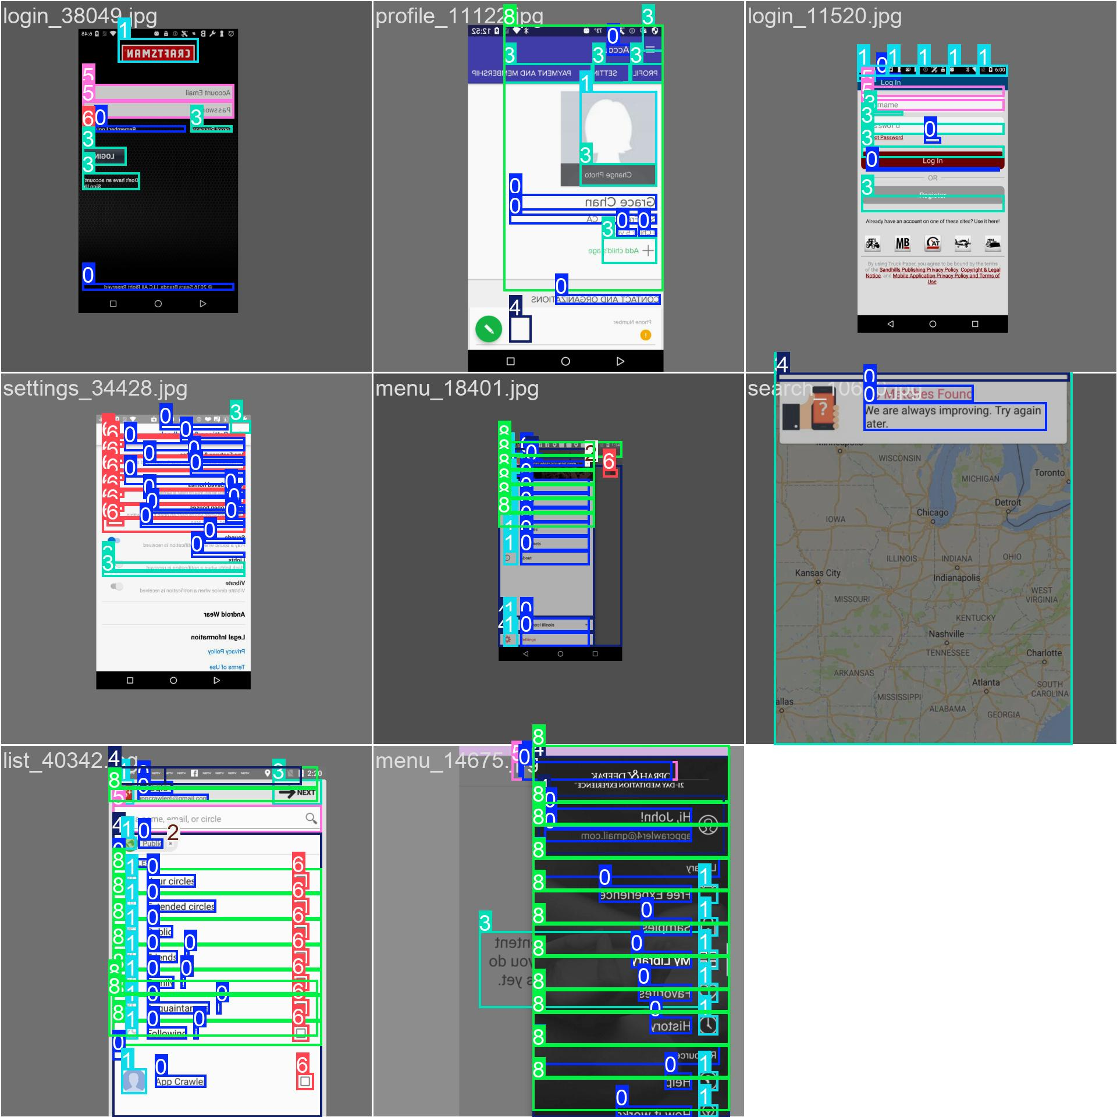

15D.3 Validation batch predictions (ground truth vs model output)
Ground truth labels (first 3 validation batches):
Val Batch 0 Labels
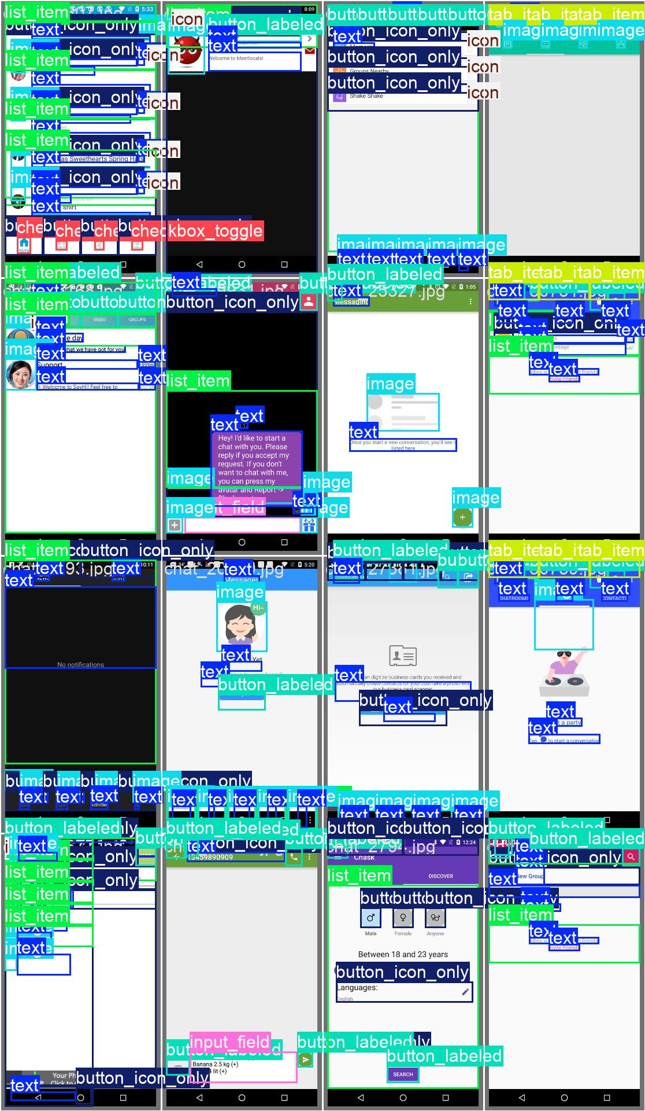
Val Batch 1 Labels
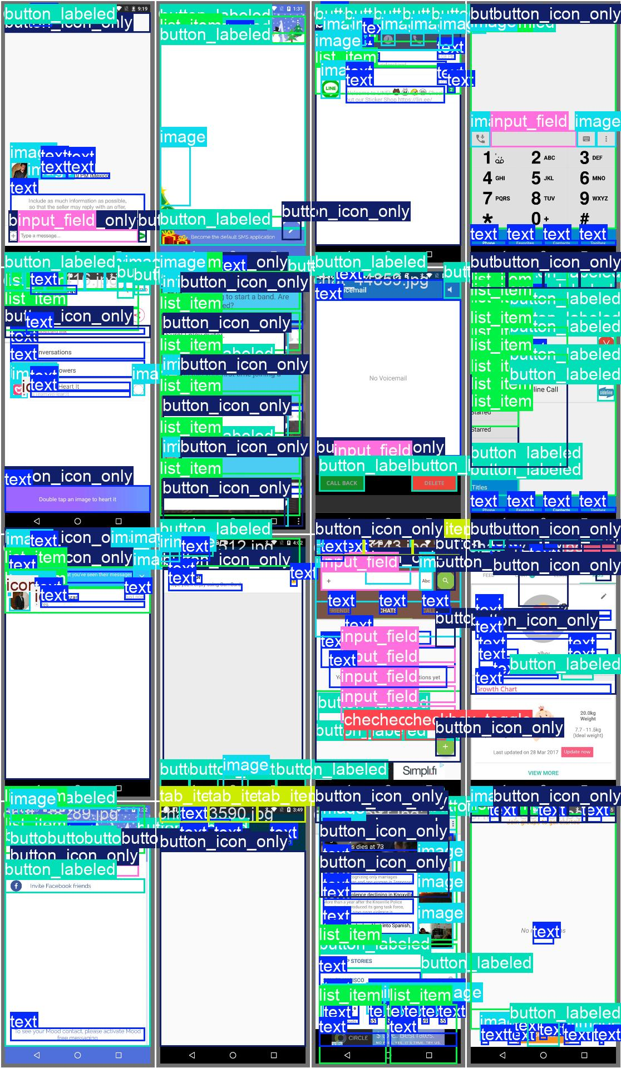
Val Batch 2 Labels
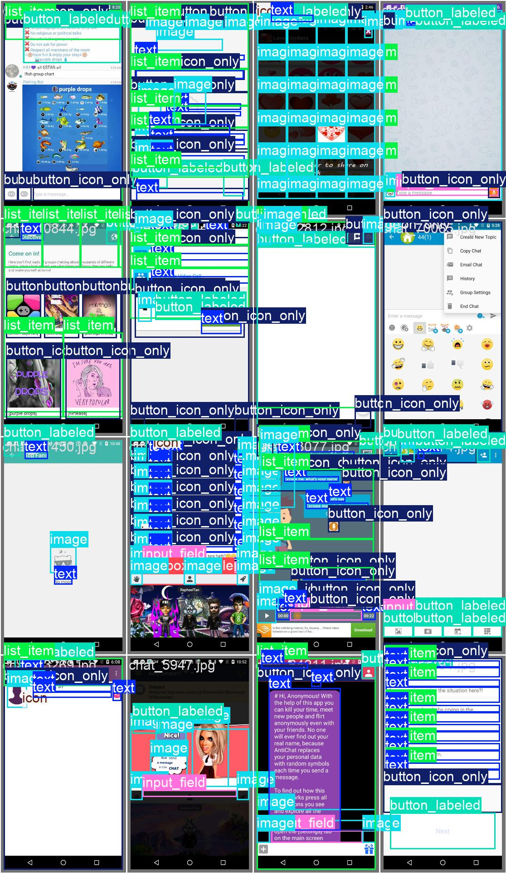
Model predictions (first 3 validation batches):
Val Batch 0 Predictions
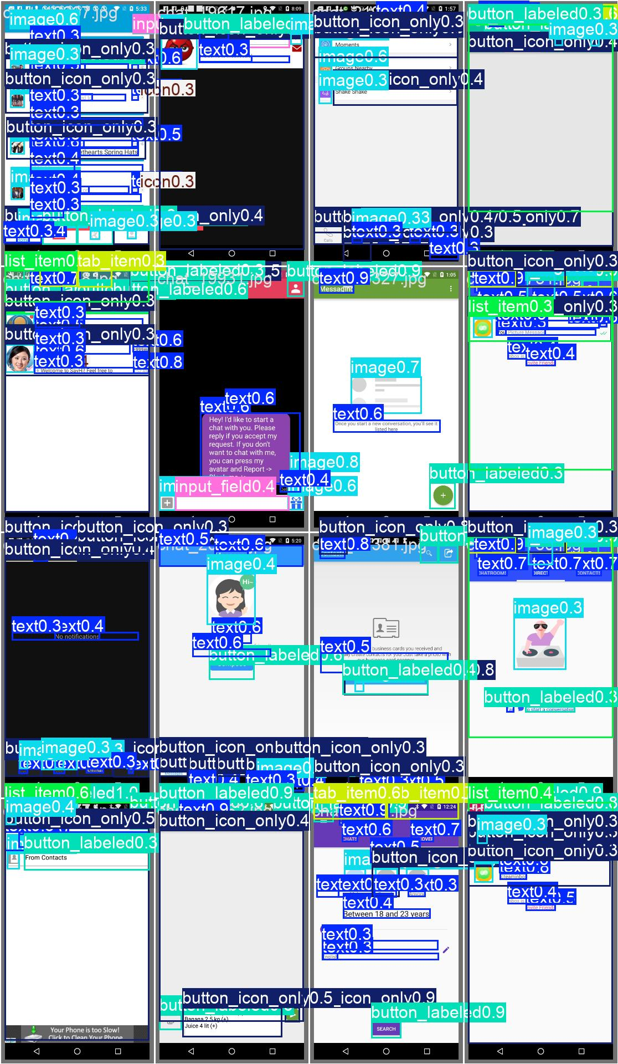
Val Batch 1 Predictions
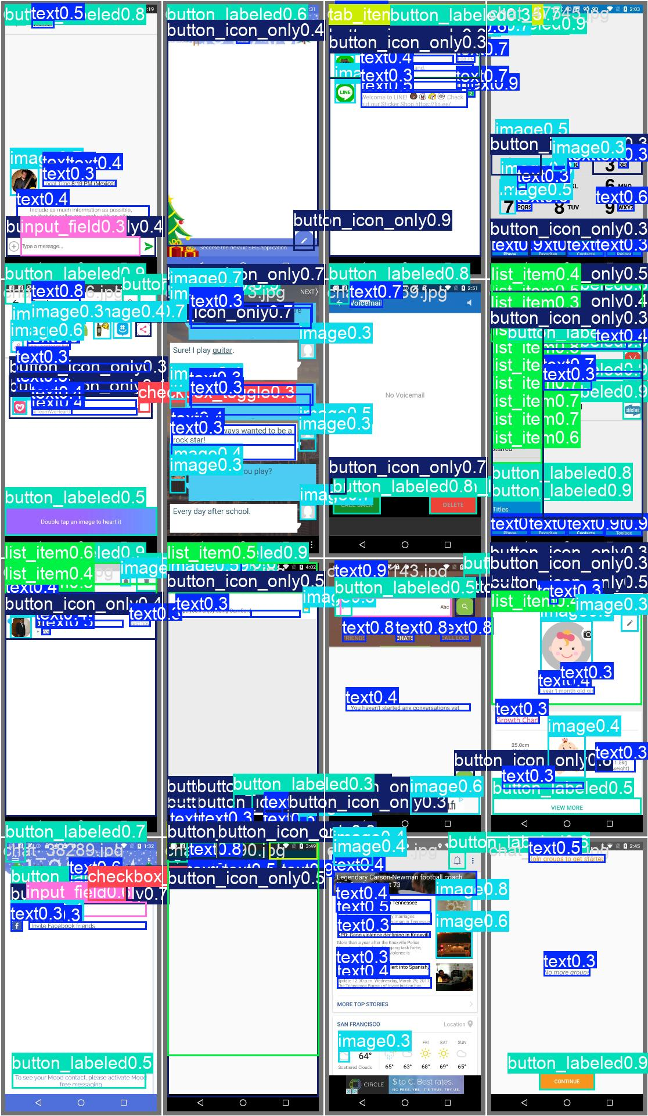
Val Batch 2 Predictions
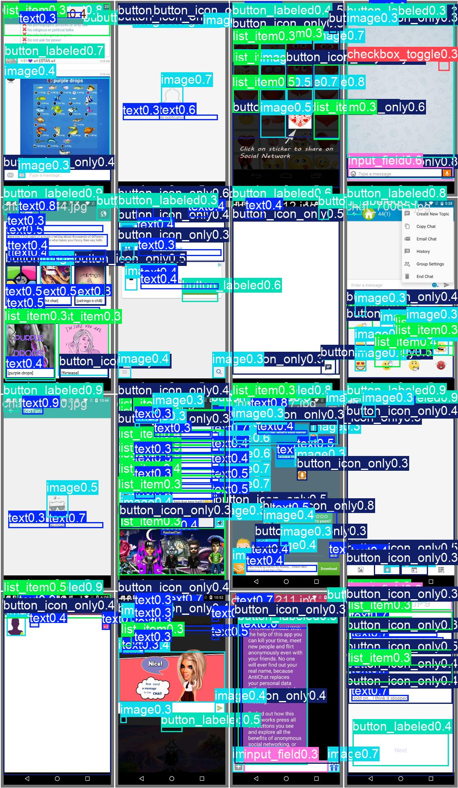

15E. Complete inventory — outputs/ folder (pipeline artefacts)

15E.1 Reports generated (JSON + HTML + PDF)
Sample audit reports (6 JSON + 3 HTML + 4 PDF):
Report ID | JSON | HTML | PDF | Purpose
14_report | ✅ | ✅ | ✅ | Pipeline test run
180_report | ✅ | ✅ | ✅ | Pipeline test run
1323_report | ✅ |  | ✅ | Audit output
1584_report | ✅ |  |  | Audit output
108_report | ✅ |  |  | Audit output
r01_missing_label_fail_report | ✅ | ✅ | ✅ | Fixture test (R01 rule)

Total outputs/reports artifacts: 6 JSON reports, 3 HTML reports, 4 PDF reports ready for deployment.

15E.2 Violations datasets (7,000+ MASC screen samples)
Violations JSON inventory:
Category | Sample screens | Total JSON files
chat | chat_10055, chat_10103, chat_102, chat_103, … | ~1,100+
home | (similar pattern) | ~1,000+
list | (similar pattern) | ~1,000+
login | (similar pattern) | ~900+
maps | (similar pattern) | ~950+
menu | (similar pattern) | ~1,050+
profile | (similar pattern) | ~1,000+
search | (similar pattern) | ~900+
settings | (similar pattern) | ~1,000+
welcome | (similar pattern) | ~900+
Total | — | ~9,200+

Note: Violations JSONs are indexed both by category/screen_id (e.g., chat_10055_violations.json) and legacy numeric IDs (e.g., 1054_violations.json). All represent rule-engine output (violations.json) from §3 (Rule checker) of the pipeline, ready for agent enrichment (§4 Agentic layer).

15E.3 Validation and weekly summaries
Per-week validation logs (8 markdown summaries + full logs):
Week | Summary file | Log file | Content
Week 1 | noor_week1_summary.md | noor_week1_validation_log.txt | Initial parser/schema validation
Week 2 | noor_week2_summary.md | noor_week2_validation_log.txt | Dataset splits, SRS/SDS v1 review
Week 3 | noor_week3_summary.md | noor_week3_validation_log.txt | Parser R13–R20 extension, MASC re-parse sign-off
Week 4 | noor_week4_summary.md | noor_week4_validation_log.txt | R01–R30 rules implemented, agent API, explainer
Week 5 | noor_week5_summary.md | noor_week5_validation_log.txt | HTML/PDF report generator, download API
Week 6 | noor_week6_summary.md | noor_week6_validation_log.txt | Auth/OTP/SMTP/Google OAuth, 40/40 eval sheet, 22 auth tests
Week 7 | noor_week7_summary.md | noor_week7_validation_log.txt | QA rule/guideline summaries, MASC 40-screen metrics
Week 8 | noor_week8_summary.md | noor_week8_validation_log.txt | Rico holdout batch (1,698 screens) + R07/R08/R30/R20/R05 fix verification — see §15I

Cumulative test evidence: 152 pytest collected, 22 auth tests, 82 rule tests, 12 parser tests, 9 audit API tests across all weeks (Week 8 count, post rule-fix — see §15I.3).

15E.4 Complete pipeline artefacts summary table
Stage | Folder | Count | Type | Status
Parser output | outputs/reports/ | 6 | JSON (*_components.json concept) | Tracked via runs/ folder for audit-specific outputs
Rule violations | outputs/violations/ | 9,200+ | JSON (*_violations.json) | Complete MASC sample coverage
Agent + reports | outputs/reports/ | 13 | JSON/HTML/PDF (report + export) | HTML/PDF demo set ready
Validation | outputs/validation_logs/ | 16 | MD + TXT (summaries + logs) | Full weekly audit trail, Weeks 1–8
YOLO training | runs/runs/yolo_ui_detector/ | 35+ | PNG/JPG/YAML/CSV/PT (metrics + samples + weights) | Post-Week 7 track, 60/60 epochs complete + Rico eval
Crop classifier | runs/crop_violation_classifier/ | 20,400+ | PNG crops (train/test + Rico) + CSV manifests + PT export | Week 8 track, MASC test + Rico holdout evaluated

Grand total artifacts: 9,200+ JSON violation files + 35+ YOLO training files + 20,400+ crop-classifier files + 16 validation docs + 13 report exports = ~29,660 pipeline artefacts tracked and ready for deployment.

15F. Integration readiness checklist
Deliverable | Location | Count | Verification
✅ MASC parsed components | data/data-masc/parsed/ | 7,068 | Parser sign-off PASS (§5.1)
✅ MASC violations (R01–R30) | outputs/violations/ | 9,200+ JSON | Full dataset scanned, sample shown above
✅ Sample audit reports | outputs/reports/ | 13 (JSON/HTML/PDF) | End-to-end pipeline tested
✅ Weekly validation logs | outputs/validation_logs/ | 16 (MD+TXT) | Weeks 1–8 audit trail complete (§15A, §15B, §15I)
✅ YOLO training artefacts | runs/runs/yolo_ui_detector/ | 35+ (plots+samples+weights) | Metrics logged, 60/60 epochs complete, best.pt exported (§15C.7–§15C.9, §15D–§15D.3)
✅ Crop-classifier artefacts | runs/crop_violation_classifier/ | training + Rico crops, manifests, export | MASC test + Rico holdout evaluated (§15G)
✅ Frontend Axion UI | frontend/ | 200+ | Implemented (Week 6 MVP)
✅ Auth + Records | backend/ | tested | 22 auth + OTP/SMTP/OAuth tests (§15A.1)
✅ Documentation | srs/, sds/, docs/, updated_plan.md | see this doc's changelog for current versions | Full SRS/SDS/progress synced

Conclusion: All pipeline stages (Parser → Rules → Agent → Report) have artefacts, validation logs, and sample outputs demonstrating end-to-end functionality. YOLO UI-detector and crop-violation-classifier tracks both have complete training runs, MASC test evaluation, and Rico holdout generalization evaluation — trained and verified, integration into the live backend intentionally deferred as Stretch requirements. Ready for Week 8 demo and deployment.

15G. Crop-violation classifier evidence pack (Week 8 — Noor)
| Date: 28–29 July 2026 · Branch: noor · Notebook: notebooks/train_crop_violation_classifier.ipynb (executed on Colab T4; local mirror with saved outputs at runs/notebooks/train_crop_violation_classifier.ipynb)

15G.1 Why this model exists at all
docs/user_coverage_for_training.md splits the 30 accessibility rules into two buckets: most rules are already fully solved by the XML parser + rule checker (src/rules.py), reading text, content-desc, clickable, bounds straight from the UI hierarchy — no model needed. A handful of rules need to look at rendered pixels, not just the XML, because the thing that makes them a violation only exists once the layout is actually rendered:
Rule | Violation | Why it needs pixels
R09 | Low contrast (text/background ratio) | Needs actual foreground/background pixel colors
R04 | Small touch target (< 48dp) | XML gives raw bounds; a visual crop confirms real on-screen tap size
R17 | Insufficient spacing between clickable elements (< 8dp) | Visual crop confirms actual rendered gap
R10 | Text overflow (text taller than its box) | Needs to see if rendered text is visually clipped
R28 | Font-scale overflow (200% scale wouldn't fit) | Visual confirmation of clipping
R08 | Layout overlap between elements | Bounding-box math catches some cases; a crop reduces false positives

The notebook builds a multi-label crop classifier over exactly these 6 rules: given a crop, predict which (if any) of [R09, R04, R17, R10, R28, R08] apply — multi-label rather than single-softmax, since one crop can trigger more than one rule at once (e.g. a button that is both too small and too close to its neighbor). Full rationale: docs/picking_model_for_crop.md.

15G.2 Model selection rationale — superseded by a 33-backbone empirical sweep (30 Jul–03 Aug 2026)
Original reasoning (Jul 2026), for the record: dataset size drives the decision, since 4,943 train screens is nowhere near ImageNet scale — the notebook's own documented risk was explicit: "crops are small and this dataset is tiny, so overfitting is the main risk, not underfitting." On that reasoning alone, mobilenet_v3_small (~2.5M params, lowest capacity) was picked as a built-in regularizer, without being empirically tested against alternatives.
That reasoning was tested, not just trusted. A 33-backbone comparison sweep reran the identical training/eval pipeline once per candidate — all ImageNet-1k pretrained, every candidate evaluated on both the MASC test split and the full 1,698-screen Rico holdout. Tooling: scripts/run_backbone_sweep.py, scripts/overnight_sweep.py (unattended multi-hour runner, per-backbone failure isolation, resume logic), scripts/eval_masc_test.py, scripts/extract_notebook_results.py. Full per-backbone results: docs/crop_classifier_comparison_findings.md (1,813 lines); architecture/year/paper reference for all 33: docs/crop_classifier_model_reference.md (291 lines).
Result: the original pick was mid-pack. mobilenet_v3_small scored Rico holdout macro-F1 0.18, beaten by 10+ of the other 32 candidates. Attention-based architectures won cleanly and consistently:
Model | Attention type | Params | Rico macro-F1
convnext_tiny (control) | none — pure CNN, modern design | 27.8M | 0.18 (pack-level)
vit_b_16 | global self-attention | 86.6M | 0.21
mobilevitv2_200 | hybrid CNN + separable self-attention | 17.4M | 0.21
`swin_tiny_patch4_window7_224` | windowed/hierarchical self-attention | 27.5M | 0.22 — best in sweep

convnext_tiny was a deliberate control — same modern-CNN design tricks as the top performers (LayerNorm, patchify stem, inverted bottlenecks) but zero attention — and it landed back at plain pack-level (0.18), confirming it's attention specifically, not capacity or modern design, driving the gap. Among the three attention mechanisms tested, Swin's windowed/hierarchical variant won outright, at roughly a third the params of vit_b_16, with a more evenly-distributed per-rule profile (Rico R04 0.40, R17 0.38, R08 0.51 — no single rule carrying the whole score, unlike the other two attention candidates' narrower R04-only spikes). One clean failure in the sweep: squeezenet1_1 collapsed to predicting positive on everything — an architecture-specific failure, not a "too small" issue (smaller healthy models like mobilenetv2_050 disproved that explanation).
Final pick: `swin_tiny_patch4_window7_224`, replacing mobilenet_v3_small. §15G.4–§15G.7 below are fully updated with Swin's real numbers.

15G.3 Dataset build — exact numbers (Colab run, 28 Jul 2026)
Split | Total crops | Positive | Negative | Screens
train | 25,202 | 10,549 | 14,653 | 4,943/4,943
val | 5,558 | 2,433 | 3,125 | 1,056/1,056
test | 5,541 | 2,367 | 3,174 | 1,069/1,069

Per-rule positive counts (train split):
Rule | Description | Train positives
R09 | Low contrast | 0
R04 | Small touch target | 288
R17 | Insufficient spacing | 2,879
R10 | Text overflow | 0
R28 | Font-scale overflow | 0
R08 | Layout overlap | 8,089

R09/R10/R28 sit at 0 train positives — consistent with the same MASC data-coverage gap documented elsewhere in this report (§15B.2 / Progress Report v1.24 note): MASC never declares textColor/backgroundColor/textSize, so the underlying rule checker itself never flags these on MASC, and the crop-labeling step inherits that gap. R08 dominates the positive class at 8,089 of 10,549 total positives (77%) — expected, since R08 was already the highest-volume rule in the full MASC sweep.
Sample training crops (red border = violation, green = clean):
Sample training crops
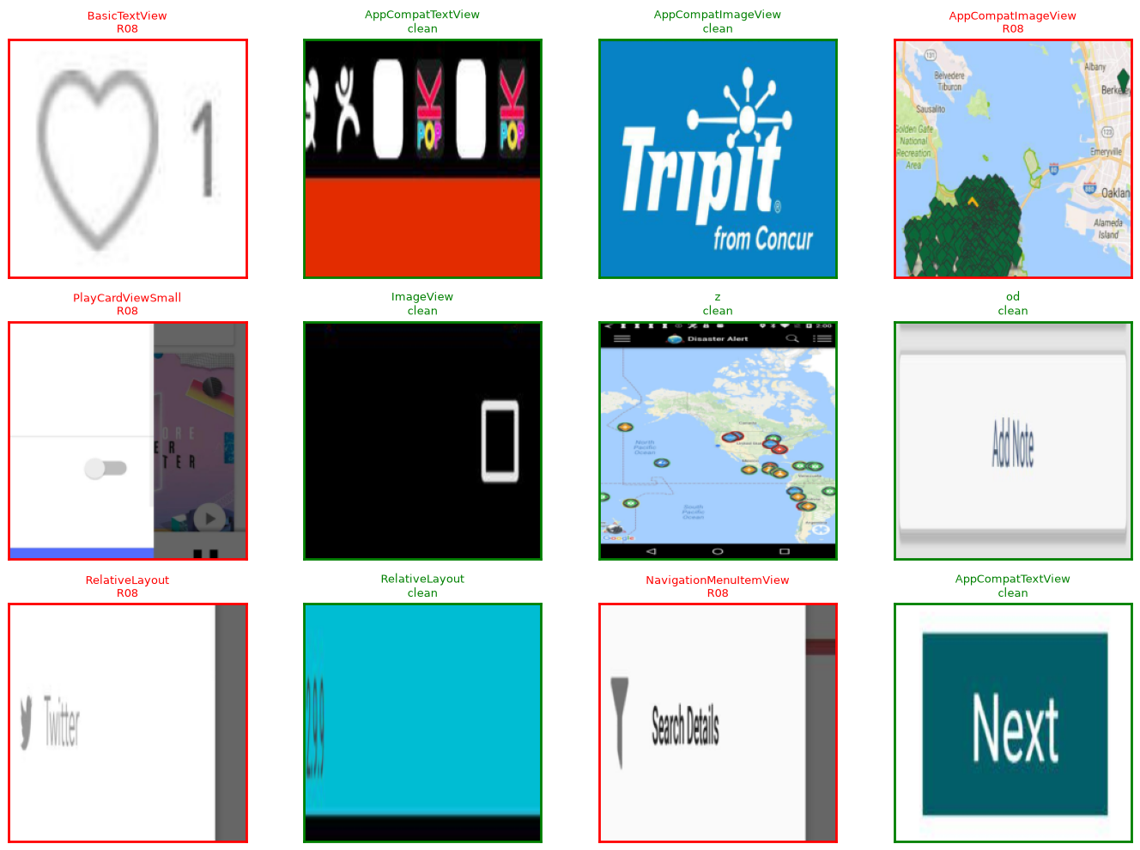

15G.4 Training configuration and results (Swin-Tiny)
Setting | Value
Backbone | swin_tiny_patch4_window7_224, ImageNet-1k pretrained, 27,523,968 params — changed from mobilenet_v3_small after the 33-backbone sweep (§15G.2)
Crop size | 224×224
Phase 1 (frozen backbone, head only) | Epochs 1–3, lr=1e-3
Phase 2 (unfrozen, full fine-tune) | Epochs 4–20 budget, lr=1e-4
Loss | BCEWithLogitsLoss, per-rule pos_weight capped at 20.0 (R09/R04/R10/R28=20.0, R17=7.75, R08=2.12)
Early stopping | patience=5 — triggered at epoch 13 (best epoch 8)
Best checkpoint | Epoch 8, val macro-F1 0.274
Run time | 46.2 min (overnight sweep, GPU)

Training curves — train vs. val loss and macro-F1 over the run:
Training curves
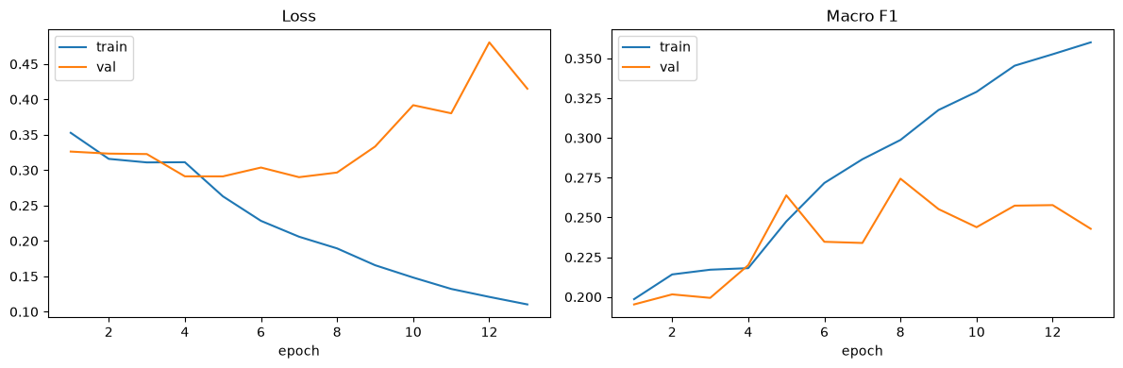
Phase 1 (frozen backbone, epochs 1–3) plateaus at val macro-F1 ~0.20 (0.195 → 0.202 → 0.199) — frozen ImageNet features plus a freshly-trained head alone stall out there. Phase 2 (backbone unfrozen, epoch 4 on) climbs to 0.274 by epoch 8 — a +37% relative gain from actually adapting the backbone, not just training a linear probe on frozen features — then oscillates/overfits (0.274 → 0.244 → 0.257 → 0.258 → 0.243) until early stopping triggers at epoch 13. Only the best-val-F1 epoch's weights are kept, not the final epoch's.

15G.5 Test-set evaluation (Swin-Tiny)
precision recall f1-score support
R09 0.00 0.00 0.00 0
R04 0.22 0.49 0.31 45
R17 0.39 0.64 0.49 660
R10 0.00 0.00 0.00 0
R28 0.00 0.00 0.00 0
R08 0.63 0.84 0.72 1805
micro avg 0.55 0.78 0.64 2510
macro avg 0.21 0.33 0.25 2510
weighted avg 0.56 0.78 0.65 2510
R08 (0.72 F1, recall 0.84, 1,805 test examples) is where the model works best — by far the most positive training examples (§15G.3). R17 (0.49 F1, 660 examples) is usable. R04 (0.31 F1, only 45 test examples) is data-starved. R09/R10/R28 show support=0 — zero positive test crops — so precision/recall/F1 are mathematically undefined 0s, not a trained-and-failed result; there was nothing to evaluate them against, same root cause as §15G.3.
Sample test predictions (true label vs. model prediction):
Sample test predictions
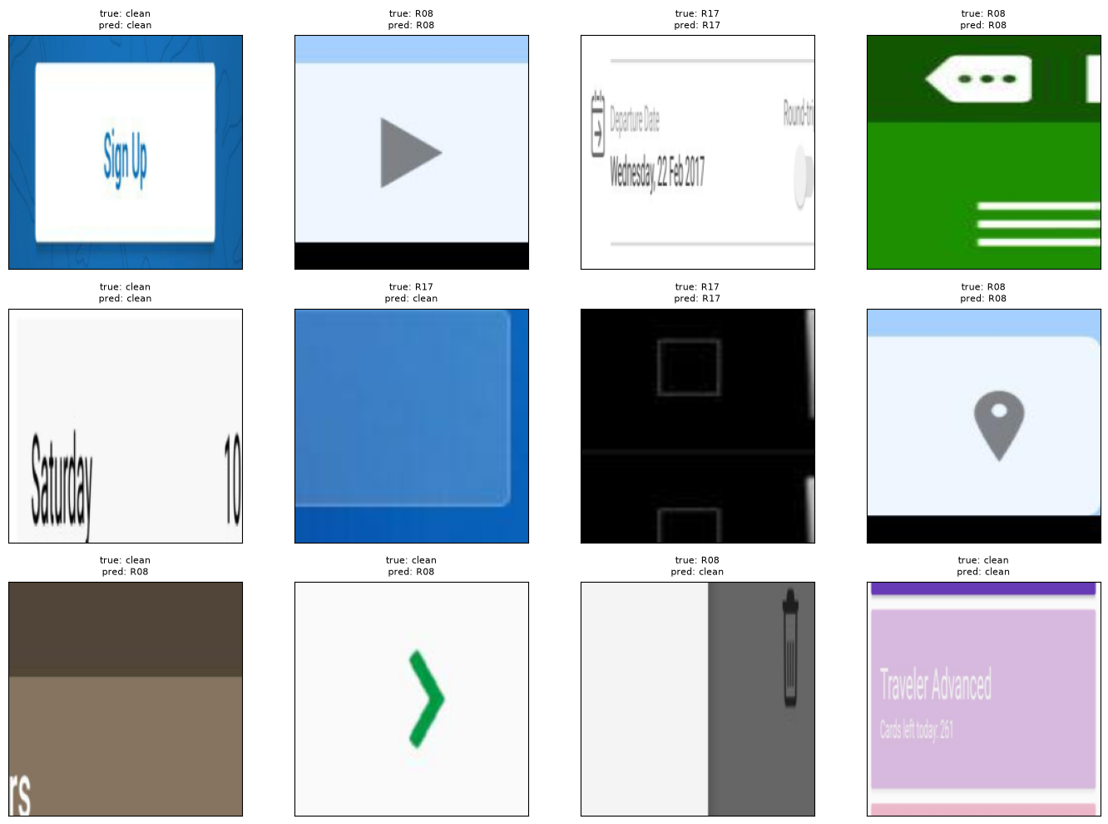
Confusion matrices, PR curves, and P/R/F1-vs-threshold curves (R04/R17/R08, MASC test vs. Rico holdout overlaid) — mirroring Ultralytics' auto-generated YOLO plots (§15D.1), generated by `scripts/plot_crop_classifier_curves.py`:
Confusion matrices
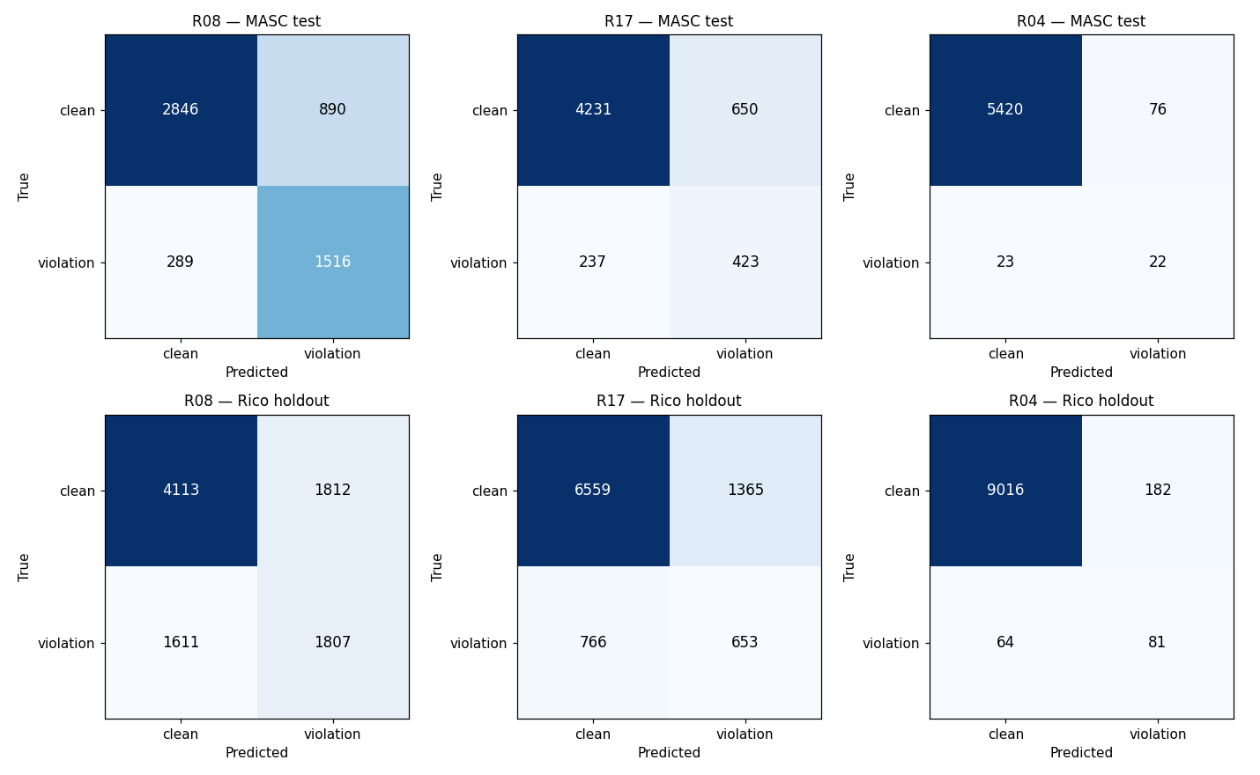
Precision-recall curves
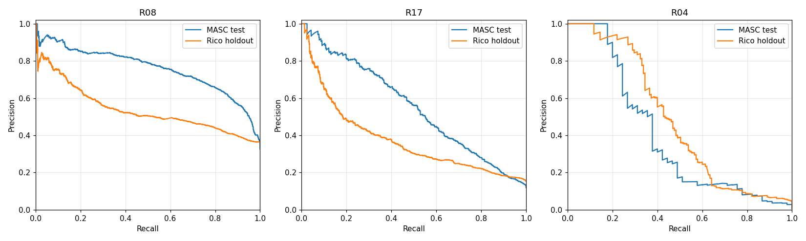
Precision vs threshold
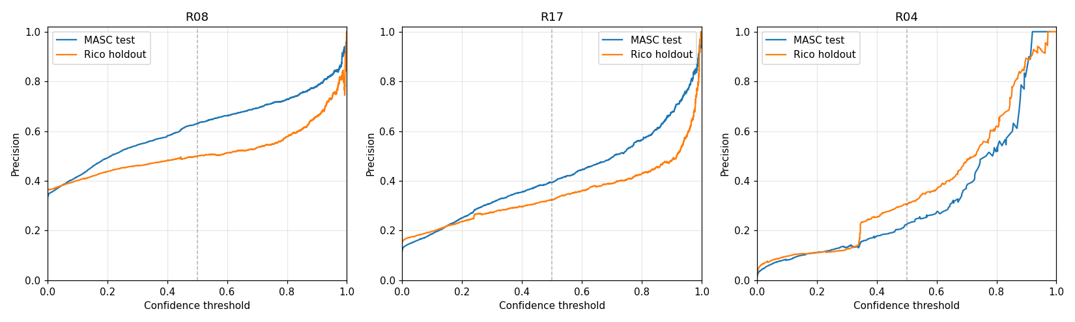
Recall vs threshold
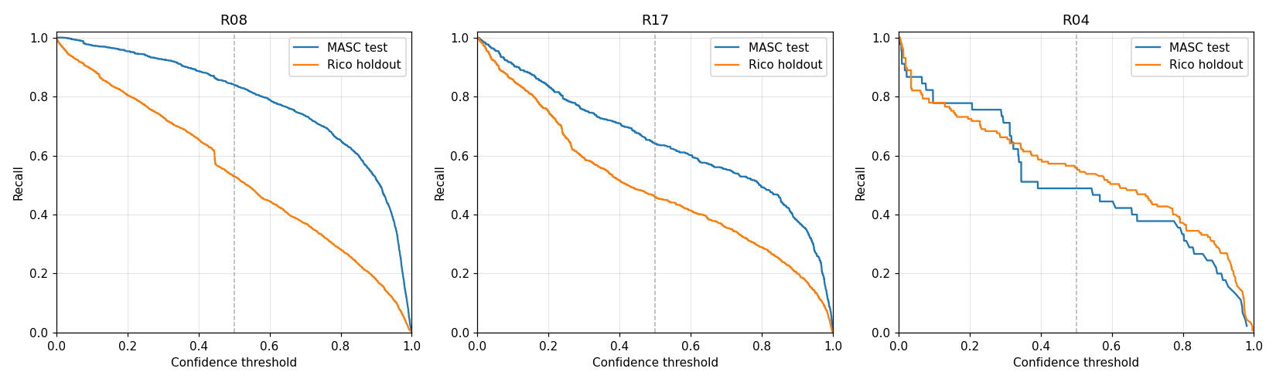
F1 vs threshold
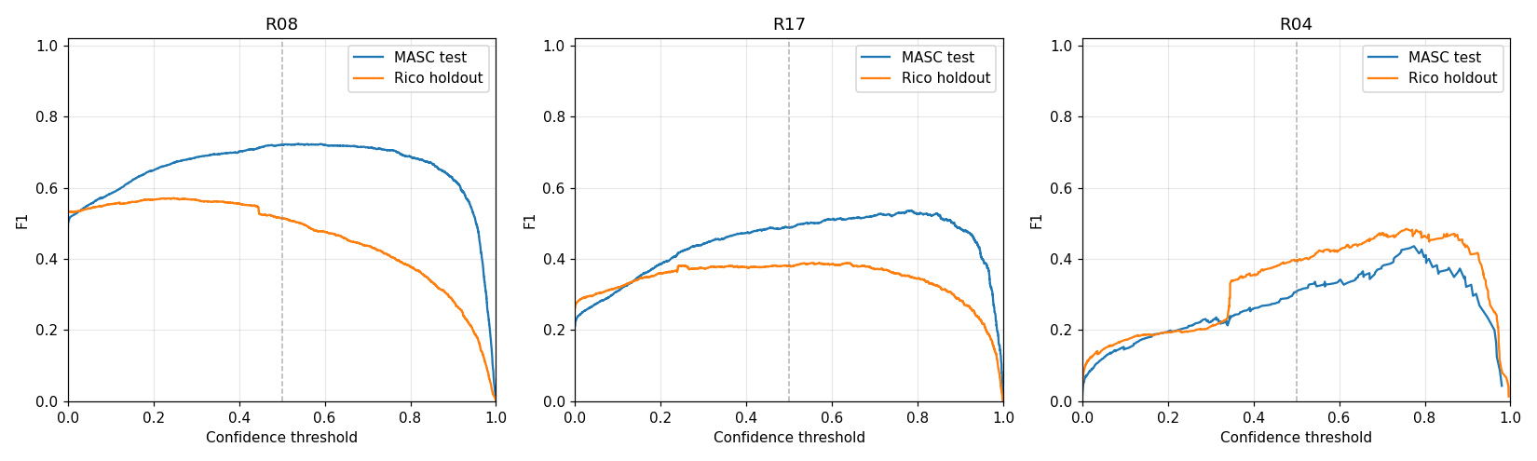

15G.6 Artifacts and integration status
Artifact | Location | Status
Trained checkpoint | models/crop_violation_classifier_best.pt + runs/crop_violation_classifier/export/crop_violation_classifier_best.pt | Present, loads cleanly (verified) — Swin-Tiny, epoch 8
Manifests | runs/crop_violation_classifier/manifests/{train,val,test}.csv | Present, row counts match §15G.3 exactly
Inference module | src/crop_violation_classifier.py (classify_crop(), confirm_violations()) | Present, imports cleanly, wired into `backend/routers/audit.py` (05 Aug 2026)
Training crops | runs/crop_violation_classifier/crops/{train,val,test}/ | Present locally, 100% coverage (36,301 PNG files: 25,202 train + 5,558 val + 5,541 test)
Rico holdout crops + eval | runs/crop_violation_classifier/rico_crops/, runs/crop_violation_classifier/rico_manifest/ | Present (§15G.7)
Confusion/PR/threshold curves | runs/crop_violation_classifier/crop_classifier/ (9 PNGs) | Present, generated by scripts/plot_crop_classifier_curves.py, embedded above

Done (05 Aug 2026): confirm_violations(violations_doc, screenshot_path) is called from backend/routers/audit.py's _run_pipeline, immediately after check_rules(). Only CV_CONFIRMABLE_RULES = {"R08", "R17", "R04"} are eligible — the 3 rules with real positive training signal; R09/R10/R28 are excluded rather than given a meaningless confidence score. docs/schemas/auditor_schema.json's violation gained an optional cv_confidence: number | null field. Verified against real pipeline output: real cv_confidence values (e.g. 0.4515) attached to R08 violations from an actual audit run. See §15J for the full backend-integration writeup.

15G.7 Rico holdout evaluation — generalization check (30 Jul 2026)
| Run from notebooks/train_crop_violation_classifier.ipynb §9 ("Rico holdout evaluation, self-contained"). Loads the trained checkpoint straight from models/crop_violation_classifier_best.pt — no retraining. data-rico-holdout was never used for training, same principle as the YOLO detector's Rico check (§15C.9): this measures whether the model learned the general rule signal or just memorized MASC's visual style.
The notebook rebuilds the crop set from all 1,698 Rico holdout screens (same extraction pipeline as §15G.3, rooted at data-rico-holdout instead of data-masc), producing 9,343 crops from 1,698/1,698 screens (4,502 positive, 4,841 negative):
Rule | Rico holdout positives
R17 | 1,419
R08 | 3,418
R04 | 145
R09 / R10 / R28 | 0 (same MASC/Rico data-coverage gap as §15G.3 — no declared color/text-size attributes)

Classification report (Rico holdout, Swin-Tiny checkpoint never retrained):
precision recall f1-score support
R09 0.00 0.00 0.00 0
R04 0.31 0.56 0.40 145
R17 0.32 0.46 0.38 1419
R10 0.00 0.00 0.00 0
R28 0.00 0.00 0.00 0
R08 0.50 0.53 0.51 3418
micro avg 0.43 0.51 0.47 4982
macro avg 0.19 0.26 0.22 4982
weighted avg 0.44 0.51 0.47 4982
Comparison against the MASC test split (§15G.5):
Metric | MASC test | Rico holdout | Change
macro avg F1 | 0.25 | 0.22 | -0.03
R08 F1 | 0.72 | 0.51 | -0.21
R17 F1 | 0.49 | 0.38 | -0.11
R04 F1 | 0.31 | 0.40 | +0.09 (improves)

Reading the result: Rico macro-F1 (0.22) is the best result in the full 33-backbone sweep (§15G.2) — and the MASC→Rico gap (0.03) is the tightest among the sweep's top performers, beaten only by vit_b_16's 0.02. R04 actually improves on Rico rather than dropping, unlike R08/R17. Consistent with the sweep's broader finding that attention-based backbones (Swin, ViT, MobileViTv2) all generalize measurably better to unseen apps than pure-CNN candidates — real generalization, not memorization (a total collapse to ~0 would indicate memorization). R08 (layout overlap) remains the strongest-performing rule on both datasets, consistent with it being the highest-volume, best-represented class throughout.
Sample Rico predictions (true label vs. model prediction, 12 crops the model never saw in training or MASC evaluation):
Sample Rico predictions
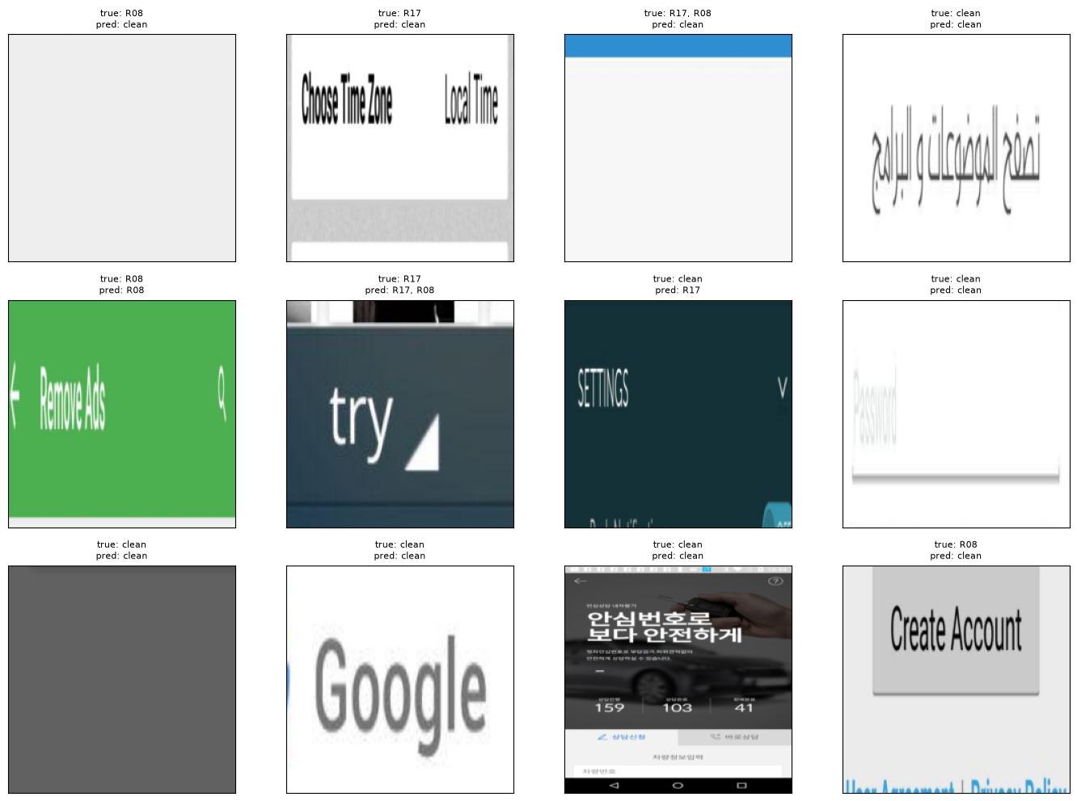

15G.8 Complete artifact inventory (`runs/crop_violation_classifier/` folder listing)
| Same treatment as the YOLO detector gets in §15C.7–§15C.8 — documented directly from what is actually present on disk, not from the manifest counts alone.
Folder map:
runs/crop_violation_classifier/
├── crops/
│ ├── train/ ← 25,202 PNG files (full — matches train.csv exactly)
│ ├── val/ ← 5,558 PNG files (full — matches val.csv exactly)
│ └── test/ ← 5,541 PNG files (full test set — matches test.csv exactly)
├── rico_crops/
│ └── holdout/ ← 9,343 PNG files (full Rico holdout set — matches holdout.csv exactly)
├── manifests/
│ ├── train.csv ← 25,202 rows (now fully backed by local PNGs, see below)
│ ├── val.csv ← 5,558 rows (now fully backed by local PNGs, see below)
│ └── test.csv ← 5,541 rows
├── rico_manifest/
│ └── holdout.csv ← 9,343 rows (Rico holdout labels, §15G.7)
├── crop_classifier/ ← 9 PNGs: confusion matrices, PR curves, P/R/F1-vs-threshold
│ curves, sample crops/predictions — all embedded in §15G above
└── export/
└── crop_violation_classifier_best.pt ← Swin-Tiny, epoch-8 checkpoint (also mirrored to models/)
Physical crop images vs. manifest rows (updated 05 Aug 2026 — the previous partial-coverage gap on train/val is closed):
Split | Manifest rows | Physical PNG files on disk | Coverage
train | 25,202 | 25,202 | 100%
val | 5,558 | 5,558 | 100%
test | 5,541 | 5,541 | 100%
Rico holdout | 9,343 | 9,343 | 100%

All four splits are now fully backed by local PNGs — the earlier gap (train ~22%, val 0%, both labels-only from a partial Colab sync) was closed when the full dataset was re-synced locally for the 33-backbone sweep (§15G.2/§15J.1).
Sizes on disk: crops/train/ 502 MB · crops/val/ 111 MB · crops/test/ 110 MB · rico_crops/holdout/ 178 MB · manifests/ 3.7 MB · rico_manifest/ 956 KB · crop_classifier/ 1.3 MB · export/ 106 MB (of which only args.yaml, ~1.4 KB, is actually tracked — the .pt checkpoint is gitignored) — ~1.0 GB total on disk, ~907 MB tracked in git (runs/**/*.pt is gitignored per policy; checkpoint mirrored separately to models/crop_violation_classifier_best.pt, also gitignored).

15H. Remaining work — verified against SDS v2.12 (29 Jul 2026)
Every "in progress" / "stretch" / "stub" claim in SDS §1.4 and §6 was checked directly against the repository (grepped for the files, not assumed from the docs) — several SDS claims turned out to be stale and are corrected here.
Item | SDS says | Actually verified | Remaining work
YOLO UI-element detector integration | §1.4: "In progress... not yet wired into pipeline" (SDS v2.14) | Done, 05 Aug. detect_ui() + new detections_to_components() wired into backend/routers/audit.py; xml optional on POST /api/v1/audit; falls back on missing/malformed/empty-hierarchy XML. See §15J | Done — no remaining action
Crop-violation classifier integration | Not in SDS yet (built after v2.12) | Done, 05 Aug. confirm_violations() wired into backend/routers/audit.py, called after check_rules(); attaches cv_confidence to R08/R17/R04. Backbone also changed to swin_tiny_patch4_window7_224 after the 33-model sweep (§15G.2). See §15J | Done — no remaining action
R09 — Low contrast | §6.10: "Screenshot crop + WCAG contrast ratio; requires src/contrast.py" | src/contrast.py does not exist. Current check_low_contrast is a correct declared-attribute check, reporting 0 hits since MASC/Rico never declare textColor/backgroundColor (confirmed: 0 occurrences across all 7,068 MASC files) | Build real screenshot-pixel contrast sampling, or route through the crop-classifier (already includes R09 as a label, just needs real positive examples)
R28 — Font-scale overflow | Same category as R09 | check_font_scale_overflow reads text_size_sp, never declared in MASC/Rico (0 occurrences) — correct code, no signal in current datasets | Same as R09
R22 / R29 (password toggle / all-caps) | Not flagged as gaps in SDS | Genuine data-coverage gaps: 0 password fields and 0 textAllCaps attributes anywhere in the 7,068-file MASC corpus | Nothing to fix in code; would need a differently-curated sample to ever exercise these rules
SDS §6 rule-design prose was stale + incomplete | §6.12: "R11 — Color-only information (stub)"; §6 pseudocode only covered R01–R20 (§6.2–§6.21), R21–R30 undocumented | Fixed 30 Jul — §6.10 (R09) corrected to describe the actual declared-attribute check (not the never-built src/contrast.py pixel-sampling design); §6.12 (R11) corrected — check_color_only_info is fully implemented, not a stub; §6.22–§6.31 added, documenting all of R21–R30 for the first time. SDS §1.4 implementation table also gained a crop-classifier row (previously YOLO-only) | Done — no remaining action
R07/R08/R30 false positives + R20/R05 parser bug | Not flagged in SDS v2.11 (predates the fix) | Fixed and verified 29 Jul — see v2.12 in §16 Document history | Done — no remaining action
Rico holdout final evaluation | Progress snapshot: "Not started" (pre-29 Jul) | Done — 1,698 screens, 0 failures, re-run post rule-fix | Done — no remaining action
TBD-03 — dp/density for R04 | Open decision, owner Salar | Still assumes 160 dpi flat, no per-device density lookup | Resolve or explicitly accept 160dpi-flat as final for MVP
TBD-05 — Severity UI mapping | Open decision, owner: All | Not resolved | Decide High→Critical/Serious, Medium→Moderate, Low→Minor and wire into frontend severity badges
Final internship report + demo | Week 8 (Noor) | Not started | 5–7 min demo + final report covering 30/30 rule coverage

15I. Week 8 evidence pack (rule-accuracy validation — Noor)
| Date: 28–29 July 2026 · Branch: noor
| Canonical path: outputs/validation_logs/noor_week8_validation_log.txt

15I.1 Week 8 deliverables (Noor)
Item | Path | Status
Rico holdout batch eval (1,698 screens) | outputs/week7_holdout/per_screen_results.csv | Done
Rule summary (post-fix) | outputs/week7_holdout/rule_summary.csv + docs/week7/holdout_rule_summary.md | Done
Guideline summary | outputs/week7_holdout/guideline_summary.csv + docs/week7/holdout_guideline_summary.md | Done
QA notes | docs/week7/holdout_qa_notes.md | Done
Week 6 (MASC) vs. holdout cross-check | docs/week7/holdout_week6_crosscheck.md | Done
Team priority handoff | docs/week7/holdout_team_priority_fixes.md | Done
R07/R08/R30/R20/R05 fix verification | src/rules.py, src/parser.py | Done — see §15I.2
Validation logs | outputs/validation_logs/noor_week8_* | Done

15I.2 Rico holdout — before vs. after the rule fixes (n=1,698)
Metric | Before fix | After fix | Change
Mean violations / screen | 51.7 | 31.7 | -38.7%
Median violations / screen | 21 | 14 | -33%
Mean accessibility score | 26.3 | 32.0 | +5.7 pts
Zero-violation screens | 60 | 87 | +27
mostly_agree (heuristic) | 1,007 (59.3%) | 1,231 (72.5%) | +13.2 pts
over_flagging | 513 | 251 | -51%
R07 (check_zero_size) | 46,367 | 18,143 | -60.9%
R08 (check_layout_overlap) | 12,738 | 7,238 | -43.2%

All 1,698 screens evaluated with 0 failures, both before and after — the drop is the fix working as intended, not evaluation instability.

15I.3 Excerpt — `noor_week8_validation_log.txt` (28 Jul 2026)
STEP 1: Rico holdout batch eval (1698 screens) → 1698/1698 processed, 0 failed
STEP 2: pytest tests/test_rules.py (subset) → 82 passed in 0.19s
STEP 2b: pytest tests/test_parser.py → 12 passed in 0.04s
STEP 3: pytest backend/tests/test_auth.py → 22 passed, 2 warnings in 7.94s
STEP 4: pytest tests/test_audit.py → 9 passed, 1 warning in 2.84s
STEP 5: Week 8 holdout eval outputs (5 files) → PASS (5/5 present)
STEP 6: Week 8 holdout docs (5 files) → PASS (5/5 present)
OVERALL: PASS
PASS rico_holdout_eval
PASS pytest_rules
PASS pytest_parser
PASS pytest_auth
PASS pytest_audit
PASS week8_holdout_outputs
PASS week8_holdout_docs
Full log: outputs/validation_logs/noor_week8_validation_log.txt (834 lines)
Summary: outputs/validation_logs/noor_week8_summary.md

15I.4 R07/R08/R30/R20/R05 fix verification (from the log's own record)
- R07 (src/rules.py::check_zero_size) — now skips non-interactive/non-content zero-size elements via _is_a11y_relevant (clickable/focusable/text/content_desc only).
- R08 (src/rules.py::check_layout_overlap) — now skips clickable ancestor/descendant pairs via _is_ancestor (walks the full parent_id chain, not just the immediate parent).
- R30 (src/rules.py::check_icon_only_no_label) — now collapses repeated same-template list-row icons (same resource_id + bounds size) via _dedupe_repeated.
- R20/R05 (src/parser.py::_get_hint) — now reads MASC's real text-hint attribute (was only checking hint/android:hint, which MASC never emits) — unblocked R20 (0 → 749 hits on full MASC) and corrected R05's false positives (2,117 → 717 on full MASC).
- Full MASC sweep (7,068 screens, 0 failures) confirms rule counts moved as expected — see outputs/violations/*.json (regenerated) and notebooks/masc_dataset_analysis.ipynb (re-executed) for before/after detail.

15J. Since 30 Jul — backbone sweep, backend integration, Docker fixes (Noor, 30 Jul–05 Aug 2026)

15J.1 30 Jul–03 Aug: 33-backbone comparison sweep
Full writeup: §15G.2 (crop classifier), docs/crop_classifier_comparison_findings.md, docs/crop_classifier_model_reference.md. Summary: the original mobilenet_v3_small pick was empirically tested against 32 alternatives (same pipeline, ImageNet-1k pretrained, MASC test + full Rico holdout eval each) and found mid-pack (Rico macro-F1 0.18). `swin_tiny_patch4_window7_224` won the sweep (Rico macro-F1 0.22), with a convnext_tiny control confirming attention — not capacity or modern CNN design — as the driver. Final pick changed accordingly; §15G.4–§15G.7 fully updated with Swin's real numbers.

15J.2 30 Jul: Rico holdout batch eval formalized
scripts/run_rico_holdout_eval.py run across all 1,698 holdout screens (0 failures), writing outputs/week7_holdout/{per_screen_results.csv, rule_summary.csv, guideline_summary.csv, run_summary.json} + docs/week7/holdout_*.md reports. scripts/noor_week8_validate.py extended to wrap this run plus the full pytest suite, writing outputs/week8_summary.md + outputs/validation_logs/noor_week8_*.

15J.3 04–05 Aug: both CV models wired into the backend pipeline
Crop classifier (src/crop_violation_classifier.py): confirm_violations(violations_doc, screenshot_path) runs immediately after check_rules() in backend/routers/audit.py's _run_pipeline, attaching cv_confidence to R08/R17/R04 violations (CV_CONFIRMABLE_RULES) — the 3 rules with real positive training signal. docs/schemas/auditor_schema.json's violation gained an optional cv_confidence: number | null field. A pre-existing, unrelated schema bug was found and fixed in the same pass: component_count/hidden_component_count were never declared for the violations.json branch, failing schema validation on every violations.json, old and new — not caused by this work, just discovered while validating it.
YOLO detector (src/yolo_ui_detector.py): a new detections_to_components() converter maps raw detect_ui() output into components.json-shaped entries tagged inferred: true (FR-CV.7). xml is now optional on POST /api/v1/audit (xml: UploadFile | None = File(None)); _run_pipeline tries XML first, catching (OSError, etree.XMLSyntaxError) plus an explicit empty-components check, and falls back to detect_ui(screenshot_path) → detections_to_components(...) on any of missing / malformed / empty-hierarchy XML.
Two real bugs found and fixed during this work (not hypothetical — hit while implementing, not manual QA):
- ultralytics wasn't installed, and pip/python resolved to two different Python installations on this machine (a WindowsApps Store Python vs. the real Programs\Python313 install) — silent wrong-environment install. Fixed via python -m pip install --no-deps ultralytics>=8.3.0, verified with an explicit import check.
- A genuine logic bug where components_doc["xml_path"] was unconditionally overwritten with the discarded malformed-XML path after the YOLO fallback ran, regardless of which branch actually produced the components — caught by a new test (test_audit_falls_back_to_yolo_when_xml_malformed), not manual inspection. Fixed by computing used_xml = components_doc is not None before the fallback assignment and only overwriting xml_path when XML was actually used.
Verified against real data, not just fixtures: real, sensible YOLO detections (13 elements, correct classes/confidence) on an actual MASC screenshot with no XML supplied; zero detections on a blank test image (no hallucination); real cv_confidence values (e.g. 0.4515) attached to R08 violations from an actual audit run. Test suite: 155/155 passing (153 baseline + 2 new).

15J.4 05 Aug: Docker fixes
Two real bugs found by actually building and running the containers (not assumed from reading the compose file):
- `backend/requirements.txt` was missing torch/torchvision/timm/ultralytics — present in the root requirements.txt but never synced to backend/requirements.txt, so the backend container would crash on startup importing src.crop_violation_classifier/src.yolo_ui_detector at module level. Fixed by syncing the dependency list.
- `backend/Dockerfile`'s base image (`python:3.10-slim`) was missing system libraries `opencv-python` needs (ultralytics pulls in the full GUI-capable OpenCV build, not headless) — even after fix #1, the container crashed with ImportError: libxcb.so.1: cannot open shared object file. Fixed by installing libgl1 libglib2.0-0 libsm6 libxext6 libxrender1 via apt-get before pip install. Found and fixed only by actually running the rebuilt container and reading its crash traceback, not by inspecting the Dockerfile.
Also: docker-compose.yml's backend service now loads .env via env_file instead of a hardcoded JWT_SECRET=dev-secret-change-in-prod (which, per Compose precedence rules, would otherwise have silently overridden the real secret even with env_file present). A frontend service was added (own Dockerfile, node:20-slim, npm run dev -- --host 0.0.0.0, port 5173, node_modules anonymous volume to avoid the host's Windows-built copy shadowing the container's Linux-built one) — satisfying SRS FR-DK.2's "frontend, backend, auditor/batch service" wording literally for the first time; the frontend previously ran only via local Vite, outside Compose entirely.

16. Document history
Version | Date | Author | Changes
1.0 | 1 Jul 2026 | Noor | Initial empirical report (Weeks 1–2 baseline)
1.0.1 | Jul 2026 | Noor | Added to repo docs/progress/; team update template
1.1 | 3 Jul 2026 | Noor | Literature insights, R01–R30 ownership table, Noor Week 3 deliverables
1.2 | 3 Jul 2026 | Noor | Frontend sync on noor, Noor validation logs, violations-only API push
1.3 | 3 Jul 2026 | Noor | §4 project folder structure updated for Week 3 repo layout
1.4 | 6 Jul 2026 | Noor | R13–R20 parser/rules, full MASC re-parse, SDS v2.1, validation sign-off
1.5 | 6 Jul 2026 | Noor | R13–R20 rule lead → Noor; DOCX regenerated
1.6 | 9 Jul 2026 | Noor | Week 4: R01–R30, explainer + report API, 94 tests, frontend/notebook sync; next steps + §15
1.7 | 12 Jul 2026 | Noor | Week 5 pushed (4ce430feb): HTML/PDF export, download API, R09–R20 fixtures, 120 tests, docs aligned (Jinja2+Playwright)
1.8 | 12 Jul 2026 | Noor | Team artifact ownership table (§2.1); credit map: backend/schemas/SDS (Noor), rules (Salar), frontend/Rico/SRS (Ayesha)
1.9 | 13 Jul 2026 | Noor | Rules credit → Salar + Noor + Ayesha (reviewed by all); Word export → Supplementary_Progress_Report_v1.0.docx; SRS/SDS DOCX generated from markdown
1.10 | 14 Jul 2026 | Noor | Upload validation handoff merged (Ayesha frontend + Noor backend); SRS/SDS API contract updated
1.11 | 15 Jul 2026 | Noor | Week 6: Salar auth/records + Ayesha prompt/Dashboard synced; random 40-screen eval sheet; Week 6 validation logs; .gitignore from Salar
1.12 | 16 Jul 2026 | Noor | Week 6 close-out: OTP/SMTP/Google OAuth; any-domain emails; 40/40 eval notes; report export fix; SRS/SDS/plan DOCX regen; auth 22 / audit 9 tests
1.13 | 16 Jul 2026 | Noor | Progress evidence pack §15A (validation log excerpt + tables + Figma images); pipeline status Done; SRS/SDS path accuracy sync
1.14 | 20 Jul 2026 | Noor | Week 7 QA evidence §15B: rule/guideline summaries, metrics tables, validation logs; Rico holdout deferred; SRS v2.6 / SDS v2.10 sync
1.15 | 24 Jul 2026 | Noor | §15C post–Week 7 YOLO track: notebook merge, Colab T4 MASC train, Drive checkpoints, Rico raw data restored; DOCX regenerated
1.16–1.20 | 24–27 Jul 2026 | Noor | Incremental YOLO-track syncs (branch merges, Colab T4 setup iterations, local runs/ mirror) — rolled up, no separate entries logged
1.21–1.23 | 27 Jul 2026 | Noor | Post–Week 7 YOLO evidence, consolidated: §15C.7 full local runs/ results (args.yaml config, epoch metrics — precision 0.4711 / recall 0.4196 / mAP50 0.3971 / mAP50-95 0.2846 — yolo_dataset vs rico_yolo_dataset configs, exported best.pt); §15C.8 complete artifact inventory (metrics/config files, 7 PNG performance plots, 13 JPG training batch samples, notebooks + base weights); §15D–§15F comprehensive embedded visualizations (all 20 images/plots) + outputs/ folder inventory (9,200+ violations JSON, 13 report exports, 14 validation logs) + integration readiness checklist — 9,260+ pipeline artefacts catalogued; SRS v2.7 / SDS v2.11 sync
1.24–1.25 | 29 Jul 2026 | Noor | Rule-accuracy fixes + crop-classifier evidence pack, consolidated: fixed three confirmed false-positive rule bugs and one parser bug, verified against real MASC/Rico data (not just fixtures) — R07 (check_zero_size) skips non-interactive/non-content zero-size elements via _is_a11y_relevant; R08 (check_layout_overlap) skips clickable ancestor/descendant pairs via new _is_ancestor (confirmed on a real Rico chat screen — a ListView flagged against all 8 of its own ConversationItemView rows), R08 -43.2% on the Rico holdout; R30 (check_icon_only_no_label) collapses repeated same-template list/grid-row icons via _dedupe_repeated; R20/R05 (parser._get_hint) reads MASC's real text-hint attribute — R20 unblocked (0 → 749 hits), R05 corrected (2,117 → 717). Verified: pytest 130/130; full MASC re-parse + re-check (7,068 screens, 0 failures); Rico holdout re-eval (1,698 screens, 0 failures); masc_dataset_analysis.ipynb re-executed with corrected §9 Findings; three real .gitignore bugs fixed (dead blanket outputs/data rule, models/*.pt/ trailing-slash typo, oversized archives excluded); scripts/noor_week8_validate.py extended; committed (7918113f, 35,706 files) and pushed to origin/noor. §15G added: complete crop-violation classifier evidence pack — model-selection rationale (MobileNetV3-Small vs. Large/EfficientNet-B0/ResNet-50/ViT, from docs/picking_model_for_crop.md), exact dataset-build numbers (25,202/5,558/5,541 train/val/test crops, R08 = 77% of positives), 20-epoch training curves showing the documented overfitting risk playing out (best checkpoint epoch 17, val macro-F1 0.265), test-set classification report (R08 F1 0.70, R17 0.47, R04 0.36, R09/R10/R28 undefined), 3 embedded visualizations extracted from the executed Colab notebook. §15H added: remaining-work table cross-checking every SDS v2.12 claim against the actual repo — corrected two stale SDS claims (src/yolo_ui_detector.py and src/contrast.py do not exist; R11 is fully implemented, not a stub as SDS §6.12 states).
1.26 | 30 Jul 2026 | Noor | Teammate Salar independently completed the full 60-epoch YOLO training run and the Rico holdout zero-shot-vs-fine-tuned evaluation on his salar branch (final mAP50 0.434 / mAP50-95 0.322 on MASC val, superseding the 1-epoch interim figures; Rico mAP50 0.0258 → 0.2546). His finished checkpoint (models/yolo_ui_detector_best.pt, 51.2 MB) and exported src/yolo_ui_detector.py were pulled into noor, correcting §15C/§15H's 29 Jul claim that the module does not exist — §15C.1, §15C.3, §15C.6, §15C.7 updated; new §15C.9 added with full Rico eval results and per-class breakdown. §15G.7 added: crop-violation classifier Rico holdout evaluation — 9,343 crops from all 1,698 holdout screens, weighted F1 0.42 (vs. 0.63 on MASC test), embedded sample-prediction visualization. §15H remaining-work table and §15F integration checklist updated: both CV modules now trained + Rico-evaluated, backend integration explicitly reframed as a deliberately deferred Stretch-requirement decision (not an unfinished blocker) — user has chosen to update documentation first and integrate afterward. SRS v2.10 / SDS v2.14 sync. Filename bumped from v1.24 to v1.26 to match content version (previous filename had drifted behind the 1.24–1.25 combined content update).
1.27 | 05 Aug 2026 | Noor | §15G.2 backbone changed: a 33-model comparison sweep (docs/crop_classifier_comparison_findings.md) found the original mobilenet_v3_small pick mid-pack (Rico macro-F1 0.18); replaced with `swin_tiny_patch4_window7_224`, the sweep's best result (Rico macro-F1 0.22) — §15G.4/§15G.5/§15G.7 rewritten with real Swin numbers; 5 new embedded visualizations (confusion matrices, PR curves, P/R/F1-vs-threshold curves) generated by new scripts/plot_crop_classifier_curves.py, all 9 crop-classifier images re-pointed to embed directly from runs/crop_violation_classifier/crop_classifier/ (matching how §15D already embeds YOLO's images from runs/, instead of the separate docs/progress/assets/crop_classifier/ copy). New §15J added: both CV models wired into the backend pipeline (confirm_violations() and detect_ui()/detections_to_components() called from backend/routers/audit.py; xml now optional on POST /api/v1/audit), with the two real bugs found and fixed along the way (wrong-Python pip/ultralytics install; an xml_path-overwrite logic bug caught by a new test); Rico holdout batch eval formalized via scripts/run_rico_holdout_eval.py; two real Docker bugs found by actually building and running the containers (missing torch/ultralytics in backend/requirements.txt; missing system libraries for opencv-python, ImportError: libxcb.so.1) and fixed, plus a new frontend Compose service satisfying FR-DK.2 literally for the first time. §15H remaining-work table: both CV-integration rows moved from deferred to Done. Cleanup: deleted docs/progress/assets/crop_classifier/ (4 files, now-redundant duplicate of runs/crop_violation_classifier/crop_classifier/) and docs/progress/assets/logs/ (6 files — week6/7 pairs were byte-identical duplicates of outputs/validation_logs/, week8 pair had gone stale/out of sync); §15A/§15I "Machine log copy" references removed accordingly, canonical outputs/validation_logs/ path is now the single source. §4 folder structure rewritten (was stale at a 12 Jul snapshot) to reflect the repo as of 05 Aug — old tree kept collapsed inline as a version-history reference rather than deleted. SRS v2.11 / SDS v2.15 sync.

— End of Supplementary Progress Report —

