Software Design Specification

Agentic Accessibility Auditor (Axion)

for Android Mobile Application UIs
Field | Value
Document version | 2.15
Status | Implementation reference
Prepared by | Muhammad Noor (Lead — primary author); Salar + Ayesha (SRS inputs, parser/UI design)
Institution | FAST-NUCES
Related SRS | SRS_Agentic_Accessibility_Auditor_v2.11.md (v2.11)
Repository | [MuhammadNoor7/agentic-accessibility-auditor](https://github.com/MuhammadNoor7/agentic-accessibility-auditor)

Document history
Version | Date | Author | Changes
1.0 | 2026 | Team | Initial SDS from merged SRS v1.x
2.0 | 2026 | Team | Aligned to SRS v2.0 with embedded Figma screenshots; auth, Records, Dashboard flows
2.1 | 2026-07-06 | Noor / Salar | Parser R13–R20 fields; rules R01–R20; MASC re-parse sign-off; audit API violations-only
2.2 | 2026-07-09 | Noor / Salar | Rules R01–R30; explainer + agent API wiring; GET …/report; visibility filter
2.3 | 2026-07-12 | Noor | Week 5: src/report.py HTML/PDF + download API; R09–R20 fixtures; team ownership alignment
2.4 | 2026-07-13 | Noor | Rules ownership → Salar + Noor + Ayesha (reviewed by all)
2.5 | 2026-07-13 | Noor | Figma screenshots restored from formatted DOCX into docs/assets/figma/; DOCX export embeds images
2.6 | 2026-07-14 | Noor | POST /audit requires screenshot + xml; server-side pair validation; tests updated
2.7 | 2026-07-15 | Noor | Week 6: JWT auth + records routers synced from Salar; Records UI live; eval sheet (40 stratified-random); validation logs; .gitignore from Salar
2.8 | 2026-07-16 | Noor | OTP/SMTP/Google OAuth design implemented; env credentials documented; report export persistence + autoescape; eval 40/40; auth suite 22 tests
2.9 | 2026-07-16 | Noor | API mount accuracy (/auth, /records, /api/v1/audit); records store records.db.json; docker = backend+auditor; 146 tests; drop planned/stretch leftovers
2.10 | 2026-07-20 | Noor | Week 7 QA scripts (run_week7_eval_analysis.py, noor_week7_validate.py); tracked outputs outputs/week7_eval/; Rico holdout script ready (run_rico_holdout_eval.py) — batch deferred
2.11 | 2026-07-27 | Noor | §3.6 added: YOLO UI-element detector module design (training config, dataset split, class taxonomy, results, src/yolo_ui_detector.py); Appendix B file map + §14 traceability updated; SRS FR-CV.4–7 cross-reference; Progress Report v1.23 comprehensive embedded visuals + outputs sync (§15D–15F)
2.12–2.13 | 2026-07-29 | Noor | §3.2 Rule engine + §6 Rule engine design updated with three false-positive fixes and one parser fix, verified against real data: check_zero_size (R07) gains _is_a11y_relevant gate; check_layout_overlap (R08) gains _is_ancestor helper skipping clickable ancestor/descendant pairs — root-caused on a real Rico screen where a clickable ListView was flagged against all 8 of its own clickable rows; check_icon_only_no_label (R30) gains _dedupe_repeated; §3.1 Parser _get_hint gains a text-hint attribute alias, unblocking R20 (0 → 749 hits) and fixing an R05 false-positive pattern (2,117 → 717). Full pytest 130/130; full MASC + Rico holdout re-verification, 0 failures. §3.7 added: complete crop-violation classifier module design — backbone selection rationale (MobileNetV3-Small vs. Large/EfficientNet-B0/ResNet-50/ViT), data/training design, 20-epoch results (best val macro-F1 0.265 at epoch 17, documented overfitting pattern confirmed), test classification report, classify_crop() inference module design — mirroring §3.6's YOLO treatment. §3.6.4 and §1.4 corrected: src/yolo_ui_detector.py does not exist (previously misreported as scaffolded). Progress Report v1.24–1.25 sync.
2.14 | 2026-07-30 | Noor | §3.6 YOLO detector fully updated: teammate Salar completed the full 60-epoch training run and Rico holdout zero-shot-vs-fine-tuned eval on the salar branch (mAP50-95 0.322 final; Rico mAP50 0.0258 → 0.2546); his checkpoint (models/yolo_ui_detector_best.pt, 51.2 MB) and src/yolo_ui_detector.py merged into noor, correcting the 29 Jul "does not exist" claim — module now exists and works, still deliberately not pipeline-wired (Stretch requirement). §3.7 crop classifier: added §3.7.4 Rico holdout eval (9,343 crops, weighted F1 0.43 vs. 0.63 MASC test). Appendix B (FR-CV.4–7) and §2.1 artifact table updated to match. Progress Report v1.26 / SRS v2.10 sync. Filename bumped from v2.12 to v2.14 to match content version (previous filename had drifted behind the 2.12–2.13 combined content update).
2.15 | 2026-08-05 | Noor | §3.7 backbone changed: a 33-model comparison sweep (all ImageNet-1k pretrained, evaluated on MASC test + full Rico holdout — docs/crop_classifier_comparison_findings.md) found the original mobilenet_v3_small pick mid-pack (Rico macro-F1 0.18); replaced with `swin_tiny_patch4_window7_224`, the sweep's best result (Rico macro-F1 0.22, best val macro-F1 0.274 at epoch 8) — §3.7.2 backbone-selection table, §3.7.3 training design, and §3.7.4 results fully rewritten with real Swin numbers. Both §3.6 (YOLO) and §3.7 (crop classifier) now wired into the backend pipeline (backend/routers/audit.py): confirm_violations() runs after check_rules() attaching cv_confidence to R08/R17/R04; xml is optional on POST /api/v1/audit with _run_pipeline falling back to detect_ui() → new detections_to_components() converter on missing/malformed/empty-hierarchy XML. §3.6.4/§3.7.5 "not yet done" wiring notes removed accordingly. §2.3 / §11.1 Docker: frontend service added to Compose (own Dockerfile, port 5173) — the "not packaged, no frontend/Dockerfile yet" note no longer applies; two real Docker bugs found and fixed by actually building/running the containers — backend/requirements.txt synced with torch/torchvision/timm/ultralytics (was missing, caused a startup crash), and backend/Dockerfile now installs libgl1/libglib2.0-0/libsm6/libxext6/libxrender1 (a second crash, ImportError: libxcb.so.1, surfaced only after fix 1 — ultralytics pulls in full opencv-python, not headless); backend now loads .env via env_file instead of a hardcoded dev JWT_SECRET. Both fixes' image rebuilds succeeded; live /health re-verification pending (Docker Desktop instability interrupted the check). SRS v2.11 sync.

Table of contents
- [Introduction](#1-introduction)
- [System architecture](#2-system-architecture)
- [Module design](#3-module-design)
- [Data design](#4-data-design)
- [API design](#5-api-design)
- [Rule engine design](#6-rule-engine-design)
- [Agentic layer design](#7-agentic-layer-design)
- [Report generator design](#8-report-generator-design)
- [Frontend design (Axion)](#9-frontend-design-axion)
- [Authentication and Records design](#10-authentication-and-records-design)
- [Deployment design](#11-deployment-design)
- [Security design](#12-security-design)
- [Testing design](#13-testing-design)
- [SRS traceability](#14-srs-traceability)
- [Appendix A: OpenAPI specification](#appendix-a-openapi-specification)
- [Appendix B: File and directory map](#appendix-b-file-and-directory-map)
- [Appendix C: Sequence diagrams](#appendix-c-sequence-diagrams)
- [Appendix D: UI component map (Figma)](#appendix-d-ui-component-map-figma)

1. Introduction

1.1 Purpose
This Software Design Specification (SDS) describes how the Agentic Accessibility Auditor is designed and implemented. It is the technical companion to SRS v2.0, which defines what the system must do.
This document provides:
- Architecture and module boundaries
- Class/function design and algorithms
- Normative JSON schema usage
- REST API contracts (OpenAPI)
- Frontend component structure (Axion)
- Auth and per-user Records storage design
- Deployment, security, and test design

1.2 Design scope
In scope | Out of scope
Parser, rule engine, agent, report generator | Business case / internship planning
FastAPI orchestrator + Axion React UI | Clinical accessibility research
Auth + Records persistence | Production HIPAA / enterprise SSO
Docker Compose topology | Play Store / APK crawling
R01–R20 rule pseudocode + parser extensions | Full R21–R30 implementation detail

1.3 Design principles
ID | Principle | Rationale
D1 | Pipeline isolation via JSON artefacts | Interns integrate through agreed files/API
D2 | Deterministic rule engine | Same input → same violations.json
D3 | LLM explains only | Agent never creates violations
D4 | Schema-first contracts | auditor_schema.json validated in CI
D5 | Hybrid parser, single traversal | UIAutomator + MASC + Rico in one pass
D6 | Fail gracefully | Bad XML, LLM timeout → structured errors
D7 | User-scoped Records | Each audit linked to authenticated user_id

1.4 Implementation status
Module | Path | Owner | Status
Hybrid XML parser | src/parser.py | Salar / Noor | Done (R13–R20 fields + visibility)
Schema helpers | src/schema_documents.py | Noor | Done (JSON envelope builders)
JSON Schema | docs/schemas/auditor_schema.json, docs/json_schemas.md | Noor | Done
Validation scripts | scripts/validate_output.py, scripts/noor_week3_validate.py, scripts/noor_week4_validate.py, scripts/noor_week5_validate.py, scripts/noor_week6_validate.py, scripts/noor_week7_validate.py, scripts/noor_week8_validate.py, scripts/masc_parse_signoff.py, scripts/run_rico_holdout_eval.py, scripts/run_week7_eval_analysis.py | Noor / Salar | Done
FastAPI audit API | backend/routers/audit.py | Noor | Done (paired upload + violations + report + download)
Auth (JWT + OTP + OAuth) | backend/auth.py, otp_store.py, email_service.py, routers/auth_router.py | Salar + Noor (OTP/SMTP/Google) | Done on noor Week 6
Records API | backend/routers/records_router.py | Salar / Noor | Done (list/create/get/delete + score/filename fields)
Rule engine | src/rules.py | Salar + Noor + Ayesha | Done (R01–R30; reviewed by all; R07/R08/R30/R20/R05 accuracy fixes verified 29 Jul against full MASC + Rico holdout)
Agent layer | src/agent.py, src/explainer.py, src/llm_providers.py | Noor | Done (API-wired; template + live LLM)
Report generator | src/report.py | Noor | Done (Jinja2 HTML + PIL + Playwright PDF)
Axion React UI | frontend/ | Ayesha / Salar / Noor | Done for MVP screens including Forgot/OTP/Reset + Google Sign-In + profile initials
pytest suite | tests/, backend/tests/ | Salar / Ayesha / Noor | Done (152 collected; auth 22, rules 82, parser 12, audit 9, …)
YOLO UI detector (screenshot-only fallback) | src/yolo_ui_detector.py, notebooks/train_yolo_ui_detector.ipynb, runs/ | Salar (notebook, full train, Rico eval) / Noor (Colab train, merge, backend wiring) | Done — full 60-epoch run (mAP50-95 0.322); best.pt exported (51.2 MB); wired into pipeline (05 Aug)
Crop-violation classifier (pixel-level rule confirmation) | src/crop_violation_classifier.py, notebooks/train_crop_violation_classifier.ipynb, runs/crop_violation_classifier/ | Noor (Colab train + Rico eval + backend wiring) | Done — backbone swin_tiny_patch4_window7_224 (after 33-model sweep), best val macro-F1 0.274 (epoch 8); MASC test macro-F1 0.25, Rico holdout macro-F1 0.22 (best in sweep); crop_violation_classifier_best.pt exported; wired into pipeline (05 Aug)

2. System architecture

2.1 Logical architecture
┌──────────────────────────────────────────────────────────────────────────┐
│ Axion React Dashboard (frontend/) │
│ Auth │ Upload │ Dashboard │ Report │ Records │ Generate Report Modal │
└───────────────────────────────┬──────────────────────────────────────────┘
│ HTTPS + JWT
┌───────────────────────────────▼──────────────────────────────────────────┐
│ FastAPI Orchestrator (backend/) │
│ /auth/* │ /audit/* │ /records/* │ PipelineService │ RecordsService │
└───┬─────────┬──────────┬──────────┬──────────┬─────────────────────────────┘
│ │ │ │ │
▼ ▼ ▼ ▼ ▼
Parser RuleEngine Agent ReportGen RecordsStore
src/ src/rules src/ src/report outputs/records/
agent
│ │ │ │
▼ ▼ ▼ ▼
components violations report.json audit_record.json
.json .json + HTML/PDF paths

2.2 Pipeline data flow
Screenshot + UIAutomator XML
→ Parser → components.json
→ Rule Engine → violations.json
→ Agent → report.json
→ Report Generator → audit_report.html / .pdf
→ Records Service → outputs/records/{user_id}/{record_id}/
→ Axion UI → Dashboard + Records list

2.3 Physical deployment (Docker Compose)
Service | Image | Port | Role
backend | ./backend/Dockerfile | 8000 | FastAPI + JWT (JWT_SECRET) + pipeline
auditor | ./Dockerfile | — | Batch parser worker (DATASET_ROOT)
frontend | ./frontend/Dockerfile | 5173 | Vite dev server (npm run dev -- --host)

Network: auditor-network (bridge). Repo root mounted at /app (backend/auditor); frontend/ mounted at /app for the frontend service, with an anonymous volume on /app/node_modules so the host's Windows-built node_modules never shadows the container's own Linux-built copy.

2.4 Per-audit run directory
outputs/runs/{audit_id}/
├── input/
│ ├── screenshot.png
│ └── window.xml
├── components.json
├── violations.json
├── report.json
├── audit_report.html
└── audit_report.pdf

2.5 Per-user Records storage (prototype)
MVP persistence is a flat JSON store, not per-user folders:
- Records: backend/data/records.db.json — each row includes record_id, user_id, screen_id, created_at, total_violations, violations_by_severity, accessibility_score, screenshot_name, xml_name, artefact paths
- Report reopen: GET /records/{id}/report loads outputs/reports/{screen_id}_report.json when present
(Folder design outputs/records/{user_id}/… remains a Should/future layout; not required for current Axion Records UI.)

3. Module design

3.1 Parser module (`src/parser.py`)
SRS: FR-PS.1–FR-PS.9 | Owner: Salar / Noor | Status: Implemented

3.1.1 Responsibilities
- Sanitize XML (strip \x00)
- Traverse hierarchy; emit flat components[]
- Infer screen_id, image_path, xml_path
- Write schema-compliant components.json

3.1.2 Public API
Function | Input | Output
load_xml_root(path) | Path | lxml root
parse_xml_tree(root) | Element | list[dict]
build_screen_document(...) | paths + components | JSON dict
parse_xml_file(xml_path, ...) | Path | output Path
parse_dataset_folder(...) | dataset root | batch stats

3.1.3 Bounds parsing algorithm
parse_bounds(raw):
if matches "[l,t][r,b]" → return [l,t,r,b] # UIAutomator
if matches "l t r b" → return [l,t,r,b] # Rico
return None
extract_bounds(element):
b = parse_bounds(element.@bounds)
if b: return b
b = parse_masc_wrapper_bounds(element)
if b: return b
if is_uiautomator_node(element):
return [0,0,0,0] # TC-01
return None

3.1.5 Extended component fields (R13–R20)
Depth-first traversal preserves parent_id and assigns focus_order in document order. MASC <wrapper> nodes are descended into (widgets are nested inside wrappers).
Field | Used by | Notes
focus_order | R15 | 1-based traversal index
parent_id | R15, hierarchy | component_id of parent or ""
long_clickable, scrollable | R18 | Gesture heuristics
media_type | R12, R13 | "", video, audio, animation
is_dialog | R19 | Confirmation dialog detection
label_for, hint, input_type, password | R05, R20 | Input labelling
important_for_accessibility | R16 | Decorative vs focusable

Also emitted: selected, checked, text_all_caps, device_info.dpi on screen document.

3.1.4 Screenshot pairing
Mirror XML path under screenshots/ with same stem; try .jpg, .jpeg, .png.

3.2 Rule engine module (`src/rules.py`)
SRS: FR-RU.1–FR-RU.30 | Owner: Salar + Noor + Ayesha (reviewed by all) | Status: Implemented (R01–R30)

3.2.1 Public API
Function | Input | Output
check(components_json) | components.json dict | violations.json dict
check_* per rule | list[dict] components | list[dict] violations

Implementation uses plain functions (not a RuleEngine class). Entry point check() filters hidden components (visibility), then chains R01–R30 checkers, reads device_info.dpi for dp rules (R04, R17, R28), and returns schema-shaped output.

3.2.2 Processing flow
- Load components[] and device_info.dpi (default 160)
- Drop components with visibility=false (MASC gone / visible-to-user=False)
- Run R01–R30 check functions in order
- Each violation includes denormalized class, bounds; pair rules add related_component (R03, R08, R17)
- Return dict with total_violations == len(violations) plus component/hidden counts

3.2.3 Rule status (Week 4)
Rules | Status
R01–R08, R10–R30 | Implemented
R09 | Implemented when declared colors present; otherwise inactive
R28 | Implemented when declared text size present; otherwise inactive

3.2.4 dp conversion
width_dp = (bounds[2] - bounds[0]) / density
height_dp = (bounds[3] - bounds[1]) / density
Default dpi = 160 when device_info absent (TBD-03).

3.2.5 Severity mapping (engine → UI)
Engine | Axion badge
Critical | Critical
High | Serious
Medium | Moderate
Low | Minor

3.3 Agent module (`src/agent.py` + `src/explainer.py`)
SRS: FR-AG.1–FR-AG.8 | Owner: Noor | Status: Done (API-wired Week 4)
def build_audit_report(
violations_doc: dict,
components_doc: dict | None = None,
*,
use_llm: bool | None = None,
) -> dict: ...
class AgenticEnricher:
def enrich(self, violations_doc: dict, components_doc: dict | None = None) -> dict: ...
- build_audit_report() produces report.json with accessibility_score, summary, and per-violation agent fields
- Live path: src/explainer.py → src/llm_providers.py (Anthropic / OpenAI / Gemini / Groq), batched, anti-hallucination match
- Fallback: template enrichment when no API key or use_llm=false (FR-AG.6)
- Wired in backend/routers/audit.py → GET /api/v1/audit/{id}/report

3.4 Report module (`src/report.py`)
SRS: FR-RP.1–FR-RP.7 | Owner: Noor | Status: Implemented (12 Jul 2026)
- Jinja2 HTML template (src/templates/audit_report.html.j2)
- PIL bounding-box annotation on screenshots
- Playwright Chromium for HTML → PDF (render_pdf_report)
- GET /api/v1/audit/{id}/report/download?format=html|pdf
- Accessibility score from agent layer (see §8.2)

3.5 API orchestrator (`backend/`)
Owner: Noor
backend/
├── main.py # FastAPI app, CORS, routers
├── config.py # env settings
├── routers/
│ ├── auth.py
│ ├── audit.py
│ └── records.py
├── services/
│ ├── pipeline.py # stage orchestration
│ ├── auth.py # JWT, OTP
│ └── records.py # user-scoped persistence
├── models/
│ ├── auth.py # Pydantic models
│ ├── audit.py
│ └── records.py
└── dependencies.py # get_current_user

3.5.1 Pipeline service
async def run_audit(audit_id: str, user_id: str) -> None:
set_status(audit_id, "parsing")
components = parse_xml_file(...)
set_status(audit_id, "checking")
violations = rule_engine.run(components)
set_status(audit_id, "explaining")
report = agent.enrich(violations, components)
set_status(audit_id, "reporting")
paths = report_gen.render(report, run_dir)
set_status(audit_id, "complete")
records_service.save(user_id, audit_id, report, paths)
Statuses: pending → parsing → checking → explaining → reporting → complete | error

3.6 YOLO UI-element detector module (screenshot-only fallback)
SRS: FR-CV.4–FR-CV.7 | Owner: Salar (training notebook, full 60-epoch train, Rico eval) / Noor (Colab training, merge, inference module, backend wiring) | Status: Done — trained (full 60-epoch run), Rico-evaluated, and wired into the backend pipeline (05 Aug 2026)

3.6.1 Purpose
The primary pipeline (§2.2) requires a paired screenshot + XML and derives components.json from the XML hierarchy. The YOLO module exists to make the auditor degrade gracefully when the XML view hierarchy is unavailable, malformed, or intentionally blocked (e.g. some hardened apps suppress the accessibility tree) — the detector infers UI element boxes and coarse types directly from screenshot pixels, so the rest of the pipeline (rule engine → agent → report) can still run on a best-effort components.json.

3.6.2 Data and training design
Decision | Detail
Train / val / test | MASC only, via existing stratified splits (data/data-masc/splits/) — never Rico
Rico holdout | Reserved for generalization eval only (zero-shot / fine-tuned comparison); enforced by a separate rico_yolo_dataset/dataset.yaml whose train/val/test all point at images/test so it can never accidentally be used to train
Label source | Generated from XML bounds at label-generation time only — the trained model sees pixels only at inference, never XML
Base architecture | Ultralytics YOLO (yolo11s.pt pretrained checkpoint as starting weights, per notebooks/train_yolo_ui_detector.ipynb)
Runtime | Google Colab T4 GPU (~16 GB)
Key hyperparameters | epochs=60 (early-stop patience=10), batch=8, imgsz=960, optimizer=auto (lr0=0.01, lrf=0.01, cos_lr=true), seed=42, deterministic=true — full config in runs/runs/yolo_ui_detector/runs/yolo_ui_detector/args.yaml
Class taxonomy (9) | text, image, icon, button_labeled, button_icon_only, input_field, checkbox_toggle, tab_item, list_item
Smoke test mode | LOCAL_MODE=True (~20 images, 1 epoch) validates paths before the full Colab run

3.6.3 Results (full run, updated 30 Jul 2026)
The full 60/60-epoch run — completed by Salar on the salar branch and merged into noor — is logged in runs/runs/yolo_ui_detector/runs/yolo_ui_detector/results.csv:
Metric | Epoch 1 (superseded) | Epoch 60/60 (final)
Precision | 0.4711 | 0.5349
Recall | 0.4196 | 0.4469
mAP50 | 0.3971 | 0.4342
mAP50-95 | 0.2846 | 0.3217
Train box/cls/dfl loss | 0.987 / 1.390 / 1.194 | 0.900 / 1.335 / 1.186
Val box/cls/dfl loss | 1.095 / 1.604 / 1.285 | 1.012 / 1.551 / 1.282

Full run artifacts (PR/F1/confusion-matrix plots, prediction samples) are documented in the Supplementary Progress Report §15C / §15C.7. Best checkpoint exported to runs/runs/yolo_ui_detector/export/yolo_ui_detector_best.pt and models/yolo_ui_detector_best.pt (both 51.2 MB, hash-identical).
Rico holdout generalization eval (30 Jul 2026): model.val() run against all 1,698 Rico holdout screens (1,683 usable), comparing the pretrained base weights (zero-shot) against the fine-tuned checkpoint:
Model | mAP50 | mAP50-95
Zero-shot (base weights) | 0.0258 | 0.0116
Fine-tuned (best.pt) | 0.2546 | 0.1732

Fine-tuning gives roughly a 10x lift in mAP50 over the untrained base on apps never seen during training, confirming the training signal transfers beyond MASC — though absolute accuracy (~0.25 mAP50) remains moderate on unseen layouts. Full per-class breakdown: Progress Report §15C.9.

3.6.4 Inference module design
# src/yolo_ui_detector.py — exists (ported from Salar's `salar` branch, 30 Jul 2026;
# previously reported as not existing, corrected here)
def detect_ui(image_path: str, weights_path: str = DEFAULT_WEIGHTS, conf: float = 0.25) -> list[dict]:
"""Run the fine-tuned YOLO detector on a screenshot and return a list of
{"bbox": [x1, y1, x2, y2], "class": str, "conf": float} dicts, one per
detected UI element, built purely from pixel detections."""
Design point | Detail
Output shape | List of per-detection dicts (bbox, class, confidence)
Confidence | Default conf=0.25 threshold, configurable per call
Rule-engine impact | Rules that depend on XML-only fields (content-desc, focus_order, hint, etc. — see §3.1.5) are expected to under-fire on YOLO-only input; this is a known, documented limitation, not silently hidden (FR-CV.7)

Wired into the backend pipeline (05 Aug 2026). A new converter, mirroring detect_ui()'s role:
CLICKABLE_CLASSES = {"button_labeled", "button_icon_only", "input_field",
"checkbox_toggle", "tab_item", "list_item"}
def detections_to_components(detections: list[dict]) -> list[dict]:
"""Map detect_ui() output into components.json-shaped entries, tagged
inferred: true (FR-CV.7) so rule confidence can be adjusted downstream."""
backend/routers/audit.py changes: xml is now optional on POST /api/v1/audit (xml: UploadFile | None = File(None)). _run_pipeline tries XML first when provided, catching (OSError, etree.XMLSyntaxError) plus an explicit empty-components check; on any of missing / malformed / empty-hierarchy XML, it falls back to detect_ui(screenshot_path) → detections_to_components(...), wrapped into a components document with xml_path="". docs/schemas/auditor_schema.json's xml_path no longer requires minLength: 1 (a screenshot-only audit has no real XML path to report), and component gained an optional inferred: boolean field. Verified end-to-end: real YOLO detections (13 elements, correct classes/confidence) on an actual MASC screenshot with no XML supplied; zero detections on a blank test image (no hallucination).

3.7 Crop-violation classifier module (pixel-level rule confirmation)
SRS: FR-CV.1–FR-CV.3 (supplementary CV signal, R09 contrast, never silently override rule results) | Owner: Noor (Colab training + inference module + backend wiring) | Status: Done — trained, Rico-evaluated, and wired into the backend pipeline (05 Aug 2026)

3.7.1 Purpose
src/rules.py is XML-only: most rules read straight from the parsed hierarchy, but six rules describe something that only really exists once the layout is rendered — a contrast ratio, a rendered touch-target size, a rendered gap, clipped text, or a visual overlap. This module is a multi-label crop classifier: given a cropped region of a screenshot, predict which of [R09, R04, R17, R10, R28, R08] apply, so the pipeline can eventually confirm or downgrade an XML-only rule's verdict with a pixel-level signal instead of trusting bounds math alone.
Rule | Violation | Why it needs pixels
R09 | Low contrast (text/background ratio) | Needs actual foreground/background pixel colors
R04 | Small touch target (< 48dp) | XML gives raw bounds; a crop confirms real on-screen tap size
R17 | Insufficient spacing (< 8dp) | Visual crop confirms actual rendered gap
R10 | Text overflow | Needs to see if rendered text is visually clipped
R28 | Font-scale overflow (200% scale) | Visual confirmation of clipping
R08 | Layout overlap | Bounding-box math catches some cases; a crop reduces false positives

Multi-label (not single-softmax) because one crop can trigger more than one rule at once — e.g. a button that is both too small and too close to its neighbor.

3.7.2 Backbone selection
mobilenet_v3_small was the original pick (§3.7.2 rationale in prior versions: dataset size, 4,943 train screens, favored a low-capacity regularizer over raw accuracy). That reasoning was never empirically tested against alternatives — so on 30 Jul–03 Aug 2026, a 33-backbone comparison sweep was run to check it: same training/eval pipeline (notebooks/train_crop_violation_classifier.ipynb) rerun once per candidate, all ImageNet-1k pretrained, every candidate evaluated on both the MASC test split and the full 1,698-screen Rico holdout. Tooling: scripts/run_backbone_sweep.py, scripts/overnight_sweep.py (unattended multi-hour runner with per-backbone failure isolation and resume logic), scripts/eval_masc_test.py, scripts/extract_notebook_results.py. Full results for all 33: docs/crop_classifier_comparison_findings.md; architecture/year/paper reference for each: docs/crop_classifier_model_reference.md.
Result: the original pick was mid-pack. mobilenet_v3_small scored Rico holdout macro-F1 0.18, beaten by 10+ of the other 32 candidates. Attention-based architectures won cleanly and consistently:
Model | Attention type | Params | Rico macro-F1
convnext_tiny (control) | none (pure CNN, modern design) | 27.8M | 0.18 (pack-level)
vit_b_16 | global (full self-attention) | 86.6M | 0.21
mobilevitv2_200 | hybrid CNN + separable self-attention | 17.4M | 0.21
`swin_tiny_patch4_window7_224` | windowed/hierarchical self-attention | 27.5M | 0.22 (best in sweep)

convnext_tiny was run as a deliberate control — same modern-CNN design tricks as the top performers (LayerNorm, patchify stem, inverted bottlenecks) but zero attention — and landed back at plain pack-level (0.18), confirming it's attention specifically, not capacity or modern design, driving the gap. Among the three attention mechanisms tested, Swin's windowed/hierarchical variant won outright, at roughly a third the parameter count of vit_b_16 and with a more evenly-distributed per-rule profile (R04 0.40, R17 0.38, R08 0.51 on Rico — no single rule carrying the whole score, unlike the other two attention-based candidates' narrower R04-only spikes). One clean failure in the sweep: squeezenet1_1 collapsed to predicting positive on everything — an architecture-specific failure, not a "too small" issue (smaller healthy models like mobilenetv2_050 disproved that explanation).
Final pick: `swin_tiny_patch4_window7_224`, replacing mobilenet_v3_small.

3.7.3 Data and training design
Decision | Detail
Train / val / test | MASC only (data/data-masc/splits/), same splits as the parser/YOLO tracks
Label source | Generated at crop-build time by running the existing, already-tested rule checker (src.rules.check()) on each screen and keeping only the 6 target rules — reuses src/rules.py rather than re-implementing contrast/overlap/spacing math
Crop extraction | Each flagged component becomes one positive crop (224×224, resized, ~15% context padding); negatives_per_screen=3 non-violating clickable/text elements sampled per screen as negatives
Backbone | swin_tiny_patch4_window7_224, ImageNet-1k pretrained, final layer replaced with a 6-way linear head (27,523,968 total params) — changed from mobilenet_v3_small after the 33-backbone sweep (§3.7.2)
Two-phase fine-tune | Phase 1 (epochs 1–3): backbone frozen, head-only at lr=1e-3. Phase 2 (epochs 4–20 budget): full unfreeze at lr=1e-4
Loss | BCEWithLogitsLoss, per-rule pos_weight capped at 20.0 (severe class imbalance — R09/R04/R10/R28 hit the cap, R17=7.75, R08=2.12)
Early stopping | patience=5 epochs without val macro-F1 improvement — triggered at epoch 13 (best epoch 8)
Checkpoint policy | Only the single best-val-F1 checkpoint is ever saved (torch.save overwrites the same path each time a new best is found) — no per-epoch snapshots, by design

Dataset build (Colab, 28 Jul 2026):
Split | Total crops | Positive | Negative | Screens
train | 25,202 | 10,549 | 14,653 | 4,943/4,943
val | 5,558 | 2,433 | 3,125 | 1,056/1,056
test | 5,541 | 2,367 | 3,174 | 1,069/1,069

Per-rule train positives: R08 = 8,089 (77% of all positives), R17 = 2,879, R04 = 288, R09/R10/R28 = 0 (same MASC data-coverage gap as §6.10/§6.21 — no declared color/text-size attributes in the corpus, so the rule checker that generates these labels never flags them on MASC either).

3.7.4 Results (Swin-Tiny, verified against the executed Colab notebook + `scripts/plot_crop_classifier_curves.py`, 04–05 Aug 2026)
Metric | Value
Best checkpoint | Epoch 8 (early-stopped at 13, patience 5)
Best val macro-F1 | 0.274
Train loss (epoch 1 → 13) | 0.353 → 0.110
Val loss (epoch 1 → 13) | 0.326 → 0.415

Phase 1 (frozen backbone, epochs 1–3) plateaus at val macro-F1 ~0.20 (0.195 → 0.202 → 0.199) — ImageNet features plus a freshly-trained head alone stall out there. Phase 2 (backbone unfrozen, epoch 4 on) climbs to 0.274 by epoch 8, a +37% relative gain from actually adapting the backbone rather than only training a linear probe on top of frozen features — then oscillates/overfits (0.274 → 0.244 → 0.257 → 0.258 → 0.243) until early stopping triggers at epoch 13. Only the best-val-F1 epoch's weights are kept (torch.save overwrites on each new best), not the final epoch's.
MASC test-split classification report:
precision recall f1-score support
R09 0.00 0.00 0.00 0
R04 0.22 0.49 0.31 45
R17 0.39 0.64 0.49 660
R10 0.00 0.00 0.00 0
R28 0.00 0.00 0.00 0
R08 0.63 0.84 0.72 1805
micro avg 0.55 0.78 0.64 2510
macro avg 0.21 0.33 0.25 2510
weighted avg 0.56 0.78 0.65 2510
R08 (0.72 F1, recall 0.84) is the strongest signal by a wide margin — the rule with by far the most positive training examples (§3.7.3). R17 (0.49) is usable. R04 (0.31) is data-starved (45 test examples). R09/R10/R28 show support=0 — undefined metrics, not a trained-and-failed result; there was nothing in MASC to evaluate against (same data-coverage gap as §6.10/§6.21). Confusion matrices and PR/P/R/F1-vs-threshold curves for R04/R17/R08 (mirroring Ultralytics' auto-generated YOLO plots): runs/crop_violation_classifier/crop_classifier/swin_tiny_patch4_window7_224_{confusion_matrices,pr_curves,p_curve,r_curve,f1_curve}.png, generated by scripts/plot_crop_classifier_curves.py.
Rico holdout generalization eval: same checkpoint, no retraining, run against 9,343 crops built from all 1,698 Rico holdout screens (never used in training):
precision recall f1-score support
R09 0.00 0.00 0.00 0
R04 0.31 0.56 0.40 145
R17 0.32 0.46 0.38 1419
R10 0.00 0.00 0.00 0
R28 0.00 0.00 0.00 0
R08 0.50 0.53 0.51 3418
micro avg 0.43 0.51 0.47 4982
macro avg 0.19 0.26 0.22 4982
weighted avg 0.44 0.51 0.47 4982
Rico macro-F1 (0.22) is the best result in the full 33-backbone sweep — and the tightest MASC→Rico gap among the top performers (R08: 0.72 → 0.51; R17: 0.49 → 0.38; R04: 0.31 → 0.40, the one rule that actually improves on Rico). Real generalization, not memorization, consistent with the sweep's broader finding that attention-based backbones (Swin, ViT, MobileViTv2) all generalize measurably better than pure-CNN candidates on unseen apps. Full breakdown: docs/crop_classifier_comparison_findings.md.

3.7.5 Inference module design
# src/crop_violation_classifier.py
def classify_crop(
image_path: str | Path,
bounds: list[int] | None = None,
weights_path: str | Path = DEFAULT_WEIGHTS,
threshold: float = 0.5,
) -> dict[str, float]:
"""Classify one crop (or region of a larger screenshot, if bounds given).
Returns {rule_id: probability} for every rule predicted above threshold,
plus every rule's raw probability under "_all"."""
CV_CONFIRMABLE_RULES = {"R08", "R17", "R04"} # the 3 rules with real positive training signal
def confirm_violations(violations_doc: dict, screenshot_path: str | Path) -> dict:
"""Attach cv_confidence to eligible violations in violations_doc, in place.
Wrapped in try/except internally so a CV failure never breaks the audit."""
Design point | Detail
Model loading | Lazily cached per weights_path in _model_cache — one load per process, not per call
Output shape | {"_all": {rule: prob, ...}, rule_above_threshold: prob, ...} — raw probabilities always available, thresholded hits called out separately
Weights default | models/crop_violation_classifier_best.pt, resolved relative to the module's own path
Integration point | backend/routers/audit.py's _run_pipeline calls confirm_violations(violations_doc, screenshot_path) immediately after check_rules() (§3.2). Only R08/R17/R04 are eligible (CV_CONFIRMABLE_RULES) — R09/R10/R28 have zero positive training examples (§3.7.3) so are excluded rather than given a meaningless confidence score

Wired into the backend pipeline (05 Aug 2026). docs/schemas/auditor_schema.json's violation definition gained an optional cv_confidence: number | null field (0–1). Verified against real pipeline output: real cv_confidence values (e.g. 0.4515) attached to R08 violations from an actual audit run. confirm_violations() never overrides or removes a rule-detected violation (FR-CV.2) — it only annotates. No automated tests exist yet for this module specifically, beyond the integration tests in tests/test_audit.py covering the pipeline-level behavior (test_audit_pipeline_attaches_cv_confidence_to_r08).

4. Data design
Normative schema: docs/schemas/auditor_schema.json

4.1 Entity relationship
User (user_id)
└── has many AuditRecord (record_id)
├── has one Screen (screen_id, image_path, xml_path)
├── has many Violations
└── has report artefacts (json, html, pdf)

4.2 components.json
Field | Type | Required
schema_version | string "1.0" | Recommended
screen_id | string | Yes
image_path | string | Yes
xml_path | string | Yes
components | array | Yes

Component (required): component_id, class, text, content_desc, resource_id, clickable, enabled, focusable, bounds[4]
Component (optional, R13–R20): hint, focus_order, parent_id, long_clickable, scrollable, selected, checked, password, text_all_caps, input_type, important_for_accessibility, media_type, is_dialog, label_for
Screen: optional device_info with dpi, width_px, height_px
Pattern: component_id matches ^c_\d{3,}$

4.3 violations.json
Screen level: schema_version, screen_id, image_path, xml_path, total_violations, violations[]
Violation: rule_id, issue, component_id, class, bounds, guideline, severity, recommendation, optional related_component
Invariant: total_violations == len(violations)

4.4 report.json
Adds summary object and agent fields per violation:
- agent_explanation
- agent_why_it_matters
- agent_developer_fix

4.5 records store (`backend/data/records.db.json`)
Field | Type | Description
record_id | string | UUID
user_id | string | Owner
screen_id | string | e.g. r01_missing_label_fail
created_at | ISO datetime | Audit timestamp
total_violations | int | Violation count
violations_by_severity | object | Severity histogram
accessibility_score | int/null | 0–100 score from agent
screenshot_name | string/null | Original upload filename
xml_name | string/null | Original upload filename
components_path / violations_path | string/null | Artefact paths when available
report_html_path | string | Relative path
report_pdf_path | string | Relative path

4.6 index.json (per user)
{
"user_id": "u_001",
"records": [
{
"record_id": "rec_abc123",
"screen_id": "screen_014",
"score": 78,
"total_issues": 7,
"created_at": "2026-07-01T12:00:00Z"
}
]
}

4.7 Validation
python test_run.py --dataset masc # batch parse + rules → parsed/ + outputs/violations/
python scripts/validate_output.py # JSON Schema spot-check
python scripts/masc_parse_signoff.py # train/val/test parse sign-off + R13–R20 counts
python scripts/noor_week3_validate.py # full pipeline: re-parse, pytest, API smoke, MASC scan
MASC artefacts:
Path | Purpose
data/data-masc/parsed/*_components.json | Re-parsed components (all categories)
data/data-masc/parsed/batch_parse_masc_full.log | Full batch parse terminal log
data/data-masc/parsed/masc_parse_signoff_report.json | Parse sign-off + R01–R20 aggregate counts
outputs/violations/*_violations.json | Per-screen rule output
outputs/validation_logs/noor_week3_validation_log.txt | Noor validation run log (appended)

Run after each pipeline stage or via python scripts/noor_week3_validate.py.

5. API design
Base URL: http://localhost:8000 (or 8002 in local multi-server demos)
Mounts: audit pipeline under /api/v1/audit/*; auth under /auth/*; records under /records/* (no /api/v1 on auth/records).
Auth: Authorization: Bearer <JWT> (except public auth endpoints and /health).

5.1 Auth endpoints
Method | Path | Description
POST | /auth/register | Email + password (≥ 8, letter+digit); optional name
POST | /auth/login | Returns JWT + user profile
GET | /auth/me | Current user (JWT)
POST | /auth/google | Google OAuth ID-token exchange
GET | /auth/config | Public flags (Google client configured?)
POST | /auth/forgot-password | Send 6-digit OTP via SMTP
POST | /auth/resend-otp | Resend OTP
POST | /auth/verify-otp | Validate OTP
POST | /auth/reset-password | Set new password

5.2 Audit endpoints
Method | Path | Description
POST | /api/v1/audit | Upload screenshot + XML (multipart: screenshot, xml); validates PNG/JPG + matching pair; optional use_llm query; start pipeline
GET | /api/v1/audit/{audit_id}/status | Pipeline status (pending → parsing → checking → explaining → complete)
GET | /api/v1/audit/{audit_id}/violations | Violations JSON (implemented)
GET | /api/v1/audit/{audit_id}/report | Report JSON with score + agent fields (implemented Week 4)
GET | `/api/v1/audit/{audit_id}/report/download?format=html\ | pdf`
POST | /api/v1/audit/batch | Batch over dataset path (Should)

5.3 Records endpoints
Method | Path | Description
POST | /records | Create record for current user (JWT) — optional accessibility_score, screenshot_name, xml_name
GET | /records | List current user's audits
GET | /records/{record_id} | Record detail + artefact paths
GET | /records/{record_id}/report | Re-open persisted outputs/reports/{screen_id}_report.json
DELETE | /records/{record_id} | Delete record

Auth endpoints (implemented Week 6 on noor): POST /auth/register, POST /auth/login, GET /auth/me, POST /auth/forgot-password, POST /auth/resend-otp, POST /auth/verify-otp, POST /auth/reset-password, POST /auth/google, GET /auth/config.

5.4 Example: POST /audit
Request: multipart/form-data — required fields screenshot (PNG/JPG), xml (.xml). Filenames must match as a pair (same stem, or shared numeric ID with matching prefix — mirrors filesMatch() in Upload.jsx).
Response 202:
{
"audit_id": "a1b2c3d4",
"status": "complete"
}
Errors: 422 if screenshot missing; 400 if invalid image type, non-XML upload, or filename pair mismatch.

5.5 Example: GET /audit/{id}/status
{
"audit_id": "a1b2c3d4",
"status": "checking",
"stage_progress": {
"parsing": "complete",
"checking": "in_progress",
"explaining": "pending",
"reporting": "pending"
},
"error": null
}

5.6 Example: GET /records
{
"records": [
{
"record_id": "8d3b7853-2aab-4f1a-8fc3-8a7cc9e20baa",
"user_id": "…",
"screen_id": "week6_smoke",
"created_at": "2026-07-15T00:00:00+00:00",
"total_violations": 2,
"violations_by_severity": {"High": 1, "Medium": 1, "Low": 0},
"components_path": "",
"violations_path": "outputs/violations/week6_smoke_violations.json",
"accessibility_score": 85,
"screenshot_name": "week6_smoke.png",
"xml_name": "week6_smoke.xml"
}
],
"total": 1
}

6. Rule engine design
Pseudocode for all 30 rules, R01–R30. Full catalogue: SRS §7.2.

6.1 Shared helpers
def is_empty(s: str) -> bool:
return not s or not s.strip()
def is_clickable(c: dict) -> bool:
return c["clickable"] is True

6.2 R01 — Missing accessible label
for c in components:
if c.clickable and is_empty(c.text) and is_empty(c.content_desc):
emit(R01, c, severity=High, guideline=G01)

6.3 R02 — Image button without description
for c in components:
if is_image_class(c.class) and c.clickable and is_empty(c.content_desc):
emit(R02, c, severity=High, guideline=G02)

6.4 R03 — Duplicate labels
Group clickable components by (text or content_desc); flag groups with ≥ 2 distinct component IDs.

6.5 R04 — Small touch target
if width_dp < 48 or height_dp < 48:
emit(R04, c, severity=High, guideline=G04)

6.6 R05 — Unlabeled input
if "EditText" in c.class and all empty(text, content_desc, hint):
emit(R05, c, severity=High, guideline=G05)

6.7 R06 — Disabled important control
clickable and not enabled without nearby explanation TextView.

6.8 R07 — Zero-size element
width <= 0 or height <= 0 or invalid rect

6.9 R08 — Layout overlap
Pairwise overlap ratio > 0.5 over smaller element area.

6.10 R09 — Low contrast (Stretch)
Corrected 30 Jul (was stale — previously described a pixel-sampling design that was never built): check_low_contrast is a declared-attribute check — flags a component when its declared text_color/background_color XML attributes produce a contrast ratio below WCAG thresholds (< 4.5:1 text, < 3:1 large text/icons). src/contrast.py (real pixel sampling from the rendered screenshot) does not exist. Reports 0 hits on both MASC and Rico — neither dataset ever declares these attributes (confirmed: 0/7,068 MASC files). This is a correct implementation with a data-coverage gap, not a bug. The only real pixel-level signal for R09 today comes from the crop classifier (§3.7), which trains R09 as one of its 6 labels — currently 0 positive examples for the same underlying reason.

6.11 R10 — Text overflow
Heuristic: TextView height < estimated text height (MVP: height < 24px with non-empty text).

6.12 R11 — Color-only information
Corrected 30 Jul (was stale — previously described as a stub): check_color_only_info() is fully implemented, not a stub. Flags checkable-state widgets (CheckBox/Switch/ToggleButton/RadioButton-class components) with empty text and empty content_desc — these widgets convey on/off state almost entirely through a fill/track color change, so with no text fallback a screen reader user gets nothing. Per G11 (WCAG 1.4.1), color alone must never be the sole carrier of meaning. Scope note: this covers "no non-visual indicator exists at all"; it does not cover true before/after color-diffing (e.g. a form border flipping red/green with no icon/message on an otherwise-labeled field) — that still needs paired snapshots or screenshot diffing, neither of which exists today (docs/r11_r12_design.md).

6.13 R12 — Missing captions
media_type in (video, audio) and no nearby caption/subtitle token in sibling text.

6.14 R13 — Audio without transcript
media_type == audio and no transcript/caption affordance nearby.

6.15 R14 — Audio-only notification
Notification-style text with no visible icon/banner nearby.

6.16 R15 — Bad focus order
Focusable components: focus_order traversal disagrees with top-to-bottom bounds order.

6.17 R16 — Decorative in focus tree
Likely decorative ImageView (no text/desc) remains focusable.

6.18 R17 — Insufficient spacing
Adjacent clickables with edge gap < 8dp; emit related_component for the paired control.

6.19 R18 — Multi-gesture only
Text/content describes pinch/zoom/multi-touch-only interaction without single-finger alternative.

6.20 R19 — Destructive without confirmation
Clickable destructive token (delete/remove) and no is_dialog / confirm text on screen.

6.21 R20 — Hint-only label
EditText with hint but no text, content_desc, label_for, or nearby label TextView. Corrected 29 Jul: _get_hint originally only checked hint/android:hint, which MASC never emits — R20 was structurally unable to fire (0 hits). Added a text-hint attribute alias (MASC's real attribute name), unblocking R20 to 749 hits on full MASC; this also corrected an R05 false-positive pattern as a side effect (2,117 → 717).

6.22 R21 — Vague error message
Error-bearing labels (identified by resource_id/class naming an error/validation message) with no text and no content_desc — the presence of an error is structurally implied but never communicated to a screen reader.

6.23 R22 — No password toggle
Password EditText fields (by inputType/resource_id/content_desc token) with no adjacent show/hide toggle control.

6.24 R23 — Unlabeled nav control
Nav-style ImageButtons (back/close/home/menu, identified by resource_id/content_desc token before falling back to class-only matching) with empty content_desc.

6.25 R24 — Missing screen title
Empty topmost/toolbar-region TextView (missing screen title) — at most one violation per screen; height_px from device_info (defaults to 0/unknown when absent) bounds the "toolbar region" search.

6.26 R25 — Uncontrolled animation
Auto-playing animation-class widgets with no pause/stop control (by resource_id/content_desc token) nearby — WCAG 2.2.2 (Pause, Stop, Hide).

6.27 R26 — No timeout warning
Countdown/session-timeout message text/resource_id token present on screen with no enabled Extend/OK control nearby — WCAG 2.2.1 (Timing Adjustable).

6.28 R27 — Complex label language
content_desc/hint text longer than a configured word-count threshold with a high average word length (jargon heuristic) — WCAG 3.1.5 (Reading Level).

6.29 R28 — Font-scale overflow (Stretch)
Declared text size (text_size_sp) wouldn't fit its bounds at ~200% system font scale. Same data-coverage gap as R09: neither MASC nor Rico XML ever declares text_size_sp, so this correctly-implemented check reports 0 hits on both datasets — a data gap, not a code gap.

6.30 R29 — All-caps body text
textAllCaps text longer than a short label (word count > 3, distinguishing body/instructional text from legitimate all-caps labels like button text). Same underlying sp/attribute data-coverage gap as R28 — 0 declared textAllCaps occurrences across the full 7,068-file MASC corpus.

6.31 R30 — Icon-only, no label (repeated-instance dedup)
Clickable icon-only elements with no text and no content_desc. Corrected 29 Jul: added _dedupe_repeated, which collapses same-resource_id-and-bounds-size repeats (e.g. every row's icon in a list/grid) into a single violation carrying an instance count, instead of one violation per repeated row — fixes over-counting one design decision as N separate issues.

7. Agentic layer design

7.1 LLM configuration
Setting | Default | Env var
Model | gpt-4o-mini | OPENAI_MODEL
Timeout | 30s | OPENAI_TIMEOUT
Temperature | 0.2 | —
Retries | 2 | —

7.2 Prompt template (per violation)
System: Explain accessibility violations only. Never invent new violations.
User:
rule_id: {rule_id}
issue: {issue}
component: {class, bounds, resource_id}
guideline: {guideline}
recommendation: {recommendation}
Return JSON: {agent_explanation, agent_why_it_matters, agent_developer_fix}

7.3 Fallback on failure
Use issue + recommendation as template fields; log API error.

8. Report generator design

8.1 HTML sections
- Cover — screen ID, date, score, total issues
- Summary — severity counts
- Annotated screenshot — PIL boxes colour-coded by severity
- Violation details — grouped Critical → High → Medium → Low
- Footer — schema version, WCAG 2.2 AA

8.2 Accessibility score formula
score = 100
score -= critical * 20 + high * 10 + medium * 5 + low * 2
score = clamp(score, 0, 100)
Maps to Axion score gauge on Dashboard (SRS FR-UI.21).

8.3 PDF generation
Primary: Jinja2 renders standalone HTML; Playwright Chromium prints HTML to PDF (page.pdf()). Requires playwright install chromium once per environment.

9. Frontend design (Axion)
Owner: Ayesha | SRS: FR-UI.*, Appendix F

9.1 Technology stack
Layer | Choice
Framework | React 18 + Vite
Styling | Tailwind CSS
Routing | React Router v6
HTTP | axios + JWT interceptor
State | React Context (MVP)

9.2 Directory structure
frontend/src/
├── api/
│ ├── authClient.ts
│ ├── auditClient.ts
│ └── recordsClient.ts
├── components/
│ ├── layout/ # Sidebar, Header, FloatingActionBar
│ ├── auth/ # SignUp, Login, ForgotPassword, OTP, Reset
│ ├── upload/ # UploadZone, ValidationPanel, FilesMatchedModal
│ ├── dashboard/ # ScoreCards, PriorityChart, ViolationsTable
│ ├── report/ # IssueCard, DownloadModal
│ └── records/ # RecordsTable, EmptyState
├── pages/
│ ├── UploadPage.tsx
│ ├── DashboardPage.tsx
│ ├── ReportPage.tsx
│ └── RecordsPage.tsx
└── theme/tokens.ts # #0b1929, #1bc99a

9.3 Key UI flows
Flow | Route | Components
Auth | /login, /signup | Auth forms per Figma
Upload | /upload | Sequential upload → Files Matched → Start Audit
Audit progress | modal overlay | Audit Complete step checklist
Dashboard | /dashboard/:auditId | Score cards, table, Issue Detail drawer
Report | /report/:auditId | Guideline breakdown, Generate Report
Records | /records | User audit history, search, re-download

9.4 TypeScript interfaces
Mirror JSON schema types: Component, Violation, ReportSummary, AuditRecord.

9.6 Figma reference screenshots
Visual source of truth: SRS Appendix F. Screenshots were restored from the legacy formatted DOCX export into docs/assets/figma/ and are embedded below for implementation reference.
Screen group | Asset file | React route(s)
Sign Up + Log In | figma-01-signup-login.png | /signup, /login
Forgot + OTP | figma-02-forgot-verify-otp.png | /forgot-password, /verify-otp
Reset + Success | figma-03-reset-password-success.png | /reset-password, /reset-success
Upload states | figma-04-upload-progress-states.png | /upload
Files Matched | figma-08-upload-files-matched.png | modal on /upload
Audit Complete + Dashboard | figma-05-audit-complete-dashboard.png | modal; /dashboard/:id
Detail drawer + Report | figma-06-dashboard-detail-report.png | drawer; /report/:id
Generate modal + PDF | figma-07-generate-report-modal-pdf.png | modal; PDF template
Records | (no screenshot — match Dashboard styling) | /records

Sign Up and Log In — implementation reference
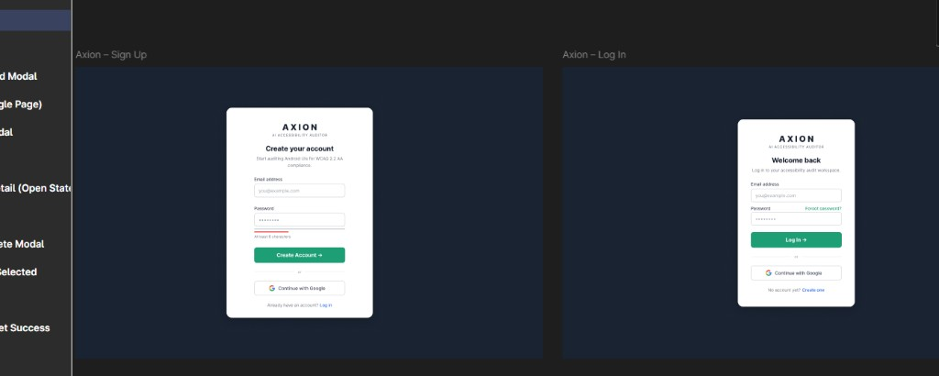
Forgot Password and Verify Code — implementation reference
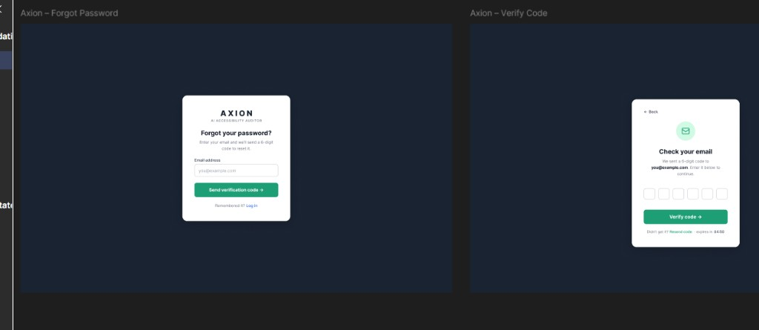
Set Password and Password Reset Success — implementation reference
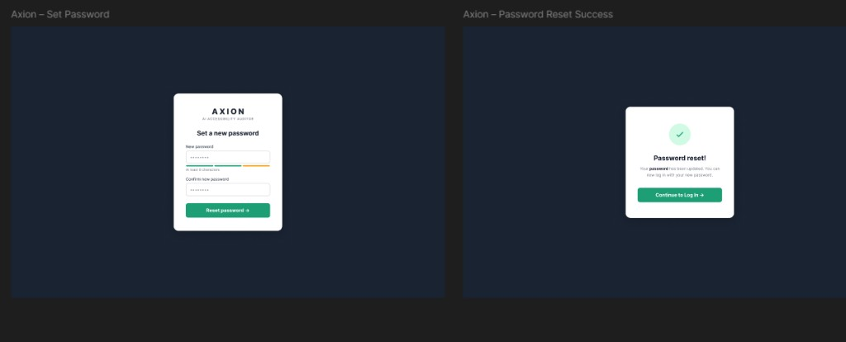
Upload screen — implementation reference
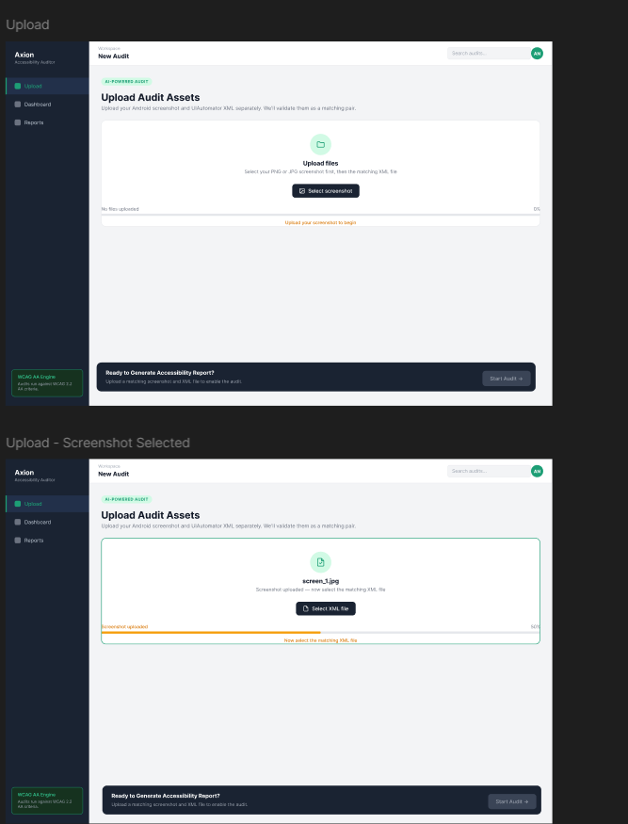
Files Matched modal — implementation reference
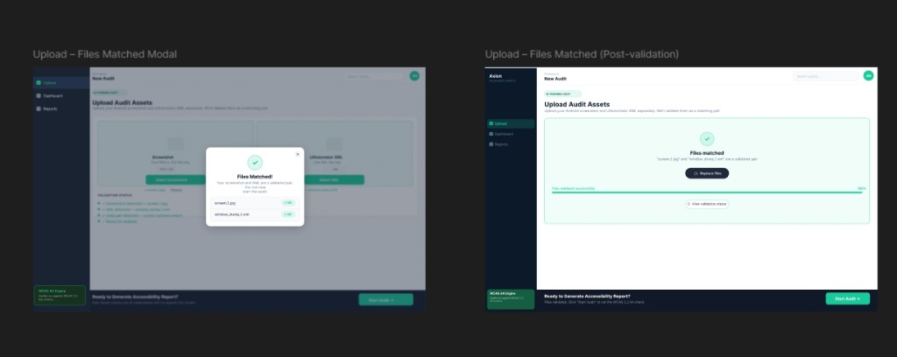
Audit Complete modal and Issues Dashboard — implementation reference
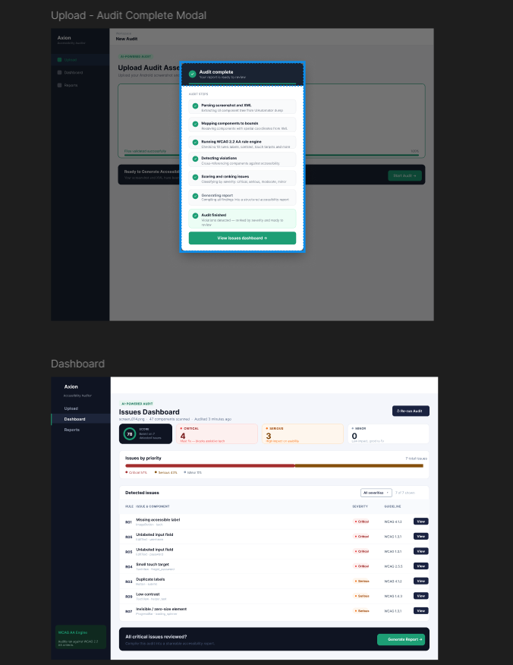
Issue Detail drawer and Audit Report — implementation reference
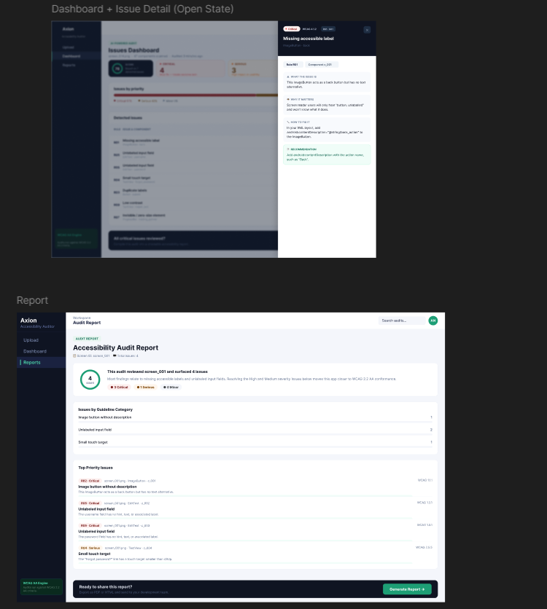
Generate Report modal and PDF layout — implementation reference
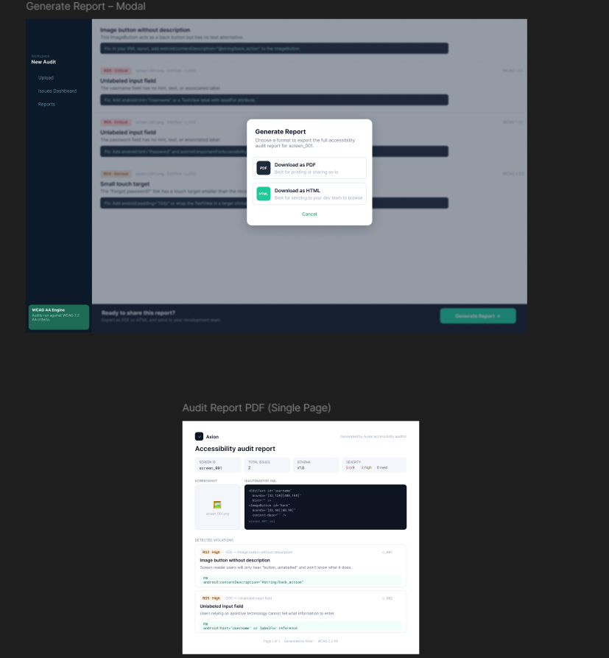

10. Authentication and Records design
SRS: FR-AUTH., FR-REC., FR-UI.40–45

10.1 Auth model (implemented Week 6)
Component | Design
Password storage | bcrypt hash in flat JSON user store (data/ scratch / prototype DB path)
Session | JWT (HS256); secret from JWT_SECRET
Sign up / login | Email + password (min 8, letter+digit); optional display name; any valid email domain (Yahoo, Outlook, education/university, …)
OTP | 6-digit code, TTL + resend; purposes: email verify + password reset; store in backend/otp_store.py (JSON file prototype)
SMTP delivery | backend/email_service.py — Gmail SMTP App Password (SMTP_HOST, SMTP_PORT, SMTP_USER, SMTP_FROM, SMTP_PASSWORD); sender is Gmail, recipients are unrestricted domains
Dev flag | AUTH_DEV_SHOW_OTP=0 when real mail works (hides debug OTP in API/UI)
Google OAuth | GIS frontend + POST /auth/google; verify ID token with GOOGLE_CLIENT_ID
Profile UI | Frontend UserAvatar shows initials from name/email

Credentials: copy .env.example → .env. Never commit SMTP_PASSWORD or JWT_SECRET. GOOGLE_CLIENT_ID is the public OAuth Web client ID from Google Cloud Console.

10.2 Records lifecycle
- User completes audit pipeline (POST /api/v1/audit …)
- Frontend (when logged in) calls POST /records with score + screenshot/XML names
- Row appended to backend/data/records.db.json (user-scoped)
- Records page calls GET /records; detail/reopen uses GET /records/{id} / …/report

10.3 Access control
- All /records/* queries filter by JWT user_id
- No cross-user record access
- Prototype rows live in backend/data/records.db.json (user-scoped by user_id)

11. Deployment design

11.1 docker-compose.yml (as implemented)
services:
frontend:
build:
context: ./frontend
dockerfile: Dockerfile
ports: ["5173:5173"]
volumes:
- ./frontend:/app
- /app/node_modules # anonymous volume: shields the container's own
# Linux-built node_modules from the host bind mount
depends_on: [backend]
networks: [auditor-network]
backend:
build:
context: ./backend
dockerfile: Dockerfile
ports: ["8000:8000"]
volumes: [".:/app"]
working_dir: /app/backend
env_file: [.env] # real secrets (JWT_SECRET, SMTP_*, LLM keys) —
# no hardcoded dev placeholder anymore
networks: [auditor-network]
auditor:
build: .
command: python /app/test_run.py
volumes: [".:/app"]
environment:
PYTHONUNBUFFERED: "1"
PARSER_MAX_FILES: "0"
DATASET_ROOT: "/app/data/data-masc"
networks: [auditor-network]
networks:
auditor-network:
driver: bridge
frontend/Dockerfile: node:20-slim, installs from package.json/package-lock.json, runs npm run dev -- --host 0.0.0.0 (Vite's default dev server only binds localhost, unreachable from outside the container without --host). Two real bugs found by actually building and running the containers, not by reading the Dockerfile: (1) backend/requirements.txt was missing torch/torchvision/timm/ultralytics (present only in the root requirements.txt) — the backend container crashed on startup importing src.crop_violation_classifier/src.yolo_ui_detector at module level; fixed by syncing the dependency list. (2) Even after fix (1), the rebuilt container still crashed — ImportError: libxcb.so.1: cannot open shared object file — because ultralytics pulls in the full GUI-capable opencv-python, not the headless build, which needs system libraries python:3.10-slim doesn't ship. Fixed by adding RUN apt-get install libgl1 libglib2.0-0 libsm6 libxext6 libxrender1 to backend/Dockerfile before pip install. Status: code fixes applied, image rebuild with both fixes succeeded (exit 0) — live container start + `/health` re-verification still pending, since Docker Desktop became unresponsive immediately after the rebuild.

11.2 Environment variables
Variable | Service | Purpose
JWT_SECRET | backend | Token signing
GOOGLE_CLIENT_ID | backend | Google Sign-In
SMTP_HOST / SMTP_PORT / SMTP_TLS | backend | OTP mail transport
SMTP_USER / SMTP_FROM / SMTP_PASSWORD | backend | Gmail App Password sender
AUTH_DEV_SHOW_OTP | backend | Hide/show debug OTP
LLM_PROVIDER / provider keys | backend | Default groq (TBD-01); optional live explanations
CORS_ORIGINS | backend | e.g. http://localhost:5173
DATASET_ROOT | auditor | Batch parse path
VITE_API_BASE | frontend | Points Axion at API; unset in Compose — browser calls localhost:8000 directly, which already matches the backend's published port

11.3 Startup
docker compose up --build
# API docs: http://localhost:8000/docs
# Health: http://localhost:8000/health
# Frontend: http://localhost:5173 (now containerized — no separate `npm run dev` needed)
Code edits (Python or React) need no rebuild — everything is bind-mounted; docker compose restart <service> (or the dev server's own reload) picks them up. Dependency changes (requirements.txt, package.json) need docker compose up --build again for that service. auditor runs test_run.py once per up and exits — expected, not a crash.

12. Security design
Threat | Mitigation
API key exposure | LLM calls server-side only
JWT theft | httpOnly cookie option (Stretch); HTTPS in prod
XXE | Safe XML parsing; no external entities
Upload abuse | 20 MB limit, MIME validation
Path traversal | Sanitize paths in Records service
Cross-user access | JWT user_id scoping on all records
OTP brute force | Rate limit + expiry countdown (Figma: 04:50)

13. Testing design
Layer | Tool | Scope
Unit | pytest | Parser (incl. MASC wrappers), R01–R20
Schema | validate_output.py | components.json / violations.json artefacts
API | pytest + TestClient | Audit violations + report (test_audit.py)
Integration | noor_week3_validate.py, noor_week4_validate.py, noor_week5_validate.py, masc_parse_signoff.py | Full pipeline + report download smoke
E2E | Manual demo | Axion signup/login → upload pair → report download → Records (working; walkthrough for Friday)
Evaluation | MASC train/val/test splits | 7,068 screens, sign-off JSON

13.1 Golden files
tests/fixtures/rules/ # 57 controlled XML screens
├── r01_missing_label_fail.xml / r01_missing_label_pass.xml
├── r02_image_button_fail.xml / r02_image_button_pass.xml
├── … (R03–R20 pass/fail where applicable)
├── r21–r30 pass/fail fixtures
└── clean_no_violations.xml
tests/test_parser.py # extended fields + MASC wrapper nesting
tests/test_rules.py # R01–R30 pass/fail fixture regression (78 tests)
tests/test_audit.py # API violations + report + download
tests/test_report.py # HTML/PDF export unit tests
tests/test_agent.py # score formula + template report
tests/test_explainer.py # anti-hallucination / batching (mocked LLM)

13.2 Sign-off tests (from SRS §10)
- TC-01: missing bounds → no crash
- R01–R30 on controlled fail/pass fixtures
- R13–R20 on controlled component dicts + MASC full-dataset scan (Week 3+)
- masc_parse_signoff_report.json → PASS (7,068 screens, 0 extended-field misses)
- API POST /audit → GET .../violations matches CLI on R01 fixture
- API GET .../report returns score + agent fields (enrichment_mode: template or llm)
- API GET .../report/download?format=html|pdf returns attachment bytes (Playwright PDF requires playwright install chromium)
- Explainer unit tests mock LLM; anti-hallucination guard covered in tests/test_explainer.py

14. SRS traceability
SRS requirement | SDS section | Implementation
FR-PS.1–9 | §3.1, §4 | src/parser.py
FR-RU.1–20 | §3.2, §6 | src/rules.py
FR-AG.1–8 | §7 | src/agent.py, src/explainer.py (Done; API-wired)
FR-RP.1–7 | §8 | src/report.py
FR-UI.* | §9, Appendix D | frontend/
FR-AUTH.* | §10.1, §5.1 | backend/routers/auth_router.py + auth.py / otp_store.py / email_service.py (Done)
FR-REC.* | §10.2, §5.3 | backend/routers/records_router.py (Done; flat backend/data/records.db.json)
Audit API (violations + report) | §5.2 | backend/routers/audit.py
FR-DK.* | §11 | docker-compose.yml
NFR-1–20 | §2, §7, §11, §12 | Cross-cutting
§8 JSON schemas | §4 | auditor_schema.json
§9 REST API | §5, Appendix A | backend/routers/
FR-CV.4–7 | §3.6 | src/yolo_ui_detector.py, notebooks/train_yolo_ui_detector.ipynb (Done — trained, Rico-evaluated, wired into backend)

Appendix A: OpenAPI specification
openapi: 3.0.3
info:
title: Agentic Accessibility Auditor API
version: 2.0.0
servers:
- url: http://localhost:8000/api/v1
paths:
/auth/login:
post:
summary: Login and receive JWT
requestBody:
required: true
content:
application/json:
schema:
type: object
required: [email, password]
properties:
email: { type: string, format: email }
password: { type: string, minLength: 8 }
responses:
"200":
description: JWT token
/audit:
post:
summary: Upload screenshot + XML and start audit
security: [{ bearerAuth: [] }]
requestBody:
content:
multipart/form-data:
schema:
type: object
required: [screenshot, xml]
properties:
screenshot: { type: string, format: binary }
xml: { type: string, format: binary }
responses:
"201": { description: Audit created }
/audit/{audit_id}/status:
get:
summary: Get pipeline status
security: [{ bearerAuth: [] }]
parameters:
- name: audit_id
in: path
required: true
schema: { type: string }
responses:
"200": { description: Status object }
/records:
get:
summary: List user's saved audits
security: [{ bearerAuth: [] }]
responses:
"200": { description: Records list }
/records/{record_id}:
get:
summary: Get record detail
security: [{ bearerAuth: [] }]
parameters:
- name: record_id
in: path
required: true
schema: { type: string }
responses:
"200": { description: Record detail }
components:
securitySchemes:
bearerAuth:
type: http
scheme: bearer
bearerFormat: JWT

Appendix B: File and directory map
Path | Role
src/parser.py | Hybrid XML parser (Done)
src/schema_documents.py | JSON envelope builders
src/rules.py | Rule engine R01–R30 (Done; R09/R28 limited without colors/text-size)
src/agent.py | Score + build_audit_report (Done; API-wired)
src/explainer.py | Live LLM recommendations (Done)
src/llm_providers.py | Multi-provider LLM client
src/guidelines.py | G01–G30 + R→G mapping
src/report.py | HTML/PDF generator (Jinja2 + Playwright)
backend/main.py | FastAPI entry
backend/routers/audit.py | Violations + report + download API (Done)
backend/auth.py / otp_store.py / email_service.py / routers/auth_router.py | JWT + OTP/SMTP + Google OAuth (Done — Salar base + Noor Week 6)
backend/routers/records_router.py | Per-user records CRUD + report reopen (Done; store backend/data/records.db.json)
scripts/noor_week6_validate.py | Week 6 auth/records + eval sheet validation
scripts/run_week7_eval_analysis.py | Week 7 MASC 40-screen rule/guideline QA analysis
scripts/noor_week7_validate.py | Week 7 eval + pytest + artifact checks + validation logs
scripts/noor_week8_validate.py | Week 8 Rico holdout batch + pytest + R07/R08/R30/R20/R05 fix verification
scripts/run_rico_holdout_eval.py | Rico holdout batch eval (Done — 1,698 screens, 0 failures, re-run post rule-fix)
tests/test_parser.py | Parser unit tests
tests/test_rules.py | Rules R01–R30 unit tests
tests/test_audit.py | Audit API tests (violations + report + download)
tests/test_report.py | Report HTML/PDF export tests
tests/test_explainer.py | Explainer anti-hallucination tests
backend/tests/test_auth.py | Auth/OTP/Google/records suite (22 tests)
frontend/src/ | Axion React app (Done for Upload/Dashboard/Report/Records/Login/SignUp/Forgot/OTP/Reset + Google Sign-In)
docs/schemas/auditor_schema.json | Normative JSON Schema
docs/json_schemas.md | Schema documentation
docs/week6/ | 40-screen eval sheet + R26–R30 design + assisted FP/miss notes
docs/week7/ | Rule/guideline coverage reports (MASC sample) + holdout_* Rico variants (Week 8)
outputs/reports/ | Agent-enriched *_report.json + generated .html / .pdf
outputs/validation_logs/ | noor_week1–week8 validation logs + summaries (16 files)
backend/data/records.db.json | Prototype per-user audit history (score + screenshot/XML names)
src/yolo_ui_detector.py | Screenshot-only YOLO fallback inference (Done; trained, Rico-evaluated, wired into backend pipeline)
notebooks/train_yolo_ui_detector.ipynb | YOLO training notebook (Salar → Noor Colab T4 run, full 60-epoch, merged 30 Jul)
runs/runs/yolo_ui_detector/export/yolo_ui_detector_best.pt | Exported best checkpoint (51.2 MB)
runs/runs/yolo_ui_detector/runs/yolo_ui_detector/{args.yaml,results.csv,*.png,*.jpg} | Full local training run config, metrics, and plots (see SDS §3.6.3, Progress Report §15C.7)
runs/runs/yolo_ui_detector/{yolo_dataset,rico_yolo_dataset}/dataset.yaml | MASC train config vs Rico holdout eval-only config
src/crop_violation_classifier.py | Pixel-level crop classifier inference (classify_crop(), confirm_violations()) (Done; swin_tiny_patch4_window7_224, trained, Rico-evaluated, wired into backend pipeline)
notebooks/train_crop_violation_classifier.ipynb | Crop classifier training notebook (Noor Colab T4 run, incl. §9 Rico holdout eval)
models/crop_violation_classifier_best.pt, runs/crop_violation_classifier/export/crop_violation_classifier_best.pt | Exported best checkpoint (6.2 MB, epoch 17)
runs/crop_violation_classifier/{crops,rico_crops}/ | Train/test/Rico-holdout crop PNGs (§15G.8 for exact per-split coverage)
runs/crop_violation_classifier/{manifests,rico_manifest}/*.csv | Per-split crop labels (train/val/test/holdout)

Appendix C: Sequence diagrams

C.1 Authenticated audit with Records save
sequenceDiagram
participant U as User
participant A as Axion UI
participant API as FastAPI
participant P as Pipeline
participant R as RecordsStore
U->>A: Login
A->>API: POST /auth/login
API-->>A: JWT
U->>A: Upload screenshot + XML
A->>API: POST /audit (JWT)
API->>P: run_audit()
P-->>API: complete + artefacts
API->>R: save(user_id, record)
API-->>A: audit_id, record_id
A-->>U: Dashboard + saved to Records

C.2 View past audit from Records
sequenceDiagram
participant U as User
participant A as Axion UI
participant API as FastAPI
U->>A: Open Reports page
A->>API: GET /records (JWT)
API-->>A: records list
U->>A: Open record
A->>API: GET /records/{id}
API-->>A: metadata + report paths
A-->>U: Report view / download

Appendix D: UI component map (Figma)
Maps Figma frames to React components (SRS Appendix F). Screenshot assets in docs/assets/figma/.
Figma frame | Screenshot | Route / trigger | React component(s)
Sign Up | figma-01-signup-login.png | /signup | SignUpPage
Log In | figma-01-signup-login.png | /login | LoginPage
Forgot Password | figma-02-forgot-verify-otp.png | /forgot-password | ForgotPasswordPage
Verify Code | figma-02-forgot-verify-otp.png | /verify-otp | OtpVerificationPage
Set Password | figma-03-reset-password-success.png | /reset-password | ResetPasswordPage
Password Reset Success | figma-03-reset-password-success.png | /reset-success | ResetSuccessPage
Upload (progress) | figma-04-upload-progress-states.png | /upload | UploadPage, UploadZone
Files Matched Modal | figma-08-upload-files-matched.png | after validation | FilesMatchedModal
Audit Complete Modal | figma-05-audit-complete-dashboard.png | after pipeline | AuditCompleteModal
Dashboard | figma-05-audit-complete-dashboard.png | /dashboard/:id | DashboardPage, ViolationsTable, ScoreGauge
Issue Detail Drawer | figma-06-dashboard-detail-report.png | View action | IssueDetailDrawer
Audit Report | figma-06-dashboard-detail-report.png | /report/:id | ReportPage
Generate Report Modal | figma-07-generate-report-modal-pdf.png | footer CTA | DownloadModal
PDF layout | figma-07-generate-report-modal-pdf.png | export | report.py HTML template
Records / Reports | — | /records | RecordsPage, RecordsTable

Design tokens: background #0b1929, primary #1bc99a, sidebar nav Upload | Dashboard | Reports.
— End of Software Design Specification v2.0 —

