Software Design Specification

Agentic Accessibility Auditor (Axion)

for Android Mobile Application UIs
Field | Value
**Document version** | 2.2
**Status** | Implementation reference
**Prepared by** | Muhammad Noor (Lead — primary author); Salar + Ayesha (SRS inputs, parser/UI design)
**Institution** | FAST-NUCES
**Related SRS** | `SRS_Agentic_Accessibility_Auditor_v2.0.md` (v2.0)
**Repository** | [MuhammadNoor7/agentic-accessibility-auditor](https://github.com/MuhammadNoor7/agentic-accessibility-auditor)

Document history
Version | Date | Author | Changes
1.0 | 2026 | Team | Initial SDS from merged SRS v1.x
**2.0** | 2026 | Team | Aligned to SRS v2.0 with embedded Figma screenshots; auth, Records, Dashboard flows
**2.1** | 2026-07-06 | Noor / Salar | Parser R13–R20 fields; rules R01–R20; MASC re-parse sign-off; audit API violations-only
**2.2** | 2026-07-09 | Noor / Salar | Rules R01–R30; explainer + agent API wiring; `GET …/report`; visibility filter
**2.3** | 2026-07-12 | Noor | Week 5: `src/report.py` HTML/PDF + download API; R09–R20 fixtures; team ownership alignment
**2.4** | 2026-07-13 | Noor | Rules ownership → Salar + Noor + Ayesha (reviewed by all)
**2.5** | 2026-07-13 | Noor | Figma screenshots restored from formatted DOCX into `docs/assets/figma/`; DOCX export embeds images
**2.6** | 2026-07-14 | Noor | `POST /audit` requires `screenshot` + `xml`; server-side pair validation; tests updated

Table of contents
1. [Introduction](#1-introduction)
2. [System architecture](#2-system-architecture)
3. [Module design](#3-module-design)
4. [Data design](#4-data-design)
5. [API design](#5-api-design)
6. [Rule engine design](#6-rule-engine-design)
7. [Agentic layer design](#7-agentic-layer-design)
8. [Report generator design](#8-report-generator-design)
9. [Frontend design (Axion)](#9-frontend-design-axion)
10. [Authentication and Records design](#10-authentication-and-records-design)
11. [Deployment design](#11-deployment-design)
12. [Security design](#12-security-design)
13. [Testing design](#13-testing-design)
14. [SRS traceability](#14-srs-traceability)
- [Appendix A: OpenAPI specification](#appendix-a-openapi-specification)
- [Appendix B: File and directory map](#appendix-b-file-and-directory-map)
- [Appendix C: Sequence diagrams](#appendix-c-sequence-diagrams)
- [Appendix D: UI component map (Figma)](#appendix-d-ui-component-map-figma)

1. Introduction

1.1 Purpose
This Software Design Specification (SDS) describes how the Agentic Accessibility Auditor is designed and implemented. It is the technical companion to SRS v2.0, which defines what the system must do.
This document provides:
- Architecture and module boundaries
- Class/function design and algorithms
- Normative JSON schema usage
- REST API contracts (OpenAPI)
- Frontend component structure (Axion)
- Auth and per-user Records storage design
- Deployment, security, and test design

1.2 Design scope
In scope | Out of scope
Parser, rule engine, agent, report generator | Business case / internship planning
FastAPI orchestrator + Axion React UI | Clinical accessibility research
Auth + Records persistence | Production HIPAA / enterprise SSO
Docker Compose topology | Play Store / APK crawling
R01–R20 rule pseudocode + parser extensions | Full R21–R30 implementation detail

1.3 Design principles
ID | Principle | Rationale
D1 | Pipeline isolation via JSON artefacts | Interns integrate through agreed files/API
D2 | Deterministic rule engine | Same input → same `violations.json`
D3 | LLM explains only | Agent never creates violations
D4 | Schema-first contracts | `auditor_schema.json` validated in CI
D5 | Hybrid parser, single traversal | UIAutomator + MASC + Rico in one pass
D6 | Fail gracefully | Bad XML, LLM timeout → structured errors
D7 | User-scoped Records | Each audit linked to authenticated `user_id`

1.4 Implementation status
Module | Path | Owner | Status
Hybrid XML parser | `src/parser.py` | Salar / Noor | **Done** (R13–R20 fields + visibility)
Schema helpers | `src/schema_documents.py` | Noor | **Done** (JSON envelope builders)
JSON Schema | `docs/schemas/auditor_schema.json`, `docs/json_schemas.md` | Noor | **Done**
Validation scripts | `scripts/validate_output.py`, `scripts/noor_week3_validate.py`, `scripts/noor_week4_validate.py`, `scripts/noor_week5_validate.py`, `scripts/masc_parse_signoff.py` | Noor / Salar | **Done**
FastAPI audit API | `backend/routers/audit.py` | Noor | **Partial** (violations + report + download; no auth/records)
Rule engine | `src/rules.py` | Salar + Noor + Ayesha | **Done** (R01–R30; reviewed by all)
Agent layer | `src/agent.py`, `src/explainer.py`, `src/llm_providers.py` | Noor | **Done** (API-wired; template + live LLM)
Report generator | `src/report.py` | Noor | **Done** (Jinja2 HTML + PIL + Playwright PDF)
Axion React UI | `frontend/` | Ayesha | **Partial** (Upload/Dashboard/Report wired; Records mock)
pytest suite | `tests/` | Salar / Noor | **Done** (120 tests)

2. System architecture

2.1 Logical architecture
┌──────────────────────────────────────────────────────────────────────────┐
│ Axion React Dashboard (frontend/) │
│ Auth │ Upload │ Dashboard │ Report │ Records │ Generate Report Modal │
└───────────────────────────────┬──────────────────────────────────────────┘
│ HTTPS + JWT
┌───────────────────────────────▼──────────────────────────────────────────┐
│ FastAPI Orchestrator (backend/) │
│ /auth/* │ /audit/* │ /records/* │ PipelineService │ RecordsService │
└───┬─────────┬──────────┬──────────┬──────────┬─────────────────────────────┘
│ │ │ │ │
▼ ▼ ▼ ▼ ▼
Parser RuleEngine Agent ReportGen RecordsStore
src/ src/rules src/ src/report outputs/records/
agent
│ │ │ │
▼ ▼ ▼ ▼
components violations report.json audit_record.json
.json .json + HTML/PDF paths

2.2 Pipeline data flow
Screenshot + UIAutomator XML
→ Parser → components.json
→ Rule Engine → violations.json
→ Agent → report.json
→ Report Generator → audit_report.html / .pdf
→ Records Service → outputs/records/{user_id}/{record_id}/
→ Axion UI → Dashboard + Records list

2.3 Physical deployment (Docker Compose)
Service | Image | Port | Role
`frontend` | `./frontend/Dockerfile` | 5173 | Axion React (Vite)
`backend` | `./backend/Dockerfile` | 8000 | FastAPI + pipeline
`auditor` | `./Dockerfile` | — | Batch parser worker
Network: auditor-network (bridge). Repo root mounted at /app.

2.4 Per-audit run directory
outputs/runs/{audit_id}/
├── input/
│ ├── screenshot.png
│ └── window.xml
├── components.json
├── violations.json
├── report.json
├── audit_report.html
└── audit_report.pdf

2.5 Per-user Records directory
outputs/records/{user_id}/
├── index.json # list of record summaries
└── {record_id}/
├── metadata.json # screen_id, score, dates, paths
├── report.json
├── audit_report.html
└── audit_report.pdf

3. Module design

3.1 Parser module (`src/parser.py`)
SRS: FR-PS.1–FR-PS.9 | Owner: Salar / Noor | Status: Implemented

3.1.1 Responsibilities
- Sanitize XML (strip \x00)
- Traverse hierarchy; emit flat components[]
- Infer screen_id, image_path, xml_path
- Write schema-compliant components.json

3.1.2 Public API
Function | Input | Output
`load_xml_root(path)` | Path | lxml root
`parse_xml_tree(root)` | Element | `list[dict]`
`build_screen_document(...)` | paths + components | JSON dict
`parse_xml_file(xml_path, ...)` | Path | output Path
`parse_dataset_folder(...)` | dataset root | batch stats

3.1.3 Bounds parsing algorithm
parse_bounds(raw):
if matches "[l,t][r,b]" → return [l,t,r,b] # UIAutomator
if matches "l t r b" → return [l,t,r,b] # Rico
return None
extract_bounds(element):
b = parse_bounds(element.@bounds)
if b: return b
b = parse_masc_wrapper_bounds(element)
if b: return b
if is_uiautomator_node(element):
return [0,0,0,0] # TC-01
return None

3.1.5 Extended component fields (R13–R20)
Depth-first traversal preserves parent_id and assigns focus_order in document order. MASC <wrapper> nodes are descended into (widgets are nested inside wrappers).
Field | Used by | Notes
`focus_order` | R15 | 1-based traversal index
`parent_id` | R15, hierarchy | `component_id` of parent or `""`
`long_clickable`, `scrollable` | R18 | Gesture heuristics
`media_type` | R12, R13 | `""`, `video`, `audio`, `animation`
`is_dialog` | R19 | Confirmation dialog detection
`label_for`, `hint`, `input_type`, `password` | R05, R20 | Input labelling
`important_for_accessibility` | R16 | Decorative vs focusable
Also emitted: selected, checked, text_all_caps, device_info.dpi on screen document.

3.1.4 Screenshot pairing
Mirror XML path under screenshots/ with same stem; try .jpg, .jpeg, .png.

3.2 Rule engine module (`src/rules.py`)
SRS: FR-RU.1–FR-RU.30 | Owner: Salar + Noor + Ayesha (reviewed by all) | Status: Implemented (R01–R30)

3.2.1 Public API
Function | Input | Output
`check(components_json)` | `components.json` dict | `violations.json` dict
`check_*` per rule | `list[dict]` components | `list[dict]` violations
Implementation uses plain functions (not a RuleEngine class). Entry point check() filters hidden components (visibility), then chains R01–R30 checkers, reads device_info.dpi for dp rules (R04, R17, R28), and returns schema-shaped output.

3.2.2 Processing flow
1. Load components[] and device_info.dpi (default 160)
2. Drop components with visibility=false (MASC gone / visible-to-user=False)
3. Run R01–R30 check functions in order
4. Each violation includes denormalized class, bounds; pair rules add related_component (R03, R08, R17)
5. Return dict with total_violations == len(violations) plus component/hidden counts

3.2.3 Rule status (Week 4)
Rules | Status
R01–R08, R10–R30 | Implemented
R09 | Implemented when declared colors present; otherwise inactive
R28 | Implemented when declared text size present; otherwise inactive

3.2.4 dp conversion
width_dp = (bounds[2] - bounds[0]) / density
height_dp = (bounds[3] - bounds[1]) / density
Default dpi = 160 when device_info absent (TBD-03).

3.2.5 Severity mapping (engine → UI)
Engine | Axion badge
Critical | Critical
High | Serious
Medium | Moderate
Low | Minor

3.3 Agent module (`src/agent.py` + `src/explainer.py`)
SRS: FR-AG.1–FR-AG.8 | Owner: Noor | Status: Done (API-wired Week 4)
def build_audit_report(
violations_doc: dict,
components_doc: dict | None = None,
*,
use_llm: bool | None = None,
) -> dict: ...
class AgenticEnricher:
def enrich(self, violations_doc: dict, components_doc: dict | None = None) -> dict: ...
- build_audit_report() produces report.json with accessibility_score, summary, and per-violation agent fields
- Live path: src/explainer.py → src/llm_providers.py (Anthropic / OpenAI / Gemini / Groq), batched, anti-hallucination match
- Fallback: template enrichment when no API key or use_llm=false (FR-AG.6)
- Wired in backend/routers/audit.py → GET /api/v1/audit/{id}/report

3.4 Report module (`src/report.py`)
SRS: FR-RP.1–FR-RP.7 | Owner: Noor | Status: Implemented (12 Jul 2026)
- Jinja2 HTML template (src/templates/audit_report.html.j2)
- PIL bounding-box annotation on screenshots
- Playwright Chromium for HTML → PDF (render_pdf_report)
- GET /api/v1/audit/{id}/report/download?format=html|pdf
- Accessibility score from agent layer (see §8.2)

3.5 API orchestrator (`backend/`)
Owner: Noor
backend/
├── main.py # FastAPI app, CORS, routers
├── config.py # env settings
├── routers/
│ ├── auth.py
│ ├── audit.py
│ └── records.py
├── services/
│ ├── pipeline.py # stage orchestration
│ ├── auth.py # JWT, OTP
│ └── records.py # user-scoped persistence
├── models/
│ ├── auth.py # Pydantic models
│ ├── audit.py
│ └── records.py
└── dependencies.py # get_current_user

3.5.1 Pipeline service
async def run_audit(audit_id: str, user_id: str) -> None:
set_status(audit_id, "parsing")
components = parse_xml_file(...)
set_status(audit_id, "checking")
violations = rule_engine.run(components)
set_status(audit_id, "explaining")
report = agent.enrich(violations, components)
set_status(audit_id, "reporting")
paths = report_gen.render(report, run_dir)
set_status(audit_id, "complete")
records_service.save(user_id, audit_id, report, paths)
Statuses: pending → parsing → checking → explaining → reporting → complete | error

4. Data design
Normative schema: docs/schemas/auditor_schema.json

4.1 Entity relationship
User (user_id)
└── has many AuditRecord (record_id)
├── has one Screen (screen_id, image_path, xml_path)
├── has many Violations
└── has report artefacts (json, html, pdf)

4.2 components.json
Field | Type | Required
`schema_version` | string `"1.0"` | Recommended
`screen_id` | string | Yes
`image_path` | string | Yes
`xml_path` | string | Yes
`components` | array | Yes
Component (required): component_id, class, text, content_desc, resource_id, clickable, enabled, focusable, bounds[4]
Component (optional, R13–R20): hint, focus_order, parent_id, long_clickable, scrollable, selected, checked, password, text_all_caps, input_type, important_for_accessibility, media_type, is_dialog, label_for
Screen: optional device_info with dpi, width_px, height_px
Pattern: component_id matches ^c_\d{3,}$

4.3 violations.json
Screen level: schema_version, screen_id, image_path, xml_path, total_violations, violations[]
Violation: rule_id, issue, component_id, class, bounds, guideline, severity, recommendation, optional related_component
Invariant: total_violations == len(violations)

4.4 report.json
Adds summary object and agent fields per violation:
- agent_explanation
- agent_why_it_matters
- agent_developer_fix

4.5 records metadata (`metadata.json`)
Field | Type | Description
`record_id` | string | UUID
`user_id` | string | Owner
`audit_id` | string | Pipeline run ID
`screen_id` | string | e.g. `screen_014`
`score` | int | 0–100
`total_issues` | int | Violation count
`severity_summary` | object | `{critical, high, medium, low}`
`created_at` | ISO datetime | Audit timestamp
`report_html_path` | string | Relative path
`report_pdf_path` | string | Relative path

4.6 index.json (per user)
{
"user_id": "u_001",
"records": [
{
"record_id": "rec_abc123",
"screen_id": "screen_014",
"score": 78,
"total_issues": 7,
"created_at": "2026-07-01T12:00:00Z"
}
]
}

4.7 Validation
python test_run.py --dataset masc # batch parse + rules → parsed/ + outputs/violations/
python scripts/validate_output.py # JSON Schema spot-check
python scripts/masc_parse_signoff.py # train/val/test parse sign-off + R13–R20 counts
python scripts/noor_week3_validate.py # full pipeline: re-parse, pytest, API smoke, MASC scan
MASC artefacts:
Path | Purpose
`data/data-masc/parsed/*_components.json` | Re-parsed components (all categories)
`data/data-masc/parsed/batch_parse_masc_full.log` | Full batch parse terminal log
`data/data-masc/parsed/masc_parse_signoff_report.json` | Parse sign-off + R01–R20 aggregate counts
`outputs/violations/*_violations.json` | Per-screen rule output
`outputs/validation_logs/noor_week3_validation_log.txt` | Noor validation run log (appended)
Run after each pipeline stage or via python scripts/noor_week3_validate.py.

5. API design
Base URL: http://localhost:8000
Prefix: /api/v1
Auth: Authorization: Bearer <JWT> (except auth endpoints)

5.1 Auth endpoints
Method | Path | Description
POST | `/auth/signup` | Email + password (≥ 8 chars)
POST | `/auth/login` | Returns JWT
POST | `/auth/google` | Google OAuth token exchange
POST | `/auth/forgot-password` | Send 6-digit OTP
POST | `/auth/verify-otp` | Validate OTP
POST | `/auth/reset-password` | Set new password

5.2 Audit endpoints
Method | Path | Description
POST | `/audit` | Upload **screenshot + XML** (`multipart`: `screenshot`, `xml`); validates PNG/JPG + matching pair; optional `use_llm` query; start pipeline
GET | `/audit/{audit_id}/status` | Pipeline status (`pending` → `parsing` → `checking` → `explaining` → `complete`)
GET | `/audit/{audit_id}/violations` | Violations JSON (**implemented**)
GET | `/audit/{audit_id}/report` | Report JSON with score + agent fields (**implemented** Week 4)
GET | `/audit/{audit_id}/report/download?format=html\ | pdf`
POST | `/audit/batch` | Batch over dataset path (Should)

5.3 Records endpoints
Method | Path | Description
GET | `/records` | List current user's audits
GET | `/records/{record_id}` | Record detail + artefact paths
GET | `/records/{record_id}/download?format=html\ | pdf`
DELETE | `/records/{record_id}` | Delete record (Stretch)

5.4 Example: POST /audit
Request: multipart/form-data — required fields screenshot (PNG/JPG), xml (.xml). Filenames must match as a pair (same stem, or shared numeric ID with matching prefix — mirrors filesMatch() in Upload.jsx).
Response 202:
{
"audit_id": "a1b2c3d4",
"status": "complete"
}
Errors: 422 if screenshot missing; 400 if invalid image type, non-XML upload, or filename pair mismatch.

5.5 Example: GET /audit/{id}/status
{
"audit_id": "a1b2c3d4",
"status": "checking",
"stage_progress": {
"parsing": "complete",
"checking": "in_progress",
"explaining": "pending",
"reporting": "pending"
},
"error": null
}

5.6 Example: GET /records
{
"user_id": "u_001",
"records": [
{
"record_id": "rec_xyz789",
"screen_id": "screen_014",
"score": 78,
"total_issues": 7,
"severity_summary": {"critical": 4, "high": 3, "medium": 0, "low": 0},
"created_at": "2026-07-01T12:00:00Z"
}
]
}

6. Rule engine design
Pseudocode for MVP rules R01–R10. Full catalogue: SRS §7.2.

6.1 Shared helpers
def is_empty(s: str) -> bool:
return not s or not s.strip()
def is_clickable(c: dict) -> bool:
return c["clickable"] is True

6.2 R01 — Missing accessible label
for c in components:
if c.clickable and is_empty(c.text) and is_empty(c.content_desc):
emit(R01, c, severity=High, guideline=G01)

6.3 R02 — Image button without description
for c in components:
if is_image_class(c.class) and c.clickable and is_empty(c.content_desc):
emit(R02, c, severity=High, guideline=G02)

6.4 R03 — Duplicate labels
Group clickable components by (text or content_desc); flag groups with ≥ 2 distinct component IDs.

6.5 R04 — Small touch target
if width_dp < 48 or height_dp < 48:
emit(R04, c, severity=High, guideline=G04)

6.6 R05 — Unlabeled input
if "EditText" in c.class and all empty(text, content_desc, hint):
emit(R05, c, severity=High, guideline=G05)

6.7 R06 — Disabled important control
clickable and not enabled without nearby explanation TextView.

6.8 R07 — Zero-size element
width <= 0 or height <= 0 or invalid rect

6.9 R08 — Layout overlap
Pairwise overlap ratio > 0.5 over smaller element area.

6.10 R09 — Low contrast (Stretch)
Screenshot crop + WCAG contrast ratio; requires src/contrast.py.

6.11 R10 — Text overflow
Heuristic: TextView height < estimated text height (MVP: height < 24px with non-empty text).

6.12 R11 — Color-only information (stub)
check_color_only_info() returns [] until before/after snapshots or screenshot colour diff is available.

6.13 R12 — Missing captions
media_type in (video, audio) and no nearby caption/subtitle token in sibling text.

6.14 R13 — Audio without transcript
media_type == audio and no transcript/caption affordance nearby.

6.15 R14 — Audio-only notification
Notification-style text with no visible icon/banner nearby.

6.16 R15 — Bad focus order
Focusable components: focus_order traversal disagrees with top-to-bottom bounds order.

6.17 R16 — Decorative in focus tree
Likely decorative ImageView (no text/desc) remains focusable.

6.18 R17 — Insufficient spacing
Adjacent clickables with edge gap < 8dp; emit related_component for the paired control.

6.19 R18 — Multi-gesture only
Text/content describes pinch/zoom/multi-touch-only interaction without single-finger alternative.

6.20 R19 — Destructive without confirmation
Clickable destructive token (delete/remove) and no is_dialog / confirm text on screen.

6.21 R20 — Hint-only label
EditText with hint but no text, content_desc, label_for, or nearby label TextView.

7. Agentic layer design

7.1 LLM configuration
Setting | Default | Env var
Model | `gpt-4o-mini` | `OPENAI_MODEL`
Timeout | 30s | `OPENAI_TIMEOUT`
Temperature | 0.2 | —
Retries | 2 | —

7.2 Prompt template (per violation)
System: Explain accessibility violations only. Never invent new violations.
User:
rule_id: {rule_id}
issue: {issue}
component: {class, bounds, resource_id}
guideline: {guideline}
recommendation: {recommendation}
Return JSON: {agent_explanation, agent_why_it_matters, agent_developer_fix}

7.3 Fallback on failure
Use issue + recommendation as template fields; log API error.

8. Report generator design

8.1 HTML sections
1. Cover — screen ID, date, score, total issues
2. Summary — severity counts
3. Annotated screenshot — PIL boxes colour-coded by severity
4. Violation details — grouped Critical → High → Medium → Low
5. Footer — schema version, WCAG 2.2 AA

8.2 Accessibility score formula
score = 100
score -= critical * 20 + high * 10 + medium * 5 + low * 2
score = clamp(score, 0, 100)
Maps to Axion score gauge on Dashboard (SRS FR-UI.21).

8.3 PDF generation
Primary: Jinja2 renders standalone HTML; Playwright Chromium prints HTML to PDF (page.pdf()). Requires playwright install chromium once per environment.

9. Frontend design (Axion)
Owner: Ayesha | SRS: FR-UI.*, Appendix F

9.1 Technology stack
Layer | Choice
Framework | React 18 + Vite
Styling | Tailwind CSS
Routing | React Router v6
HTTP | axios + JWT interceptor
State | React Context (MVP)

9.2 Directory structure
frontend/src/
├── api/
│ ├── authClient.ts
│ ├── auditClient.ts
│ └── recordsClient.ts
├── components/
│ ├── layout/ # Sidebar, Header, FloatingActionBar
│ ├── auth/ # SignUp, Login, ForgotPassword, OTP, Reset
│ ├── upload/ # UploadZone, ValidationPanel, FilesMatchedModal
│ ├── dashboard/ # ScoreCards, PriorityChart, ViolationsTable
│ ├── report/ # IssueCard, DownloadModal
│ └── records/ # RecordsTable, EmptyState
├── pages/
│ ├── UploadPage.tsx
│ ├── DashboardPage.tsx
│ ├── ReportPage.tsx
│ └── RecordsPage.tsx
└── theme/tokens.ts # #0b1929, #1bc99a

9.3 Key UI flows
Flow | Route | Components
Auth | `/login`, `/signup` | Auth forms per Figma
Upload | `/upload` | Sequential upload → Files Matched → Start Audit
Audit progress | modal overlay | Audit Complete step checklist
Dashboard | `/dashboard/:auditId` | Score cards, table, Issue Detail drawer
Report | `/report/:auditId` | Guideline breakdown, Generate Report
Records | `/records` | User audit history, search, re-download

9.4 TypeScript interfaces
Mirror JSON schema types: Component, Violation, ReportSummary, AuditRecord.

9.6 Figma reference screenshots
Visual source of truth: SRS Appendix F. Screenshots were restored from the legacy formatted DOCX export into docs/assets/figma/ and are embedded below for implementation reference.
Screen group | Asset file | React route(s)
Sign Up + Log In | `figma-01-signup-login.png` | `/signup`, `/login`
Forgot + OTP | `figma-02-forgot-verify-otp.png` | `/forgot-password`, `/verify-otp`
Reset + Success | `figma-03-reset-password-success.png` | `/reset-password`, `/reset-success`
Upload states | `figma-04-upload-progress-states.png` | `/upload`
Files Matched | `figma-08-upload-files-matched.png` | modal on `/upload`
Audit Complete + Dashboard | `figma-05-audit-complete-dashboard.png` | modal; `/dashboard/:id`
Detail drawer + Report | `figma-06-dashboard-detail-report.png` | drawer; `/report/:id`
Generate modal + PDF | `figma-07-generate-report-modal-pdf.png` | modal; PDF template
Records | *(no screenshot — match Dashboard styling)* | `/records`
Sign Up and Log In — implementation reference
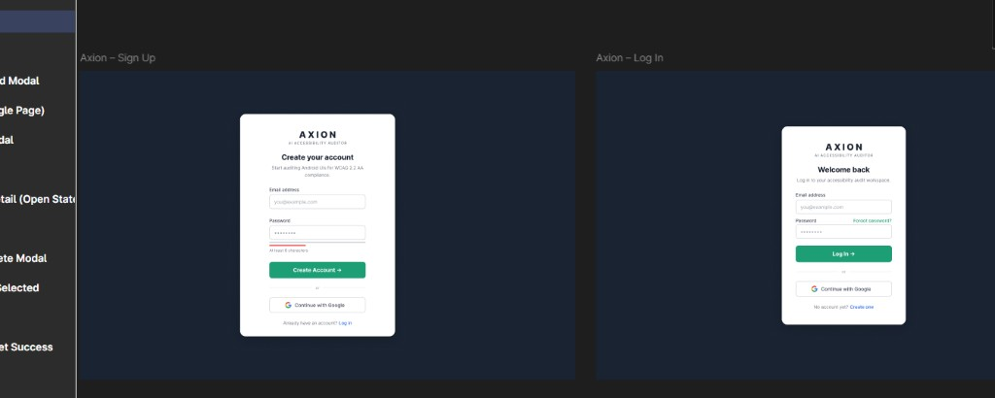
Forgot Password and Verify Code — implementation reference
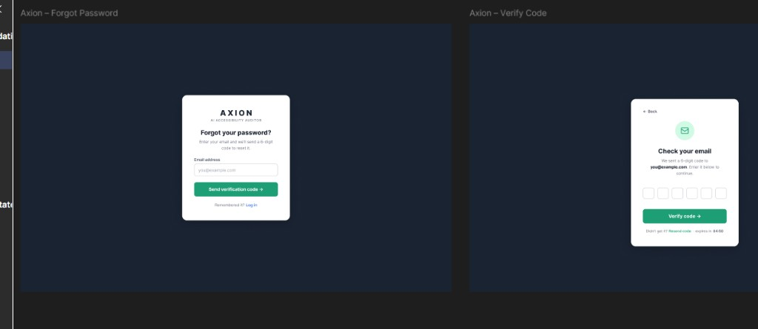
Set Password and Password Reset Success — implementation reference
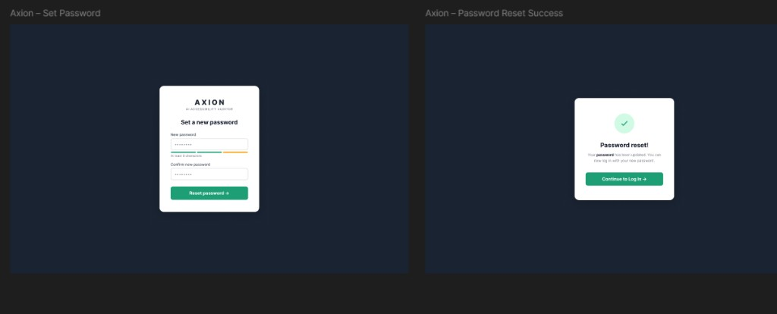
Upload screen — implementation reference
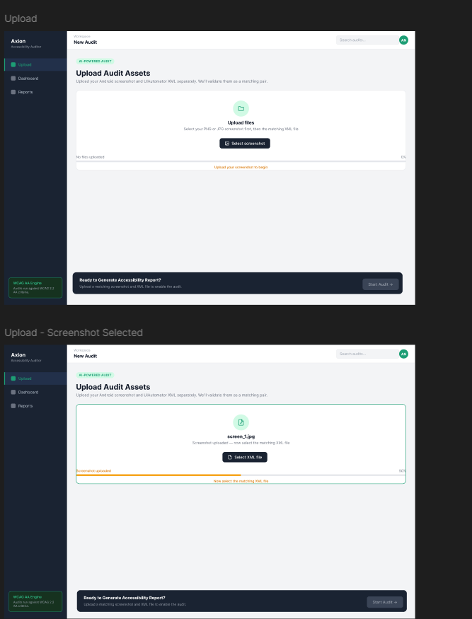
Files Matched modal — implementation reference
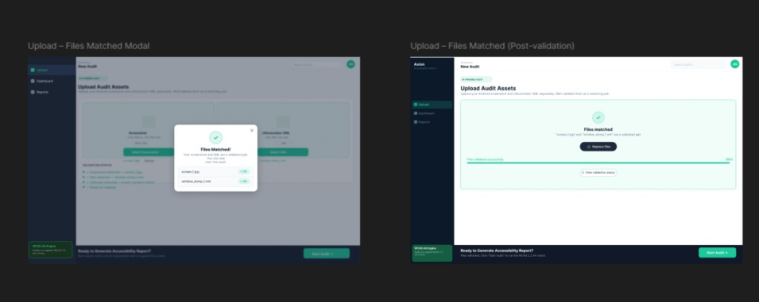
Audit Complete modal and Issues Dashboard — implementation reference
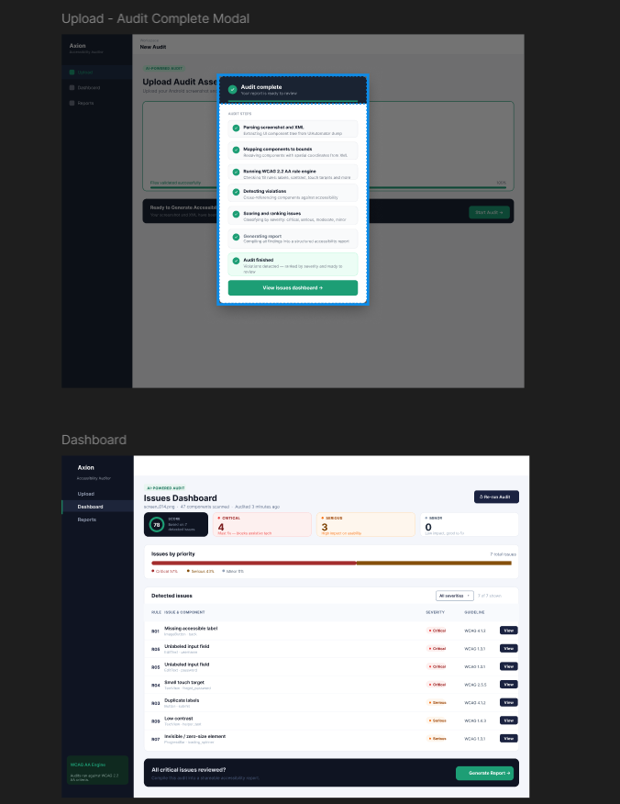
Issue Detail drawer and Audit Report — implementation reference
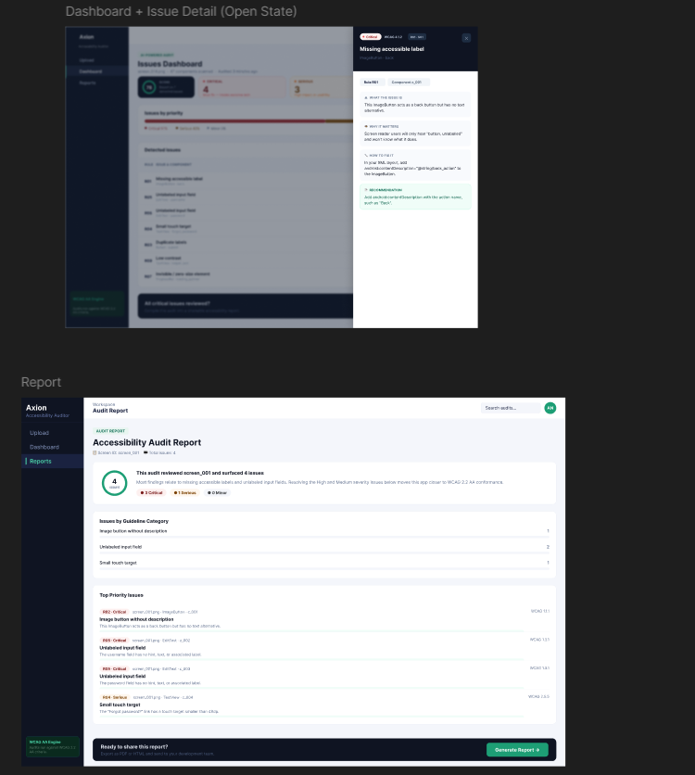
Generate Report modal and PDF layout — implementation reference
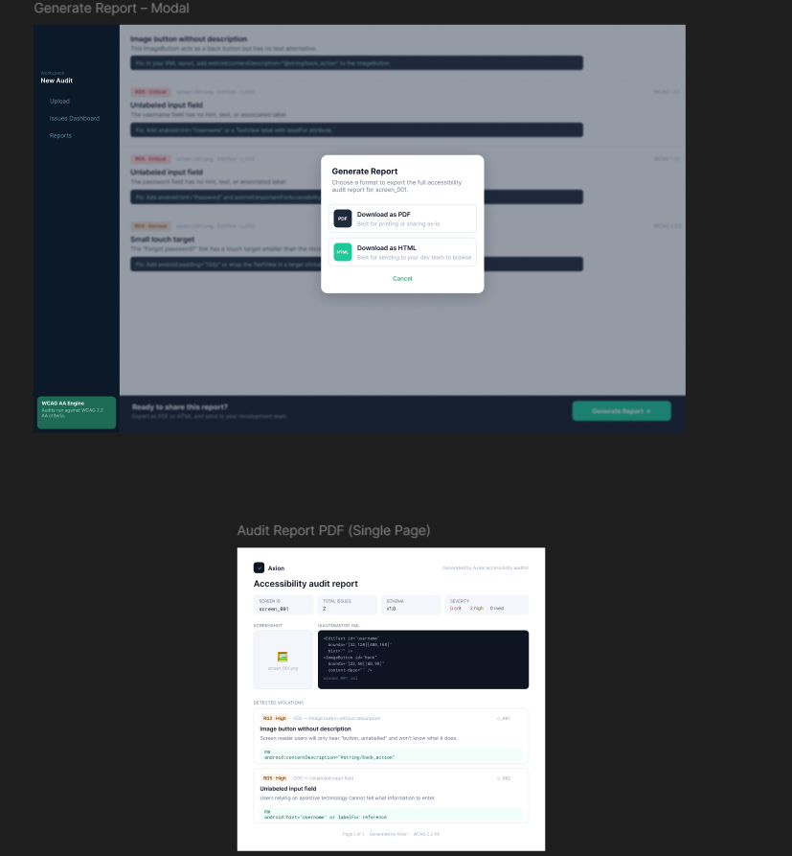

10. Authentication and Records design
SRS: FR-AUTH., FR-REC., FR-UI.40–45

10.1 Auth model (prototype)
Component | Design
Password storage | bcrypt hash in `data/users.json` or SQLite
Session | JWT (HS256), 24h expiry
OTP | 6-digit code, 5 min TTL, stored in memory or Redis (prototype: JSON file)
Google OAuth | Verify ID token server-side; create/link user

10.2 Records lifecycle
1. User completes audit pipeline
2. RecordsService.save(user_id, audit_artifacts) copies HTML/PDF + metadata
3. Append summary to outputs/records/{user_id}/index.json
4. Records page reads index; detail view loads metadata.json + report

10.3 Access control
- All /records/* queries filter by JWT user_id
- No cross-user record access
- File paths validated to stay under outputs/records/{user_id}/

11. Deployment design

11.1 docker-compose.yml (target)
services:
frontend:
build: ./frontend
ports: ["5173:5173"]
environment:
VITE_API_BASE: http://backend:8000
depends_on: [backend]
backend:
build: ./backend
ports: ["8000:8000"]
env_file: .env
volumes: [".:/app"]
working_dir: /app/backend
auditor:
build: .
command: python /app/test_run.py
environment:
DATASET_ROOT: /app/data/data-masc

11.2 Environment variables
Variable | Service | Purpose
`OPENAI_API_KEY` | backend | LLM
`JWT_SECRET` | backend | Token signing
`CORS_ORIGINS` | backend | `http://localhost:5173`
`DATASET_ROOT` | auditor | Batch parse path

11.3 Startup
docker-compose up --build
# Frontend: http://localhost:5173
# API docs: http://localhost:8000/docs
# Health: http://localhost:8000/health

12. Security design
Threat | Mitigation
API key exposure | LLM calls server-side only
JWT theft | httpOnly cookie option (Stretch); HTTPS in prod
XXE | Safe XML parsing; no external entities
Upload abuse | 20 MB limit, MIME validation
Path traversal | Sanitize paths in Records service
Cross-user access | JWT `user_id` scoping on all records
OTP brute force | Rate limit + expiry countdown (Figma: 04:50)

13. Testing design
Layer | Tool | Scope
Unit | pytest | Parser (incl. MASC wrappers), R01–R20
Schema | `validate_output.py` | `components.json` / `violations.json` artefacts
API | pytest + TestClient | Audit violations + report (`test_audit.py`)
Integration | `noor_week3_validate.py`, `noor_week4_validate.py`, `noor_week5_validate.py`, `masc_parse_signoff.py` | Full pipeline + report download smoke
E2E | Manual / Playwright | Axion upload → Records (planned)
Evaluation | MASC train/val/test splits | 7,068 screens, sign-off JSON

13.1 Golden files
tests/fixtures/rules/ # 57 controlled XML screens
├── r01_missing_label_fail.xml / r01_missing_label_pass.xml
├── r02_image_button_fail.xml / r02_image_button_pass.xml
├── … (R03–R20 pass/fail where applicable)
├── r21–r30 pass/fail fixtures
└── clean_no_violations.xml
tests/test_parser.py # extended fields + MASC wrapper nesting
tests/test_rules.py # R01–R30 pass/fail fixture regression (78 tests)
tests/test_audit.py # API violations + report + download
tests/test_report.py # HTML/PDF export unit tests
tests/test_agent.py # score formula + template report
tests/test_explainer.py # anti-hallucination / batching (mocked LLM)

13.2 Sign-off tests (from SRS §10)
- TC-01: missing bounds → no crash
- R01–R30 on controlled fail/pass fixtures
- R13–R20 on controlled component dicts + MASC full-dataset scan (Week 3+)
- masc_parse_signoff_report.json → PASS (7,068 screens, 0 extended-field misses)
- API POST /audit → GET .../violations matches CLI on R01 fixture
- API GET .../report returns score + agent fields (enrichment_mode: template or llm)
- API GET .../report/download?format=html|pdf returns attachment bytes (Playwright PDF requires playwright install chromium)
- Explainer unit tests mock LLM; anti-hallucination guard covered in tests/test_explainer.py

14. SRS traceability
SRS requirement | SDS section | Implementation
FR-PS.1–9 | §3.1, §4 | `src/parser.py`
FR-RU.1–20 | §3.2, §6 | `src/rules.py`
FR-AG.1–8 | §7 | `src/agent.py`, `src/explainer.py` (**Done**; API-wired)
FR-RP.1–7 | §8 | `src/report.py`
FR-UI.* | §9, Appendix D | `frontend/`
FR-AUTH.* | §10.1, §5.1 | `backend/routers/auth.py` (planned)
FR-REC.* | §10.2, §5.3 | `backend/services/records.py` (planned)
Audit API (violations + report) | §5.2 | `backend/routers/audit.py`
FR-DK.* | §11 | `docker-compose.yml`
NFR-1–20 | §2, §7, §11, §12 | Cross-cutting
§8 JSON schemas | §4 | `auditor_schema.json`
§9 REST API | §5, Appendix A | `backend/routers/`

Appendix A: OpenAPI specification
openapi: 3.0.3
info:
title: Agentic Accessibility Auditor API
version: 2.0.0
servers:
- url: http://localhost:8000/api/v1
paths:
/auth/login:
post:
summary: Login and receive JWT
requestBody:
required: true
content:
application/json:
schema:
type: object
required: [email, password]
properties:
email: { type: string, format: email }
password: { type: string, minLength: 8 }
responses:
"200":
description: JWT token
/audit:
post:
summary: Upload screenshot + XML and start audit
security: [{ bearerAuth: [] }]
requestBody:
content:
multipart/form-data:
schema:
type: object
required: [screenshot, xml]
properties:
screenshot: { type: string, format: binary }
xml: { type: string, format: binary }
responses:
"201": { description: Audit created }
/audit/{audit_id}/status:
get:
summary: Get pipeline status
security: [{ bearerAuth: [] }]
parameters:
- name: audit_id
in: path
required: true
schema: { type: string }
responses:
"200": { description: Status object }
/records:
get:
summary: List user's saved audits
security: [{ bearerAuth: [] }]
responses:
"200": { description: Records list }
/records/{record_id}:
get:
summary: Get record detail
security: [{ bearerAuth: [] }]
parameters:
- name: record_id
in: path
required: true
schema: { type: string }
responses:
"200": { description: Record detail }
components:
securitySchemes:
bearerAuth:
type: http
scheme: bearer
bearerFormat: JWT

Appendix B: File and directory map
Path | Role
`src/parser.py` | Hybrid XML parser (**Done**)
`src/schema_documents.py` | JSON envelope builders
`src/rules.py` | Rule engine R01–R30 (**Done**; R09/R28 limited without colors/text-size)
`src/agent.py` | Score + `build_audit_report` (**Done**; API-wired)
`src/explainer.py` | Live LLM recommendations (**Done**)
`src/llm_providers.py` | Multi-provider LLM client
`src/guidelines.py` | G01–G30 + R→G mapping
`src/report.py` | HTML/PDF generator (Jinja2 + Playwright)
`backend/main.py` | FastAPI entry
`backend/routers/audit.py` | Violations + report + download API (**Partial** — no auth/records persistence)
`backend/routers/` | Auth, records (planned)
`scripts/noor_week3_validate.py` | Week 3 validation pipeline
`scripts/noor_week4_validate.py` | Week 4 agent + report API validation
`scripts/noor_week5_validate.py` | Week 5 HTML/PDF + download validation
`scripts/masc_parse_signoff.py` | MASC parse sign-off
`scripts/run_explainer_sample.py` | Stage 3 LLM sample runner
`tests/test_parser.py` | Parser unit tests
`tests/test_rules.py` | Rules R01–R30 unit tests
`tests/test_audit.py` | Audit API tests (violations + report + download)
`tests/test_report.py` | Report HTML/PDF export tests
`tests/test_explainer.py` | Explainer anti-hallucination tests
`frontend/src/` | Axion React app (**Partial** — Upload/Dashboard/Report wired)
`docs/schemas/auditor_schema.json` | Normative JSON Schema
`docs/json_schemas.md` | Schema documentation
`outputs/reports/` | Agent-enriched `*_report.json` + generated `.html` / `.pdf`
`outputs/records/` | Per-user saved audits (planned)
`data/data-masc/` | Primary dataset
`data/data-rico-holdout/` | Unseen evaluation

Appendix C: Sequence diagrams

C.1 Authenticated audit with Records save
sequenceDiagram
participant U as User
participant A as Axion UI
participant API as FastAPI
participant P as Pipeline
participant R as RecordsStore
U->>A: Login
A->>API: POST /auth/login
API-->>A: JWT
U->>A: Upload screenshot + XML
A->>API: POST /audit (JWT)
API->>P: run_audit()
P-->>API: complete + artefacts
API->>R: save(user_id, record)
API-->>A: audit_id, record_id
A-->>U: Dashboard + saved to Records

C.2 View past audit from Records
sequenceDiagram
participant U as User
participant A as Axion UI
participant API as FastAPI
U->>A: Open Reports page
A->>API: GET /records (JWT)
API-->>A: records list
U->>A: Open record
A->>API: GET /records/{id}
API-->>A: metadata + report paths
A-->>U: Report view / download

Appendix D: UI component map (Figma)
Maps Figma frames to React components (SRS Appendix F). Screenshot assets in docs/assets/figma/.
Figma frame | Screenshot | Route / trigger | React component(s)
Sign Up | `figma-01-signup-login.png` | `/signup` | `SignUpPage`
Log In | `figma-01-signup-login.png` | `/login` | `LoginPage`
Forgot Password | `figma-02-forgot-verify-otp.png` | `/forgot-password` | `ForgotPasswordPage`
Verify Code | `figma-02-forgot-verify-otp.png` | `/verify-otp` | `OtpVerificationPage`
Set Password | `figma-03-reset-password-success.png` | `/reset-password` | `ResetPasswordPage`
Password Reset Success | `figma-03-reset-password-success.png` | `/reset-success` | `ResetSuccessPage`
Upload (progress) | `figma-04-upload-progress-states.png` | `/upload` | `UploadPage`, `UploadZone`
Files Matched Modal | `figma-08-upload-files-matched.png` | after validation | `FilesMatchedModal`
Audit Complete Modal | `figma-05-audit-complete-dashboard.png` | after pipeline | `AuditCompleteModal`
Dashboard | `figma-05-audit-complete-dashboard.png` | `/dashboard/:id` | `DashboardPage`, `ViolationsTable`, `ScoreGauge`
Issue Detail Drawer | `figma-06-dashboard-detail-report.png` | View action | `IssueDetailDrawer`
Audit Report | `figma-06-dashboard-detail-report.png` | `/report/:id` | `ReportPage`
Generate Report Modal | `figma-07-generate-report-modal-pdf.png` | footer CTA | `DownloadModal`
PDF layout | `figma-07-generate-report-modal-pdf.png` | export | `report.py` HTML template
Records / Reports | — | `/records` | `RecordsPage`, `RecordsTable`
Design tokens: background #0b1929, primary #1bc99a, sidebar nav Upload | Dashboard | Reports.
— End of Software Design Specification v2.0 —

