Software Requirements Specification

Agentic Accessibility Auditor (Axion)

for Android Mobile Application UIs
Field | Value
Document version | 2.0
Status | Draft for SDS handoff
Prepared by | Muhammad Noor (Lead, i233068), Ayesha Naveed (UI/Schemas), Salar (Parser/Rules/Docker)
Institution | National University of Computer and Emerging Sciences (FAST-NUCES)
Internship duration | 8 weeks (Summer 2026)
Standards basis | IEEE 830-style SRS structure
Supersedes | SRS v1.0 documents (Axion + Agentic)

────────────────────────────────────────────────────────────────────────

Document history
Version | Date | Author | Changes
1.0 (Axion) | 2026 | Ayesha Naveed | Initial Axion UI-focused SRS with G01–G30, R01–R30, Figma screen specs
1.0 (Agentic) | 2026 | Team | Module-based SRS with Docker, R1–R10 core, stretch goals
2.0 | 2026 | Team | Unified SRS combining both documents, repo reality (MASC/Rico), JSON schemas, API contract, evaluation plan

**Note on UI specifications:** Screen layouts, branding, and interaction flows in Section 3.1 and **Appendix F** are derived from **Ayesha Naveed's Figma designs** shared in `#tem-all-dynamo` Slack. Reference screenshots are embedded in Appendix F (`docs/assets/figma/`). Screens covered: Sign Up, Log In, Forgot Password, OTP Verify, Reset Password, Upload (all states), Audit Complete modal, Dashboard, Issue Detail drawer, Audit Report, Generate Report modal, and **Records (Reports)** page.
────────────────────────────────────────────────────────────────────────

Table of contents
- Introduction
- Overall description
- External interface requirements
- System features and functional requirements
- Non-functional requirements
- Data collection and storage
- Accessibility guidelines and detection rules
- JSON schema contracts
- REST API requirements
- Module-level acceptance criteria
- Evaluation plan
- Deliverables
- Other requirements
- Appendix A: Use cases
- Appendix B: Requirements traceability matrix
- Appendix C: Glossary
- Appendix D: TBD list
- Appendix E: Docker and deployment
- Appendix F: Axion UI screen specifications (Figma / Slack)
────────────────────────────────────────────────────────────────────────

1. Introduction

1.1 Purpose
This Software Requirements Specification (SRS) defines the functional and non-functional requirements for the Agentic Accessibility Auditor — a two-month summer internship prototype developed at FAST-NUCES.
The system accepts an Android UI screenshot and a UIAutomator XML hierarchy dump, detects accessibility violations against WCAG 2.2 AA–aligned guidelines using a deterministic rule engine, generates AI-powered explanations and developer fix recommendations via an agentic LLM layer, and produces structured HTML/PDF audit reports through a React web dashboard branded Axion.
This document is the single authoritative requirements reference for:
- Development and testing by the three-intern team
- Integration against agreed JSON data contracts
- Supervisor evaluation and SDS (Software Design Specification) authoring
- Acceptance criteria at module and system level
What this document specifies: what the system must do.
What the SDS specifies: how modules are designed, class diagrams, algorithms, and normative schema validation rules.

1.2 Document conventions
This document follows IEEE 830-style SRS conventions:
Convention | Meaning
shall | Mandatory requirement
should | Desirable requirement; may be deferred to stretch if schedule requires
Stretch | Explicitly lower priority; not required for minimum prototype acceptance
FR-<MODULE>.<n> | Functional requirement ID (module-grouped, from Agentic SRS)
FR-AAA-<nn> | Legacy functional requirement ID (from Axion SRS; mapped in Appendix B)
NFR-<n> | Non-functional requirement ID
G01–G30 | Accessibility guideline identifiers
R01–R30 | Detection rule identifiers
Must Have | Required for internship sign-off
Should Have | Expected if schedule permits
Stretch | Optional enhancement
TBD-xx | Open item; see Appendix D

Higher-level requirement priority propagates to sub-requirements unless stated otherwise.

1.3 Intended audience and reading suggestions
Audience | Focus sections
Salar (Intern 1) — Parser, rules, Docker, datasets | §4.2, §4.3, §6, §7, §8, Appendix E
Ayesha (Intern 2) — Figma, React dashboard, JSON schemas | §3.1, §4.1, §4.5, §8, Appendix F
Muhammad Noor (Lead, Intern 3) — LLM agent, reports, evaluation | §4.4, §4.6, §11, §12
Supervisor / Evaluator | All sections; §10–§12 for acceptance
Future maintainers | §2, §7, §8, §9, Appendix C

All readers should begin with Section 2 (Overall Description) before detailed requirements.

1.4 Product scope

1.4.1 In scope
The Agentic Accessibility Auditor is a standalone prototype tool targeting Android mobile UI accessibility evaluation. The system shall:
- Accept paired inputs: one Android UI screenshot (PNG/JPG) and one UIAutomator XML hierarchy file
- Parse XML to extract structured component attributes (class, bounds, text, content-desc, clickable, enabled, focusable, resource-id)
- Run deterministic rule-based accessibility checks mapped to guidelines G01–G30 and rules R01–R30
- Use an agentic LLM layer to generate human-readable explanations, impact descriptions, and developer fix suggestions per violation already detected by the rule engine
- Generate developer-facing HTML/PDF audit reports with severity scores, guideline mappings, annotated screenshots, and recommendations
- Provide a React-based web frontend (Axion) for file upload, issues dashboard, and report download
- Deploy via Docker Compose with documented single-command startup
- Evaluate on MASC (development/tuning) and Rico holdout (unseen final evaluation) datasets

1.4.2 Priority tiers (merged resolution)
Tier | Scope
Must Have (MVP) | Parser → R01–R10 rule engine → LLM explanations → HTML/PDF report → Axion Upload + Issues + Report screens → Auth + Records → Docker Compose → evaluation on 25–40 screens
Should Have | R11–R20 rules; Issues dashboard filtering; batch CLI/API; annotated screenshot regions in UI; Figma-approved Axion branding
Stretch | R21–R30 rules; CV contrast (R09); legacy CNN classifier signal; interactive click-to-highlight in HTML report; benchmark dataset export

1.4.3 Out of scope
The following are explicitly excluded from this prototype:
- Automated APK or Play Store crawling
- Full WCAG conformance certification or legal compliance audit
- Clinical disability studies or user testing with disabled participants
- Real-device ADB integration for automated capture at runtime (manual/offline collection only)
- iOS, web, or desktop UI hierarchy support
- Production-grade SSO, enterprise IAM, or HIPAA-grade user management (prototype uses JWT + local/SQLite store)
- Lab pathology / NDA-covered code, data, or infrastructure reuse

1.4.4 Scope clarifications (resolving prior SRS conflicts)
Topic | Axion SRS said | Agentic SRS said | Merged decision
Rule count MVP | R1–R10 required; R11–R20 stretch; doc also lists R01–R30 | R1–R10 only | R01–R10 Must; R11–R20 Should; R21–R30 Stretch
Contrast (R09) | Required in rules table; also "advanced contrast out of scope" | Optional CV stretch | R09 Stretch — requires screenshot crop + contrast computation
Auth / OTP UI | Required | Not mentioned | Must Have — Figma-approved Sign Up, Log In, Forgot Password, OTP, Reset Password (Appendix F)
Records page | Not in v1 | Not mentioned | Must Have — per-user audit history on sidebar Reports nav
Dataset | Rico only | Rico / public sources | MASC primary (7,068 screens); Rico holdout for unseen eval; Rico source corpus in final_rico/
Docker | Not required | Required | Required
CNN classifier | Not mentioned | Stretch | Stretch — supplementary signal only; never overrides rule engine

1.5 Definitions, acronyms, and abbreviations
See Appendix C: Glossary.

1.6 References
# | Reference
R1 | Agentic Accessibility Auditor Internship Plan, Version 1.0, FAST-NUCES, 2026
R2 | Agentic Accessibility Auditor Internship Plan & Final Report Template (8-week plan: Docker, React/Tailwind, Figma, CNN)
R3 | GitHub Repository: MuhammadNoor7/agentic-accessibility-auditor
R4 | WCAG 2.2 AA Guidelines — W3C Web Accessibility Initiative (WAI)
R5 | MASC Dataset — Mobile App Dataset for Building Classification Applications (Google Drive)
R6 | Rico Dataset — Android UI screenshots and view hierarchies
R7 | UIAutomator2 Documentation — Android Developers
R8 | IEEE Std 830-1998 — Recommended Practice for Software Requirements Specifications
R9 | FastAPI Documentation — https://fastapi.tiangolo.com
R10 | React 18 + Vite + Tailwind CSS Documentation
R11 | Project docs: docs/json_schemas.md, docs/accessibility_guidelines_report.md, docs/qa_test_plan.md
R12 | Ayesha Naveed — Axion Figma designs (shared via #tem-all-dynamo Slack)

────────────────────────────────────────────────────────────────────────

2. Overall description

2.1 Product perspective
The Agentic Accessibility Auditor is an independent prototype system, not a sub-module of a larger existing platform. It is developed as an 8-week internship deliverable under team-lead supervision.
The system is structured as a six-layer pipeline:
Input Layer → Parsing Layer → Rule Checker (+ optional CV/CNN) → Agentic Layer → Report Layer → Evaluation Layer
Each layer produces a structured JSON artefact consumed by the next, enabling the three interns to develop independently against agreed data contracts.
The frontend (Axion) interacts with the backend pipeline via a FastAPI REST API. The React frontend serves as both the user-facing demo tool and the primary deliverable for the UI intern.
High-level data flow:
Screenshot + UIAutomator XML
→ XML Parser (components.json)
→ Rule Engine + optional CV/CNN (violations.json)
→ Agentic Explanation Layer (report.json / recommendations.json)
→ Report Generator (audit_report.html / .pdf)
→ React Dashboard (Axion) + Evaluation summary
All stages are orchestrated behind Docker-managed backend services (Appendix E).

2.2 Product functions
# | Function | Priority
F1 | File upload — Accept paired PNG/JPG screenshot and UIAutomator XML via web interface | Must
F2 | Pair validation — Verify screenshot and XML share matching screen IDs before analysis | Must
F3 | XML parsing — Extract UI component attributes into structured components.json | Must
F4 | Rule-based checking — Detect violations across R01–R30 (R01–R10 minimum) | Must (R01–R10)
F5 | Agentic explanation — LLM generates per-violation explanation, impact, and fix | Must
F6 | Audit report generation — HTML/PDF with scores, severity, annotated screenshots | Must
F7 | Issues dashboard — Filterable violation table in web UI | Must
F8 | Report download — PDF and HTML from interface | Must
F9 | Batch evaluation — Run pipeline across curated dataset screens | Should
F10 | Optional CV contrast + CNN signal — Supplementary visual analysis | Stretch
F11 | User authentication (Axion) — Sign up, login, forgot password + OTP reset flow | Must
F12 | Records page — Per-user audit history; store and retrieve reports against authenticated account | Must

2.3 User classes and characteristics
User class | Description | Technical level | Primary functions
Android Developer | Developer integrating accessibility into their Android app | Medium–High | Upload files, review violations, apply fix suggestions
QA / Accessibility Tester | Tester running audits on multiple screens | Medium | Batch uploads, download reports, review severity breakdown
Intern / Developer | Team member building or testing the pipeline | High | All functions; backend debugging; rule authoring
Supervisor / Evaluator | Team lead or academic evaluator reviewing outputs | Low–Medium | View reports; assess output quality and rule correctness

2.4 Operating environment
Component | Requirement
Client | Modern desktop browser (Chrome, Firefox, Edge); JavaScript enabled
Frontend | React 18 + Vite + Tailwind CSS; dev server localhost:5173
Backend | Python 3.11+ with FastAPI
Deployment | Docker + Docker Compose on Linux/macOS/Windows (Docker Desktop)
Database | No persistent database for prototype; file-system JSON storage per audit run
LLM | OpenAI API (GPT-4o or equivalent) via HTTPS; API key in environment variables only
Datasets (local) | MASC (data/data-masc/), Rico holdout (data/data-rico-holdout/), generic uploads (data/xml/, data/screenshots/)
Offline capture | Android emulator or physical device with ADB + UIAutomator (dataset collection only)

2.5 Design and implementation constraints
# | Constraint
C1 | Prototype must be completed within 8 weeks
C2 | Team size is three interns; each owns a primary module (see §2.6)
C3 | All code shall be pushed to GitHub at least 3 times per week
C4 | Only open-source tools except OpenAI API (team-provisioned)
C5 | The LLM agent shall not invent violations; it only explains rule-detected issues
C6 | All inter-module communication uses structured JSON following agreed schemas (§8)
C7 | Rule engine output shall be deterministic — identical input → identical violations.json
C8 | CNN outputs (if used) shall never silently override rule-based results
C9 | Axion UI shall follow approved Figma designs (Appendix F)
C10 | Lab computational pathology / NDA-covered assets are out of scope

2.6 Team responsibilities (module ownership)
Intern | Branch | Primary ownership
Salar | salar | Data collection, hybrid XML parser, rule checker (R01–R30), Docker, batch scripts
Ayesha | ayesha | JSON schemas, Figma design, React/Tailwind Axion dashboard
Muhammad Noor (Lead) | noor | LLM agent layer, report generation (HTML/PDF), evaluation plan, project coordination

2.7 User documentation
The following documentation shall be maintained:
Document | Location | Owner
README with setup, folder structure, module descriptions | Repository root | All
FastAPI Swagger UI | /docs on backend | Salar
Windows setup guide | docs/windows_setup.md | All
JSON schemas | docs/json_schemas.md | Ayesha / Noor
Accessibility guidelines report | docs/accessibility_guidelines_report.md | Ayesha / Noor
QA test plan | docs/qa_test_plan.md | Noor
Weekly progress notes | docs/progress/ | Each intern
Final internship report | docs/ | All

2.8 Assumptions and dependencies
Assumptions:
- Users supply valid, matching screenshot/XML pairs with consistent screen IDs in filenames
- OpenAI API is accessible with a valid team API key for the project duration
- MASC and Rico holdout datasets are downloaded and stored in the agreed folder structure
- All three interns develop modules concurrently and integrate against agreed JSON schemas
- Figma designs in #tem-all-dynamo represent the approved Axion UI baseline
Dependencies:
Dependency | Purpose
MASC Dataset | Primary development and tuning corpus (7,068 paired screens)
Rico holdout | Unseen final evaluation (1,698 screens, MASC-disjoint)
OpenAI GPT-4o API | Agentic explanation and fix suggestion layer
WeasyPrint / pdfkit | HTML-to-PDF report conversion
PIL / OpenCV | Screenshot annotation and bounding box rendering
lxml / xml.etree | XML hierarchy parsing
Docker / Docker Compose | Containerized deployment
Legacy CNN classifier (Stretch) | Optional supplementary visual signal

────────────────────────────────────────────────────────────────────────

3. External interface requirements

3.1 User interfaces — Axion web dashboard
The system shall provide a React-based web interface (Axion) designed in Figma and implemented to match approved designs. Full per-screen specifications are in Appendix F.

3.1.1 Global UI requirements
ID | Requirement | Priority
FR-UI.1 | All authenticated screens shall display consistent Axion branding: sunburst-ring logo, AXION wordmark, AI ACCESSIBILITY AUDITOR subtitle, WCAG AA Engine badge | Must
FR-UI.2 | Color theme: dark navy background #0b1929; primary action teal #1bc99a; white card surfaces for forms and content panels | Must
FR-UI.3 | All primary action buttons shall use fill color #1bc99a and remain always visible (not hover-dependent) — consistent with accessibility best practice for the auditor's own UI | Must
FR-UI.4 | Layout shall include a persistent sidebar with: Axion logo, Workspace / New Audit header, navigation links (Upload, Dashboard, Reports), WCAG AA Engine badge at bottom; top header shows search bar ("Search audits…") and user profile avatar (initials) | Must
FR-UI.5 | Responsive design targeting desktop browsers; reference width 1440px | Must
FR-UI.6 | Dashboard UI shall be designed in Figma first and implemented to match approved design before final delivery | Must
FR-UI.7 | UI shall meet basic keyboard navigability and sufficient contrast on primary controls | Should

3.1.2 Screen inventory
Screen | Description | Priority
Sign Up | Email + password; password strength hint; Continue with Google | Must
Log In | Email + password; Forgot password link; Continue with Google | Must
Forgot Password | Email → 6-digit OTP → Set password → Success confirmation | Must
Upload | Sequential screenshot/XML upload, validation panel, Files Matched modal, Start Audit | Must
Audit Complete modal | Pipeline step checklist; View issues dashboard → | Must
Dashboard | Score gauge, severity summary cards, issues-by-priority bar, violations table, Issue Detail drawer | Must
Audit Report | Score, guideline breakdown, top priority issues, Generate Report action | Must
Generate Report modal | PDF and HTML download options | Must
Records (Reports) | Per-user table of past audits with score, date, severity summary; open/download past reports | Must

3.1.3 Upload screen (Must Have)
ID | Requirement
FR-UI.10 | Sequential upload flow in a unified drop zone: first select PNG/JPG screenshot, then select matching UIAutomator XML (.xml); show progress at 0% → 50% → 100%
FR-UI.11 | Display selected filenames; show screenshot preview thumbnail/link when image selected
FR-UI.12 | Validation Status panel with four real-time checks: (1) screenshot detected, (2) XML detected, (3) valid pair detected, (4) ready for analysis
FR-UI.13 | Files Matched success modal when pair validates; lists both filenames with OK badges; dismiss to show validated state with Replace files action
FR-UI.14 | Floating bottom bar with "Start Audit →" button (teal); disabled until all four validation checks pass
FR-UI.15 | Display upload progress, helper text, and error/loading states (invalid file type, oversized file, parsing failure)
FR-UI.16 | Reject mismatched pairs with clear error message
FR-UI.17 | Audit Complete modal after pipeline finishes: checklist of seven pipeline steps with checkmarks; primary action View issues dashboard →

3.1.4 Dashboard (Must Have)
ID | Requirement
FR-UI.20 | Page title Issues Dashboard with screen filename, component count, and audit timestamp
FR-UI.21 | Accessibility Score circular gauge (0–100) and summary cards: Critical, Serious, Moderate/Minor counts
FR-UI.22 | Issues by Priority horizontal segmented bar (percentage by severity)
FR-UI.23 | Violations table columns: Rule, Issue & Component, Severity, Guideline, Action (View)
FR-UI.24 | Severity badges: Critical / Serious / Moderate / Minor (colour-coded per Figma)
FR-UI.25 | Re-run Audit action in header
FR-UI.26 | Clicking View opens Issue Detail drawer (right overlay) with: WHAT THE ISSUE IS, WHY IT MATTERS, HOW TO FIX IT (code block), RECOMMENDATION panel
FR-UI.27 | Floating bottom bar: Generate Report → (teal, always visible)

3.1.5 Audit Report screen (Must Have)
ID | Requirement
FR-UI.30 | Display Accessibility Score, total issues, severity breakdown, Issues by Guideline Category
FR-UI.31 | Top Priority Issues list: rule ID, severity badge, component path, issue title, WCAG guideline
FR-UI.32 | Per-violation detail blocks with AI explanation, why it matters, developer fix code block (as in exported PDF layout)
FR-UI.33 | Floating bottom bar "Generate Report →" (teal, always visible)
FR-UI.34 | Clicking Generate Report opens modal with Download as PDF, Download as HTML, and Cancel
FR-UI.35 | Exported PDF shall match Figma layout: header metadata (screen ID, total issues, schema version, severity summary), screenshot, XML snippet, violation blocks with fix highlights

3.1.6 Records page — Reports (Must Have)
Each authenticated user shall have a Records page (sidebar nav: Reports) listing all audits completed under their account.
ID | Requirement
FR-UI.40 | Records page shall display a table/list of past audits for the logged-in user only
FR-UI.41 | Each record row: screen ID / filename, audit date, accessibility score, total issues, severity summary (Critical / Serious / Moderate / Minor counts)
FR-UI.42 | User shall open a past record to view Audit Report or re-download PDF/HTML
FR-UI.43 | Empty state when user has no saved audits with CTA to Upload new audit
FR-UI.44 | Search/filter audits by screen ID or date (uses header search bar)
FR-UI.45 | Records UI shall follow same Axion design system as Dashboard (sidebar, header, teal CTAs)

3.2 Hardware interfaces
The system does not directly interface with hardware at runtime.
Assumption | Detail
Client devices | Modern web browser with JavaScript
Server | Sufficient RAM for LLM API calls and optional CV processing
Android device | Used offline only during dataset collection via ADB; not required for deployed prototype

3.3 Software interfaces
Component | Version | Purpose | Interface type
React + Vite + Tailwind | 18+ / 5+ | Frontend UI | Internal
FastAPI | 0.110+ | Backend REST API | Internal
Python | 3.11+ | Core pipeline | Internal
lxml / xml.etree | 5+ / stdlib | XML parsing | Internal
PIL / OpenCV | 10+ / 4+ | Screenshot annotation | Internal
OpenAI API (GPT-4o) | v1 | Agentic layer | REST HTTPS
WeasyPrint / pdfkit | Latest | HTML → PDF | Internal
Docker / Compose | Latest | Deployment | Internal
MASC / Rico datasets | — | Evaluation data | File system
Legacy CNN (Stretch) | TBD | Visual supplementary signal | Internal model file

Inter-module JSON contracts:
Producer | Consumer | Artifact
XML Parser | Rule Engine | components.json
Rule Engine | Agentic Layer | violations.json
Agentic Layer | Report Generator / UI | report.json
Report Generator | UI / user | audit_report.html, audit_report.pdf

3.4 Communications interfaces
ID | Requirement
FR-COM.1 | Client-server communication shall use HTTP/HTTPS
FR-COM.2 | FastAPI endpoints shall return JSON responses (except file downloads)
FR-COM.3 | Frontend communicates via fetch/axios to FastAPI
FR-COM.4 | OpenAI API called server-side only; API key never exposed to client
FR-COM.5 | CORS configured for frontend origin (localhost:5173 in development)
FR-COM.6 | Standard HTTP status codes: 200, 201, 400, 422, 500
FR-COM.7 | Docker internal network for frontend ↔ backend ↔ auditor service (Appendix E)

────────────────────────────────────────────────────────────────────────

4. System features and functional requirements
Requirements are grouped by module. Legacy FR-AAA-xx IDs from the Axion SRS are mapped in Appendix B.

4.1 Input layer — file upload and pair validation
Description: Accept paired screenshot and XML through Axion; validate matching screen IDs before analysis.
Priority: High — all downstream features depend on this.
Owner: Ayesha (UI) + Salar (backend validation)
Stimulus/response:
- User navigates to Upload screen → system displays upload drop zone and Validation Status panel
- User selects PNG/JPG → filename shown; progress 50%; prompt to select XML
- User selects XML → filenames shown; pair validation runs
- Valid pair → Files Matched modal; Validation Status all green; progress 100%
- All checks pass → Start Audit → activates in bottom bar
- User clicks Start Audit → pipeline runs → Audit Complete modal → navigate to Dashboard
ID | Requirement | Priority | Maps to
FR-IN.1 | Web UI allowing upload of screenshot (.png/.jpg) and matching UIAutomator XML (.xml) | Must | FR-AAA-01, 02, 26
FR-IN.2 | Validate matching screen identifier; reject mismatched pairs with clear error | Must | FR-AAA-03, 05
FR-IN.3 | Validation Status panel: screenshot detected, XML detected, valid pair, ready for analysis | Must | FR-AAA-04, 27
FR-IN.4 | Screenshot preview on image selection | Must | FR-AAA-06
FR-IN.5 | Display upload progress and error/loading states | Should | —
FR-IN.6 | Trigger full pipeline (parse → rules → agent → report) with single user action | Must | —
FR-IN.7 | Enforce max file size 20 MB per file | Must | NFR-10

Pairing convention: Screenshot and XML for the same screen share the same stem, e.g. chat/49879.jpg + chat/49879.xml, or screen_001.png + window_001.xml.

4.2 Parsing layer — XML component extraction
Description: Parse UIAutomator XML hierarchy; produce components.json.
Priority: High.
Owner: Salar
Supported XML formats (hybrid parser):
Format | Recognition
UIAutomator | <node class="…" bounds="[l,t][r,b]">
MASC | UIAutomator nodes + <wrapper> numeric bounds
Rico | Widget tags + space-separated bounds
Generic upload | Any element with class/widget tag + bounds

ID | Requirement | Priority | Maps to
FR-PS.1 | Extract for every node: class, text, content-desc, resource-id, clickable, enabled, focusable, bounds | Must | FR-AAA-07
FR-PS.2 | Assign unique component_id (e.g. c_001) to each component | Must | FR-AAA-08
FR-PS.3 | Convert bounds to integer array [left, top, right, bottom] | Must | FR-AAA-09
FR-PS.4 | Handle missing attributes gracefully ("" or false defaults) | Must | FR-AAA-10
FR-PS.5 | Output components.json conforming to §8 schema | Must | FR-AAA-11
FR-PS.6 | Process nested hierarchies of arbitrary depth | Must | FR-AAA-12
FR-PS.7 | Link component bounds to paired screenshot region for annotation | Should | —
FR-PS.8 | Handle malformed/incomplete XML gracefully; report parsing error, do not crash pipeline | Must | —
FR-PS.9 | Strip null bytes before parse; TC-01: missing bounds → [0,0,0,0] or skip per tag rules | Must | TC-01

Output path convention:
Input | Output
data/xml/{screen}.xml | data/parsed/{screen}_components.json
data/data-masc/xml/{cat}/{id}.xml | data/data-masc/parsed/{cat}/{id}_components.json
data/data-rico-holdout/xml/{cat}/{id}.xml | data/data-rico-holdout/parsed/{cat}/{id}_components.json

4.3 Rule checker — accessibility violation detection
Description: Apply deterministic rules to parsed components; produce violations.json.
Priority: High.
Owner: Salar
ID | Requirement | Priority
FR-RU.1 | Detect R01 — missing accessible label: clickable + empty text + empty content-desc | Must
FR-RU.2 | Detect R02 — image button without description | Must
FR-RU.3 | Detect R03 — duplicate labels | Must
FR-RU.4 | Detect R04 — small touch target (< 48dp width or height) | Must
FR-RU.5 | Detect R05 — unlabeled input field | Must
FR-RU.6 | Detect R06 — disabled important control | Must
FR-RU.7 | Detect R07 — invisible/zero-size component | Must
FR-RU.8 | Detect R08 — layout overlap (>50% of smaller element) | Must
FR-RU.9 | Detect R09 — low contrast via screenshot crop (Stretch) | Stretch
FR-RU.10 | Detect R10 — text overflow / clipping | Must
FR-RU.11 | Implement R11–R20 as Should Have stretch within internship | Should
FR-RU.12 | Implement R21–R30 as Stretch | Stretch
FR-RU.13 | Each violation includes: rule_id, issue, component_id, class, bounds, guideline, severity, recommendation | Must
FR-RU.14 | Include related_component for pair rules R03, R08, R17 | Must
FR-RU.15 | Rule engine runs independently of agent; deterministic output for identical input | Must
FR-RU.16 | No false positives on components satisfying rule conditions (within defined limits) | Must
FR-RU.17 | Apply 48dp threshold using screen density metadata when available (ADB wm density or dataset metadata) | Must
FR-RU.18 | Output violations.json conforming to §8; total_violations === violations.length | Must

Full rule logic: Section 7.

4.4 Computer vision and legacy CNN module (Stretch)
ID | Requirement | Priority
FR-CV.1 | Optionally run legacy CNN accessibility classifier on screenshot as supplementary signal | Stretch
FR-CV.2 | CNN outputs clearly distinguished from rule violations; never silently override rule results | Stretch
FR-CV.3 | R09 contrast: crop screenshot using XML bounds; compute WCAG-style ratio (< 4.5:1 text, < 3:1 large/icons) | Stretch

4.5 Agentic layer — LLM explanation and fix generation
Description: Generate human-readable content for each rule-detected violation.
Priority: High.
Owner: Muhammad Noor
Flow: Agent receives violations.json + components.json → structured prompt per violation → LLM response merged into report.
ID | Requirement | Priority | Maps to
FR-AG.1 | Generate agent_explanation — plain-English issue description (1–2 sentences) | Must | FR-AAA-19
FR-AG.2 | Generate agent_why_it_matters — impact on users with disabilities (1–2 sentences) | Must | FR-AAA-20
FR-AG.3 | Generate agent_developer_fix — concrete Android XML/code fix (1–3 lines) | Must | FR-AAA-21
FR-AG.4 | Shall not invent violations beyond those in violations.json | Must | FR-AAA-22
FR-AG.5 | Include schema_version in output | Must | FR-AAA-23
FR-AG.6 | Handle API timeouts/errors gracefully; fallback to template explanation | Must | FR-AAA-24
FR-AG.7 | System prompt explicitly instructs: do not fabricate violations | Must | FR-AAA-25
FR-AG.8 | Store output in report.json / recommendations.json linked by violation and component IDs | Must | —

4.6 Report layer — HTML/PDF audit report generation
Description: Produce developer-friendly reports from enriched violation data.
Priority: High.
Owner: Muhammad Noor
ID | Requirement | Priority | Maps to
FR-RP.1 | HTML report: project header, screen ID, accessibility score, issue summary, per-issue detail, annotated screenshots | Must | FR-AAA-36
FR-RP.2 | PDF version of same report (WeasyPrint or pdfkit) | Must | FR-AAA-37
FR-RP.3 | Violations grouped by severity (Critical/High first) | Must | FR-AAA-38
FR-RP.4 | Each section: rule ID, WCAG reference, severity, component ID, explanation, why it matters, developer fix | Must | FR-AAA-39
FR-RP.5 | Cover section: audit date, screen filename, total violation count | Should | FR-AAA-40
FR-RP.6 | Report traceable to screen_id, image_path, xml_path | Must | —
FR-RP.7 | Clickable issue → highlight bounding box on screenshot (Stretch) | Stretch | —

4.7 Containerization and orchestration
Owner: Salar
ID | Requirement | Priority
FR-DK.1 | All backend components deployable as Docker containers | Must
FR-DK.2 | Docker Compose config: frontend, backend, auditor/batch service on internal network | Must
FR-DK.3 | System starts via single documented command on clean Docker-enabled host | Must
FR-DK.4 | FastAPI health endpoint at /health (port 8000) | Must
FR-DK.5 | Auditor service runs batch parser against MASC by default (test_run.py) | Should

4.8 Evaluation and benchmark dataset
Owner: Muhammad Noor (coordination); all interns contribute
ID | Requirement | Priority
FR-EV.1 | End-to-end test on 25–40 distinct Android screens minimum | Must
FR-EV.2 | Manual review: label each violation Correct / False Positive / Missed | Must
FR-EV.3 | Support batch pipeline across dataset folder | Should
FR-EV.4 | Compile validated outputs into labeled benchmark dataset (screenshot, XML, violations) | Stretch
FR-EV.5 | Final evaluation on Rico holdout (unseen, never used for tuning) | Must
FR-EV.6 | Controlled XML test cases (10–15) with known R01–R05 violations | Must

4.9 User accounts, authentication, and Records storage
Owner: Ayesha (UI + API integration); Salar (backend persistence)
ID | Requirement | Priority
FR-AUTH.1 | Sign Up with email + password (min 8 characters) and optional Continue with Google | Must
FR-AUTH.2 | Log In with email + password; issue JWT session token | Must
FR-AUTH.3 | Forgot Password flow: email → 6-digit OTP (5-minute expiry, resend) → set new password → success screen | Must
FR-AUTH.4 | Password fields masked; strength indicator on sign-up and reset | Must
FR-AUTH.5 | Protected routes require valid JWT; unauthenticated users redirected to Log In | Must
FR-REC.1 | Associate each completed audit with authenticated user_id | Must
FR-REC.2 | Persist audit metadata and report artifacts for Records page retrieval | Must
FR-REC.3 | User shall only access their own records (no cross-user visibility) | Must
FR-REC.4 | API: GET /api/v1/records (list) and GET /api/v1/records/{record_id} (detail) scoped to current user | Must
FR-REC.5 | DELETE /api/v1/records/{record_id} (Stretch) | Stretch

Auth API (Must):
Endpoint | Method | Purpose
/api/v1/auth/signup | POST | Register account
/api/v1/auth/login | POST | Login → JWT
/api/v1/auth/forgot-password | POST | Send OTP email
/api/v1/auth/verify-otp | POST | Verify 6-digit code
/api/v1/auth/reset-password | POST | Set new password

────────────────────────────────────────────────────────────────────────

5. Non-functional requirements
ID | Category | Requirement | Priority
NFR-1 | Performance | Full report pipeline (parse → rules → agent → report) for single screen (~200 components) within 30 seconds, excluding LLM API latency | Must
NFR-2 | Performance | XML parser: standard file (up to 2,000 nodes) within 5 seconds | Must
NFR-3 | Performance | Rule checker R01–R10 on parsed file within 3 seconds | Must
NFR-4 | Performance | Backend upload/status API within 2 seconds (excluding LLM) | Must
NFR-5 | Performance | React frontend Lighthouse performance score ≥ 80 on desktop | Should
NFR-6 | Usability | New user uploads pair and obtains report in ≤ 5 user actions without reading docs | Must
NFR-7 | Reliability | Rule engine produces identical violations.json for identical input across runs | Must
NFR-8 | Explainability | Agent produces zero hallucinated violations in manual review | Must
NFR-9 | Maintainability | Each module README documents input/output schema; functions have short docstrings | Must
NFR-10 | Security | OpenAI API key never exposed to client browser | Must
NFR-11 | Security | Validate MIME type before processing; reject non-image/non-XML | Must
NFR-12 | Security | HTTPS in production; XXE-safe XML parsing | Must
NFR-13 | Security | Max upload 20 MB per file | Must
NFR-14 | Portability | Runs on Docker-enabled Linux/macOS/Windows without host-specific config | Must
NFR-15 | Portability | Frontend renders on Chrome, Firefox, Edge (latest) | Must
NFR-16 | Scalability | Architecture supports batch processing without structural changes | Should
NFR-17 | Interoperability | All inter-module exchange via versioned JSON schemas (§8) | Must
NFR-18 | Auditability | Every report violation traces to rule ID + component ID; every recommendation traces to violation | Must
NFR-19 | Code quality | External datasets/APIs documented with source and license | Must
NFR-20 | Data retention | Uploaded files not retained beyond session unless saved to dataset folder | Must

5.1 Business rules
# | Rule
BR-1 | LLM agent explains only rule-detected violations
BR-2 | Each intern owns one primary pipeline layer; cross-layer changes require lead agreement
BR-3 | GitHub push ≥ 3× per week; weekly demos mandatory
BR-4 | Evaluation dataset: ≥ 25–40 paired screens; Rico holdout reserved for final unseen eval
BR-5 | MASC train+val used for development; MASC test for internal regression only

────────────────────────────────────────────────────────────────────────

6. Data collection and storage

6.1 Dataset strategy
Dataset | Path | Size | Split | Purpose
MASC | data/data-masc/ | 7,068 pairs | 70% train / 15% val / 15% test | Development, parser tuning, rule development
Rico holdout | data/data-rico-holdout/ | 1,698 pairs | 100% held out | Final unseen evaluation — no tuning
final_rico | data/final_rico/ | Source corpus | — | Build holdout only; not for direct eval
Uploads | data/xml/, data/screenshots/ | Ad hoc | — | New/unknown apps via dashboard

Regenerate splits: python scripts/split_masc_dataset.py
Build holdout: python scripts/build_rico_holdout.py

6.2 Real-device collection (offline)
For supplementary collection via Android emulator or device:
adb devices
adb exec-out screencap -p > data/screenshots/screen_001.png
adb shell uiautomator dump /sdcard/window_001.xml
adb pull /sdcard/window_001.xml data/xml/window_001.xml
adb shell wm size
adb shell wm density

6.3 Folder structure
Folder | Contents
data/screenshots/ | PNG/JPG screenshots
data/xml/ | Matching UIAutomator XML
data/parsed/ | Generic parser output
data/data-masc/xml/, screenshots/, parsed/, splits/ | MASC dataset tree
data/data-rico-holdout/ | Holdout xml, screenshots, parsed, manifest
outputs/violations/ | Rule checker JSON
outputs/reports/ | HTML/PDF reports
docs/examples/ | Sample JSON per pipeline stage
docs/progress/ | Weekly intern notes

6.4 Git policy
Commit: source, docs, scripts, Docker, requirements, parser artifacts on salar, splits, holdout manifest metadata
Do not commit: .venv/, .env, raw xml/screenshots/json trees, large binary datasets
────────────────────────────────────────────────────────────────────────

7. Accessibility guidelines and detection rules
Canonical reference: docs/accessibility_guidelines_report.md. Summary below.

7.1 Guidelines G01–G30
ID | Issue | User group | WCAG
G01 | Missing accessible label | Blind / Low Vision | 4.1.2
G02 | Image button without description | Blind | 1.1.1
G03 | Duplicate labels | Blind / Cognitive | 4.1.2
G04 | Small touch target | Motor / Elderly | 2.5.5
G05 | Unlabeled input field | Blind / Cognitive | 1.3.1
G06 | Disabled important control | All | 2.1.1
G07 | Invisible or zero-size component | All / Blind | 1.3.1
G08 | Possible layout overlap | All / Blind | 1.3.2
G09 | Low contrast | Low Vision / Color Blind | 1.4.3
G10 | Text overflow | Low Vision / Cognitive | 1.4.4
G11 | Information by color alone | Color Blind | 1.4.1
G12 | Missing captions on video | Deaf / HoH | 1.2.2
G13 | Audio-only without transcript | Deaf / HoH | 1.2.1
G14 | Notification audio only | Deaf / HoH | 1.3.3
G15 | Logical focus / reading order | Blind / Motor | 1.3.2 / 2.4.3
G16 | Non-interactive in focus tree | Blind | 1.3.1
G17 | Insufficient touch target spacing | Motor | 2.5.5
G18 | Multi-finger gesture required | Motor | 2.1.1
G19 | No confirmation for destructive action | Motor / Cognitive | 3.3.4
G20 | Input label disappears on focus | Cognitive | 3.3.2
G21 | Vague or missing error messages | Cognitive / Blind | 3.3.1 / 3.3.3
G22 | Password lacks show/hide toggle | Cognitive / Motor | 3.3.1
G23 | Navigation control not labeled | Blind | 2.4.6
G24 | Screen has no descriptive title | Blind / Cognitive | 2.4.2
G25 | Uncontrolled auto-updating content | Cognitive / ADHD | 2.2.2
G26 | Session timeout without warning | Cognitive | 2.2.1
G27 | Complex or jargon-heavy labels | Cognitive / Low Literacy | 3.1.5
G28 | Text does not scale with system font | Low Vision / Elderly | 1.4.4
G29 | All-caps body content | Cognitive / Dyslexia | 3.1.5
G30 | Icon-only button no text alternative | Blind / Low Literacy | 1.1.1

7.2 Detection rules R01–R30
Rule | Detection logic | Severity | Guidelines | MVP
R01 | clickable + empty text + empty content-desc → Missing Label | High | G01,G02,G30 | Must
R02 | ImageButton/clickable ImageView + empty content-desc → No Image Desc | High | G02,G30 | Must
R03 | 2+ clickable share identical text/content-desc → Duplicate Label | Medium | G03 | Must
R04 | clickable + (width or height < 48dp) → Small Touch Target | High | G04,G17 | Must
R05 | EditText + empty hint/text/content-desc → Unlabeled Input | High | G05,G20 | Must
R06 | clickable + enabled=false + no explanation → Disabled Control | Medium | G06,G26 | Must
R07 | zero/invalid bounds → Zero-Size Element | Medium | G07,G25 | Must
R08 | overlap >50% smaller area → Layout Overlap | Medium | G08,G15 | Must
R09 | contrast < 4.5:1 (text) or < 3:1 (icons) → Low Contrast | Medium | G09,G11 | Stretch
R10 | TextView bounds < estimated text height → Text Overflow | Low/Med | G10,G28,G29 | Must
R11 | state change color-only → Color-Only Info | High | G11 | Should
R12 | VideoView + no caption toggle → Missing Captions | High | G12 | Should
R13 | audio-only + no transcript → No Transcript | High | G13 | Should
R14 | alert + no visible icon → Audio-Only Notification | Medium | G14 | Should
R15 | focus order ≠ visual order → Bad Focus Order | Medium | G15,G16 | Should
R16 | decorative + focusable → Decorative In Focus Tree | Low | G16 | Should
R17 | gap between clickables < 8dp → Insufficient Spacing | Medium | G17 | Should
R18 | multi-touch only → Multi-Gesture Only | High | G18 | Should
R19 | destructive button + no confirm → No Confirmation | Medium | G19 | Should
R20 | EditText hint-only → Hint-Only Label | Medium | G05,G20 | Should
R21–R30 | See docs/accessibility_guidelines_report.md | Various | Various | Stretch

7.3 User group coverage
Group | Primary rules
Blind / Screen Reader | R01,R02,R03,R15,R16,R23,R24,R30
Low Vision | R09,R10,R28
Color Blind | R09,R11
Deaf / HoH | R12,R13,R14
Motor Impaired | R04,R06,R17,R18,R19
Cognitive | R03,R20,R21,R22,R27
All Users | R06,R07,R08

────────────────────────────────────────────────────────────────────────

8. JSON schema contracts
Normative detail: docs/json_schemas.md and docs/schemas/auditor_schema.json. Summary:

8.1 components.json (Parser output)
Field | Required | Type
schema_version | Recommended | string "1.0"
screen_id | Yes | string
image_path | Yes | string
xml_path | Yes | string
components | Yes | array

Per component: component_id, class, text, content_desc, resource_id, clickable, enabled, focusable, bounds[4]

8.2 violations.json (Rule engine output)
Screen level: schema_version, screen_id, image_path, xml_path, total_violations, violations[]
Per violation: rule_id, issue, component_id, class, bounds, guideline, severity (Critical|High|Medium|Low), recommendation, optional related_component

8.3 report.json (Agent + report output)
Adds to violations: summary (counts by severity), agent_explanation, agent_why_it_matters, agent_developer_fix
Example files: docs/examples/components.json, violations.json, report.json
────────────────────────────────────────────────────────────────────────

9. REST API requirements
Minimum API contract for Axion ↔ FastAPI (normative OpenAPI in SDS):
Method | Endpoint | Description
GET | /health | Health check
POST | /api/v1/audit | Upload XML; returns { audit_id, status } (Week 3–4 implemented; optional use_llm query)
GET | /api/v1/audit/{audit_id}/status | Pipeline status: pending, parsing, checking, explaining, complete, error
GET | /api/v1/audit/{audit_id}/violations | Returns violations JSON (Week 3 implemented)
GET | /api/v1/audit/{audit_id}/report | Returns report JSON with score + agent fields (Week 4 implemented; template or live LLM)
GET | /api/v1/audit/{audit_id}/report/download?format=html\ | pdf | File download (Week 5+ — not yet implemented)
POST | /api/v1/audit/batch | Batch run over server-side dataset path (Should)
POST | /api/v1/auth/signup | Register account (Must)
POST | /api/v1/auth/login | Login → JWT (Must)
POST | /api/v1/auth/forgot-password | Send OTP email (Must)
POST | /api/v1/auth/verify-otp | Verify 6-digit code (Must)
POST | /api/v1/auth/reset-password | Set new password (Must)
GET | /api/v1/records | List authenticated user's audit history (Must)
GET | /api/v1/records/{record_id} | Fetch one saved audit record (Must)

Error responses: JSON body with detail message; 400 invalid pair; 422 validation; 500 pipeline failure.
────────────────────────────────────────────────────────────────────────

10. Module-level acceptance criteria
Module | Minimum acceptance | Owner
XML Parser | Extracts all required fields for MASC/Rico/UIAutomator formats; TC-01 pass; outputs valid components.json | Salar
Rule Checker | R01–R05 detect on 10–15 controlled cases with zero false negatives; outputs valid violations.json | Salar
Guideline mapping | Every violation has WCAG guideline reference, severity, detection note | Salar
Agentic layer | Generates all three agent fields per violation; zero fabricated violations | Noor
UI Dashboard (Axion) | Upload, validation panel, issues table, report view, PDF/HTML download | Ayesha
Report generator | Readable HTML/PDF with score, summary, per-violation detail, fixes | Noor
Docker | docker-compose up --build starts backend + auditor; /health responds | Salar
Evaluation | 25–40 screens tested; Rico holdout final summary; manual validation documented | All

────────────────────────────────────────────────────────────────────────

11. Evaluation plan
Aspect | How measured
Rule correctness | 10–15 controlled XML examples; precision/recall for R01–R10
Screen-level testing | Full pipeline on 25–40 screens (MASC val/test)
Unseen generalization | Rico holdout — never used during tuning
Manual validation | Classify each finding: Correct / Incorrect / Uncertain
Report quality | LLM explanations understandable to developer unfamiliar with WCAG
Usability | ≤ 5 actions to report without documentation
LLM faithfulness | No violations in output absent from violations.json
Parser regression | MASC train split batch parse without fatal errors

Sign-off aligns with docs/qa_test_plan.md (TC-01–TC-06).
────────────────────────────────────────────────────────────────────────

12. Deliverables
Deliverable | Description | Owner
Working prototype | End-to-end: upload → parse → rules → agent → report | All
Code repository | Clean GitHub repo with README, requirements, module docs | All
Sample dataset outputs | 25–40 screens with pipeline artifacts | Salar
Rule documentation | R01–R10 (min) implemented rules, logic, limitations | Salar
Agent & report docs | Prompt templates, sample reports, limitations | Noor
Axion UI | Figma + implemented React dashboard | Ayesha
JSON schemas | Documented + validated examples | Ayesha / Noor
Evaluation summary | Manual validation + Rico holdout results | Noor
Final internship report | Problem, method, implementation, results, future work | All
Final demo | 5–7 min live demo: problem → architecture → audit → report | All
Benchmark dataset (Stretch) | Labeled screenshot/XML/violation triples | All

────────────────────────────────────────────────────────────────────────

13. Other requirements
Topic | Requirement
Localization | English only; i18n not required
Versioning | All JSON outputs include schema_version
Legal | No clinical testing; production data-protection compliance out of scope
Streamlit | Streamlit demo (app.py) permitted for parser dev; Axion React is production UI target

────────────────────────────────────────────────────────────────────────

Appendix A: Use cases

UC-1: Upload and audit a single screen
Field | Value
Actor | Android Developer / QA
Preconditions | User logged in; matching screenshot + XML pair
Main flow | Log in → Upload → validate pair → Start Audit → Audit Complete modal → Dashboard → Generate Report → audit saved to Records
Postconditions | HTML/PDF report available; record visible on Reports page
Alternate | Mismatched or malformed files → error message; pipeline does not proceed

UC-2: Batch evaluation
Field | Value
Actor | Intern developer
Preconditions | Curated 25–40+ pairs in dataset folder
Main flow | Run batch pipeline → report per screen → manual review Correct/FP/Missed
Postconditions | Evaluation summary; optional benchmark dataset

UC-3: Review report and apply fix
Field | Value
Actor | Android Developer
Preconditions | Report generated for a screen
Main flow | Open report → select issue → view highlight (Stretch) → read explanation and fix
Postconditions | Actionable guidance for layout/attribute changes

UC-4: Authenticate to Axion (Must)
Field | Value
Actor | Any user
Main flow | Sign Up or Log In → optional Forgot Password OTP flow → access Workspace
Postconditions | Authenticated session; JWT stored client-side

UC-5: View past audits on Records page (Must)
Field | Value
Actor | Authenticated user
Preconditions | User has completed ≥ 1 audit
Main flow | Open Reports in sidebar → browse audit list → open record → view report or download PDF/HTML
Postconditions | Past audit retrieved without re-running pipeline

────────────────────────────────────────────────────────────────────────

Appendix B: Requirements traceability matrix
Req ID | Description | Priority | Feature | Owner | Status
FR-IN.1 | Accept screenshot + XML | Must | §4.1 | Ayesha | Pending
FR-IN.2 | Validate pair screen ID | Must | §4.1 | Salar | Pending
FR-PS.1 | Extract XML attributes | Must | §4.2 | Salar | Done
FR-RU.1–10 | Rules R01–R10 | Must | §4.3 | Salar | Done
FR-RU.11–30 | Rules R11–R30 | Should/Stretch | §4.3 | Team | Done (R09/R28 limited without colors/text-size)
FR-AG.1–7 | Agent explanations | Must | §4.5 | Noor | Done (API-wired; template + LLM)
FR-RP.1–2 | HTML/PDF reports | Must | §4.6 | Noor | Planned
FR-UI.10–17 | Upload + modals | Must | §3.1 | Ayesha | In Progress (UI scaffold; not API-wired)
FR-UI.20–27 | Dashboard + drawer | Must | §3.1 | Ayesha | In Progress (mock data)
FR-UI.30–35 | Report screen + modal + PDF | Must | §3.1 | Ayesha | In Progress (mock data)
FR-UI.40–45 | Records page | Must | §3.1 | Ayesha | Planned
FR-AUTH.1–5 | Authentication | Must | §4.9 | Ayesha / Salar | Planned
FR-REC.1–4 | Records storage | Must | §4.9 | Salar / Ayesha | Planned
FR-DK.1–3 | Docker Compose | Must | §4.7 | Salar | Partial
FR-EV.1–6 | Evaluation | Must | §4.8 | Noor | Planned
FR-CV.1–3 | CV/CNN/R09 | Stretch | §4.4 | Noor | Stretch
FR-AAA-01 … 40 | Legacy IDs | — | Mapped above | — | —

────────────────────────────────────────────────────────────────────────

Appendix C: Glossary
Term | Definition
AAA | Agentic Accessibility Auditor
Axion | Brand name and React frontend for the auditor
ADB | Android Debug Bridge
Agentic Layer | LLM module explaining rule-detected violations only
bounds | [left, top, right, bottom] pixel coordinates
content-desc | Android contentDescription for screen readers
dp | Density-independent pixels (48dp min touch target)
MASC | Mobile App Screens Classification dataset (primary)
Rico holdout | MASC-disjoint Rico subset for unseen evaluation
Rule Engine | Deterministic non-AI violation detector
schema_version | Version field in all JSON pipeline outputs
UIAutomator XML | Android UI hierarchy dump
WCAG | Web Content Accessibility Guidelines
Violation | Rule-detected issue on a specific component

────────────────────────────────────────────────────────────────────────

Appendix D: TBD list
ID | Description | Expected resolution
TBD-01 | Final LLM model / provider (cost vs quality) | Week 4 — Open (Noor + Ayesha; resolve via prompt experiments)
TBD-02 | Accessibility score formula (0–100) | Week 2 / SDS
TBD-03 | dp/density strategy for R04 on static XML without ADB metadata | Week 2
TBD-04 | Screenshot storage for deployed demo (local vs cloud) | Week 2
TBD-05 | Severity mapping: rule High/Medium/Low → UI Critical/Serious/Moderate/Minor | Week 2
TBD-06 | Auth flow in or out of MVP | Resolved — Must Have (SRS §4.9, Appendix F; see §9 auth endpoints)
TBD-07 | schema_version numbering convention | Week 1
TBD-08 | OpenAPI spec publication path | SDS

────────────────────────────────────────────────────────────────────────

Appendix E: Docker and deployment
Services (`docker-compose.yml`):
Service | Role | Port
backend | FastAPI API | 8000
auditor | Batch parser (test_run.py) against MASC | internal
frontend (planned) | React Axion dashboard | 5173

Startup:
docker-compose up --build
# Health: http://localhost:8000/health
Environment: DATASET_ROOT=/app/data/data-masc, PARSER_MAX_FILES=0 (full batch)
────────────────────────────────────────────────────────────────────────

Appendix F: Axion UI screen specifications (Figma)
**Source:** Ayesha Naveed's Figma designs (shared in `#tem-all-dynamo` Slack). All screens below are **Must Have** unless marked otherwise. Embedded screenshots are stored in `docs/assets/figma/`.

F.1 Design system
Token | Value | Usage
Background | #0b1929 | Page background (dark navy)
Primary action | #1bc99a | Buttons, CTAs, active nav (teal)
Surface | #FFFFFF | Cards, forms, modals
Text primary | White on dark; dark on white cards
Logo | Sunburst-ring icon + AXION wordmark
Subtitle | AI ACCESSIBILITY AUDITOR
Badge | WCAG AA Engine (sidebar footer)
Sidebar nav | Upload · Dashboard · Reports
Header | Breadcrumb, search ("Search audits…"), user avatar (initials)

Accessibility of Axion itself: Primary buttons must not rely on hover-only visibility; focus states required for keyboard users.

F.2 Sign Up and Log In (Must Have)
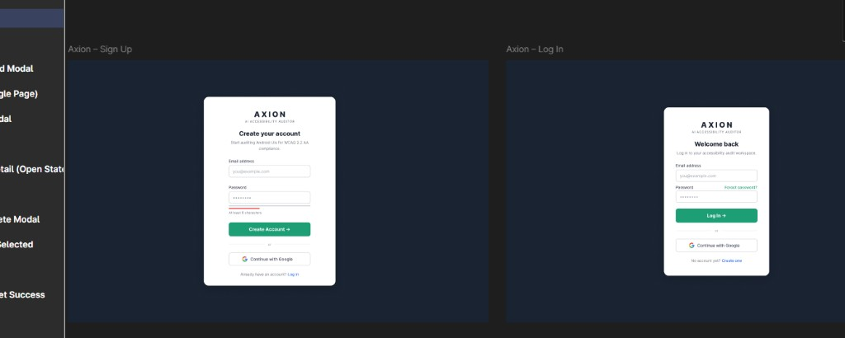
Sign Up and Log In screens — Axion Figma

Screen | Elements
Sign Up | Title "Create your account"; Email; Password (min 8 chars + strength hint); Create Account →; Continue with Google; link to Log In
Log In | Title "Welcome back"; Email; Password; Forgot password? link; Log In →; Continue with Google; link to Sign Up

F.3 Forgot Password and OTP Verify (Must Have)
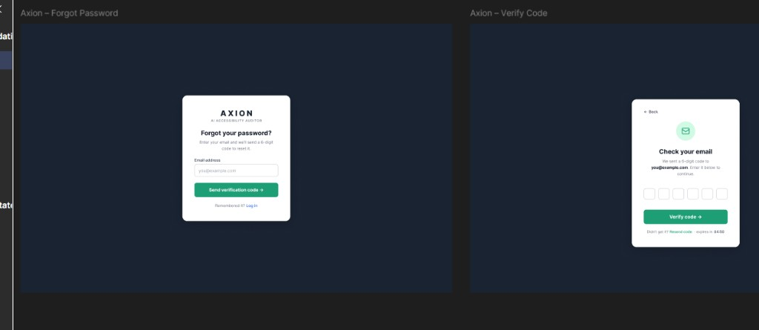
Forgot Password and Verify Code screens

Step | Elements
Forgot Password | "Forgot your password?"; email field; Send verification code →; "Remembered it? Log in"
Verify Code | ← Back; envelope icon; "Check your email"; six OTP digit boxes; Verify code →; resend timer (e.g. expires in 04:50)

F.4 Set Password and Reset Success (Must Have)
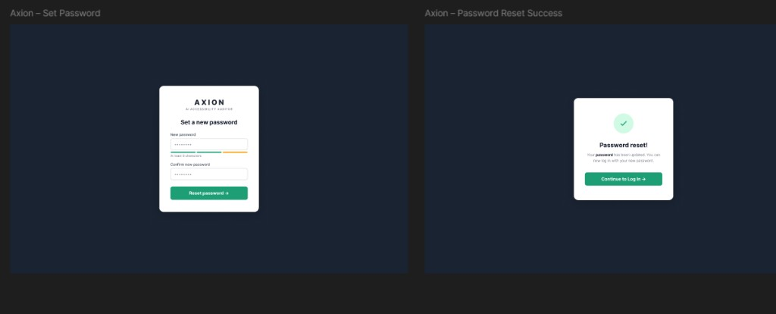
Set Password and Password Reset Success

Step | Elements
Set Password | New password + confirm; strength meter; Reset password →
Success | Green checkmark; "Password reset!"; Continue to Log In →

F.5 Upload — progress states (Must Have)
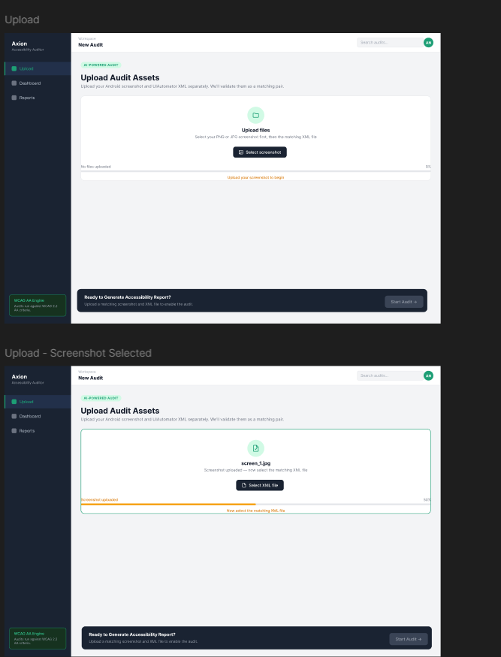
Upload screen — initial and screenshot-uploaded states

- AI-POWERED AUDIT badge; title Upload Audit Assets
- Unified drop zone: Select screenshot → then Select XML file
- Progress bar: 0% → 50% → 100% with helper text
- Bottom bar: disabled Start Audit → until pair validated

F.6 Upload — Files Matched (Must Have)
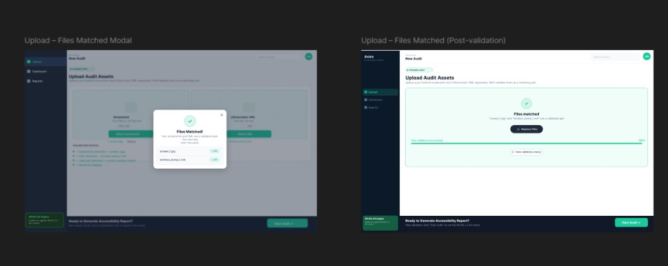
Files Matched modal and validated state

- Files Matched! modal lists screen_1.jpg + window_dump_1.xml with OK badges
- Post-dismiss: green validated panel, Replace files, 100% progress, View validation status
- Validation Status checklist (all four green) visible in background

F.7 Audit Complete modal and Dashboard (Must Have)
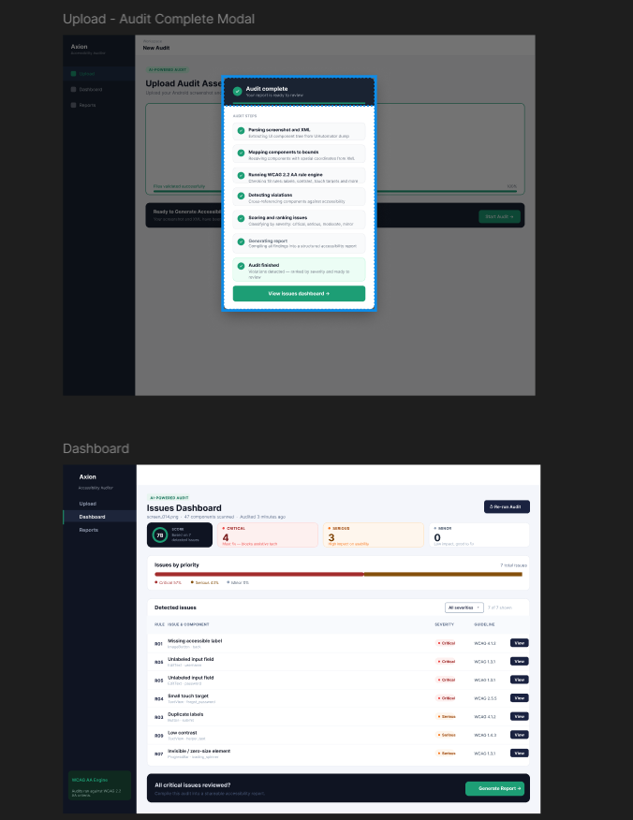
Audit Complete modal and Issues Dashboard

Audit Complete modal: seven pipeline steps with checkmarks; View issues dashboard →
Dashboard: score gauge (0–100); Critical / Serious / Minor cards; Issues by Priority bar; violations table (Rule, Issue & Component, Severity, Guideline, View); bottom Generate Report →

F.8 Dashboard Issue Detail and Audit Report (Must Have)
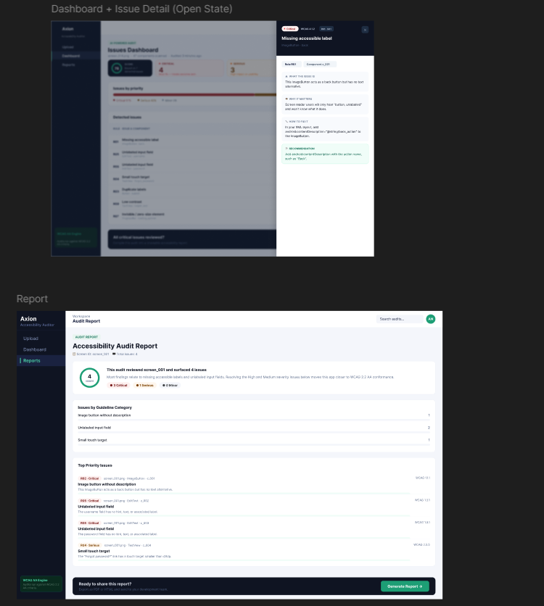
Issue Detail drawer and Audit Report page

Issue Detail drawer: Critical badge; WHAT THE ISSUE IS / WHY IT MATTERS / HOW TO FIX IT / RECOMMENDATION; tabs Rule + Component
Audit Report: score summary; Issues by Guideline Category; Top Priority Issues with WCAG refs; Generate Report footer

F.9 Generate Report modal and PDF layout (Must Have)
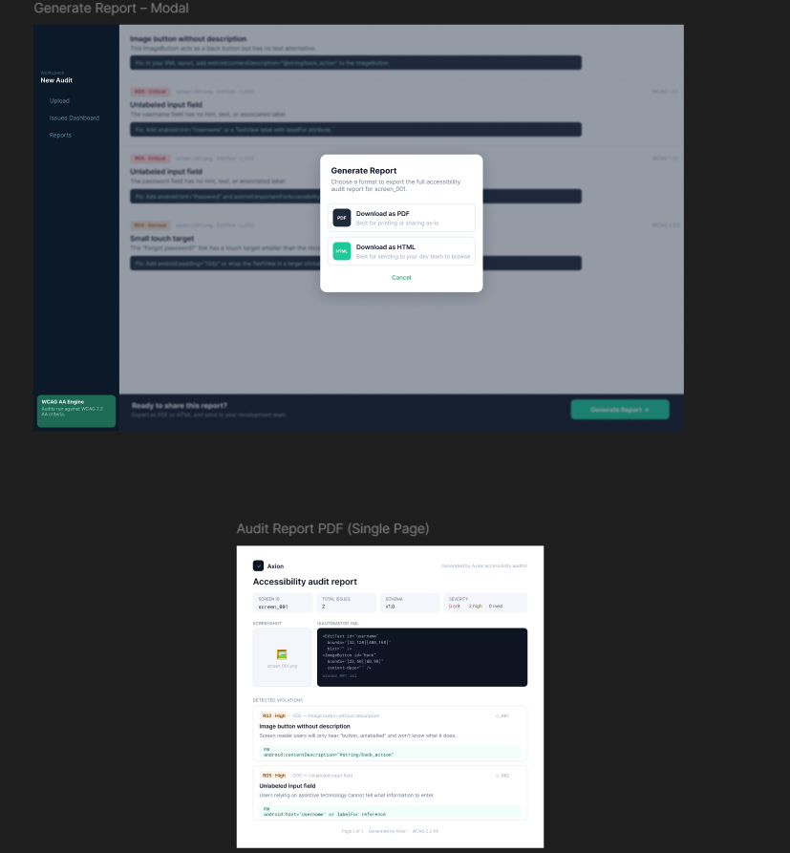
Generate Report modal and PDF single-page layout

Modal: Download as PDF (print/share); Download as HTML (dev team); Cancel
PDF: Axion header; metadata boxes (Screen ID, Total Issues, Schema, Severity); screenshot + XML snippet; violation blocks with green fix highlights

F.10 Records page — Reports (Must Have)
No Figma screenshot was provided for Records; implement using the same design system as Dashboard:
Element | Specification
Route | Sidebar Reports → /records
Table columns | Screen ID, Date, Score, Total issues, Critical, Serious, Moderate, Minor
Row action | Open report view or download PDF/HTML
Empty state | Illustration + "No audits yet" + Start new audit → link to Upload
Scope | Show logged-in user's audits only (FR-REC.3)

F.11 Navigation map
[Sign Up] ←→ [Log In] → [Forgot Password → OTP → Reset → Success]
↓
[Upload] → [Files Matched] → [Start Audit] → [Audit Complete modal]
↓
[Dashboard] → [Issue Detail drawer] → [Audit Report] → [Generate Report Modal]
↓
[Records / Reports] (saved audits list)
────────────────────────────────────────────────────────────────────────
— End of Software Requirements Specification v2.0 —

