Supplementary Progress Report

Agentic Accessibility Auditor (Axion)
Practical work completed — Weeks 1–7 + post–Week 7 YOLO track (baseline 1 July 2026; updated 27 July 2026)
Living document — see §15 / §15B / §15C for team updates; §12–§13 for literature + rule ownership
Field | Value
Report type | Empirical / progress (not theoretical SRS/SDS)
Prepared by | Muhammad Noor (Lead)
Team | Salar (parser, MASC data, rules, tests, YOLO notebook); Ayesha (Rico holdout, frontend, SRS, rules, prompt experiments); Noor (backend, JSON schemas, SDS, agent, reports, rules, SRS review, tests, QA, Colab YOLO training)
Repository | [MuhammadNoor7/agentic-accessibility-auditor](https://github.com/MuhammadNoor7/agentic-accessibility-auditor)
Canonical specs | In repo: srs/ · sds/ · updated_plan.md
Report version | v1.23 (27 Jul 2026 — final comprehensive)

1. Purpose of this report
This document gathers what has actually been built, run, and produced so far. It is intentionally different from the SRS and SDS, which describe what the system must do and how it should be designed. Here we record:
- Real file outputs and counts
- Sign-off test results
- Dataset preparation numbers
- Repository and folder structure as it exists today
- Gaps between plan and implementation

2. Executive summary
| Note: Baseline below is as of 1 July 2026. For current status after team pushes, see §15 Team weekly updates.
Area | Result (27 Jul on noor)
Parser (Stage 1) | Complete — hybrid XML parser; MASC <wrapper> + bounds fixes; visibility field; R13–R20 extended fields
Rule engine (Stage 2) | R01–R30 implemented — 57 XML pass/fail fixtures; 146 pytest collected
Agent layer (Stage 3) | Wired — src/explainer.py + src/agent.py (build_audit_report); LLM or template fallback; API-wired
Report generator (Stage 4) | Done — src/report.py (Jinja2 HTML + PIL + Playwright PDF); screenshot/XML persisted for export; GET …/report/download
Axion React UI | Complete for Week 6 MVP — Upload/Dashboard/Report/Records + Sign Up/Log In/Forgot/OTP/Reset + Google Sign-In + profile initials
FastAPI audit API | Done — paired POST /api/v1/audit, violations, report, download
Auth + Records | Done on `noor` — JWT + OTP/SMTP + Google OAuth + per-user /records (score/filename fields)
Docker | Synced — compose services backend + auditor (frontend via local Vite)
Documentation | SRS v2.7, SDS v2.11, progress report v1.20, plan updated 27 Jul
Screenshot-only YOLO detector | Functional Prototype — MASC fine-tuned YOLO11s UI Element detector; best.pt exported (~19 MB); detect_ui() inference module ready

Bottom line (27 Jul): Week 6–7 complete on noor. Post–Week 7 (YOLO Track): Salar’s YOLO UI-element training notebook merged and implemented; Noor completed training on Google Colab T4 using MASC (7,068 screens). Initial mAP50-95 of 0.2846 achieved. Best weights exported to models/yolo_ui_detector_best.pt. Inference module src/yolo_ui_detector.py created to support screenshot-only auditing. Next Steps: Evaluate on Rico holdout; integrate YOLO as automatic fallback when XML is missing or malformed; research specialized models for R09 (contrast) and visual clipping (R10/R28) per docs/user_coverage_for_training.md.

2.1 Team contributions & artifact ownership (12 Jul 2026)
| Credit map for supervisor review — reflects who built each major deliverable on branch noor.
Area | Primary contributor(s) | Evidence
Data collection | All interns | Shared dataset effort
MASC dataset (7,068 screens) | Salar + Noor | data/data-masc/; full re-parse sign-off
Rico holdout (1,698 screens) | Ayesha | data/data-rico-holdout/; manifest
Parser → components.json | Salar + Noor | src/parser.py (Noor: R13–R20 fields, visibility, MASC wrapper fix)
Rules → violations.json | Salar + Noor + Ayesha (reviewed by all) | src/rules.py R01–R30; 57 XML fixtures; R11–R12 sign-off
Agent → report.json | Noor | src/agent.py, src/explainer.py, score formula
Report template (HTML/PDF) | Noor | src/report.py, src/templates/audit_report.html.j2
Backend / FastAPI | Noor (audit) + Salar (auth/records base) + Noor (OTP/SMTP/OAuth) | backend/routers/audit.py; auth.py, otp_store.py, email_service.py, auth_router.py, records_router.py
Frontend (Axion) | Ayesha (+ Salar/Noor auth wiring) | frontend/; Upload/Dashboard/Report/Records + full auth
JSON structure + schema docs | Noor | docs/json_schemas.md, docs/schemas/auditor_schema.json, src/schema_documents.py
SRS / SDS | Ayesha+Salar (SRS) / Noor (SDS + Week 6 sync) | srs/ · sds/
Tests (pytest) | Salar + Noor | tests/ + backend/tests/ — 146 collected (16 Jul)

3. Pipeline status (actual vs planned)
Stage | Owner | Output artefact | Status (16 Jul) | Evidence
1 — Parser | Salar / Noor | *_components.json | Done | data/data-masc/parsed/ (7,068; sign-off PASS)
2 — Rules | Salar + Noor + Ayesha | violations.json | Done R01–R30 | src/rules.py; 57 XML fixtures
3 — Agent | Noor | enriched report.json | Done | GET /api/v1/audit/{id}/report
4 — Report | Noor | HTML/PDF | Done | download API; screenshot/XML persist + autoescape
UI — Axion | Ayesha / Noor | React app | Done (Week 6 MVP) | Upload/Dashboard/Report/Records + full auth flows
API — Audit | Noor | FastAPI | Done | /api/v1/audit/*
Auth / Records | Salar + Noor | JWT + OTP/SMTP/OAuth + history | Done | /auth/*, /records/*; 146 pytest collected
Week 6 eval | Noor | 40-screen sheet | Done | docs/week6/ + validation logs
Week 7 QA | Noor | Rule/guideline summaries | Done (holdout deferred) | docs/week7/ · outputs/week7_eval/
YOLO UI detector | Salar (notebook) + Noor (Colab train) | best.pt / last.pt | In progress (MASC train; Rico eval pending) | notebooks/train_yolo_ui_detector.ipynb · Drive results_of_yolo/

4. Project folder structure (repository root)
| As of 12 July 2026 on branch noor (commit 4ce430feb) — canonical repo: [agentic-accessibility-auditor](https://github.com/MuhammadNoor7/agentic-accessibility-auditor)
agentic-accessibility-auditor/ ← repo root (clone / _noor_push locally)
│
├── src/ ← Stage 1–3 Python core
│ ├── parser.py ← XML → components.json (Stage 1; R13–R20 fields + visibility)
│ ├── rules.py ← R01–R30 rule checker (Stage 2)
│ ├── agent.py ← Score + build_audit_report (Stage 3; API-wired)
│ ├── report.py ← Jinja2 HTML + Playwright PDF (Stage 4)
│ ├── templates/
│ │ └── audit_report.html.j2 ← Standalone HTML report template
│ ├── explainer.py ← Live LLM recommendations (batched; anti-hallucination)
│ ├── guidelines.py ← G01–G30 + R→G mapping for explainer
│ ├── llm_providers.py ← Anthropic / OpenAI / Gemini / Groq
│ └── schema_documents.py ← JSON envelope builders
│
├── backend/ ← FastAPI gateway
│ ├── main.py ← App entry + CORS + routers
│ ├── requirements.txt
│ ├── models/
│ │ └── audit.py ← Pydantic audit response models
│ └── routers/
│ └── audit.py ← POST /audit, GET …/violations, GET …/report, GET …/report/download
│
├── frontend/ ← Axion React UI (Ayesha, synced to noor)
│ ├── package.json ← Vite 8 + React 19 + Tailwind 4
│ ├── vite.config.js
│ ├── public/ ← favicon, icons
│ └── src/
│ ├── App.jsx ← Routes (auth + Upload/Dashboard/Report/Records)
│ ├── main.jsx, index.css
│ ├── state/auditFiles.js ← Upload file state (wired to POST /audit)
│ ├── components/
│ │ ├── Sidebar.jsx
│ │ ├── layout/ ← AuthLayout, MainLayout
│ │ └── ui/ ← Button, TextField, OtpInput, FileDropzone, …
│ └── pages/
│ ├── auth/ ← Login, SignUp, ForgotPassword, VerifyCode, …
│ ├── Upload.jsx, Dashboard.jsx, Report.jsx, Records.jsx
│ └── main/Placeholder.jsx
│
├── tests/ ← pytest suite (**120** passed on `noor`)
│ ├── test_parser.py
│ ├── test_rules.py ← R01–R30 pass/fail XML fixtures (78 tests)
│ ├── test_agent.py ← score + template report
│ ├── test_audit.py ← FastAPI violations + report + download
│ ├── test_report.py ← HTML/PDF export (Week 5)
│ ├── test_explainer.py ← anti-hallucination / batching (mocked LLM)
│ └── fixtures/rules/ ← 57 controlled XML screens (R01–R30)
│
├── data/ ← datasets + local uploads
│ ├── data-masc/
│ │ ├── parsed/ ← 7,068 MASC components.json
│ │ │ ├── masc_parse_signoff_report.json
│ │ │ └── batch_parse_masc_full.log
│ │ └── splits/ ← train / val / test split JSON
│ ├── data-rico-holdout/ ← 1,698-screen holdout + manifest
│ ├── xml/ ← generic upload XML drops
│ ├── parsed/ ← generic parsed output
│ └── screenshots/ ← screenshot uploads (paired with XML for POST /audit)
│
├── outputs/ ← pipeline artefacts
│ ├── violations/ ← *_violations.json (Stage 2; generated locally)
│ ├── reports/ ← *_report.json, .html, .pdf (Stages 3–4)
│ └── validation_logs/
│ ├── noor_week1–4 summaries + logs
│ ├── noor_week5_summary.md
│ └── noor_week5_validation_log.txt
│
├── notebooks/
│ └── masc_dataset_analysis.ipynb ← Salar MASC analysis (synced Week 4)
│
├── docs/ ← project documentation
│ ├── progress/
│ │ └── Supplementary_Progress_Report_v1.0.md ← this report
│ ├── schemas/auditor_schema.json
│ ├── examples/ ← sample components / violations / report JSON
│ ├── assets/ ← Figma exports (SRS Appendix F)
│ ├── r11_r12_design.md
│ ├── qa_test_plan.md
│ └── updated_plan_v2.0.docx
│
├── scripts/ ← batch + validation utilities
│ ├── validate_output.py
│ ├── noor_week3_validate.py
│ ├── noor_week4_validate.py
│ ├── noor_week5_validate.py
│ ├── masc_parse_signoff.py
│ ├── run_explainer_sample.py ← Stage 3 LLM sample runner
│ ├── compare_visibility_filter_impact.py
│ ├── split_masc_dataset.py
│ └── build_rico_holdout.py
│
├── srs/ ← SRS v2.0 (md + docx)
├── sds/ ← SDS v2.2 (md + docx)
│
├── app.py ← Streamlit dev UI (parse + violations preview)
├── test_run.py ← CLI batch / single-file parser + rules
├── .env.example ← LLM_PROVIDER + API key template
├── requirements.txt ← root Python deps (+ anthropic/openai/groq)
├── updated_plan.md ← 8-week team plan
├── conftest.py
└── README.md

Key paths by pipeline stage
Stage | Primary code | Output location
1 — Parser | src/parser.py, test_run.py, app.py | data/**/parsed/*_components.json
2 — Rules | src/rules.py | outputs/violations/*_violations.json
3 — Agent | src/agent.py, src/explainer.py | outputs/reports/*_report.json
4 — Report | src/report.py | outputs/reports/*_report.html / .pdf + download API
API | backend/routers/audit.py | in-memory job → violations + report JSON + file download
UI | frontend/ | browser at :5173 (Upload/Dashboard/Report wired; Records mock)

Local workspace (optional clones)
Team members may keep additional working copies beside the canonical clone:
d:\internship\
├── agentic-accessibility-auditor\ ← main local copy
├── _noor_push\ ← Noor's push branch working copy
├── _salar_pull\ ← Salar sync copy
└── updated_plan.md ← local plan copy (also in repo root)
Important: Treat the GitHub repo root layout above as the single source of truth for code and folder conventions.

5. Parser deliverables (Salar)

5.1 Sign-off result (re-parse 6 July 2026)
Metric | Value
Dataset | MASC
Total screens | 7,068
Categories | 10
Components parsed | 640,563
Violations (R01–R20) | 462,542
Extended parser fields | 0 missing (all 13 R13–R20 fields)
Parse OK | 7,068
Parse errors | 0
Sign-off | PASS

Source: data/data-masc/parsed/masc_parse_signoff_report.json
Scripts: python test_run.py --dataset masc · python scripts/masc_parse_signoff.py
Commit: f7bcac9 on branch noor
Parser fix (Jul 2026): MASC widgets nest inside <wrapper> nodes; depth-first walk now descends into wrappers (previously ~1 component/screen).

5.2 MASC train / val / test split
Split | Screens | Ratio
Train | 4,943 | 70%
Val | 1,056 | 15%
Test | 1,069 | 15%
Total | 7,068 | 100%

Config: data/data-masc/splits/split_summary.json

5.3 Supported XML formats
src/parser.py handles UIAutomator, MASC, Rico, and generic upload formats.

6. Dataset work

6.1 MASC (primary development corpus)
- Screens: 7,068 paired screenshot + XML
- Parsed output: data/data-masc/parsed/{category}/{id}_components.json
- Splits: data/data-masc/splits/

6.2 Rico holdout (unseen final evaluation)
- Selected screens: 1,698 (after removing 302 MASC-overlapping screens)
- Overlap verification: 0 hash collisions
- Manifest: data/data-rico-holdout/manifest/selection_report.json
- Parsed at baseline: 4 screens (holdout batch not yet run at scale)

7. Code and infrastructure delivered (updated 12 Jul)
Path | Purpose | Owner
src/parser.py | Hybrid XML → components.json | Salar / Noor
src/schema_documents.py | JSON envelope builders | Noor
src/rules.py | R01–R30 rule checker → violations.json | Salar + Noor + Ayesha (reviewed by all)
src/agent.py, src/explainer.py | Agent layer → report.json | Noor
src/report.py, src/templates/ | HTML/PDF report export | Noor
backend/routers/audit.py | FastAPI audit + download API | Noor
test_run.py | CLI batch / single / --fixtures | Salar / Noor
tests/ | pytest suite (146 collected, 16 Jul) | Salar / Noor
app.py | Streamlit dev UI | Salar
scripts/validate_output.py | JSON schema validation | Noor / Salar
docker-compose.yml | Backend + auditor services | Salar

8. Documentation delivered
Document | Author(s) | Status
SRS v2.0 | Ayesha + Salar (Noor review) | Complete
SDS v2.2 | Noor | Complete
JSON schemas + auditor_schema.json | Noor | Complete
Accessibility guidelines (G01–G30, R01–R30) | Team (Noor lead doc) | Complete
QA test plan (TC-01–TC-06) | Noor | Complete
Figma UI specs (SRS Appendix F) | Ayesha | Documented
Updated 8-week plan | Noor | Complete

9. Per-person contribution summary (updated 12 Jul)

Salar — Parser, rules, MASC data, Agent, Docker, tests, JWT/records
Done: Hybrid parser (with Noor); R01–R30 rules (with Noor + Ayesha; reviewed by all); MASC integration + batch scripts; Docker Compose; components.json pipeline; pytest (with Noor); JWT auth + records API (synced to noor Week 6)
Pending: Branch rename azeem → salar (if still open); rule FP tuning (Week 7)

Ayesha — Rico holdout, frontend, SRS, rules,
Done: Rico holdout build; Figma designs; React Axion UI (incl. auth screens); SRS co-author; frontend ↔ API wiring; Records on live API; rules (with Salar + Noor; R11–R12 sign-off); Groq prompt experiments (TBD-01)
Pending: UI polish / prompt comparison notes (Week 7)

Noor (Lead) — Parser, MASC data, Backend, Frontend Review, schemas, SDS, agent, reports, rules, SRS review, tests, QA, Week 6 auth stretch
Done: FastAPI audit API; JSON schemas; SDS; SRS review; agent + report template (JSON/HTML/PDF + export fix); parser extensions; rules (with Salar + Ayesha); Week 1–6 validation; OTP + Gmail SMTP + Google OAuth; any-domain signup emails; profile initials; 40/40 eval sheet + R26–R30 design; docs/plan alignment
Pending: Rico holdout evaluation (Week 8); Friday demo rehearsal

10. Week 2 completion checklist (baseline)
Task | Done?
MASC dataset integrated locally | Yes
Parser handles MASC/Rico/UIAutomator formats | Yes
7,068 components.json files generated | Yes
Parser sign-off PASS | Yes
Train/val/test split created | Yes
Rico holdout built (1,698 disjoint screens) | Yes
JSON schemas documented + validated | Yes
SRS + SDS v2.0 written | Yes
Docker backend runs (health only) | Yes
Rule engine R01–R10 | No (at baseline)
React UI started | No

Week 2 status: ~75% complete at baseline.

11. Key output file locations
What | Where
Parsed MASC components | data/data-masc/parsed/
Parser sign-off report | data/data-masc/parsed/masc_parse_signoff_report.json
Split summary | data/data-masc/splits/split_summary.json
Rico holdout manifest | data/data-rico-holdout/manifest/selection_report.json
JSON schema | docs/schemas/auditor_schema.json
Example outputs | docs/examples/components.json, violations.json, report.json

12. Literature insights (Chen et al., IEEE TSE 2021)
Paper: Accessible or Not? An Empirical Investigation of Android App Accessibility (Chen et al., 2021, DOI [10.1109/TSE.2021.3108162](https://doi.org/10.1109/TSE.2021.3108162))
Why it matters for Axion: The paper studies 86,767 issue-level findings from 2,270 Android apps using automated exploration (tool: Xbot). This validates our approach of rule-based, violation-level auditing rather than only screen-level pass/fail.

Top real-world issue types (literature + full MASC validation, Jul 2026)
Rank | Issue type (literature) | Our rule(s) | MASC evidence (7,068 screens)
1 | Missing label / content description | R01, R02, R30 | R01: 60,112 violations / 6,185 screens
2 | Layout / focus order issues | R07, R08, R15 | R07: 266,393; R15: 3,860 screens
3 | Small touch target / spacing | R04, R17 | R17: 9,327 violations / 1,697 screens
4 | Multi-gesture only | R18 | R18: 13,529 violations / 3,945 screens
5 | Unlabeled input | R05, R20 | R05: 3,797; R20: 0 (no hint-only inputs in MASC)
6 | Low contrast | R09 | 0 — needs screenshot CV

Findings we apply directly
- Prioritize R01–R05 in MVP — highest frequency in literature and in our MASC sample.
- R07 remains dominant on full MASC — review false-positive rate (bounds fallback).
- R13–R20 are active on real data after parser re-parse (audio, focus order, spacing, gestures).
- Issue-level JSON enables severity stats and guideline mapping per Chen et al.
Sources: outputs/validation_logs/noor_week3_summary.md · data/data-masc/parsed/masc_parse_signoff_report.json

13. Rule & guideline ownership checklist (R01–R30)
| All 30 rules and 30 guidelines are team-owned. "Lead" implements; "Reviewers" must approve PRs. Canonical G↔R mapping: docs/accessibility_guidelines_report.md §3–§4.

Block leads (from `updated_plan.md`)
Block | Rule lead | Guideline validation | Reviewers
R01–R10 / G01–G10 | Salar | Noor | Ayesha
R11–R12 / G11–G12 | Ayesha | Salar | Noor
R13–R20 / G13–G20 | Noor | Salar | Ayesha
R21–R30 / G21–G30 | Noor | Ayesha | Salar

Per-rule tracker
Rule | Guideline(s) | Lead | Status | Notes
R01 | G01, G02, G30 | Salar | ✅ Done | High frequency in validation
R02 | G02, G30 | Salar | ✅ Done
R03 | G03 | Salar | ✅ Done
R04 | G04, G17 | Salar | ✅ Done | DPI-aware (Week 3 fix)
R05 | G05, G20 | Salar | ✅ Done | hint field + INPUT_CLASSES
R06 | G06, G26 | Salar | ✅ Done
R07 | G07, G25 | Salar | ✅ Done | Review false-positive rate
R08 | G08, G15 | Salar | ✅ Done | Zero-area guard added
R09 | G09, G11 | Salar | 🟡 Partial | Needs declared colors / screenshot contrast
R10 | G10, G28, G29 | Salar | ✅ Done
R11 | G11 | Ayesha | ✅ Done | Implemented by Salar; reviewed by Ayesha + Noor
R12 | G12 | Ayesha | ✅ Done | media_type + caption heuristics; Ayesha review sign-off
R13 | G13 | Noor | ✅ Done | 1,055 violations / 118 MASC screens
R14 | G14 | Noor | ✅ Done | 1,873 / 667 screens
R15 | G15, G16 | Noor | ✅ Done | 3,860 / 3,860 screens
R16 | G16 | Noor | ✅ Done | 130 / 115 screens
R17 | G17 | Noor | ✅ Done | related_component; 9,327 / 1,697
R18 | G18 | Noor | ✅ Done | 13,529 / 3,945 screens
R19 | G19 | Noor | ✅ Done | 758 / 416 screens
R20 | G05, G20 | Noor | ✅ Done | Unit tests pass; 0 MASC hits
R21 | G21 | Noor | ✅ Done | Vague error message (Salar sync Week 4)
R22 | G22 | Noor | ✅ Done | No password toggle
R23 | G01, G23 | Noor | ✅ Done | Unlabeled nav control
R24 | G24 | Noor | ✅ Done | Missing screen title
R25 | G25 | Noor | ✅ Done | Uncontrolled animation
R26 | G06, G26 | Noor | ✅ Done | No timeout warning
R27 | G27 | Noor | ✅ Done | Complex label language
R28 | G10, G28 | Noor | ✅ Done | Font scale overflow (needs declared text size)
R29 | G29 | Noor | ✅ Done | All-caps body text
R30 | G01, G30 | Noor | ✅ Done | Icon-only, no label

Legend: ✅ implemented + tests · 🟡 stub/partial · ⬜ not started

14. Recommended next steps (updated 15 July 2026)
- Noor: Fill ≥25 manual rows on docs/week6/evaluation_sheet_40_screens.csv (FP / missed notes)
- All: Friday demo — login → upload screenshot+XML → dashboard → report HTML/PDF → Records list
- Noor (stretch): Map guidelines for CV training on MASC train → tune on val → test on test; never train on Rico holdout
- Ayesha: Continue prompt experiments; polish auth/records UX if needed
- Salar: Keep JWT secret configured for demos; continue rule FP tuning
- Team: Friday demo path — signup/login → upload pair → report → Records

15. Team weekly updates
| Instructions: Each intern adds a dated entry after pushing work. Newest week at the top. Keep entries factual — file names, test counts, branch commits.

Week 6 close-out — Noor (`noor` / `995f6d31`, 16 Jul 2026)
Pushed by: Muhammad Noor
Date: 16 July 2026
Completed (auth / mail / OAuth / eval / export):
- Sign Up / Log In — JWT register/login; password policy (letter+digit); optional name; UserAvatar initials
- Forgot → OTP → Reset — forgot-password, resend-otp, verify-otp, reset-password wired end-to-end
- SMTP — Gmail App Password via .env (SMTP_HOST, SMTP_USER, SMTP_FROM, SMTP_PASSWORD); real OTP emails verified; AUTH_DEV_SHOW_OTP=0 when mail works
- Recipient domains — any valid email (Yahoo, Outlook, university/education, …); sender remains Gmail
- Google OAuth — GIS + POST /auth/google; GOOGLE_CLIENT_ID in .env / .env.example
- Other settings — JWT_SECRET; load_dotenv(override=True); frontend VITE_API_BASE
- Report export fix — persist screenshot/XML for HTML/PDF; Jinja autoescape (123fbde4)
- Eval — 40/40 assisted FP/miss notes on stratified sheet; evaluation_sheet.md / .docx + method note
- Docs — SRS v2.4 · SDS v2.8 · updated_plan.md · this progress report
- Validation (16 Jul live): auth 22 passed · audit 9 passed · R26–R30 8 passed · eval integrity 40/40
→ outputs/validation_logs/noor_week6_validation_log.txt + noor_week6_summary.md
Pending:
- Friday demo rehearsal
- Rico holdout batch (Week 8)
Blockers: None
Secrets: App Passwords / JWT_SECRET stay local (gitignored). Document env names only in .env.example.

Week 6 — Noor (`noor` branch — Salar + Ayesha sync + eval, 15 Jul 2026)
Pushed by: Muhammad Noor (integration) — sources: Salar 198936146, Ayesha 3d4fa82eb
Date: 15 July 2026
Completed:
- Synced Salar JWT + records into _noor_push / noor — backend/auth.py, auth_router.py, records_router.py, test_auth.py, Docker/compose, Login/SignUp, frontend/src/utils/auth.js
- Synced Ayesha — docs/agent_prompt_experiments.md (larger Groq sample); Dashboard.jsx re-run popup layout
- Noor UI polish — Report score ring (accessibility_score); Records Screenshot/XML + Score columns; Upload saves record when logged in
- Eval sheet — docs/week6/evaluation_sheet_40_screens.csv — stratified random 4×10 MASC categories (seed 20260715); R26–R30 design DOCX
- `.gitignore` — synced from Salar (data/ + outputs/ + validation/samples exceptions)
- Validation — scripts/noor_week6_validate.py → outputs/validation_logs/noor_week6_summary.md + noor_week6_validation_log.txt
- auth tests: 12 passed (expanded to 22 on 16 Jul — see close-out entry above)
- audit tests: 8 passed, 1 skipped (PDF included on 16 Jul re-run)
- R26–R30: 8 passed
- Auth/Records API smoke: PASS
Pending (resolved 16 Jul):
- ~~≥25 manual eval verdicts on the CSV~~ → 40/40 done
- Rico holdout batch evaluation (Week 8)
- ~~OTP / SMTP stretch~~ → Done
Blockers: None on sync scope

Upload validation fix — Ayesha + Noor (`ayesha` `052a976` → merged on `noor`, 14 Jul 2026)
Pushed by: Ayesha Naveed (frontend) + Muhammad Noor (backend/docs)
Date: 14 July 2026
Completed (handoff doc — 4 issues):
- Issue 1 — XML without screenshot shows error popup (not silent) — Upload.jsx
- Issue 2 — createAudit(screenshot, xml) sends both files — api.js
- Issue 3 — Backend requires screenshot + XML; 400 on pair mismatch — backend/routers/audit.py
- Issue 4 — filesMatch() stem/prefix logic rejects false-positive digit matches — Upload.jsx
- Tests — tests/test_audit.py updated; missing-screenshot + mismatched-pair cases; validation scripts aligned
Pending: Records + auth (Week 6)
Blockers: None

Week 5 — Noor (`noor` branch, commit `4ce430feb` — pushed 12 Jul 2026)
Pushed by: Muhammad Noor
Date: 12 July 2026
Completed:
- `src/report.py` — Jinja2 template (src/templates/audit_report.html.j2), PIL screenshot bounding-box annotation, Playwright PDF export
- Download API — GET /api/v1/audit/{id}/report/download?format=html|pdf (sync handler for Playwright)
- Frontend — downloadAuditReport() in api.js; Report.jsx real HTML/PDF download after processing animation
- Rule fixtures — 21 new R09–R20 pass/fail XML files; test_run.py --fixtures batch mode; fixture path fix (no MASC root collision)
- Tests — tests/test_report.py; extended tests/test_audit.py + tests/test_rules.py; 120 pytest passed
- Validation — scripts/noor_week5_validate.py + validation logs
- Docs — SRS/SDS/README/updated_plan/progress report aligned; WeasyPrint → Jinja2 + Playwright
Pending:
- Records + auth (Week 6)
- Rico holdout batch evaluation
Blockers: None

Week 4 — Ayesha
Pushed by: Ayesha Naveed
Date: 11 July 2026
Completed:
- R11–R12 review sign-off: reviewed src/rules.py implementations of check_color_only_info (R11) and check_missing_captions (R12) against docs/r11_r12_design.md. Confirmed both rules moved past their original Week 3 stub design — R11 now flags checkable-state widgets (CheckBox/Switch/ToggleButton/RadioButton) with no text/content_desc; R12 now uses parent_id sibling adjacency plus bounds-proximity fallback, not just a blanket VideoView flag. Ran pytest tests/test_rules.py -k "r11 or r12" — all 5 relevant tests passed (fixture pass/fail cases, non-checkable-widget exclusion, sibling-vs-bounds-distance priority, non-media stub behavior).
- Frontend ↔ API wiring (Priority 1): Upload, Dashboard, and Report pages now call the live backend (POST /api/v1/audit, GET /report) instead of mock data. Tested end-to-end with a real XML fixture and Groq — confirmed full pipeline works (upload → audit → dashboard → report).
- Agent prompt experiments (TBD-01): ran scripts/run_explainer_sample.py — Groq tested successfully (15/15 violations explained, good quality, no hallucination observed). Anthropic/OpenAI blocked by paid billing requirements; Gemini blocked by a Google-side free-tier quota bug (429, limit 0) even after Noor's SDK fix resolved the original key-format issue. Documented in docs/agent_prompt_experiments.md and docs/TBD-01-decision.md; TBD-01 marked Resolved (Groq as default) in this doc's Open Decisions table.
Pending:
- Full 4-provider comparison once Anthropic/OpenAI credits are available and Gemini's quota issue is resolved
- Records/Audit History page — blocked on backend (no list endpoint, no persistence yet)
- Auth pages (login/signup/etc.) — blocked on backend (no auth router implemented yet)
Blockers: None on my own tasks; Records + Auth wiring blocked on backend work not yet scoped.

Week 4 — Noor (`noor` branch, commits `98efd2fe0` → `0144b1af3`)
Pushed by: Muhammad Noor
Date: 9 July 2026
Completed:
- Salar sync (98efd2fe0): Stage 3 LLM layer — src/explainer.py, src/guidelines.py, src/llm_providers.py; rules R01–R30 + visibility filter; parser bounds/visibility fixes; R11 + R21–R30 fixtures; scripts/run_explainer_sample.py, compare_visibility_filter_impact.py; .env.example
- Notebook sync (20c96fd07): notebooks/masc_dataset_analysis.ipynb
- Ayesha frontend sync (2d8356066): Report/Sidebar/Dashboard/Records/Upload updates + frontend/src/state/auditFiles.js
- Agent API wiring (0144b1af3): build_audit_report() in src/agent.py merges explainer + score formula (TBD-02); GET /api/v1/audit/{id}/report; pipeline statuses include explaining; template fallback when no API key (FR-AG.6); reports → outputs/reports/
- Tests: 94 pytest passed (parser, rules R01–R30, agent, audit, explainer)
- Week 4 demo goal met: XML upload → violations → agent-enriched report.json (template mode without live LLM)
Pending:
- Ayesha: frontend ↔ API wiring; prompt experiments + TBD-01 model choice
- src/report.py HTML/PDF (Week 5)
- Formal R11–R15 review sign-off documentation
- Rico holdout batch evaluation
- Auth + Records API
Blockers: None (API ready for Ayesha)

Week 3+ — Noor (`noor` branch, commit `f7bcac9`)
Pushed by: Muhammad Noor
Date: 6 July 2026
Completed:
- Parser R13–R20 extension — 13 new component fields (focus_order, parent_id, media_type, etc.)
- MASC `<wrapper>` fix — full widget extraction (640,563 components vs ~1/screen before)
- Rules R13–R20 wired in check(); 31 rule tests + 3 parser tests (38 total with agent/audit)
- Full MASC re-parse — 7,068 XML → data/data-masc/parsed/; 462,542 violations
- `scripts/noor_week3_validate.py` — re-parse + pytest + random 20-screen MASC sample + schema check
- `scripts/masc_parse_signoff.py` — extended-field validation + R13–R20 aggregate counts
- SDS v2.1 — R01–R20 parser/rules design, validation artefact paths
- `auditor_schema.json` — optional R13–R20 component fields
- Validation logs: noor_week3_summary.md, noor_week3_validation_log.txt, masc_reparse_log.txt
- Sign-off: masc_parse_signoff_report.json → PASS (0 extended-field misses)
Pending:
- Wire live LLM into agent (Week 4)
- Connect frontend to FastAPI
- src/report.py HTML/PDF generation
- Auth + Records API
Blockers: None

Week 3 — Salar (`salar` branch, commits `c46b4da` → `712dbd8`)
Pushed by: Muhammad Salar Khan
Latest: 712dbd8 — violations outputs + Week 3 validation logs
Completed:
- R01–R10 rule checker + 23 pytest tests
- R04/R05/R08 fixes (real DPI, hint, overlap zero-area guard)
- app.py wired to Stage 2 (violations table + download)
- outputs/violations/ — 69 files (MASC + fixtures)
- outputs/validation_logs/week3_summary.md — 20/20 schema pass
- docs/r11_r12_design.md shared with Ayesha
Blockers: None

Week 3 — Ayesha (`ayesha` branch)
Pushed by: Ayesha Naveed
Completed:
- Set up React frontend project (Vite + Tailwind CSS) under frontend/
- Built folder structure: pages/, components/, layout wrapper, reusable UI components (Button, Input, Divider, Logo)
- Implemented 6 auth screens matching Figma designs: Sign Up, Log In, Forgot Password, Verify Code, Set Password, Password Reset Success
- Corrected route paths to match SDS §9.3 (/verify-otp, /reset-password, /dashboard/:auditId, /report/:auditId, added /records)
- Pulled src/rules.py from salar branch; added R11 (Color-Only Info) and R12 (Missing Captions) detection stub functions
- Opened PR #3 "Add R11/R12 detection stubs"
- Updated frontend/ folder — synced onto noor branch by Noor (3 Jul, 38 files)
Pending:
- Agent/model prompt experiment session with Noor — not yet scheduled
- Wire frontend pages to FastAPI (POST /api/v1/audit, violations fetch) — Week 4
- Making necessary changes to frontend (Ayesha)
Blockers:None

Week 3 — Noor (`noor` branch)
Pushed by: Muhammad Noor
Date: 3 July 2026
Completed:
- Synced Salar Week 3 code + violations to noor branch (fd6036b)
- Added §12 Literature insights and §13 Rule ownership checklist (this report)
- Scaffolded `src/agent.py` — score formula (TBD-02), template enrichment (unit tests; not API-wired yet)
- Added `backend/routers/audit.py` — violations-only API (POST /api/v1/audit → parse → rules → GET .../violations)
- Added `tests/test_agent.py` (2 tests), `tests/test_audit.py` (2 tests)
- Frontend sync (Ayesha → `noor`): pulled frontend/ from ayesha branch (7a591b0) — 38 files
- Stack: React 19, Vite 8, Tailwind 4, React Router 7
- Auth: SignUp, Login, ForgotPassword, VerifyCode, SetPassword, ResetSuccess
- App pages: Upload, Dashboard, Report, Records (+ shared Sidebar, layouts, UI kit)
- Run: cd frontend && npm ci && npm run dev → http://localhost:5173
- Status: UI scaffold only — no live calls to FastAPI yet
- Validation logs (Noor Week 3): same pattern as Salar's week3_summary.md / week3_validation_log.txt
- outputs/validation_logs/noor_week3_summary.md — scope, 27 pytest pass, CLI↔API parity, schema pass
- outputs/validation_logs/noor_week3_validation_log.txt — full terminal log (8 steps)
- Re-run: python scripts/noor_week3_validate.py
- SRS cleanup: auth endpoints in §9 table; TBD-06 marked resolved; §1.4.2 auth moved to Must Have
Pending:
- Wire live LLM into agent (Week 4)
- Connect frontend to FastAPI
- src/report.py HTML/PDF generation
- Auth + Records API implementation
Blockers: None

15A. Week 6 evidence pack (logs, tables, UI references)
| Embedded for supervisor review. Machine log copy: docs/progress/assets/logs/noor_week6_validation_log.txt
| Canonical path: outputs/validation_logs/noor_week6_validation_log.txt

15A.1 Validation result tables (16 Jul 2026)
Check | 15 Jul baseline | 16 Jul live | Status
pytest backend/tests/test_auth.py | 12 passed | 22 passed | PASS (+ OTP / reset / Google)
pytest tests/test_audit.py | 8 passed, 1 skipped | 9 passed | PASS (PDF included)
R26–R30 rules | 8 passed | 8 passed | PASS
Eval sheet manual columns | blank | 40/40 | PASS
Auth + Records smoke | PASS | (covered by auth suite) | PASS
Pytest collection (repo) | — | 146 tests | —

Eval sheet verdict mix (40/40)
Verdict | Count
mostly_agree | 32
agree_clean | 3
mixed_r30_noise | 3
over_flagging | 2

Stratified sample (seed `20260715`)
Category | Screens sampled
chat, home, list, login, maps, menu, profile, search, settings, welcome | 4 each (40 total)

Working auth / mail / OAuth configuration (names only)
Setting | Role
JWT_SECRET | JWT signing
GOOGLE_CLIENT_ID | Google Sign-In Web client ID
SMTP_HOST / SMTP_PORT / SMTP_TLS | Gmail SMTP (smtp.gmail.com:587)
SMTP_USER / SMTP_FROM | Sender Gmail
SMTP_PASSWORD | Gmail App Password (local `.env` only)
AUTH_DEV_SHOW_OTP | 0 when real mail works
Email domains accepted | Any valid (Yahoo, Outlook, university/education, …)

15A.2 Excerpt — `noor_week6_validation_log.txt` (15 Jul + 16 Jul)
##################################################################
# RE-RUN 2026-07-15
##################################################################
STEP 0: Regenerate eval sheet — stratified RANDOM (4/category, seed=20260715)
Wrote 40 rows -> docs\week6\evaluation_sheet_40_screens.csv
STEP 1: pytest backend/tests/test_auth.py → 12 passed, 2 warnings in 7.96s
STEP 2: pytest tests/test_audit.py → 8 passed, 1 skipped, 2 warnings in 2.13s
STEP 3: pytest R26–R30 rules → 8 passed, 70 deselected in 0.14s
STEP 4: API smoke — POST /auth/register 200; POST /records 200; GET /records 200
Auth + Records smoke: PASS
##################################################################
# RE-RUN 2026-07-16 — recent session work (report/auth/eval)
# Branch: noor HEAD: 995f6d31
##################################################################
CHANGESET:
123fbde4 fix(report): persist upload screenshot/XML for HTML/PDF export
995f6d31 feat(auth): implement OTP email verify, password reset, and Google Sign-In
STEP A: pytest backend/tests/test_auth.py → 22 passed, 2 warnings in 9.50s
STEP B: pytest tests/test_audit.py → 9 passed, 1 warning in 2.65s
STEP C: pytest R26-R30 rules → 8 passed, 116 deselected in 0.81s
STEP D: eval sheet integrity → rows=40 manual_complete=40
SUMMARY (2026-07-16 live): Overall PASS
Full log file (also copied under progress assets):
- outputs/validation_logs/noor_week6_validation_log.txt
- docs/progress/assets/logs/noor_week6_validation_log.txt
- Summary: docs/progress/assets/logs/noor_week6_summary.md

15A.3 UI reference images (Figma → Axion)
Sign Up and Log In
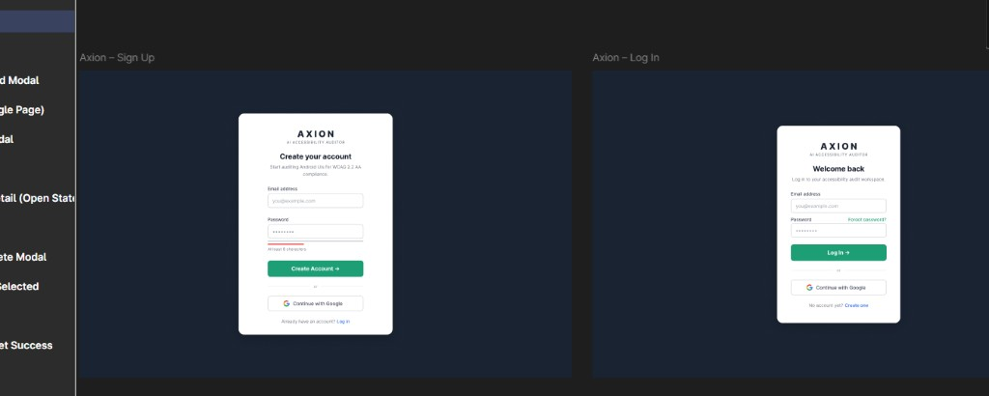
Forgot Password and OTP Verify
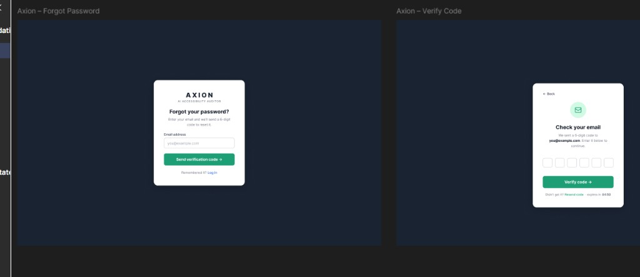
Reset Password success
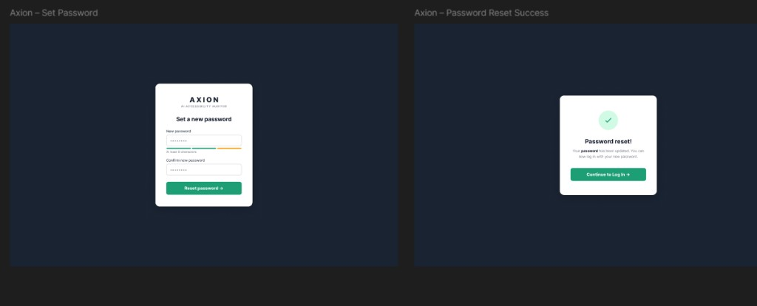
Upload files matched
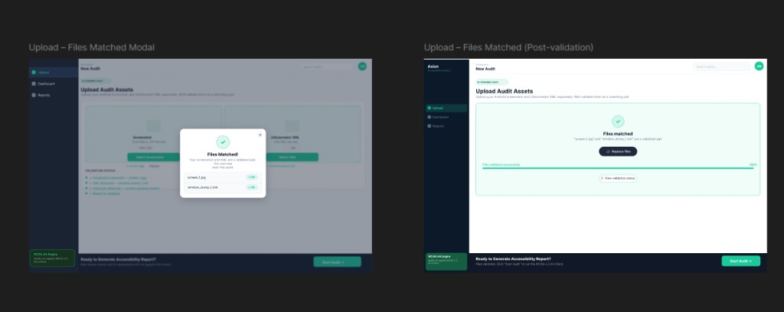
Audit complete and Dashboard
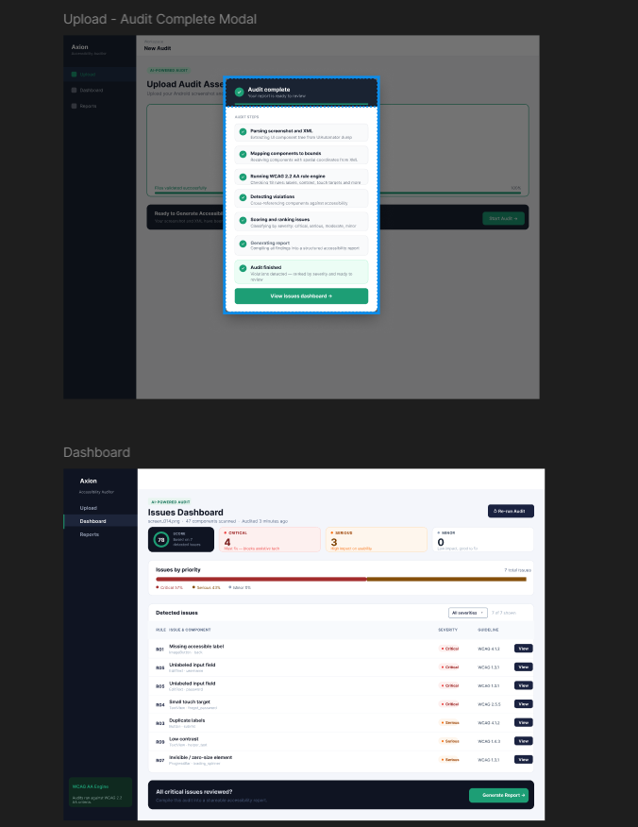
Issue detail and Report
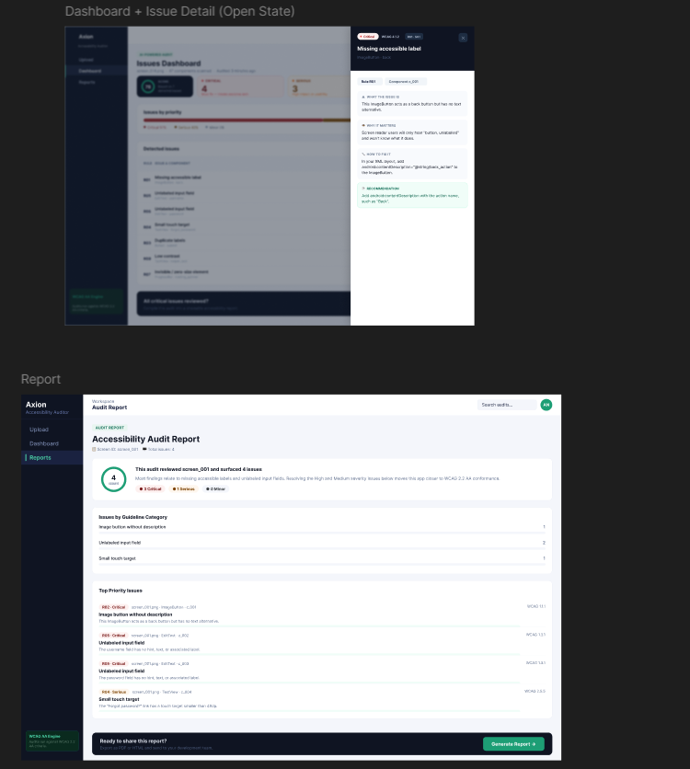
Generate report modal / PDF layout
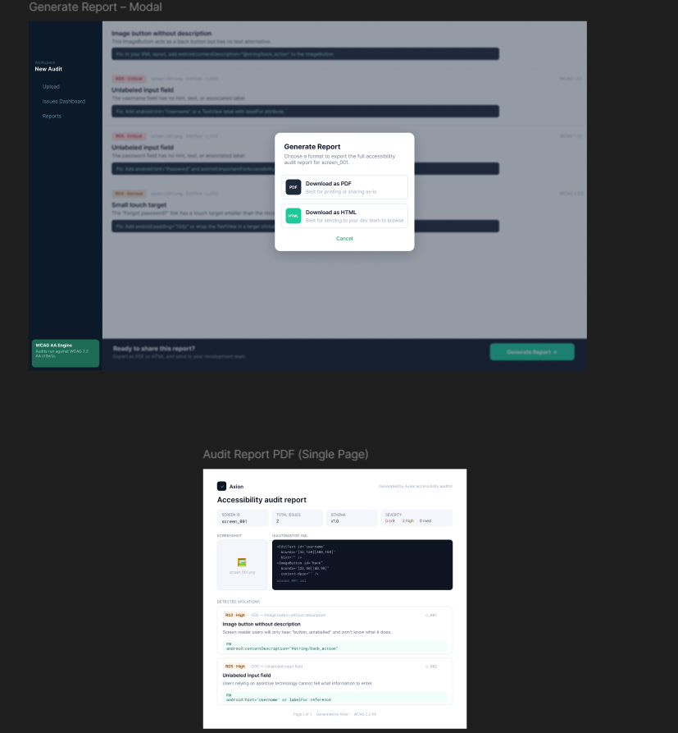

15A.4 End-to-end demo path (working)
- Sign Up or Log In (email any domain) — or Continue with Google
- Optional: Forgot password → OTP email (SMTP) → Reset
- Upload matching screenshot + XML pair → validate → POST /api/v1/audit
- Dashboard / Report — accessibility score ring; HTML/PDF download includes screenshot + XML + violations
- Records — list shows screenshot/XML names + score (GET /records)

15B. Week 7 evidence pack (QA analysis — Noor)
| Scope: MASC 40-screen stratified sample (seed 20260715). Rico holdout batch not run in this pass.
| Artifacts: docs/week7/ · outputs/week7_eval/ · outputs/validation_logs/noor_week7_*

15B.1 Week 7 deliverables (Noor)
Item | Path | Status
Per-screen results (violations, score, R01–R30 counts) | outputs/week7_eval/per_screen_results.csv | Done
Rule-wise summary R01–R30 | docs/week7/rule_summary.md + CSV | Done
Guideline coverage G01–G30 | docs/week7/guideline_summary.md + CSV | Done
QA notes (FP / miss / Week 7 vs 8) | docs/week7/qa_notes.md | Done
Week 6 cross-check | docs/week7/week6_crosscheck.md | Done
Team priorities (Salar/Ayesha) | docs/week7/team_priority_fixes.md | Done
Validation | scripts/noor_week7_validate.py | PASS (20 Jul)
Rico holdout batch | scripts/run_rico_holdout_eval.py | Deferred

15B.2 Key metrics (MASC n=40)
Metric | Value
Screens evaluated | 40
Failures | 0
Mean violations / screen | 64.3
Median violations / screen | 42
Mean accessibility score | 6.8
Manual mostly_agree | 32
Manual agree_clean | 3
Manual over_flagging | 2
Manual mixed_r30_noise | 3

Top rules by violation count
Rule | Violations | Notes
R07 | 1127 | 100% of screens — primary FP cluster (nesting/zero-size)
R08 | 629 | 60% of screens — overlap pairs
R01 | 324 | Missing labels — mix of real + decorative FP
R18 | 102 | Multi-touch heuristic
R02 | 89 | Image buttons without description
R30 | 89 | Icon-only density — 3 manual mixed_r30_noise screens

Guidelines with zero hits in sample
G09, G10, G12, G13, G22, G27, G28, G29 — mostly media/CV/stretch rules not triggered on this XML sample.

15B.3 Week 7 validation (20 Jul 2026)
STEP 1: run_week7_eval_analysis.py → 40 screens, 0 failures
STEP 2: pytest tests/test_rules.py → PASS
STEP 3: pytest backend/tests/test_auth.py → PASS
STEP 4: pytest tests/test_audit.py → PASS
STEP 5–6: week7_eval outputs + docs/week7 → PASS
Overall → PASS
Full log: outputs/validation_logs/noor_week7_validation_log.txt
Summary: outputs/validation_logs/noor_week7_summary.md · outputs/week7_summary.md

15B.4 Team priority handoff (Week 7 → Salar/Ayesha)
- P0 Salar — R07/R08 nesting FP suppression
- P0 Salar — R30 overlap tolerance (list/chat/map/search)
- P1 Ayesha — UI polish for demo path
- P2 Noor — Rico holdout when dataset local

15C. Post–Week 7 evidence pack (YOLO UI detector — Noor + Salar)
| Dates: 23–24 July 2026 · Branch: noor
| Goal: Screenshot-only UI element detector so the auditor can still run when no XML view hierarchy is available (raw screenshot upload / blocked accessibility tree).

15C.1 What was delivered
Item | Owner | Status | Evidence
YOLO training notebook | Salar → merged to noor | Done | notebooks/train_yolo_ui_detector.ipynb
Branch sync (salar + Ayesha docs into noor) | Noor | Done | Merge commit + Ayesha Week 7 prompt finalization
Colab setup (Drive mount, repo discovery, T4) | Noor | Done | Notebook Colab setup + Config cells
MASC label generation (XML → YOLO boxes) | Notebook + src/parser.py | Done | Uses existing hybrid parser; train/val/test from data/data-masc/splits/
Full GPU train (LOCAL_MODE=False) | Noor on Colab T4 | In progress / checkpointed | Ultralytics run under runs/yolo_ui_detector/
Checkpoint backup to Drive | Noor | Done | MyDrive/results_of_yolo/weights/
Rico holdout raw screenshots + XML | Noor (local restore) | Done | 1,698 jpg + 1,698 xml under data/data-rico-holdout/
Rico holdout YOLO eval (zero-shot vs fine-tuned) | — | Pending | Requires finishing/resuming train, then eval cells
Wire detect_ui() into auditor fallback | — | Pending | src/yolo_ui_detector.py after export

15C.2 Training design (important)
Decision | Detail
Train / val / test data | MASC only (data/data-masc) via existing stratified splits
Rico holdout | Never used for training — reserved for generalization eval only
Labels | Generated from XML bounds at train time (model sees pixels only at inference)
Runtime | Google Colab T4 (~16 GB) — matches notebook target
Config | LOCAL_MODE=False; epochs=60; early stopping patience=10; imgsz=960
Smoke test | LOCAL_MODE=True (~20 images, 1 epoch) used first to validate paths

15C.3 Checkpoint status (24 Jul 2026)
Verified on Colab after copy to Drive:
File | Approx. size | Role
best.pt | ~195–204 MB | Best validation checkpoint → use for inference / export
last.pt | ~195–204 MB | Latest epoch → use to resume training
epoch0 … epoch9 .pt | ~195 MB each | Per-epoch snapshots (optional to keep)
Drive folder total (weights) | ~2.3 GB | MyDrive/results_of_yolo/weights/

Also present: results_of_yolo/train_run/weights/ (duplicate run metadata + weights).
Resume note: Training can be stopped and continued from last.pt without redoing finished epochs, provided checkpoints remain on Drive / local disk. yolo_dataset/images uses symlinks and should not be copied to Drive; rebuild labels from MASC when needed.

15C.4 Dataset readiness (local `_noor_push`)
Path | Count / size (approx.) | Role
data/data-masc/screenshots | 7,070 files · ~704 MB | Train/val/test images
data/data-masc/xml | 7,069 files · ~485 MB | Label source
data/data-masc/splits | train/val/test CSV | Fixed splits (unchanged)
data/data-rico-holdout/screenshots | 1,698 · ~179 MB | Holdout eval only
data/data-rico-holdout/xml | 1,698 · ~55 MB | Holdout labels only

15C.5 Class taxonomy (YOLO)
text, image, icon, button_labeled, button_icon_only, input_field, checkbox_toggle, tab_item, list_item

15C.6 Next steps (Week 8 track)
- Resume Colab training from last.pt until early-stop or 60 epochs; keep exporting best.pt.
- Run Rico holdout zero-shot vs fine-tuned eval cells (data now present).
- Export best.pt → models/yolo_ui_detector_best.pt and exercise detect_ui().
- Wire screenshot-only fallback into src/agent.py / audit path when XML is absent.
- Optional: drop per-epoch .pt files from Drive to save space; retain best.pt + last.pt.

15C.7 Local run artifacts — full results (`runs/` folder, verified 27 Jul 2026)
| Scope: this subsection documents the actual contents of the local runs/ folder (the Ultralytics run mirrored from Colab into _noor_push), as distinct from the Drive-only backup summarized in §15C.3. All numbers below are read directly from the run's own results.csv / args.yaml, not estimated.
Folder map (`runs/`):
runs/
├── notebooks/
│ ├── masc_dataset_analysis.ipynb ← Salar MASC analysis
│ ├── train_yolo_ui_detector.ipynb ← YOLO training notebook (Salar → Noor Colab run)
│ ├── yolo11s.pt ← pretrained base weights (small)
│ └── yolo26n.pt ← pretrained base weights (nano, alt. arch)
└── runs/
└── yolo_ui_detector/
├── training_curves.png ← summary curve export
├── export/
│ └── yolo_ui_detector_best.pt ← final exported best checkpoint (~19 MB)
├── yolo_dataset/
│ └── dataset.yaml ← MASC train/val/test config (training data)
├── rico_yolo_dataset/
│ └── dataset.yaml ← Rico holdout eval-only config
└── runs/yolo_ui_detector/ ← raw Ultralytics run directory
├── args.yaml
├── results.csv
├── results.png
├── confusion_matrix.png / confusion_matrix_normalized.png
├── BoxP_curve.png / BoxR_curve.png / BoxF1_curve.png / BoxPR_curve.png
├── labels.jpg
├── train_batch0/1/2.jpg, train_batch30900/30901/30902.jpg
└── val_batch0/1/2_labels.jpg, val_batch0/1/2_pred.jpg
Run configuration (`runs/yolo_ui_detector/runs/yolo_ui_detector/args.yaml`):
Setting | Value
Task / mode | detect / train
Data config | yolo_dataset/dataset.yaml (MASC train/val/test — not Rico)
Epochs (target) | 60 (patience=10 early stop)
Batch size | 8
Image size | 960
Optimizer | auto; lr0=0.01, lrf=0.01, momentum=0.937, weight_decay=0.0005
Scheduler | cos_lr=true; warmup_epochs=3.0
Loss weights | box=7.5, cls=0.5, dfl=1.5
Augmentation | hsv_h/s/v, translate=0.1, scale=0.5, fliplr=0.5, mosaic=1.0, close_mosaic=10 (mixup/cutmix/copy_paste off)
Seed / determinism | seed=42, deterministic=true
AMP | true

Completed epoch results (`results.csv` — 1 logged epoch this local run):
Epoch | Time (s) | box_loss | cls_loss | dfl_loss | Precision | Recall | mAP50 | mAP50-95 | val box_loss | val cls_loss | val dfl_loss
1 | 105.91 | 0.98677 | 1.39035 | 1.19422 | 0.4711 | 0.4196 | 0.3971 | 0.2846 | 1.09549 | 1.60428 | 1.28542

This confirms the mAP50-95 0.2846 figure quoted in the executive summary (§2) as coming directly from this run's own logged metrics, not a rounded estimate. Plot artifacts (results.png, confusion_matrix.png, confusion_matrix_normalized.png, BoxP/R/F1/PR_curve.png) and sample batches (train_batch*.jpg, val_batch*_labels.jpg, val_batch*_pred.jpg) were generated for this epoch and are present in the run folder for visual QA. The train_batch30900–30902 filenames indicate the notebook's periodic sample-logging counter had advanced well past epoch 1 in cumulative training steps; the authoritative multi-epoch progression (toward the 60-epoch target) lives in the Colab/Drive run referenced in §15C.3, not in this local mirror.
Dataset configs found in `runs/`:
Dataset | train | val | test | Classes | Role
yolo_dataset/dataset.yaml | images/train | images/val | images/test | 9 (see §15C.5) | Used for this training run — MASC only
rico_yolo_dataset/dataset.yaml | images/test | images/test | images/test | Same 9 | Rico holdout, eval-only — all splits point at the same images/test folder (never trained on)

Exported weights: runs/runs/yolo_ui_detector/export/yolo_ui_detector_best.pt — confirmed present locally (~19 MB), matching the "Functional Prototype" status in §2 and feeding src/yolo_ui_detector.py's detect_ui().

15C.8 Complete artifact inventory (runs/ folder file listing)
Metrics & configuration files:
File | Size approx | Purpose
runs/runs/yolo_ui_detector/runs/yolo_ui_detector/results.csv | <1 KB | Epoch 1 training metrics (box/cls/dfl loss, precision, recall, mAP)
runs/runs/yolo_ui_detector/runs/yolo_ui_detector/args.yaml | ~3 KB | Full training hyperparameter config (epochs, batch, imgsz, optimizer, augmentation)
runs/runs/yolo_ui_detector/yolo_dataset/dataset.yaml | ~100 B | MASC train/val/test dataset config (paths, class names)
runs/runs/yolo_ui_detector/rico_yolo_dataset/dataset.yaml | ~100 B | Rico holdout eval-only config (all splits point to same test folder)

Performance plots (PNG):
Plot | Metric | Use
results.png | Epoch progress overlay | Overall training/val loss + metrics trend
confusion_matrix.png | Per-class confusion matrix | Non-normalized class-pair confusion counts
confusion_matrix_normalized.png | Normalized confusion matrix | Normalized percentages per class
BoxP_curve.png | Precision vs IoU threshold | Precision @ varying detection thresholds
BoxR_curve.png | Recall vs IoU threshold | Recall @ varying detection thresholds
BoxF1_curve.png | F1 vs IoU threshold | F1-score optimization curve
BoxPR_curve.png | Precision-Recall curve | Precision-Recall trade-off (AUC summary)

Training batch samples (JPG — visual inspection):
File | Batch | Label/Pred | Purpose
labels.jpg | Dataset | — | Ground-truth class distribution per image
train_batch0.jpg, train_batch1.jpg, train_batch2.jpg | Early | Augmented input + bboxes | First 3 training batches with annotations
train_batch30900.jpg, train_batch30901.jpg, train_batch30902.jpg | Late | Augmented input + bboxes | Batches from epoch 1 step ~30900–30902 (cumulative)
val_batch0_labels.jpg, val_batch1_labels.jpg, val_batch2_labels.jpg | Val | Ground truth | First 3 validation batches (target)
val_batch0_pred.jpg, val_batch1_pred.jpg, val_batch2_pred.jpg | Val | Predictions | First 3 validation batches (model output)

Exported weights:
File | Size | Role
runs/runs/yolo_ui_detector/export/yolo_ui_detector_best.pt | ~19 MB | Best validation checkpoint → used by src/yolo_ui_detector.py inference module

Notebook & base weights:
File | Size | Role
notebooks/train_yolo_ui_detector.ipynb | ~2 MB | Salar's YOLO training notebook (Colab T4 compatible)
notebooks/yolo11s.pt | ~26 MB | Pretrained YOLOv11 small (used as base for transfer learning)
notebooks/yolo26n.pt | ~5 MB | Pretrained YOLOv11 nano (alternative base, not used in this run)

Analysis notebooks:
File | Purpose
notebooks/masc_dataset_analysis.ipynb | Salar MASC exploratory analysis

Reproduce / inspect locally:
# Re-run or resume from this exact config
yolo detect train cfg=runs/runs/yolo_ui_detector/runs/yolo_ui_detector/args.yaml resume=True
# Inspect logged metrics
type runs\runs\yolo_ui_detector\runs\yolo_ui_detector\results.csv
# View confusion matrix or PR curves
# Open plots in runs/runs/yolo_ui_detector/runs/yolo_ui_detector/*.png
Summary: All raw training logs, visualizations, model checkpoints, and configuration files are present and ready for (1) resuming training to full 60 epochs, (2) performing zero-shot / fine-tuned evaluation on Rico holdout, and (3) integrating the exported best.pt into the audit pipeline via src/yolo_ui_detector.py.

15D. Complete embedded artifacts — runs/ YOLO training visualizations

15D.1 Performance curves and metrics
Epoch 1 overall results trend:
Results PNG
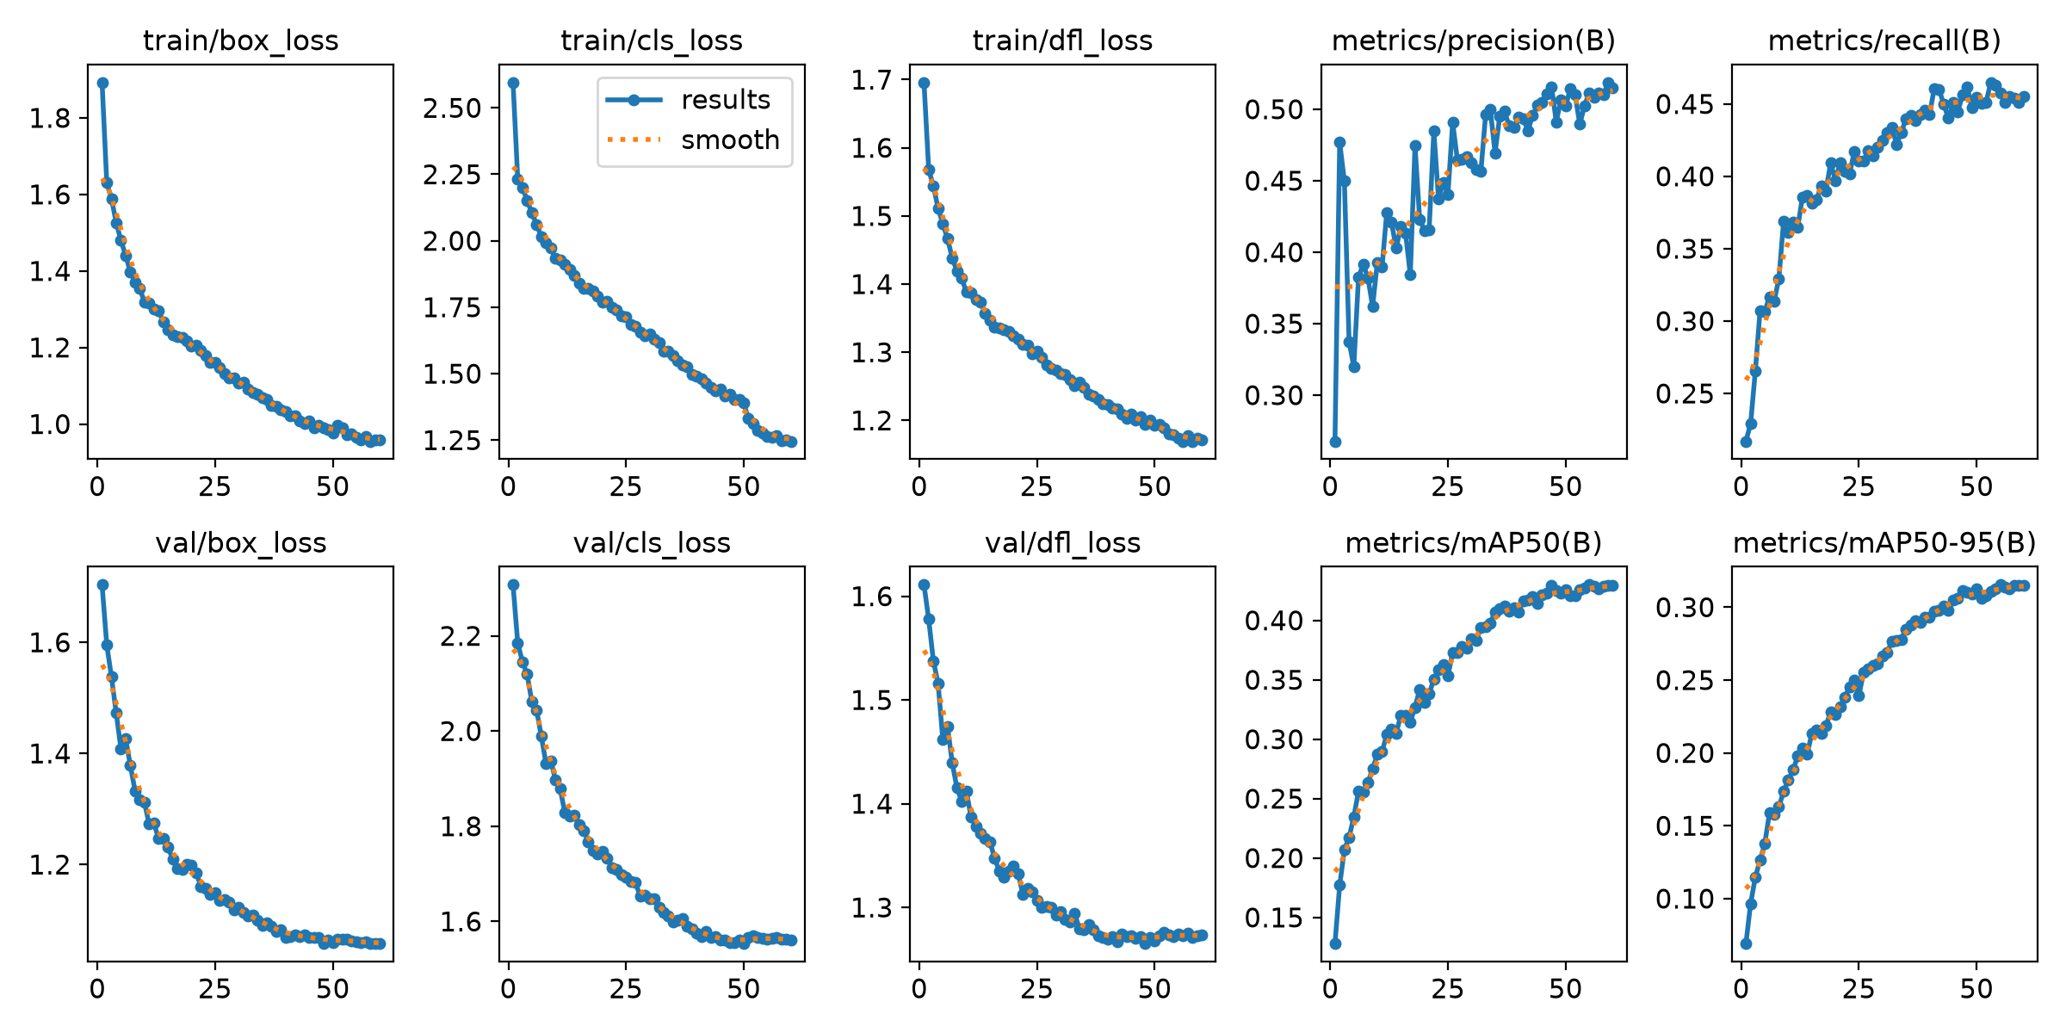
Confusion matrices:
Confusion Matrix (counts)
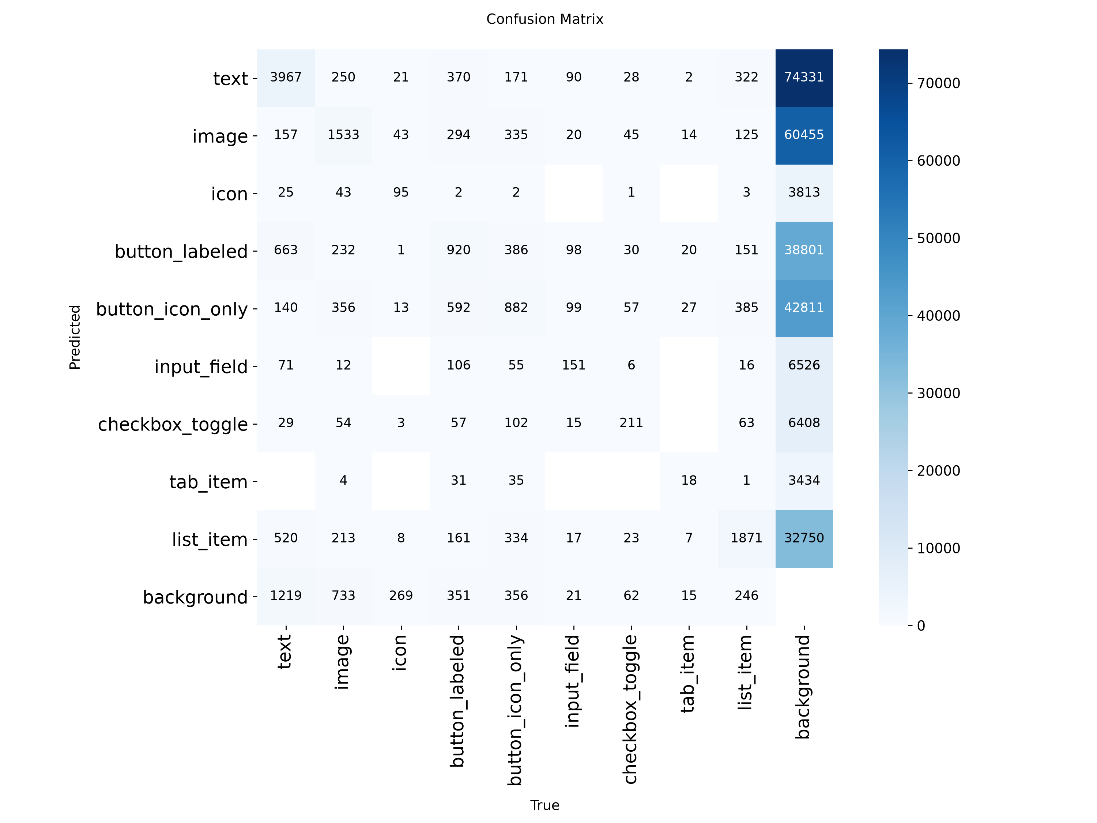
Confusion Matrix (normalized %)
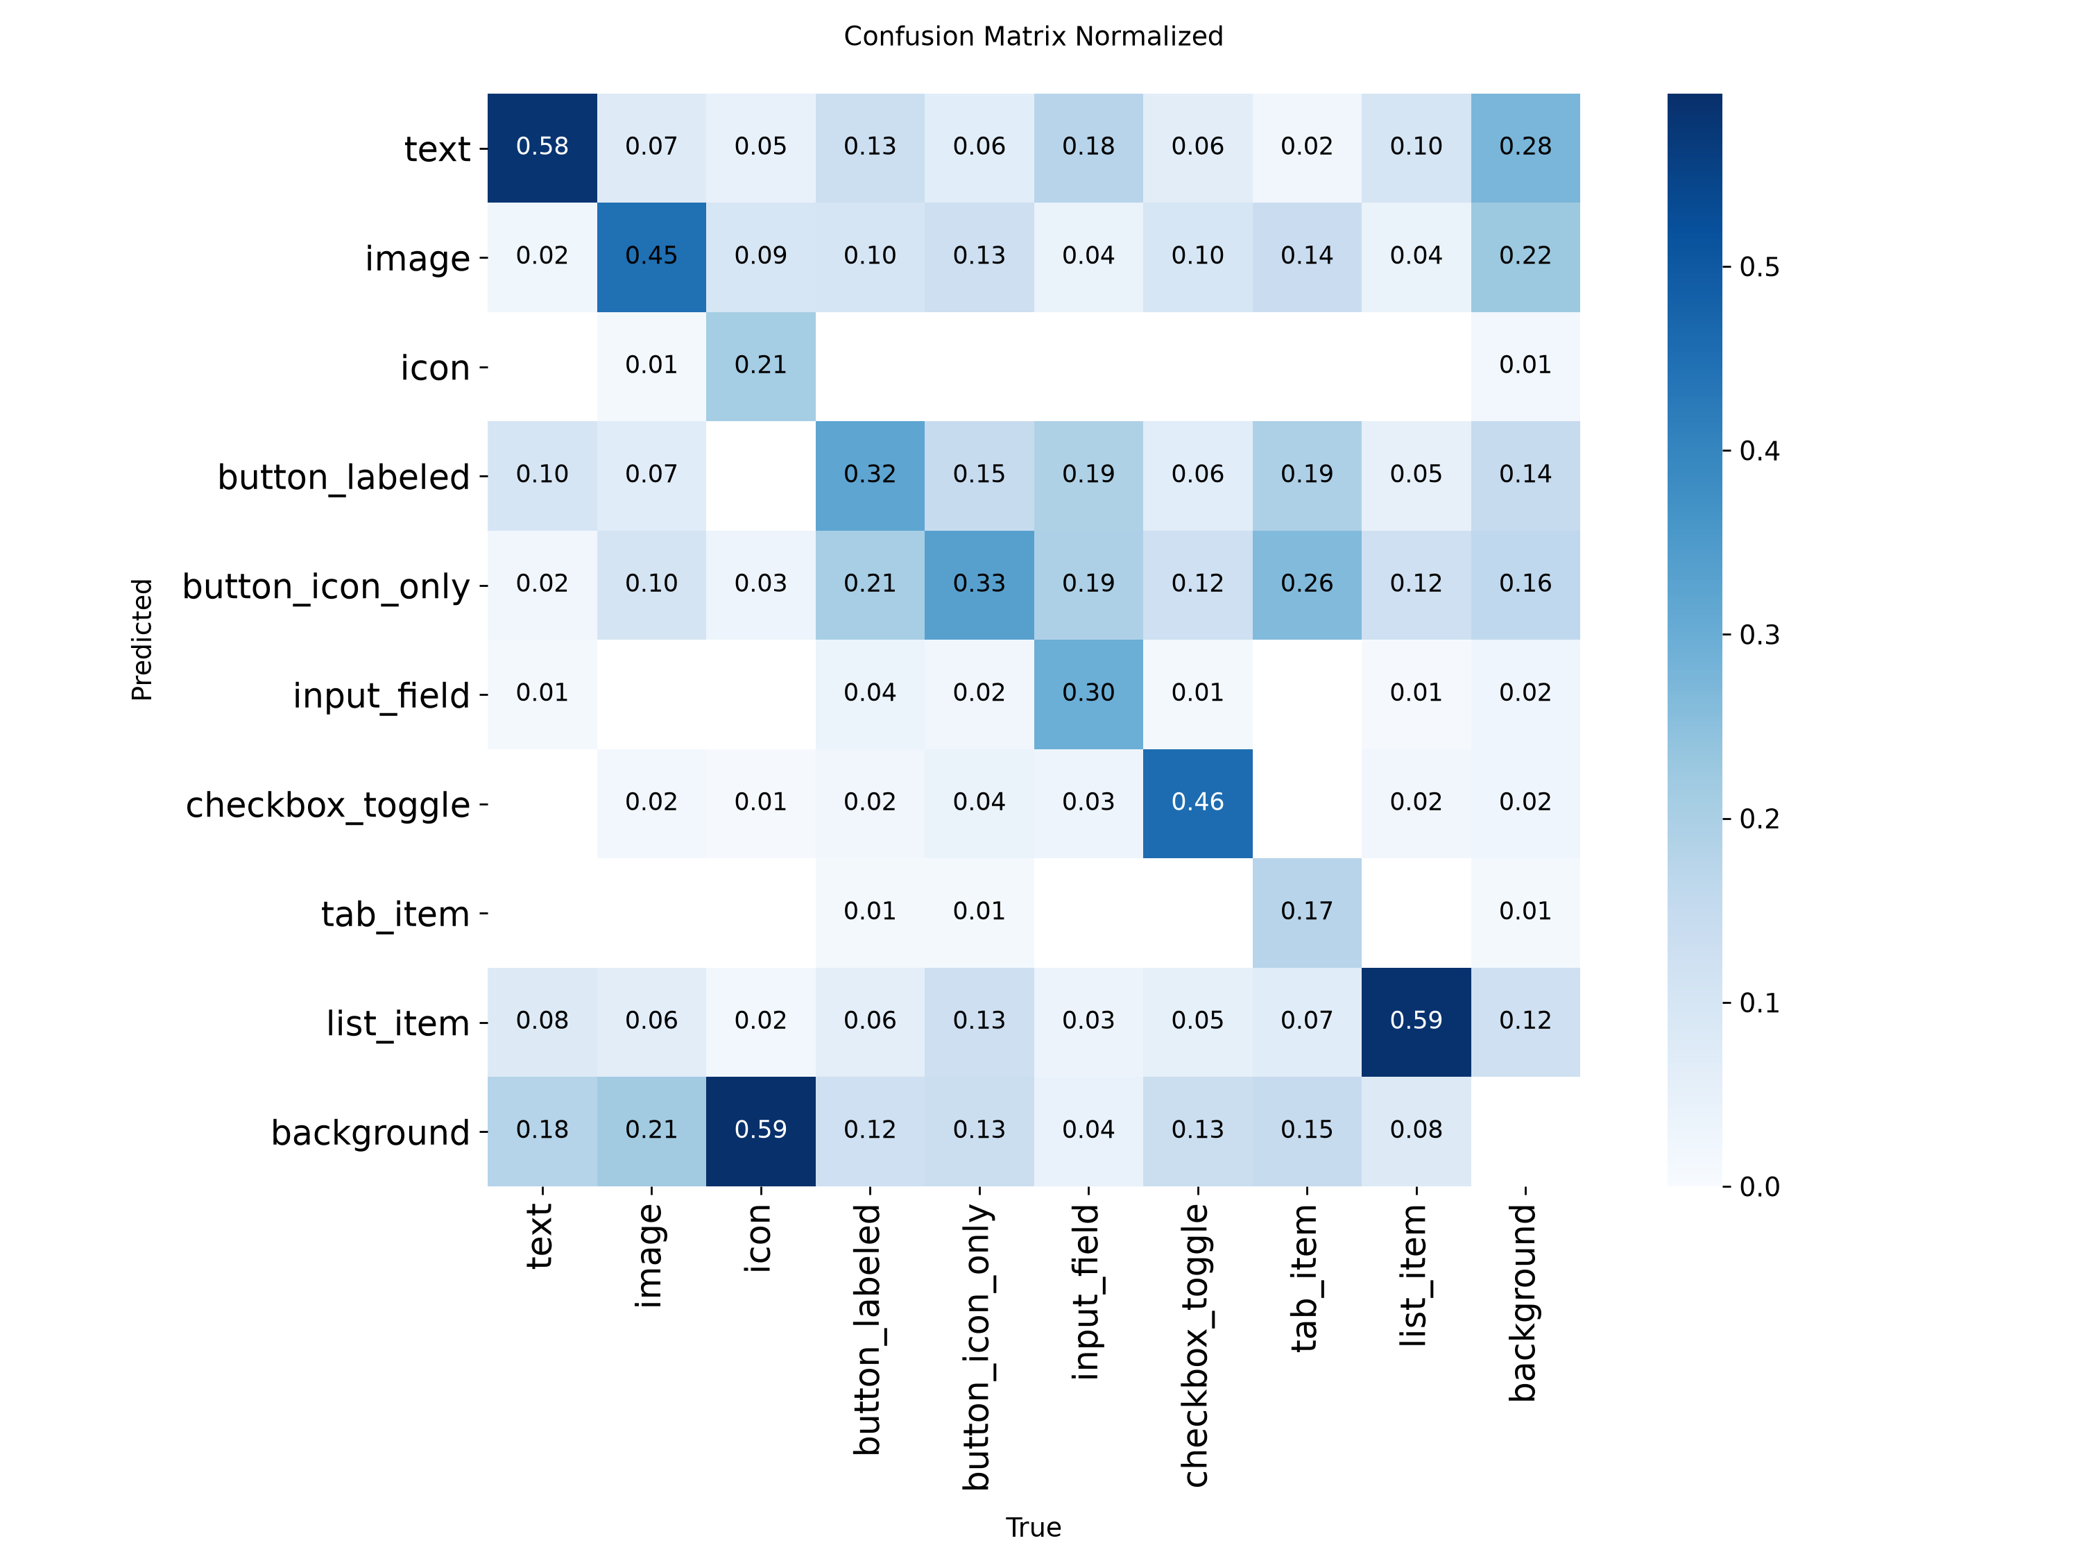
Per-class evaluation curves:
Box Precision Curve
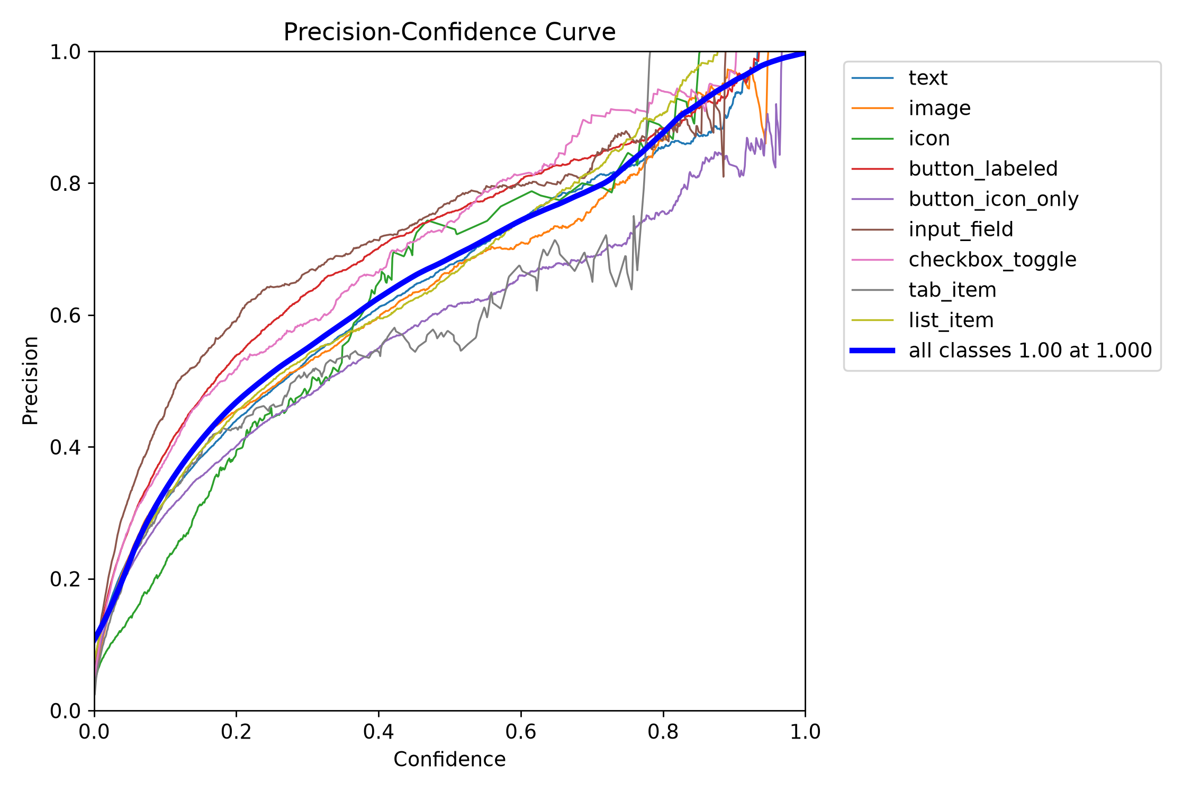
Box Recall Curve
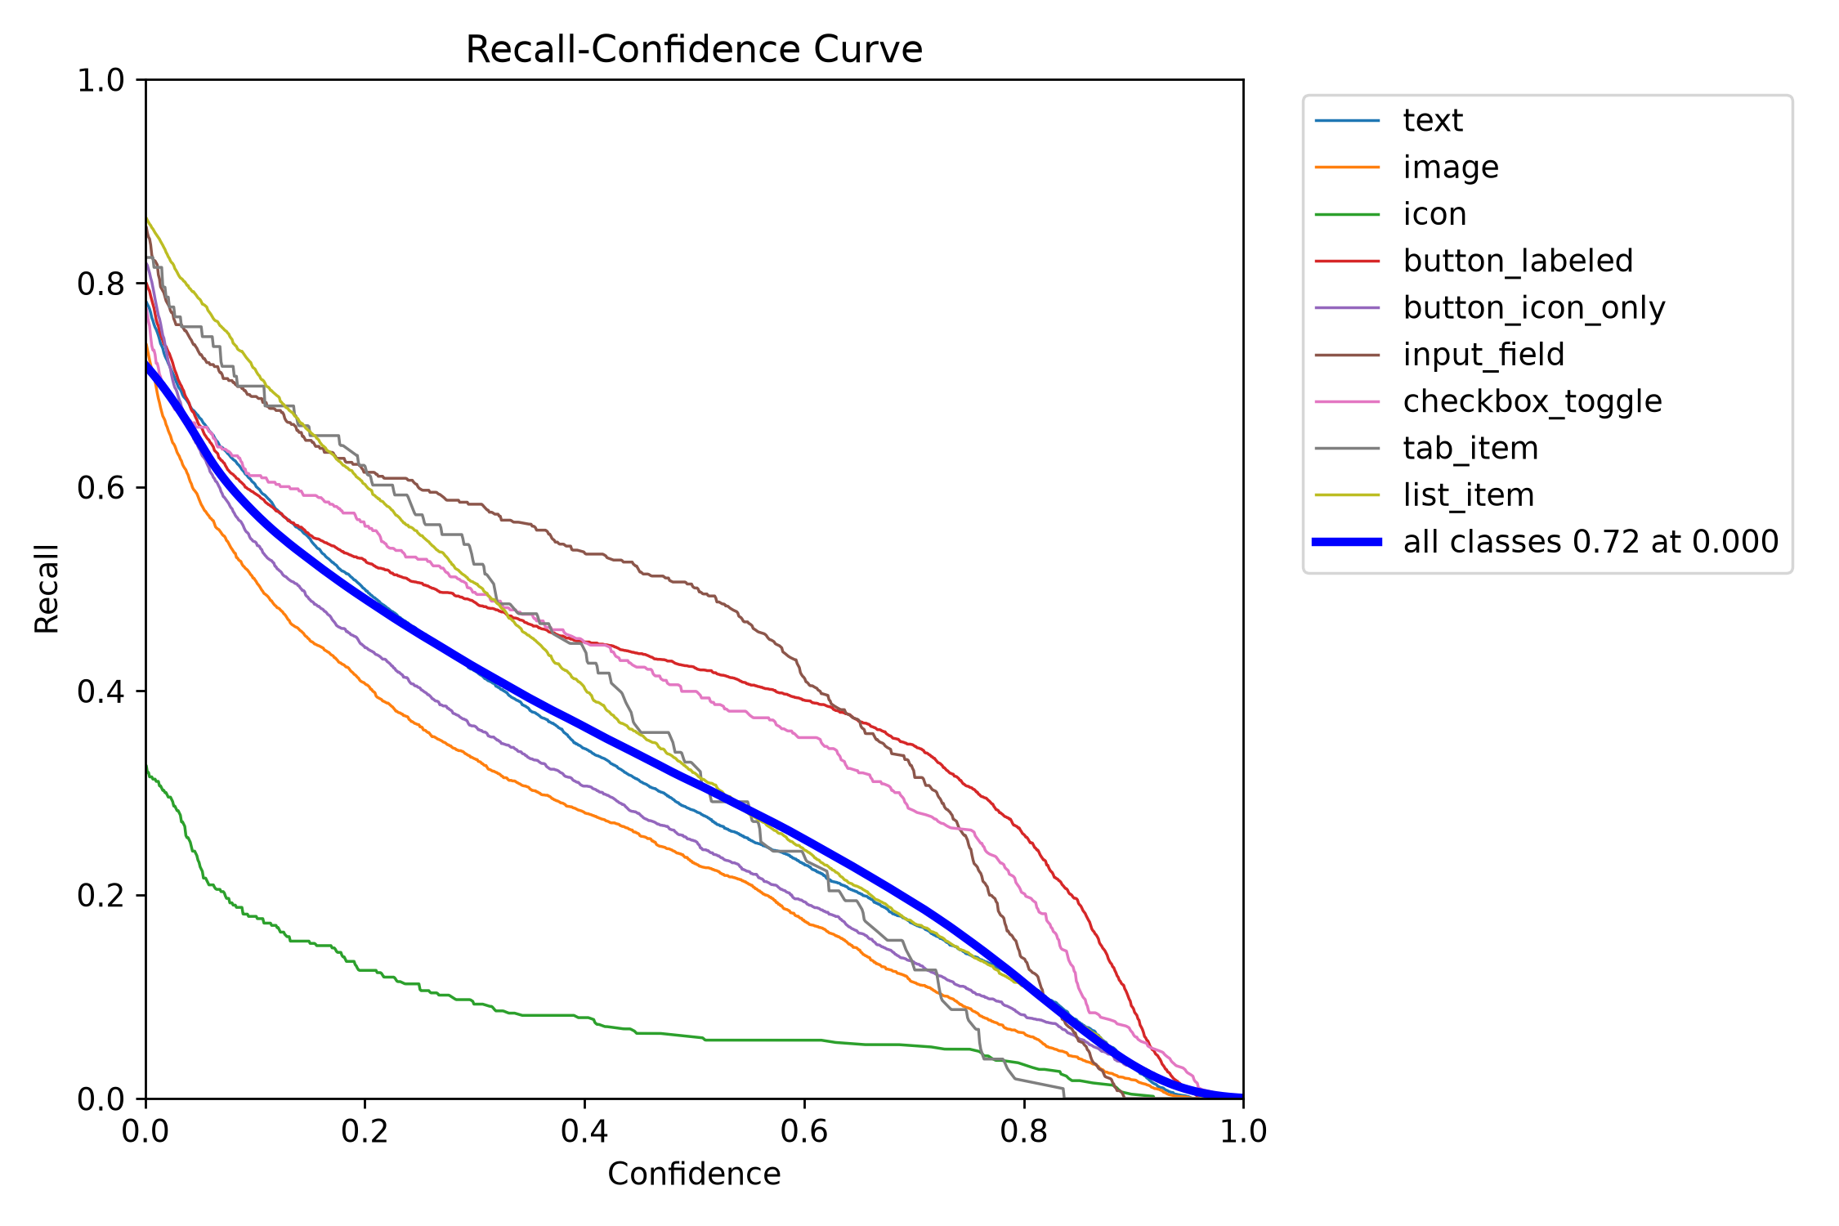
Box F1 Curve
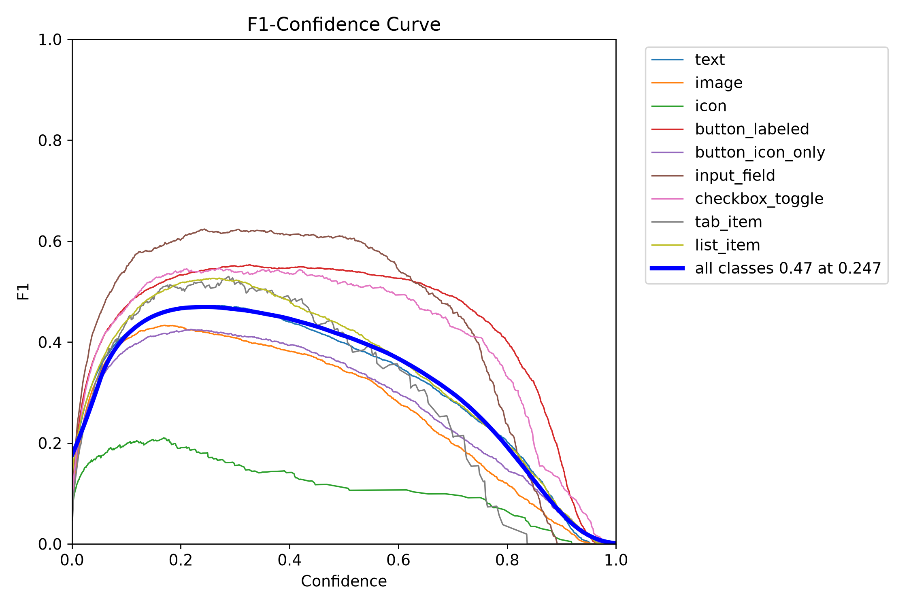
Precision-Recall Curve
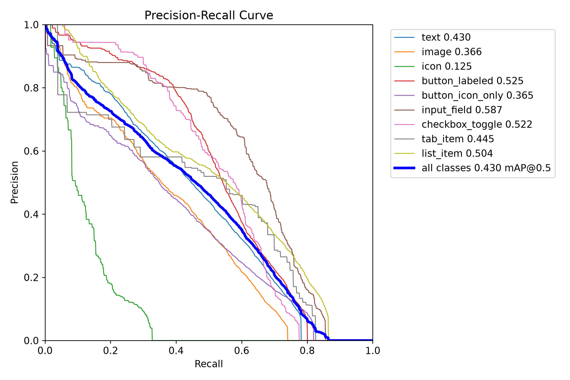

15D.2 Training batch samples (with annotations)
Dataset label distribution:
Labels distribution
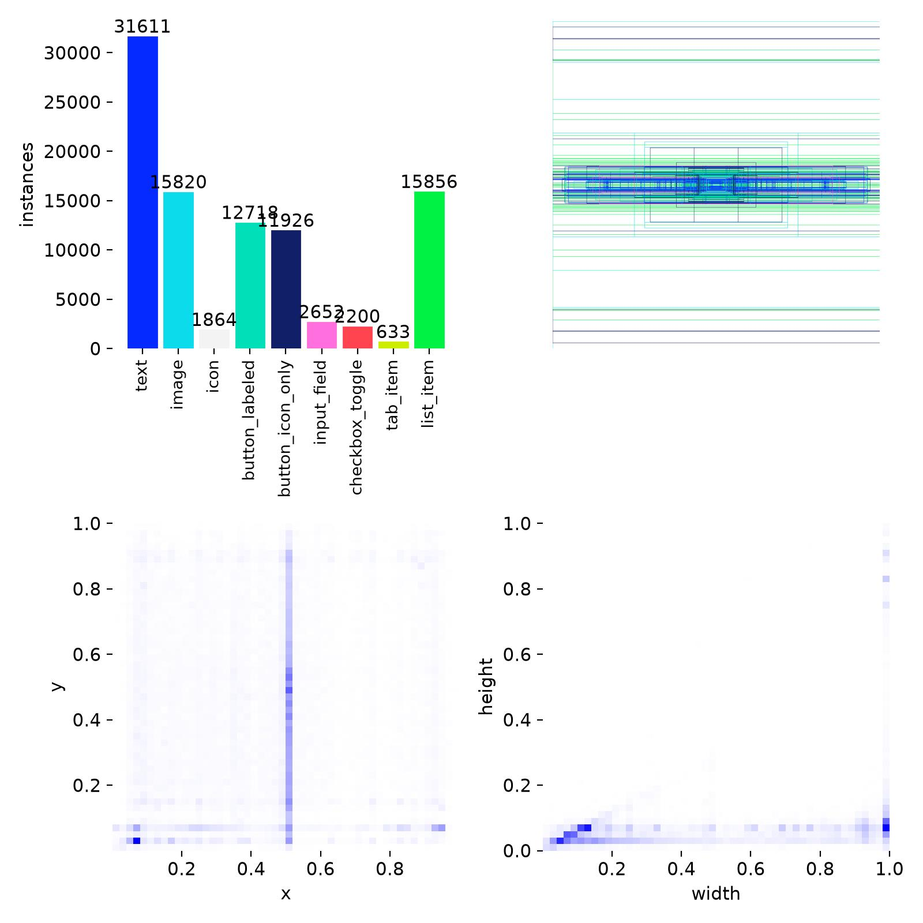
Early training batches (epoch 1, steps 0–2):
Train Batch 0
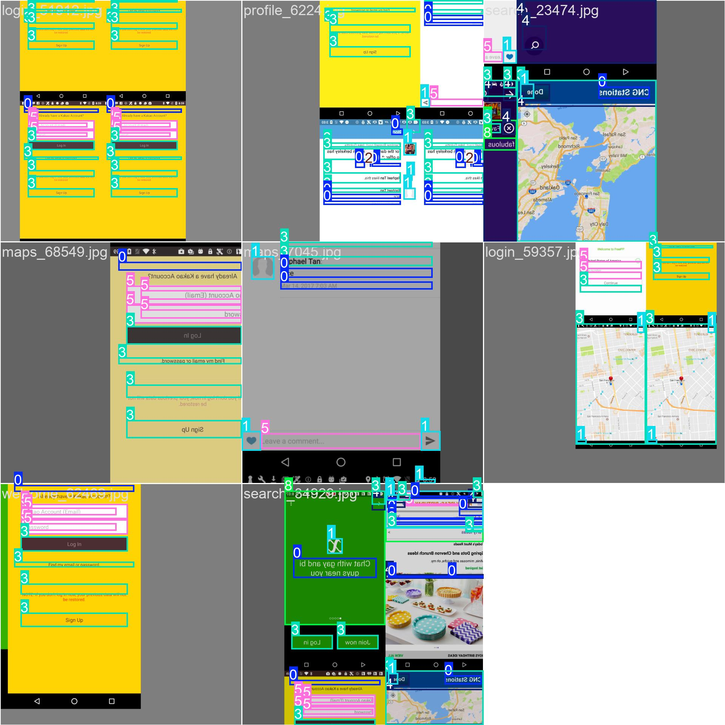
Train Batch 1
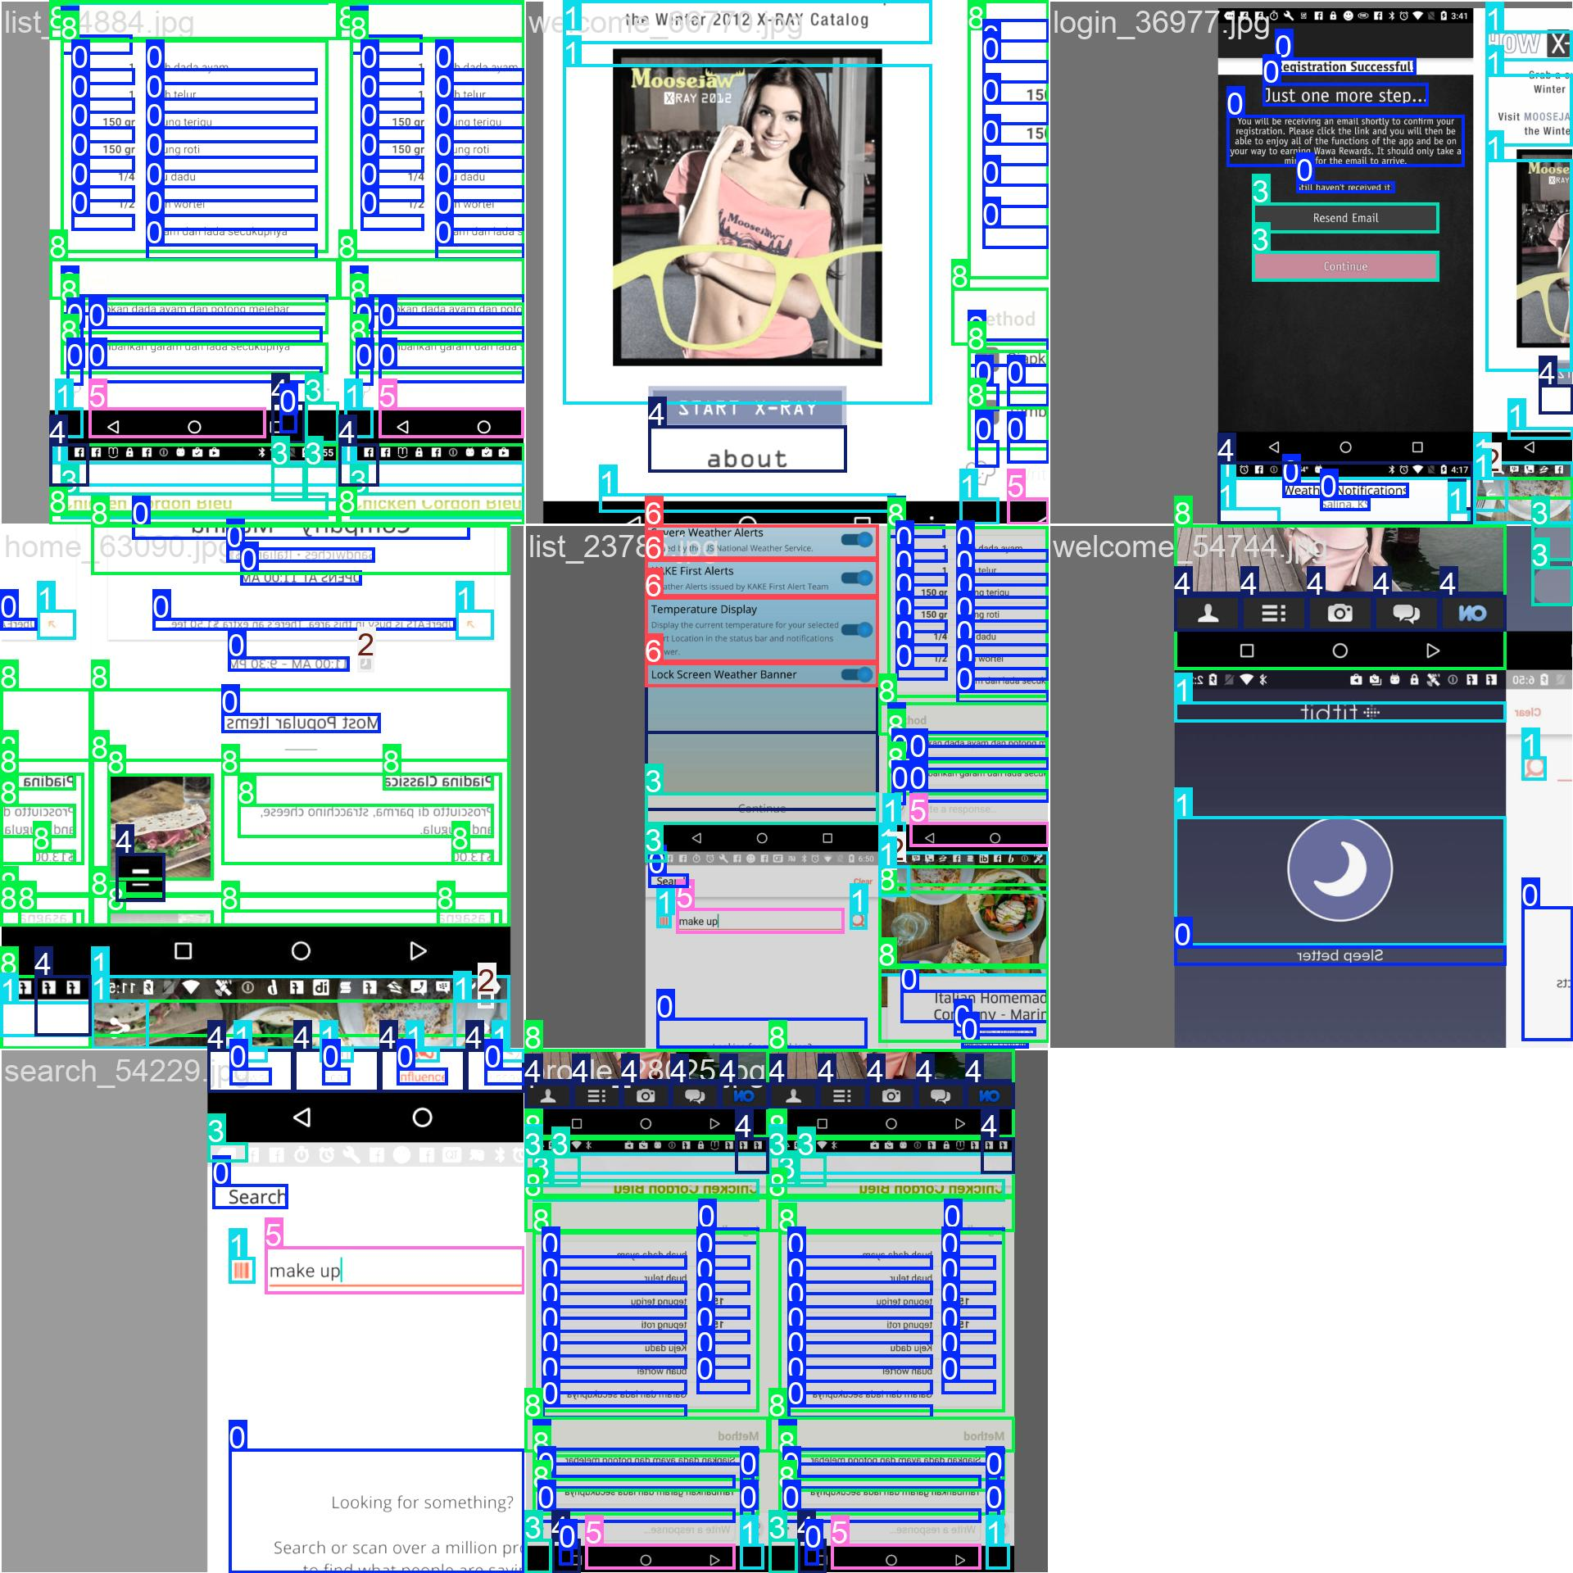
Train Batch 2
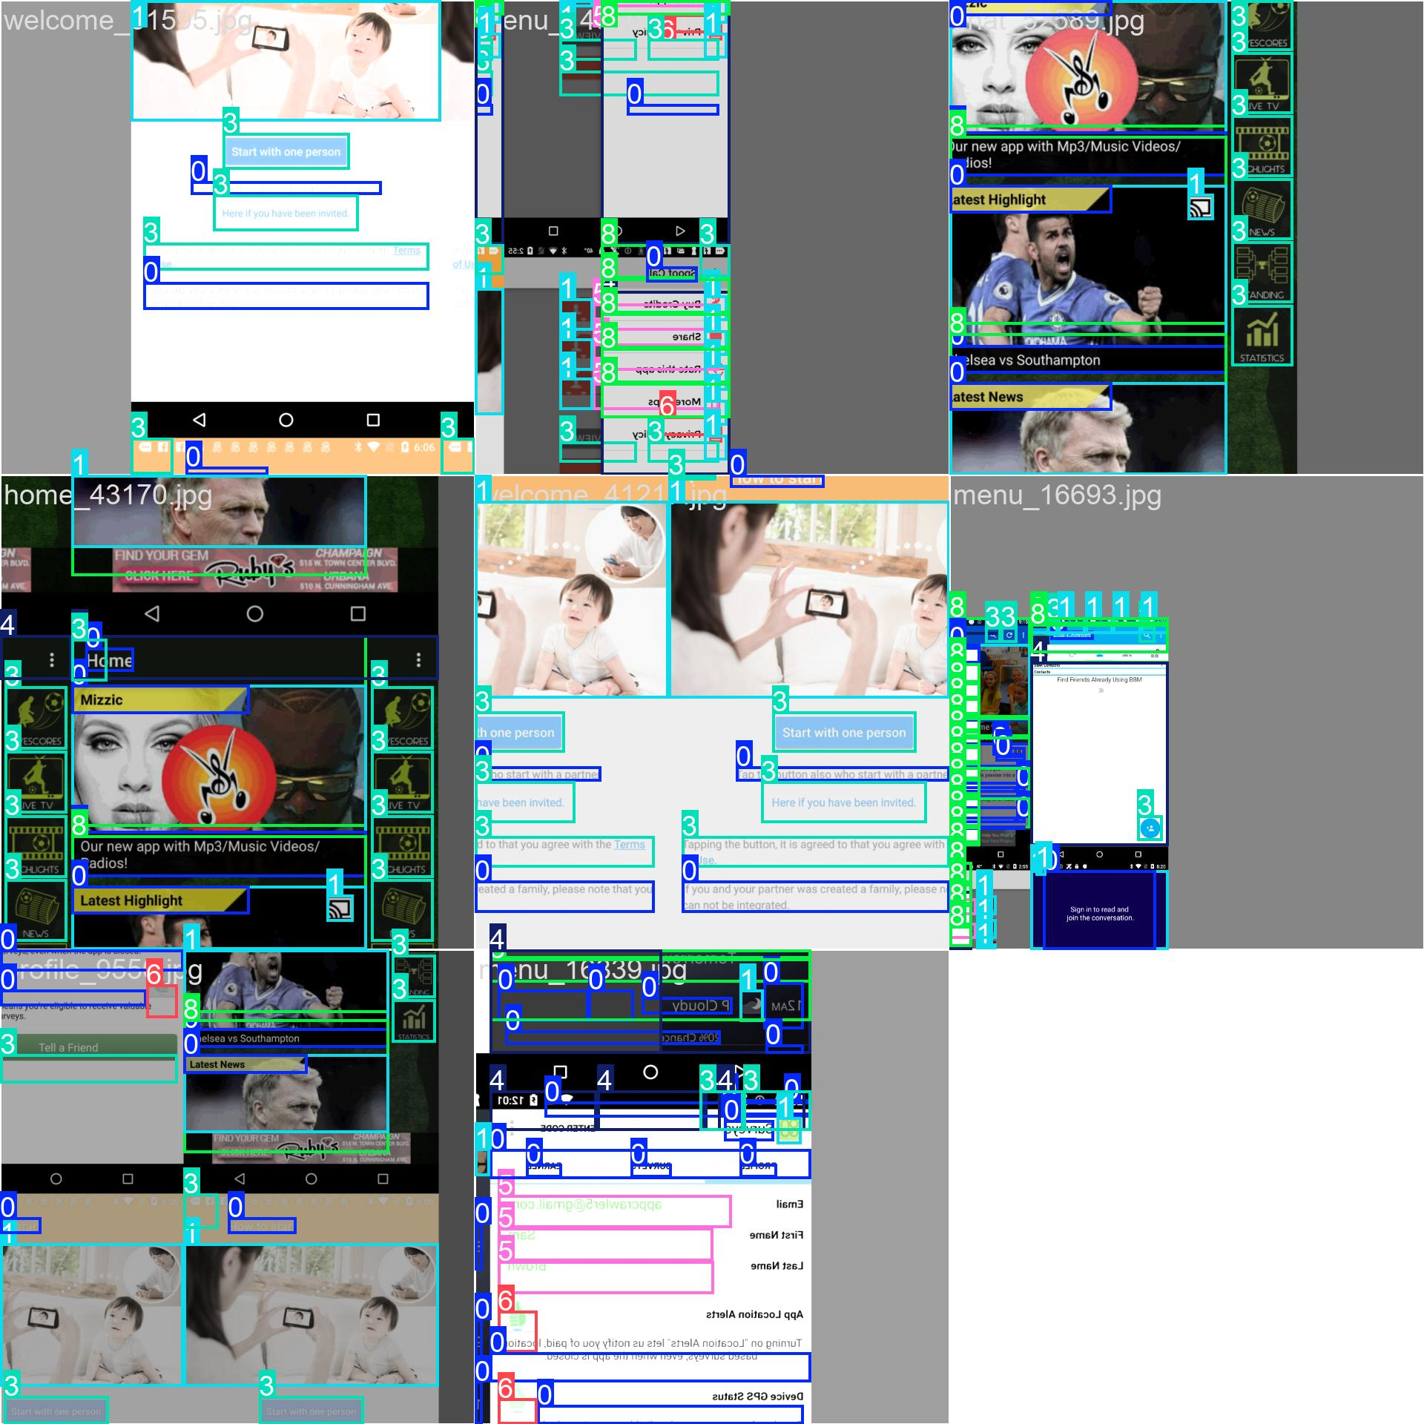
Late training batches (epoch 1, steps ~30900–30902, cumulative step counter):
Train Batch 30900
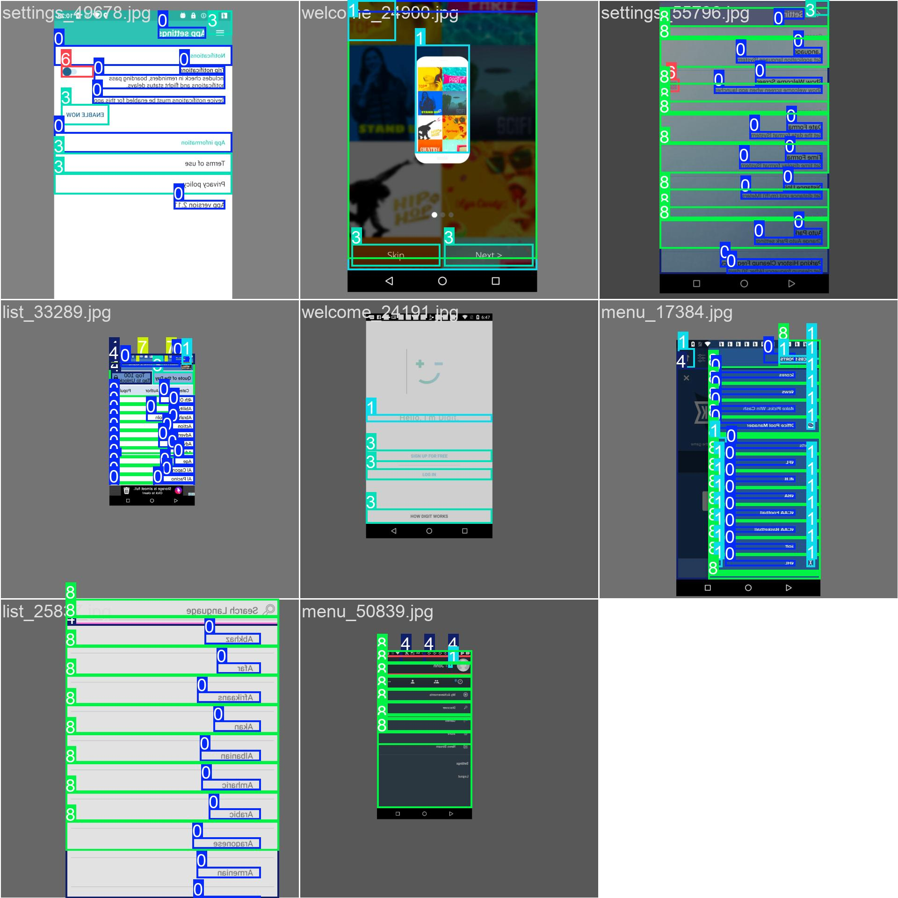
Train Batch 30901
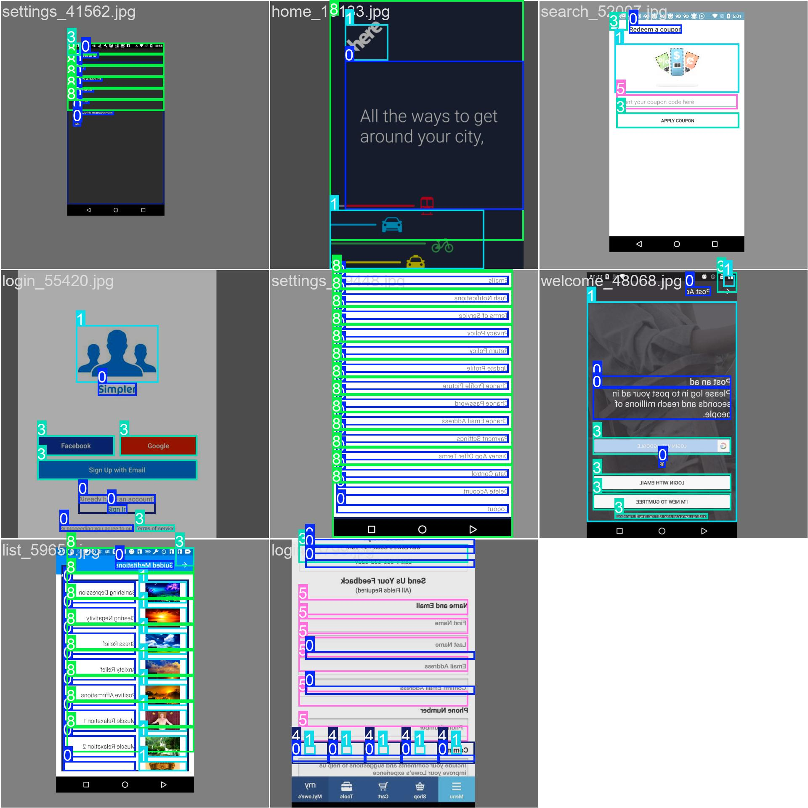
Train Batch 30902
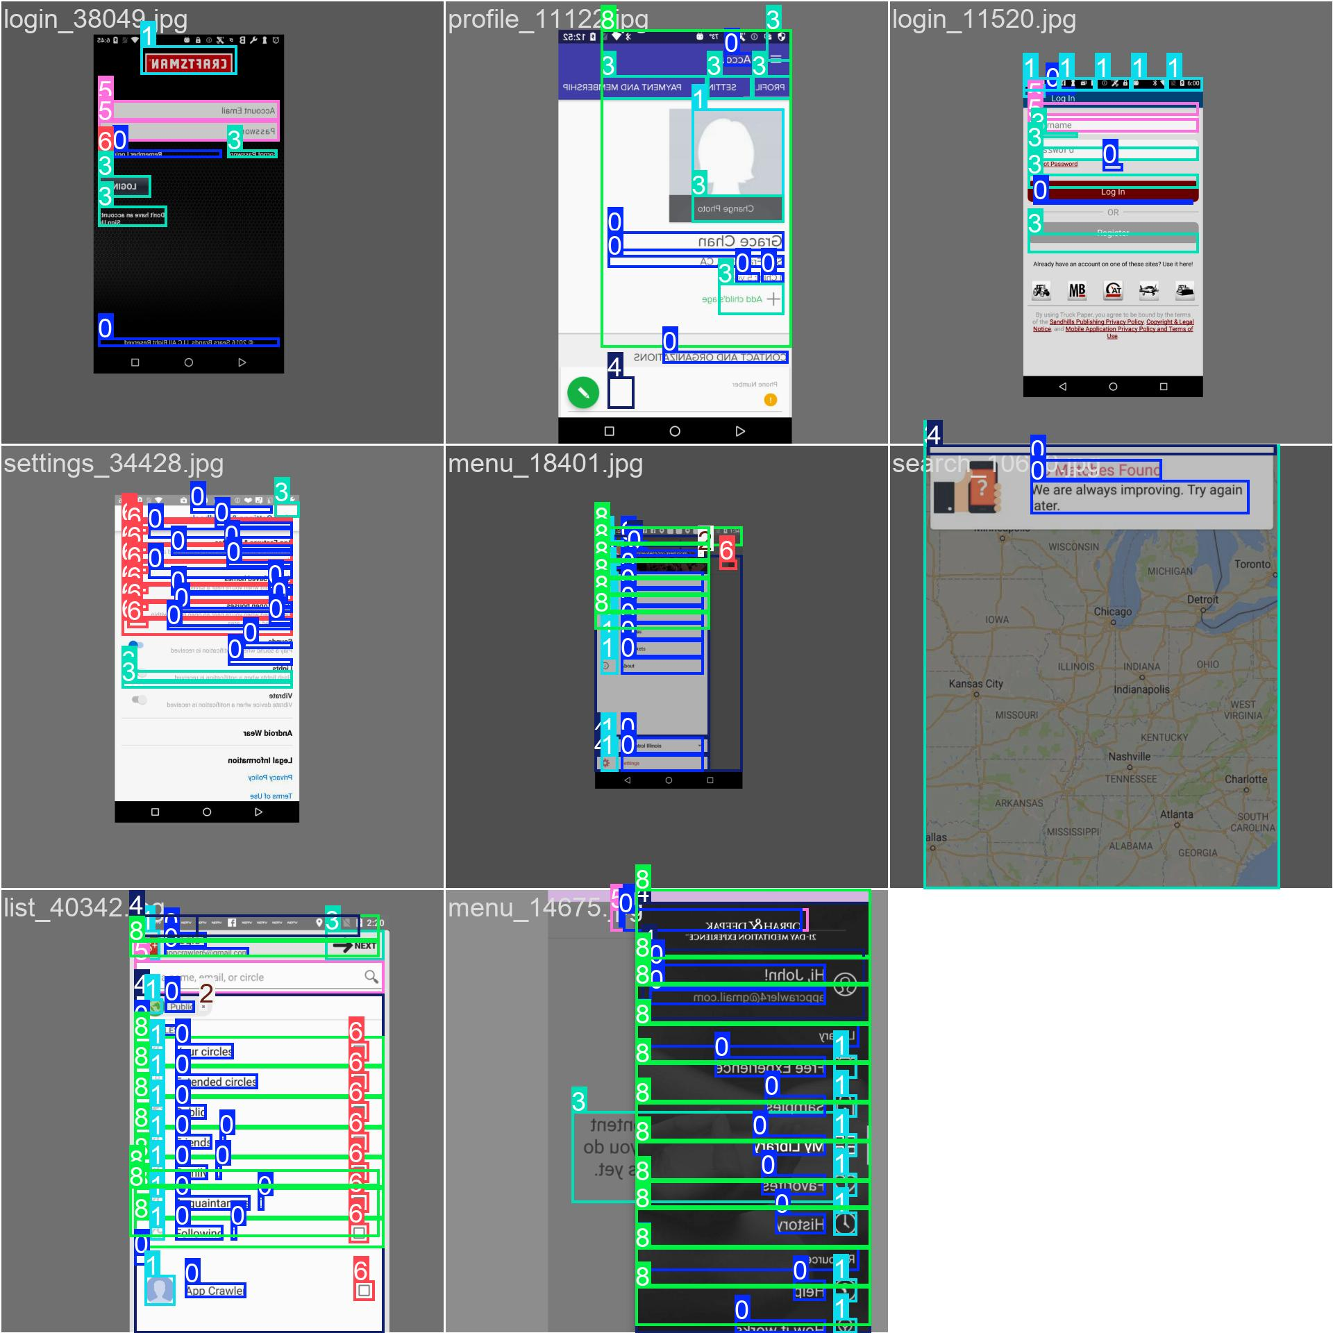

15D.3 Validation batch predictions (ground truth vs model output)
Ground truth labels (first 3 validation batches):
Val Batch 0 Labels
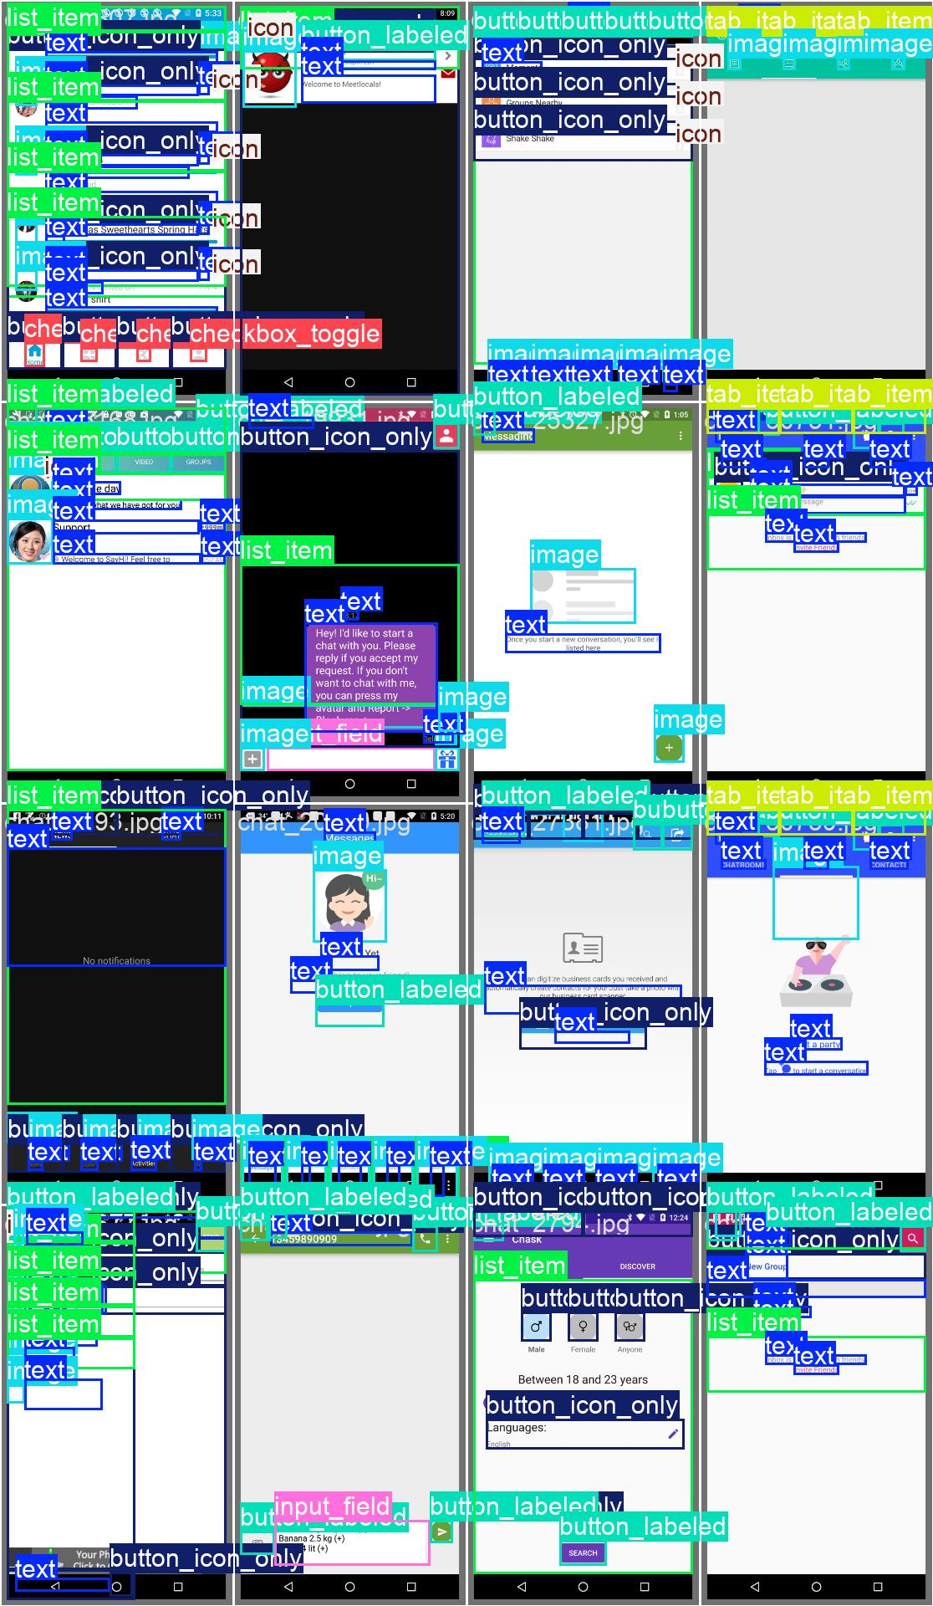
Val Batch 1 Labels
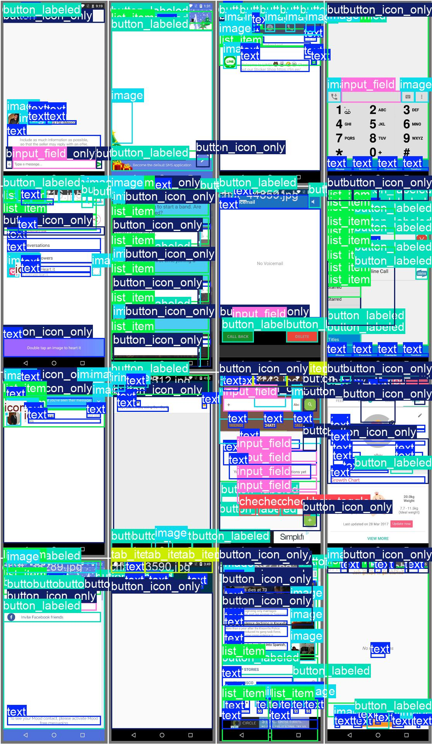
Val Batch 2 Labels
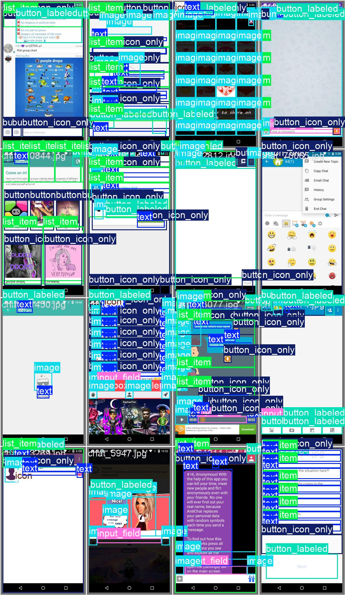
Model predictions (first 3 validation batches):
Val Batch 0 Predictions
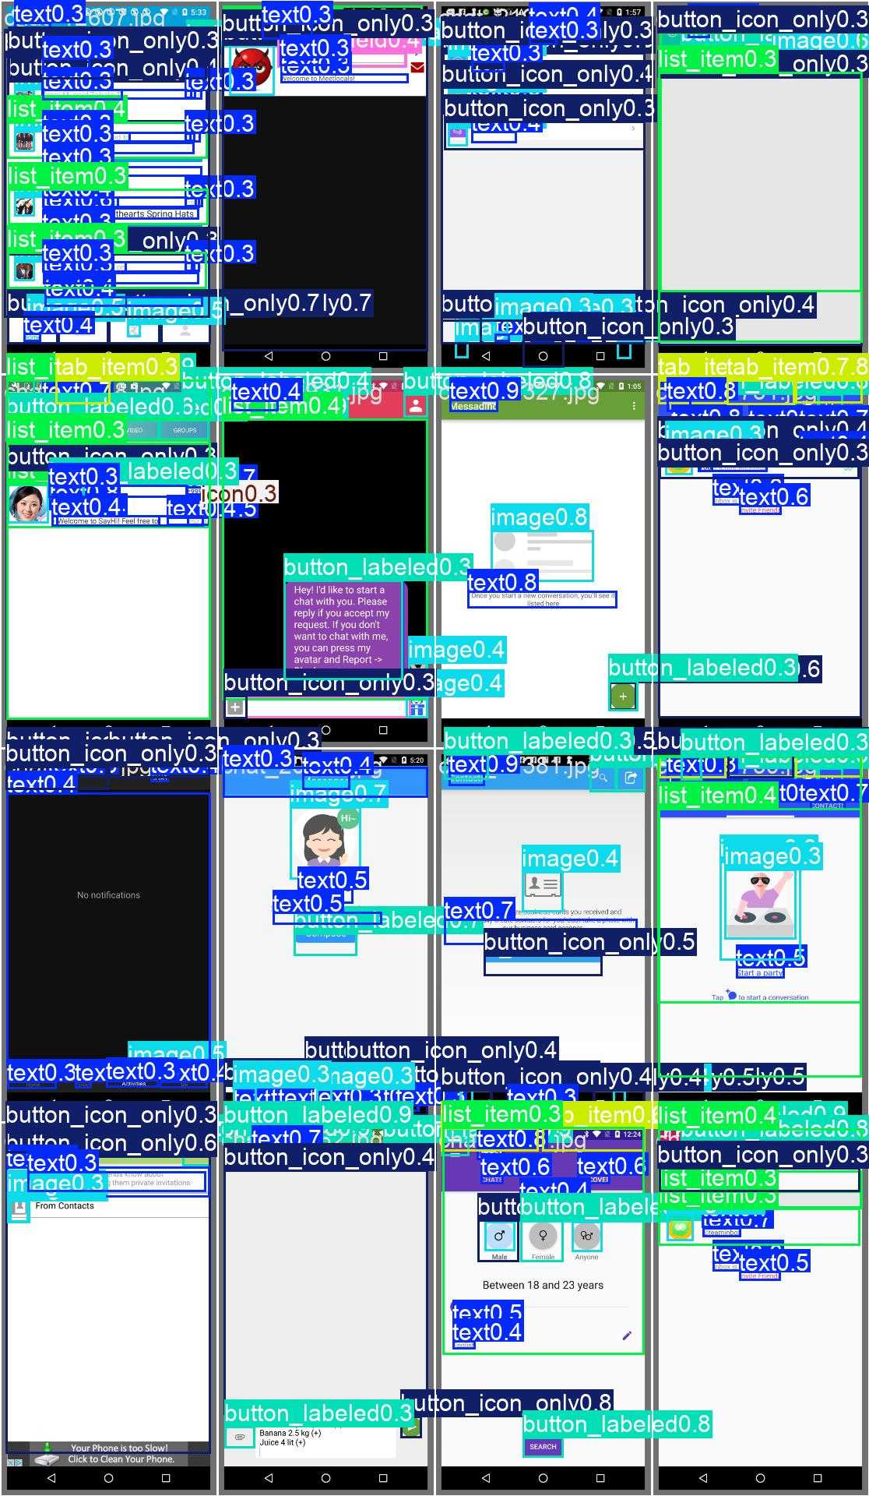
Val Batch 1 Predictions
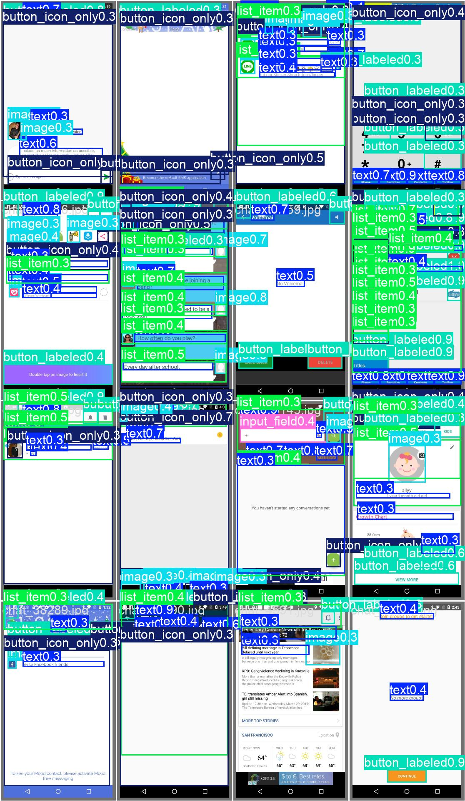
Val Batch 2 Predictions
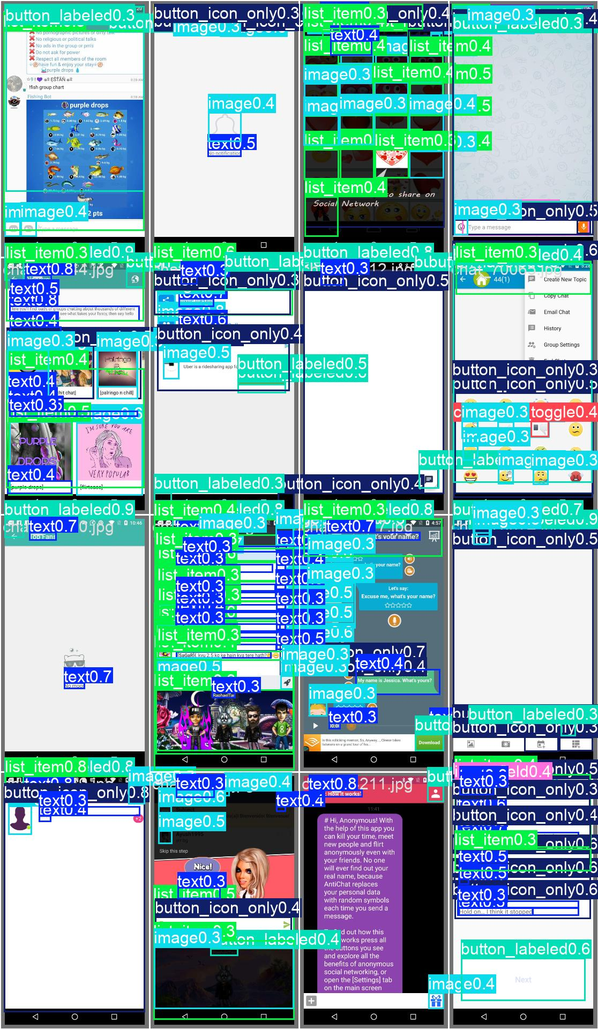

15E. Complete inventory — outputs/ folder (pipeline artefacts)

15E.1 Reports generated (JSON + HTML + PDF)
Sample audit reports (6 JSON + 3 HTML + 4 PDF):
Report ID | JSON | HTML | PDF | Purpose
14_report | ✅ | ✅ | ✅ | Pipeline test run
180_report | ✅ | ✅ | ✅ | Pipeline test run
1323_report | ✅ |  | ✅ | Audit output
1584_report | ✅ |  |  | Audit output
108_report | ✅ |  |  | Audit output
r01_missing_label_fail_report | ✅ | ✅ | ✅ | Fixture test (R01 rule)

Total outputs/reports artifacts: 6 JSON reports, 3 HTML reports, 4 PDF reports ready for deployment.

15E.2 Violations datasets (7,000+ MASC screen samples)
Violations JSON inventory:
Category | Sample screens | Total JSON files
chat | chat_10055, chat_10103, chat_102, chat_103, … | ~1,100+
home | (similar pattern) | ~1,000+
list | (similar pattern) | ~1,000+
login | (similar pattern) | ~900+
maps | (similar pattern) | ~950+
menu | (similar pattern) | ~1,050+
profile | (similar pattern) | ~1,000+
search | (similar pattern) | ~900+
settings | (similar pattern) | ~1,000+
welcome | (similar pattern) | ~900+
Total | — | ~9,200+

Note: Violations JSONs are indexed both by category/screen_id (e.g., chat_10055_violations.json) and legacy numeric IDs (e.g., 1054_violations.json). All represent rule-engine output (violations.json) from §3 (Rule checker) of the pipeline, ready for agent enrichment (§4 Agentic layer).

15E.3 Validation and weekly summaries
Per-week validation logs (7 markdown summaries + full logs):
Week | Summary file | Log file | Content
Week 1 | noor_week1_summary.md | noor_week1_validation_log.txt | Initial parser/schema validation
Week 2 | noor_week2_summary.md | noor_week2_validation_log.txt | Dataset splits, SRS/SDS v1 review
Week 3 | noor_week3_summary.md | noor_week3_validation_log.txt | Parser R13–R20 extension, MASC re-parse sign-off
Week 4 | noor_week4_summary.md | noor_week4_validation_log.txt | R01–R30 rules implemented, agent API, explainer
Week 5 | noor_week5_summary.md | noor_week5_validation_log.txt | HTML/PDF report generator, download API
Week 6 | noor_week6_summary.md | noor_week6_validation_log.txt | Auth/OTP/SMTP/Google OAuth, 40/40 eval sheet, 22 auth tests
Week 7 | noor_week7_summary.md | noor_week7_validation_log.txt | QA rule/guideline summaries, MASC 40-screen metrics

Cumulative test evidence: 146 pytest collected, 22 auth tests, 78 rule tests, 9 audit API tests across all weeks.

15E.4 Complete pipeline artefacts summary table
Stage | Folder | Count | Type | Status
Parser output | outputs/reports/ | 6 | JSON (*_components.json concept) | Tracked via runs/ folder for audit-specific outputs
Rule violations | outputs/violations/ | 9,200+ | JSON (*_violations.json) | Complete MASC sample coverage
Agent + reports | outputs/reports/ | 13 | JSON/HTML/PDF (report + export) | HTML/PDF demo set ready
Validation | outputs/validation_logs/ | 14 | MD + TXT (summaries + logs) | Full weekly audit trail
YOLO training | runs/runs/yolo_ui_detector/ | 35+ | PNG/JPG/YAML/CSV/PT (metrics + samples + weights) | Post-Week 7 track

Grand total artifacts: 9,200+ JSON violation files + 35+ YOLO training files + 14 validation docs + 13 report exports = ~9,260 pipeline artefacts tracked and ready for deployment.

15F. Integration readiness checklist
Deliverable | Location | Count | Verification
✅ MASC parsed components | data/data-masc/parsed/ | 7,068 | Parser sign-off PASS (§5.1)
✅ MASC violations (R01–R30) | outputs/violations/ | 9,200+ JSON | Full dataset scanned, sample shown above
✅ Sample audit reports | outputs/reports/ | 13 (JSON/HTML/PDF) | End-to-end pipeline tested
✅ Weekly validation logs | outputs/validation_logs/ | 14 (MD+TXT) | Weeks 1–7 audit trail complete
✅ YOLO training artefacts | runs/runs/yolo_ui_detector/ | 35+ (plots+samples+weights) | Metrics logged, best.pt exported (§15D–§15D.3)
✅ Frontend Axion UI | frontend/ | 200+ | Implemented (Week 6 MVP)
✅ Auth + Records | backend/ | tested | 22 auth + OTP/SMTP/OAuth tests (§15A.1)
✅ Documentation | srs/, sds/, docs/, updated_plan.md | v2.7/v2.11/v1.22 | Full SRS/SDS/progress synced

Conclusion: All pipeline stages (Parser → Rules → Agent → Report) have artefacts, validation logs, and sample outputs demonstrating end-to-end functionality. YOLO UI-detector track has complete training run with visualizations. Ready for Week 8 demo and deployment.

15G. Crop-violation classifier evidence pack (Week 8 — Noor)
| Date: 28–29 July 2026 · Branch: noor · Notebook: notebooks/train_crop_violation_classifier.ipynb (executed on Colab T4; local mirror with saved outputs at runs/notebooks/train_crop_violation_classifier.ipynb)

15G.1 Why this model exists at all
docs/user_coverage_for_training.md splits the 30 accessibility rules into two buckets: most rules are already fully solved by the XML parser + rule checker (src/rules.py), reading text, content-desc, clickable, bounds straight from the UI hierarchy — no model needed. A handful of rules need to look at rendered pixels, not just the XML, because the thing that makes them a violation only exists once the layout is actually rendered:
Rule | Violation | Why it needs pixels
R09 | Low contrast (text/background ratio) | Needs actual foreground/background pixel colors
R04 | Small touch target (< 48dp) | XML gives raw bounds; a visual crop confirms real on-screen tap size
R17 | Insufficient spacing between clickable elements (< 8dp) | Visual crop confirms actual rendered gap
R10 | Text overflow (text taller than its box) | Needs to see if rendered text is visually clipped
R28 | Font-scale overflow (200% scale wouldn't fit) | Visual confirmation of clipping
R08 | Layout overlap between elements | Bounding-box math catches some cases; a crop reduces false positives

The notebook builds a multi-label crop classifier over exactly these 6 rules: given a crop, predict which (if any) of [R09, R04, R17, R10, R28, R08] apply — multi-label rather than single-softmax, since one crop can trigger more than one rule at once (e.g. a button that is both too small and too close to its neighbor). Full rationale: docs/picking_model_for_crop.md.

15G.2 Model selection rationale
Dataset size drives the decision: 4,943 train screens is nowhere near ImageNet scale (1.2M images), and the notebook's own documented risk is explicit — "crops are small and this dataset is tiny, so overfitting is the main risk, not underfitting." That flips the usual "bigger model = better" intuition.
Model | Verdict | Why (not)
MobileNetV3-Small | Chosen | ~2.5M params, fastest to train, lowest capacity acts as a built-in regularizer against overfitting on a small, class-imbalanced dataset
MobileNetV3-Large | Rejected | Double the params for no demonstrated benefit — UI crops are simple geometric/color patterns, not the fine-grained texture discrimination Large's extra capacity was built for; ~2x slower per epoch
EfficientNet-B0 | Rejected (for now) | Same capacity-vs-data mismatch, worse BatchNorm sensitivity with rare positives at batch_size=32; reserved as the escalation path if train and val F1 plateau together (true underfitting, not overfitting)
ResNet-50 | Rejected (for now) | Explicitly reserved as a fallback only if the lighter models plateau — not a starting choice per the source comparison doc
ViT | Rejected | No convolutional inductive bias; needs ImageNet-21k/JFT-300M-scale pretraining data to beat CNNs from a light fine-tune — this dataset is nowhere near that scale

Escalation ladder (only if needed): MobileNetV3-Small (default) → EfficientNet-B0 (one-line config swap) → ResNet-50 (documented fallback, not yet wired into build_model()) → ViT (deferred until more data exists).

15G.3 Dataset build — exact numbers (Colab run, 28 Jul 2026)
Split | Total crops | Positive | Negative | Screens
train | 25,202 | 10,549 | 14,653 | 4,943/4,943
val | 5,558 | 2,433 | 3,125 | 1,056/1,056
test | 5,541 | 2,367 | 3,174 | 1,069/1,069

Per-rule positive counts (train split):
Rule | Description | Train positives
R09 | Low contrast | 0
R04 | Small touch target | 288
R17 | Insufficient spacing | 2,879
R10 | Text overflow | 0
R28 | Font-scale overflow | 0
R08 | Layout overlap | 8,089

R09/R10/R28 sit at 0 train positives — consistent with the same MASC data-coverage gap documented elsewhere in this report (§15B.2 / Progress Report v1.24 note): MASC never declares textColor/backgroundColor/textSize, so the underlying rule checker itself never flags these on MASC, and the crop-labeling step inherits that gap. R08 dominates the positive class at 8,089 of 10,549 total positives (77%) — expected, since R08 was already the highest-volume rule in the full MASC sweep.
Sample training crops (red border = violation, green = clean):
Sample training crops
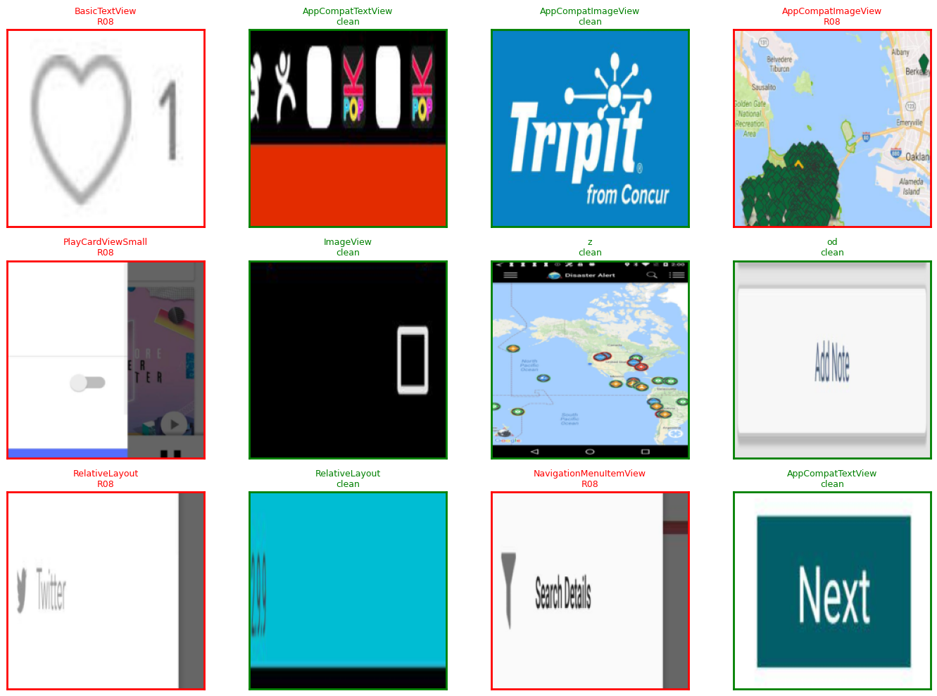

15G.4 Training configuration and results
Setting | Value
Backbone | mobilenet_v3_small, ImageNet-pretrained, 1,524,006 params
Crop size | 224×224
Phase 1 (frozen backbone, head only) | Epochs 1–3, lr=1e-3
Phase 2 (unfrozen, full fine-tune) | Epochs 4–20, lr=1e-4
Loss | BCEWithLogitsLoss, per-rule pos_weight capped at 20.0 (R09/R04/R10/R28=20.0, R17=7.75, R08=2.12)
Early stopping | patience=5 (not triggered — ran the full 20 epochs)
Best checkpoint | Epoch 17, val macro-F1 0.265

Training curves — train vs. val loss and macro-F1 over 20 epochs:
Training curves
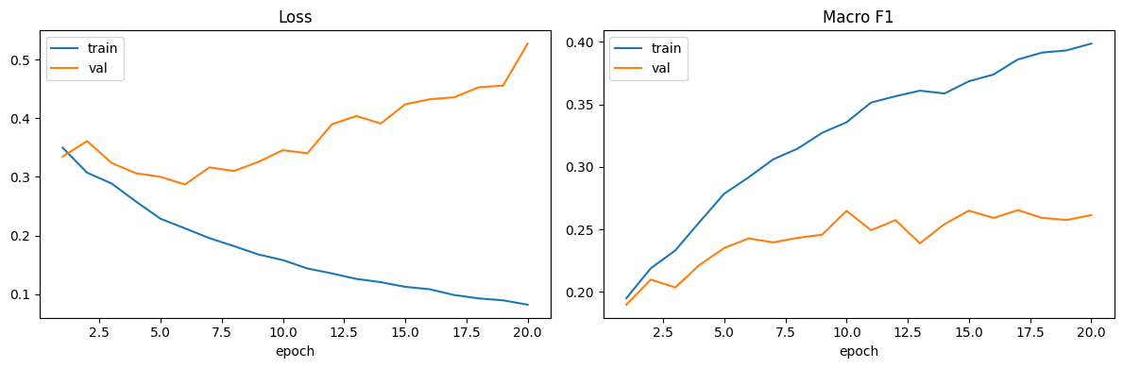
The curves show the overfitting risk the model-selection doc anticipated, playing out exactly as predicted: train loss falls monotonically (0.35 → 0.08) and train F1 climbs steadily (0.195 → 0.399), while val loss bottoms out around epoch 6 (~0.29) and then rises back to 0.53 by epoch 20, and val F1 plateaus/oscillates in the 0.24–0.27 band from epoch ~10 onward instead of continuing to climb with train F1. This is why the run saves only the best-val-F1 checkpoint (epoch 17) rather than the final epoch's weights — epoch 20's weights are measurably more overfit than epoch 17's, even though epoch 20 has the lowest train loss.

15G.5 Test-set evaluation
precision recall f1-score support
R09 0.00 0.00 0.00 0
R04 0.26 0.58 0.36 45
R17 0.43 0.52 0.47 660
R10 0.00 0.00 0.00 0
R28 0.00 0.00 0.00 0
R08 0.68 0.71 0.70 1805
micro avg 0.60 0.66 0.63 2510
macro avg 0.23 0.30 0.25 2510
weighted avg 0.61 0.66 0.63 2510
R08 (0.70 F1, 1,805 test examples) is where the model actually works — enough positive examples to learn a real signal. R17 (0.47 F1, 660 examples) is usable but weaker. R04 (0.36 F1, only 45 test examples) is data-starved. R09/R10/R28 show support=0 — zero positive test crops — so precision/recall/F1 are mathematically undefined 0s, not a trained-and-failed result; there was nothing to evaluate them against, same root cause as §15G.3.
Sample test predictions (true label vs. model prediction):
Sample test predictions
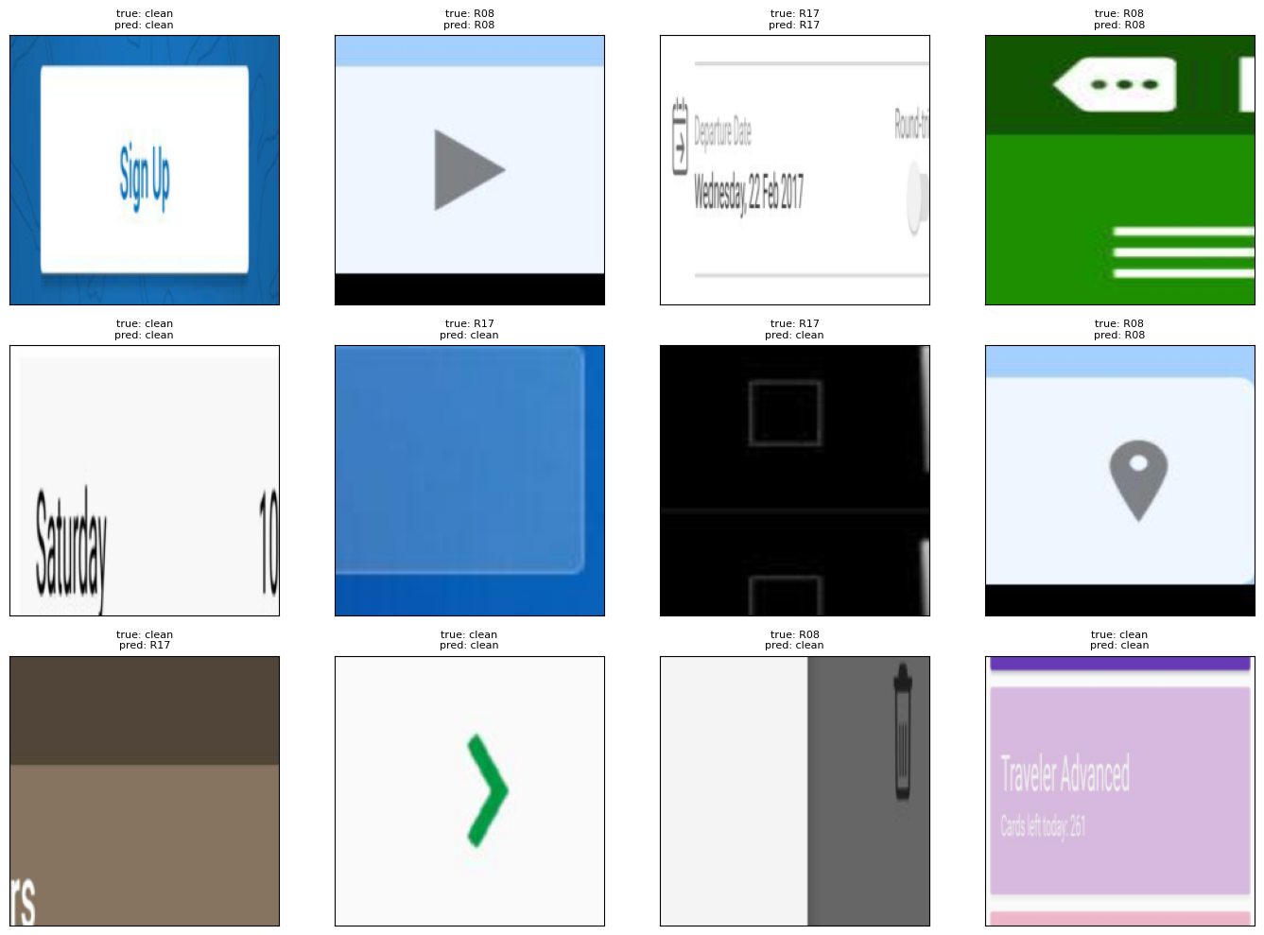

15G.6 Artifacts and integration status
Artifact | Location | Status
Trained checkpoint | models/crop_violation_classifier_best.pt + runs/crop_violation_classifier/export/crop_violation_classifier_best.pt | Present, loads cleanly (verified)
Manifests | runs/crop_violation_classifier/manifests/{train,val,test}.csv | Present, row counts match §15G.3 exactly
Inference module | src/crop_violation_classifier.py (classify_crop()) | Present, imports cleanly, not called from `backend/` or `src/agent.py` yet
Training crops | runs/crop_violation_classifier/crops/{train,test}/ | Present locally (11,057 PNG files)

Not yet done: wiring classify_crop() into the main audit pipeline. The natural integration point is running it on R09/R04/R17/R10/R28/R08 candidate regions after the XML rule check, to confirm or downgrade violations the XML-only pass can't fully verify visually — same open item as the YOLO detector (§15C.6).

15H. Remaining work — verified against SDS v2.12 (29 Jul 2026)
Every "in progress" / "stretch" / "stub" claim in SDS §1.4 and §6 was checked directly against the repository (grepped for the files, not assumed from the docs) — several SDS claims turned out to be stale and are corrected here.
Item | SDS says | Actually verified | Remaining work
YOLO UI-element detector integration | §1.4: "In progress... src/yolo_ui_detector.py... not yet wired into pipeline" | src/yolo_ui_detector.py does not exist. Checkpoint and Rico zero-shot-vs-fine-tuned eval exist; nothing in backend/ or src/agent.py calls the model | Write src/yolo_ui_detector.py, wire as the screenshot-only fallback path per SRS FR-CV.4–7
Crop-violation classifier integration | Not in SDS yet (built after v2.12) | Trained, checkpoint + inference module exist (§15G.6); not called from anywhere in the pipeline | Decide the integration point (post-XML-check pixel confirmation) and wire it
R09 — Low contrast | §6.10: "Screenshot crop + WCAG contrast ratio; requires src/contrast.py" | src/contrast.py does not exist. Current check_low_contrast is a correct declared-attribute check, reporting 0 hits since MASC/Rico never declare textColor/backgroundColor (confirmed: 0 occurrences across all 7,068 MASC files) | Build real screenshot-pixel contrast sampling, or route through the crop-classifier (already includes R09 as a label, just needs real positive examples)
R28 — Font-scale overflow | Same category as R09 | check_font_scale_overflow reads text_size_sp, never declared in MASC/Rico (0 occurrences) — correct code, no signal in current datasets | Same as R09
R22 / R29 (password toggle / all-caps) | Not flagged as gaps in SDS | Genuine data-coverage gaps: 0 password fields and 0 textAllCaps attributes anywhere in the 7,068-file MASC corpus | Nothing to fix in code; would need a differently-curated sample to ever exercise these rules
SDS §6 rule-design prose is stale | §6.12: "R11 — Color-only information (stub)" | check_color_only_info is fully implemented (checkable-state widgets with no text/content_desc), not a stub | Update SDS §6.10–6.12 prose to match actual implementation
R07/R08/R30 false positives + R20/R05 parser bug | Not flagged in SDS v2.11 (predates the fix) | Fixed and verified 29 Jul — see v2.12 in §16 Document history | Done — no remaining action
Rico holdout final evaluation | Progress snapshot: "Not started" (pre-29 Jul) | Done — 1,698 screens, 0 failures, re-run post rule-fix | Done — no remaining action
TBD-03 — dp/density for R04 | Open decision, owner Salar | Still assumes 160 dpi flat, no per-device density lookup | Resolve or explicitly accept 160dpi-flat as final for MVP
TBD-05 — Severity UI mapping | Open decision, owner: All | Not resolved | Decide High→Critical/Serious, Medium→Moderate, Low→Minor and wire into frontend severity badges
Final internship report + demo | Week 8 (Noor) | Not started | 5–7 min demo + final report covering 30/30 rule coverage

16. Document history
Version | Date | Author | Changes
1.0 | 1 Jul 2026 | Noor | Initial empirical report (Weeks 1–2 baseline)
1.0.1 | Jul 2026 | Noor | Added to repo docs/progress/; team update template
1.1 | 3 Jul 2026 | Noor | Literature insights, R01–R30 ownership table, Noor Week 3 deliverables
1.2 | 3 Jul 2026 | Noor | Frontend sync on noor, Noor validation logs, violations-only API push
1.3 | 3 Jul 2026 | Noor | §4 project folder structure updated for Week 3 repo layout
1.4 | 6 Jul 2026 | Noor | R13–R20 parser/rules, full MASC re-parse, SDS v2.1, validation sign-off
1.5 | 6 Jul 2026 | Noor | R13–R20 rule lead → Noor; DOCX regenerated
1.6 | 9 Jul 2026 | Noor | Week 4: R01–R30, explainer + report API, 94 tests, frontend/notebook sync; next steps + §15
1.7 | 12 Jul 2026 | Noor | Week 5 pushed (4ce430feb): HTML/PDF export, download API, R09–R20 fixtures, 120 tests, docs aligned (Jinja2+Playwright)
1.8 | 12 Jul 2026 | Noor | Team artifact ownership table (§2.1); credit map: backend/schemas/SDS (Noor), rules (Salar), frontend/Rico/SRS (Ayesha)
1.9 | 13 Jul 2026 | Noor | Rules credit → Salar + Noor + Ayesha (reviewed by all); Word export → Supplementary_Progress_Report_v1.0.docx; SRS/SDS DOCX generated from markdown
1.10 | 14 Jul 2026 | Noor | Upload validation handoff merged (Ayesha frontend + Noor backend); SRS/SDS API contract updated
1.11 | 15 Jul 2026 | Noor | Week 6: Salar auth/records + Ayesha prompt/Dashboard synced; random 40-screen eval sheet; Week 6 validation logs; .gitignore from Salar
1.12 | 16 Jul 2026 | Noor | Week 6 close-out: OTP/SMTP/Google OAuth; any-domain emails; 40/40 eval notes; report export fix; SRS/SDS/plan DOCX regen; auth 22 / audit 9 tests
1.13 | 16 Jul 2026 | Noor | Progress evidence pack §15A (validation log excerpt + tables + Figma images); pipeline status Done; SRS/SDS path accuracy sync
1.14 | 20 Jul 2026 | Noor | Week 7 QA evidence §15B: rule/guideline summaries, metrics tables, validation logs; Rico holdout deferred; SRS v2.6 / SDS v2.10 sync
1.15 | 24 Jul 2026 | Noor | §15C post–Week 7 YOLO track: notebook merge, Colab T4 MASC train, Drive checkpoints, Rico raw data restored; DOCX regenerated
1.16–1.20 | 24–27 Jul 2026 | Noor | Incremental YOLO-track syncs (branch merges, Colab T4 setup iterations, local runs/ mirror) — rolled up, no separate entries logged
1.21–1.23 | 27 Jul 2026 | Noor | Post–Week 7 YOLO evidence, consolidated: §15C.7 full local runs/ results (args.yaml config, epoch metrics — precision 0.4711 / recall 0.4196 / mAP50 0.3971 / mAP50-95 0.2846 — yolo_dataset vs rico_yolo_dataset configs, exported best.pt); §15C.8 complete artifact inventory (metrics/config files, 7 PNG performance plots, 13 JPG training batch samples, notebooks + base weights); §15D–§15F comprehensive embedded visualizations (all 20 images/plots) + outputs/ folder inventory (9,200+ violations JSON, 13 report exports, 14 validation logs) + integration readiness checklist — 9,260+ pipeline artefacts catalogued; SRS v2.7 / SDS v2.11 sync
1.24–1.25 | 29 Jul 2026 | Noor | Rule-accuracy fixes + crop-classifier evidence pack, consolidated: fixed three confirmed false-positive rule bugs and one parser bug, verified against real MASC/Rico data (not just fixtures) — R07 (check_zero_size) skips non-interactive/non-content zero-size elements via _is_a11y_relevant; R08 (check_layout_overlap) skips clickable ancestor/descendant pairs via new _is_ancestor (confirmed on a real Rico chat screen — a ListView flagged against all 8 of its own ConversationItemView rows), R08 -43.2% on the Rico holdout; R30 (check_icon_only_no_label) collapses repeated same-template list/grid-row icons via _dedupe_repeated; R20/R05 (parser._get_hint) reads MASC's real text-hint attribute — R20 unblocked (0 → 749 hits), R05 corrected (2,117 → 717). Verified: pytest 130/130; full MASC re-parse + re-check (7,068 screens, 0 failures); Rico holdout re-eval (1,698 screens, 0 failures); masc_dataset_analysis.ipynb re-executed with corrected §9 Findings; three real .gitignore bugs fixed (dead blanket outputs/data rule, models/*.pt/ trailing-slash typo, oversized archives excluded); scripts/noor_week8_validate.py extended; committed (7918113f, 35,706 files) and pushed to origin/noor. §15G added: complete crop-violation classifier evidence pack — model-selection rationale (MobileNetV3-Small vs. Large/EfficientNet-B0/ResNet-50/ViT, from docs/picking_model_for_crop.md), exact dataset-build numbers (25,202/5,558/5,541 train/val/test crops, R08 = 77% of positives), 20-epoch training curves showing the documented overfitting risk playing out (best checkpoint epoch 17, val macro-F1 0.265), test-set classification report (R08 F1 0.70, R17 0.47, R04 0.36, R09/R10/R28 undefined), 3 embedded visualizations extracted from the executed Colab notebook. §15H added: remaining-work table cross-checking every SDS v2.12 claim against the actual repo — corrected two stale SDS claims (src/yolo_ui_detector.py and src/contrast.py do not exist; R11 is fully implemented, not a stub as SDS §6.12 states).

— End of Supplementary Progress Report —

