Software Design Specification

Agentic Accessibility Auditor (Axion)

for Android Mobile Application UIs
Field | Value
Document version | 2.11
Status | Implementation reference
Prepared by | Muhammad Noor (Lead — primary author); Salar + Ayesha (SRS inputs, parser/UI design)
Institution | FAST-NUCES
Related SRS | SRS_Agentic_Accessibility_Auditor_v2.0.md (v2.0)
Repository | [MuhammadNoor7/agentic-accessibility-auditor](https://github.com/MuhammadNoor7/agentic-accessibility-auditor)

Document history
Version | Date | Author | Changes
1.0 | 2026 | Team | Initial SDS from merged SRS v1.x
2.0 | 2026 | Team | Aligned to SRS v2.0 with embedded Figma screenshots; auth, Records, Dashboard flows
2.1 | 2026-07-06 | Noor / Salar | Parser R13–R20 fields; rules R01–R20; MASC re-parse sign-off; audit API violations-only
2.2 | 2026-07-09 | Noor / Salar | Rules R01–R30; explainer + agent API wiring; GET …/report; visibility filter
2.3 | 2026-07-12 | Noor | Week 5: src/report.py HTML/PDF + download API; R09–R20 fixtures; team ownership alignment
2.4 | 2026-07-13 | Noor | Rules ownership → Salar + Noor + Ayesha (reviewed by all)
2.5 | 2026-07-13 | Noor | Figma screenshots restored from formatted DOCX into docs/assets/figma/; DOCX export embeds images
2.6 | 2026-07-14 | Noor | POST /audit requires screenshot + xml; server-side pair validation; tests updated
2.7 | 2026-07-15 | Noor | Week 6: JWT auth + records routers synced from Salar; Records UI live; eval sheet (40 stratified-random); validation logs; .gitignore from Salar
2.8 | 2026-07-16 | Noor | OTP/SMTP/Google OAuth design implemented; env credentials documented; report export persistence + autoescape; eval 40/40; auth suite 22 tests
2.9 | 2026-07-16 | Noor | API mount accuracy (/auth, /records, /api/v1/audit); records store records.db.json; docker = backend+auditor; 146 tests; drop planned/stretch leftovers
2.10 | 2026-07-20 | Noor | Week 7 QA scripts (run_week7_eval_analysis.py, noor_week7_validate.py); tracked outputs outputs/week7_eval/; Rico holdout script ready (run_rico_holdout_eval.py) — batch deferred
2.11 | 2026-07-27 | Noor | §3.6 added: YOLO UI-element detector module design (training config, dataset split, class taxonomy, results, src/yolo_ui_detector.py); Appendix B file map + §14 traceability updated; SRS FR-CV.4–7 cross-reference; Progress Report v1.23 comprehensive embedded visuals + outputs sync (§15D–15F)
2.12–2.13 | 2026-07-29 | Noor | §3.2 Rule engine + §6 Rule engine design updated with three false-positive fixes and one parser fix, verified against real data: check_zero_size (R07) gains _is_a11y_relevant gate; check_layout_overlap (R08) gains _is_ancestor helper skipping clickable ancestor/descendant pairs — root-caused on a real Rico screen where a clickable ListView was flagged against all 8 of its own clickable rows; check_icon_only_no_label (R30) gains _dedupe_repeated; §3.1 Parser _get_hint gains a text-hint attribute alias, unblocking R20 (0 → 749 hits) and fixing an R05 false-positive pattern (2,117 → 717). Full pytest 130/130; full MASC + Rico holdout re-verification, 0 failures. §3.7 added: complete crop-violation classifier module design — backbone selection rationale (MobileNetV3-Small vs. Large/EfficientNet-B0/ResNet-50/ViT), data/training design, 20-epoch results (best val macro-F1 0.265 at epoch 17, documented overfitting pattern confirmed), test classification report, classify_crop() inference module design — mirroring §3.6's YOLO treatment. §3.6.4 and §1.4 corrected: src/yolo_ui_detector.py does not exist (previously misreported as scaffolded). Progress Report v1.24–1.25 sync.

Table of contents
- [Introduction](#1-introduction)
- [System architecture](#2-system-architecture)
- [Module design](#3-module-design)
- [Data design](#4-data-design)
- [API design](#5-api-design)
- [Rule engine design](#6-rule-engine-design)
- [Agentic layer design](#7-agentic-layer-design)
- [Report generator design](#8-report-generator-design)
- [Frontend design (Axion)](#9-frontend-design-axion)
- [Authentication and Records design](#10-authentication-and-records-design)
- [Deployment design](#11-deployment-design)
- [Security design](#12-security-design)
- [Testing design](#13-testing-design)
- [SRS traceability](#14-srs-traceability)
- [Appendix A: OpenAPI specification](#appendix-a-openapi-specification)
- [Appendix B: File and directory map](#appendix-b-file-and-directory-map)
- [Appendix C: Sequence diagrams](#appendix-c-sequence-diagrams)
- [Appendix D: UI component map (Figma)](#appendix-d-ui-component-map-figma)

1. Introduction

1.1 Purpose
This Software Design Specification (SDS) describes how the Agentic Accessibility Auditor is designed and implemented. It is the technical companion to SRS v2.0, which defines what the system must do.
This document provides:
- Architecture and module boundaries
- Class/function design and algorithms
- Normative JSON schema usage
- REST API contracts (OpenAPI)
- Frontend component structure (Axion)
- Auth and per-user Records storage design
- Deployment, security, and test design

1.2 Design scope
In scope | Out of scope
Parser, rule engine, agent, report generator | Business case / internship planning
FastAPI orchestrator + Axion React UI | Clinical accessibility research
Auth + Records persistence | Production HIPAA / enterprise SSO
Docker Compose topology | Play Store / APK crawling
R01–R20 rule pseudocode + parser extensions | Full R21–R30 implementation detail

1.3 Design principles
ID | Principle | Rationale
D1 | Pipeline isolation via JSON artefacts | Interns integrate through agreed files/API
D2 | Deterministic rule engine | Same input → same violations.json
D3 | LLM explains only | Agent never creates violations
D4 | Schema-first contracts | auditor_schema.json validated in CI
D5 | Hybrid parser, single traversal | UIAutomator + MASC + Rico in one pass
D6 | Fail gracefully | Bad XML, LLM timeout → structured errors
D7 | User-scoped Records | Each audit linked to authenticated user_id

1.4 Implementation status
Module | Path | Owner | Status
Hybrid XML parser | src/parser.py | Salar / Noor | Done (R13–R20 fields + visibility)
Schema helpers | src/schema_documents.py | Noor | Done (JSON envelope builders)
JSON Schema | docs/schemas/auditor_schema.json, docs/json_schemas.md | Noor | Done
Validation scripts | scripts/validate_output.py, scripts/noor_week3_validate.py, scripts/noor_week4_validate.py, scripts/noor_week5_validate.py, scripts/noor_week6_validate.py, scripts/masc_parse_signoff.py | Noor / Salar | Done
FastAPI audit API | backend/routers/audit.py | Noor | Done (paired upload + violations + report + download)
Auth (JWT + OTP + OAuth) | backend/auth.py, otp_store.py, email_service.py, routers/auth_router.py | Salar + Noor (OTP/SMTP/Google) | Done on noor Week 6
Records API | backend/routers/records_router.py | Salar / Noor | Done (list/create/get/delete + score/filename fields)
Rule engine | src/rules.py | Salar + Noor + Ayesha | Done (R01–R30; reviewed by all)
Agent layer | src/agent.py, src/explainer.py, src/llm_providers.py | Noor | Done (API-wired; template + live LLM)
Report generator | src/report.py | Noor | Done (Jinja2 HTML + PIL + Playwright PDF)
Axion React UI | frontend/ | Ayesha / Salar / Noor | Done for MVP screens including Forgot/OTP/Reset + Google Sign-In + profile initials
pytest suite | tests/, backend/tests/ | Salar / Noor | Done (146 collected; auth 22, rules 78, audit 9, …)
YOLO UI detector (screenshot-only fallback) | src/yolo_ui_detector.py, notebooks/train_yolo_ui_detector.ipynb, runs/ | Salar (notebook) / Noor (Colab train) | In progress — MASC-only training run 1 epoch logged (mAP50-95 0.285); best.pt exported; not yet wired into pipeline

2. System architecture

2.1 Logical architecture
┌──────────────────────────────────────────────────────────────────────────┐
│ Axion React Dashboard (frontend/) │
│ Auth │ Upload │ Dashboard │ Report │ Records │ Generate Report Modal │
└───────────────────────────────┬──────────────────────────────────────────┘
│ HTTPS + JWT
┌───────────────────────────────▼──────────────────────────────────────────┐
│ FastAPI Orchestrator (backend/) │
│ /auth/* │ /audit/* │ /records/* │ PipelineService │ RecordsService │
└───┬─────────┬──────────┬──────────┬──────────┬─────────────────────────────┘
│ │ │ │ │
▼ ▼ ▼ ▼ ▼
Parser RuleEngine Agent ReportGen RecordsStore
src/ src/rules src/ src/report outputs/records/
agent
│ │ │ │
▼ ▼ ▼ ▼
components violations report.json audit_record.json
.json .json + HTML/PDF paths

2.2 Pipeline data flow
Screenshot + UIAutomator XML
→ Parser → components.json
→ Rule Engine → violations.json
→ Agent → report.json
→ Report Generator → audit_report.html / .pdf
→ Records Service → outputs/records/{user_id}/{record_id}/
→ Axion UI → Dashboard + Records list

2.3 Physical deployment (Docker Compose)
Service | Image | Port | Role
backend | ./backend/Dockerfile | 8000 | FastAPI + JWT (JWT_SECRET) + pipeline
auditor | ./Dockerfile | — | Batch parser worker (DATASET_ROOT)

Network: auditor-network (bridge). Repo root mounted at /app.
Frontend: Vite app runs locally (npm run dev); not packaged in current docker-compose.yml (no frontend/Dockerfile yet).

2.4 Per-audit run directory
outputs/runs/{audit_id}/
├── input/
│ ├── screenshot.png
│ └── window.xml
├── components.json
├── violations.json
├── report.json
├── audit_report.html
└── audit_report.pdf

2.5 Per-user Records storage (prototype)
MVP persistence is a flat JSON store, not per-user folders:
- Records: backend/data/records.db.json — each row includes record_id, user_id, screen_id, created_at, total_violations, violations_by_severity, accessibility_score, screenshot_name, xml_name, artefact paths
- Report reopen: GET /records/{id}/report loads outputs/reports/{screen_id}_report.json when present
(Folder design outputs/records/{user_id}/… remains a Should/future layout; not required for current Axion Records UI.)

3. Module design

3.1 Parser module (`src/parser.py`)
SRS: FR-PS.1–FR-PS.9 | Owner: Salar / Noor | Status: Implemented

3.1.1 Responsibilities
- Sanitize XML (strip \x00)
- Traverse hierarchy; emit flat components[]
- Infer screen_id, image_path, xml_path
- Write schema-compliant components.json

3.1.2 Public API
Function | Input | Output
load_xml_root(path) | Path | lxml root
parse_xml_tree(root) | Element | list[dict]
build_screen_document(...) | paths + components | JSON dict
parse_xml_file(xml_path, ...) | Path | output Path
parse_dataset_folder(...) | dataset root | batch stats

3.1.3 Bounds parsing algorithm
parse_bounds(raw):
if matches "[l,t][r,b]" → return [l,t,r,b] # UIAutomator
if matches "l t r b" → return [l,t,r,b] # Rico
return None
extract_bounds(element):
b = parse_bounds(element.@bounds)
if b: return b
b = parse_masc_wrapper_bounds(element)
if b: return b
if is_uiautomator_node(element):
return [0,0,0,0] # TC-01
return None

3.1.5 Extended component fields (R13–R20)
Depth-first traversal preserves parent_id and assigns focus_order in document order. MASC <wrapper> nodes are descended into (widgets are nested inside wrappers).
Field | Used by | Notes
focus_order | R15 | 1-based traversal index
parent_id | R15, hierarchy | component_id of parent or ""
long_clickable, scrollable | R18 | Gesture heuristics
media_type | R12, R13 | "", video, audio, animation
is_dialog | R19 | Confirmation dialog detection
label_for, hint, input_type, password | R05, R20 | Input labelling
important_for_accessibility | R16 | Decorative vs focusable

Also emitted: selected, checked, text_all_caps, device_info.dpi on screen document.

3.1.4 Screenshot pairing
Mirror XML path under screenshots/ with same stem; try .jpg, .jpeg, .png.

3.2 Rule engine module (`src/rules.py`)
SRS: FR-RU.1–FR-RU.30 | Owner: Salar + Noor + Ayesha (reviewed by all) | Status: Implemented (R01–R30)

3.2.1 Public API
Function | Input | Output
check(components_json) | components.json dict | violations.json dict
check_* per rule | list[dict] components | list[dict] violations

Implementation uses plain functions (not a RuleEngine class). Entry point check() filters hidden components (visibility), then chains R01–R30 checkers, reads device_info.dpi for dp rules (R04, R17, R28), and returns schema-shaped output.

3.2.2 Processing flow
- Load components[] and device_info.dpi (default 160)
- Drop components with visibility=false (MASC gone / visible-to-user=False)
- Run R01–R30 check functions in order
- Each violation includes denormalized class, bounds; pair rules add related_component (R03, R08, R17)
- Return dict with total_violations == len(violations) plus component/hidden counts

3.2.3 Rule status (Week 4)
Rules | Status
R01–R08, R10–R30 | Implemented
R09 | Implemented when declared colors present; otherwise inactive
R28 | Implemented when declared text size present; otherwise inactive

3.2.4 dp conversion
width_dp = (bounds[2] - bounds[0]) / density
height_dp = (bounds[3] - bounds[1]) / density
Default dpi = 160 when device_info absent (TBD-03).

3.2.5 Severity mapping (engine → UI)
Engine | Axion badge
Critical | Critical
High | Serious
Medium | Moderate
Low | Minor

3.3 Agent module (`src/agent.py` + `src/explainer.py`)
SRS: FR-AG.1–FR-AG.8 | Owner: Noor | Status: Done (API-wired Week 4)
def build_audit_report(
violations_doc: dict,
components_doc: dict | None = None,
*,
use_llm: bool | None = None,
) -> dict: ...
class AgenticEnricher:
def enrich(self, violations_doc: dict, components_doc: dict | None = None) -> dict: ...
- build_audit_report() produces report.json with accessibility_score, summary, and per-violation agent fields
- Live path: src/explainer.py → src/llm_providers.py (Anthropic / OpenAI / Gemini / Groq), batched, anti-hallucination match
- Fallback: template enrichment when no API key or use_llm=false (FR-AG.6)
- Wired in backend/routers/audit.py → GET /api/v1/audit/{id}/report

3.4 Report module (`src/report.py`)
SRS: FR-RP.1–FR-RP.7 | Owner: Noor | Status: Implemented (12 Jul 2026)
- Jinja2 HTML template (src/templates/audit_report.html.j2)
- PIL bounding-box annotation on screenshots
- Playwright Chromium for HTML → PDF (render_pdf_report)
- GET /api/v1/audit/{id}/report/download?format=html|pdf
- Accessibility score from agent layer (see §8.2)

3.5 API orchestrator (`backend/`)
Owner: Noor
backend/
├── main.py # FastAPI app, CORS, routers
├── config.py # env settings
├── routers/
│ ├── auth.py
│ ├── audit.py
│ └── records.py
├── services/
│ ├── pipeline.py # stage orchestration
│ ├── auth.py # JWT, OTP
│ └── records.py # user-scoped persistence
├── models/
│ ├── auth.py # Pydantic models
│ ├── audit.py
│ └── records.py
└── dependencies.py # get_current_user

3.5.1 Pipeline service
async def run_audit(audit_id: str, user_id: str) -> None:
set_status(audit_id, "parsing")
components = parse_xml_file(...)
set_status(audit_id, "checking")
violations = rule_engine.run(components)
set_status(audit_id, "explaining")
report = agent.enrich(violations, components)
set_status(audit_id, "reporting")
paths = report_gen.render(report, run_dir)
set_status(audit_id, "complete")
records_service.save(user_id, audit_id, report, paths)
Statuses: pending → parsing → checking → explaining → reporting → complete | error

3.6 YOLO UI-element detector module (screenshot-only fallback)
SRS: FR-CV.4–FR-CV.7 | Owner: Salar (training notebook) / Noor (Colab training + inference module) | Status: In progress (training) — inference module scaffolded, not pipeline-wired

3.6.1 Purpose
The primary pipeline (§2.2) requires a paired screenshot + XML and derives components.json from the XML hierarchy. The YOLO module exists to make the auditor degrade gracefully when the XML view hierarchy is unavailable, malformed, or intentionally blocked (e.g. some hardened apps suppress the accessibility tree) — the detector infers UI element boxes and coarse types directly from screenshot pixels, so the rest of the pipeline (rule engine → agent → report) can still run on a best-effort components.json.

3.6.2 Data and training design
Decision | Detail
Train / val / test | MASC only, via existing stratified splits (data/data-masc/splits/) — never Rico
Rico holdout | Reserved for generalization eval only (zero-shot / fine-tuned comparison); enforced by a separate rico_yolo_dataset/dataset.yaml whose train/val/test all point at images/test so it can never accidentally be used to train
Label source | Generated from XML bounds at label-generation time only — the trained model sees pixels only at inference, never XML
Base architecture | Ultralytics YOLO (yolo11s.pt pretrained checkpoint as starting weights, per notebooks/train_yolo_ui_detector.ipynb)
Runtime | Google Colab T4 GPU (~16 GB)
Key hyperparameters | epochs=60 (early-stop patience=10), batch=8, imgsz=960, optimizer=auto (lr0=0.01, lrf=0.01, cos_lr=true), seed=42, deterministic=true — full config in runs/runs/yolo_ui_detector/runs/yolo_ui_detector/args.yaml
Class taxonomy (9) | text, image, icon, button_labeled, button_icon_only, input_field, checkbox_toggle, tab_item, list_item
Smoke test mode | LOCAL_MODE=True (~20 images, 1 epoch) validates paths before the full Colab run

3.6.3 Results (local run, verified 27 Jul 2026)
One completed epoch is logged in the local run mirror (runs/runs/yolo_ui_detector/runs/yolo_ui_detector/results.csv):
Metric | Value
Precision | 0.4711
Recall | 0.4196
mAP50 | 0.3971
mAP50-95 | 0.2846
Train box/cls/dfl loss | 0.987 / 1.390 / 1.194
Val box/cls/dfl loss | 1.095 / 1.604 / 1.285

Full run artifacts (PR/F1/confusion-matrix plots, prediction samples) and the longer multi-epoch Colab/Drive progression are documented in the Supplementary Progress Report §15C / §15C.7. Best checkpoint exported to runs/runs/yolo_ui_detector/export/yolo_ui_detector_best.pt (~19 MB).

3.6.4 Inference module design
# src/yolo_ui_detector.py (planned signature — file does not exist yet, corrected 29 Jul;
# contrast with §3.7.5's classify_crop(), which is real and imports/runs today)
def detect_ui(image_path: str, weights_path: str = "models/yolo_ui_detector_best.pt") -> dict:
"""Run the fine-tuned YOLO detector on a screenshot and return a
components.json-compatible structure (component_id, class, bounds,
inferred=True) built purely from pixel detections."""
Design point | Detail
Output shape | Matches §4.2 components.json schema, with each component tagged inferred: true (no text / content_desc — YOLO does not read text)
Confidence | Detections below a configurable confidence threshold are dropped before rule checking
Integration point (planned) | backend/services/pipeline.py — if XML parsing fails or is absent, fall back to detect_ui(screenshot) instead of parse_xml_file(...) before handing off to the rule engine (§3.2)
Rule-engine impact | Rules that depend on XML-only fields (content-desc, focus_order, hint, etc. — see §3.1.5) are expected to under-fire on YOLO-only input; this is a known, documented limitation, not silently hidden (FR-CV.7)

Not yet done: pipeline wiring (fallback trigger in pipeline.py), Rico holdout zero-shot/fine-tuned comparison, and full 60-epoch convergence. Tracked in Progress Report §15C.6 Next steps.

3.7 Crop-violation classifier module (pixel-level rule confirmation)
SRS: FR-CV.1–FR-CV.3 (supplementary CV signal, R09 contrast, never silently override rule results) | Owner: Noor (Colab training + inference module) | Status: Trained, inference module working, not pipeline-wired

3.7.1 Purpose
src/rules.py is XML-only: most rules read straight from the parsed hierarchy, but six rules describe something that only really exists once the layout is rendered — a contrast ratio, a rendered touch-target size, a rendered gap, clipped text, or a visual overlap. This module is a multi-label crop classifier: given a cropped region of a screenshot, predict which of [R09, R04, R17, R10, R28, R08] apply, so the pipeline can eventually confirm or downgrade an XML-only rule's verdict with a pixel-level signal instead of trusting bounds math alone.
Rule | Violation | Why it needs pixels
R09 | Low contrast (text/background ratio) | Needs actual foreground/background pixel colors
R04 | Small touch target (< 48dp) | XML gives raw bounds; a crop confirms real on-screen tap size
R17 | Insufficient spacing (< 8dp) | Visual crop confirms actual rendered gap
R10 | Text overflow | Needs to see if rendered text is visually clipped
R28 | Font-scale overflow (200% scale) | Visual confirmation of clipping
R08 | Layout overlap | Bounding-box math catches some cases; a crop reduces false positives

Multi-label (not single-softmax) because one crop can trigger more than one rule at once — e.g. a button that is both too small and too close to its neighbor.

3.7.2 Backbone selection
Dataset size drove the decision, not raw accuracy tables: 4,943 train screens is far below ImageNet scale, and the notebook's own documented risk is explicit — "crops are small and this dataset is tiny, so overfitting is the main risk, not underfitting."
Model | Params | Verdict | Why (not)
MobileNetV3-Small | ~2.5M | Chosen | Fastest to train; lowest capacity acts as a built-in regularizer against overfitting on a small, imbalanced dataset
MobileNetV3-Large | ~5.4M | Rejected | Double the params for no demonstrated benefit on simple geometric/color crop patterns; ~2x slower/epoch
EfficientNet-B0 | ~5.3M | Rejected (for now) | Same capacity-vs-data mismatch, worse; more BatchNorm-sensitive with rare positives at batch_size=32. Escalation path if train and val F1 plateau together
ResNet-50 | ~25M | Rejected (for now) | Documented fallback only if lighter models plateau — not a starting choice
ViT | Varies | Rejected | No convolutional inductive bias; needs ImageNet-21k/JFT-300M-scale pretraining to beat CNNs from a light fine-tune

Full rationale: docs/picking_model_for_crop.md.

3.7.3 Data and training design
Decision | Detail
Train / val / test | MASC only (data/data-masc/splits/), same splits as the parser/YOLO tracks
Label source | Generated at crop-build time by running the existing, already-tested rule checker (src.rules.check()) on each screen and keeping only the 6 target rules — reuses src/rules.py rather than re-implementing contrast/overlap/spacing math
Crop extraction | Each flagged component becomes one positive crop (224×224, resized, ~15% context padding); negatives_per_screen=3 non-violating clickable/text elements sampled per screen as negatives
Backbone | mobilenet_v3_small, ImageNet-pretrained, final layer replaced with a 6-way linear head (1,524,006 total params)
Two-phase fine-tune | Phase 1 (epochs 1–3): backbone frozen, head-only at lr=1e-3. Phase 2 (epochs 4–20): full unfreeze at lr=1e-4
Loss | BCEWithLogitsLoss, per-rule pos_weight capped at 20.0 (severe class imbalance — R09/R04/R10/R28 hit the cap, R17=7.75, R08=2.12)
Early stopping | patience=5 epochs without val macro-F1 improvement (not triggered — full 20 epochs ran)
Checkpoint policy | Only the single best-val-F1 checkpoint is ever saved (torch.save overwrites the same path each time a new best is found) — no per-epoch snapshots, by design

Dataset build (Colab, 28 Jul 2026):
Split | Total crops | Positive | Negative | Screens
train | 25,202 | 10,549 | 14,653 | 4,943/4,943
val | 5,558 | 2,433 | 3,125 | 1,056/1,056
test | 5,541 | 2,367 | 3,174 | 1,069/1,069

Per-rule train positives: R08 = 8,089 (77% of all positives), R17 = 2,879, R04 = 288, R09/R10/R28 = 0 (same MASC data-coverage gap as §6.10/§6.21 — no declared color/text-size attributes in the corpus, so the rule checker that generates these labels never flags them on MASC either).

3.7.4 Results (verified from the executed Colab notebook, 28–29 Jul 2026)
Metric | Value
Best checkpoint | Epoch 17 of 20
Best val macro-F1 | 0.265
Train loss (epoch 1 → 20) | 0.350 → 0.082
Val loss (epoch 1 → 20) | 0.335 → 0.528

Train loss falls monotonically and train F1 climbs steadily (0.195 → 0.399) while val loss bottoms out around epoch 6 and then rises, and val F1 plateaus/oscillates in the 0.24–0.27 band from epoch ~10 onward — the overfitting pattern §3.7.2 anticipated, playing out exactly as documented. This is why only the best-val-F1 epoch's weights are kept, not the final epoch's (epoch 20 has the lowest train loss but is measurably more overfit than epoch 17).
Test-set classification report:
precision recall f1-score support
R09 0.00 0.00 0.00 0
R04 0.26 0.58 0.36 45
R17 0.43 0.52 0.47 660
R10 0.00 0.00 0.00 0
R28 0.00 0.00 0.00 0
R08 0.68 0.71 0.70 1805
macro avg 0.23 0.30 0.25 2510
R08 (0.70 F1) is where the model actually works — enough positive examples to learn real signal. R17 (0.47) is usable but weaker. R04 (0.36) is data-starved (45 test examples). R09/R10/R28 show support=0 — undefined metrics, not a trained-and-failed result; there was nothing to evaluate against. Full curves, sample crops, and prediction grids: Progress Report §15G.

3.7.5 Inference module design
# src/crop_violation_classifier.py (real — imports and runs, unlike §3.6.4's scaffold)
def classify_crop(
image_path: str | Path,
bounds: list[int] | None = None,
weights_path: str | Path = DEFAULT_WEIGHTS,
threshold: float = 0.5,
) -> dict[str, float]:
"""Classify one crop (or region of a larger screenshot, if bounds given).
Returns {rule_id: probability} for every rule predicted above threshold,
plus every rule's raw probability under "_all"."""
Design point | Detail
Model loading | Lazily cached per weights_path in _model_cache — one load per process, not per call
Output shape | {"_all": {rule: prob, ...}, rule_above_threshold: prob, ...} — raw probabilities always available, thresholded hits called out separately
Weights default | models/crop_violation_classifier_best.pt, resolved relative to the module's own path
Integration point (planned, not done) | After the XML rule check (§3.2) runs, call classify_crop() on the bounds of any R09/R04/R17/R10/R28/R08 candidate to confirm or downgrade it with a pixel-level signal, mirroring FR-CV.2's "never silently override" rule

Not yet done: pipeline wiring (nothing in backend/ or src/agent.py calls classify_crop() yet — same open item as §3.6's YOLO detector), and no automated tests exist for this module. Tracked in Progress Report §15G.6.

4. Data design
Normative schema: docs/schemas/auditor_schema.json

4.1 Entity relationship
User (user_id)
└── has many AuditRecord (record_id)
├── has one Screen (screen_id, image_path, xml_path)
├── has many Violations
└── has report artefacts (json, html, pdf)

4.2 components.json
Field | Type | Required
schema_version | string "1.0" | Recommended
screen_id | string | Yes
image_path | string | Yes
xml_path | string | Yes
components | array | Yes

Component (required): component_id, class, text, content_desc, resource_id, clickable, enabled, focusable, bounds[4]
Component (optional, R13–R20): hint, focus_order, parent_id, long_clickable, scrollable, selected, checked, password, text_all_caps, input_type, important_for_accessibility, media_type, is_dialog, label_for
Screen: optional device_info with dpi, width_px, height_px
Pattern: component_id matches ^c_\d{3,}$

4.3 violations.json
Screen level: schema_version, screen_id, image_path, xml_path, total_violations, violations[]
Violation: rule_id, issue, component_id, class, bounds, guideline, severity, recommendation, optional related_component
Invariant: total_violations == len(violations)

4.4 report.json
Adds summary object and agent fields per violation:
- agent_explanation
- agent_why_it_matters
- agent_developer_fix

4.5 records store (`backend/data/records.db.json`)
Field | Type | Description
record_id | string | UUID
user_id | string | Owner
screen_id | string | e.g. r01_missing_label_fail
created_at | ISO datetime | Audit timestamp
total_violations | int | Violation count
violations_by_severity | object | Severity histogram
accessibility_score | int/null | 0–100 score from agent
screenshot_name | string/null | Original upload filename
xml_name | string/null | Original upload filename
components_path / violations_path | string/null | Artefact paths when available
report_html_path | string | Relative path
report_pdf_path | string | Relative path

4.6 index.json (per user)
{
"user_id": "u_001",
"records": [
{
"record_id": "rec_abc123",
"screen_id": "screen_014",
"score": 78,
"total_issues": 7,
"created_at": "2026-07-01T12:00:00Z"
}
]
}

4.7 Validation
python test_run.py --dataset masc # batch parse + rules → parsed/ + outputs/violations/
python scripts/validate_output.py # JSON Schema spot-check
python scripts/masc_parse_signoff.py # train/val/test parse sign-off + R13–R20 counts
python scripts/noor_week3_validate.py # full pipeline: re-parse, pytest, API smoke, MASC scan
MASC artefacts:
Path | Purpose
data/data-masc/parsed/*_components.json | Re-parsed components (all categories)
data/data-masc/parsed/batch_parse_masc_full.log | Full batch parse terminal log
data/data-masc/parsed/masc_parse_signoff_report.json | Parse sign-off + R01–R20 aggregate counts
outputs/violations/*_violations.json | Per-screen rule output
outputs/validation_logs/noor_week3_validation_log.txt | Noor validation run log (appended)

Run after each pipeline stage or via python scripts/noor_week3_validate.py.

5. API design
Base URL: http://localhost:8000 (or 8002 in local multi-server demos)
Mounts: audit pipeline under /api/v1/audit/*; auth under /auth/*; records under /records/* (no /api/v1 on auth/records).
Auth: Authorization: Bearer <JWT> (except public auth endpoints and /health).

5.1 Auth endpoints
Method | Path | Description
POST | /auth/register | Email + password (≥ 8, letter+digit); optional name
POST | /auth/login | Returns JWT + user profile
GET | /auth/me | Current user (JWT)
POST | /auth/google | Google OAuth ID-token exchange
GET | /auth/config | Public flags (Google client configured?)
POST | /auth/forgot-password | Send 6-digit OTP via SMTP
POST | /auth/resend-otp | Resend OTP
POST | /auth/verify-otp | Validate OTP
POST | /auth/reset-password | Set new password

5.2 Audit endpoints
Method | Path | Description
POST | /api/v1/audit | Upload screenshot + XML (multipart: screenshot, xml); validates PNG/JPG + matching pair; optional use_llm query; start pipeline
GET | /api/v1/audit/{audit_id}/status | Pipeline status (pending → parsing → checking → explaining → complete)
GET | /api/v1/audit/{audit_id}/violations | Violations JSON (implemented)
GET | /api/v1/audit/{audit_id}/report | Report JSON with score + agent fields (implemented Week 4)
GET | `/api/v1/audit/{audit_id}/report/download?format=html\ | pdf`
POST | /api/v1/audit/batch | Batch over dataset path (Should)

5.3 Records endpoints
Method | Path | Description
POST | /records | Create record for current user (JWT) — optional accessibility_score, screenshot_name, xml_name
GET | /records | List current user's audits
GET | /records/{record_id} | Record detail + artefact paths
GET | /records/{record_id}/report | Re-open persisted outputs/reports/{screen_id}_report.json
DELETE | /records/{record_id} | Delete record

Auth endpoints (implemented Week 6 on noor): POST /auth/register, POST /auth/login, GET /auth/me, POST /auth/forgot-password, POST /auth/resend-otp, POST /auth/verify-otp, POST /auth/reset-password, POST /auth/google, GET /auth/config.

5.4 Example: POST /audit
Request: multipart/form-data — required fields screenshot (PNG/JPG), xml (.xml). Filenames must match as a pair (same stem, or shared numeric ID with matching prefix — mirrors filesMatch() in Upload.jsx).
Response 202:
{
"audit_id": "a1b2c3d4",
"status": "complete"
}
Errors: 422 if screenshot missing; 400 if invalid image type, non-XML upload, or filename pair mismatch.

5.5 Example: GET /audit/{id}/status
{
"audit_id": "a1b2c3d4",
"status": "checking",
"stage_progress": {
"parsing": "complete",
"checking": "in_progress",
"explaining": "pending",
"reporting": "pending"
},
"error": null
}

5.6 Example: GET /records
{
"records": [
{
"record_id": "8d3b7853-2aab-4f1a-8fc3-8a7cc9e20baa",
"user_id": "…",
"screen_id": "week6_smoke",
"created_at": "2026-07-15T00:00:00+00:00",
"total_violations": 2,
"violations_by_severity": {"High": 1, "Medium": 1, "Low": 0},
"components_path": "",
"violations_path": "outputs/violations/week6_smoke_violations.json",
"accessibility_score": 85,
"screenshot_name": "week6_smoke.png",
"xml_name": "week6_smoke.xml"
}
],
"total": 1
}

6. Rule engine design
Pseudocode for MVP rules R01–R10. Full catalogue: SRS §7.2.

6.1 Shared helpers
def is_empty(s: str) -> bool:
return not s or not s.strip()
def is_clickable(c: dict) -> bool:
return c["clickable"] is True

6.2 R01 — Missing accessible label
for c in components:
if c.clickable and is_empty(c.text) and is_empty(c.content_desc):
emit(R01, c, severity=High, guideline=G01)

6.3 R02 — Image button without description
for c in components:
if is_image_class(c.class) and c.clickable and is_empty(c.content_desc):
emit(R02, c, severity=High, guideline=G02)

6.4 R03 — Duplicate labels
Group clickable components by (text or content_desc); flag groups with ≥ 2 distinct component IDs.

6.5 R04 — Small touch target
if width_dp < 48 or height_dp < 48:
emit(R04, c, severity=High, guideline=G04)

6.6 R05 — Unlabeled input
if "EditText" in c.class and all empty(text, content_desc, hint):
emit(R05, c, severity=High, guideline=G05)

6.7 R06 — Disabled important control
clickable and not enabled without nearby explanation TextView.

6.8 R07 — Zero-size element
width <= 0 or height <= 0 or invalid rect

6.9 R08 — Layout overlap
Pairwise overlap ratio > 0.5 over smaller element area.

6.10 R09 — Low contrast (Stretch)
Screenshot crop + WCAG contrast ratio; requires src/contrast.py.

6.11 R10 — Text overflow
Heuristic: TextView height < estimated text height (MVP: height < 24px with non-empty text).

6.12 R11 — Color-only information (stub)
check_color_only_info() returns [] until before/after snapshots or screenshot colour diff is available.

6.13 R12 — Missing captions
media_type in (video, audio) and no nearby caption/subtitle token in sibling text.

6.14 R13 — Audio without transcript
media_type == audio and no transcript/caption affordance nearby.

6.15 R14 — Audio-only notification
Notification-style text with no visible icon/banner nearby.

6.16 R15 — Bad focus order
Focusable components: focus_order traversal disagrees with top-to-bottom bounds order.

6.17 R16 — Decorative in focus tree
Likely decorative ImageView (no text/desc) remains focusable.

6.18 R17 — Insufficient spacing
Adjacent clickables with edge gap < 8dp; emit related_component for the paired control.

6.19 R18 — Multi-gesture only
Text/content describes pinch/zoom/multi-touch-only interaction without single-finger alternative.

6.20 R19 — Destructive without confirmation
Clickable destructive token (delete/remove) and no is_dialog / confirm text on screen.

6.21 R20 — Hint-only label
EditText with hint but no text, content_desc, label_for, or nearby label TextView.

7. Agentic layer design

7.1 LLM configuration
Setting | Default | Env var
Model | gpt-4o-mini | OPENAI_MODEL
Timeout | 30s | OPENAI_TIMEOUT
Temperature | 0.2 | —
Retries | 2 | —

7.2 Prompt template (per violation)
System: Explain accessibility violations only. Never invent new violations.
User:
rule_id: {rule_id}
issue: {issue}
component: {class, bounds, resource_id}
guideline: {guideline}
recommendation: {recommendation}
Return JSON: {agent_explanation, agent_why_it_matters, agent_developer_fix}

7.3 Fallback on failure
Use issue + recommendation as template fields; log API error.

8. Report generator design

8.1 HTML sections
- Cover — screen ID, date, score, total issues
- Summary — severity counts
- Annotated screenshot — PIL boxes colour-coded by severity
- Violation details — grouped Critical → High → Medium → Low
- Footer — schema version, WCAG 2.2 AA

8.2 Accessibility score formula
score = 100
score -= critical * 20 + high * 10 + medium * 5 + low * 2
score = clamp(score, 0, 100)
Maps to Axion score gauge on Dashboard (SRS FR-UI.21).

8.3 PDF generation
Primary: Jinja2 renders standalone HTML; Playwright Chromium prints HTML to PDF (page.pdf()). Requires playwright install chromium once per environment.

9. Frontend design (Axion)
Owner: Ayesha | SRS: FR-UI.*, Appendix F

9.1 Technology stack
Layer | Choice
Framework | React 18 + Vite
Styling | Tailwind CSS
Routing | React Router v6
HTTP | axios + JWT interceptor
State | React Context (MVP)

9.2 Directory structure
frontend/src/
├── api/
│ ├── authClient.ts
│ ├── auditClient.ts
│ └── recordsClient.ts
├── components/
│ ├── layout/ # Sidebar, Header, FloatingActionBar
│ ├── auth/ # SignUp, Login, ForgotPassword, OTP, Reset
│ ├── upload/ # UploadZone, ValidationPanel, FilesMatchedModal
│ ├── dashboard/ # ScoreCards, PriorityChart, ViolationsTable
│ ├── report/ # IssueCard, DownloadModal
│ └── records/ # RecordsTable, EmptyState
├── pages/
│ ├── UploadPage.tsx
│ ├── DashboardPage.tsx
│ ├── ReportPage.tsx
│ └── RecordsPage.tsx
└── theme/tokens.ts # #0b1929, #1bc99a

9.3 Key UI flows
Flow | Route | Components
Auth | /login, /signup | Auth forms per Figma
Upload | /upload | Sequential upload → Files Matched → Start Audit
Audit progress | modal overlay | Audit Complete step checklist
Dashboard | /dashboard/:auditId | Score cards, table, Issue Detail drawer
Report | /report/:auditId | Guideline breakdown, Generate Report
Records | /records | User audit history, search, re-download

9.4 TypeScript interfaces
Mirror JSON schema types: Component, Violation, ReportSummary, AuditRecord.

9.6 Figma reference screenshots
Visual source of truth: SRS Appendix F. Screenshots were restored from the legacy formatted DOCX export into docs/assets/figma/ and are embedded below for implementation reference.
Screen group | Asset file | React route(s)
Sign Up + Log In | figma-01-signup-login.png | /signup, /login
Forgot + OTP | figma-02-forgot-verify-otp.png | /forgot-password, /verify-otp
Reset + Success | figma-03-reset-password-success.png | /reset-password, /reset-success
Upload states | figma-04-upload-progress-states.png | /upload
Files Matched | figma-08-upload-files-matched.png | modal on /upload
Audit Complete + Dashboard | figma-05-audit-complete-dashboard.png | modal; /dashboard/:id
Detail drawer + Report | figma-06-dashboard-detail-report.png | drawer; /report/:id
Generate modal + PDF | figma-07-generate-report-modal-pdf.png | modal; PDF template
Records | (no screenshot — match Dashboard styling) | /records

Sign Up and Log In — implementation reference
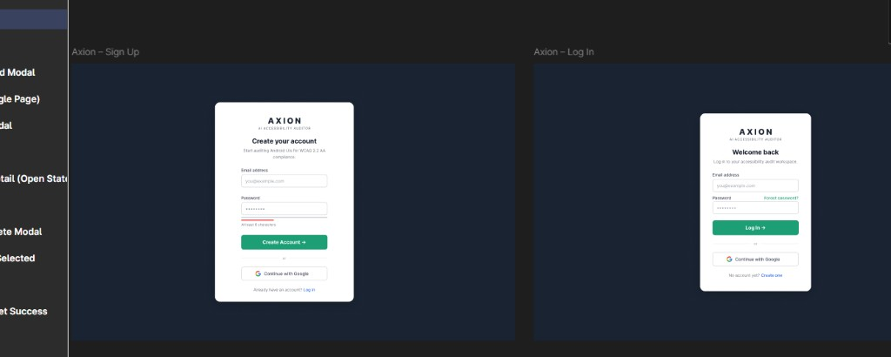
Forgot Password and Verify Code — implementation reference
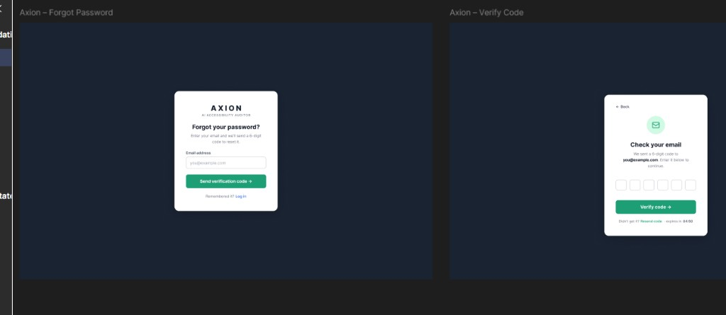
Set Password and Password Reset Success — implementation reference
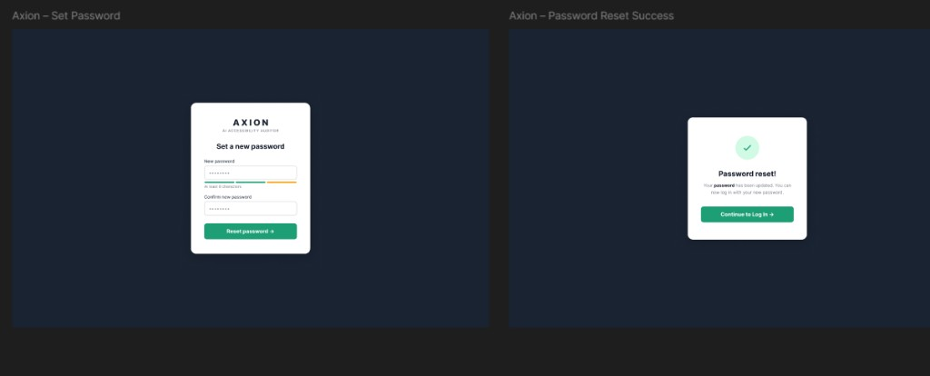
Upload screen — implementation reference
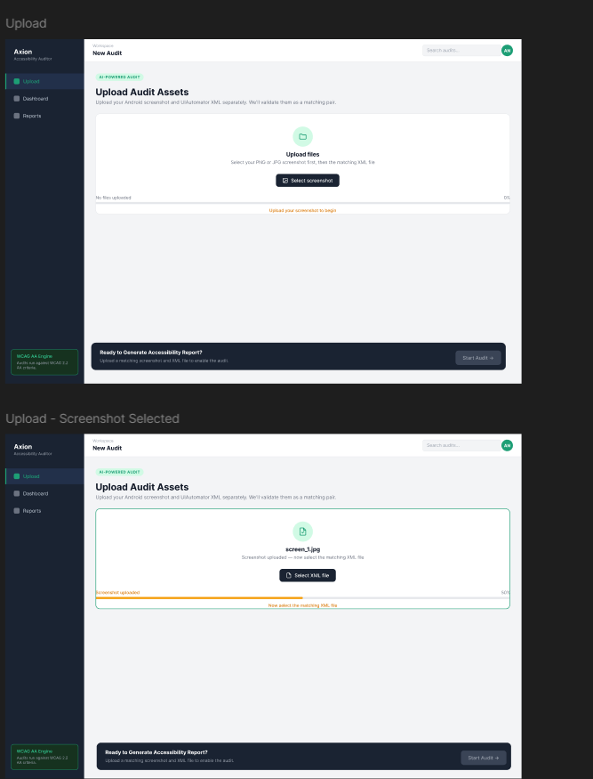
Files Matched modal — implementation reference
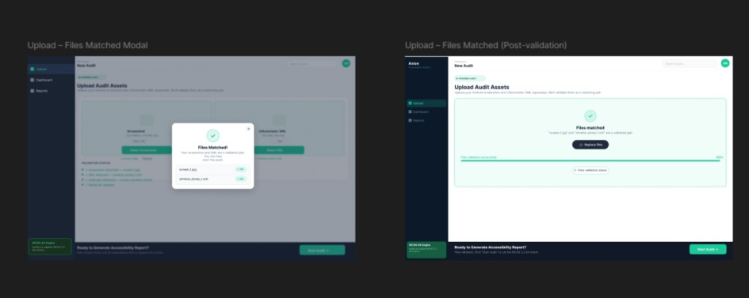
Audit Complete modal and Issues Dashboard — implementation reference
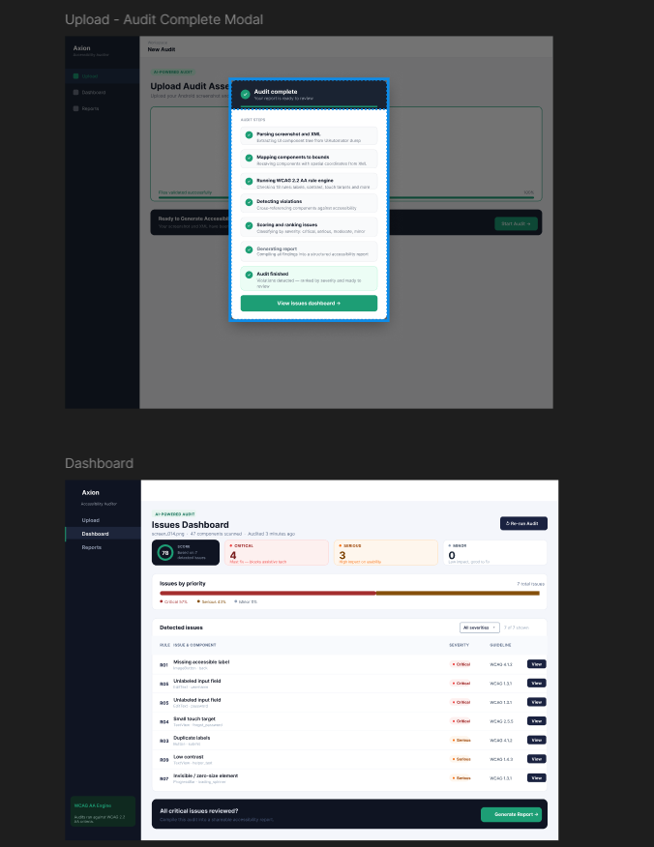
Issue Detail drawer and Audit Report — implementation reference
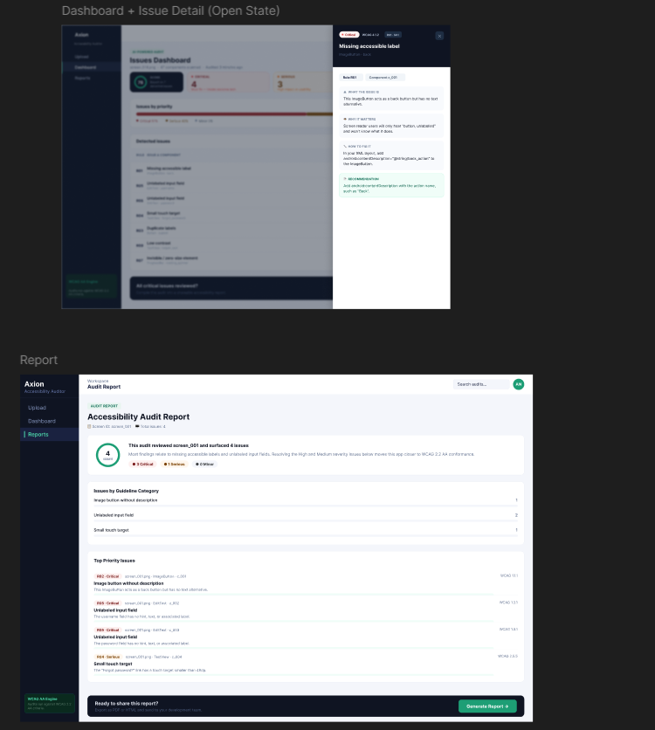
Generate Report modal and PDF layout — implementation reference
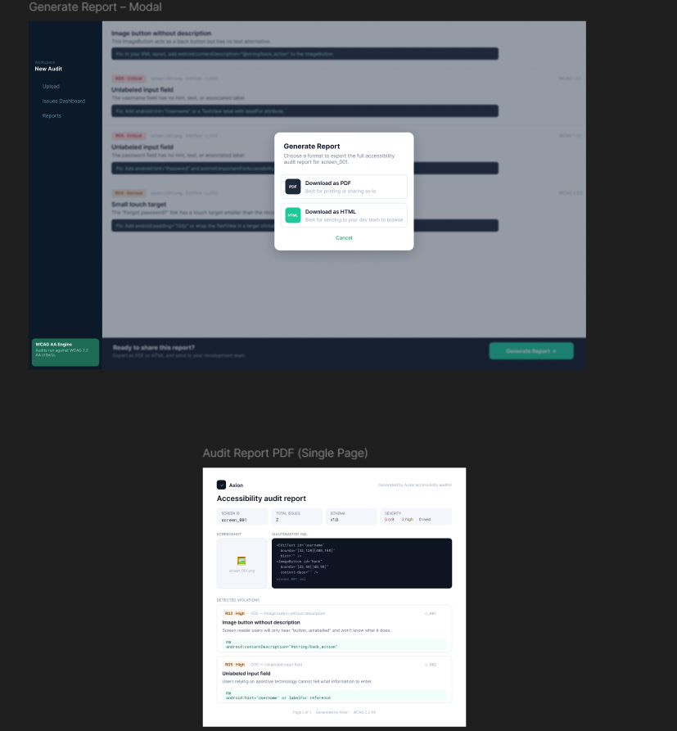

10. Authentication and Records design
SRS: FR-AUTH., FR-REC., FR-UI.40–45

10.1 Auth model (implemented Week 6)
Component | Design
Password storage | bcrypt hash in flat JSON user store (data/ scratch / prototype DB path)
Session | JWT (HS256); secret from JWT_SECRET
Sign up / login | Email + password (min 8, letter+digit); optional display name; any valid email domain (Yahoo, Outlook, education/university, …)
OTP | 6-digit code, TTL + resend; purposes: email verify + password reset; store in backend/otp_store.py (JSON file prototype)
SMTP delivery | backend/email_service.py — Gmail SMTP App Password (SMTP_HOST, SMTP_PORT, SMTP_USER, SMTP_FROM, SMTP_PASSWORD); sender is Gmail, recipients are unrestricted domains
Dev flag | AUTH_DEV_SHOW_OTP=0 when real mail works (hides debug OTP in API/UI)
Google OAuth | GIS frontend + POST /auth/google; verify ID token with GOOGLE_CLIENT_ID
Profile UI | Frontend UserAvatar shows initials from name/email

Credentials: copy .env.example → .env. Never commit SMTP_PASSWORD or JWT_SECRET. GOOGLE_CLIENT_ID is the public OAuth Web client ID from Google Cloud Console.

10.2 Records lifecycle
- User completes audit pipeline (POST /api/v1/audit …)
- Frontend (when logged in) calls POST /records with score + screenshot/XML names
- Row appended to backend/data/records.db.json (user-scoped)
- Records page calls GET /records; detail/reopen uses GET /records/{id} / …/report

10.3 Access control
- All /records/* queries filter by JWT user_id
- No cross-user record access
- Prototype rows live in backend/data/records.db.json (user-scoped by user_id)

11. Deployment design

11.1 docker-compose.yml (as implemented)
services:
backend:
build:
context: ./backend
dockerfile: Dockerfile
ports: ["8000:8000"]
volumes: [".:/app"]
working_dir: /app/backend
environment:
- JWT_SECRET=dev-secret-change-in-prod
networks: [auditor-network]
auditor:
build: .
volumes: [".:/app"]
working_dir: /app
environment:
- DATASET_ROOT=/app/data
networks: [auditor-network]
networks:
auditor-network:
driver: bridge
Note: Axion frontend is run with Vite locally (frontend/). Packaging frontend into Compose remains a future Should item.

11.2 Environment variables
Variable | Service | Purpose
JWT_SECRET | backend | Token signing
GOOGLE_CLIENT_ID | backend | Google Sign-In
SMTP_HOST / SMTP_PORT / SMTP_TLS | backend | OTP mail transport
SMTP_USER / SMTP_FROM / SMTP_PASSWORD | backend | Gmail App Password sender
AUTH_DEV_SHOW_OTP | backend | Hide/show debug OTP
LLM_* / provider keys | backend | Optional live explanations
CORS_ORIGINS | backend | e.g. http://localhost:5173
DATASET_ROOT | auditor | Batch parse path
VITE_API_BASE | frontend (local) | Points Axion at API

11.3 Startup
docker-compose up --build
# API docs: http://localhost:8000/docs
# Health: http://localhost:8000/health
# Frontend: cd frontend && npm run dev → http://localhost:5173

12. Security design
Threat | Mitigation
API key exposure | LLM calls server-side only
JWT theft | httpOnly cookie option (Stretch); HTTPS in prod
XXE | Safe XML parsing; no external entities
Upload abuse | 20 MB limit, MIME validation
Path traversal | Sanitize paths in Records service
Cross-user access | JWT user_id scoping on all records
OTP brute force | Rate limit + expiry countdown (Figma: 04:50)

13. Testing design
Layer | Tool | Scope
Unit | pytest | Parser (incl. MASC wrappers), R01–R20
Schema | validate_output.py | components.json / violations.json artefacts
API | pytest + TestClient | Audit violations + report (test_audit.py)
Integration | noor_week3_validate.py, noor_week4_validate.py, noor_week5_validate.py, masc_parse_signoff.py | Full pipeline + report download smoke
E2E | Manual demo | Axion signup/login → upload pair → report download → Records (working; walkthrough for Friday)
Evaluation | MASC train/val/test splits | 7,068 screens, sign-off JSON

13.1 Golden files
tests/fixtures/rules/ # 57 controlled XML screens
├── r01_missing_label_fail.xml / r01_missing_label_pass.xml
├── r02_image_button_fail.xml / r02_image_button_pass.xml
├── … (R03–R20 pass/fail where applicable)
├── r21–r30 pass/fail fixtures
└── clean_no_violations.xml
tests/test_parser.py # extended fields + MASC wrapper nesting
tests/test_rules.py # R01–R30 pass/fail fixture regression (78 tests)
tests/test_audit.py # API violations + report + download
tests/test_report.py # HTML/PDF export unit tests
tests/test_agent.py # score formula + template report
tests/test_explainer.py # anti-hallucination / batching (mocked LLM)

13.2 Sign-off tests (from SRS §10)
- TC-01: missing bounds → no crash
- R01–R30 on controlled fail/pass fixtures
- R13–R20 on controlled component dicts + MASC full-dataset scan (Week 3+)
- masc_parse_signoff_report.json → PASS (7,068 screens, 0 extended-field misses)
- API POST /audit → GET .../violations matches CLI on R01 fixture
- API GET .../report returns score + agent fields (enrichment_mode: template or llm)
- API GET .../report/download?format=html|pdf returns attachment bytes (Playwright PDF requires playwright install chromium)
- Explainer unit tests mock LLM; anti-hallucination guard covered in tests/test_explainer.py

14. SRS traceability
SRS requirement | SDS section | Implementation
FR-PS.1–9 | §3.1, §4 | src/parser.py
FR-RU.1–20 | §3.2, §6 | src/rules.py
FR-AG.1–8 | §7 | src/agent.py, src/explainer.py (Done; API-wired)
FR-RP.1–7 | §8 | src/report.py
FR-UI.* | §9, Appendix D | frontend/
FR-AUTH.* | §10.1, §5.1 | backend/routers/auth_router.py + auth.py / otp_store.py / email_service.py (Done)
FR-REC.* | §10.2, §5.3 | backend/routers/records_router.py (Done; flat backend/data/records.db.json)
Audit API (violations + report) | §5.2 | backend/routers/audit.py
FR-DK.* | §11 | docker-compose.yml
NFR-1–20 | §2, §7, §11, §12 | Cross-cutting
§8 JSON schemas | §4 | auditor_schema.json
§9 REST API | §5, Appendix A | backend/routers/
FR-CV.4–7 | §3.6 | src/yolo_ui_detector.py, notebooks/train_yolo_ui_detector.ipynb (In progress)

Appendix A: OpenAPI specification
openapi: 3.0.3
info:
title: Agentic Accessibility Auditor API
version: 2.0.0
servers:
- url: http://localhost:8000/api/v1
paths:
/auth/login:
post:
summary: Login and receive JWT
requestBody:
required: true
content:
application/json:
schema:
type: object
required: [email, password]
properties:
email: { type: string, format: email }
password: { type: string, minLength: 8 }
responses:
"200":
description: JWT token
/audit:
post:
summary: Upload screenshot + XML and start audit
security: [{ bearerAuth: [] }]
requestBody:
content:
multipart/form-data:
schema:
type: object
required: [screenshot, xml]
properties:
screenshot: { type: string, format: binary }
xml: { type: string, format: binary }
responses:
"201": { description: Audit created }
/audit/{audit_id}/status:
get:
summary: Get pipeline status
security: [{ bearerAuth: [] }]
parameters:
- name: audit_id
in: path
required: true
schema: { type: string }
responses:
"200": { description: Status object }
/records:
get:
summary: List user's saved audits
security: [{ bearerAuth: [] }]
responses:
"200": { description: Records list }
/records/{record_id}:
get:
summary: Get record detail
security: [{ bearerAuth: [] }]
parameters:
- name: record_id
in: path
required: true
schema: { type: string }
responses:
"200": { description: Record detail }
components:
securitySchemes:
bearerAuth:
type: http
scheme: bearer
bearerFormat: JWT

Appendix B: File and directory map
Path | Role
src/parser.py | Hybrid XML parser (Done)
src/schema_documents.py | JSON envelope builders
src/rules.py | Rule engine R01–R30 (Done; R09/R28 limited without colors/text-size)
src/agent.py | Score + build_audit_report (Done; API-wired)
src/explainer.py | Live LLM recommendations (Done)
src/llm_providers.py | Multi-provider LLM client
src/guidelines.py | G01–G30 + R→G mapping
src/report.py | HTML/PDF generator (Jinja2 + Playwright)
backend/main.py | FastAPI entry
backend/routers/audit.py | Violations + report + download API (Done)
backend/auth.py / otp_store.py / email_service.py / routers/auth_router.py | JWT + OTP/SMTP + Google OAuth (Done — Salar base + Noor Week 6)
backend/routers/records_router.py | Per-user records CRUD + report reopen (Done; store backend/data/records.db.json)
scripts/noor_week6_validate.py | Week 6 auth/records + eval sheet validation
scripts/run_week7_eval_analysis.py | Week 7 MASC 40-screen rule/guideline QA analysis
scripts/noor_week7_validate.py | Week 7 eval + pytest + artifact checks + validation logs
scripts/run_rico_holdout_eval.py | Rico holdout batch eval (deferred; ready when dataset local)
tests/test_parser.py | Parser unit tests
tests/test_rules.py | Rules R01–R30 unit tests
tests/test_audit.py | Audit API tests (violations + report + download)
tests/test_report.py | Report HTML/PDF export tests
tests/test_explainer.py | Explainer anti-hallucination tests
backend/tests/test_auth.py | Auth/OTP/Google/records suite (22 tests)
frontend/src/ | Axion React app (Done for Upload/Dashboard/Report/Records/Login/SignUp/Forgot/OTP/Reset + Google Sign-In)
docs/schemas/auditor_schema.json | Normative JSON Schema
docs/json_schemas.md | Schema documentation
docs/week6/ | 40-screen eval sheet + R26–R30 design + assisted FP/miss notes
outputs/reports/ | Agent-enriched *_report.json + generated .html / .pdf
outputs/validation_logs/ | noor_week1–week6 validation logs + summaries
backend/data/records.db.json | Prototype per-user audit history (score + screenshot/XML names)
src/yolo_ui_detector.py | Screenshot-only YOLO fallback inference (In progress; scaffolded)
notebooks/train_yolo_ui_detector.ipynb | YOLO training notebook (Salar → Noor Colab T4 run)
runs/runs/yolo_ui_detector/export/yolo_ui_detector_best.pt | Exported best checkpoint (~19 MB)
runs/runs/yolo_ui_detector/runs/yolo_ui_detector/{args.yaml,results.csv,*.png,*.jpg} | Full local training run config, metrics, and plots (see SDS §3.6.3, Progress Report §15C.7)
runs/runs/yolo_ui_detector/{yolo_dataset,rico_yolo_dataset}/dataset.yaml | MASC train config vs Rico holdout eval-only config

Appendix C: Sequence diagrams

C.1 Authenticated audit with Records save
sequenceDiagram
participant U as User
participant A as Axion UI
participant API as FastAPI
participant P as Pipeline
participant R as RecordsStore
U->>A: Login
A->>API: POST /auth/login
API-->>A: JWT
U->>A: Upload screenshot + XML
A->>API: POST /audit (JWT)
API->>P: run_audit()
P-->>API: complete + artefacts
API->>R: save(user_id, record)
API-->>A: audit_id, record_id
A-->>U: Dashboard + saved to Records

C.2 View past audit from Records
sequenceDiagram
participant U as User
participant A as Axion UI
participant API as FastAPI
U->>A: Open Reports page
A->>API: GET /records (JWT)
API-->>A: records list
U->>A: Open record
A->>API: GET /records/{id}
API-->>A: metadata + report paths
A-->>U: Report view / download

Appendix D: UI component map (Figma)
Maps Figma frames to React components (SRS Appendix F). Screenshot assets in docs/assets/figma/.
Figma frame | Screenshot | Route / trigger | React component(s)
Sign Up | figma-01-signup-login.png | /signup | SignUpPage
Log In | figma-01-signup-login.png | /login | LoginPage
Forgot Password | figma-02-forgot-verify-otp.png | /forgot-password | ForgotPasswordPage
Verify Code | figma-02-forgot-verify-otp.png | /verify-otp | OtpVerificationPage
Set Password | figma-03-reset-password-success.png | /reset-password | ResetPasswordPage
Password Reset Success | figma-03-reset-password-success.png | /reset-success | ResetSuccessPage
Upload (progress) | figma-04-upload-progress-states.png | /upload | UploadPage, UploadZone
Files Matched Modal | figma-08-upload-files-matched.png | after validation | FilesMatchedModal
Audit Complete Modal | figma-05-audit-complete-dashboard.png | after pipeline | AuditCompleteModal
Dashboard | figma-05-audit-complete-dashboard.png | /dashboard/:id | DashboardPage, ViolationsTable, ScoreGauge
Issue Detail Drawer | figma-06-dashboard-detail-report.png | View action | IssueDetailDrawer
Audit Report | figma-06-dashboard-detail-report.png | /report/:id | ReportPage
Generate Report Modal | figma-07-generate-report-modal-pdf.png | footer CTA | DownloadModal
PDF layout | figma-07-generate-report-modal-pdf.png | export | report.py HTML template
Records / Reports | — | /records | RecordsPage, RecordsTable

Design tokens: background #0b1929, primary #1bc99a, sidebar nav Upload | Dashboard | Reports.
— End of Software Design Specification v2.0 —

