TITTLE: HUFFMAN ALGORITHM GUIDE

Written by : Muzammil Tanvir , Muhammad Nouman

This manual guide will teach you and explain every thing about
Compression algorithms (i.e huffman encoding) after reading this mannual you will be able to understand and implement compression algorithm.

Working :

Libraries used and basic class structure:

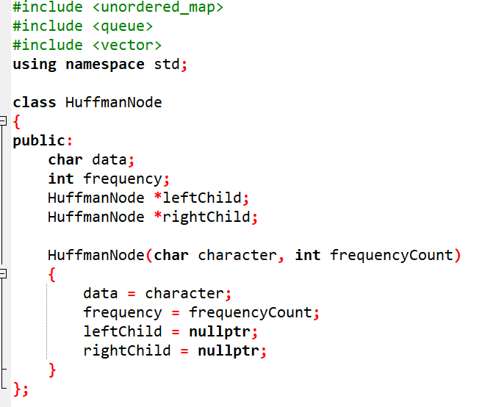

Step 01:

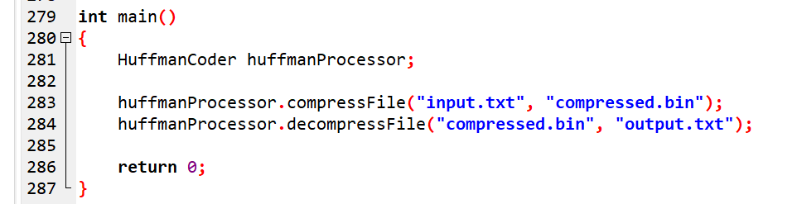

Firstly we created a an object for huffman coder class in which all the required functions will be implemented and then called the compressfile function.

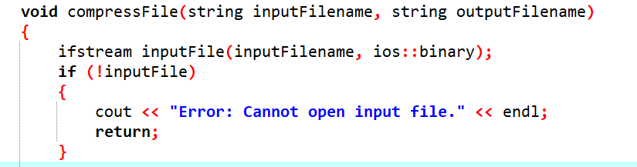

Compressfile function will take input filename and the output file names as input and then we then some error handling for file operation.

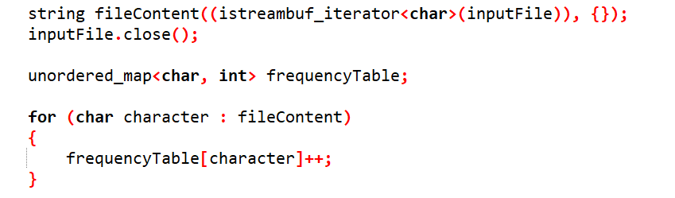

Then we used unordered_map in which we used char as key and int datatype as value this was the purpose of using unordered_map and then created its object named frequencyTable this will count the frequency (i.e the number of times a particular character has occurred as shown bellow in a dry run with an example sentence)
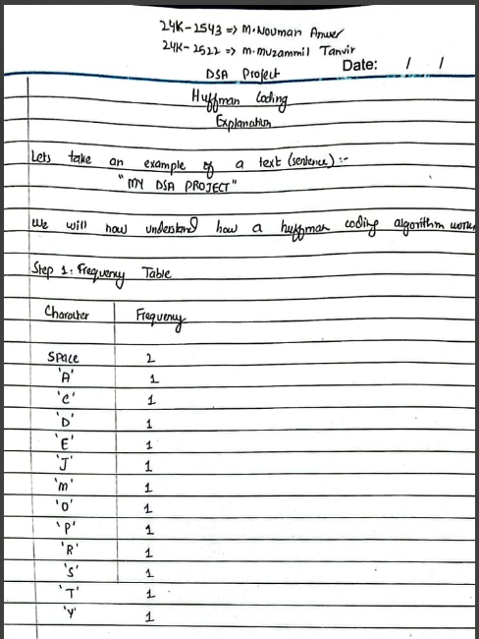

For example:
Space is 2 means 2 times (“ “) appeared.
Rest all Characters apperaed once so Frequesncy is 1 for all.

Step 02:

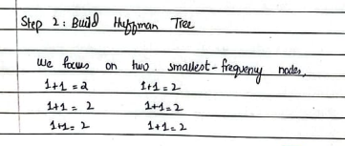

For this we used priority queue.

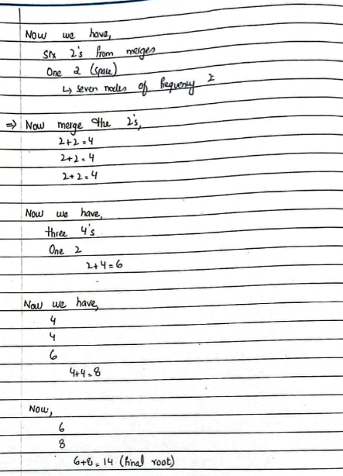

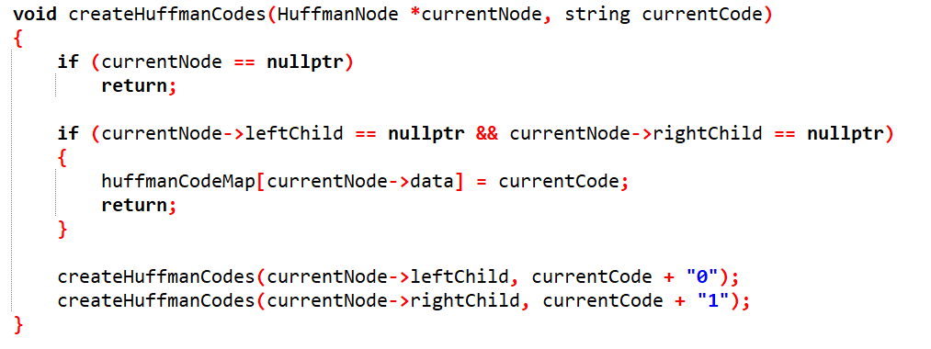

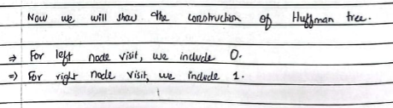

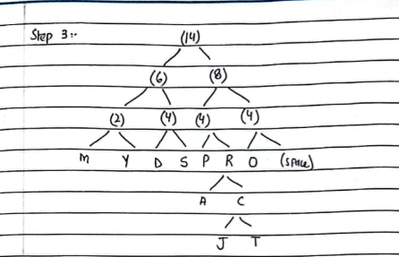

STEP 04:
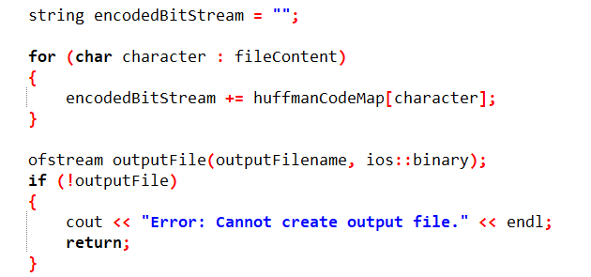

How codes are generated?
Iterate through the haffman tree for one left move add 0 and for one right move add 1. for example in The given sentence you have to move 4 lefts to get to ‘M’ which means 4 lefts (I.e code generated 0000)

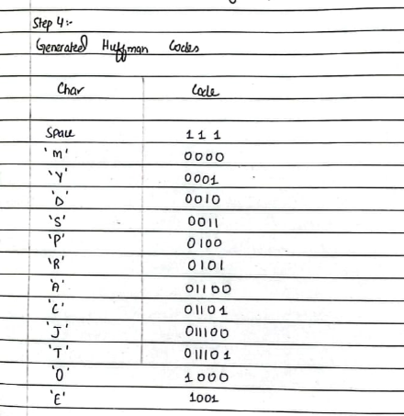

STEP 05:

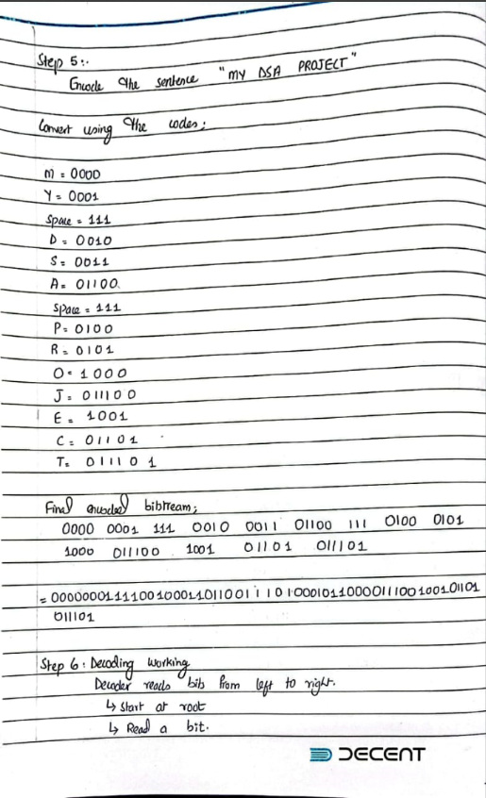

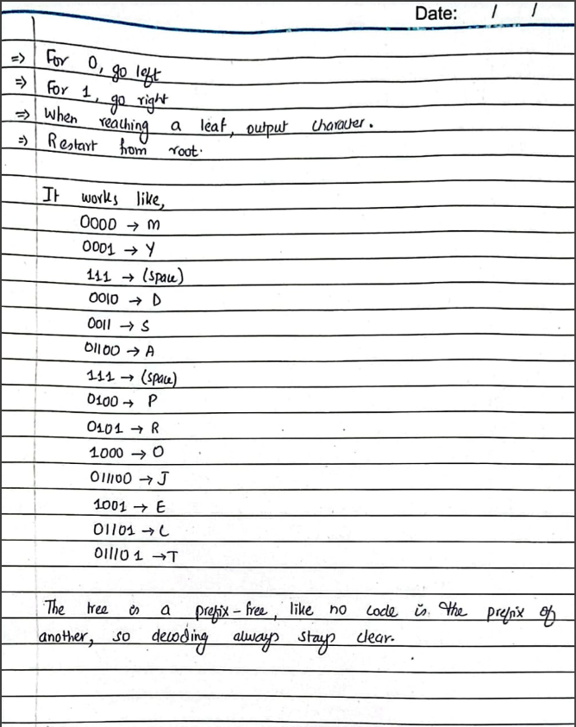

NOTE:
If we can convert to binary data by using simple file operations then why using haffman encoding and other alogorithms and do they store data in files same like standard binary file storing?

ANSWER:
Compared to standard binary storage huffman encoding stores only the actual bits needed for each character instead of always using 8 bits per character. I.e if a character huffman is 110 (3 bits) standard storage would still use 8 bits, but our Huffman based storage uses just 3 bits adding padding only at the end to complete the last byte. Thats how we save space by giving shorter codes to frequent characters, which reduces the overall file size compared to the standard binary method.

SUCCESSFUL RUN

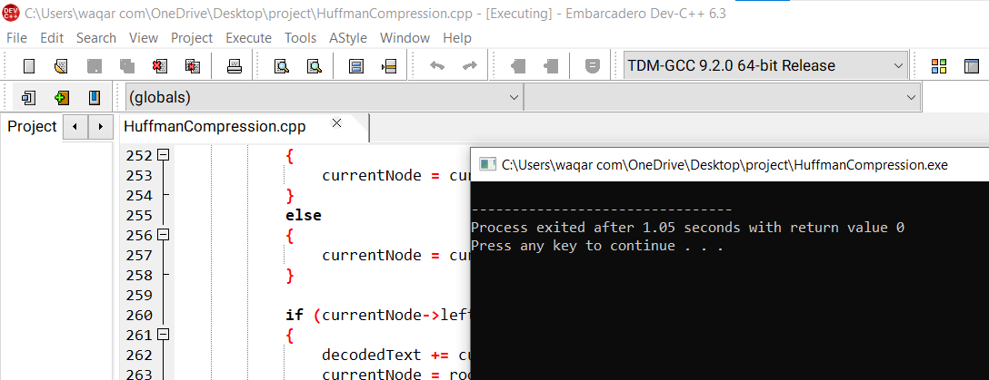

INPUT FILE WITH 5000 WORDS PARA:



RESULT:

Check file size for input and compressed file
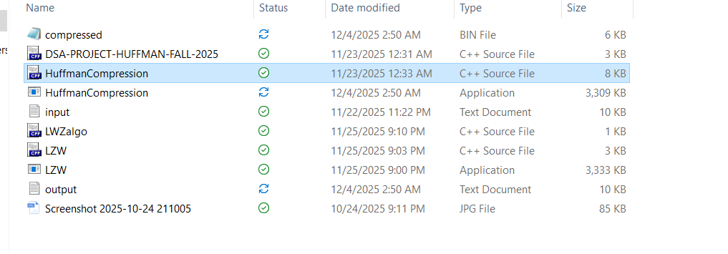

LWZ ALGORITHM

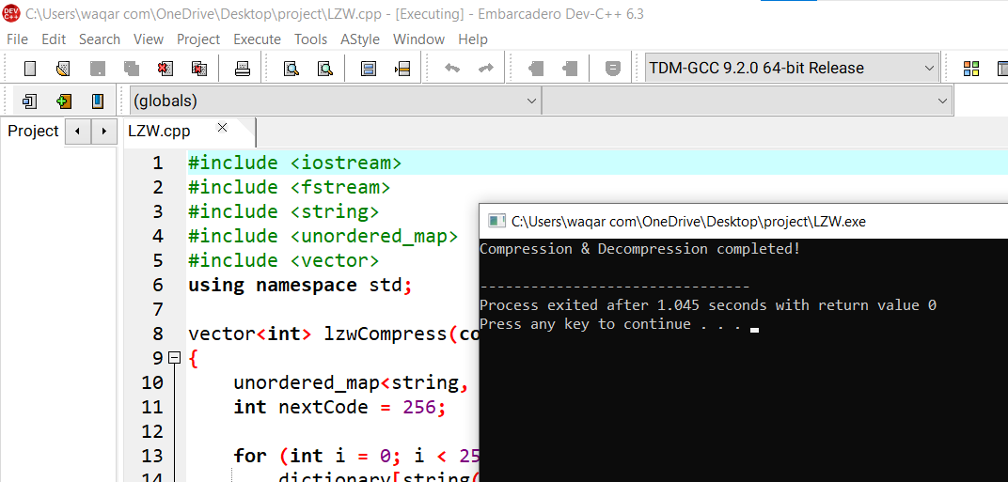

CHECK INPUT AND COMPRESSED FILE SIZE

