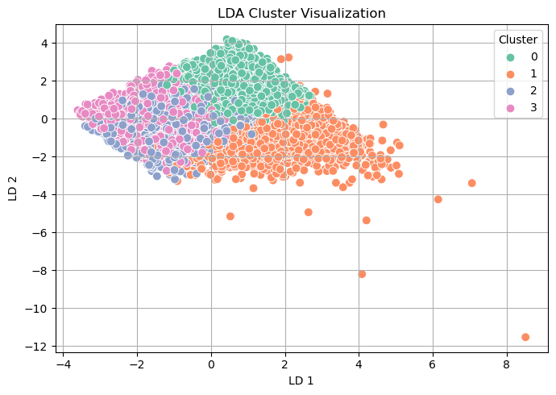
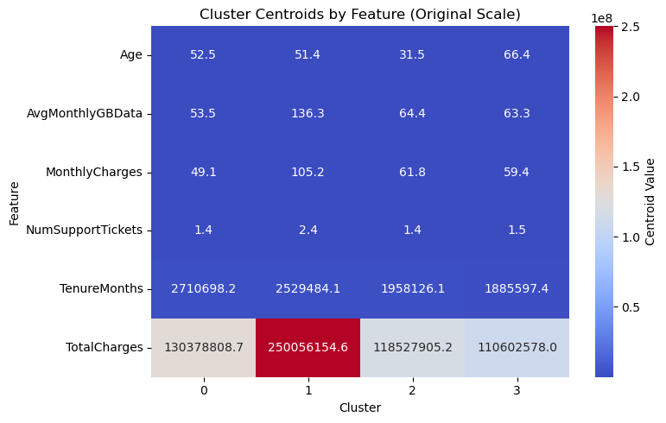
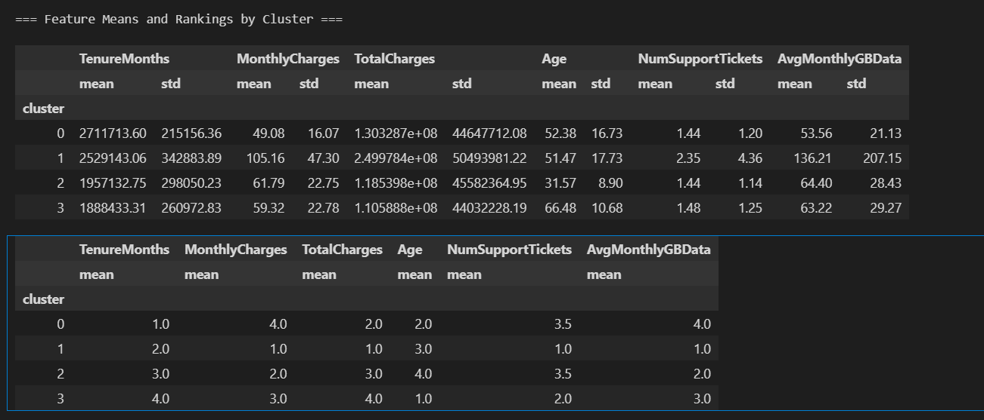
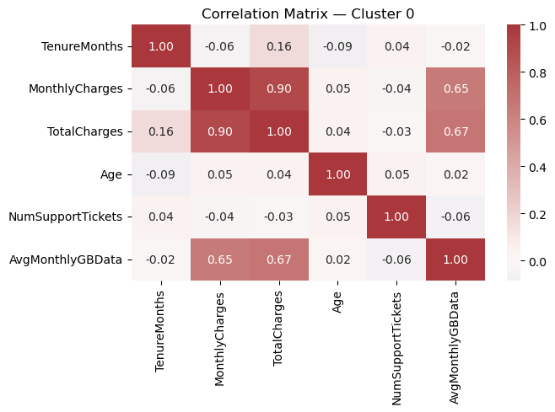
--- Summary: Cluster 0 ---
TotalCharges 1.303287e+08
TenureMonths 2.711714e+06
AvgMonthlyGBData 5.356000e+01
Age 5.238000e+01
MonthlyCharges 4.908000e+01
NumSupportTickets 1.440000e+00
dtype: float64
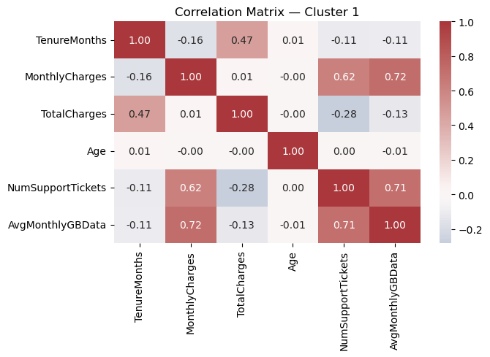
--- Summary: Cluster 1 ---
TotalCharges 2.499784e+08
TenureMonths 2.529143e+06
AvgMonthlyGBData 1.362100e+02
MonthlyCharges 1.051600e+02
Age 5.147000e+01
NumSupportTickets 2.350000e+00
dtype: float64

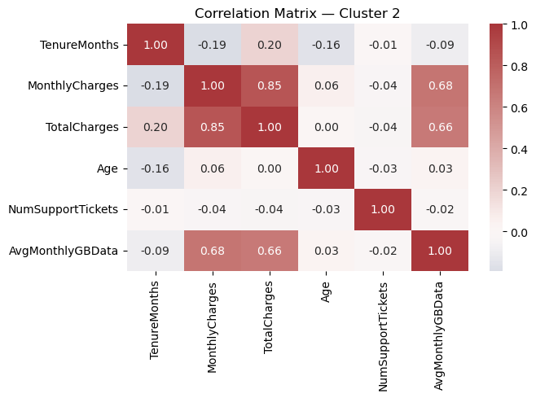
--- Summary: Cluster 2 ---
TotalCharges 1.185398e+08
TenureMonths 1.957133e+06
AvgMonthlyGBData 6.440000e+01
MonthlyCharges 6.179000e+01
Age 3.157000e+01
NumSupportTickets 1.440000e+00
dtype: float64

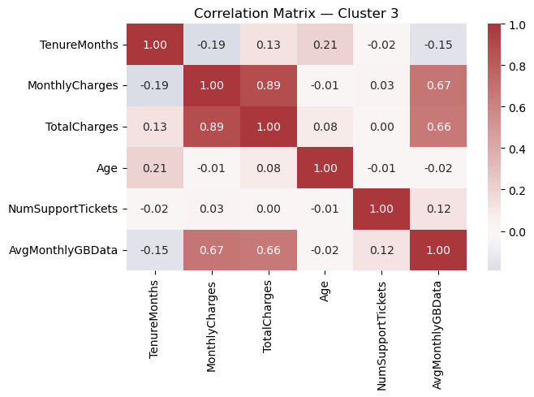
--- Summary: Cluster 3 ---
TotalCharges 1.105888e+08
TenureMonths 1.888433e+06
Age 6.648000e+01
AvgMonthlyGBData 6.322000e+01
MonthlyCharges 5.932000e+01
NumSupportTickets 1.480000e+00
dtype: float64

Cluster | MonthlyCharges | TotalCharges | TenureMonths | Age | NumSupportTickets | AvgMonthlyGBData | Key Traits
0 | Low (~49) | Medium (~130M) | Highest (~2.7M) | 52.4 | Very Low (~1.44) | Low (~53.6) | Loyal Low-Usage Seniors
1 | Highest (~105) | Highest (~250M) | High (~2.5M) | 51.4 | High (~2.35) | Very High (~136) | Demanding Premium Users
2 | Mid (~61.8) | Low (~118M) | Low (~1.95M) | Young (31.6) | Low (~1.44) | Moderate (~64.4) | Young Newcomers
3 | Mid (~59.3) | Lowest (~110M) | Lowest (~1.88M) | Senior (66.5) | Low (~1.48) | Moderate (~63.2) | Senior Budget Users

Customer Segment Descriptions

Cluster 0 – Loyal Low-Usage Seniors
- Traits: Low monthly spending, longest tenure, moderate age, very few support tickets.
- Behavior: These are long-term customers who pay reliably but don’t use many services. Likely to be price-sensitive and stable.
- Strategy:
  - Retain through loyalty rewards or senior-focused bundles.
  - Avoid over-marketing; focus on relationship.

Cluster 1 – Demanding Premium Users
- Traits: Very high data usage, highest bills and total charges, high support usage.
- Behavior: Heavy and potentially frustrated users. Most profitable but also high maintenance.
- Strategy:
  - Focus on premium support and service quality.
  - Upsell exclusive plans, loyalty perks, and priority service.

Cluster 2 – Young Newcomers
- Traits: Lowest tenure and age, moderate usage and charges.
- Behavior: Newer entrants with growth potential. Less demanding now but may churn.
- Strategy:
  - Nurture with discounts, tutorials, and onboarding experiences.
  - Trigger upsell journeys based on usage spikes.

Cluster 3 – Senior Budget Users
- Traits: Oldest demographic, lowest total charges, low-medium usage.
- Behavior: Value-conscious older users who don’t engage much with support.
- Strategy:
  - Provide clear, affordable packages.
  - Avoid complexity; promote trust and reliability.

=== Cluster-wise Churn Prediction Rate ===
cluster Churn_Rate
0 0 0.484018
1 1 0.478261
2 2 0.533019
3 3 0.479070

