Lab 1

**Objective : To learn conceptual and logical Transactional Database Design**

1. Draw ERDs for the following case studies:
   1. The study team identified a preliminary set of 11 entity types that describe the data required by the hospital in support of the various business functions: FACILITY, PHYSICIAN, PATIENT, DIAGNOSTIC UNIT, WARD, STAFF, ORDER, SERVICE/ DRUG, MEDICAL/SURGICAL ITEM, SUPPLY ITEM, and VENDOR. From discussions with hospital staff, reviewing hospital documents, and studying existing information systems, the study team developed a list of business rules describing the policies of the hospital and nature of the hospital’s operation that govern the relationships among these entities. Some of these rules follow:
2. A FACILITY maintains one or more DIAGNOSTIC UNITs (radiology, clinical laboratory, cardiac diagnostic unit, etc.).
3. A FACILITY contains a number of WARDs (obstetrics, oncology, geriatrics, etc.).
4. Each WARD is assigned a certain number of STAFF members (nurses, secretaries, etc.); a STAFF member may be assigned to multiple WARDs.
5. A FACILITY staffs its medical team with a number of PHYSICIANs. A PHYSICIAN may be on the staff of more than one FACILITY.
6. A PHYSICIAN treats PATIENTs, and a PATIENT is treated by any number of PHYSICIANs.
7. A PHYSICIAN diagnoses PATIENTs, and a PATIENT is diagnosed by any number of PHYSICIANs.
8. A PATIENT may be assigned to a WARD (outpatients are not assigned to a WARD). The hospital cares only about the current WARD a patient is assigned to (if assigned at all).
9. A PATIENT uses MEDICAL/SURGICAL ITEMs, which are supplied by VENDORs. A VENDOR also provides SUPPLY ITEMs that are used for housekeeping and maintenance purposes.
10. A PHYSICIAN writes one or more ORDERs for a PATIENT. Each ORDER is for a given PATIENT, and a PATIENT may have many ORDERs.
11. An ORDER can be for a SERVICE such as diagnostic test (lab tests such as lipid profile, CBC, liver function tests; diagnostic imaging such as MRIs and X-rays) or a DRUG.

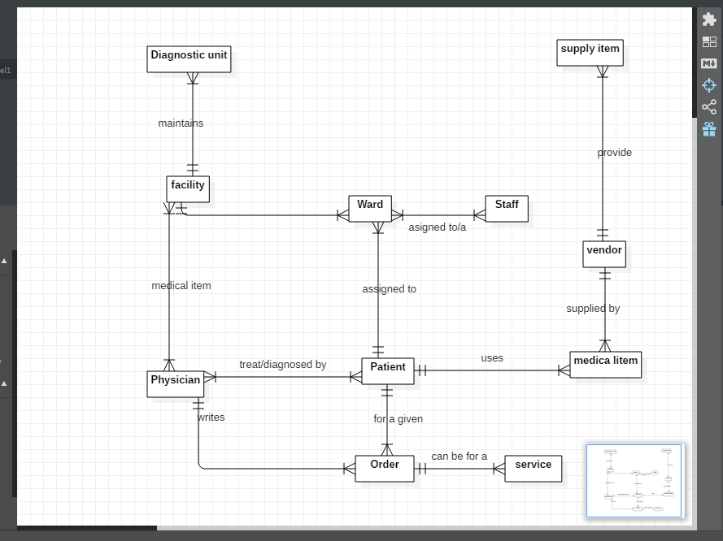

2.For each of the descriptions below, perform the following tasks:

i. Identify the degree and cardinalities of the relationship.

ii. Express the relationships in each description graphically with a logical design ER diagram

1. A book is identified by its ISBN number, and it has a title, a price, and a date of publication. It is published by a publisher, which has its own ID number and a name. Each book has exactly one publisher, but one publisher typically publishes multiple books over time.

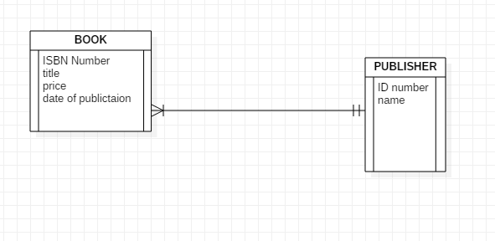

The degree is 2 and cardinalities of the relationship one-t- many

A piano manufacturer wants to keep track of all the pianos it makes individually. Each piano has an identifying serial number and a manufacturing completion date. Each instrument represents exactly one piano model, all of which have an identification number and a name. In addition, the company wants to maintain information about the designer of the model. Over time, the company often manufactures thousands of pianos of a certain model, and the model design is specified before any single piano exists.

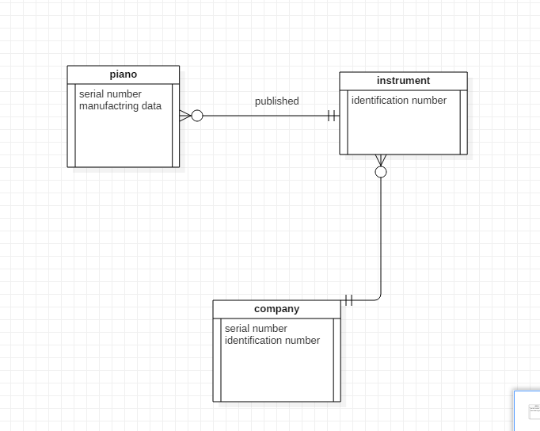

1. The degree is 2 and relationship is

One-to-many between instrument and piano .

One-to-many between company and instrument

A piano manufacturer (see above) employs piano technicians who are responsible for inspecting the instruments before they are shipped to the customers. Each piano is inspected by at least two technicians (identified by their employee number). For each separate inspection, the company needs to record its date and a quality evaluation grade.

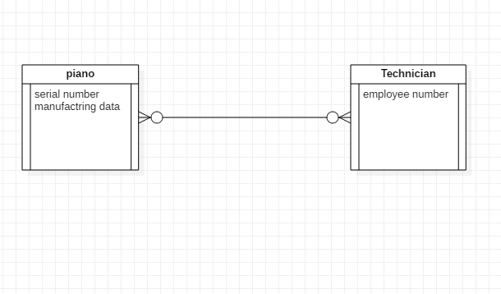

1. The piano technicians (see above) have a hierarchy of reporting relationships: Some of them have supervisory responsibilities in addition to their inspection role and have multiple other technicians report to them. The supervisors themselves report to the chief technician of the company.

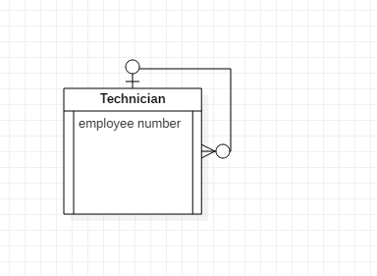

The degree is 2 and relationship is many to many

1. The entity type STUDENT has the following attributes: Student Name, Address, Phone, Age, Activity, and No of Years. Activity represents some campus-based student activity, and No of Years represents the number of years the student has engaged in this activity. A given student may engage in more than one activity. Draw a logical ERD for this situation. What attribute or attributes did you designate as the identifier for the STUDENT entity? Why?

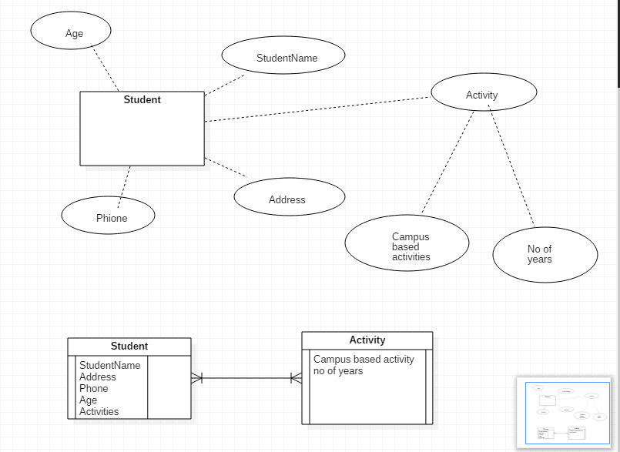

1. A college course may have one or more scheduled sections or may not have a scheduled section. Attributes of COURSE include Course ID, Course Name, and Units. Attributes of SECTION include Section Number and Semester ID. Semester ID is composed of two parts: Semester and Year. Section Number is an integer (such as 1 or 2) that distinguishes one section from another for the same course but does not uniquely identify a section. How did you model SECTION? Why did you choose this way versus alternative ways to model SECTION?

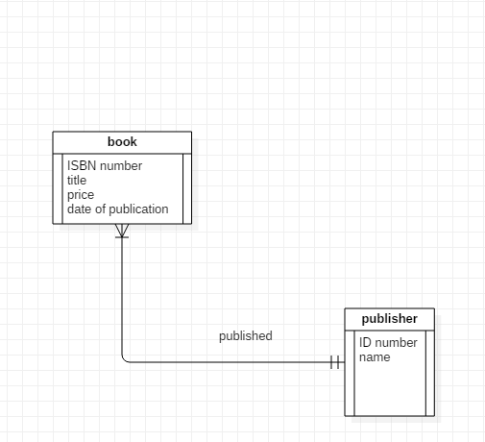 The degree is 2 and cardinalities of the relationship one-t- many