Distribution Manual Entry:

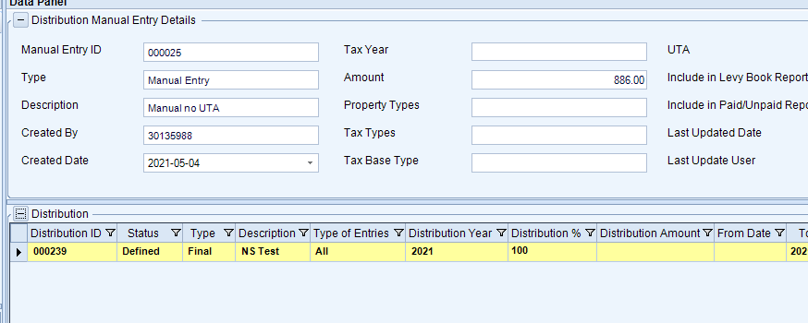

Its linked Distribution Details and corresponding sub-ledger records:

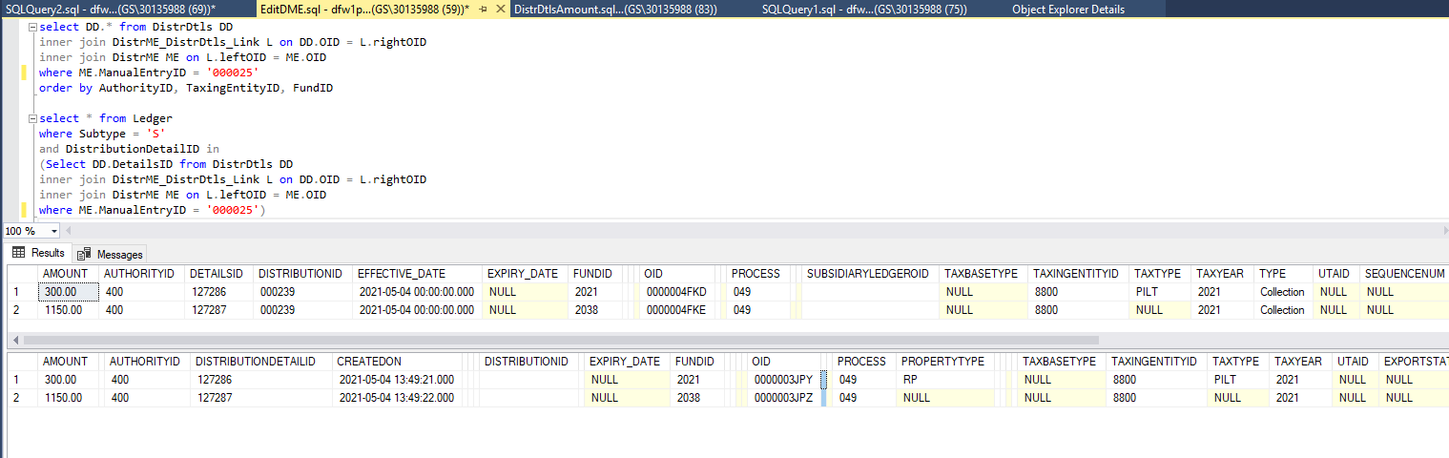

Both Distribution Details are linked to the same Distribution linked to Distribution Manual Entry:

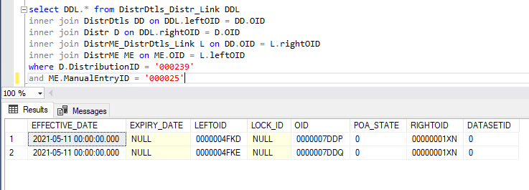

* Run Edit Distribution Manual Entry process
* Click Next on the first step
* Select one of the Distribution Details
* right-click selected Distribution Details and select Delete

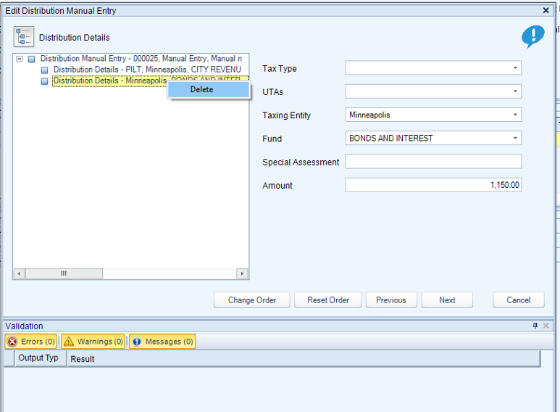

* Distribution Details is removed
* Click Next and run the process to the end
* Check if Ledger Engine wrote an adjusting entry for the sub-ledger associated with the deleted Distribution Details, to adjust the amount to 0:

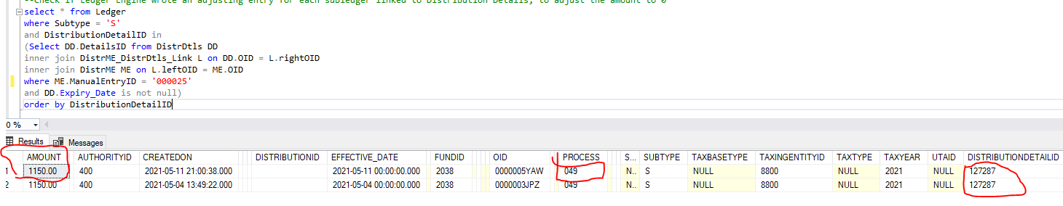

Record that is created is not correct. It should have reversed amount of the original record, so it should be negative in this case (-1150.00) and the process value should be 050 for the negative amount.

DistributionDetailID should be empty on both records.

Link between Subsidiary Ledger and Distribution Details should be expired and DistributionDetails.SubsidiaryLedgerOID should be set to empty – (these two steps cannot be tested now because this link doesn’t get created when Distribution Manual Entry is created and SubsidiaryLedgerOID doesn’t get set– bug 76359)

* Check if Subsidiary Ledger records for the remaining Distribution Details are unchanged and there are no new records created:

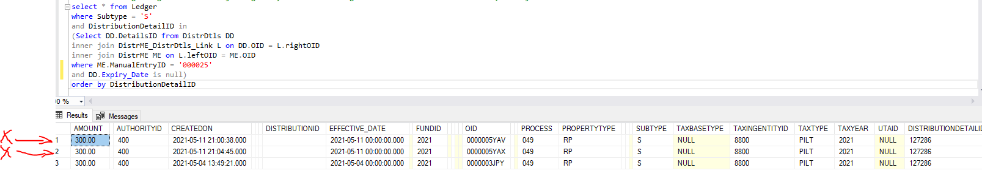

System created two new records that are not supposed to be created.