**DAY 2 PLANNING THE TECHNICAL FOUNDATION:**

**DAY 2 GOAL:**

The goal of this technical foundation is to align the technical implementation of the project with the business goals and to create a solid framework for the marketplace. The plan includes system architecture design, workflows, and API requirements. These will guide the implementation phase and ensure scalability and efficiency for the application built during the hackathon.

1. **Define Technical Requirements:**

* **Frontend Requirements**:
* **Framework:** Next.js (React-based)
* **Responsive design for both desktop and mobile users.**
* **Pages:**
  + **Home:** For product browsing and marketplace overview.
  + **Product Listing:** Displays all available items for sale or rent.
  + **Product Details:** Shows specific product information.
  + **Cart:** Enables users to manage selected items.
  + **Wishlist:** Enables users to add their favourite products on wishlist page.
  + **Checkout:** Allows users to input payment and shipping details.
  + **Order Confirmation:** Provides users with a summary of their order.
* **Backend Requirements**:
* **Sanity CMS**:
  + Used to manage structured data, including products, customers, and orders.
  + Sanity schema includes **Product**, **Cart**, **Wishlist** and **Shipment** entities.
* API endpoints to interact with Sanity for fetching data to frontend.
* **Third-Party APIs**:
* **Payment Gateway API** (e.g., Stripe) for handling transactions.
* **Shipment Tracking API** to update users on order delivery.

1. **Design System Architecture:**

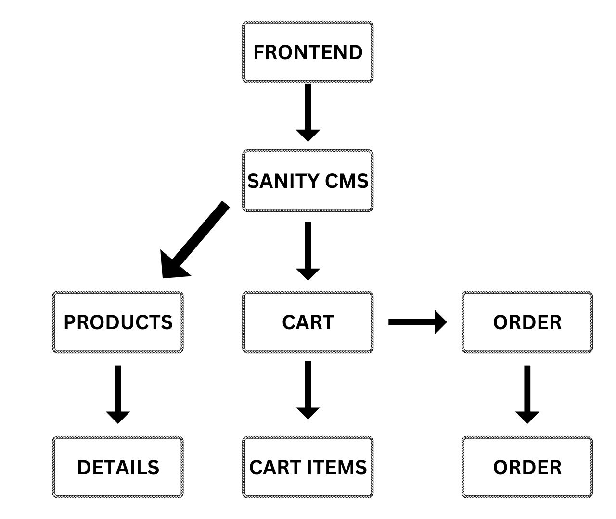

**WORKFLOW EXAMPLE:**

* User logs in or signs up.
* User browses products via the frontend.
* The frontend fetches data from the Sanity CMS through an API.
* Users add items to their cart and proceed to checkout.
* Payment details are processed via a Payment Gateway.
* Shipment tracking updates are retrieved from a third-party API and displayed to the user

1. **Plan API Requirements:**

* **/Products:**
* **Api/products:**

**Method:** GET

**Purpose:** Fetch all products from sanity

* **/Cart:**
* **Api/add-to-cart:**
* **Method:** POST
* **Purpose:** Create cart or add items to cart
* **Api/remove-from-cart:**
  + **Method:** PATCH
  + **Purpose:**  Removes cart items from cart
* **/Wishlist:**
* **Api/add-to-wishlist:**
* **Method:** POST
* **Purpose:** Add items to wishlist
* **Api/remove-from-wishlist:**
  + **Method:** PATCH
  + **Purpose:** Remove items from wishlist

1. **SANITY SCHEMAS:**

* **PRODUCT**

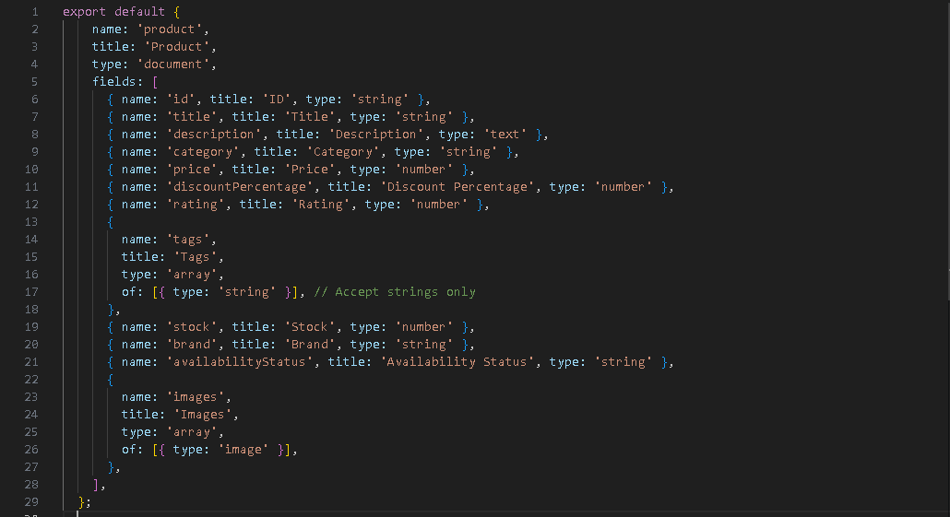

* **CART**

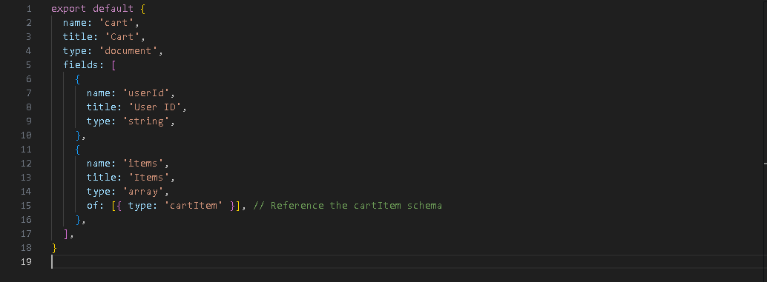

* **CART ITEM**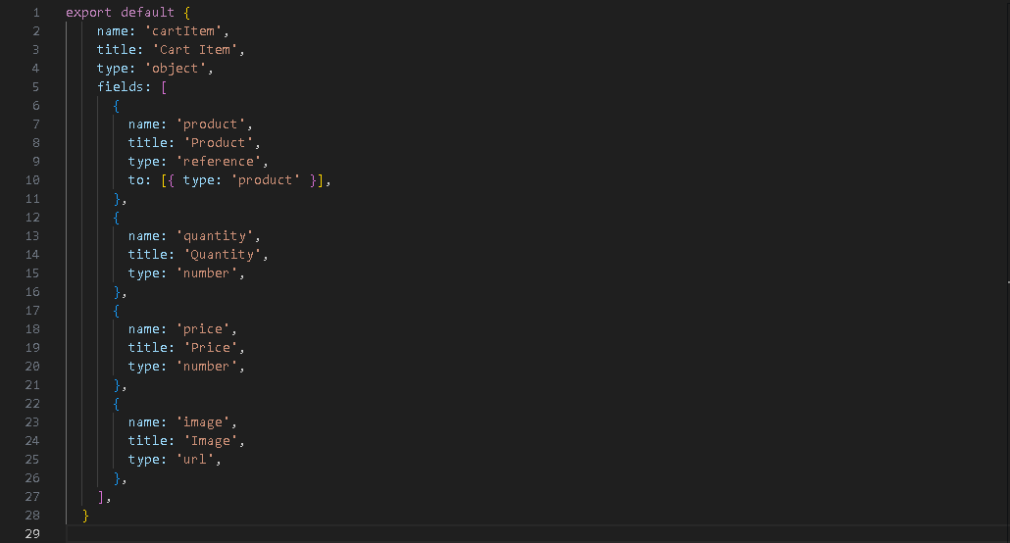
* **WISHLIST**

