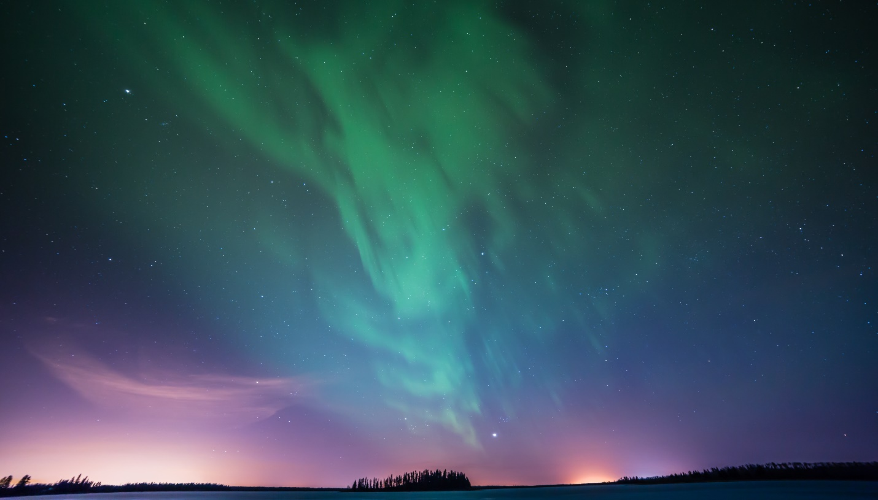

**Aurora**

"Vivid hues dance across the northern sky, as the aurora whispers tales of cosmic beauty."

**History**

Aurora dances in the celestial ballet, painting the night sky with hues of ethereal light. A mesmerizing display, nature's nocturnal masterpiece unfolds in the shimmering embrace of the Northern Lights.