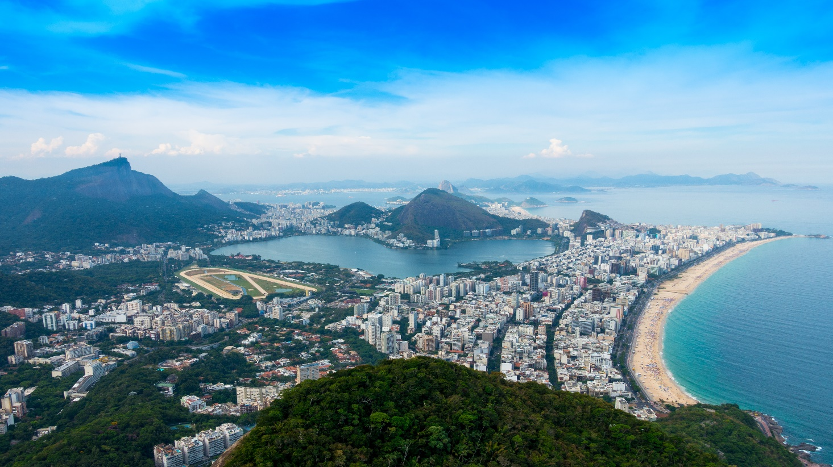 **Harbour Of Rio De Janeiru**

I believe you may be referring to the city of Rio de Janeiro, known for its iconic harbor, beautiful beaches, and vibrant culture.

**History**

There is no historical record of a "Harbour of Rio de Jabeiru." It seems there might be a confusion in the name or location. Rio de Janeiro, however, has a significant historical harbor known as Guanabara Bay.