Documentation
About Dark Theme

First of All I created switch UI Component and text in Component/settings/SettingsMain.js File

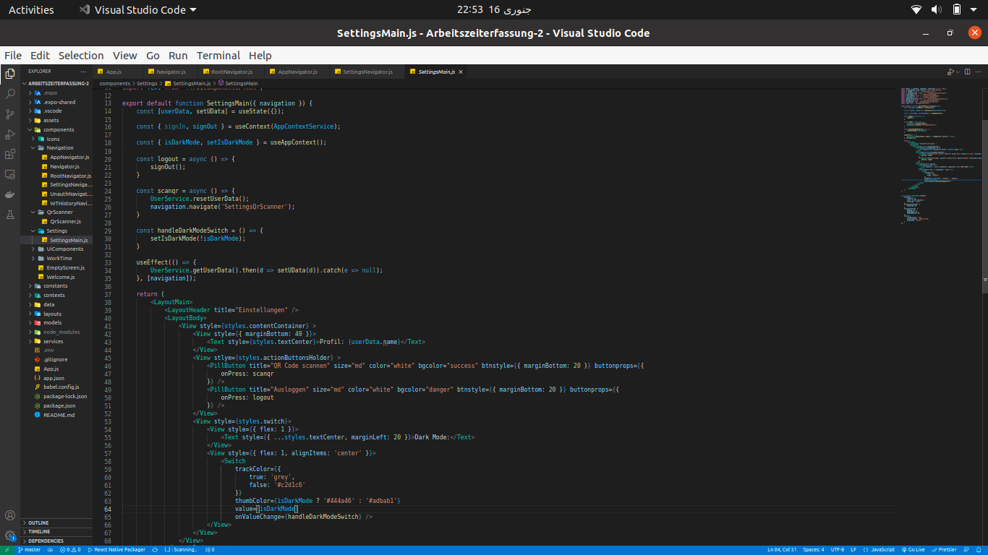

Then I created whole App’s state (Context Api React Native hook) which exists in contexts/ContextProvider.js and define darkTheme state there. The benefit of doing this is to know when we toggle the switch of dark mode and update context state which leads to re render of all the components through then we can interpolate color on this change

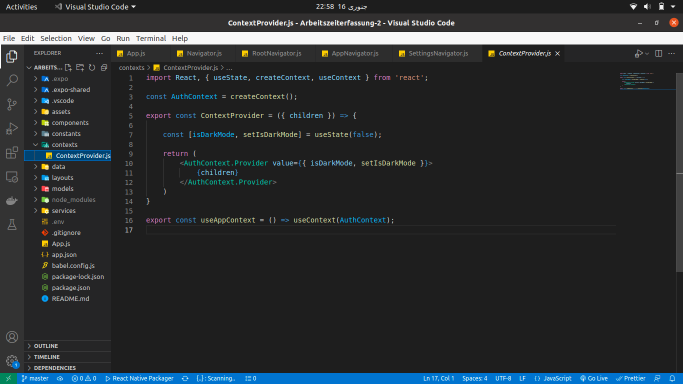

Then I am interpolating colors using react-native-reanimated 2 and also by vanilla animated Api.

I then created 2 files with View.js and Text.js

components/UIComponents/View.js
components/UIComponents/Text.js

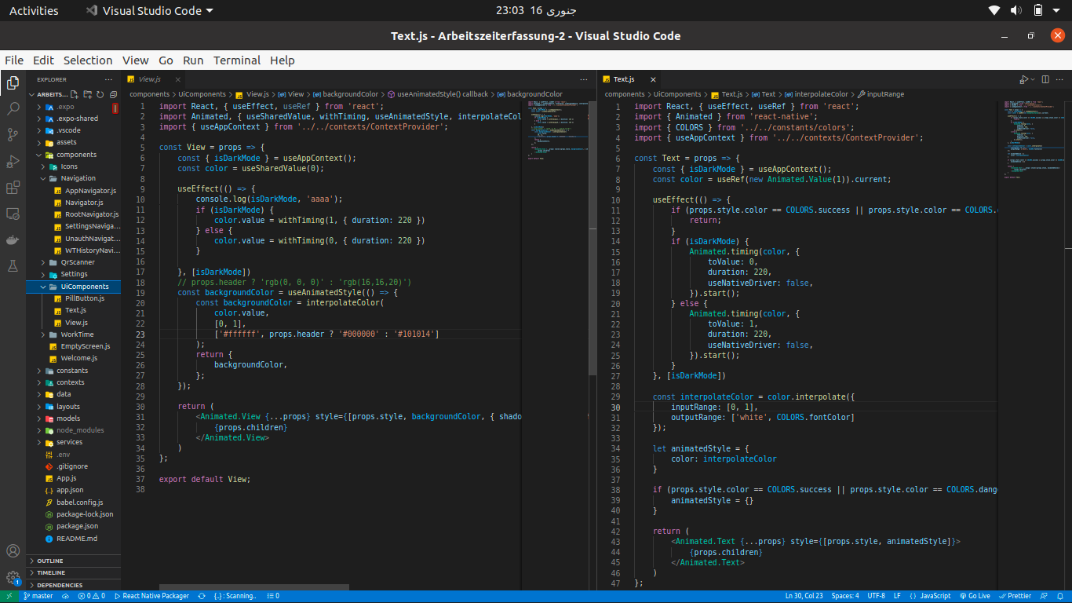
And I am just by accessing context (App State) interpolating the values.

And after creating 2 files I am changing the layout files in order to use newly created VIEW and TEXT Components instead from React Native.

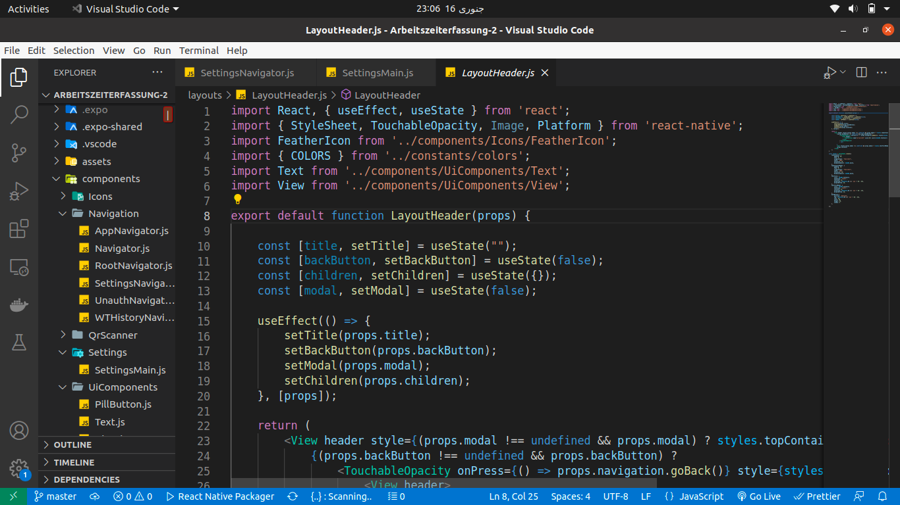
That’s how I changed main Layout Files (1 example is above).

And that’s how we are interpolating and applied dark theme.

