

**Submitted by:** Muhammad Raffey

**Submitted to:** Sir Hassan

**Sap ID:** 70153209

**Department:** CS

**Section:** 3E

**Lab Task:** 8

# **Solution Task-1:**

**.model small**

**.stack 100h**

**.data**

**inpMsg db 'Enter your Marks out of 10: $'**

**newline db 0Dh,0Ah,'$'**

**.code**

**main proc**

**mov ax,@data**

**mov ds,ax**

**mov ah,09h**

**lea dx,inpMsg**

**int 21h**

**mov ah,01h**

**int 21h**

**sub al,30h**

**mov bl,al**

**mov ah,09h**

**lea dx,newline**

**int 21h**

**mov al,bl**

**mov bl,10**

**mul bl**

**xor cx,cx**

**extract_loop:**

**xor dx,dx**

**mov bx,10**

**div bx**

**push dx**

**inc cx**

**cmp ax,0**

**jne extract_loop**

**print_loop:**

**pop dx**

**add dl,30h**

**mov ah,02h**

**int 21h**

**loop print_loop**

**mov ah,4Ch**

**int 21h**

**main endp**

**end main**

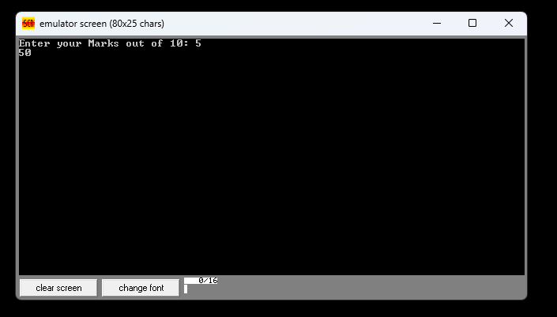

# **Solution Task-2:**

**.model small**

**.stack 100h**

**.data**

**inpMsg db 'Enter your penalty out of 5: $'**

**newline db 0Dh,0Ah,'$'**

**.code**

**main proc**

**mov ax, @data**

**mov ds, ax**

**mov ah, 09h**

**lea dx, inpMsg**

**int 21h**

**mov ah, 01h**

**int 21h**

**sub al, 30h**

**mov bl, al**

**mov ah, 09h**

**lea dx, newline**

**int 21h**

**mov al, bl**

**mov bl, 0FDh**

**imul bl**

**mov cl, 2**

**idiv cl**

**cmp al, 0**

**jge print_pos**

**neg al**

**mov bl, al**

**mov dl, '-'**

**mov ah, 02h**

**int 21h**

**mov al, bl**

**print_pos:**

**add al, 30h**

**mov dl, al**

**mov ah, 02h**

**int 21h**

**mov ah, 4Ch**

**int 21h**

**main endp**

**end main**

