**COMSATS UNIVERSITY ISLAMABAD**

**ATTOCK CAMPUS**

**DEPARTMENT OF COMPUTER SCIENCE**

**PROGRAM BS-SE**

**NAME: MUHAMMAD RAMZAN**

**REG. NO: SP23-BSE-027**

**SUBJECT: DATA STRUCTURE**

**ASSIGNMENT NO: 01**

**DATE: 24 SEP 2024**

**SUBMITTED TO: SIR M.KAMRAN**

Task Manager Based on Linked Lists

**INTRODUCTION:**

This assignment aims to implement a simple task management system using a singly linked list data structure in C++.There is a list, and each of its nodes represents a task annotated with an ID, description and priority. The system allows users to add new tasks, view all tasks, remove the highest priority task, and remove a specific task by its ID.

**CODE EXPLANATION**

The code is neatly structured and divided into multiple components:

* **Task Struct:**

Defines the structure of a task, including its ID, description, priority, and a pointer to the next task.

* **Head Pointer:**

Points to the head of the linked list.

* **Addtask():**

Adds a new task to the list at the correct position based on priority.

* **Removehighestprioritytask():**

Removes the task with the highest priority (head of the list).

* **Removetaskbyid():**

Removes a task with a specific ID.

* **Viewtasks():**

Prints all tasks in the linked list.

* **Main() Function:**

Handles the user menu and calls the appropriate functions based on user input.

**CONCLUSION:**

This assignment has helped me understand the concept of linked lists and their applications in creating data structures. I learned how to create, manipulate, and traverse linked lists effectively. I also gained experience in implementing practical functionalities like task management.

CHALLENGES AND IMPROVEMENTS

Instead of always throwing "undefined behavior" charges that should not be appearing normally, hands may enable the code to recover from errors more robustly and generate nice error to make the functions less dangerous.

Persistence (1 point): Save and load the task list to a file so that users can save their data even after quitting the program.

More Features: Research about possible features you might want to include, such as searching tasks by a description, ordering tasks by priority, editing existing tasks

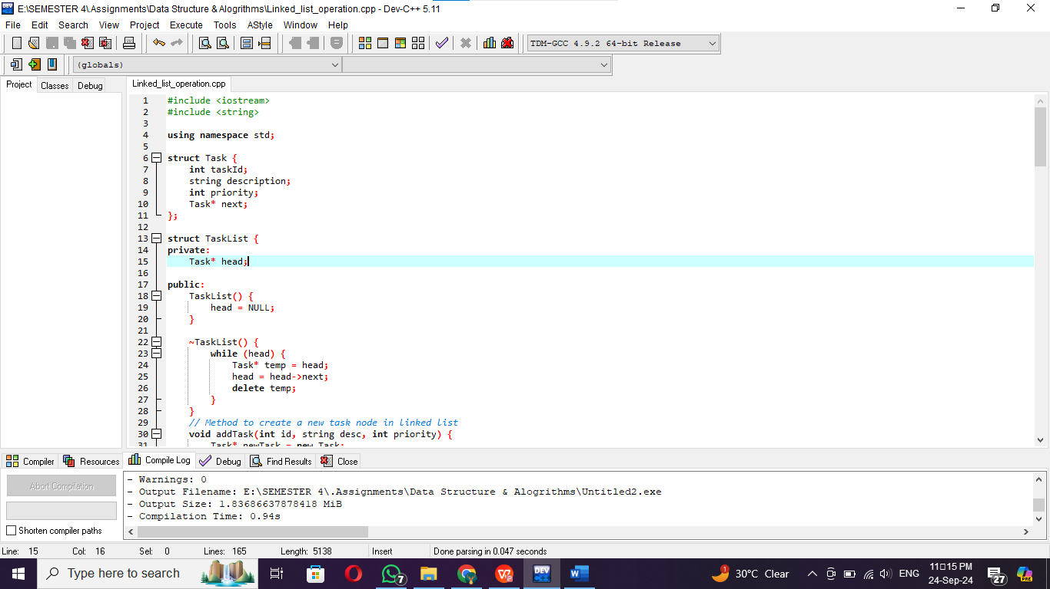**SCREENSHOT**

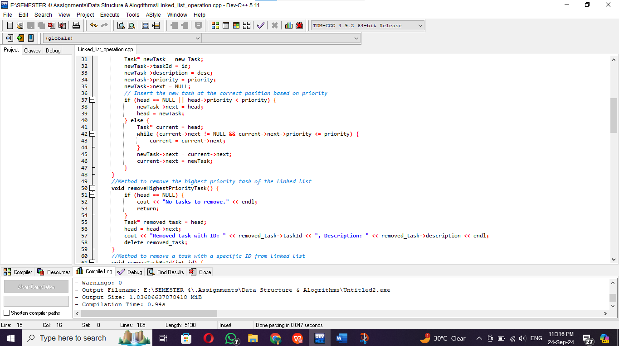

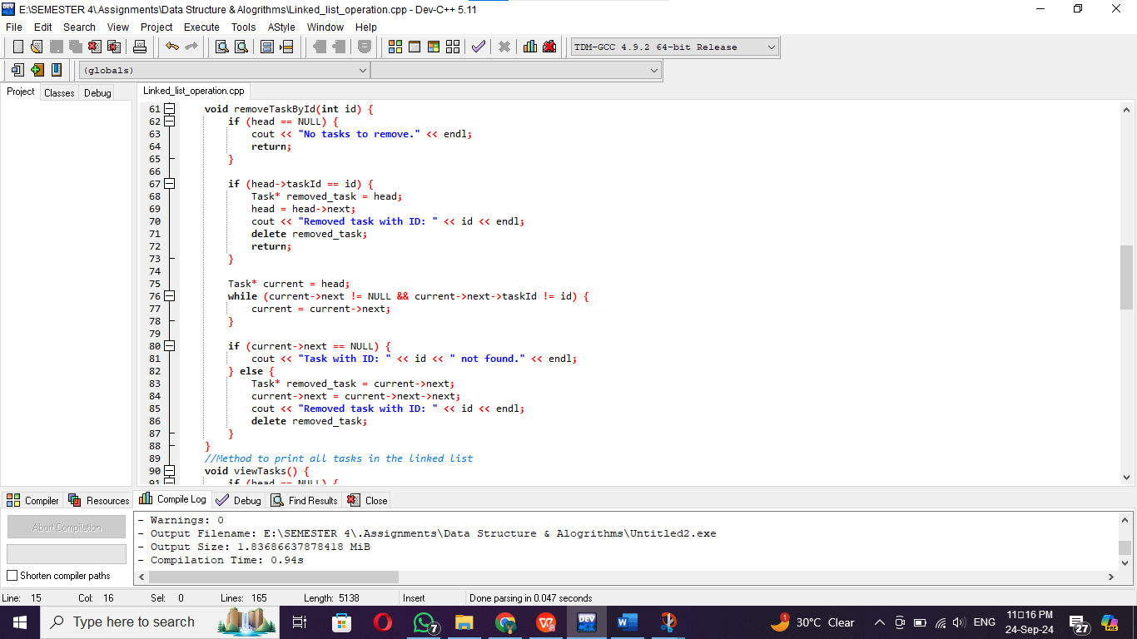

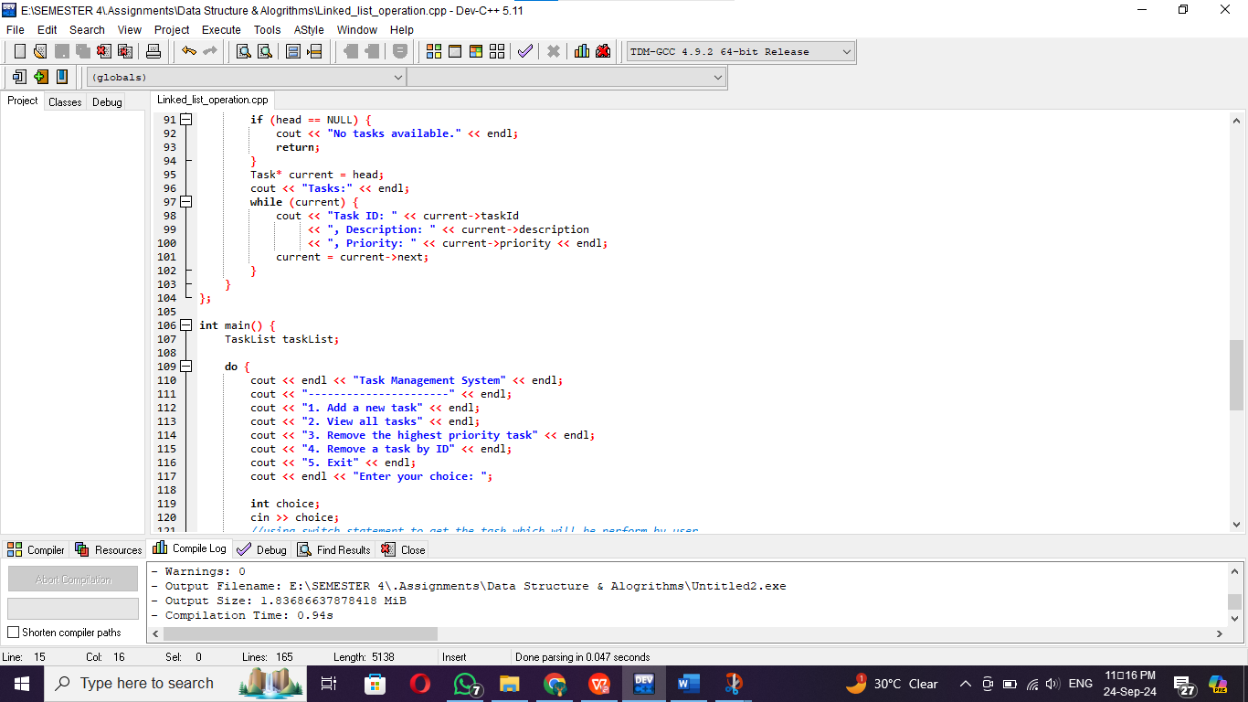

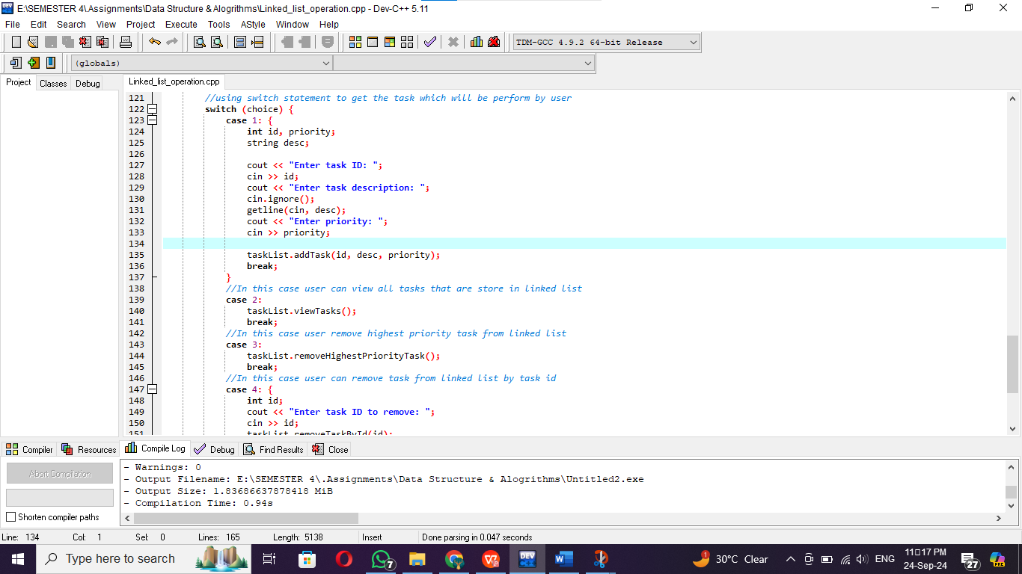

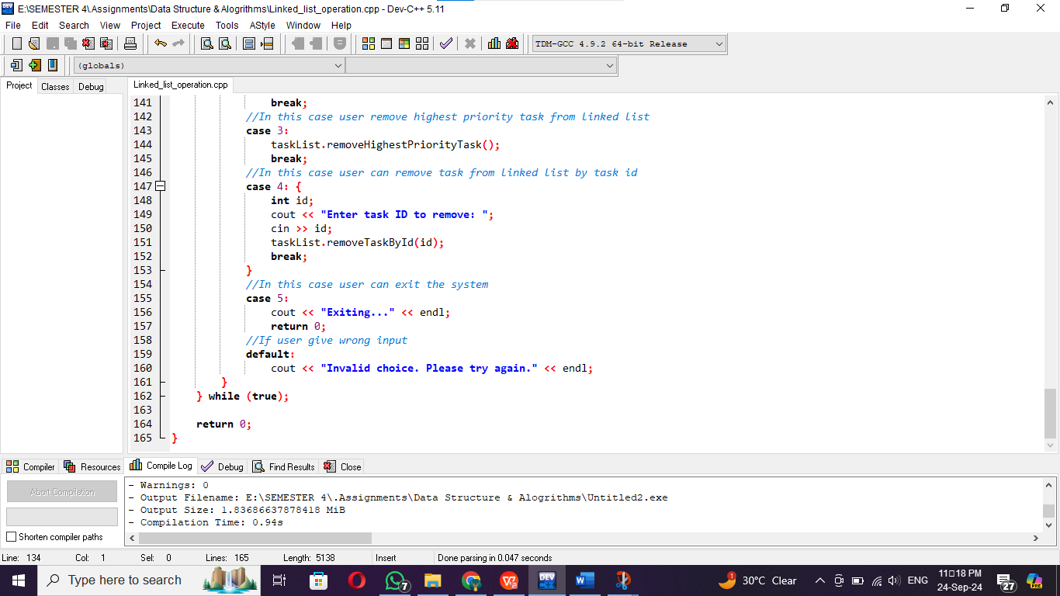

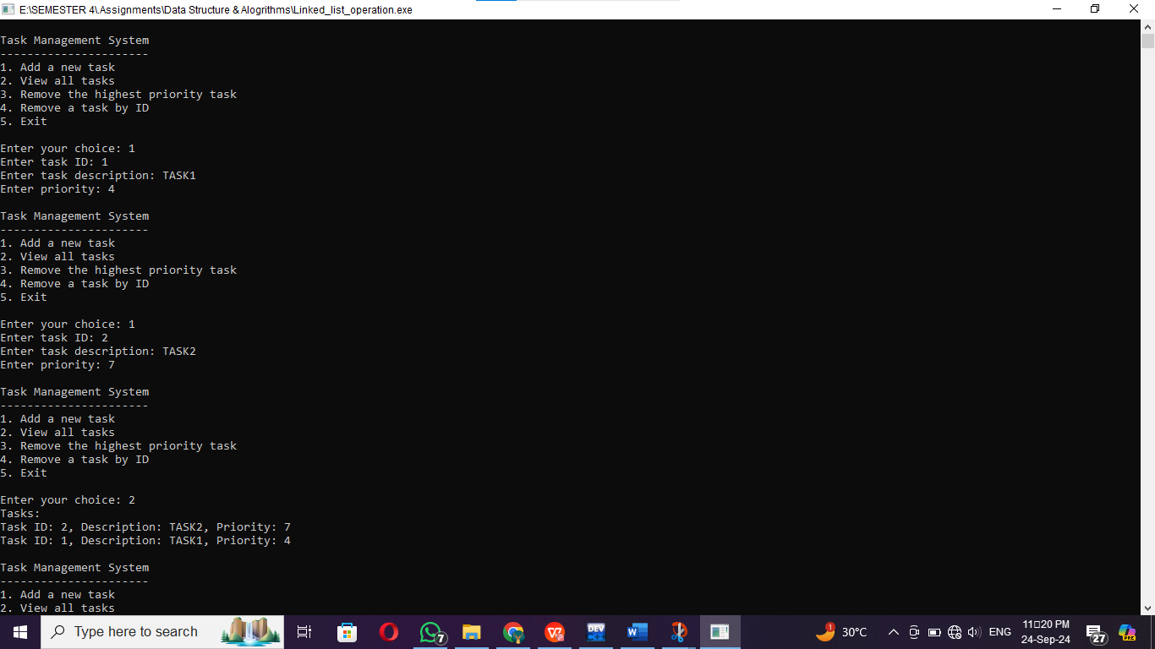OUTPUT

