Carton Packing Screen Specification

1. Executive Summary & Operational Role
The Carton Packing Module (Screen #7) is the critical shop-floor packaging, cartonization, and shipment-readiness checkpoint in the Active Wear Manufacturing Execution System (MES). Located directly after garment assembly and quality finishing, it controls and audits the physical packing of finished garments into shipping cartons prior to warehouse intake.
Operating at Locator 13 (Packing Floor), the screen verifies physical carton barcodes and unique QR labels against ERP Packing Instructions, Sales Orders, and Customer PO specifications. It guarantees that every carton contains the exact prescribed garment styles, colors, sizes, and pack ratios, strictly locks packing sessions to a single Sale Order to prevent cross-order contamination, blocks duplicate or already-packed cartons, and registers positive WIP inventory ready for warehouse receipt at Locator 14 (MD Receiving / Warehouse).

2. End-to-End Operational Lifecycle & Sequence Flow
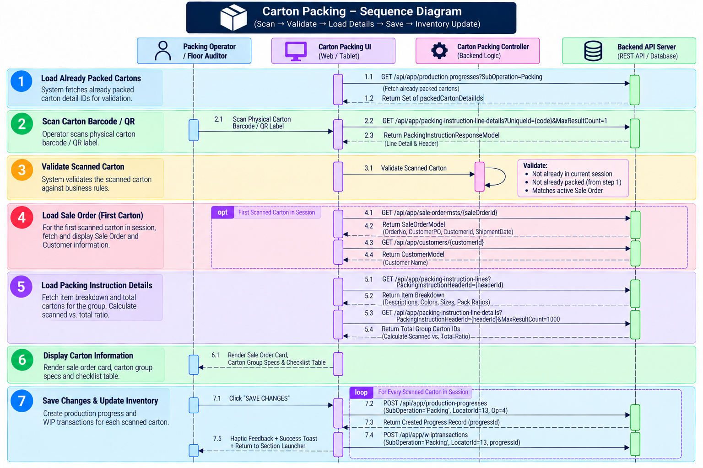

3. Operational Workflow & Interaction Architecture

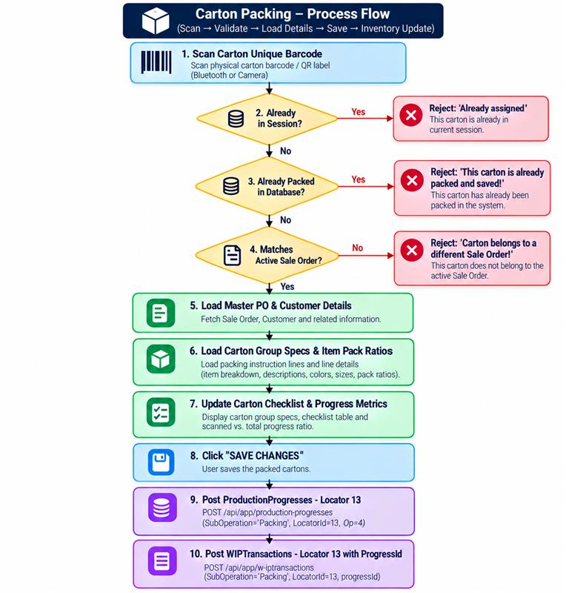

A. Real-Time Hardware & Camera Scanning
The module supports dual scanning inputs to maximize shop-floor throughput:
- Hardware Bluetooth Scanner: Built-in hardware key listener (`HardwareKeyboard`) with `BarcodeBufferParser` for continuous, zero-latency scanning via handheld laser guns without opening on-screen camera dialogs.
- Camera Scanner HUD (`ScannerAlwaysOpen`): An integrated camera viewfinder dialog that renders live scan results, immediate validation error banners, and the active session checklist table simultaneously.

B. Single Sale Order Session Isolation
To eliminate cross-order mixups during packing:
- The first carton scanned establishes the active session's master `saleOrderId`.
- The system immediately queries the Sale Order Master and Customer entities to lock the HUD with Order Number, Customer PO, Customer Name, and Scheduled Shipment Date.
- Any subsequently scanned carton belonging to a different Sale Order is instantly rejected with an explicit error alert indicating the expected vs. scanned order IDs.

C. Expandable Carton Group Specifications & Metrics
Scanned cartons are dynamically aggregated into their master Carton Groups (e.g., *Group A - Mixed Assortment*, *Group B - Solid Packs*). Each group panel provides:
- Real-Time Progress Tracking: Calculates `${totalScanned} / ${totalCartons} Cartons Scanned` by combining historical database-packed cartons with active session scanned items.
- Dimensional & Weight Metrics: Displays Net Weight, Gross Weight (with dynamic unit of measure e.g., Kg/Pack), Dimensions ($L \times W \times H$), and Total Unique Items.
- Pack Ratio Breakdown Table: Details every garment item code, fabric color description, garment size badge, and exact pack ratio (e.g., $1 : 12$ pieces per carton).

D. Interactive Carton Scan Checklist
The lower section displays a real-time checklist table showing:
- Carton Unique ID (`uniqueId`): Highlighted in bold navy blue for quick physical verification.
- Carton Group Code: Identifies the master packaging group.
- Packs per Carton: Total packaged consumer packs inside the box.
- Individual Delete Action: Operators can remove any mis-scanned carton from the session with a confirmation modal, dynamically refreshing group counts and Sale Order locks.

4. Data Integration & Backend Table Integration

Initial Inflow & Packed Cartons Pre-Caching
Upon screen loading, the controller executes `GET /api/app/production-progresses?SubOperation=Packing&MaxResultCount=1000` via `CartonPackingRepo`. It extracts all existing `packingInstructionLineDetailId` foreign keys into a high-performance in-memory `Set<int>`. This pre-cached set allows instantaneous client-side detection of cartons that have already been finalized on the packing floor, preventing duplicate scanning attempts before any network payload is generated.

Carton Validation & Master Data Enrichment
When an operator scans a barcode, the system queries `GET /api/app/packing-instruction-line-details?UniqueId={code}&MaxResultCount=1`. The API returns a composite `PackingInstructionResponseModel` containing both `packingInstructionLineDetail` (holding `id`, `uniqueId`, `packingInstructionHeaderId`) and `packingInstructionHeader` (holding `id`, `cartonGroup`, `packingType`, `packsPerCarton`, `noCartons`, `weight`, `grossWeight`, `netWeight`, `measurementUom`, `length`, `width`, `height`, and `saleOrderMstId`).
If the session's Sale Order is not yet locked, the system executes `GET /api/app/sale-order-msts/{saleOrderId}` to extract `orderNo`, `customerPO`, `customerId`, and `shipmentDate` from `SaleOrderModel`, followed by `GET /api/app/customers/{customerId}` to resolve the official `CustomerModel.name`.
Simultaneously, the system queries `GET /api/app/packing-instruction-lines?PackingInstructionHeaderId={headerId}` to load `PackingInstructionLineResponse` objects containing `itemDef.description`, `itemDef.colorDescription`, `itemDef.sizeDescription`, and `packRatio`. Finally, it queries `GET /api/app/packing-instruction-line-details?PackingInstructionHeaderId={headerId}&MaxResultCount=1000` to cache all detail IDs belonging to the carton group, enabling accurate progress bar calculations.

Save Handover & Two-Stage Inventory Transition
When the operator taps SAVE CHANGES, the system processes each scanned carton sequentially to guarantee transactional integrity:
- Production Progress Creation (`productionProgresses` Entity): Dispatches `POST /api/app/production-progresses` with a JSON payload containing `subOperation = 'Packing'`, `transactionType = 0`, `operationId = 4`, `shiftId = 1`, `locatorId = 13` (Packing Floor), `primaryQuantity = 1.0`, `secondaryQuantity = 1.0`, `operatorDescription = 'system'`, and `packingInstructionLineDetailId`.
- Progress ID Resolution: Captures the newly generated `productionProgress.id` from the creation response or triggers an immediate query fallback via `GET /api/app/production-progresses?PackingInstructionLineDetailId={id}`.
- WIP Transaction Inflow (`wipTransactions` Entity): Dispatches `POST /api/app/w-iPTransactions` containing `subOperation = 'Packing'`, `transactionType = 0`, `operationId = 4`, `shiftId = 1`, `locatorId = 13`, `packingInstructionLineDetailId`, and the linked `progressId`.
This dual-write transition officially records the carton as active finished inventory residing at Locator 13 (Packing Floor), establishing the mandatory prerequisite required for final warehouse intake at Locator 14 (MD Receiving).

5. Business Validations & Operational Guardrails:

The Carton Packing Console enforces a series of real-time validation checks and operational guardrails across barcode scanning, data integrity, order boundaries, and inventory transitions:

Barcode Input Validation & Session Duplicate Guard: When a barcode is read from either a laser gun or the camera viewfinder HUD, the system immediately checks if the trimmed input is empty, returning an instant error ("Invalid carton code") for corrupt or blank scans. It then searches the active session's scanned list (scannedCartons); if the carton's unique barcode has already been added to the active queue, the scan is rejected with the message "Already assigned", preventing duplicate entries in a single packing batch.

Database Completion Lock: To prevent double-packing or unauthorized re-scanning of cartons that have already been finalized on the shop floor, the system checks the scanned carton's packingInstructionLineDetail.id against the pre-cached packedCartonDetailIds set (retrieved from historical production progress records). If the carton has already been processed and saved, scanning is hard-blocked with the error "This carton is already packed and saved!".

Single Sale Order Boundary Enforcement: The console strictly isolates packing sessions to a single Sales Order to eliminate cross-order contamination. The very first carton scanned locks the active session to its parent saleOrderId. If an operator subsequently scans a carton belonging to a different Sales Order, the system instantly blocks the scan with an explicit error: "Carton belongs to a different Sale Order (Expected: X, scanned: Y)!".

Save Prerequisite & Downstream MD Receiving Requirement: The top header's SAVE CHANGES button remains disabled and grayed out until at least one valid carton is added to the checklist. Once saved, the system sets locatorId = 13 across both productionProgresses and wipTransactions. This creates the mandatory audit trail required by MD Receiving (Locator 14), ensuring warehouse personnel cannot intake cartons that were not officially packed and validated on the packing floor.

Sequential Transaction Auditing & Failure Rollback: During the save operation, the system processes each carton sequentially, creating progress and WIP transactions while capturing any individual network or database write failures into a failedCartons tracker. If any carton fails to write, the system displays a descriptive snackbar listing the failed carton identifiers and preserves the session state so the operator can retry without losing their progress.

