MD Receiving Screen Specification

1. Executive Summary & Operational Role
The MD (Materials Department) Receiving Module (Screen #8) is the final warehouse audit and finished goods intake checkpoint in the Active Wear Manufacturing Execution System (MES). Positioned at the terminal boundary between production floor packaging and warehouse storage, this console manages the physical receipt of completed shipping cartons transferring from Locator 13 (Packing Floor) into the permanent finished goods warehouse designated as Locator 14 (MD Receiving / Warehouse).
Acting as a strict quality and inventory gatekeeper, the screen verifies that every incoming carton was legitimately packed and saved in the upstream Carton Packing module before granting warehouse entry. It executes an automated double-entry inventory transfer—checking cartons out of WIP packing buffers and booking them into warehouse stock—while preventing duplicate receipts or unauthorized unverified carton entries.

2. End-to-End Operational Lifecycle & Sequence Flow
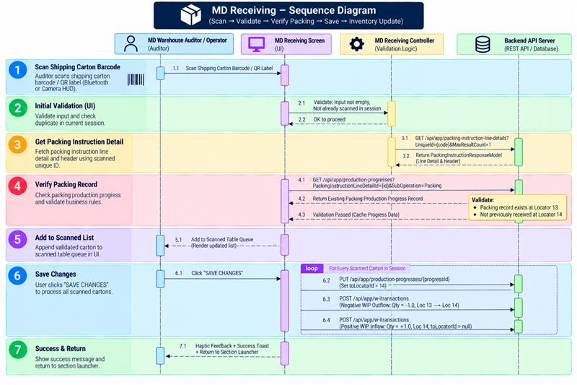

3. Operational Workflow & Floor Intake Architecture

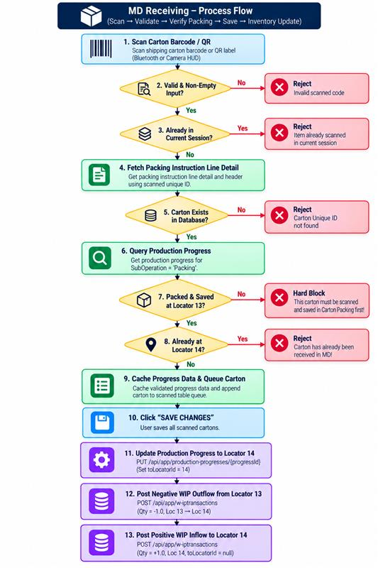

A. High-Throughput Barcode Scanning
The module provides flexible scanning inputs configured for warehouse dock operations:
- Bluetooth Laser Gun Scanner: Continuous background listener (`HardwareKeyboard` with `BarcodeBufferParser`) capturing raw keystroke streams for rapid, hands-free pallet receiving.
- Integrated Camera HUD (`ScannerAlwaysOpen`): An active viewfinder dialog allowing warehouse operators to scan barcode labels, observe instant validation feedback, and monitor the live receiving queue simultaneously.

B. Two-Stage Intake Verification
When a carton barcode is read, the system executes a mandatory two-stage audit:
- ERP Entity Resolution: Maps the physical code to its master `PackingInstructionLineDetail` record.
- Packing Floor Audit Guard: Queries backend progress logs to confirm that the carton was processed through Locator 13 (Packing Floor). If the carton was never packed or saved in Carton Packing, warehouse intake is immediately locked.

C. Live Material Queue Grid
Scanned cartons render in an intake table displaying:
- Carton Unique ID (`uniqueId`): Stylized in bold navy blue for fast physical shipping label verification.
- Carton Group: Displays the master packaging classification (e.g., solid size, mixed assortment).
- Packs per Carton: Displays packaged consumer pack quantities inside the box.
- Inline Delete Action: Enables immediate removal of any incorrectly scanned box prior to saving.

4. Data Integration & Backend Table Integration

Initial Discovery & Carton Verification Inflow
When an operator scans a carton code, the controller calls `GET /api/app/packing-instruction-line-details?UniqueId={code}&MaxResultCount=1` via `MdReceivingRepo`. If the code exists, the API returns a `PackingInstructionResponseModel` linking `packingInstructionLineDetail` (containing `id`, `uniqueId`, and `packingInstructionHeaderId`) with `packingInstructionHeader` (containing `cartonGroup` and `packsPerCarton`).
To enforce the packing floor audit gate, the controller immediately dispatches `GET /api/app/production-progresses` with query parameters `PackingInstructionLineDetailId = lineDetailId` and `SubOperation = 'Packing'`. If the query returns an empty list, the carton is rejected because no prior packaging progress exists. If a record is found, the system inspects `toLocatorId` and `locatorId` to ensure the carton has not already been received into Locator 14. The raw progress map is stored in an in-memory dictionary (`productionProgressMap[lineDetailId]`) for subsequent update execution.

Save Handover & Double-Entry Inventory Settlement
When the auditor taps SAVE CHANGES, the system processes each verified carton through a three-stage transactional settlement:
- Production Progress Progression (`productionProgresses` Entity): The system updates the original packing progress record via `PUT /api/app/production-progresses/{progressId}`, modifying `toLocatorId = 14`. This flags the progress entity as transitioning into warehouse custody.
- Negative WIP Outflow (`wipTransactions` Entity): The system posts a negative WIP transaction via `POST /api/app/w-iPTransactions` with `subOperation = 'Locator Transfer'`, `transactionType = 1` (Issue / Outflow), `primaryQuantity = -1.0`, `secondaryQuantity = -1.0`, `operationId = 4`, `shiftId = 1`, `locatorId = 13` (Source: Packing Floor), `toLocatorId = 14`, `packingInstructionLineDetailId = lineDetailId`, and `progressId = progressId`. This officially relieves the packing floor of the physical carton.
- Positive WIP Inflow (`wipTransactions` Entity): The system posts a positive WIP transaction via `POST /api/app/w-iPTransactions` with `subOperation = 'MD Receiving'`, `transactionType = 0` (Receipt / Inflow), `primaryQuantity = 1.0`, `secondaryQuantity = 1.0`, `operationId = 4`, `shiftId = 1`, `locatorId = 14` (Destination: MD Receiving / Warehouse), `toLocatorId = null`, `packingInstructionLineDetailId = lineDetailId`, and `progressId = progressId`. Setting `toLocatorId = null` signifies that the carton has arrived at its final warehouse destination and is no longer moving work-in-progress.

5. Business Validations & Operational Guardrails
The MD Receiving console enforces a comprehensive set of real-time operational guardrails and automated business validation checks across scanning, inventory lineage, and double-entry transaction posting:
- Barcode String Sanitization & Session Duplication Guard: When a barcode is read from either a laser gun or camera scanner, the system trims leading and trailing whitespace and immediately rejects blank inputs (*"Invalid scanned code"*). It then inspects the active session's scanned list (`scannedCartons`); if the scanned carton's unique identifier is already queued in the current table, the scan is rejected with the message *"Item already scanned in current session"*, preventing accidental double-scanning of the same physical box.
- Upstream Packing Floor Audit Guard (Hard Block): To prevent empty, dummy, or unverified cartons from bypassing the packing department and entering finished goods inventory, the system queries backend production progress records for `SubOperation = 'Packing'`. If no completed packing progress record exists for the scanned `packingInstructionLineDetailId`, the carton is strictly hard-blocked with the error *"This carton must be scanned and saved in Carton Packing first!"*.
- Warehouse Double-Receipt Prevention Lock: If a valid carton is scanned, the system evaluates the cached production progress entity's location fields (`toLocatorId` and `locatorId`). If either field is already set to `14`, indicating that the carton was previously received and booked into the finished goods warehouse, the system blocks the transaction with the warning *"Carton has already been received in MD!"*.
- Save Activation Prerequisite & Transaction Integrity: The top header's SAVE CHANGES button remains disabled and grayed out whenever the scanned list is empty, preventing accidental blank submissions. During save execution, the system processes each carton sequentially, verifying cached progress IDs and updating progress entities before executing the double-entry WIP debit and credit transactions. If any individual API call fails, the system captures the failure in a tracking list, displays a descriptive error toast detailing the specific failed cartons, and retains uncommitted items on-screen for operator remediation.

