Stitching Line Allocation (Schedule) Screen Specification

1. Executive Summary & Operational Role
The Stitching Line Allocation Module (also referred to as Stitching Line Schedule) is the core planning and dispatching console that maps finished garment bundles, purchase orders, colors, and sizes to specific physical sewing and stitching assembly lines (Cost Center Lines).
Operating as the critical bridge between prep departments (Lapping / Induction Store) and final garment assembly, this screen allows production supervisors and industrial engineers to dynamically balance floor line capacities, allocate unassigned production bundles to sewing lines, and re-allocate active bundles across lines to resolve bottlenecks. It guarantees strict real-time data synchronization between high-level purchase order schedules (`poStyle` master entity) and low-level shop-floor sewing tracking entities (`sewingMapping` master entity).

2. End-to-End Operational Lifecycle & Synchronization Flow
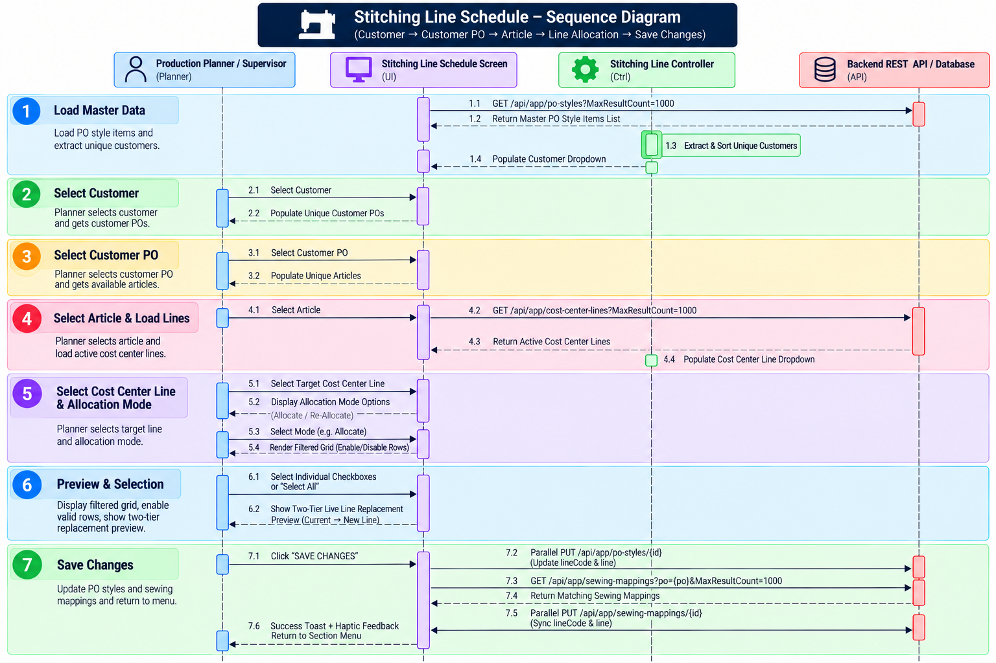

3. Operational Workflow & Cascading Filtering Architecture
The screen enforces a strict 4-tier cascading hierarchy to eliminate invalid cross-allocation and guide the planner to the exact bundle group:

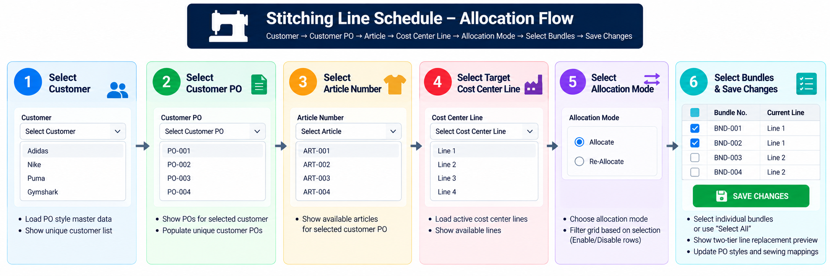

A. Stage 1 — Customer Selection
Upon screen launch, the system automatically queries all active PO style records. The planner begins by selecting a client from the searchable Select Customer dropdown. Selecting a new customer instantly clears any downstream selections (Customer PO, Article, Cost Center Line, Allocation Mode, and selected table items) to maintain data purity.

B. Stage 2 — Customer PO Filtering
Once a customer is selected, the Select Customer PO dropdown unlocks, dynamically populated only with purchase orders (`po`) registered under the selected customer. Changing the PO selection clears downstream Article, Line, and table choices.

C. Stage 3 — Article Number Isolation
Selecting a Customer PO dynamically extracts and sorts all distinct garment article codes (`articleNo`) tied to that specific Customer + PO combination. When an article is chosen, the system automatically triggers an asynchronous background call to retrieve all active factory sewing lines.

D. Stage 4 — Target Cost Center Line Assignment
The planner selects the target sewing line (e.g., *Line 01 - Activewear Tops*, *Line 02 - Bottoms*) from the Select Cost Center Line dropdown. This line represents the destination line to which the chosen garment bundles will be assigned.

E. Stage 5 — Allocation Mode Selection
Once a Cost Center Line is chosen, the screen reveals two exclusive operational modes:
- Allocate Mode: Isolates unassigned garment bundles (`line == null` or empty). Checkboxes are active only for unallocated bundles, allowing first-time dispatch to the sewing floor.
- Re-Allocate Mode: Isolates previously assigned garment bundles (`line != null`). Checkboxes are active only for assigned bundles, allowing supervisors to re-route bundles to alternative sewing lines during line balancing or machine downtime.

- `colorCode` (`String`): Garment color specification.
- `size` (`String`): Garment size dimension.
- `quantity` (`int`): Garment piece count in bundle.
- `lineCode` (`String`): Assigned Cost Center Line code (e.g., `L01`).
- `line` (`String`): Assigned Cost Center Line full description.
- `masterQrReference` (`String`): QR code linking parent garment bundle.
- `so` (`String`): Sales Order reference number.

`CostCenterLine` Entity
- `id` (`int`, Primary Key): Unique cost center identifier.
- `name` (`String`): Line code / short name (e.g., `Line 01`).
- `description` (`String`): Descriptive line name (e.g., `Stitching Line 01 - Tops`).

`SewingMapping` Entity
- `id` (`int`, Primary Key): Floor sewing mapping record identifier.
- `customer` (`String`): Customer identifier.
- `po` (`String`): Customer PO number.
- `bundleNo` (`String`): Bundle identifier matching the PO style.
- `lineCode` (`String`): Synchronized sewing line code.
- `line` (`String`): Synchronized sewing line description.

