GBS Receiving Module - Functional & Technical Specification
The GBS (Goods-Based Stock) Receiving Module acts as the material intake and quality audit checkpoint between the knitting floor and downstream processing. It audits fabric output from Locator 2 (Knitting Buffer), verifies quality hold statuses, and transitions accepted goods to Locator 3 (GBS Buffer / Production Floor), while routing non-standard output to Locator 16 (Sample Store) or Locator 17 (C-Grade Store).

1. Module Overview & Operational Lifecycle
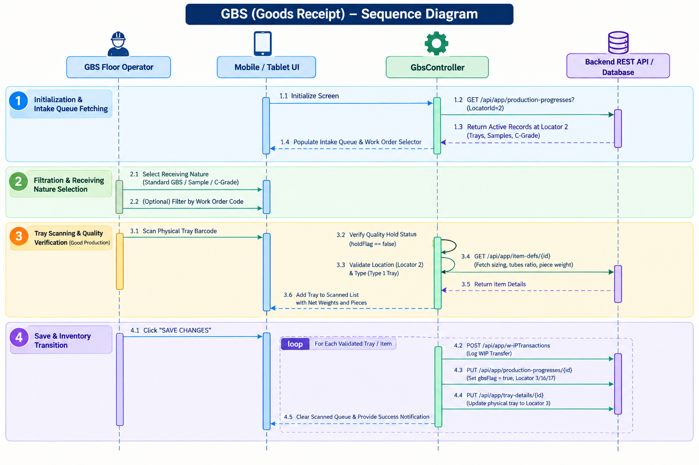

2. End-to-End Operational Workflow & Data Integration

A. Initialization & Intake Queue Fetching
When the GBS Receiving screen mounts, the system queries the `ProductionProgresses` table (`GET /api/app/production-progresses?LocatorId=2&MaxResultCount=1000`). This fetches all active records and physical containers that have been completed at the knitting machines and are currently stationed at Locator 2 (Knitting Buffer). The controller extracts unique `WorkOrderHeader` entities from these records to populate the Work Order filter dropdown.

B. Receiving Nature Selection & Work Order Filtering
Operators can select between three receiving modes using the top nature switcher:
- Standard GBS Receiving (Good Production): Active by default. Filters for standard production trays (`productNature != 1` and `productGrade != 2`) that are not on quality hold.
- Sample Receiving: Filters for development and test fabric runs (`productNature == 1`), which are grouped by Work Order and Item for bulk checkbox selection.
- C-Grade Receiving: Filters for lower-grade fabric seconds (`productGrade == 2`), which are aggregated by Work Order and Item displaying total weight in kilograms.
- *Work Order Filter*: Selecting a specific Work Order isolates records for that run. Operators can click "SHOW TRAYS" to open a modal overview of all pending trays waiting at Locator 2 for that order.

C. Physical Tray Scanning & Quality Verification (Good Production)
In standard GBS mode, the operator scans physical tray barcodes using a Bluetooth scanner gun or the built-in camera scanner. The system searches the local intake cache for matching tray codes or progress codes. If a tray is found with `holdFlag == true`, it is immediately rejected. For accepted trays, the system queries the `ItemDefs` table (`GET /api/app/item-defs/{id}`) to retrieve color descriptions, sizing specifications, per-garment tube multipliers, and piece weights, automatically calculating the total piece count (`Qty × perGarmentTube`) and net weight (`Qty × pieceWeight`).

D. Bulk Group Selection (Sample & C-Grade Modes)
For Sample and C-Grade production, physical trays are not used. Instead, the screen aggregates individual records into consolidated style groups showing Work Order Code, Item Description, Total Tubes, Total Pieces, Total Weight (g / kg), and combined quality remarks. Operators select individual groups or use the "SELECT ALL" toggle to prepare records for batch receiving.

3. Business Validations & Operational Guards

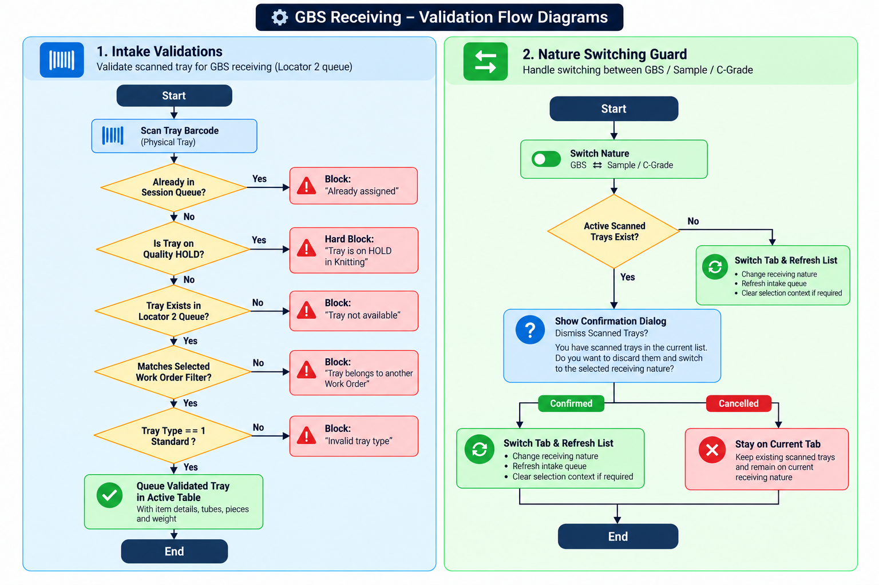

Core Validation Rules:
- Quality Hold Guard: Trays flagged with `holdFlag == true` at knitting are strictly blocked from GBS intake until formally inspected and released.
- Intake Location Lock: Trays must physically reside at Locator 2 (Knitting Buffer). Any tray already received or located elsewhere is rejected.
- Work Order Matching: If an operator filters by a specific Work Order, scanning a tray belonging to a different order is blocked to prevent accidental cross-batch mixing.
- Container Type Rule: Only Type `1` trays (Standard Knitting Trays) can be received in GBS mode.
- Session Switch Guard: Changing receiving nature when trays are queued prompts a confirmation dialog to prevent accidental data loss.

4. Save Actions & Inventory Handover
When the operator clicks SAVE CHANGES, the system transitions inventory into the target department:
- For Good Production (GBS Receiving):
- Log WIP Transaction: Posts `POST /api/app/w-iPTransactions` with `subOperation = "GBS Receiving"`, `transactionType = 6`, and `locatorId = 3`.
- Update Production Progress: Updates `PUT /api/app/production-progresses/{id}` setting `gbsFlag = true`, `subOperation = "GBS Received"`, and updating `locatorId` to 3 (GBS Buffer).
- Update Physical Container: Updates `PUT /api/app/tray-details/{id}` setting `locatorId = 3`, unlocking the tray for batching in subsequent manufacturing operations.
- For Sample & C-Grade Receiving:
- Sample Routing: Logs WIP transactions and updates progress records to Locator 16 (Sample Store) with `subOperation = "Sample Received"`.
- C-Grade Routing: Logs WIP transactions and updates progress records to Locator 17 (C-Grade Store) with `subOperation = "C Grade Received"`.
- Completion: Clears selection checkboxes, displays a success notification, and silently refreshes the remaining intake queue.

