Induction Store Module - Functional & Technical Specification
The Induction Store Module (`InductionStoreScreen` and `InductionController`) serves as the staging inventory portal for finished garment piece trays coming off the manufacturing floor. It audits completed trays that have cleared upstream operations (including Lapping piece re-assignment), checks for PBS quality holds, and formally admits them into the central warehouse designated as Locator 11 (Induction Store), setting the `pbsFlag = true` to ready goods for final assembly or carton packing.

Module Overview & Operational Lifecycle

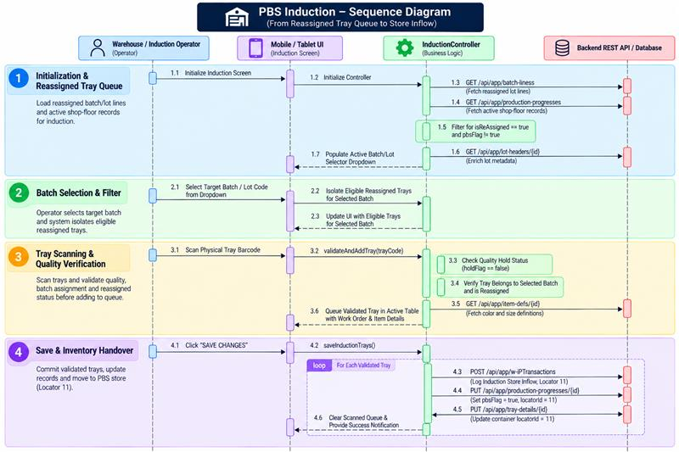

2. End-to-End Operational Workflow & Data Integration

A. Initialization & Reassigned Queue Discovery
When `InductionStoreScreen` mounts, the system calls the `BatchLines` table (`GET /api/app/batch-liness?MaxResultCount=1000`) and the `ProductionProgresses` table (`GET /api/app/production-progresses`). The controller cross-references records to identify trays that have successfully completed Lapping piece re-assignment (`isReAssigned == true` or `subOperation == "handover"`). It automatically filters out trays that are on quality hold (`holdFlag == true`) or have already been inducted (`pbsFlag == true`). It then fetches associated `LotHeaders` metadata to populate the Batch/Lot Number dropdown selector.

B. Batch Selection & Filter Isolation
Operators select the active master lot from the dropdown menu. This filters the background intake queue so that only reassigned piece trays belonging to that specific batch can be scanned. If no batch is chosen, the screen prevents scanning to enforce batch-level traceability.

C. Physical Tray Scanning & Verification
Operators scan physical tray barcodes using a Bluetooth scanner gun or the built-in camera scanner. The system verifies that the scanned barcode matches a valid tray in the filtered batch queue. The container must be active, configured as a standard knitting tray (`trayType == 1`), and not flagged with a quality hold in PBS. The system queries the `ItemDefs` table (`GET /api/app/item-defs/{id}`) to load garment color descriptions and sizing specifications, then appends the verified container to the active checklist table.

3. Business Validations & Operational Guards

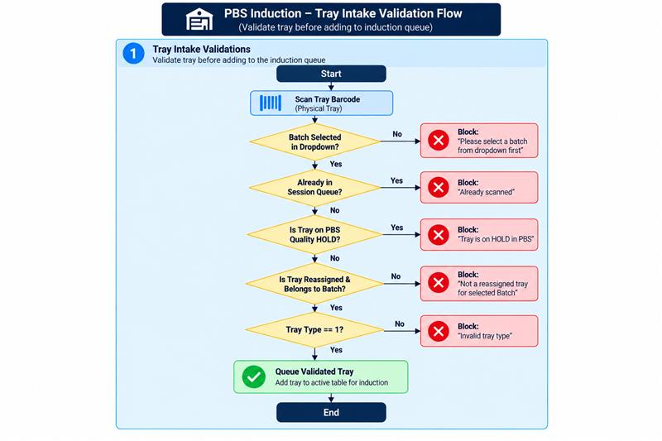

Core Validation Rules:
- Batch Selection Prerequisite: Operators cannot scan any trays until a target Batch/Lot Number has been chosen.
- Reassigned State Lock: Only trays that have completed Lapping tube cutting and piece re-assignment (`isReAssigned == true`) are eligible for Induction Store intake; raw un-cut tube trays are rejected.
- Quality Hold Guard: Trays flagged with `holdFlag == true` in PBS are strictly blocked from induction until formally cleared.
- Batch Consistency Rule: Trays belonging to a different batch header are rejected to prevent mixing items between distinct manufacturing lots.
- Container Type Rule: Only Type `1` trays (Standard Knitting Trays) can be processed into the Induction Store.

4. Save Actions & Inventory Handover
Clicking SAVE CHANGES transitions the scanned goods into permanent warehouse inventory:
- Log WIP Transaction: Posts `POST /api/app/w-iPTransactions` with `subOperation = "Induction Store"`, `transactionType = 1`, and `locatorId = 11`.
- Update Production Progress: Updates `PUT /api/app/production-progresses/{id}` setting `pbsFlag = true` and `locatorId = 11` (Induction Store Warehouse).
- Update Physical Container: Updates `PUT /api/app/tray-details/{id}` setting `locatorId = 11`, marking the tray as staged and ready for assembly line issue or carton packing.
- Completion Feedback: Haptic feedback is triggered, the scanned tray table is cleared, and the batch queue silently refreshes.

