Knitting Production Module - Functional & Technical Specification
The Knitting Production Module serves as the primary shop-floor execution portal for the manufacturing plant. It registers initial garment fabric output at the knitting machines, binds physical barcode trays to planned Work Orders, enforces production quotas, and posts inventory progress to Locator 2 (Knitting Buffer).

Module Overview & Operational Lifecycle

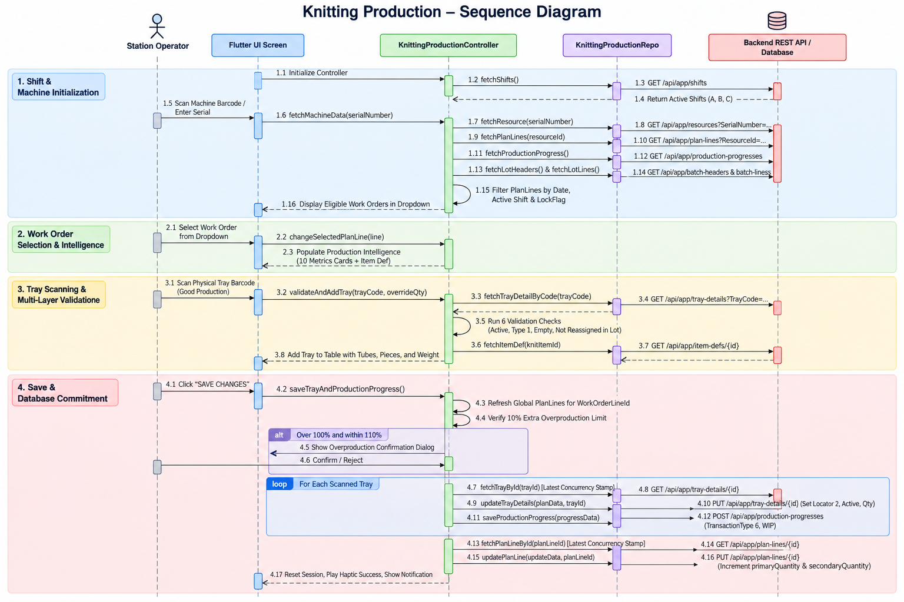

2. End-to-End Operational Workflow & Data Integration

A. Shift & System Initialization
When the screen mounts, the application queries the `Shifts` table (`GET /api/app/shifts`) to retrieve all operational shift definitions (`startTime`, `endTime`, `code`). The system evaluates the device clock to determine the current active shift (A, B, or C). For the overnight C-Shift (operating across midnight), if the current hour is before 06:00 AM, the target plan date is automatically set to the previous calendar day to align with the shift's starting date. Toggling the "Use Previous Shift" switch recalculates the shift and date targets accordingly.

B. Machine Scanning & Plan Retrieval
Scanning a machine's barcode queries the `Resources` table (`GET /api/app/resources?SerialNumber=...`) to retrieve the machine's ID, name, brand, and weight capacity. Once verified, the application retrieves all scheduled orders from the `PlanLines` table (`GET /api/app/plan-lines?ResourceId=...`). The system filters these records locally to display only lines where `planHeader.lockFlag == true` (approved plans) and where the scheduled date and shift match the active target. Concurrently, draft lot lines from `BatchHeaders` and `BatchLines` are loaded to check for container locks, and global work order plan lines (`GET /api/app/plan-lines?WorkOrderLineId=...`) are fetched to compute company-wide fulfillment totals across all machines.

C. Work Order Selection & Production Intelligence
Selecting an approved Work Order loads the plan line context and populates key metrics: Sales Order Number, Customer PO, Article Number, Planned Quantity, Completed Output, Remaining Quantity, Tubes per Garment, and Piece Weight. Sizing and ratio details are cross-referenced with the `ItemDefs` table (`GET /api/app/item-defs/{id}`), and the standard tray quantity (`quantityPerTray`) is pre-populated as the default scanning value.

D. Physical Tray Scanning & Verification (Good Production)
When scanning physical trays for standard production, the system queries the `TrayDetails` table (`GET /api/app/tray-details?TrayCode=...`). The container must pass five validation checks: it must be active (`active == true`), configured as a standard knitting tray (`trayType == 1`), physically empty (`locatorId == null` or `trayQuantity == 0`), not already in the active session queue, and not flagged as reassigned (`isReAssigned == true`) in any draft Lapping batch. Validated trays are queued in the active table with calculated tube counts, total garment pieces (`Qty × perGarmentTube`), and gross weight (`Qty × pieceWeight`).

E. Sample & C-Grade Production
For non-standard production (Sample or C-Grade), physical trays are not bound. The operator selects the respective production type and enters the tube quantity along with mandatory remarks. Sample runs update `sampleQty` with `productNature = 1`, while C-Grade runs update `cGradeQty` with `productGrade = 2`.

3. Business Validations & Overproduction Safeguards

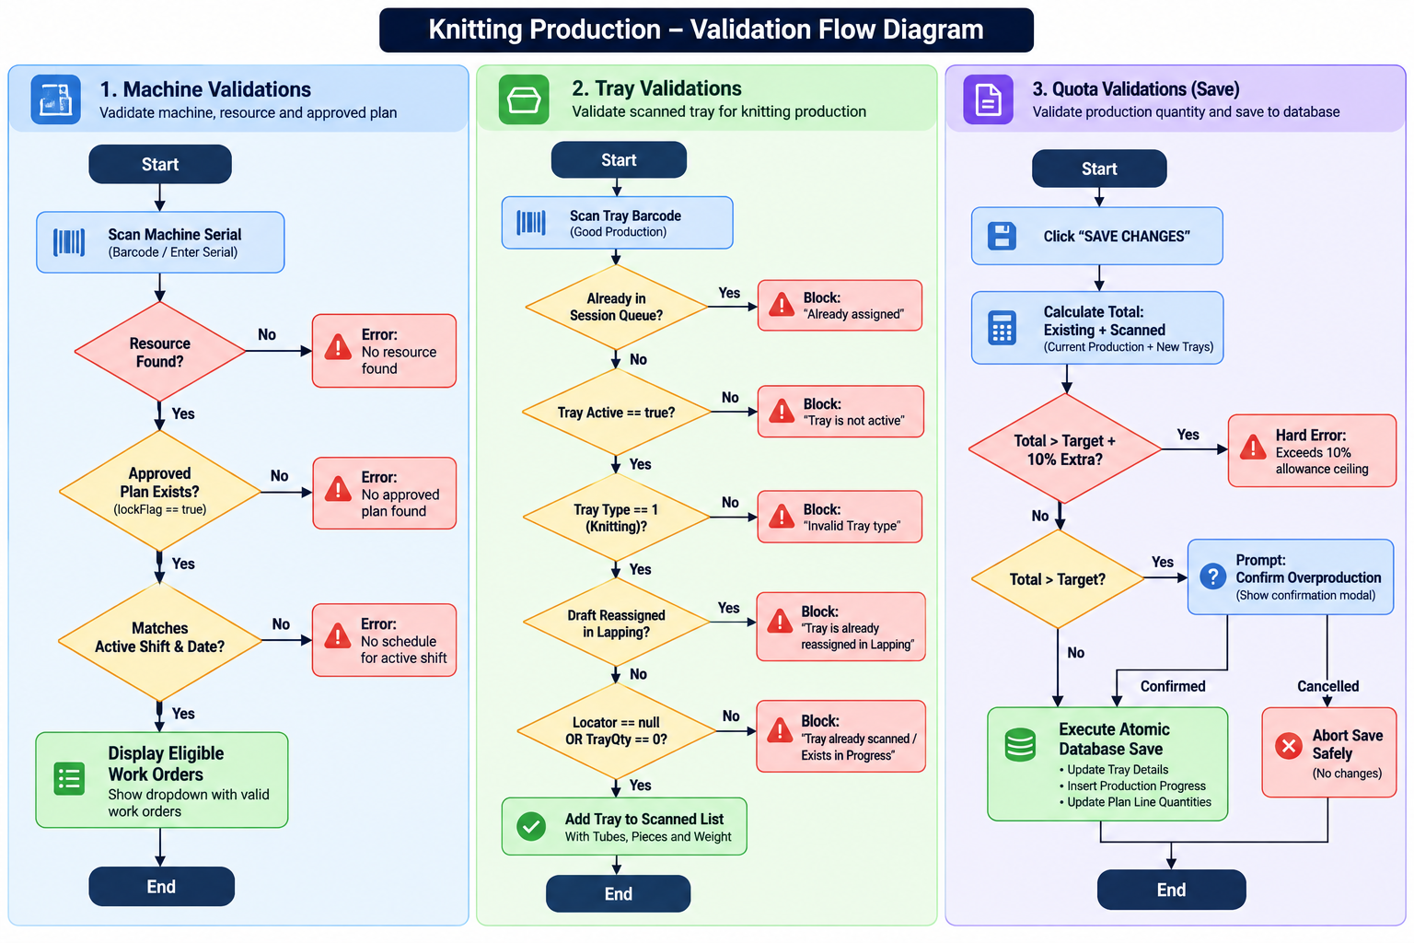

Core Validation Rules:
- Approved Plan Lock: Only plans with `planHeader.lockFlag == true` can be executed on the floor.
- Empty Container Requirement: Trays with existing inventory or stationed at any locator are blocked until emptied downstream.
- Lapping Lot Protection: Trays assigned to unlocked draft lot headers in Lapping cannot be bound at knitting.
- 10% Overproduction Ceiling: Total work order production cannot exceed `tubesAfterAdjustment + 10%`. Output between 100% and 110% requires supervisor confirmation, while output above 110% is hard-blocked.

