Lot Making & Lot History Module - Functional & Technical Specification
The Lot Making Module (`LotListScreen`, `LotMakingScreen`, and `LotMakingController`) manages the consolidation of individual GBS-received trays into master manufacturing lots (Batches). It provides capacity planning for processing machines (e.g., Heatset, Dyeing), enforces routing sequence consistency, and manages the complete lot lifecycle across two distinct operational stages: (a) New Lot Making & Planning and (b) Lot History (Draft & Issued Management).

1. Module Overview & Lifecycle Flowchart
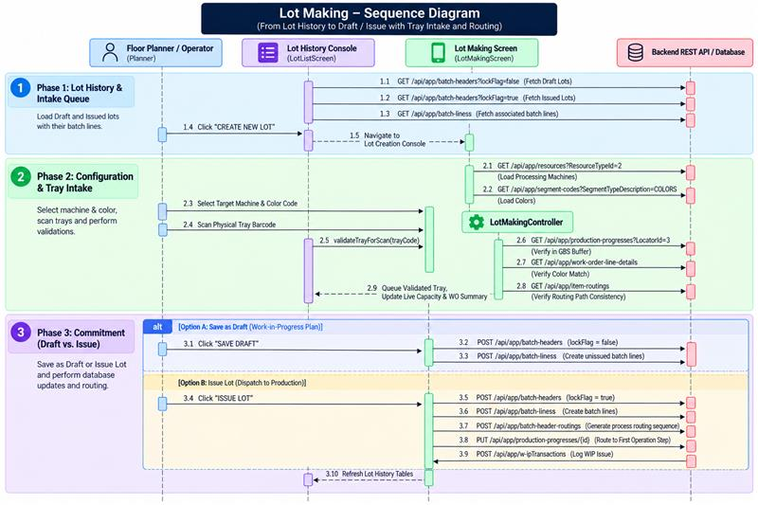

2. End-to-End Operational Workflow & Data Integration

A. Lot History Dashboard (Draft & Issued Tabs)
Upon opening the module, `LotListScreen` queries the `BatchHeaders` table (`GET /api/app/batch-headers`) and `BatchLines` table (`GET /api/app/batch-liness?MaxResultCount=1000`) to present two tabbed operational views:
- Draft Lots Tab (`lockFlag == false`): Displays pending or incomplete lots. Planners can edit draft lots (re-opening `LotMakingScreen` with preloaded trays), delete unwanted drafts (`DELETE /api/app/batch-headers/{id}`), or issue them directly once finalized. A global background Bluetooth listener allows operators to scan trays directly on the list view to auto-append items to selected drafts.
- Issued Lots Tab (`lockFlag == true`): Displays finalized, active production lots running on the plant floor. Expandable accordion rows allow supervisors to view all linked trays, piece counts, and garment descriptions. Operators can also scan and bind transport trolleys (Type `4` containers) or print physical lot traveler sheets.

B. New Lot Creation & Machine Capacity Planning
When creating or editing a lot, the system queries the `Resources` table (`GET /api/app/resources?ResourceTypeId=2`) to fetch processing machines (Heatset/Dyeing units) and the `SegmentCodes` table (`GET /api/app/segment-codes?SegmentTypeDescription=COLORS`) for standard fabric colors. Selecting a machine automatically loads its maximum weight capacity. As trays are scanned, the console maintains a live Machine Load Progress Bar and summary metrics (Total Trays, Total Tubes, Machine Capacity, Allocated Weight, and Remaining Weight in grams).

C. Physical Tray Intake & Multi-Layer Verification
Scanning a tray queries the `ProductionProgresses` table (`GET /api/app/production-progresses?LocatorId=3`) to verify that the container is actively sitting in Locator 3 (GBS Buffer) with `gbsFlag == true`. The system then calls the Work Order Line Details endpoint (`GET /api/app/work-order-line-details`) to verify that the tray matches the chosen batch color. Next, the system calls `GET /api/app/item-routings?ItemDefId=...` to extract the tray's operational routing path; all trays in a single lot must share the exact same sequence of operations. Finally, the system calculates the projected total weight to ensure the addition does not breach the machine's maximum capacity ceiling.

D. Work Order Summary Aggregation
The console dynamically consolidates queued trays into an aggregated Work Order Summary grid, grouping records by Work Order Code + Item Description + Size. This gives planners immediate visibility into the style and size breakdown of the lot before saving.

3. Business Validations & Operational Guards

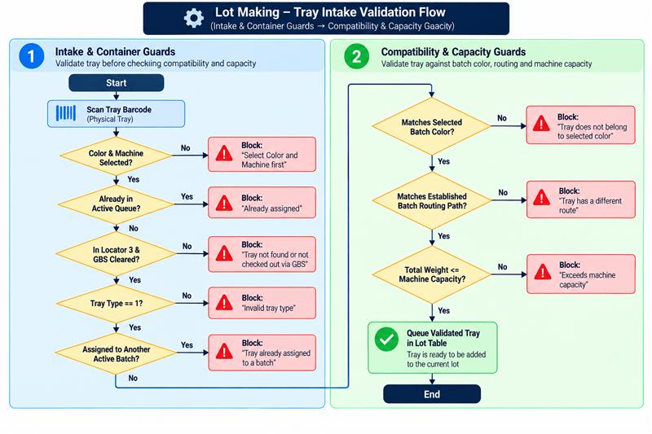

Core Validation Rules:
- Prerequisite Lock: Machine and Color selections are mandatory before any tray scanning can occur.
- GBS Clearance Lock: Trays must reside at Locator 3 with `gbsFlag == true`. Trays still sitting in Knitting (Locator 2) or previous departments are rejected.
- Single Batch Assignment: A tray cannot be linked to more than one batch header in the database.
- Color Consistency Rule: All trays in a lot must share the exact same fabric color code.
- Routing Path Uniformity: The first tray scanned sets the master routing template. Any subsequent tray with differing operation IDs or step counts is rejected.
- Machine Capacity Ceiling: Cumulative tray weight (`Qty × pieceWeight`) cannot exceed the processing machine's rated capacity limit.

4. Save Actions & Issuance Handover
The module supports two saving pathways depending on the planning status:
- Save as Draft (`lockFlag = false`):
- Creates or updates `POST /api/app/batch-headers` with `lockFlag = false`, storing the lot code, plan date, machine ID, color code, and shift ID.
- Generates `POST /api/app/batch-liness` records linking each tray to the draft header.
- Leaves trays at Locator 3 so they remain editable in the Draft Lots list.
- Issue Lot (`lockFlag = true`):
- Creates or updates `batch-headers` setting `lockFlag = true`, locking the lot from further edits.
- Generates `POST /api/app/batch-header-routings` records establishing the official manufacturing sequence.
- Updates each tray's `ProductionProgress` record (`PUT /api/app/production-progresses/{id}`): sets `batchHeaderId`, sets `transactionType = 2` (Issued/WIP), and routes the tray to the first operational step in its routing template.
- Posts `POST /api/app/w-iPTransactions` records to log the formal WIP dispatch to the processing floor.

