**PROJECT PRAKTIKUM**

Laporan ini dibuat untuk memenuhi tugas mata kuliah

**“Praktikum Pemrograman Web 1”**

yang diampu oleh Ibu Yati Nurhayati, S.Kom., M.Kom.

**MODUL 9 & 10**



**NIM : 20230810088**

**NAMA : Muhammad Rizal Nurfirdaus**

**KELAS : TINFC-2023-04**

**TEKNIK INFORMATIKA**

**FAKULTAS ILMU KOMPUTER**

**UNIVERSITAS KUNINGAN**

**Project**

1. Tugas-M7.html

<!DOCTYPE html>

<html lang="en">

  <head>

    <meta charset="UTF-8" />

    <meta name="viewport" content="width=device-width, initial-scale=1.0" />

    <title>Best Hotel</title>

    <!-- Bootstrap CSS -->

    <link href="css/bootstrap.min.css" rel="stylesheet" />

    <style>

      /* Tambahan untuk styling */

      .navbar-dark .navbar-nav .nav-link {

        color: #f8f9fa;

      }

      .img-grid img {

        object-fit: cover;

        height: 200px;

      }

      header {

        background-color: #343a40;

        color: white;

        padding: 10px 0;

      }

      header .logo-title {

        display: flex;

        align-items: center;

        gap: 15px;

      }

      header img {

        border-radius: 8px;

      }

      footer {

        background-color: #343a40;

        color: white;

        padding: 10px 0;

      }

    </style>

  </head>

  <body>

    <!-- Header -->

    <header class="d-flex justify-content-between align-items-center container">

      <div class="logo-title">

        <img src="../../images/logo.png" alt="Logo" style="width: 70px;" />

        <h1 class="h3 mb-0">BEST HOTEL</h1>

      </div>

      <img src="../../images/tampilan.jpg" alt="Hotel Header" style="width: 350px; height: 150px; object-fit: cover;" />

    </header>

    <!-- Navbar -->

    <nav class="navbar navbar-expand-lg navbar-dark bg-dark">

      <div class="container">

        <a class="navbar-brand" href="#">Best Hotel</a>

        <button class="navbar-toggler" type="button" data-bs-toggle="collapse" data-bs-target="#navbarNav" aria-controls="navbarNav" aria-expanded="false" aria-label="Toggle navigation">

          <span class="navbar-toggler-icon"></span>

        </button>

        <div class="collapse navbar-collapse" id="navbarNav">

          <ul class="navbar-nav">

            <li class="nav-item">

              <a class="nav-link active" aria-current="page" href="#home">Home</a>

            </li>

            <li class="nav-item">

              <a class="nav-link" href="../Modul3/M3-T1.html" target="_blank">Kamar</a>

            </li>

            <li class="nav-item dropdown">

              <a class="nav-link dropdown-toggle" href="#" id="navbarDropdown" role="button" data-bs-toggle="dropdown" aria-expanded="false">

                Fasilitas

              </a>

              <ul class="dropdown-menu" aria-labelledby="navbarDropdown">

                <li><a class="dropdown-item" href="#petualangan">Petualangan Alam</a></li>

                <li class="dropdown-submenu">

                  <a class="dropdown-item dropdown-toggle" href="#">Kolam Renang</a>

                  <ul class="dropdown-menu">

                    <li><a class="dropdown-item" href="#sumberairpanas">Sumber Air Panas</a></li>

                    <li><a class="dropdown-item" href="#kolamreguler">Kolam Reguler</a></li>

                  </ul>

                </li>

                <li><a class="dropdown-item" href="#pusatkebugaran">Pusat Kebugaran</a></li>

                <li><a class="dropdown-item" href="#ruangrapat">Ruang Rapat</a></li>

              </ul>

            </li>

            <li class="nav-item">

              <a class="nav-link" href="#pesan">Pesan Sekarang</a>

            </li>

          </ul>

        </div>

      </div>

    </nav>

    <!-- Content -->

    <div class="container my-4">

      <div class="row">

        <!-- Videos -->

        <aside class="col-md-4">

          <div class="ratio ratio-16x9 mb-3">

            <iframe src="https://www.youtube.com/embed/1uOR0B6q_0w" title="Video 1" allowfullscreen></iframe>

          </div>

          <div class="ratio ratio-16x9 mb-3">

            <iframe src="https://www.youtube.com/embed/V0ZmEre9PIU" title="Video 2" allowfullscreen></iframe>

          </div>

          <div class="ratio ratio-16x9 mb-3">

            <iframe src="https://www.youtube.com/embed/7vTRXLMGCXo" title="Video 3" allowfullscreen></iframe>

          </div>

        </aside>

        <!-- Photos -->

        <section class="col-md-8">

          <div class="row img-grid g-3">

            <div class="col-sm-6 col-md-4">

              <img src="../../images/kamar1.jpg" alt="Kamar 1" class="img-fluid rounded" />

            </div>

            <div class="col-sm-6 col-md-4">

              <img src="../../images/kamar2.jpg" alt="Kamar 2" class="img-fluid rounded" />

            </div>

            <div class="col-sm-6 col-md-4">

              <img src="../../images/kamar3.jpg" alt="Kamar 3" class="img-fluid rounded" />

            </div>

            <div class="col-sm-6 col-md-4">

              <img src="../../images/kamar4.jpg" alt="Kamar 4" class="img-fluid rounded" />

            </div>

            <div class="col-sm-6 col-md-4">

              <img src="../../images/kamar5.jpg" alt="Kamar 5" class="img-fluid rounded" />

            </div>

            <div class="col-sm-6 col-md-4">

              <img src="../../images/kamar6.jpg" alt="Kamar 6" class="img-fluid rounded" />

            </div>

          </div>

        </section>

      </div>

    </div>

    <!-- Footer -->

    <footer class="bg-dark text-white text-center py-3">

      <p class="mb-0">&copy; 2024 Best Hotel</p>

    </footer>

    <!-- Bootstrap JS -->

    <script src="js/bootstrap.bundle.min.js"></script>

    <script>

      // Script tambahan untuk dropdown submenu

      document.querySelectorAll('.dropdown-submenu .dropdown-toggle').forEach(function (dropdown) {

        dropdown.addEventListener('click', function (e) {

          e.stopPropagation();

          this.nextElementSibling.classList.toggle('show');

        });

      });

    </script>

  </body>

</html>

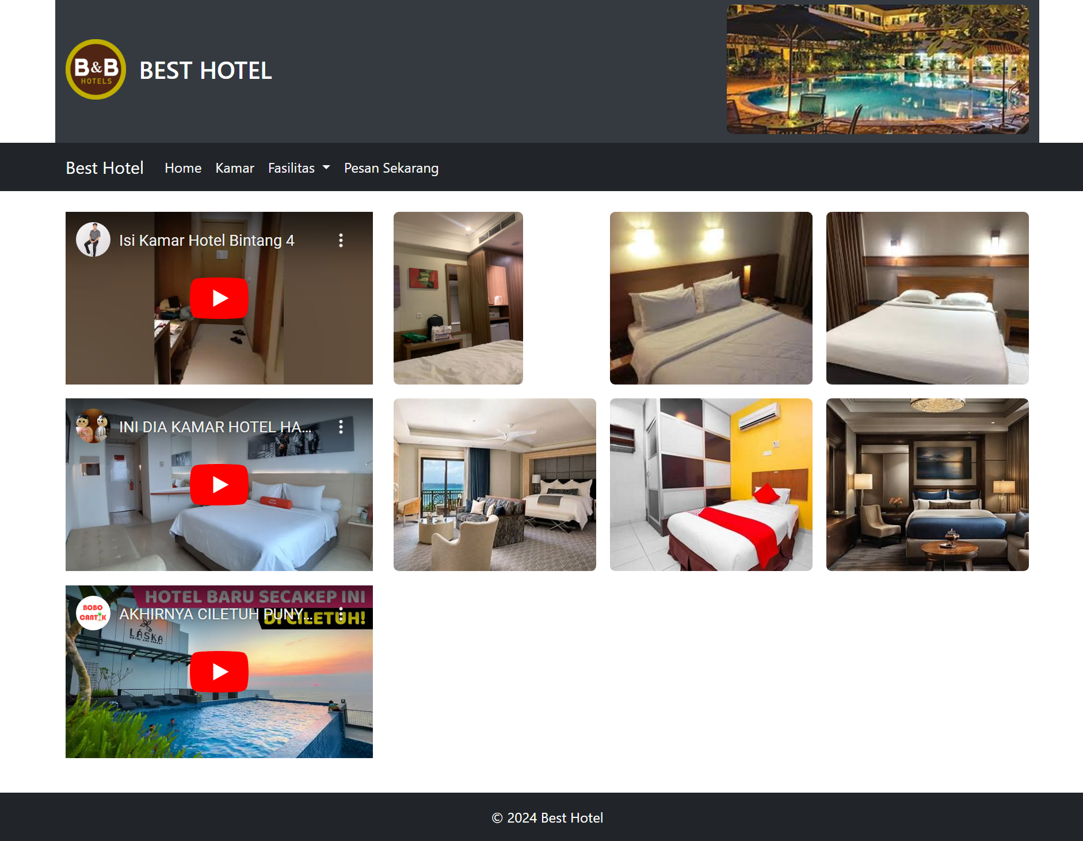

**Analisis :**

Kode HTML yang dimodifikasi dengan Bootstrap menunjukkan peningkatan responsivitas dan tata letak yang lebih rapi, berkat sistem grid dan komponen bawaan seperti navbar, dropdown, dan rasio video. Penataan gambar kamar dengan grid membuat tampilan lebih estetis, dan navigasi yang collapsible meningkatkan pengalaman pengguna di perangkat kecil. Selain itu, penggunaan file Bootstrap lokal memberikan kontrol lebih baik atas dependensi.