FINAL PROJECT REPORT
E-Canteen v2
A Campus Digital Canteen and Pre-Order System
Built with Java, Spring Boot, MyBatis, Thymeleaf and MySQL

Name: Muhammad Rizki Eka Pratama (李睿祺)
Student ID: L25020010
Course: J2EE Web Application Development
University: Nanjing Xiaozhuang University
Date: June 2026

Abstract
E-Canteen v2 is a web-based pre-order and pickup system for a campus canteen, developed as the final project for the J2EE Web Application Development course. The system allows students to browse open stalls, search the menu, manage a shopping cart, check out items from several stalls in a single step, choose a payment method, and follow each order until it is ready for pickup. Stall owners use a dedicated vendor portal to manage their menu and stock, set a discount, and move orders through their stages, while a superadmin approves new vendors, manages users and stalls, sets a campus-wide promotion, and reviews an audit log of important actions.
The application is built on the layered Spring MVC architecture studied in class. Thymeleaf renders the pages, @Controller classes handle requests, @Service classes hold the business rules, and MyBatis XML mappers run hand-written SQL against a MySQL database of eleven tables. This report records the requirements, the system and database design, and the implementation of the core flows. It pays particular attention to four parts that needed real design work: splitting one cart into one order per stall, stacking the stall discount and the campus promotion, keeping every monetary total computed on the server, and enforcing role-based access through a single interceptor. Passwords are stored as BCrypt hashes and key events are recorded in a security log.

Table of Contents

Abstract 2
Table of Contents 3
1. Introduction 4
1.1 Background 4
1.2 Project Objectives 4
1.3 Project Scope 4
1.4 Technology Stack 5
1.5 Report Structure 5
2. Design Analysis 6
2.1 Requirements Analysis 6
2.2 Actors and the Role Lifecycle 6
2.3 Use Case Analysis 7
2.4 System Architecture 9
2.5 Database Design 10
2.6 Key Process Design 12
2.7 Page and Navigation Design 13
2.8 Design Assumptions and Constraints 14
2.9 Security Design 14
2.10 Technology Choices and Trade-offs 15
3. Design Implementation 16
3.1 Project Structure 16
3.2 Registration and Login 16
3.3 Access Control with One Interceptor 18
3.4 Browsing the Menu and the Cart 18
3.5 Checkout, Per-Stall Split, and Discounts 20
3.6 Tracking and Advancing an Order 22
3.7 The Vendor Portal 23
3.8 The Superadmin Control Center 26
3.9 Profile and Password Change 30
4. Conclusion 32
4.1 Result Against the Requirements 32
4.2 Limitations 32
4.3 Future Work 32
4.4 What the Project Taught 32
References 33

1. Introduction

1.1 Background
Most campuses share the same picture at lunch time. There is a long line in front of the food stalls, students keep checking the clock because the next class starts in ten minutes, and the stall owner tries to remember who ordered what. The food itself is usually fine. The real problem is the waiting and the small mistakes that happen when everything is done verbally and on paper.
My own campus already accepts the meal card, WeChat, and Alipay, so payment is not the main pain point for us. But this is not the case everywhere. Many schools and campuses, including a number in Indonesia where I am from, still have no digital canteen system at all. Ordering is still walk up, queue, say the order out loud, pay cash, and wait. That gap is what this project tries to close.
E-Canteen v2 is a small but complete solution for that situation. The idea is inspired by food apps such as GoFood and Meituan, with one important difference: there is no delivery driver. Nobody rides to the dorm. Instead the student opens the website, browses the stalls, adds food to the cart, pays online, and the order goes straight to the stall. When the food is ready the student walks over, shows the order number, and picks it up. The slogan on the login page sums it up: Skip the line. Order ahead.

1.2 Project Objectives
The project was driven by two clear goals. The first was to solve a real problem that I understand from experience, namely the queue and the order mistakes at a busy canteen. A pre-order and pickup system addresses both without expensive hardware or a fleet of couriers. The second goal was to practise a full J2EE web application rather than a toy example. A single-page to-do list would not exercise much, so the project deliberately covers multiple user roles, login and sessions, a shopping cart, a checkout that touches several tables at once, file uploads for food photos, and an administrative side for managing the whole canteen.

1.3 Project Scope
To keep the project realistic for one semester, the scope was fixed early. What the system does:
- Students can register, log in, browse stalls and menus, search, add items to a cart, check out, choose a payment method, and track each order until pickup.
- Vendors (stall owners) have their own portal to manage their menu and stock, accept and advance orders, set a discount, and see a small sales report and customer reviews.
- A superadmin oversees the whole canteen: approving new vendors, managing users and stalls, setting a campus-wide promotion, viewing every transaction, and reading an audit log of important actions.
What the system intentionally does not do: it does not move real money. Payment means choose a method and then show the QR or tap the meal card at the stall, which matches how a campus canteen actually works. There is also no delivery and no live kitchen display. The focus is the ordering and management flow, not the cooking.

1.4 Technology Stack
The project uses a modern Java web stack that still follows the classic J2EE ideas taught in class. A request arrives over HTTP, a controller handles it, the work is divided into layers, and the data lives in a relational database.
Part | Technology | Role in the project
Language | Java 17 | The implementation language for the whole application.
Framework | Spring Boot 3 (Spring MVC) | Provides the controller and dispatcher structure and the wiring.
Data access | MyBatis (XML mappers) | Maps Java calls to hand-written SQL for every query.
View | Thymeleaf | Renders the server-side HTML pages.
Database | MySQL 8 | Stores all data across 11 relational tables.
Security | BCrypt (Spring Security crypto) | Hashes passwords before they are stored.
Styling | Tailwind CSS and custom CSS | Styles the pages in the red, yellow, and black theme.

1.5 Report Structure
The rest of this report is organised in three chapters. Chapter 2 covers the design analysis: the requirements, the actors and their roles, the use cases, the layered architecture, the database, the key processes, the security design, and the technology trade-offs. Chapter 3 shows how that design was implemented, with the key code first and a screenshot of the working screen after it. Chapter 4 concludes by checking the result against the requirements and listing the limitations and possible next steps.

2. Design Analysis
This chapter is about the thinking before the code: who uses the system, what they need to do, how the application is structured in layers, how the database is shaped, how the harder processes were designed, and how the system is kept secure. The screenshots and the actual code appear in Chapter 3.

2.1 Requirements Analysis
The starting point was to write down what each kind of user needs. Splitting the requirements by role made the rest of the design easier, because almost every feature belongs clearly to one role.

Functional requirements
- Student: sign up and log in, see which stalls are open, search the menu, add, update, and remove cart items, check out with a payment method, see a live order status, cancel an order while it is still pending, re-order a past order, and leave a star rating after pickup.
- Vendor (stall owner): apply to open a stall, and once approved, add and edit menu items with photos and stock, open or close the stall, move an order through its stages, set a discount for the whole stall, and view total sales and reviews.
- Superadmin: approve or reject vendor applications, suspend, re-activate, or reset the password of any user, suspend a stall, set a campus-wide discount, see every order in the system, and read an activity log.

Non-functional requirements
Each quality attribute was given a concrete target so it was clear when the work on it was good enough. The table below was the checklist held to during development. How each target is achieved is covered in the security and process sections.
Quality | Target for this project
Security | Hashed passwords, role-checked pages, ownership checks, and an audit log of key actions.
Data integrity | Totals computed on the server, stock never negative, past orders never change.
Usability | Each role has its own area and clear feedback messages on errors.
Maintainability | Strict layering so each kind of change has one obvious place to make it.
Performance | Joined queries instead of many small ones, which is fine for a single-campus scale.

2.2 Actors and the Role Lifecycle
The system has four kinds of users, stored in a single users table with a role column. The notable part is that a vendor is not a fixed role. It changes over time, which the design had to account for.
Role value | Who they are | Main area
student | A normal customer (the default for self-registration). | /menu, /cart, /order, /profile
vendor | Someone who registered as a vendor but is still waiting for approval. | /vendor (apply page only)
admin | An approved vendor who now owns a stall. | /admin (the vendor portal)
superadmin | The canteen operator. Created once, directly in the database. | /superadmin
The lifecycle works like this. A person registers as a vendor, submits a stall application, and waits. When the superadmin approves it, the same account is upgraded to admin and a stall is created and linked to it. From that moment the vendor portal unlocks. The live role change is handled inside the login interceptor, so the user does not need to log out and back in.

2.3 Use Case Analysis

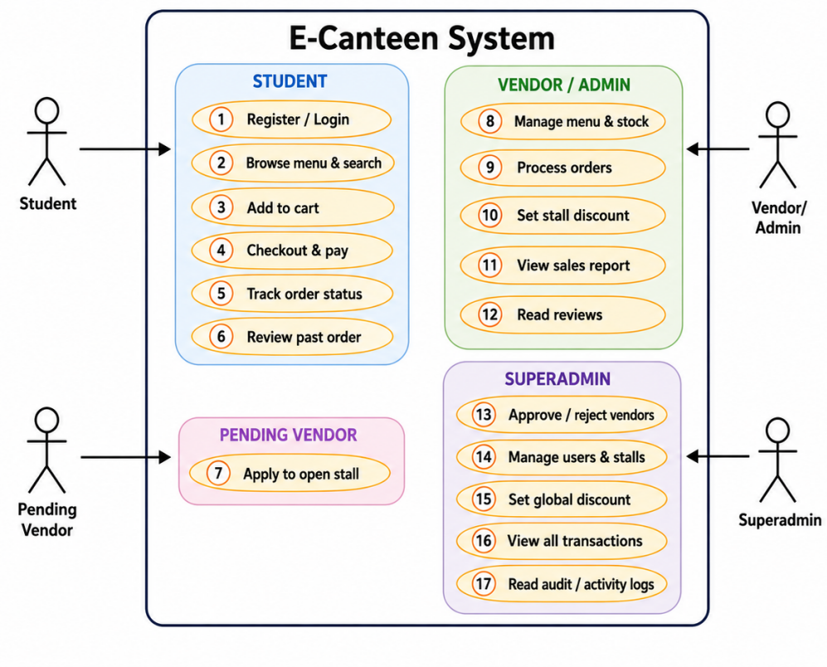
Figure 2.1. Use case diagram showing the four actors and what each one can do.
The diagram makes the separation of duties clear. The student side is about buying food. The vendor side is about running one stall. The superadmin side is about running the whole canteen and keeping it healthy. A pending vendor has only a single use case, apply to open a stall, which keeps that account out of everything else until it is approved.
To check the harder flows before coding them, a short description was written for one key use case per actor, four in total, so every kind of user is covered. These short tables caught alternate paths such as an empty cart or a sold-out item that would otherwise have been forgotten.

Use case: Checkout
Field | Description
Actor | Student
Goal | Turn the cart into confirmed orders and choose how to pay.
Precondition | The student is logged in and the cart has at least one item.
Main flow | 1. Student opens the cart and clicks Checkout.  2. System shows the price breakdown (subtotal, stall discount, campus promo, total).  3. Student picks a payment method and confirms.  4. System re-checks stock, splits the cart by stall, creates one order per stall, freezes the lines, reduces stock, and clears the cart.  5. System shows the confirmation with one receipt per stall.
Alternate flows | A1. Cart is empty, so checkout is blocked with a message.  A2. An item is sold out, so checkout stops and tells the student which item.
Postcondition | One or more PENDING orders exist, stock is reduced, and the cart is empty.

Use case: Apply to open a stall
Field | Description
Actor | Pending Vendor
Goal | Register a stall and wait for the superadmin to approve it.
Precondition | The user is logged in with the role vendor (registered as a vendor, not yet approved).
Main flow | 1. Vendor opens the apply page.  2. Vendor fills in the stall name, description, owner name, and phone.  3. System checks there is no application already pending or approved for this account.  4. System saves the application with status PENDING.  5. Vendor is shown an awaiting-approval screen.
Alternate flows | A1. An application is already PENDING, so the system asks the vendor to wait.  A2. The stall was already approved, so the vendor is sent to the vendor portal instead.
Postcondition | A vendor application with status PENDING exists for the superadmin to review.

Use case: Advance an order
Field | Description
Actor | Vendor (Admin)
Goal | Move one of the stall orders forward to its next stage.
Precondition | The user is logged in as admin and the order belongs to their own stall.
Main flow | 1. Vendor opens Manage Orders.  2. System lists the orders for that vendor stall.  3. Vendor clicks Advance on an order.  4. System confirms the order belongs to this stall, then moves the status one step (PENDING to PROCESSING to READY to PICKED_UP) and writes a row to the status log.
Alternate flows | A1. The order is not this stall order, so the action is ignored.  A2. The order is already PICKED_UP, so it stays unchanged.
Postcondition | The order is one stage further and the change is recorded in its status timeline.

Use case: Approve vendor application
Field | Description
Actor | Superadmin
Goal | Turn a pending vendor into a working stall owner.
Precondition | A vendor application exists with status PENDING.
Main flow | 1. Superadmin opens Vendor Approvals.  2. System lists each pending application with its details.  3. Superadmin clicks Approve.  4. System creates a stall, links it to the applicant, and upgrades the account role from vendor to admin.  5. The application is marked APPROVED.
Alternate flow | A1. Superadmin clicks Reject and may add a reason. The application is marked REJECTED and no stall is created.
Postcondition | The applicant can now log in to the vendor portal and manage their stall.

2.4 System Architecture
The system follows the layered MVC structure that J2EE encourages. Every request flows top to bottom through clear layers, and each layer only talks to the one directly below it. This keeps the code easy to reason about. If a bug is about a button, the place to look is a controller. If it is about a wrong total, the place to look is a service. If it is about wrong data, the place to look is a mapper.
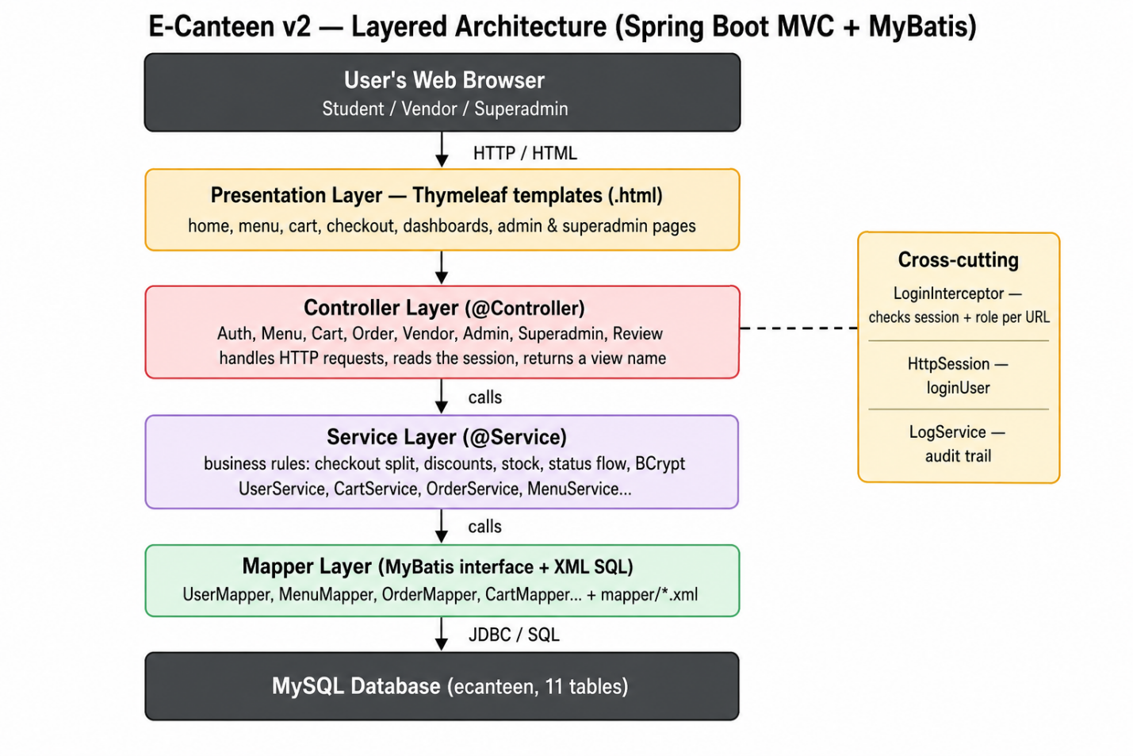
Figure 2.2. Layered architecture of E-Canteen v2.

What each layer is responsible for
- Presentation (Thymeleaf): the HTML pages the user sees. They only display data and submit forms, and contain no business logic.
- Controller (@Controller): receives the HTTP request, reads the logged-in user from the session, calls a service, and returns the name of the page to show.
- Service (@Service): where the real rules live, such as splitting a cart into orders, calculating discounts, checking stock, advancing an order status, and hashing passwords. These are kept out of the controllers on purpose.
- Mapper (MyBatis): a Java interface plus an XML file with the actual SQL. This is the only layer that knows about the database.
Two things sit beside these layers. The LoginInterceptor checks every protected request before it reaches a controller, and the LogService writes important events such as logins, orders, and discount changes into an audit table.

2.5 Database Design
The database has eleven tables, grouped around three ideas: people (users, stalls), the catalogue (menu items, discounts), and transactions (cart, orders, order items, status logs, reviews). Two extra tables, vendor applications and security logs, support the approval flow and the audit trail. The entity relationship diagram below shows the tables and how the foreign keys connect them.
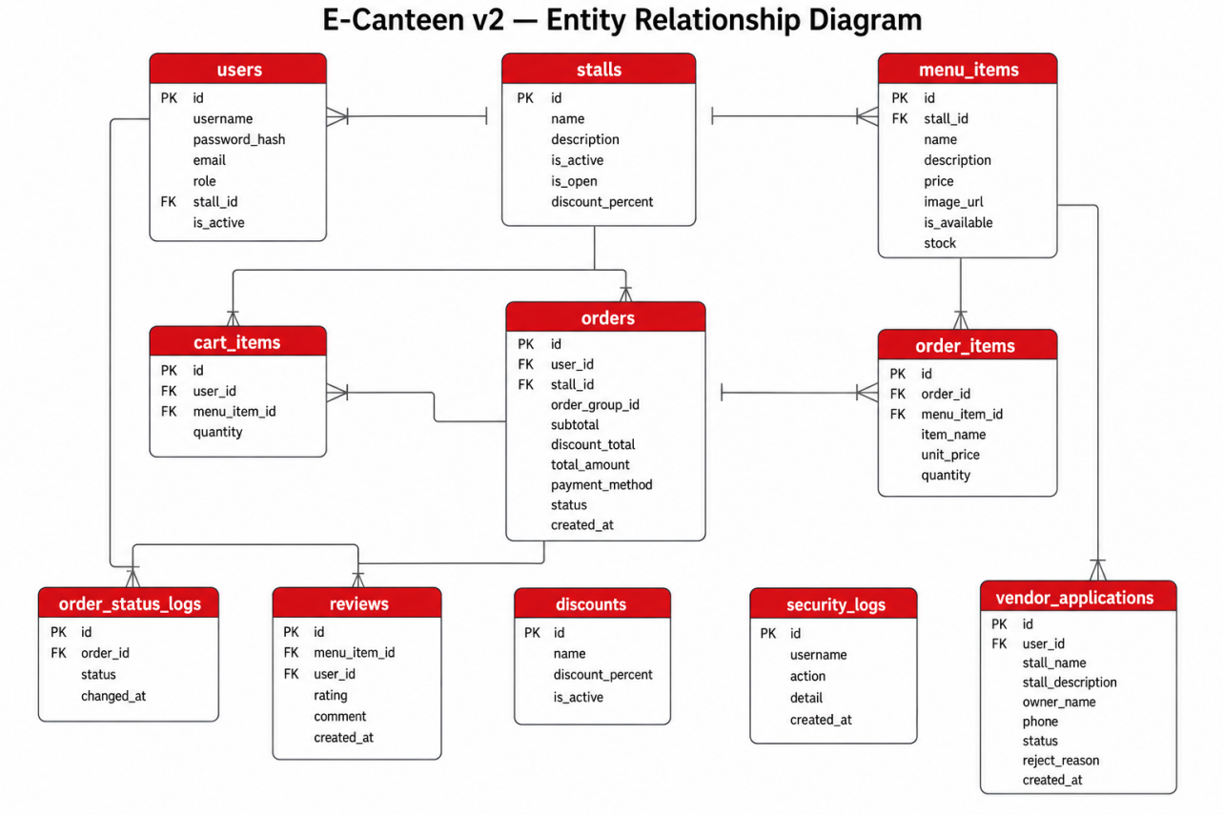
Figure 2.3. Entity relationship diagram (eleven tables).

Tables and the reasoning behind them
Table | Purpose and design note
users | One table for all roles, separated by the role column. A nullable stall_id links an approved vendor to their stall.
stalls | Each stall has its own open/closed flag and its own discount_percent, so vendors are independent of each other.
menu_items | Belongs to a stall. Has stock and is_available so an item can be hidden or sold out.
cart_items | A temporary shopping cart per user. Cleared automatically after a successful checkout.
orders | One order is one stall. An order_group_id ties together orders made in the same checkout so they show as one receipt.
order_items | The frozen lines of an order. The name and unit price are copied at checkout, so editing the menu later never changes a past order.
order_status_logs | A row every time a status changes, which gives the student a timeline.
discounts | Global campus promotions set by the superadmin (only one active at a time).
reviews | A 1 to 5 star rating and comment, tied to a menu item and the student who wrote it.
vendor_applications | A pending stall request with owner details, approved or rejected by the superadmin.
security_logs | An append-only audit trail of who did what and when.

Keys and normalization
Every table has a surrogate integer primary key, and the relationships are enforced with foreign key constraints rather than repeated text. As a result the schema reaches third normal form for the parts where it matters: each fact lives in one place. A stall name is only in stalls, a user detail only in users, and the catalogue only in menu_items. The data definition below shows the two core transaction tables, where the design decisions are most visible.
-- one order header belongs to exactly one stall
CREATE TABLE orders (
id INT PRIMARY KEY AUTO_INCREMENT,
user_id INT NOT NULL,
stall_id INT NOT NULL,
order_group_id INT DEFAULT NULL, -- groups a multi-stall checkout
subtotal DECIMAL(10,2) NOT NULL DEFAULT 0.00,
discount_total DECIMAL(10,2) NOT NULL DEFAULT 0.00,
total_amount DECIMAL(10,2) NOT NULL DEFAULT 0.00,
payment_method VARCHAR(30) NOT NULL DEFAULT 'CASH',
status VARCHAR(30) NOT NULL DEFAULT 'PENDING',
created_at DATETIME NOT NULL DEFAULT CURRENT_TIMESTAMP,
FOREIGN KEY (user_id) REFERENCES users (id),
FOREIGN KEY (stall_id) REFERENCES stalls (id)
);

-- frozen order lines: name and price copied at checkout
CREATE TABLE order_items (
id INT PRIMARY KEY AUTO_INCREMENT,
order_id INT NOT NULL,
menu_item_id INT DEFAULT NULL, -- NULL if the item was later deleted
item_name VARCHAR(100) NOT NULL, -- copied, not joined
unit_price DECIMAL(10,2) NOT NULL, -- copied, not joined
quantity INT NOT NULL DEFAULT 1,
FOREIGN KEY (order_id) REFERENCES orders (id),
FOREIGN KEY (menu_item_id) REFERENCES menu_items (id)
);
Listing 2.1. Key DDL for the orders and order_items tables.

The one deliberate departure from strict normalization is in order_items. The item name and unit price are copied into the row at checkout instead of being joined back from menu_items every time. This is technically redundant, but it is intentional. An order is a historical record, so a later change to a menu price or name must not silently rewrite a receipt that was already paid. A little duplication is traded for correctness, which is the right call for anything financial. Money is stored as DECIMAL(10,2) rather than a floating-point type for the same reason.

2.6 Key Process Design
A few processes were more than simple create-read-update-delete and needed real design. These are the parts that took the most thought.

Checkout: one cart, several orders
A student can put food from different stalls into one cart, but each stall prepares and is paid separately. So checkout does not create a single order. It groups the cart by stall and creates one order per stall, then tags them all with the same group id so the student still sees one tidy receipt. The sequence below shows the flow.
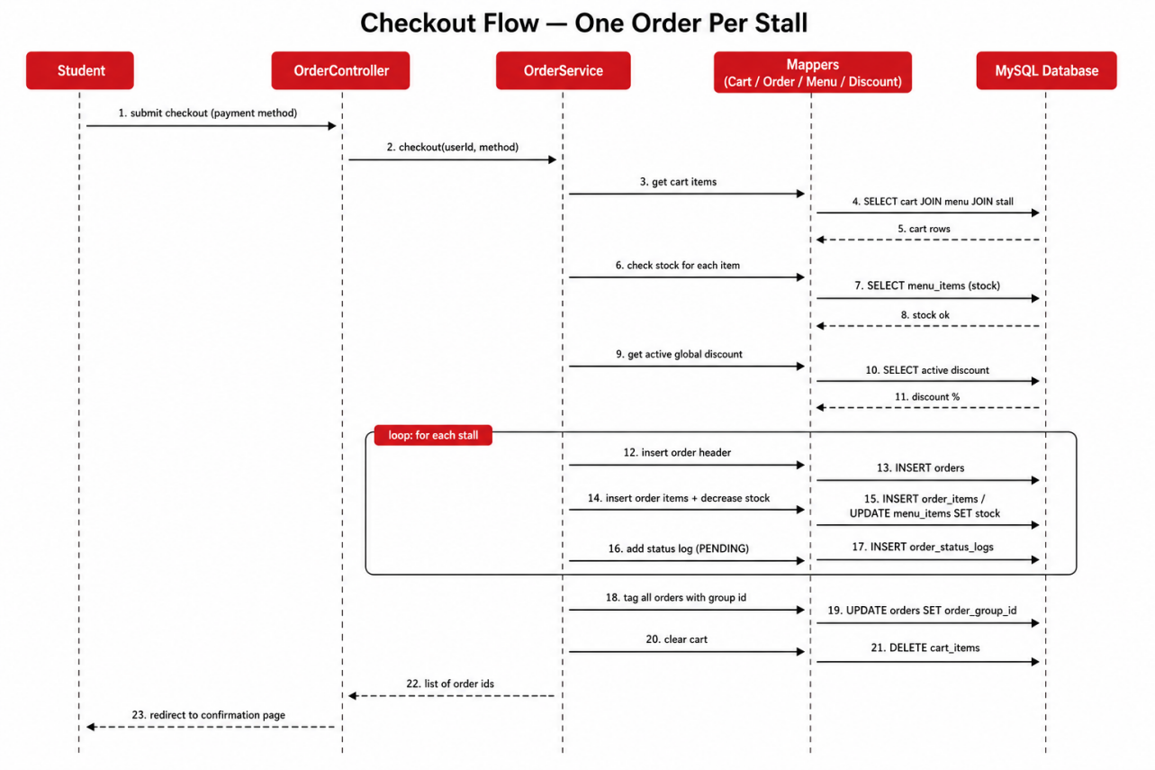
Figure 2.4. Checkout sequence: the cart is split into one order per stall.
Inside the same loop the system also freezes each line item, reduces the stock of every item bought, and finally clears the cart. Before any of this runs, a stock check makes sure nothing in the cart is sold out, so a student can never buy more than what exists.

Discounts: two layers that stack
There are two independent discounts and they apply in order. First the stall discount, set by the vendor, comes off the stall subtotal. Then the campus promotion, set by the superadmin, comes off what is left. The design keeps the two separate so a vendor promotion and a campus-wide event can both be active without one cancelling the other. Every total is calculated on the server with BigDecimal and rounded to two decimals, never in the browser. The worked example below shows the order of operations for one stall.
Step | Amount
Stall subtotal (the items from this stall) | 50.00
Stall discount, 10 percent of 50.00 | -5.00
After the stall discount | 45.00
Campus promotion, 5 percent of 45.00 | -2.25
Amount payable for this stall | 42.75
Because the campus promotion is applied to the remainder rather than the original subtotal, the two discounts do not simply add up to 15 percent. The order of the steps matters, which is exactly why the calculation is fixed on the server and never trusted from the page.

Order status: a simple, one-way flow
An order moves through four stages, and the vendor pushes it forward one step at a time. A pending order can still be cancelled by the student, in which case the stock is put back. The status logic is kept as a plain switch statement rather than a full state-machine pattern, because for four states that is clearer to read.
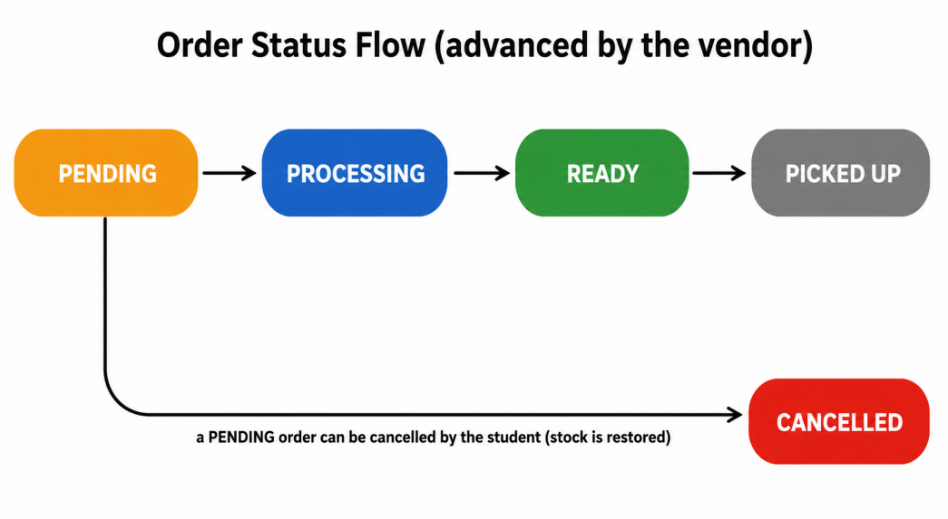
Figure 2.5. The order status flow.

2.7 Page and Navigation Design
Because each role lives in its own area, the URL layout was designed so the area is obvious from the address itself. The single login interceptor guards exactly these URL prefixes, so any request outside a role area bounces back to that role home page.
Area / URL prefix | Who | Main pages
/login, /register, /register-vendor | Everyone (public) | Login, student sign-up, vendor sign-up
/menu, /cart, /order, /review, /profile | Student | Home, menu, cart, checkout, order history and detail, reviews, profile
/vendor | Pending vendor | Apply-to-open-a-stall form, waiting screen
/admin | Vendor (admin) | Dashboard, manage menu, manage orders, stall discount, sales report, reviews
/superadmin | Superadmin | Overview, approvals, users, stalls, discounts, transactions, reviews, logs

2.8 Design Assumptions and Constraints
A few clear assumptions kept the project focused and finishable. Writing them down also made it easier to leave out features that were not the point of the exercise.
- Payment is confirmed in person at the stall, by showing the QR or tapping the meal card. The system records the chosen method but never moves real money.
- One order belongs to exactly one stall. A multi-stall cart becomes several orders that share one group id.
- Only one global campus promotion is active at a time, which keeps the discount calculation predictable.
- The single superadmin account is created directly in the database during setup. The application never offers a way to create another one.
- Food photos are uploaded as image files (maximum 5 MB) and served from an uploads folder, rather than stored in the database.

2.9 Security Design
Security was treated as part of the design rather than something added at the end. A system that handles accounts and money needs it built in. The table lists each realistic concern for a small campus application and how the design answers it.
Concern | How the design handles it
Stolen password file | Passwords are never stored in plain text. They are hashed with BCrypt, which is slow on purpose and salts each hash.
Unauthorized page access | One interceptor checks login and role on every protected URL, so a student cannot reach an admin or superadmin page even by typing the address.
Acting on another user data | Services verify ownership before acting. A vendor can only advance their own stall orders, and a student can only cancel their own order.
Suspended user still active | The interceptor re-reads the account on every request, so a suspended user is blocked on the next click, not when the session expires.
Tampered prices or totals | All money is recalculated on the server with BigDecimal. Nothing about price is trusted from the browser.
Overselling stock | The decrease-stock query only succeeds when enough stock exists, so two simultaneous checkouts cannot both take the last item.
No trace of actions | Logins, orders, and discount changes are written to an append-only security log for the superadmin to review.
Protected accounts | The service layer refuses to suspend or reset another superadmin, no matter what the form submits.

2.10 Technology Choices and Trade-offs
A J2EE application can be built in several ways, so part of the design was choosing the tools. The older Servlet and JSP style taught in class and the modern Spring style are the same ideas with less boilerplate. The aim was to pick tools that could be understood and explained, not the newest one. The reasoning for the main choices, including what was given up, is below.
Decision | What was picked | Why, and the trade-off
Web framework | Spring Boot 3.5.15 (Spring MVC) | It gives the same front-controller and dispatcher idea as raw servlets, without writing web.xml or wiring everything by hand. Trade-off: a lot happens behind the scenes, so it was necessary to learn what Spring does.
Data access | MyBatis 3.0.5 with XML SQL | It allows real SQL, close to the JDBC taught in class, but without the repetitive try/catch and result-set code. Trade-off: more mapper files to keep in sync than a full ORM, but the exact query that runs is always visible.
ORM choice | MyBatis instead of JPA/Hibernate | JPA hides the SQL, which is convenient but makes performance problems hard to see. For learning, visible queries were preferred. Trade-off: the SQL is written by hand.
View | Thymeleaf | The modern replacement for JSP. It is plain HTML with small attributes, so the pages still open in a browser as files. Trade-off: server-side rendering, with no single-page interactivity.
Passwords | BCrypt (spring-security-crypto) | A well-tested, deliberately slow hash with built-in salting. Trade-off: slightly slower logins, which is the point.
Database | MySQL 8 (InnoDB) | The relational model fits the FK-heavy schema. InnoDB gives row-level locking. Trade-off: MySQL-specific SQL in a few places.
Build tool | Maven | Dependency management and packaging are handled by pom.xml, which is the standard for Spring Boot starters. Trade-off: verbose XML compared to Gradle.
CSS | Tailwind CSS (CDN) | Utility classes applied directly in Thymeleaf templates eliminate a separate stylesheet build step. Trade-off: CDN means no offline build; class lists in HTML are verbose.

3. Design Implementation
This chapter turns the design from Chapter 2 into a working application. For each part the key code is shown first, then the screen it produces. The snippets are deliberately short, showing the key idea rather than the whole file.

3.1 Project Structure
The code follows the layers directly, so the package names match the architecture diagram. Anyone opening the project can guess where a class lives from its job.
src/main/java/com/canteen
├─ controller/ AuthController, MenuController, CartController,
│ OrderController, VendorController, AdminController,
│ SuperadminController, ReviewController, ProfileController
├─ service/ UserService, MenuService, CartService, OrderService, ...
├─ mapper/ UserMapper, MenuMapper, OrderMapper, CartMapper, ...
├─ entity/ User, Stall, MenuItem, Order, OrderItem, ...
├─ interceptor/ LoginInterceptor
└─ config/ WebConfig, PasswordConfig
src/main/resources
├─ mapper/ *.xml (the SQL for each mapper)
└─ templates/ *.html (Thymeleaf pages)
Listing 3.1. Package layout.

3.2 Registration and Login
A new user can register as a student or as a vendor. Both go through the same service, and the only difference is the starting role. The raw password is never stored. It is hashed with BCrypt before it touches the database.
// UserService.java
public boolean register(String username, String email, String rawPassword) {
if (userMapper.findByUsername(username) != null) {
return false; // username already taken
}
User user = new User();
user.setUsername(username);
user.setEmail(email);
user.setPasswordHash(passwordEncoder.encode(rawPassword)); // BCrypt hash
user.setRole("student");
userMapper.insertUser(user);
return true;
}
Listing 3.2. Registration hashes the password before saving.

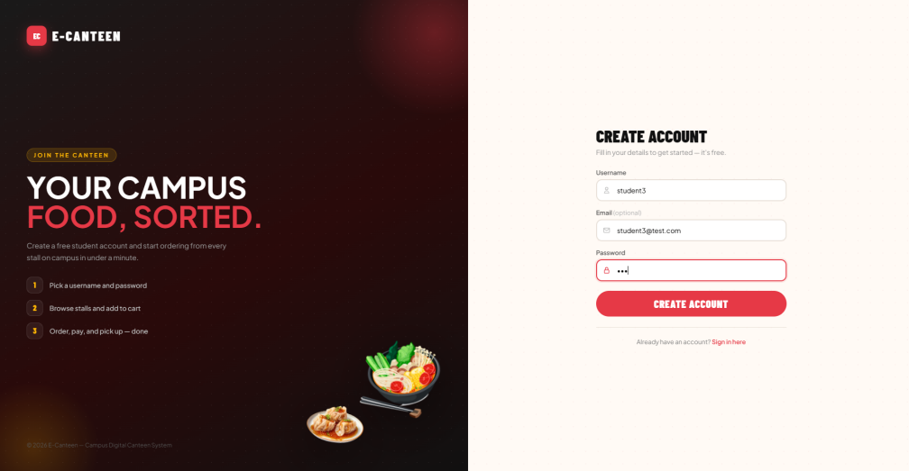
Figure 3.1. Student registration page.
On login the password is checked with BCrypt, suspended accounts are blocked, the result is written to the audit log, and each role is sent to its own home page. Every login attempt, success or failure, is recorded. Registering as a vendor uses the very same form and service, but the account starts with the role vendor instead of student. After signing up the vendor fills in a stall application and waits on a holding screen until the superadmin approves it.
// AuthController.java (login)
User user = userService.login(username, password);
if (user == null) {
logService.record(username, "LOGIN_FAILURE", "wrong username/password");
model.addAttribute("error", "Incorrect username or password.");
return "login";
}
session.setAttribute("loginUser", user);
logService.record(username, "LOGIN_SUCCESS", "role=" + user.getRole());
if ("superadmin".equals(user.getRole())) return "redirect:/superadmin";
if ("admin".equals(user.getRole())) return "redirect:/admin";
if ("vendor".equals(user.getRole())) return "redirect:/vendor";
return "redirect:/menu";
Listing 3.3. Login redirects each role to its own area and logs the event.

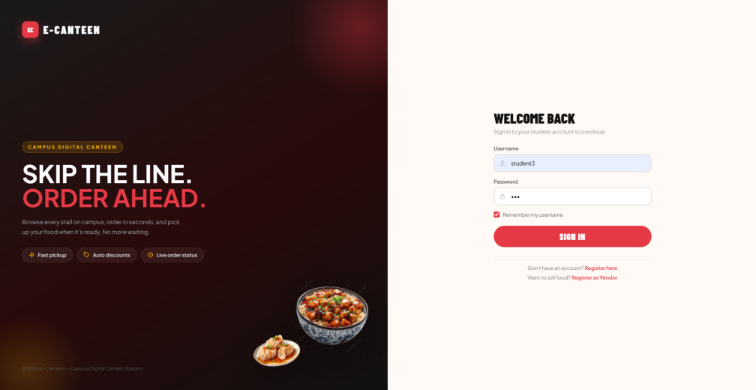
Figure 3.2. Login page with the slogan "Skip the line. Order ahead."

3.3 Access Control with One Interceptor
Instead of repeating security checks everywhere, a single interceptor is registered over all protected URL patterns. This is the implementation of the access-control design: one place that checks login, account status, and role before any controller runs.
// WebConfig.java
registry.addInterceptor(loginInterceptor)
.addPathPatterns("/menu", "/menu/**", "/cart/**", "/order/**",
"/review/**", "/profile", "/profile/**",
"/vendor", "/vendor/**", "/admin/**", "/superadmin/**");
Listing 3.4. Registering the interceptor for every protected area.

// LoginInterceptor.java (status and role check)
User fresh = userMapper.findById(user.getId()); // re-read from DB
if (fresh == null || Boolean.FALSE.equals(fresh.getIsActive())) {
session.invalidate(); // suspended, kick out
response.sendRedirect("/login?suspended=1");
return false;
}
if (!fresh.getRole().equals(user.getRole())) { // role changed?
session.setAttribute("loginUser", fresh); // e.g. vendor to admin
}
// then: if the URL area does not match the role, redirect home
Listing 3.5. Checking account status and role on every request.

3.4 Browsing the Menu and the Cart
Search is a small but clear example of MyBatis dynamic SQL. The same query handles both show everything and filter by keyword. The WHERE clause for the keyword only appears when a keyword was actually typed.
<!-- MenuMapper.xml -->
<select id="searchItemsByStall" resultType="MenuItem">
SELECT id, stall_id, name, price, image_url, is_available, stock
FROM menu_items
WHERE stall_id = #{stallId}
<if test="keyword != null and keyword != ''">
AND name LIKE CONCAT('%', #{keyword}, '%')
</if>
ORDER BY id
</select>
Listing 3.6. One query that searches only when a keyword is given.

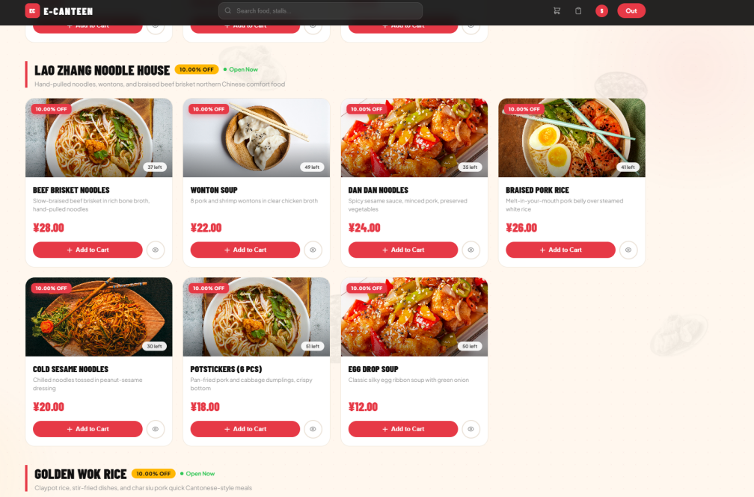
Figure 3.3. Browsing a stall menu. Every card has an Add to Cart button.
The cart page needs information from three tables at once: the cart row, the menu item (name and price), and the stall (name and discount). Rather than make several calls, one joined query fills the whole view through a MyBatis resultMap.
<!-- CartMapper.xml -->
<select id="findCartView" resultMap="cartViewMap">
SELECT c.id, c.menu_item_id, m.name AS item_name, m.price AS unit_price,
c.quantity, s.id AS stall_id, s.name AS stall_name,
s.discount_percent AS stall_discount_percent
FROM cart_items c
JOIN menu_items m ON c.menu_item_id = m.id
JOIN stalls s ON m.stall_id = s.id
WHERE c.user_id = #{userId}
ORDER BY c.id
</select>
Listing 3.7. One joined query builds the whole cart view.

Adding to the cart is validated on the server, not just in the page. Even if someone re-enabled a hidden button, the service still refuses an item that is unavailable or whose stall is closed. If the item is already in the cart, the quantity goes up by one instead of adding a duplicate row.
// CartService.addToCart(...)
MenuItem item = menuMapper.findItemById(menuItemId);
if (item == null || !item.isOrderable()) {
return "This item is unavailable or out of stock.";
}
Stall stall = menuMapper.findStallById(item.getStallId());
if (stall == null || !Boolean.TRUE.equals(stall.getIsOpen())) {
return "The stall is currently closed, you can't order yet.";
}
// already in cart: just increase the quantity, else insert a new row
Listing 3.8. Add-to-cart is checked on the server side.

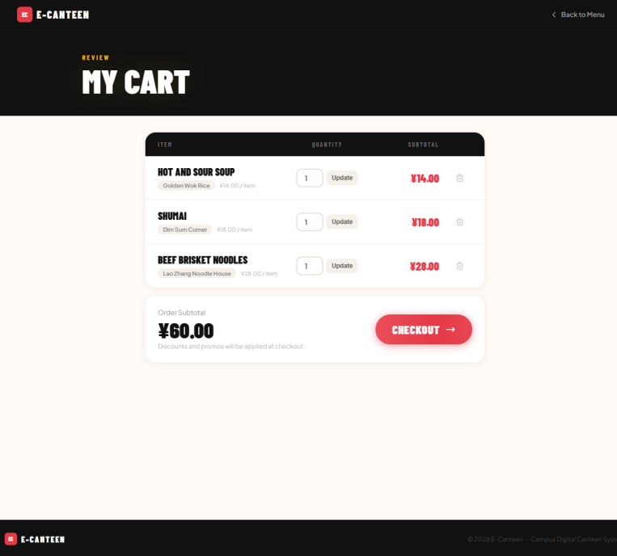
Figure 3.4. The cart, with items from three different stalls and a running subtotal.

3.5 Checkout, Per-Stall Split, and Discounts
Checkout is the heart of the project. The cart in Figure 3.4 holds items from three stalls, so the system creates three separate orders but shows them together. When the order is placed, the service groups the cart by stall and loops over each group. For every stall it computes the subtotal, applies the stall discount, then applies the campus promotion on the remainder, freezes the line items, and reduces stock.
// OrderService.checkout(...) inside the loop over each stall
for (CartView row : stallRows) {
BigDecimal lineTotal = row.getUnitPrice()
.multiply(BigDecimal.valueOf(row.getQuantity()));
subtotal = subtotal.add(lineTotal);
stallDiscount = stallDiscount.add(
lineTotal.multiply(row.getStallDiscountPercent())
.divide(HUNDRED, 2, RoundingMode.HALF_UP));
}
BigDecimal afterStall = subtotal.subtract(stallDiscount);
BigDecimal adminDiscount = afterStall.multiply(adminPercent)
.divide(HUNDRED, 2, RoundingMode.HALF_UP);
BigDecimal total = subtotal.subtract(stallDiscount).subtract(adminDiscount);
orderMapper.insertOrder(order); // one order per stall
Listing 3.9. Discounts stack: stall discount first, campus promotion on the remainder.

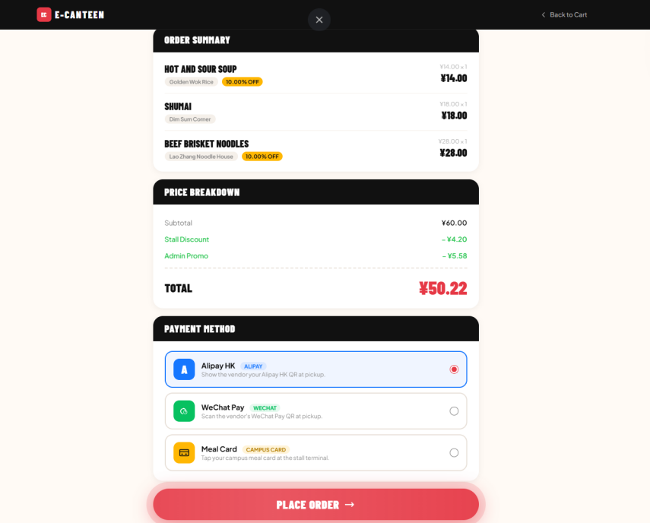
Figure 3.5. Checkout: the price breakdown and the three payment methods (Alipay HK, WeChat Pay, Meal Card).
The confirmation page spells out what happens next, so the student knows the deal is wait for READY, then walk over and pick up. There is no driver coming.
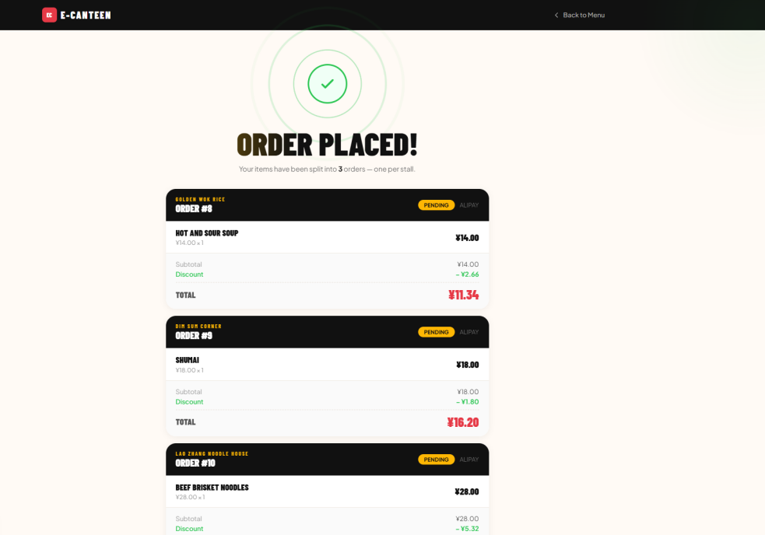
Figure 3.6. Confirmation: the items have been split into three orders, one per stall.

3.6 Tracking and Advancing an Order
On the vendor side, advancing the status is one method. It is kept as a plain switch, which is easy to read and easy to record in the audit log.
// OrderService.advanceStatus(...)
switch (current) {
case "PENDING": next = "PROCESSING"; break;
case "PROCESSING": next = "READY"; break;
case "READY": next = "PICKED_UP"; break;
default: next = current; break; // PICKED_UP stays
}
if (!next.equals(current)) {
orderMapper.updateStatus(orderId, next);
addStatusLog(orderId, next); // write the timeline row
}
Listing 3.10. Moving an order one step forward.

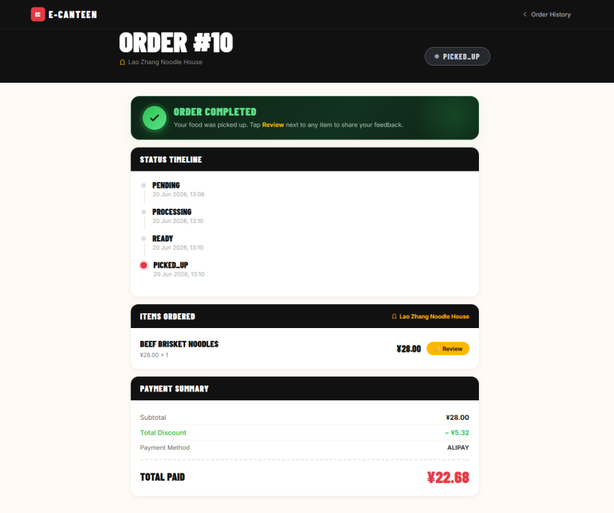
Figure 3.7. Order detail with the full status timeline built from the status-log table.
While an order is still PENDING the student can cancel it, and the items go back on the shelf. The service first checks the order really belongs to that student and is still cancellable, then restores the stock of every line before marking it cancelled, which is the exact reverse of checkout. A past order can also be repeated, which simply drops its items back into the cart.
// OrderService.cancelOrder(...)
if (!"PENDING".equals(order.getStatus())) {
return false; // already being prepared
}
for (OrderItem item : items) { // put the stock back
menuMapper.restoreStock(item.getMenuItemId(), item.getQuantity());
}
orderMapper.updateStatus(orderId, "CANCELLED");
addStatusLog(orderId, "CANCELLED");
Listing 3.11. Cancelling a pending order restores stock.

3.7 The Vendor Portal
Once approved, a vendor gets a dashboard with a 7-day revenue chart and a donut of orders by status, plus shortcuts to every management page. The role stored in the database is admin, which is why the interceptor lets them into the /admin area. The dashboard numbers come straight from the order table. The donut counts orders by status for this stall, and the revenue figure sums today sales.
// OrderService.java, the figures behind the vendor dashboard
public int countOrdersByStallAndStatus(Integer stallId, String status) {
return orderMapper.countOrdersByStallAndStatus(stallId, status);
}
public BigDecimal getTodayRevenueByStall(Integer stallId) {
return orderMapper.todayRevenueByStall(stallId);
}
Listing 3.12. The queries that fill the vendor dashboard.

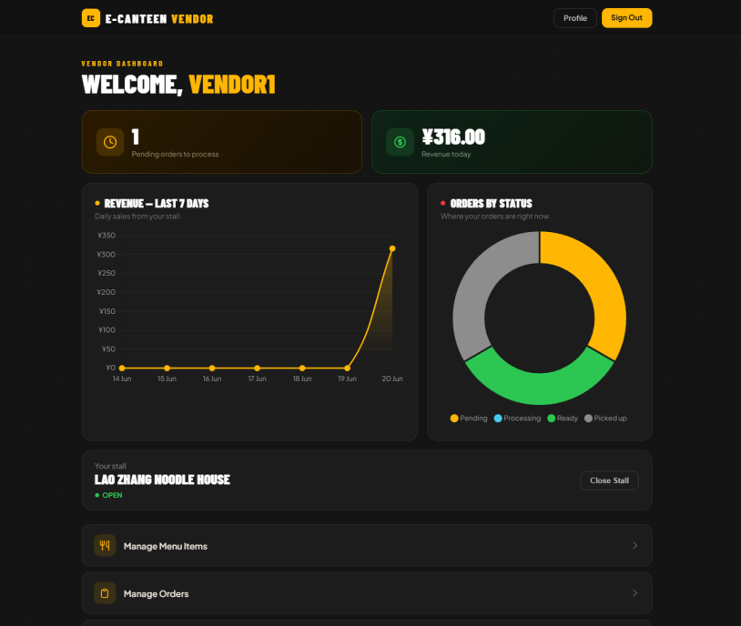
Figure 3.8. Vendor dashboard: revenue, orders-by-status, and the open/close switch.
A vendor can only ever touch their own stall. Before advancing an order, the service confirms the order actually belongs to that stall, so one vendor can never change another vendor order.
// OrderService.java
public void advanceStatusForStall(Integer orderId, Integer stallId) {
if (orderMapper.countOrderInStall(orderId, stallId) == 0) {
return; // not this stall order, ignore
}
advanceStatus(orderId);
}
Listing 3.13. A vendor may only advance their own stall orders.

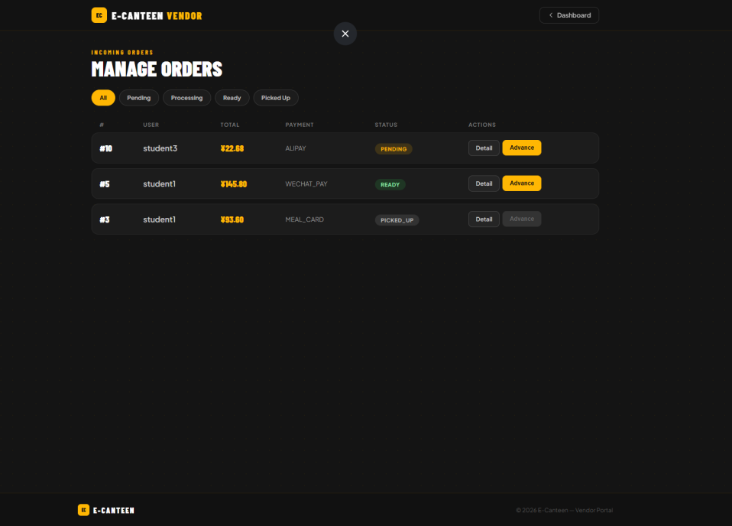
Figure 3.9. Manage Orders: advance each order with one button.
Stock is handled defensively in the SQL itself. The checkout update only runs when there is enough stock, and it flips the item to unavailable the moment stock reaches zero, so a sold-out dish disappears from the menu without anyone doing it by hand.
<!-- MenuMapper.xml -->
<update id="decreaseStock">
UPDATE menu_items
SET stock = stock - #{qty},
is_available = CASE WHEN (stock - #{qty}) &lt;= 0
THEN FALSE ELSE is_available END
WHERE id = #{id} AND stock >= #{qty} <!-- never go negative -->
</update>
Listing 3.14. Stock can never go below zero, enforced in the query.

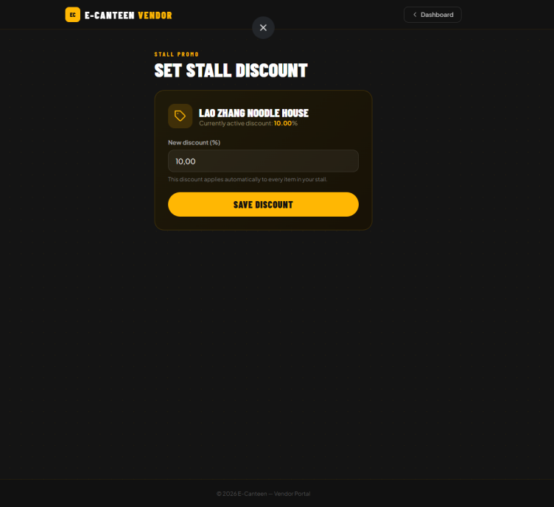
Figure 3.10. Setting a single discount for the whole stall.

3.8 The Superadmin Control Center
The superadmin sees the whole canteen at a glance: registered users, active stalls, total revenue, orders today, and charts for revenue over time and per stall. Each headline number is computed in the service layer, for example the total revenue and the count of stalls that are still active.
// SuperadminService.java, overview numbers
public BigDecimal getTotalRevenue() {
SalesReport total = orderService.salesTotal();
return total != null ? total.getRevenue() : BigDecimal.ZERO;
}
public long getTotalActiveStalls() {
return menuMapper.findAllStalls().stream()
.filter(s -> Boolean.TRUE.equals(s.getIsActive())).count();
}
Listing 3.15. The overview totals are calculated on the server.

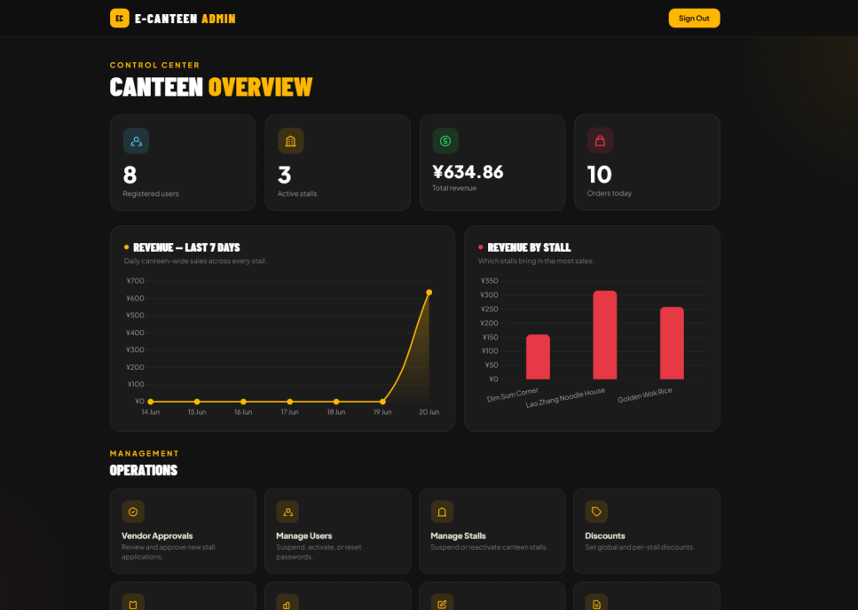
Figure 3.11. Superadmin overview dashboard.
Approving a vendor ties the whole role lifecycle together. The method is short, but it is the moment a pending vendor becomes a real stall owner. It creates the stall, promotes the account from vendor to admin, links the two, and marks the application approved, all in one step.
// VendorService.approve(...)
Stall stall = new Stall();
stall.setName(app.getStallName());
stall.setDescription(app.getStallDescription());
stall.setIsActive(true);
menuMapper.insertStall(stall); // create the stall

userMapper.updateRoleAndStall(app.getUserId(), "admin", stall.getId());
vendorMapper.updateStatus(applicationId, "APPROVED");
Listing 3.16. Approving an application creates the stall and promotes the user.

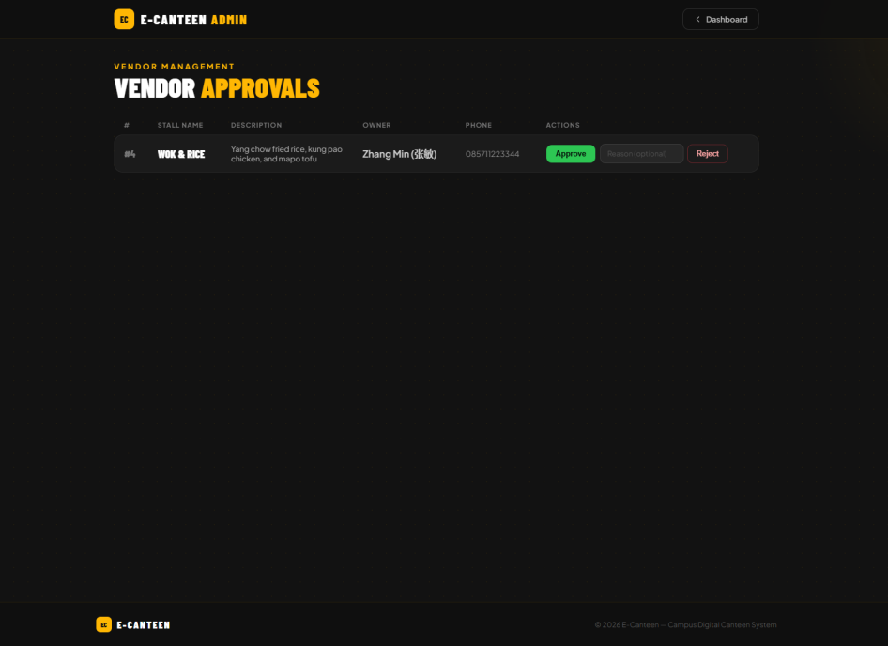
Figure 3.12. Vendor approvals: approve or reject with a reason.
User management has guard rails. A superadmin cannot suspend or reset another superadmin. The service refuses it regardless of what the form sends.
// UserService.setActive(...)
User target = userMapper.findById(id);
if (target == null || "superadmin".equals(target.getRole())) {
return; // never suspend a superadmin
}
userMapper.setActive(id, active);
Listing 3.17. A protected-account rule lives in the service, not the page.

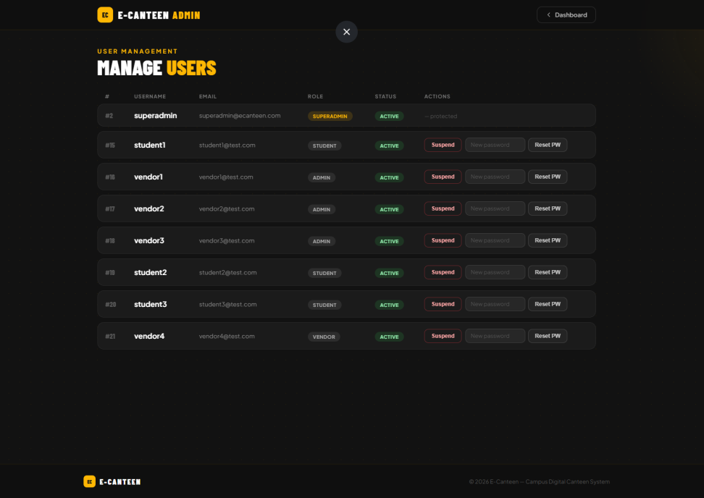
Figure 3.13. Manage users: suspend, reactivate, or reset a password.
Finally, the activity log gives the superadmin an audit trail. Every login, order, and discount change is written here through the LogService, which also made debugging during development easier.
// LogService.java, one row per important action
public void record(String username, String action, String detail) {
SecurityLog log = new SecurityLog();
log.setUsername(username);
log.setAction(action);
log.setDetail(detail);
logMapper.insertLog(log);
}
Listing 3.18. Writing a single audit-trail entry.

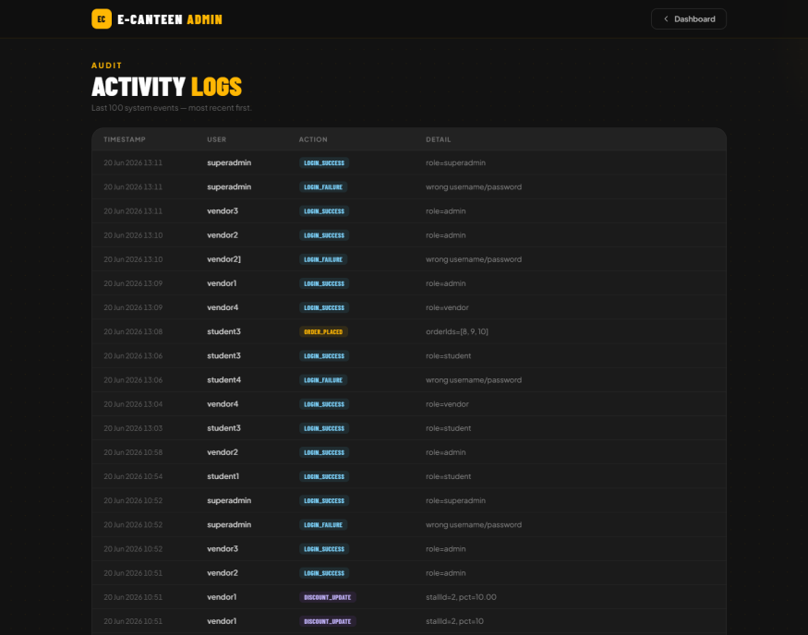
Figure 3.14. The activity log: an audit trail of important events.
The superadmin can also suspend a whole stall, which hides it from students instantly, and moderate reviews by removing anything inappropriate.
// SuperadminService.java
public void setStallActive(Integer id, boolean active) {
menuMapper.setStallActive(id, active); // hide or show a whole stall
}
public void deleteReview(Integer id) {
reviewService.deleteReview(id); // remove one review
}
Listing 3.19. Suspending a stall and removing a review.

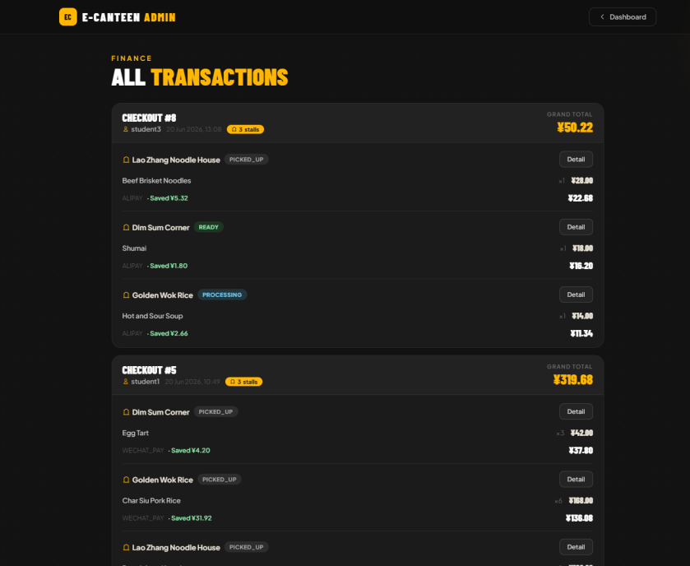
Figure 3.15. Every transaction, grouped by checkout and stall.

3.9 Profile and Password Change
Every logged-in user has a profile page showing their account details and a form to change their own password. The change is only allowed when the current password is verified first, and the new one is hashed just like at registration. After pickup a student can also leave a 1 to 5 star review on a menu item.
// UserService.changePassword(...)
if (!passwordEncoder.matches(oldPassword, user.getPasswordHash())) {
return false; // old password is wrong
}
userMapper.updatePassword(user.getId(), passwordEncoder.encode(newPassword));
return true;
Listing 3.20. Changing your own password verifies the old one first.

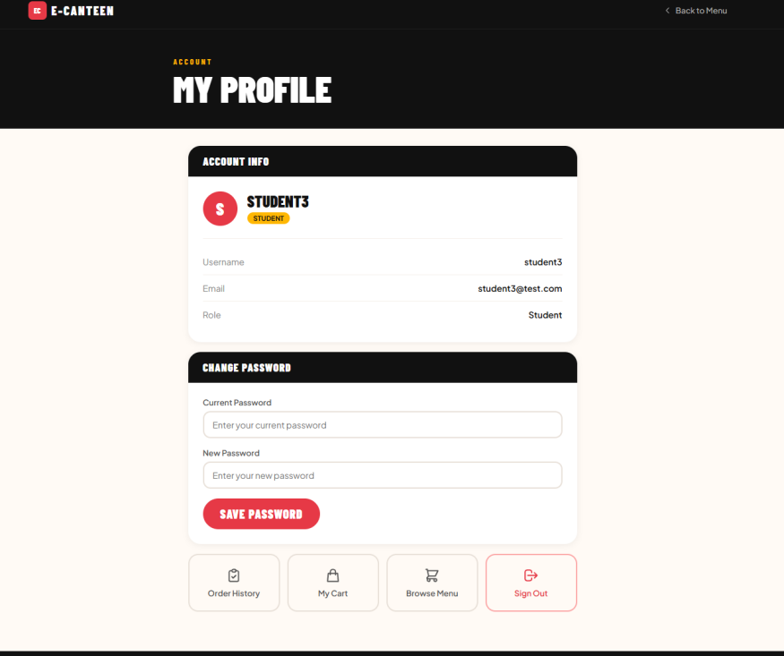
Figure 3.16. The student profile page with the change-password form.

4. Conclusion

4.1 Result Against the Requirements
E-Canteen v2 meets the requirements set out in Section 2.1. On the student side, a user can register, log in, browse open stalls, search, manage a cart, check out across several stalls at once, choose a payment method, track each order, cancel a pending order, re-order, and leave a review. On the vendor side, an approved owner can manage menu and stock, open or close the stall, advance orders, set a discount, and view sales and reviews. On the superadmin side, the operator can approve or reject vendors, manage users and stalls, set a campus promotion, see every transaction, and read the activity log. The non-functional targets are also met: passwords are hashed, pages are role-checked, totals are computed on the server, stock cannot go negative, and key actions are logged.
The four parts that needed real design all work as intended. The per-stall checkout split produces one order per stall under a shared group id, the two discounts stack in the right order, every monetary value is recomputed on the server with BigDecimal, and a single interceptor enforces login, account status, and role on every protected URL.

4.2 Limitations
The project has clear limits, most of them on purpose. It does not move real money, so payment is confirmed in person at the stall. There is no live notification when an order is ready, so the student has to refresh the order page. The stock guard protects against overselling at the database level, but the application was not load-tested under heavy concurrent traffic. There are also no automated tests yet, so every change was verified by hand.

4.3 Future Work
Several extensions would follow naturally from the current design. Real online payment could replace the in-person confirmation. A push or email notification could tell the student the moment an order turns READY. A dedicated kitchen display would help a busy stall. Automated unit and integration tests would make future changes safer. None of these change the core architecture, which is a sign that the layering held up.

4.4 What the Project Taught
The project covered almost every part of a Java web application, from sessions and access control to a checkout that touches several tables in one transaction. Keeping the business rules in the service layer kept the controllers short and made bugs easy to locate. Freezing order lines at checkout was a lesson in modelling data over time rather than only the present moment. Putting all access control in one interceptor showed in practice why doing a cross-cutting concern in a single place is good advice. For a final project, the result is a complete and coherent system that demonstrates how the pieces of a J2EE application fit together, which was the goal.

References
[1] Spring Boot Reference Documentation. Pivotal/VMware. https://docs.spring.io/spring-boot/
[2] Spring Framework Documentation, Web MVC. https://docs.spring.io/spring-framework/reference/web/webmvc.html
[3] MyBatis 3 Documentation, XML Mappers and Dynamic SQL. https://mybatis.org/mybatis-3/
[4] Thymeleaf Documentation, Tutorial: Using Thymeleaf. https://www.thymeleaf.org/documentation.html
[5] Spring Security Reference, Password Storage and BCryptPasswordEncoder. https://docs.spring.io/spring-security/reference/features/authentication/password-storage.html
[6] MySQL 8.0 Reference Manual. Oracle. https://dev.mysql.com/doc/refman/8.0/en/
[7] Tailwind CSS Documentation. https://tailwindcss.com/docs
[8] E. F. Codd. A Relational Model of Data for Large Shared Data Banks. Communications of the ACM, 13(6), 1970.
[9] OWASP Top 10. Open Worldwide Application Security Project. https://owasp.org/Top10/
[10] E-Canteen v2 project source code (local Git repository), schema.sql and src/main/java/com/canteen.

