

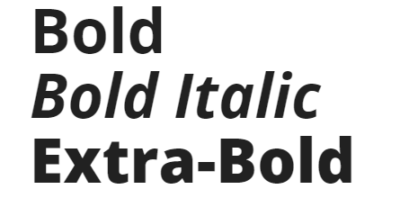

**Website Titles/Main Website Headers: 68px**

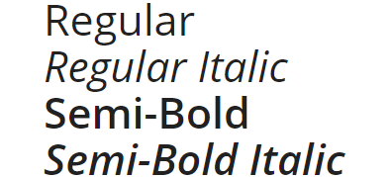

**Topic Headers (h2, h3): 43px**

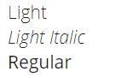

**Minimum font size: 21px**



Inspiration Board

Link: <https://pin.it/wxpyb7u7qtyxo6>

Preview

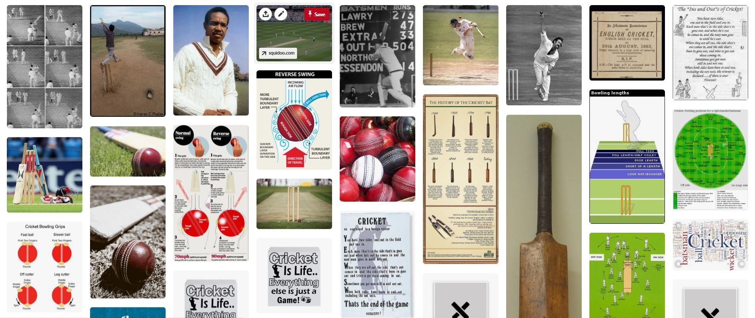



Home Page:

Image

Image

Page Page Website Title Page Page

Image

Image

Page: About

Page Page Website Title Page Page

About Description

Image

Slideshow of Permanent Members JS

Page: Famous Cricket Grounds (12 countries)

Page Page Website Title Page Page

Slideshow of Famous Grounds in Country A

Slideshow of Famous Grounds in Country B

Slideshow of Famous Grounds in Country C, etc.

Page: Cricket Vocabulary Page

Page Page Website Title Page Page

Slideshow of Several Pictures Correlated with Vocabulary Term

Captions with Terms and Definitions

Page: API: With Search Bar: Related to Cricket---From Either NY Times or ESPN

Page Page Website Title Page Page

Using either NY Times or ESPN API to get news articles on Cricket with a Search Term