WHMIS
Pharmaceutical Distribution ERP

System Presentation

Prepared for
MASTER PHARMACUTICALS DISTRIBUTOR
A product of
Virtual Wisdom Technologies (SMC-Private) Limited

Purchasing • Inventory • Sales • Bookings • Receivables • Reporting
August 2026 · Confidential

Confidentiality Notice
This document and the WHMIS platform it describes are the confidential and proprietary property of Virtual Wisdom Technologies (SMC-Private) Limited. It has been prepared exclusively for MASTER PHARMACUTICALS DISTRIBUTOR for the sole purpose of evaluating the system.
Its contents may not be copied, reproduced, distributed or disclosed to any third party, in whole or in part, without the prior written consent of Virtual Wisdom Technologies (SMC-Private) Limited. By receiving this document, the recipient agrees to keep its contents confidential and to use them only for the intended evaluation.
© 2026 Virtual Wisdom Technologies (SMC-Private) Limited. All rights reserved.

Contents
Right-click here and choose “Update Field” to build the contents.

Executive Summary
WHMIS is a complete, purpose-built distribution management platform for pharmaceutical distributors. It unifies every step of the business — purchasing stock and tracking batches, booking orders from the field, invoicing pharmacies, collecting payments, and analysing profit — inside a single, fast, secure web application. Instead of juggling spreadsheets, hand-written registers and disconnected tools, the entire team works from one accurate, always-current source of truth.
Pharmaceutical distribution is uniquely demanding. Products move in batches with expiry dates; suppliers reward you with free “bonus” goods that quietly change your real cost; pharmacies buy on credit; and margins are thin. Small, everyday errors — an expiring batch shipped late, a customer pushed past their credit limit, a trade scheme applied inconsistently — erode profit silently, month after month. WHMIS is engineered around exactly these realities, so the system protects your margin while your team simply does its job.
Why WHMIS fits MASTER PHARMACUTICALS DISTRIBUTOR
Your business runs on batches, bonus stock, credit customers and trade schemes — the very things generic accounting software handles poorly. WHMIS was built for pharmaceutical distribution first, so the controls you need are already in place on day one, not bolted on later.

What WHMIS delivers
- One connected workflow — purchase → stock → book → sell → collect → report — with every figure reconciled automatically.
- Purpose-built for pharma: batch and expiry tracking, bonus-stock handling, and a true cost that includes free goods.
- Localised for Pakistan: prices in PKR, with GST and NTN / STRN / CNIC fields on every party and document.
- Fast, keyboard-driven data entry so your team bills in seconds, not minutes.
- Runs on ordinary cPanel web hosting and works from any browser — no special servers or installs.
- Secure by role, so every staff member sees only what their job requires.

MODULE 01 · OVERVIEW

Executive Dashboard — Your Business at a Glance
The dashboard is the first screen your team sees each day, and it is designed to answer the questions an owner actually asks: How are we selling? How much are we making? Who owes us money, and who do we owe? It pulls live figures from across the system and presents them as clear cards and a twelve-month trend, so you understand the health of the business in seconds — without opening a single report or spreadsheet.
Why this matters
Most distributors only discover a bad month when the accounts are closed weeks later. A live dashboard turns that hindsight into foresight — you see receivables climbing, profit dipping or stock value ballooning while there is still time to act.

Key capabilities
- Today at a glance — today’s sales and purchases, plus this month’s sales and profit, shown the moment you log in.
- Cash-flow visibility — total receivable from customers and total payable to suppliers, always current.
- Inventory value — the worth of everything you hold, valued at true cost, so capital tied up in stock is never a mystery.
- Work-in-progress — counts of draft invoices and bookings awaiting approval, so nothing is left unfinished.
- Twelve-month trend — a sales-and-profit chart that makes momentum — or a slowdown — impossible to miss.
Business benefits
- Decisions based on today’s numbers, not last month’s.
- Early warning on receivables, profit and overstock.
- Less time compiling figures, more time acting on them.

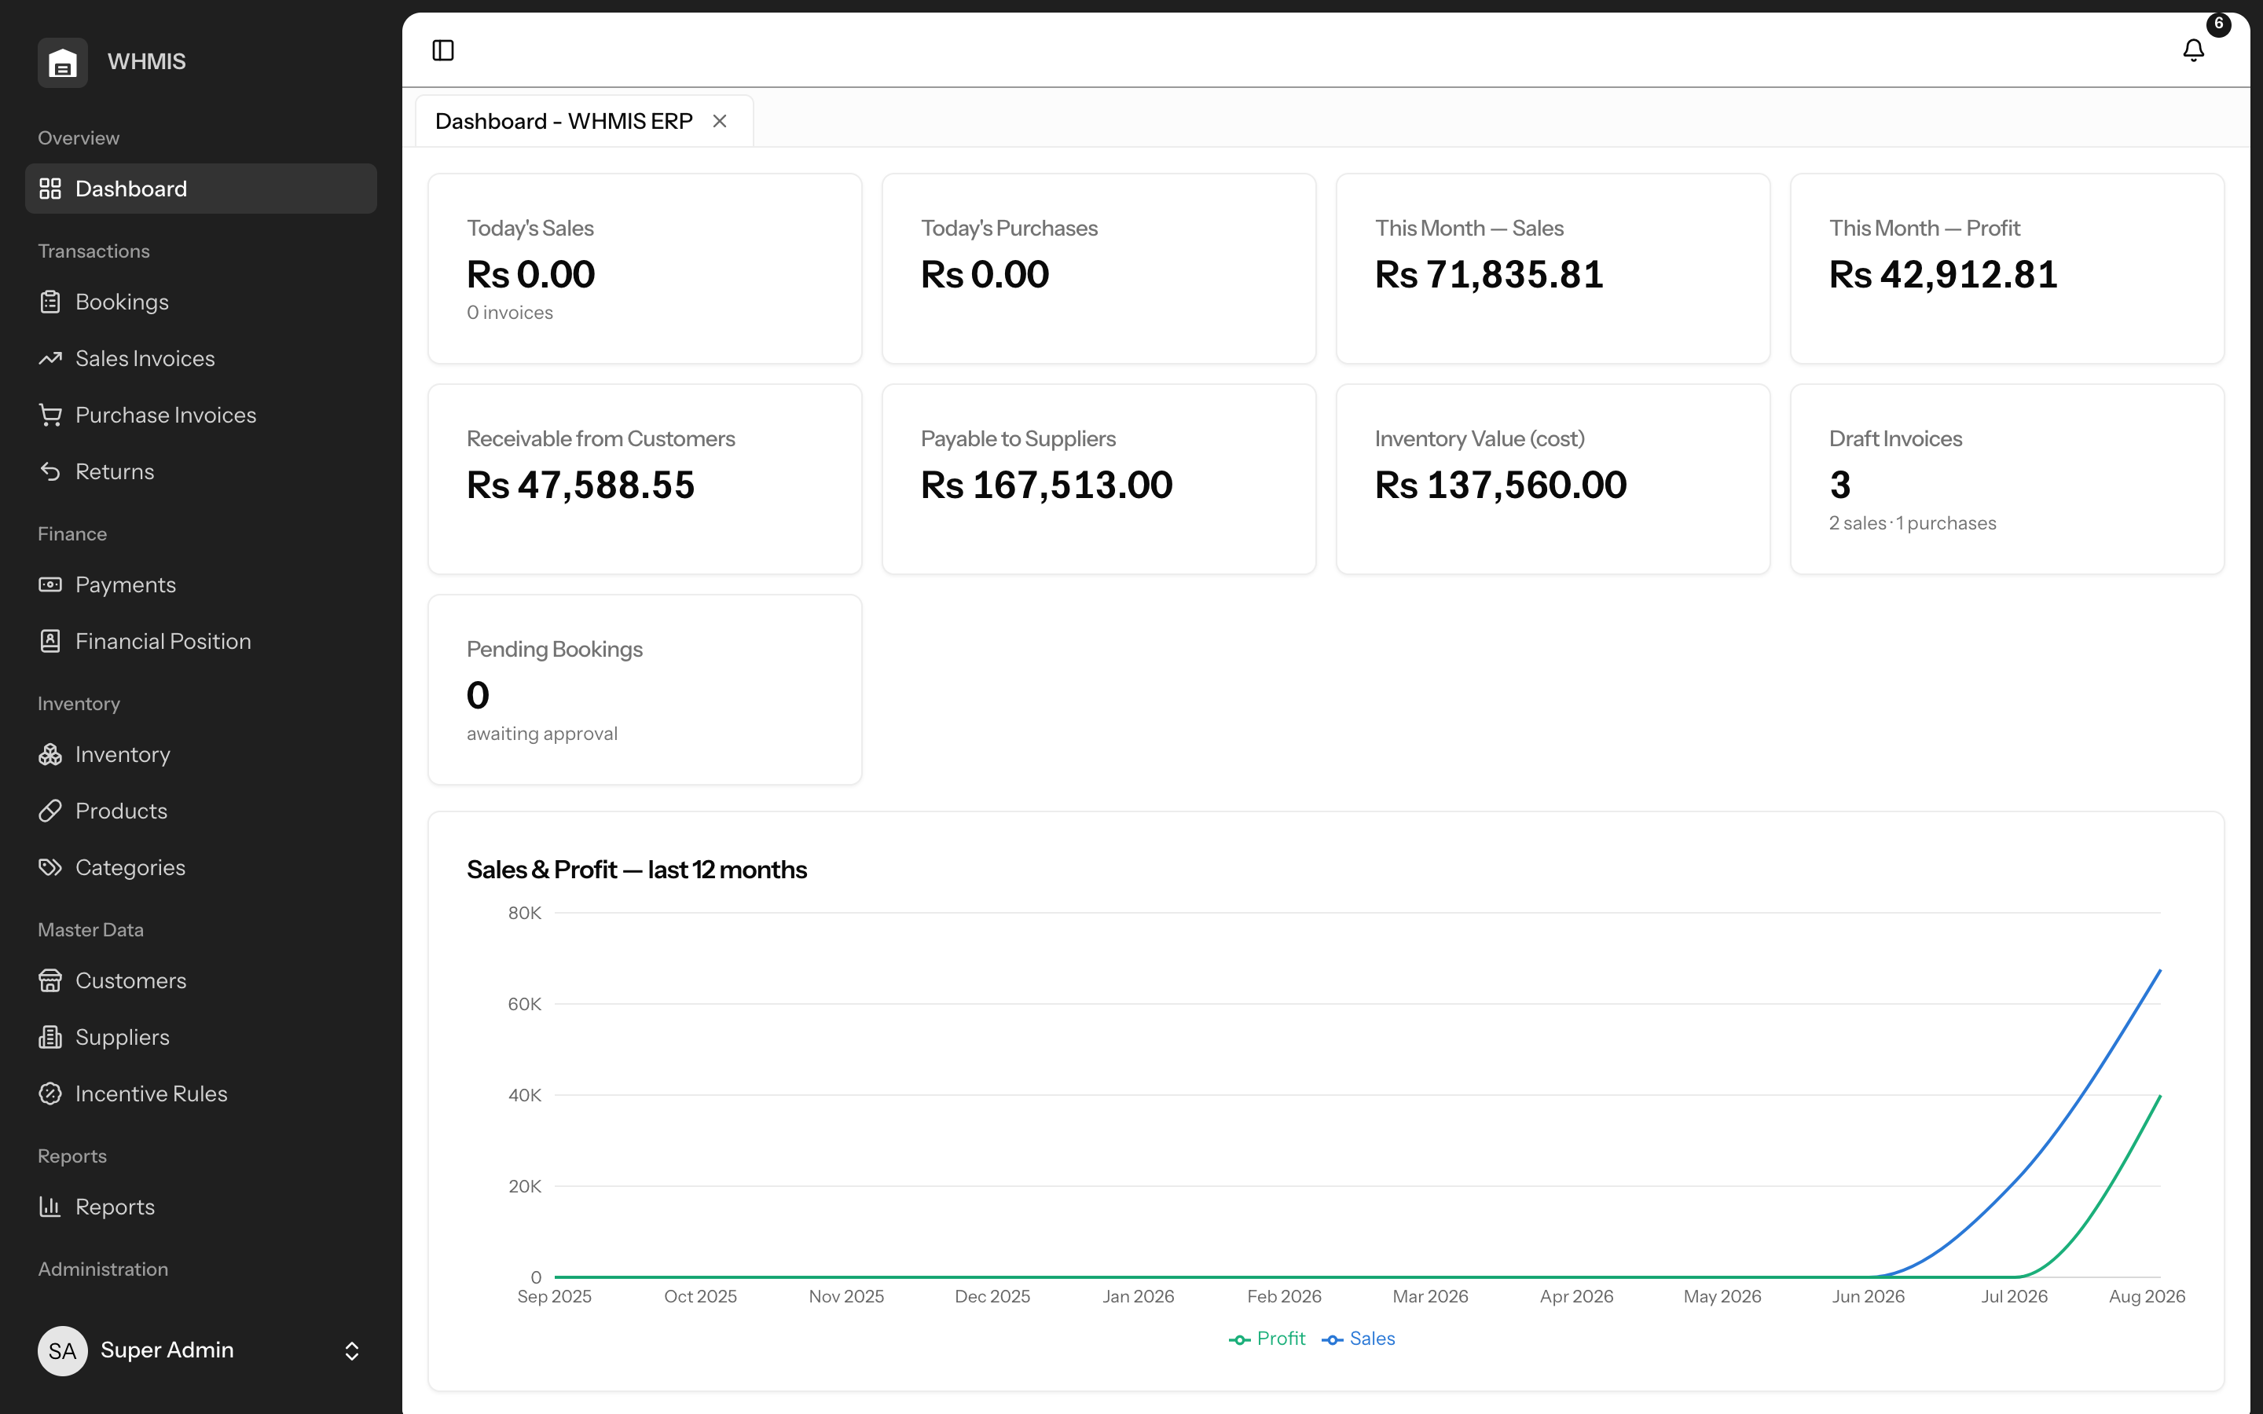
The dashboard: the key numbers and a 12-month trend on one screen.

MODULE 02 · TRANSACTIONS

Sales Invoicing — Bill Accurately in Seconds
Sales is the heart of your day, and WHMIS makes it fast and error-proof. Invoices are raised on a keyboard-driven grid that a trained operator can fly through without ever reaching for the mouse. As each line is entered, the system applies the right price, discount and GST, pulls stock from the correct batch, and checks the customer’s credit — then re-verifies every figure on the server before the invoice is posted, so a mistyped total can never slip through.
Why this matters
Every invoice touches stock, pricing, credit and profit at once. When those are handled by hand, errors are inevitable — the wrong batch shipped, an expired product sold, a risky customer over-extended. WHMIS removes that risk from the busiest, most repetitive task in your business.

Key capabilities
- High-speed entry — add products, quantities and bonus units entirely from the keyboard, built for high daily volumes.
- Automatic pricing — line discounts, GST and margins are computed instantly and re-checked by the server on save.
- Batch-aware stock — goods are drawn from the earliest-expiry batch automatically, so you never oversell or ship expired stock.
- Credit control — customers over their credit limit are blocked before a credit invoice can be posted.
- Cash and credit — cash invoices settle themselves on posting; credit sales flow straight to the customer’s ledger.
- Professional output — every invoice prints or shares as a clean, branded PDF.
Business benefits
- Faster billing counters and shorter queues.
- Fewer pricing disputes and zero expired-stock shipments.
- Credit exposure controlled automatically, protecting cash flow.

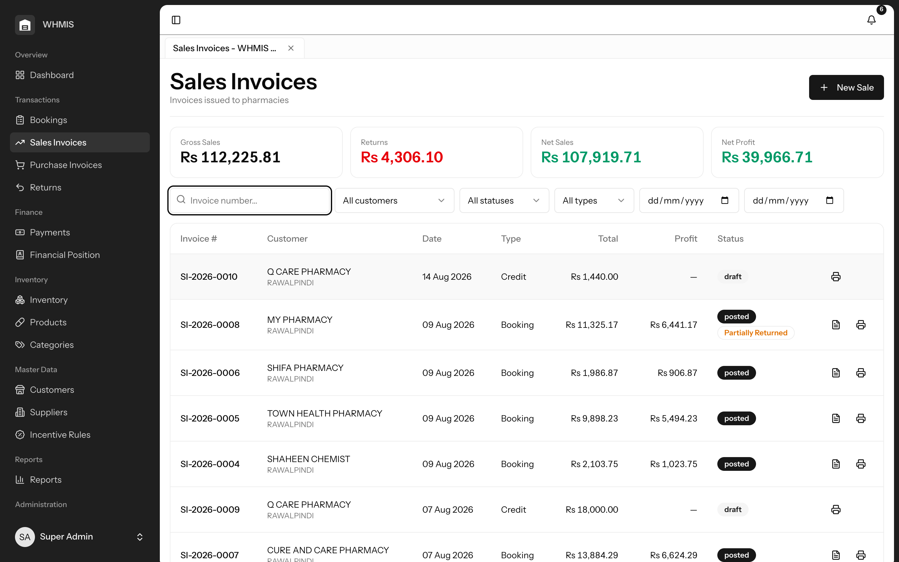
Sales register with gross, returns, net and profit summarised at the top.
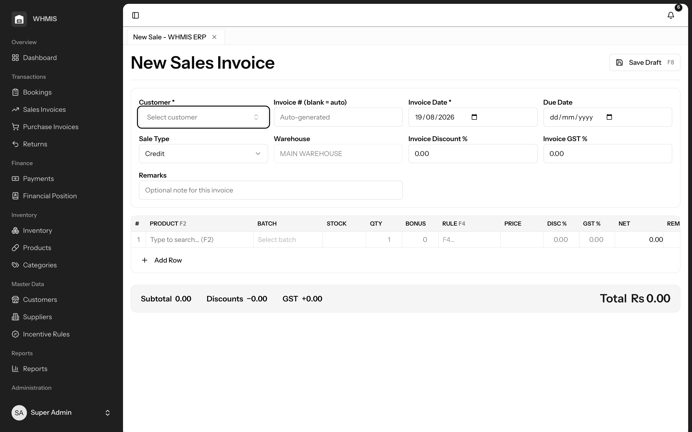
The fast invoice-entry grid, built for high-volume billing.

MODULE 03 · TRANSACTIONS

Bookings & Approvals — From Field Order to Invoice
Field bookers capture pharmacy orders on the same fast grid your billing team uses, and each order flows through a clear submit-and-approve workflow. A manager reviews, then approves or rejects with a single click; an approved booking becomes a ready-to-bill draft sales invoice in one step, carrying its pricing and trade schemes with it. Nothing is re-keyed, and nothing is lost between the field and the invoice.
Why this matters
Orders taken on paper or over the phone get mis-transcribed, forgotten or billed at the wrong price. A structured booking pipeline gives you accountability — you know who booked what, who approved it, and that it will be invoiced exactly as agreed.

Key capabilities
- Familiar order entry — bookers use the same grid as sales, so training is minimal and errors are rare.
- Approval workflow — every booking is submitted for review and approved or rejected by a manager.
- One-click conversion — an approved booking becomes a draft sales invoice instantly, with no re-entry.
- Stacked trade schemes — multiple incentives — say a free-goods deal plus a percentage discount — can be applied to one line and carried through to the sale.
- Clear ownership — bookers see only their own customers’ orders, keeping the pipeline tidy and accountable.
Business benefits
- A disciplined, auditable order-to-invoice pipeline.
- No lost orders and no re-keying between field and office.
- Trade schemes honoured exactly as promised to the pharmacy.

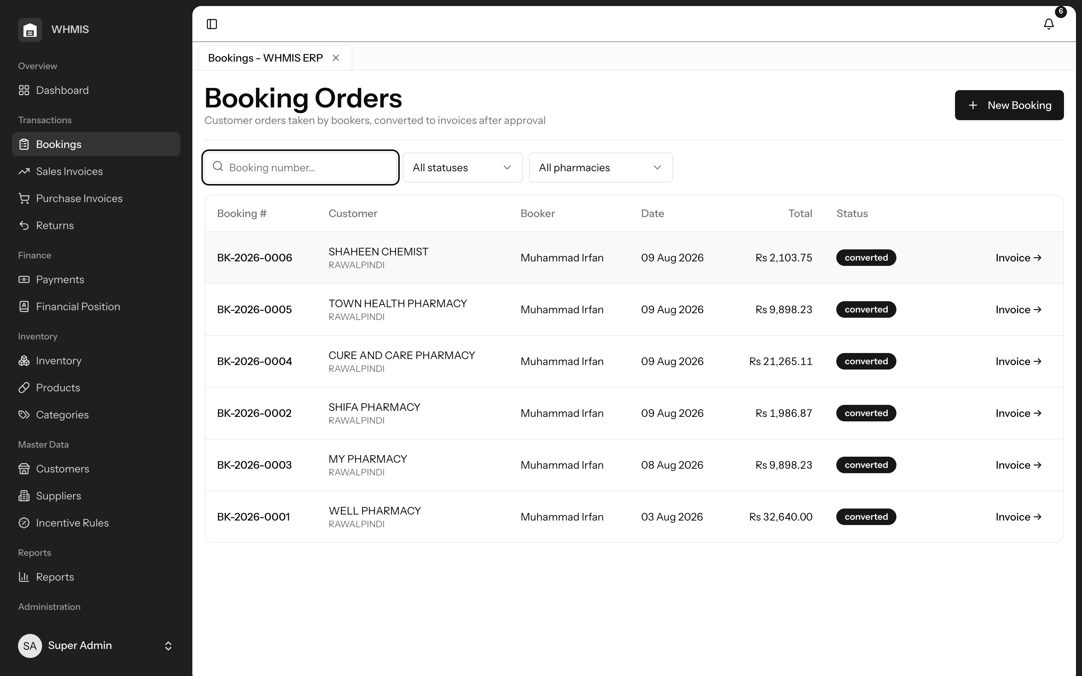
The bookings pipeline, tracked by status through to conversion.
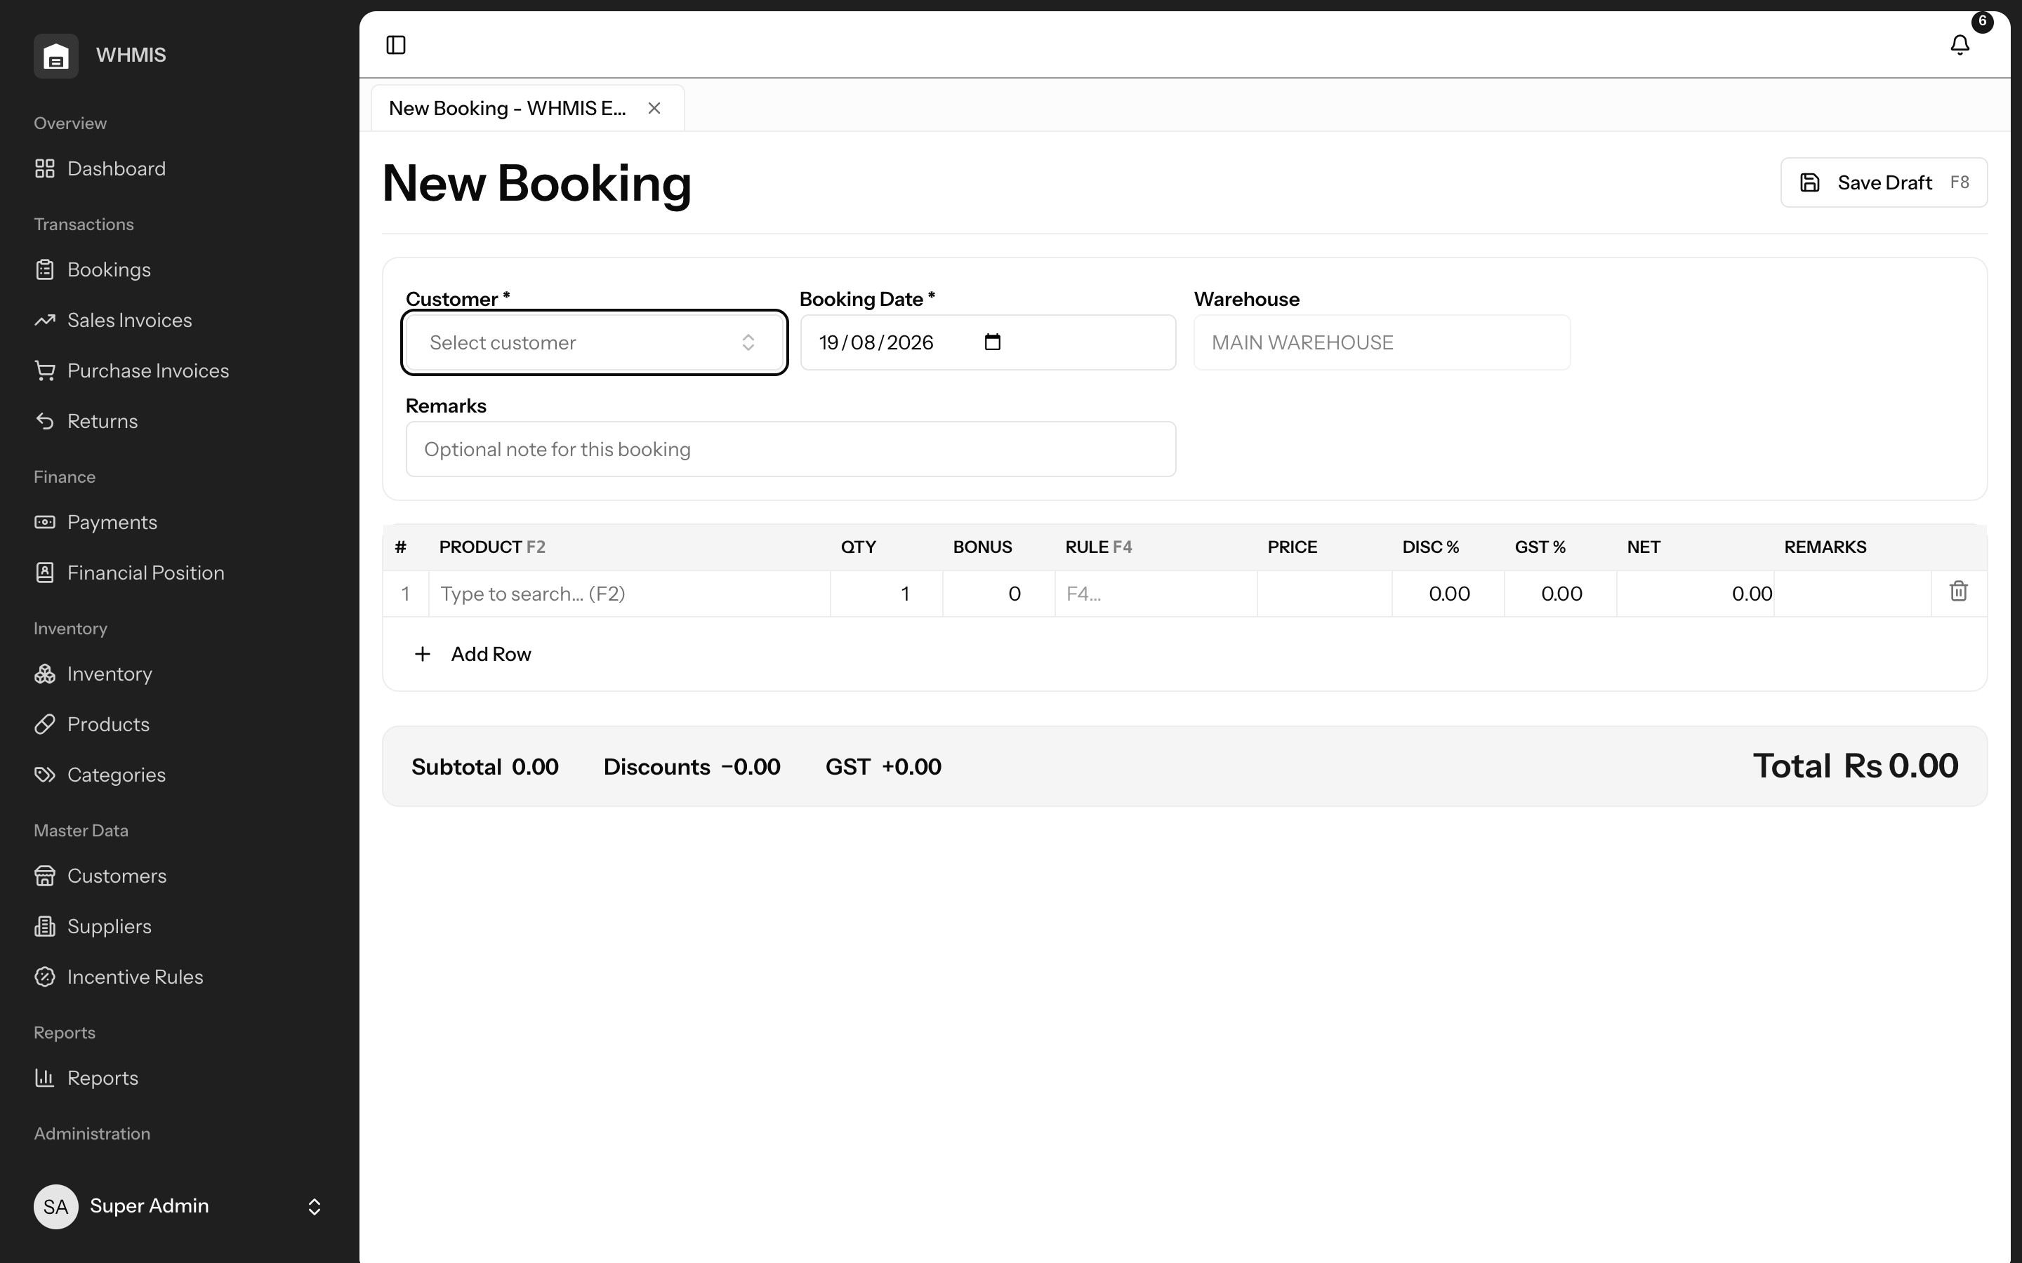
Order entry for field bookers, mirroring the sales experience.

MODULE 04 · TRANSACTIONS

Purchasing & Bonus Stock — Know Your True Cost
Purchases are recorded with the detail that matters in pharma — batch numbers, expiry dates, and the free “bonus” units suppliers give you. On posting, stock is created automatically and the free goods are folded into the batch’s effective cost. That single piece of accounting discipline means your profit figures are honest: the free units you later give away are already accounted for, so you are never fooled by margins that look better than they really are.
Why this matters
Bonus stock is where distributor profit quietly leaks. If free goods are ignored in costing, every report overstates your margin — and you make pricing and scheme decisions on numbers that are wrong. WHMIS gets this right by design.

Key capabilities
- Batch & expiry capture — record batch number and expiry on every purchase line; stock is created automatically on posting.
- True cost with bonus — free units dilute the batch’s effective cost, so profit is always calculated truthfully.
- Supplier ledger — credit and cash purchases update supplier payables and the ledger automatically.
- Controlled corrections — posted documents are never silently edited; changes are made through auditable reversals.
Business benefits
- Profit reporting you can actually trust.
- Complete batch and expiry traceability from the moment stock arrives.
- Supplier balances that are always accurate.

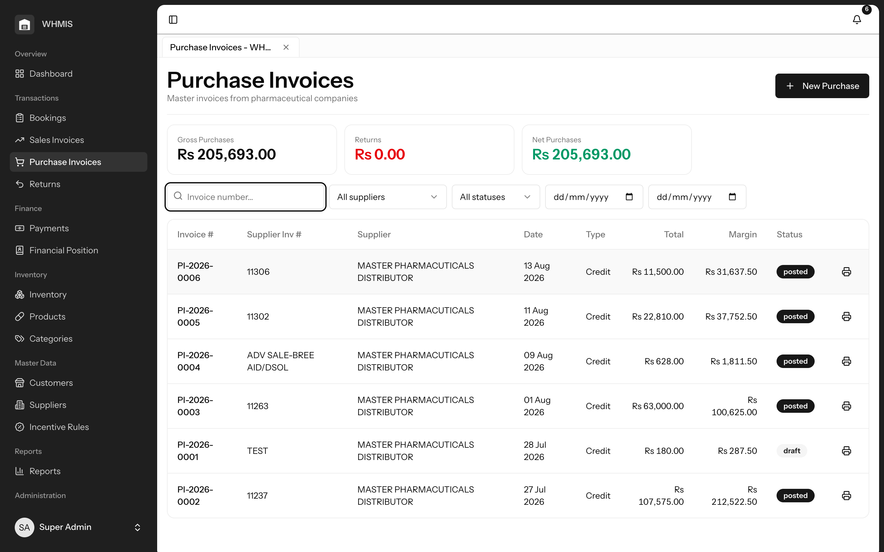
Purchase register with per-supplier volume and status.
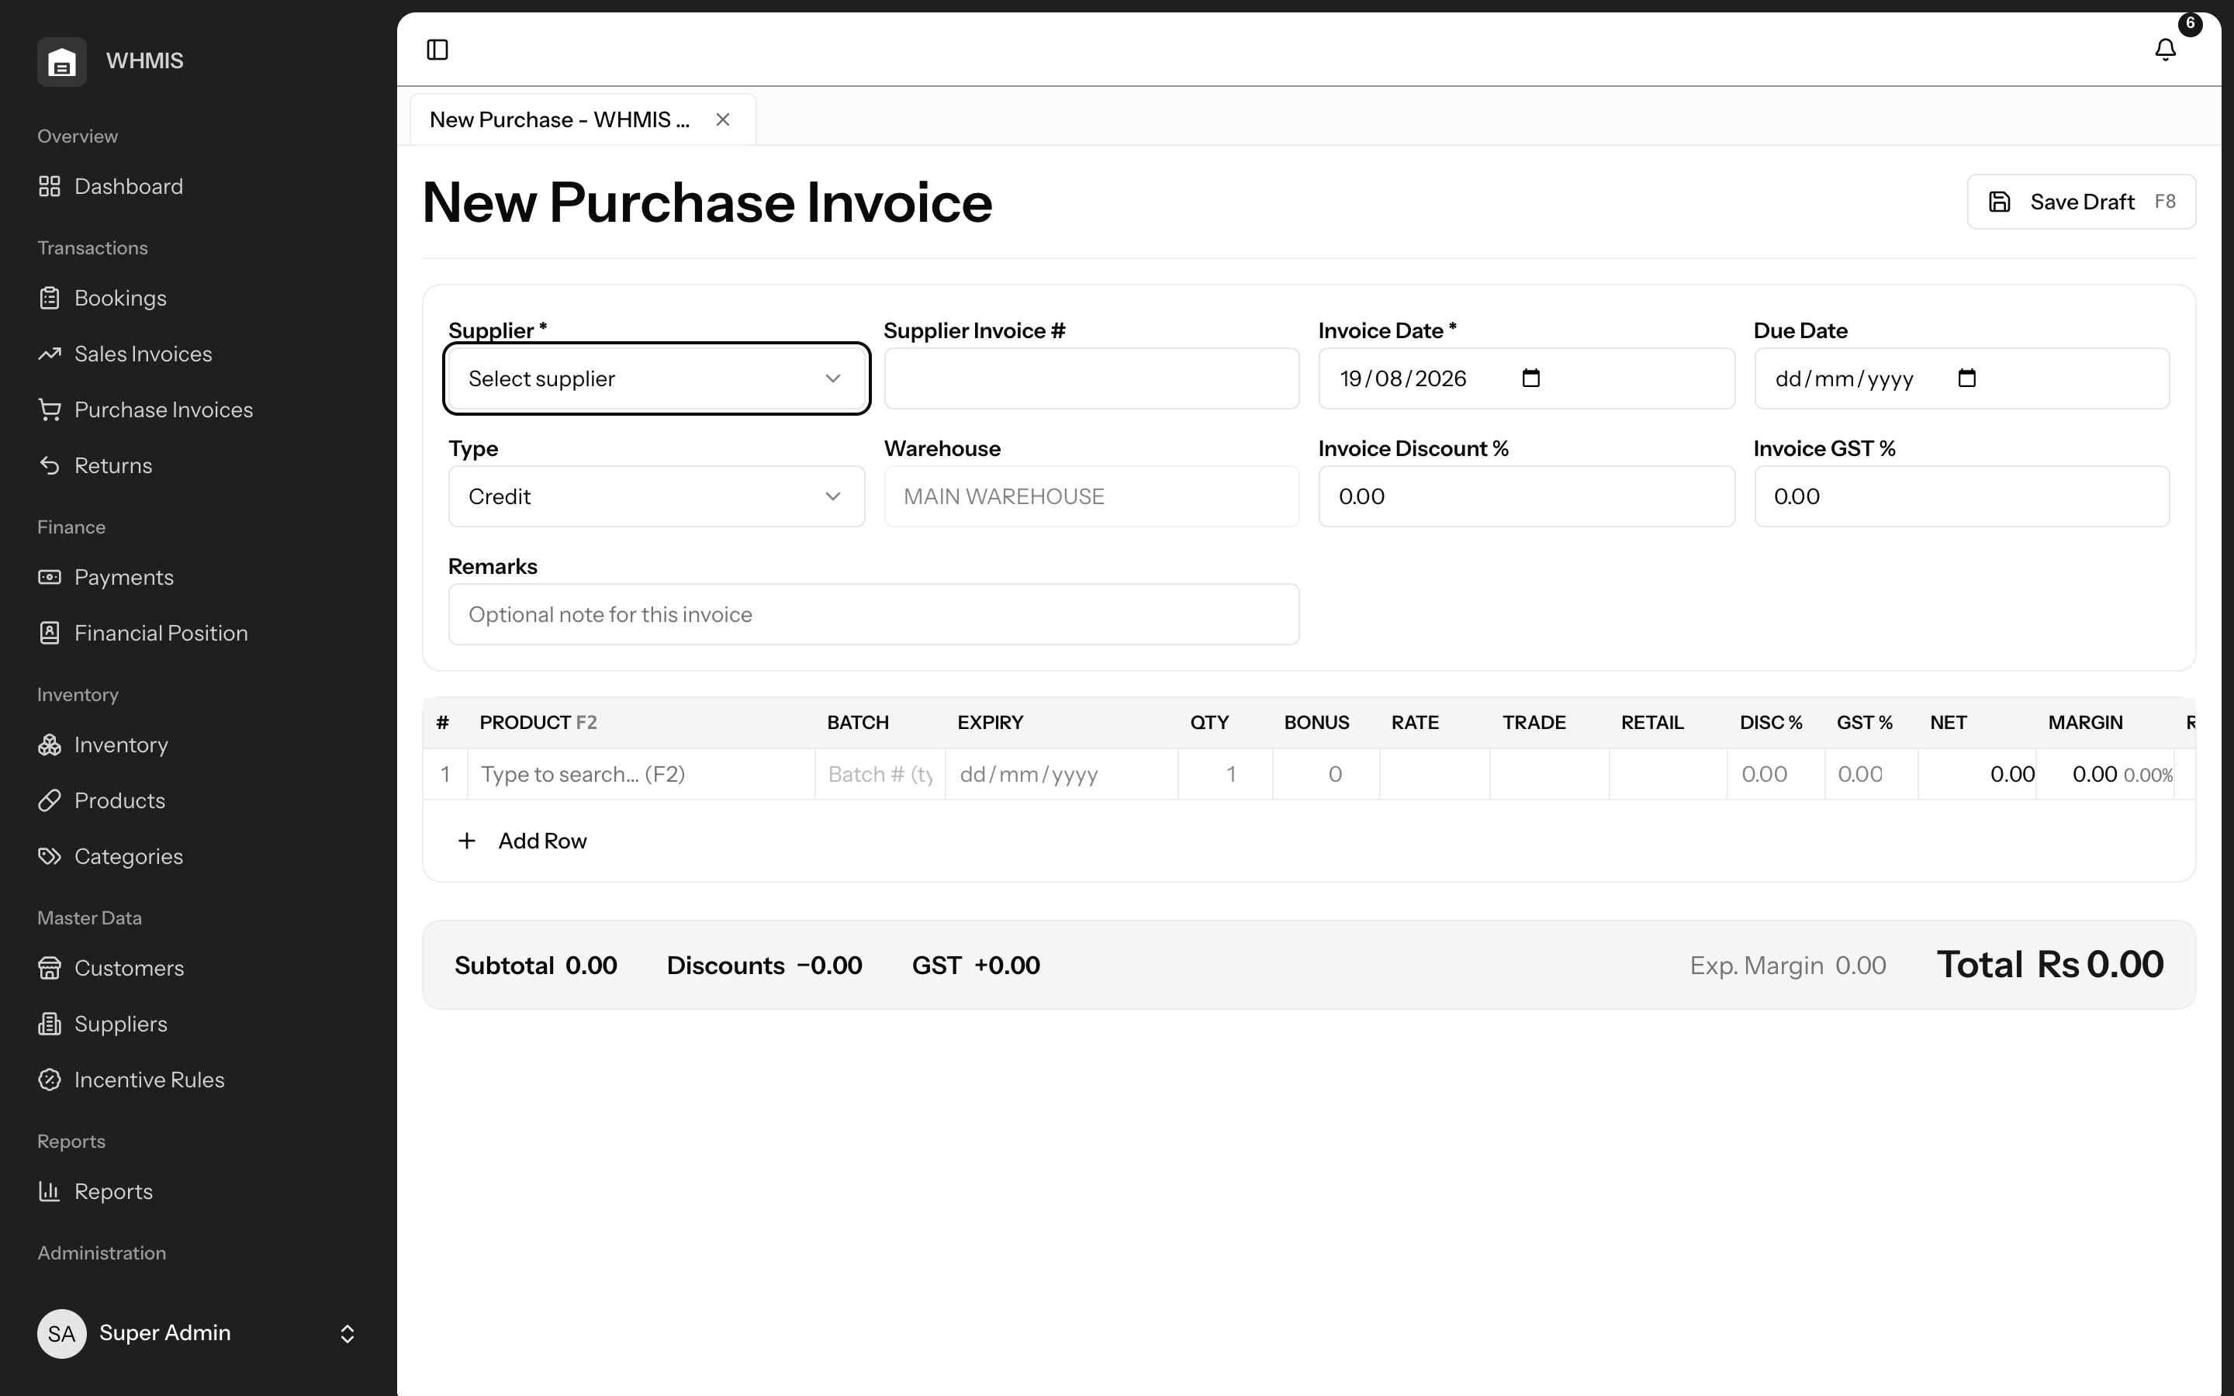
Purchase entry capturing batch, expiry and bonus units.

MODULE 05 · INVENTORY

Inventory, Batches & Expiry — Stop Losing Stock to Waste
WHMIS tracks stock not just by product but by individual batch, each with its own expiry date and true cost. When goods are sold, the system consumes the earliest-expiring batch first, actively pushing older stock out before it can expire. Near-expiry and low-stock situations are surfaced early, and every movement in and out is recorded in an append-only history you can always trust.
Why this matters
Expired stock is money thrown away, and stock-outs are lost sales. For a pharmaceutical distributor, expiry management is not a nicety — it is a direct line to your bottom line. WHMIS turns expiry control from a manual worry into an automatic behaviour.

Key capabilities
- Live batch stock — current quantities by product and by batch, valued at true cost.
- Expiry-first issue (FIFO) — the earliest-expiring batch is always consumed first, minimising write-offs.
- Early warnings — near-expiry and low-stock visibility so you act before a loss or a shortage happens.
- Full traceability — an append-only movement history records every unit’s journey in and out.
Business benefits
- Fewer expiry write-offs and fewer stock-outs.
- Confidence in exactly what you hold and what it is worth.
- A clean audit trail for every unit of stock.

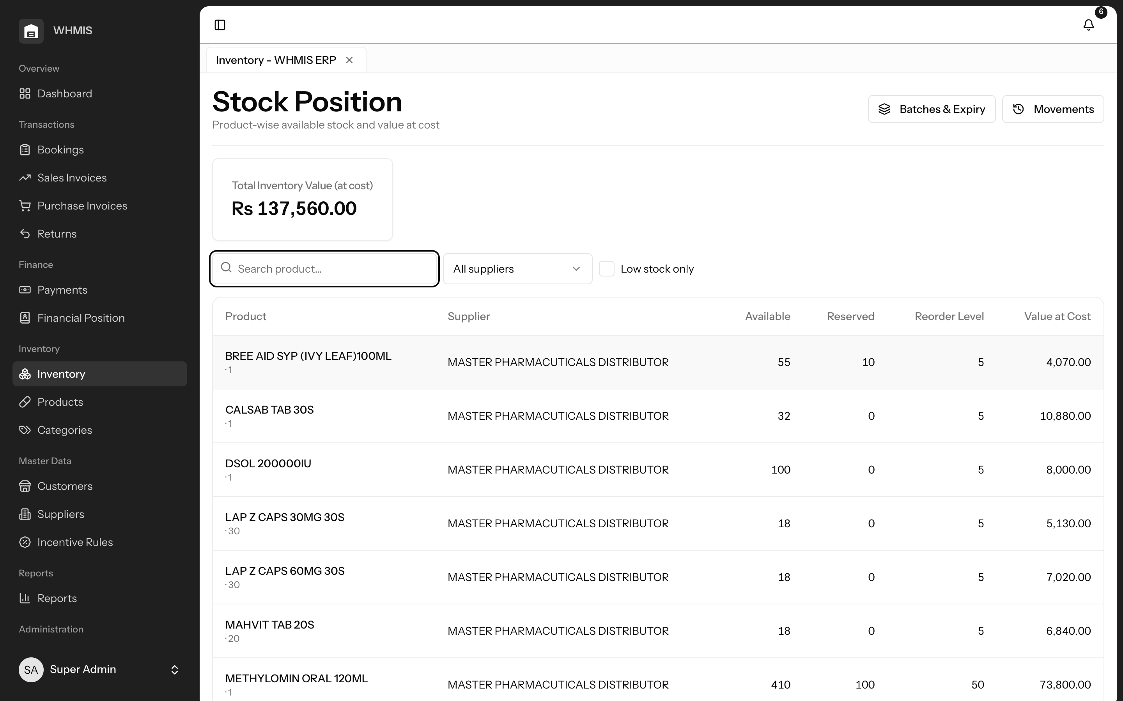
Current stock and value across your catalogue.
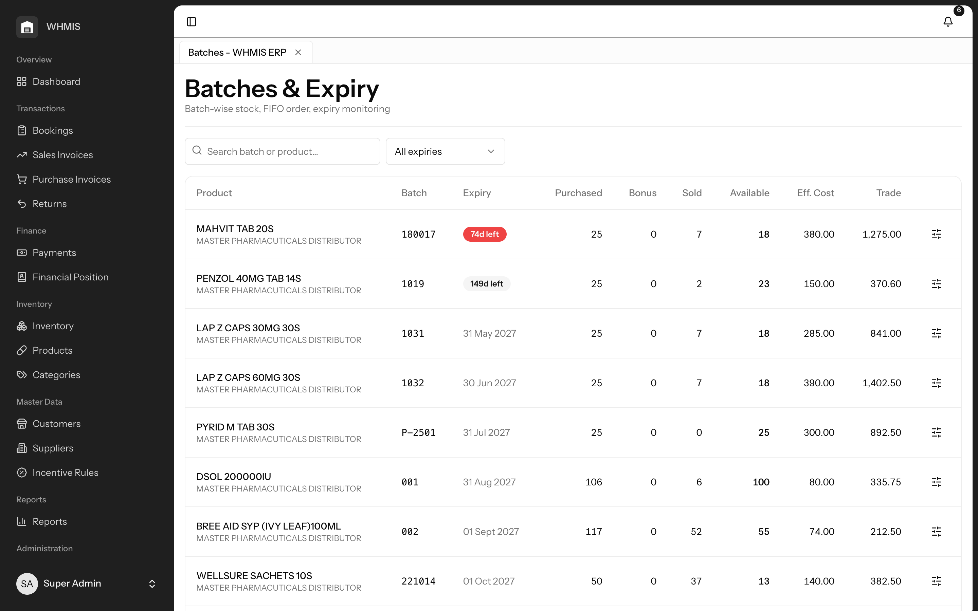
Batch-level detail with expiry dates and quantities.

MODULE 06 · MASTER DATA

Products & Suppliers — A Clean Foundation
Everything the system does rests on well-organised master data, and WHMIS makes it easy to set up and maintain. Products carry trade and retail pricing, tax and supplier links, and can be grouped by category; suppliers hold the full tax details needed for compliant documents. When you are starting out or onboarding a new range, you can import products and customers in bulk from Excel, with each row validated and clear errors shown for anything that needs attention.
Why this matters
Messy product and price lists cause wrong invoices, wrong margins and wasted time. Getting master data right once — and being able to bulk-load it — saves countless hours and prevents errors everywhere else in the system.

Key capabilities
- Complete product records — trade and retail prices, tax, supplier and category on every product.
- Compliant supplier records — full NTN / STRN and contact details for correct documentation.
- Bulk Excel import — load products and customers in bulk, with per-row validation and downloadable templates.
- Simple organisation — categories keep large catalogues easy to navigate.
Business benefits
- A fast, error-free start with bulk onboarding.
- Correct pricing and tax on every document that follows.
- A tidy catalogue that scales as your range grows.

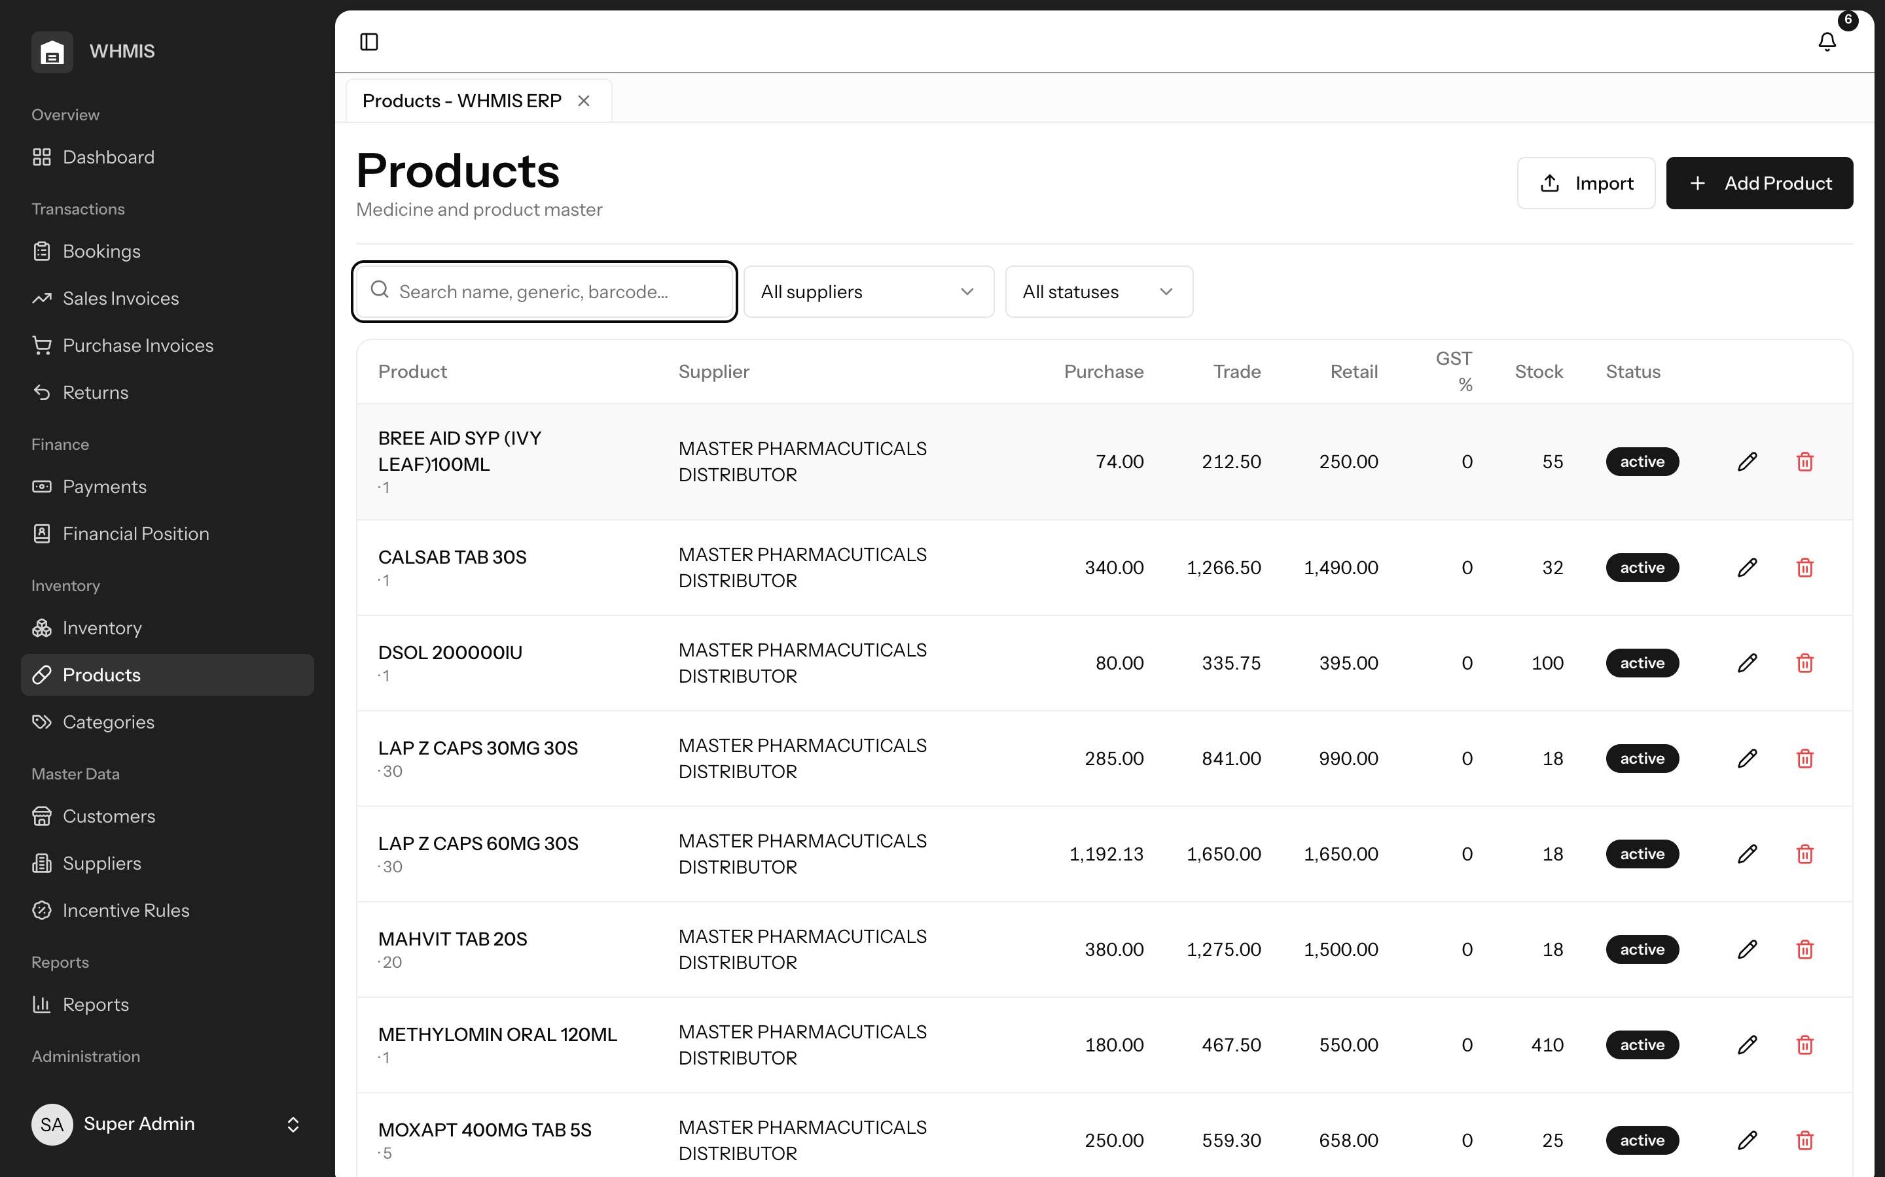
The product catalogue with pricing and supplier links.
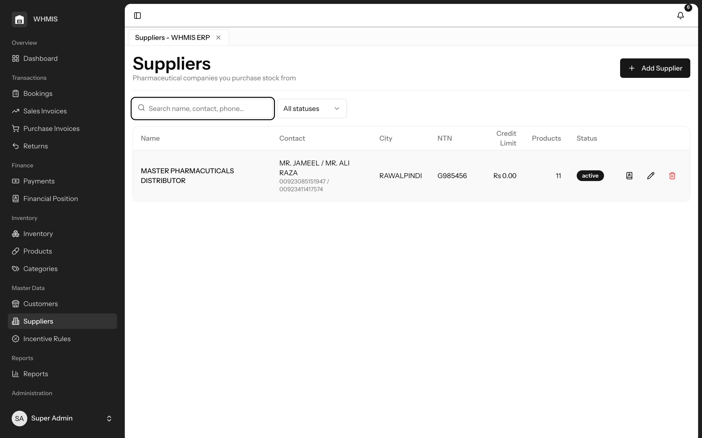
Supplier directory with tax and contact details.

MODULE 07 · FINANCE

Customers, Ledger & Aging — Know Who Owes You
Every customer has a complete profile — credit limit, assigned booker and tax details — and a running ledger that captures each invoice, receipt and adjustment in one place. Outstanding balances are automatically bucketed by age, so your recovery team can see at a glance which accounts are current, which are stretching, and which are genuinely overdue, and chase the right money first.
Why this matters
In a credit-driven business, cash is only as healthy as your collections. Without clear, aged balances, overdue money hides in plain sight and working capital quietly drains away. Aging turns a vague worry into a prioritised action list.

Key capabilities
- Rich customer profiles — credit limits, assigned bookers and tax fields on every pharmacy.
- Per-customer ledger — every invoice, receipt and adjustment in a single, clear statement.
- Aged outstanding — balances split into age buckets so overdue accounts stand out immediately.
- Credit awareness — limits feed directly into sales, blocking risky exposure at the point of billing.
Business benefits
- Faster, smarter collections and healthier cash flow.
- Instant answers to “how much does this pharmacy owe us?”
- Credit risk controlled before it becomes bad debt.

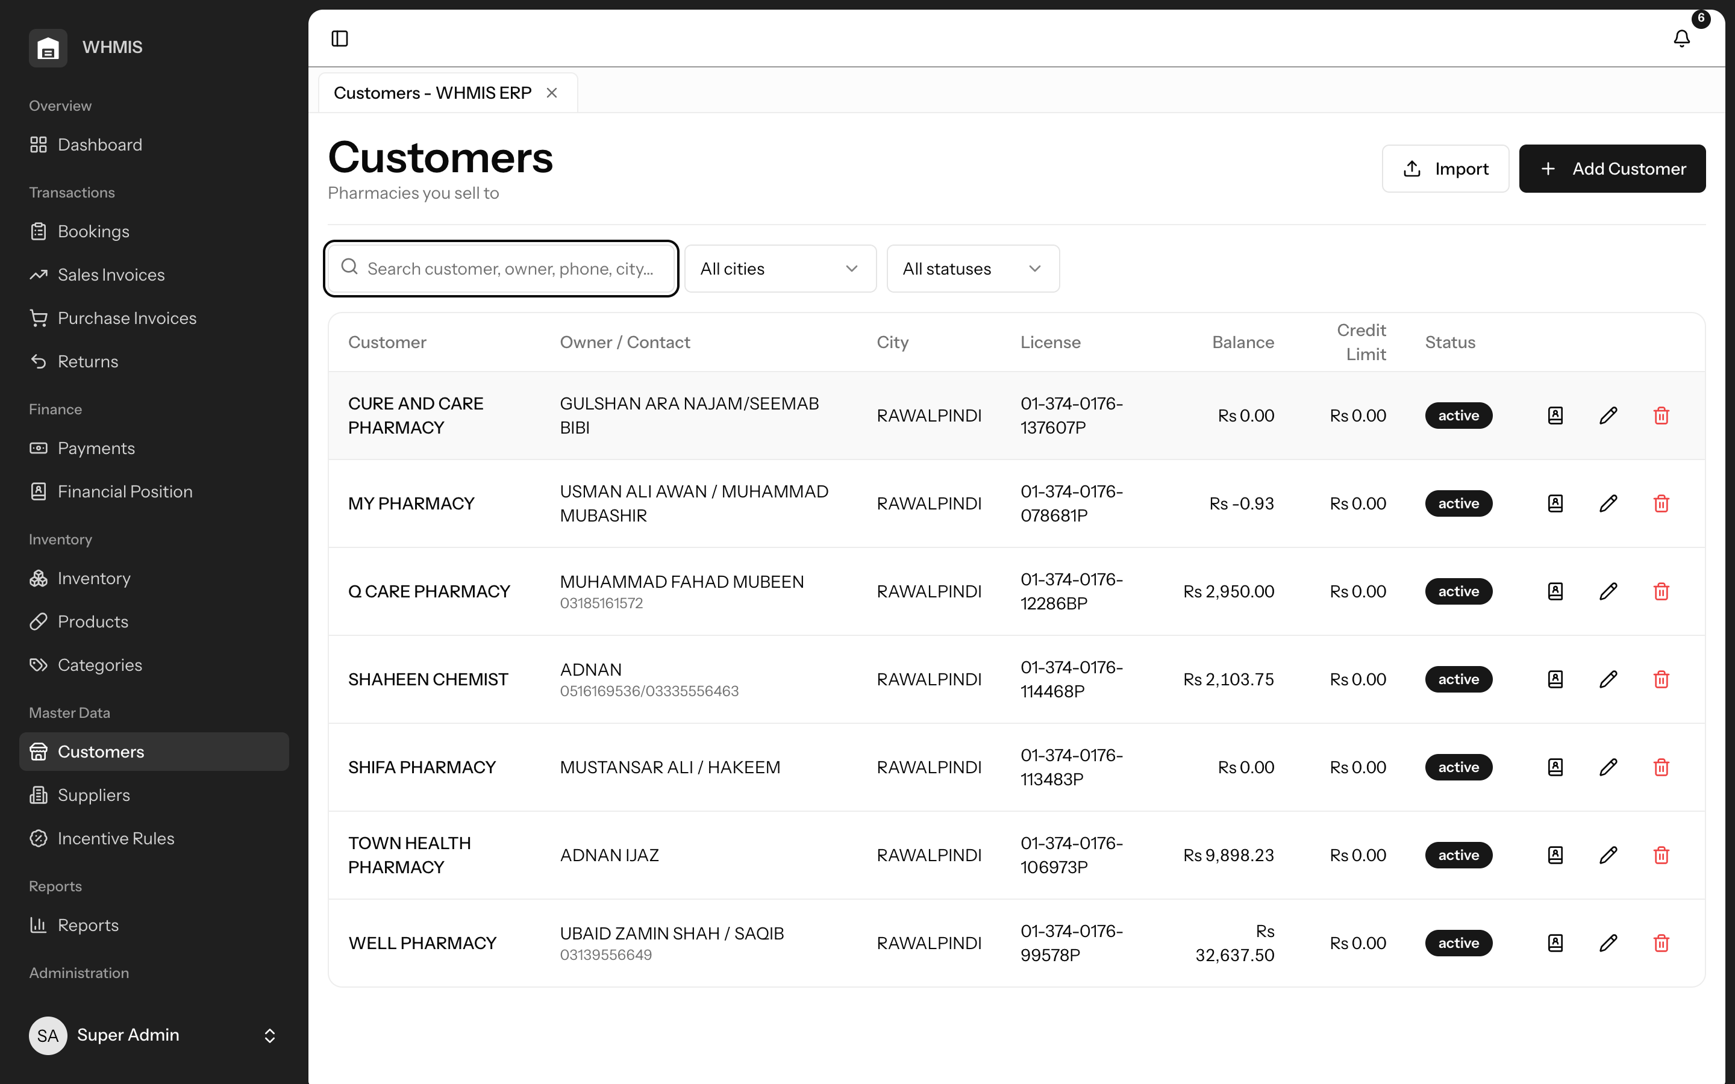
Customer directory with credit limits and balances.
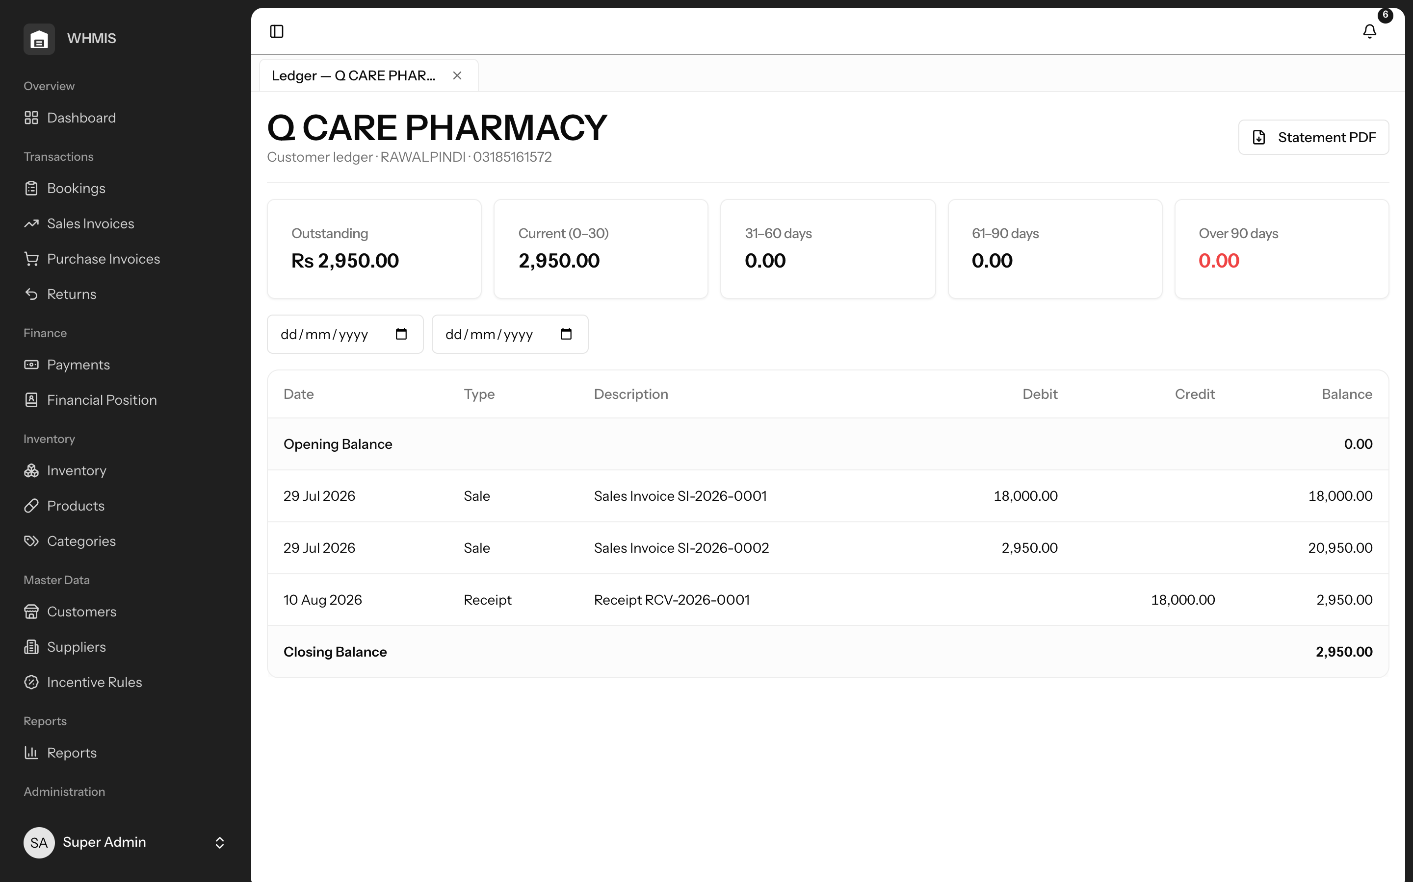
A customer’s running ledger and outstanding position.

MODULE 08 · SALES ENABLEMENT

Incentive Rules — Your Trade Schemes, Applied Consistently
Trade schemes drive sales in pharma, but applied by hand they are inconsistent and hard to measure. WHMIS lets you define each scheme once — free-goods bonuses like 10 + 2, slab-based bonuses, percentage or fixed discounts, or special prices — and target it to a specific customer, product or supplier, or make it global, with clear priorities. The rule simply fills in the invoice line, so your team can still adjust manually, and an “Incentives Given” report shows exactly what every scheme has cost you.
Why this matters
Schemes are a major cost of doing business, yet most distributors cannot say what they actually spend on them. Defining schemes centrally means every customer is treated consistently and fairly — and, for the first time, you can measure the return on that spend.

Key capabilities
- Every scheme type — quantity bonus, slab bonus, percentage and fixed discounts, and special prices.
- Precise targeting — apply a scheme to a customer, product or supplier — or globally — with priorities to resolve overlaps.
- Manual override — rules only fill the line, so your staff always keep the final say.
- Full measurement — the Incentives Given report reveals the true cost of every scheme, per customer.
Business benefits
- Consistent, fair pricing across every pharmacy.
- Trade-scheme spend you can finally see and control.
- Faster billing, because schemes apply themselves.

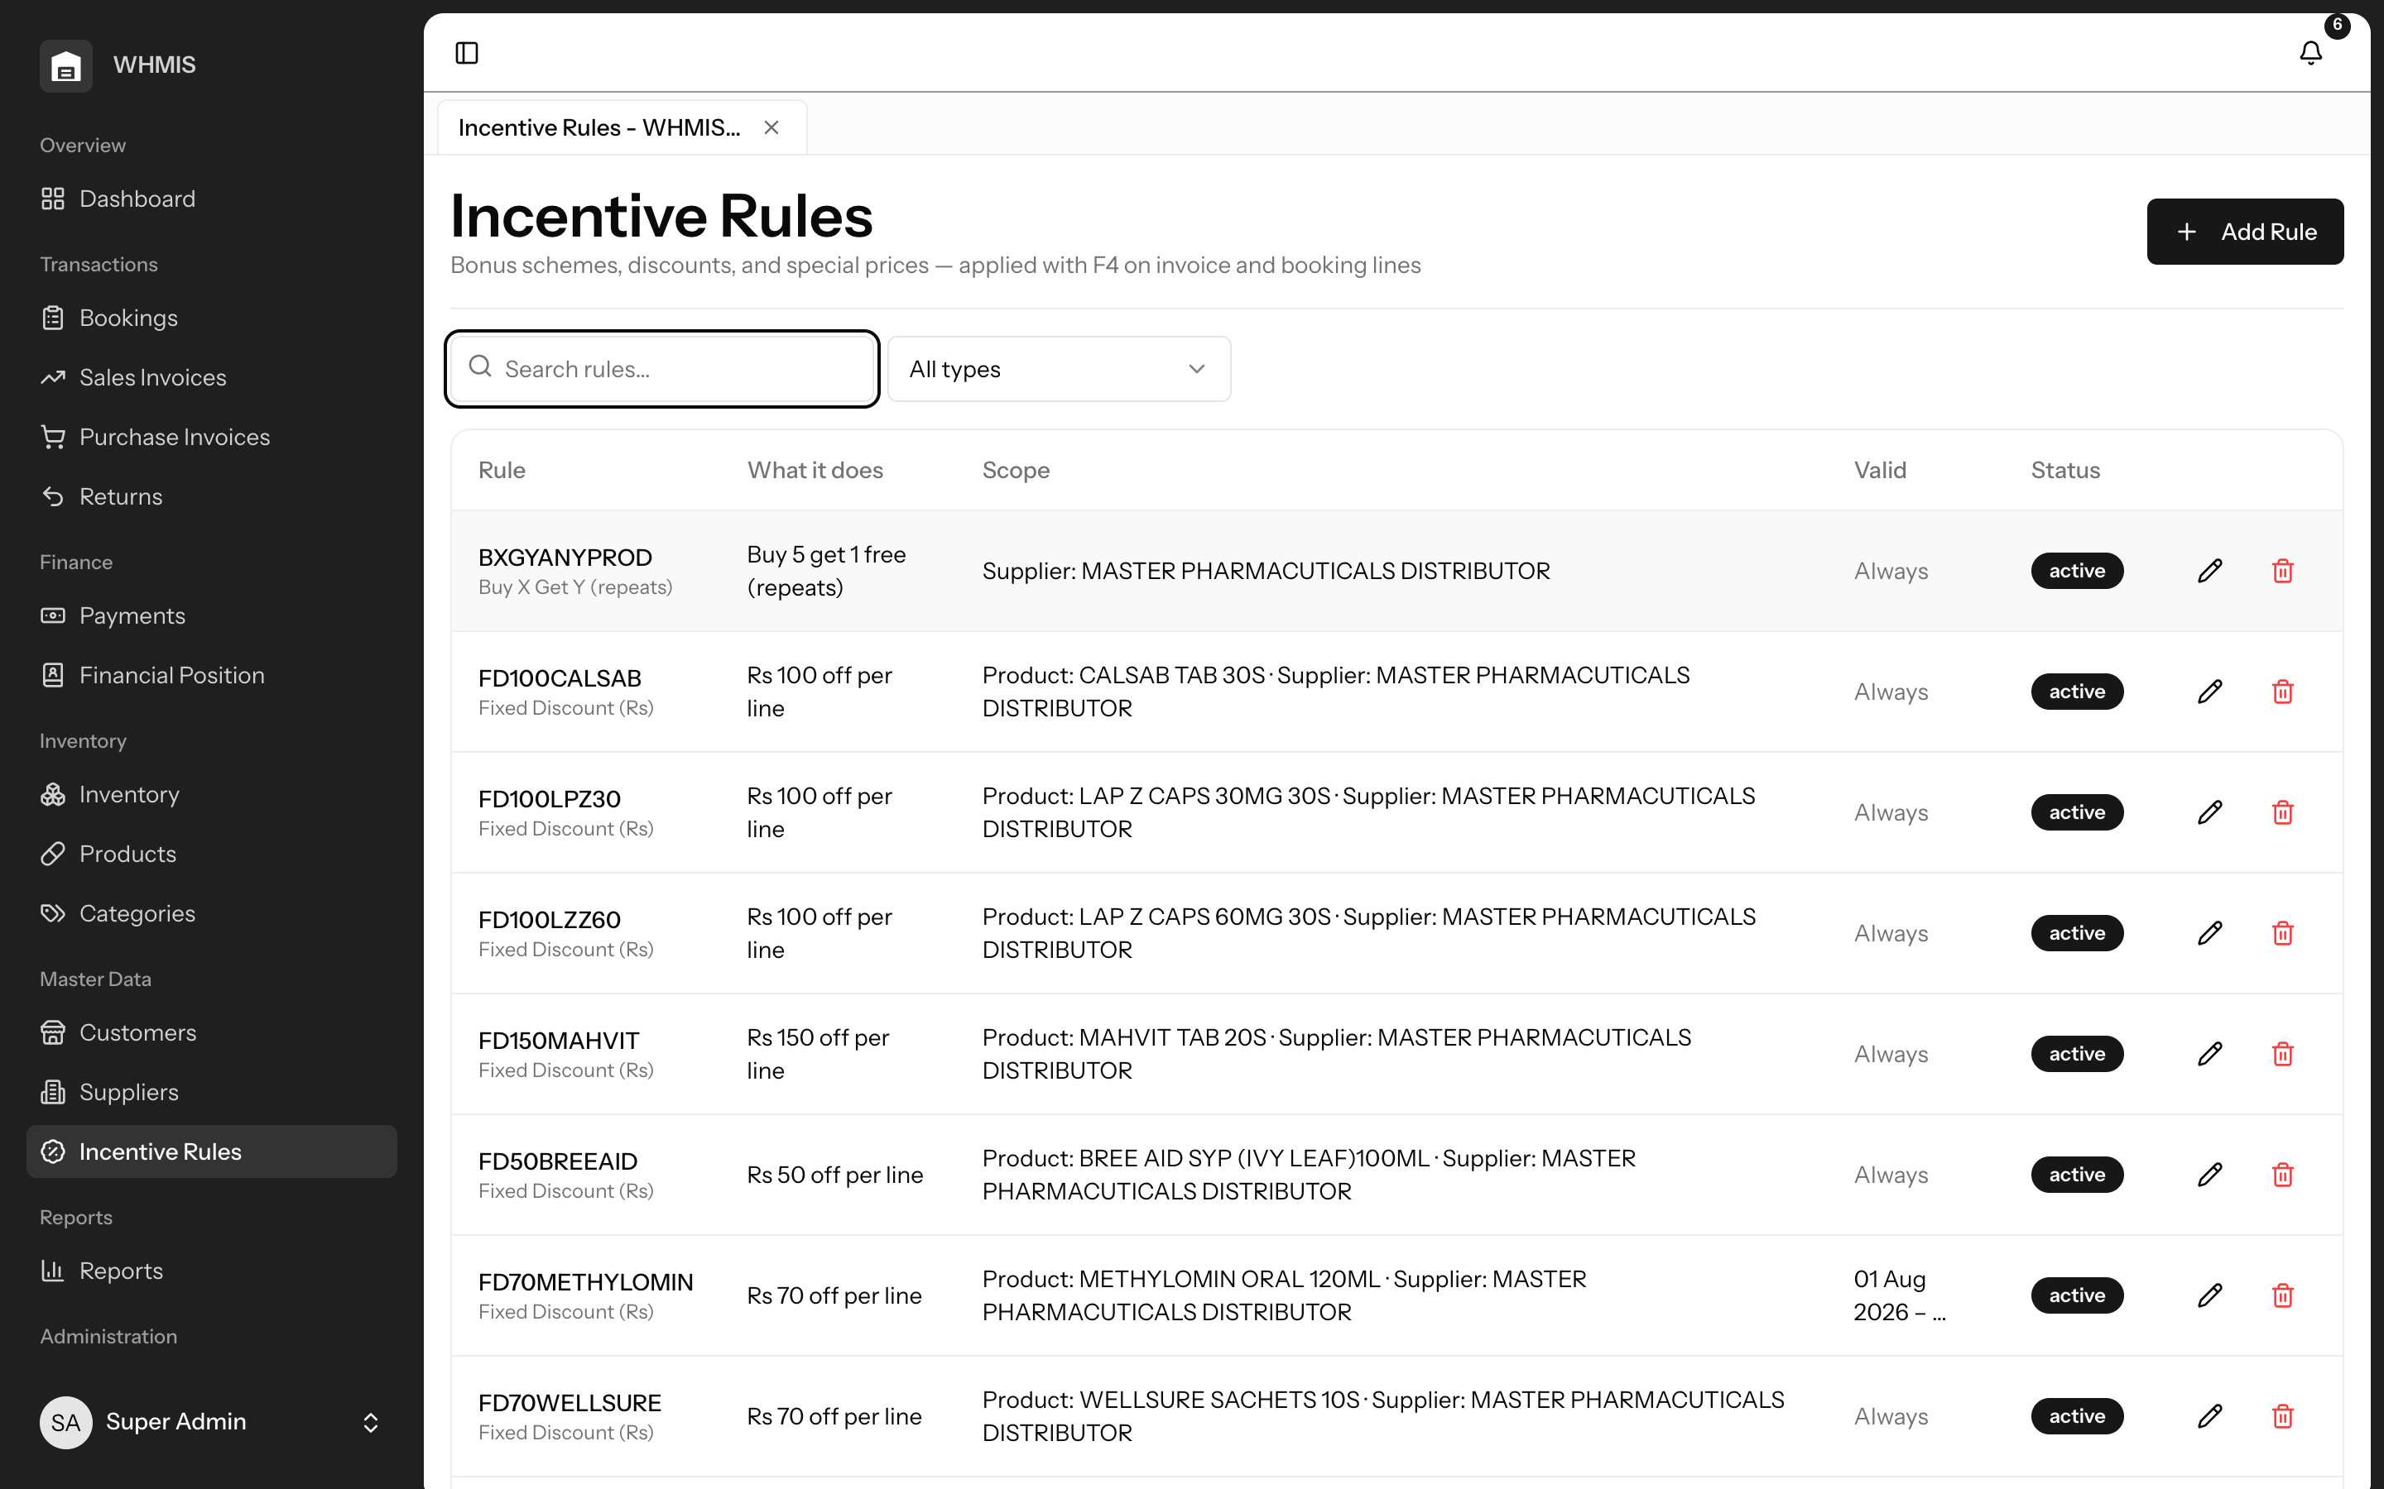
The incentive-rule library, covering every scheme type.

MODULE 09 · FINANCE

Payments & Receipts — Keep Every Balance Current
Customer receipts and supplier payments are recorded across cash and bank and allocated against the invoices they settle. Balances and aging update the instant a payment is entered, cash sales settle themselves on posting, and clear running totals show money in, money out and your net position — so your books are always up to date, not reconciled at month-end.
Why this matters
When payments are logged separately from invoices, balances drift and disputes follow. Allocating receipts against invoices as they happen keeps every customer and supplier statement accurate and defensible at all times.

Key capabilities
- Receipts and payments — record both, across cash and bank, in one place.
- Invoice allocation — apply money received to the specific invoices it clears.
- Instant balances — aging and outstanding update immediately, with cash sales auto-settled.
- Net position — running totals of inflow, outflow and the balance between them.
Business benefits
- Always-accurate customer and supplier statements.
- Fewer payment disputes and faster reconciliation.
- A live view of cash movement.

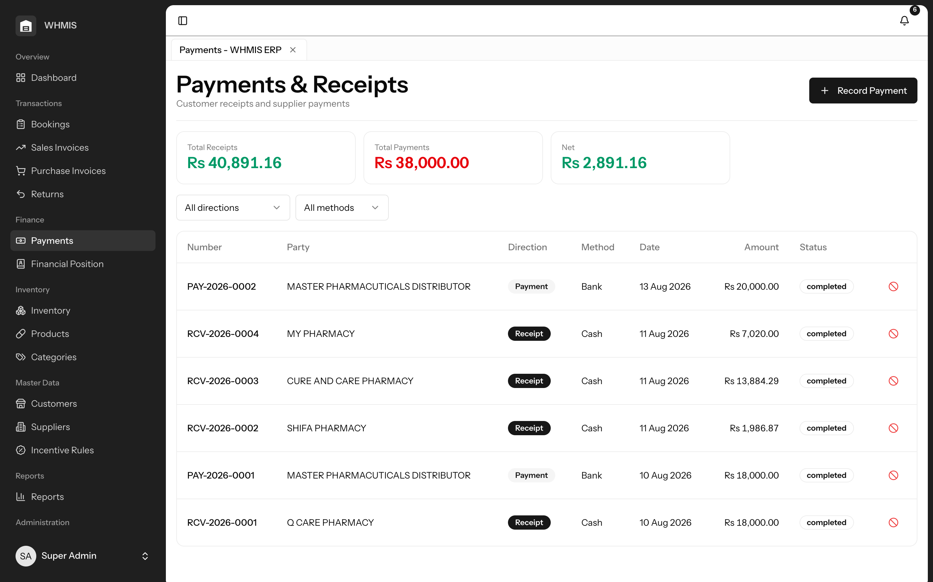
Receipts and payments with a live net position.

MODULE 10 · FINANCE

Financial Position — What You Own vs. What You Owe
The Financial Position screen answers the single most important question an owner asks: where do we stand right now? On one page it sets what your customers owe you against what you owe your suppliers and shows the net figure between them. Three headline cards — Due from Customers, Owed to Suppliers and Net Position — sit above a full receivables statement (with aging buckets and how much each pharmacy has paid in the period) and a matching payables statement, followed by a complete log of every payment in and out for the chosen dates. Pick any date range and print the whole statement to PDF.
Why this matters
Profit on paper means little if the cash is stuck in receivables while supplier bills come due. A single, current view of receivables versus payables — and the net position between them — is what tells you whether the business can meet its obligations this week. Without it, that judgement is guesswork.

Key capabilities
- Net position at a glance — Due from Customers, Owed to Suppliers and the Net Position, headlined at the top.
- Full receivables statement — every customer balance with aging buckets and amount received in the period.
- Full payables statement — every supplier balance with aging, so upcoming obligations are clear.
- Payment log — a dated record of every receipt and payment in and out for the selected window.
- Any period, one click to PDF — choose a date range and print the entire statement for owners, banks or auditors.
Business benefits
- An instant, honest answer to “can we meet our commitments this week?”
- Cash tied up in receivables set plainly against what you owe.
- A print-ready position statement whenever it is needed.

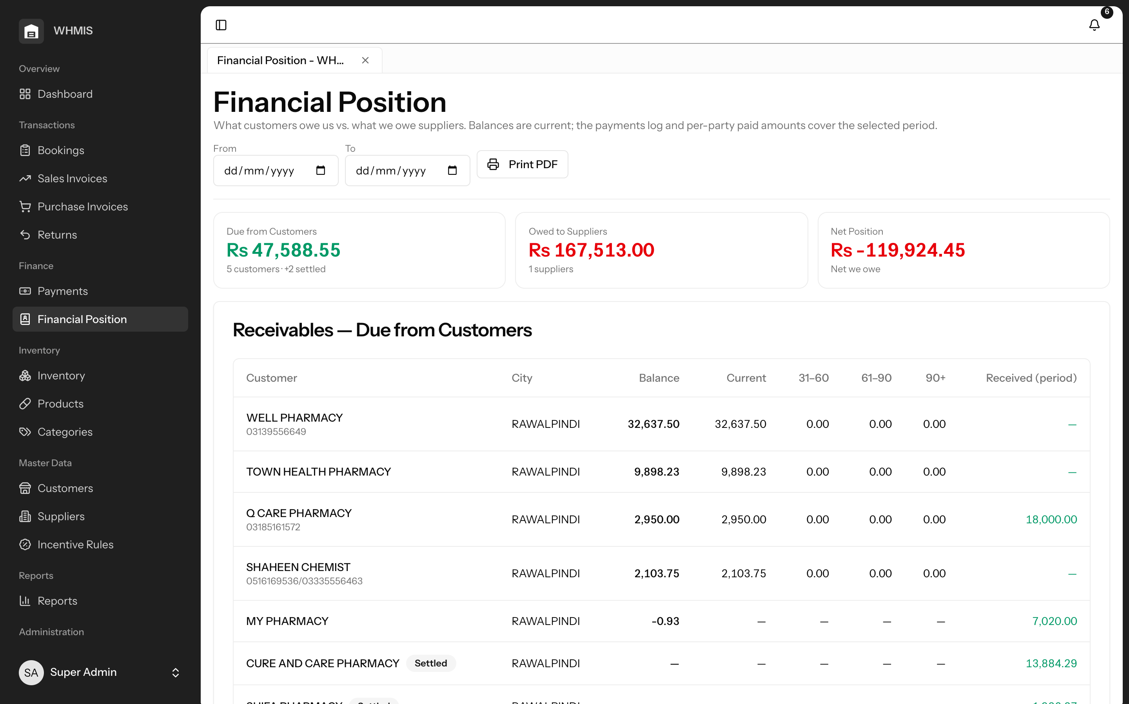
Financial Position: receivables vs. payables with the net position headlined.
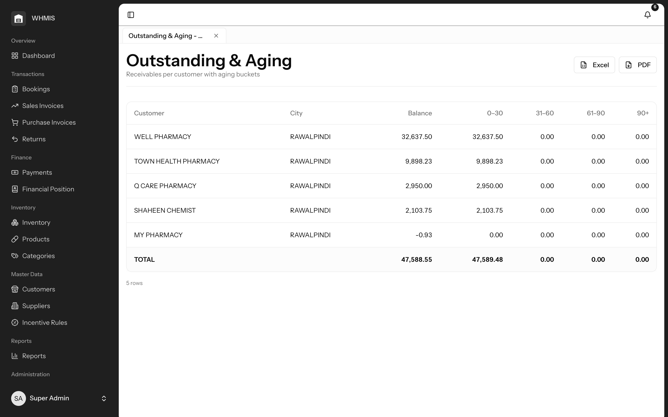
Outstanding & Aging — receivables split into age buckets.
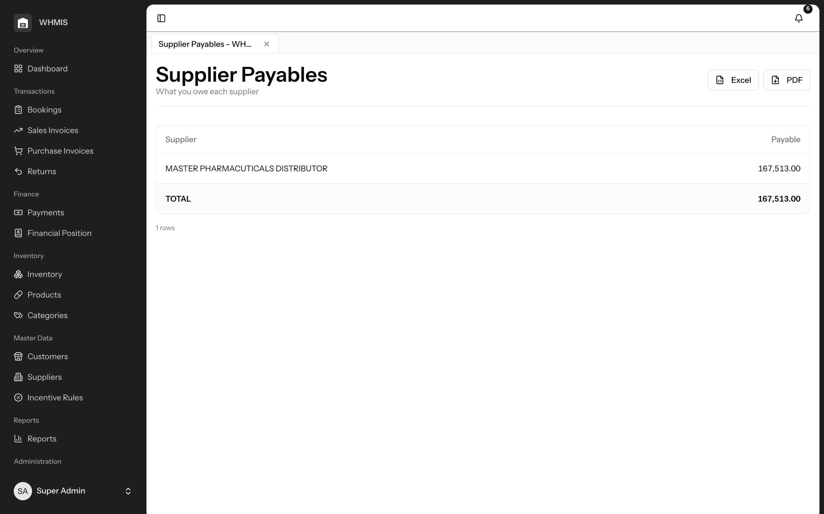
Supplier Payables — what you owe each supplier.

MODULE 11 · TRANSACTIONS

Returns — Clean Reversals, No Manual Mess
Returns are handled properly, not patched by hand. A sales return restores stock to the exact batches it was sold from and refunds the customer proportionally; a purchase return reverses stock and the supplier’s balance. Returns post immediately with the correct credit and debit notes, so inventory and ledgers stay perfectly in step without any manual adjustment.
Why this matters
In pharma, returns are constant — near-expiry stock comes back from pharmacies, and damaged or wrong goods go back to suppliers. Handled by hand, each one risks double-counting stock, refunding the wrong amount, or leaving a batch’s records inconsistent. WHMIS makes every reversal exact — back to the right batch, at the right value — so your inventory and your accounts never drift apart.

Key capabilities
- Batch-accurate restock — sales returns go back to the specific batches originally sold.
- Proportional refunds — the refund matches the value of the goods returned.
- Supplier returns — purchase returns reverse stock and the supplier balance cleanly.
- Immediate posting — returns settle at once with proper credit and debit notes.
Business benefits
- Inventory and accounts that never drift after a return.
- No error-prone manual adjustments.
- A clear, documented trail for every return.

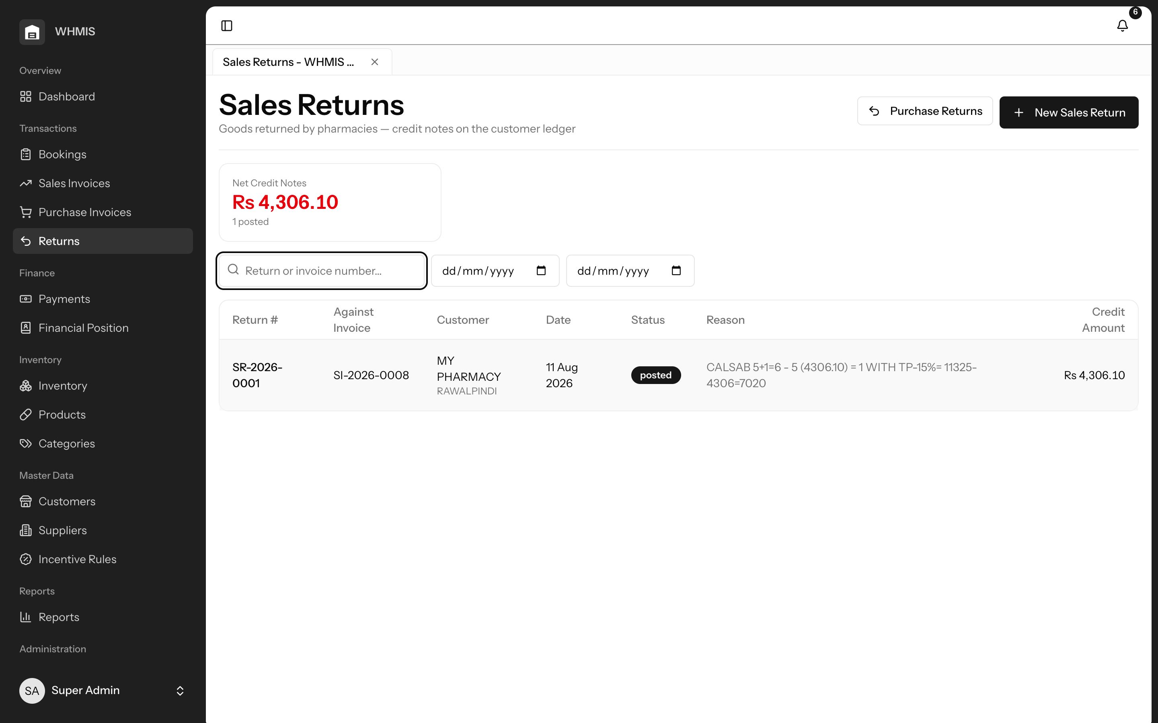
Sales returns, tracked against the original invoice.

MODULE 12 · INSIGHTS

Reports & Analytics — Seventeen Reports, One Click to Export
WHMIS ships with seventeen ready-made reports spanning Sales, Purchases, Inventory and Finance — the exact views a distributor needs to run and defend the business. Each one renders on screen with totals and, where useful, a chart, and each exports to Excel or PDF with a single click for sharing with owners, auditors or partners. There is nothing to build or configure; the insight is already there.
Why this matters
Data you cannot see is data you cannot act on. Pre-built, exportable reports mean you spend your time deciding, not assembling — and everyone, from the owner to the auditor, works from the same trusted figures.

Key capabilities
- Sales insight — registers, product and customer profitability, booker performance, and incentives given.
- Purchase insight — registers, supplier analysis, and bonus received versus bonus given.
- Inventory insight — stock position, stock movement, expiry, and slow- versus fast-movers.
- Financial insight — outstanding and aging, supplier payables, and a twelve-month profit trend.
- Export anywhere — one click to Excel or PDF on every report.
Business benefits
- Immediate answers across every part of the business.
- Board-ready and audit-ready figures on demand.
- No spreadsheets to build or maintain.

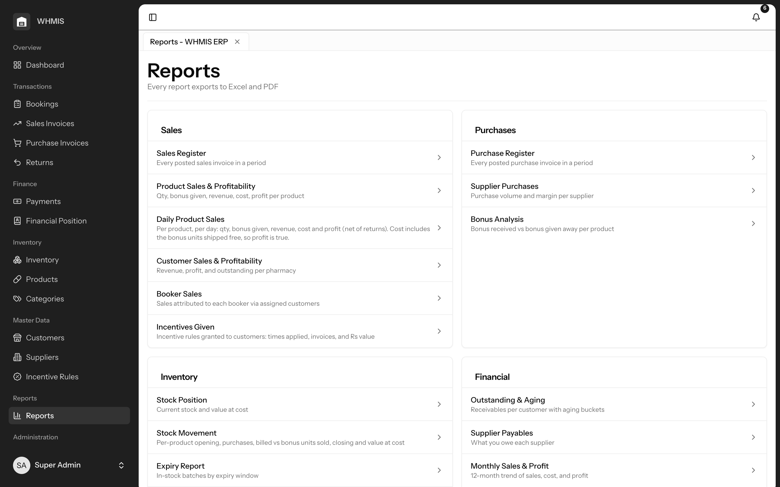
The report catalogue, grouped by area.
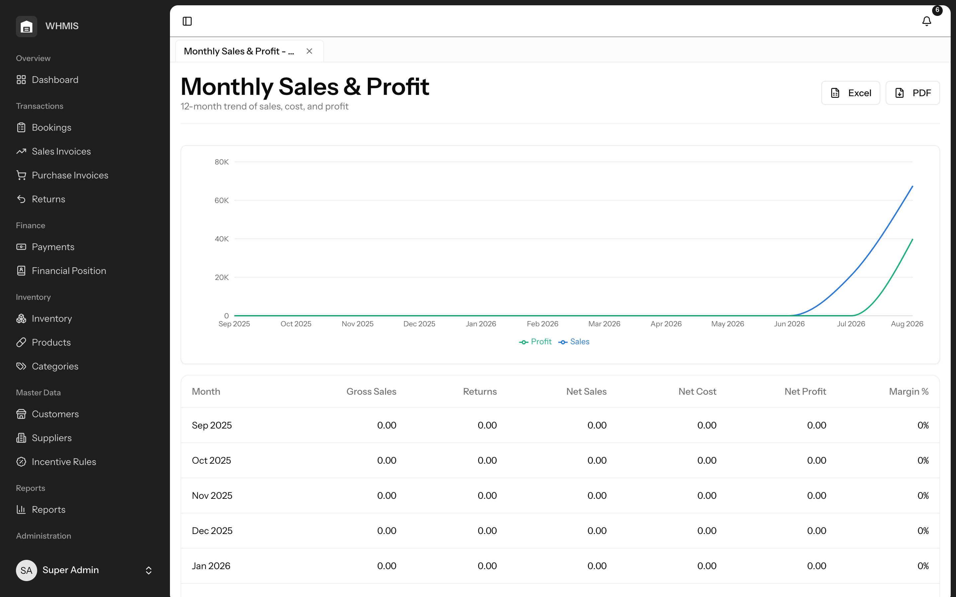
A report with chart, totals and Excel / PDF export.
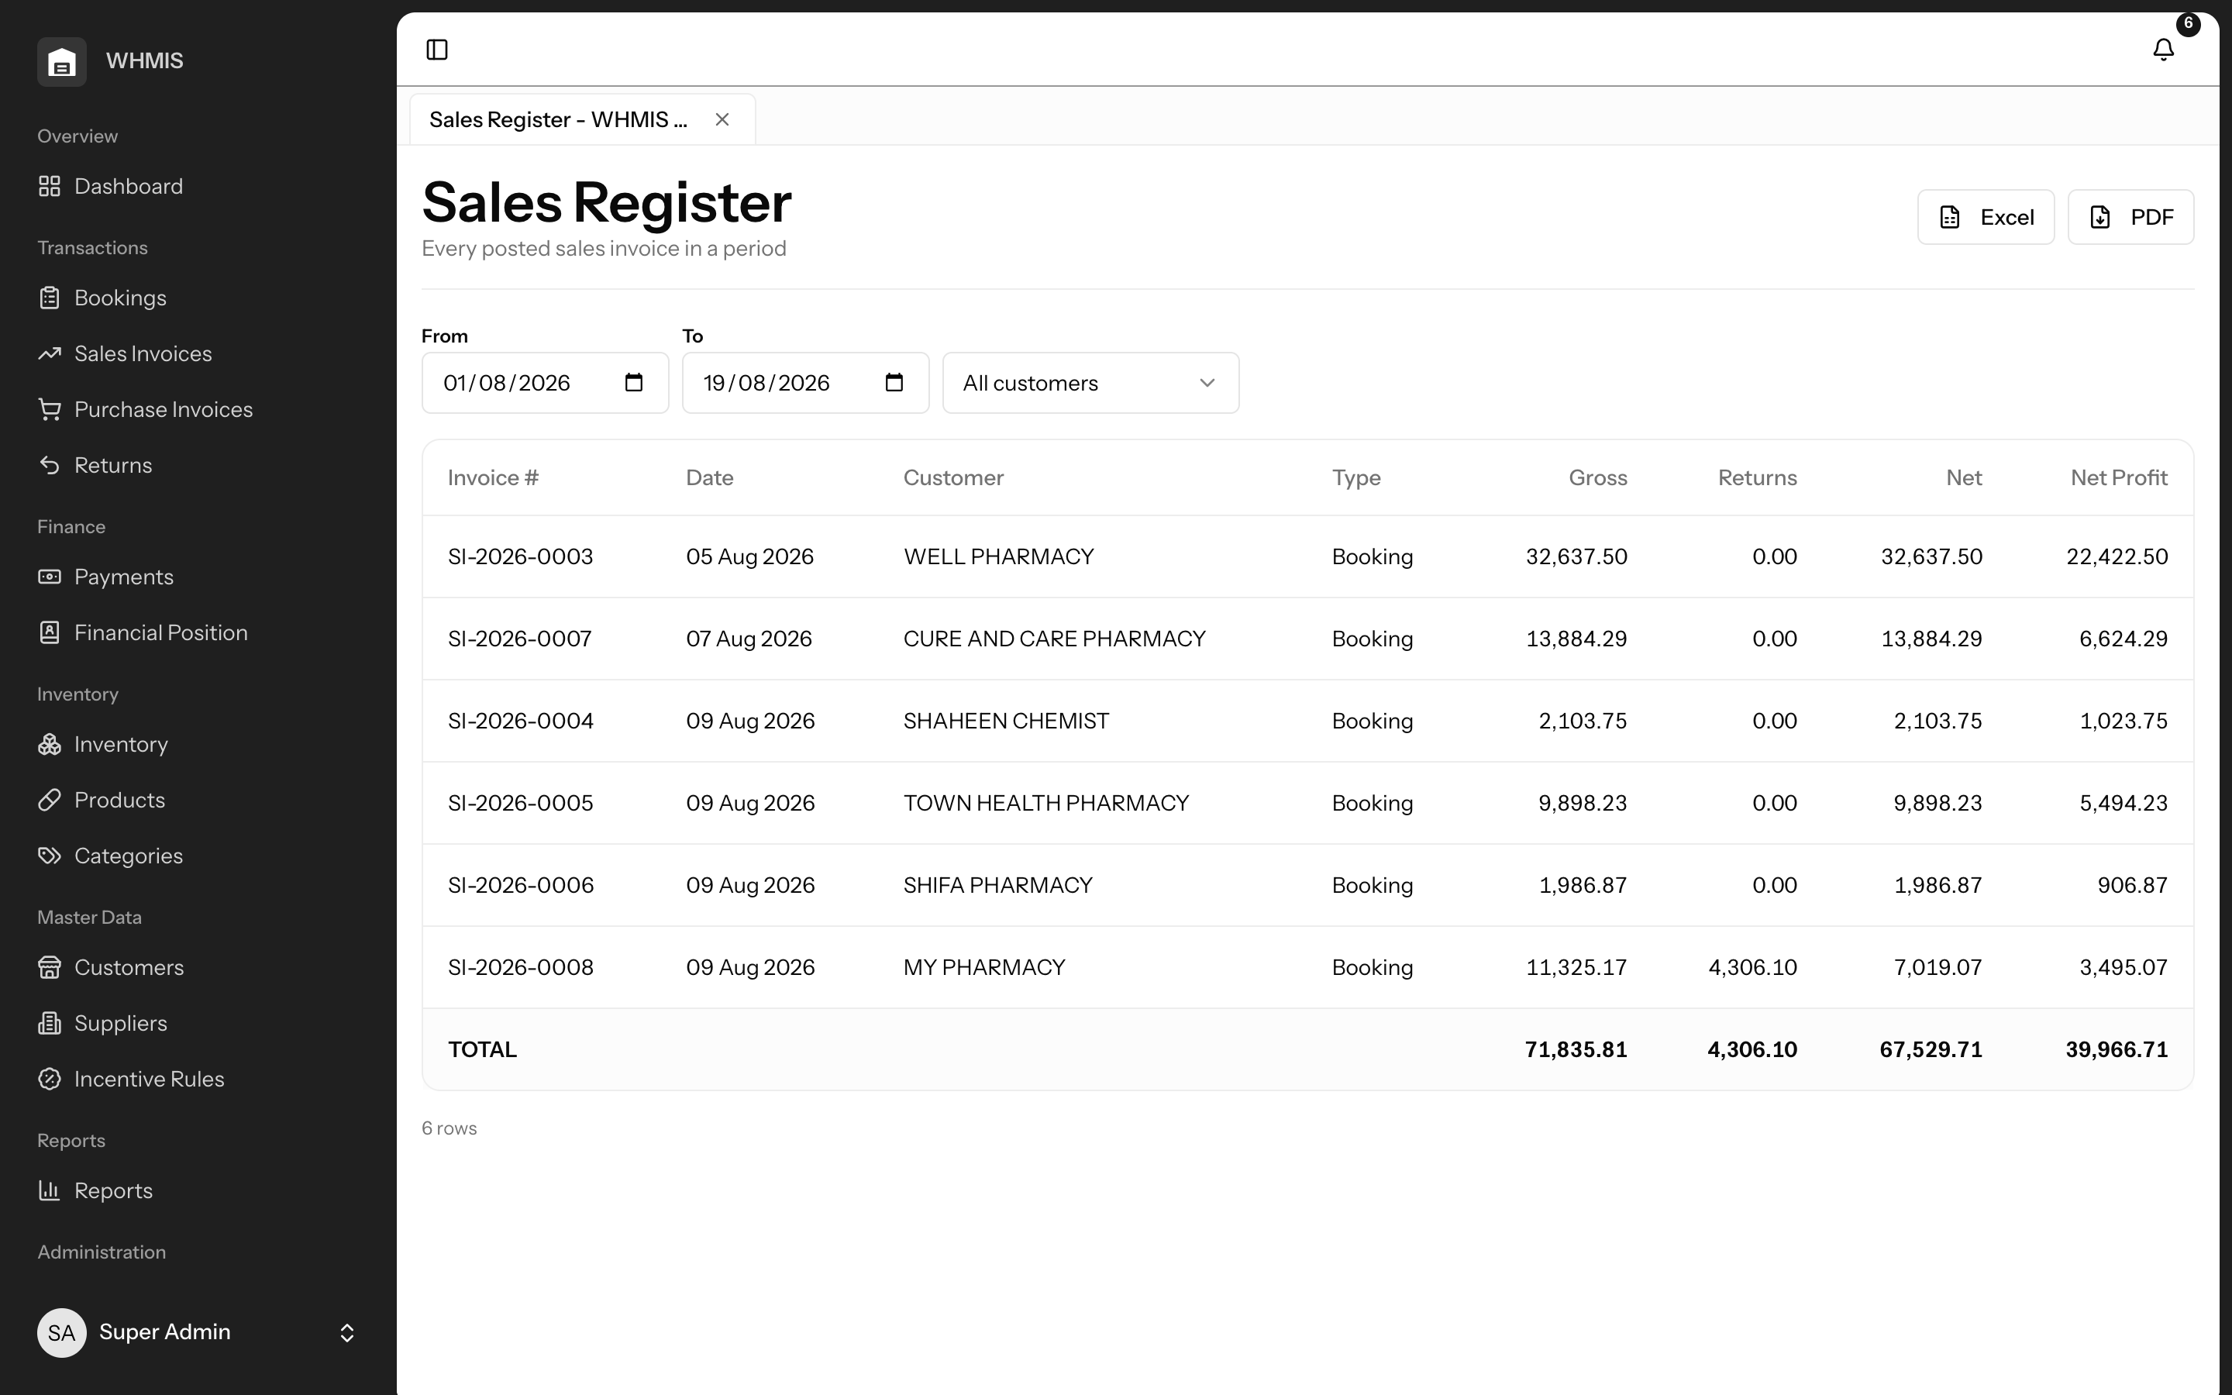
The sales register — one of seventeen built-in reports.

MODULE 13 · PLATFORM

Workspace Tabs — Many Screens, One Window
Distribution work is rarely one thing at a time — a call comes in while you are mid-invoice, and a report is needed while an order is half-entered. WHMIS lets you open sales, bookings, inventory and reports as tabs inside a single window and switch between them instantly. Each tab keeps its own data, filters and half-typed entries, so you never lose your place or your work when you jump between tasks.
Why this matters
Constantly reloading pages and re-entering filters wastes minutes that add up across a busy day. A tabbed workspace keeps your team in flow and their work safe.

Key capabilities
- Multiple screens at once — open several parts of the system side by side as tabs.
- Instant switching — move between tasks with no reload and no waiting.
- State retained — each tab remembers its data, filters and unsaved entries.
- Familiar experience — a browser-like feel your team already understands.
Business benefits
- Higher productivity through uninterrupted multitasking.
- No lost work when switching between tasks.
- A modern, intuitive experience with almost no training.

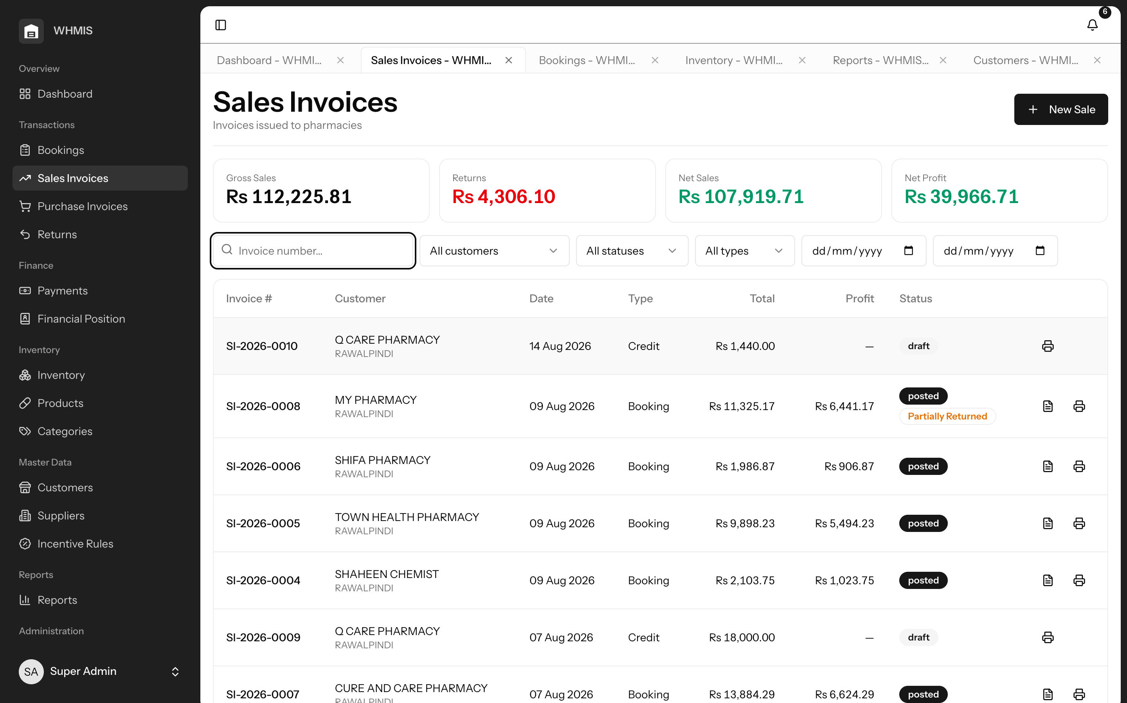
Several screens open as tabs, each retaining its own state.

MODULE 14 · PLATFORM

Security & Access — The Right Access for Every Role
WHMIS gives every team member exactly the access their job requires — and nothing more. Role-based permissions govern every sensitive action, from posting a sale to approving a booking, and roles such as booker are deliberately restricted so field staff can create orders but never touch billing or master pricing. Meanwhile, in-app notifications keep the right people informed about low stock, upcoming expiry, overdue balances and pending approvals.
Why this matters
Uncontrolled access is how prices get changed, discounts get abused and mistakes go unnoticed. Scoping access to roles protects both your data and your margin, and gives you a clear line of accountability.

Key capabilities
- Role-based permissions — every sensitive action is gated by role.
- Least-privilege by design — bookers and other roles see only what they need.
- Proactive alerts — notifications flag low stock, expiry, overdue balances and approvals awaiting action.
- Accountability — actions are tied to the user who performed them.
Business benefits
- Sensitive functions protected from accidental or deliberate misuse.
- Clear accountability across the team.
- Important issues surfaced automatically, before they cost you.

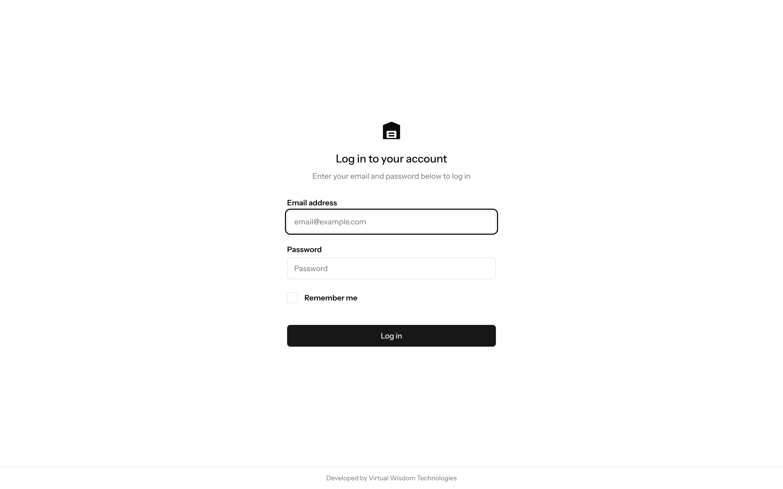
Secure sign-in; access is scoped to each user’s role.

MODULE 15 · PLATFORM

Deployment & Localisation — Built to Fit How You Work
WHMIS is delivered as a single, self-contained application that runs on standard cPanel web hosting — no specialist servers, no complex infrastructure and nothing for your staff to install. It is used from any modern browser on desktop or laptop, and it speaks your language commercially: prices in PKR and Pakistan tax fields (GST, NTN, STRN, CNIC) throughout, so your documents are compliant from the very first invoice. Your data lives in your own database, under your control.
Why this matters
Software that demands heavy infrastructure or foreign tax assumptions becomes a burden. WHMIS is designed to fit the way distributors in Pakistan already host, work and comply — so adoption is low-risk and low-cost.

Key capabilities
- Simple hosting — deploys to ordinary cPanel hosting; no special servers required.
- Browser-based — accessible from any modern browser, with nothing to install.
- Pakistan-ready — PKR currency and GST / NTN / STRN / CNIC fields built in.
- Your data, your control — everything is stored in your own database.
Business benefits
- Low-cost, low-risk deployment on hosting you already understand.
- Compliant documents out of the box.
- Full ownership of your business data.

Thank you. Virtual Wisdom Technologies (SMC-Private) Limited would be glad to walk the team at MASTER PHARMACUTICALS DISTRIBUTOR through any part of WHMIS in a live, hands-on demonstration.

