Machine Learning Course Project
Heart Disease Prediction
A Web-Based Machine Learning Application with Multi-Model Comparison
Project Report
Submitted by: ____________________________
Student ID: ____________________________
Course: Machine Learning
Instructor: ____________________________
June 2026

Abstract
Cardiovascular disease is one of the leading causes of death worldwide, and early identification of at-risk patients can significantly improve outcomes. This project presents a fully self-contained, web-based machine learning application that predicts the presence of heart disease from eleven routine clinical measurements. Four supervised classification algorithms — Logistic Regression, Random Forest, Support Vector Machine and Gradient Boosting — were trained and evaluated on the combined UCI Heart Disease dataset (920 records). All models are trained and executed locally with no external prediction APIs. The Random Forest model achieved the highest discriminative ability with a ROC-AUC of 0.901, while the Support Vector Machine achieved the highest test accuracy (0.821). The application, built with Streamlit, lets a user enter patient measurements to obtain a risk prediction and provides an interactive dashboard comparing all models across accuracy, precision, recall, F1-score, ROC-AUC, training time and confusion matrices.
Keywords: heart disease, classification, scikit-learn, Streamlit, model comparison, ROC-AUC.

Table of Contents

1. Introduction and Problem Statement
Cardiovascular diseases (CVDs) are the number-one cause of death globally, taking an estimated 17.9 million lives each year according to the World Health Organization. Many of these deaths are premature and preventable when risk factors are detected early. Clinicians routinely record measurements such as blood pressure, cholesterol, resting ECG results and exercise response; however, manually combining these indicators into an accurate risk assessment is difficult and subjective.
The problem addressed in this project is: given a set of routine clinical measurements for a patient, can we automatically and reliably predict whether that patient has heart disease? This is a binary classification problem. The goal is not to replace medical judgement but to provide a fast, data-driven decision-support tool and, in the context of this course, to demonstrate the full machine-learning workflow inside a usable web application.

1.1 Objectives
- Build a web-based application that lets a user enter patient data and receive a heart-disease risk prediction.
- Train and evaluate at least two machine-learning algorithms on the same dataset.
- Keep the system fully self-contained — all models trained and executed locally, with no external prediction APIs.
- Provide a dashboard that compares the models across accuracy, precision, recall, F1-score, ROC-AUC, training time and confusion matrices.
- Document the complete methodology and results in this report.

2. Literature Review
Heart-disease prediction using machine learning is a well-studied problem, and the UCI Heart Disease dataset is one of the most widely used benchmarks in the field. Detrano et al. (1989) originally applied a logistic-regression-based algorithm to the Cleveland data and reported approximately 77% diagnostic accuracy, establishing the dataset as a reference benchmark.
Subsequent studies explored a broad range of classifiers. Logistic Regression and Naive Bayes remain popular baselines because of their interpretability, while tree-based ensembles such as Random Forest and Gradient Boosting frequently report the strongest performance, typically in the 80–90% accuracy range depending on preprocessing and validation strategy. Support Vector Machines with non-linear kernels are also commonly competitive on this dataset. Across the literature, three themes recur: (i) careful handling of missing values materially affects results, (ii) ROC-AUC is preferred over raw accuracy for medical screening because it captures the trade-off between sensitivity and specificity, and (iii) recall (sensitivity) is especially important because a false negative — missing a genuinely sick patient — is more costly than a false positive.
This project builds on those lessons: it combines all four UCI databases to enlarge the sample, treats physiologically impossible zero values as missing, imputes them inside a leakage-free pipeline, and reports a full suite of metrics rather than accuracy alone — with particular attention to recall and ROC-AUC.

3. Dataset Description
The data used is the UCI Heart Disease Data Set (Dua & Graff, UCI Machine Learning Repository). It is distributed as four separate databases collected at different institutions: Cleveland Clinic (303 records), Hungarian Institute of Cardiology (294), University Hospital Zurich/Basel, Switzerland (123) and the V.A. Medical Center, Long Beach (200). These were combined into a single table of 920 records, comfortably exceeding the recommended minimum of 500.
Eleven clinical features are used to predict a binary target. The original dataset codes the diagnosis on a 0–4 scale; following standard practice this is binarised so that any value greater than zero indicates the presence of disease. The class distribution is reasonably balanced: 509 patients with disease and 411 without.
Feature | Type | Description
age | Numeric | Age of the patient in years
sex | Categorical | Biological sex (1 = male, 0 = female)
cp | Categorical | Chest pain type (1–4)
trestbps | Numeric | Resting blood pressure (mm Hg)
chol | Numeric | Serum cholesterol (mg/dl)
fbs | Categorical | Fasting blood sugar > 120 mg/dl (1/0)
restecg | Categorical | Resting electrocardiographic results (0–2)
thalach | Numeric | Maximum heart rate achieved
exang | Categorical | Exercise-induced angina (1/0)
oldpeak | Numeric | ST depression induced by exercise
slope | Categorical | Slope of the peak exercise ST segment (1–3)
target | Binary | Diagnosis: 1 = disease present, 0 = absent
Table 1. Features in the combined Heart Disease dataset.
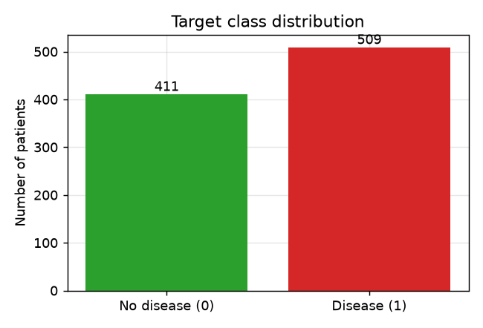
Figure 1. Target class distribution (disease vs. no disease).

4. Data Preprocessing
Several preprocessing steps were required to turn the raw UCI files into a clean, model-ready dataset. These steps are implemented in code (src/build_dataset.py and src/preprocess.py) so that they are fully reproducible.
- Merging: the four institutional databases share the same 14-attribute schema and were concatenated into one table.
- Missing-value coding: the raw files use '?' for missing entries. In addition, cholesterol and resting-blood-pressure values recorded as 0 are physiologically impossible and represent 'not measured'; these were converted to missing values (172 cholesterol and 1 blood-pressure records).
- Dropping sparse attributes: the 'ca' (number of major vessels) and 'thal' attributes are missing for the majority of the combined records (≈66% and ≈53% respectively) and were removed to avoid excessive imputation.
- Imputation: remaining missing values are filled inside the modelling pipeline — the median for numeric features and the most-frequent category for categorical features.
- Scaling and encoding: numeric features are standardised (zero mean, unit variance); categorical features are one-hot encoded.
Crucially, all imputation, scaling and encoding are wrapped in a single scikit-learn ColumnTransformer that is fitted only on the training data and applied to the test data. This prevents data leakage and guarantees that the exact same transformations are applied when the live web application makes a prediction.

5. Feature Engineering
The eleven retained attributes are themselves clinically meaningful, so feature engineering focused on correct representation rather than on creating many derived variables. Features were explicitly separated into numeric and categorical groups, each receiving an appropriate transformation. One-hot encoding allows the linear and kernel models to treat categories such as chest-pain type without imposing a false ordinal relationship, while standardisation ensures that distance- and gradient-based models (SVM, Logistic Regression) are not dominated by large-scale features such as cholesterol.
Correlation analysis (Figure 2) confirms that the engineered features carry signal: maximum heart rate (thalach) is negatively correlated with the target, while exercise-induced angina (exang), ST depression (oldpeak) and chest-pain type show clear positive associations with the presence of disease — relationships that are consistent with cardiology domain knowledge.
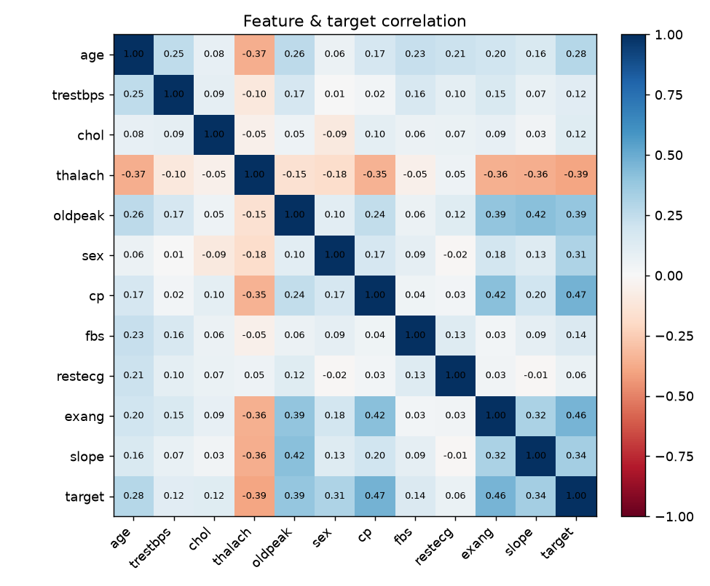
Figure 2. Correlation matrix of features and target.

6. Algorithms Used
Four supervised classification algorithms were selected to span a range of model families — linear, kernel-based and tree-ensemble — so that the comparison is informative:
- Logistic Regression — a linear, highly interpretable baseline that models the log-odds of disease as a weighted sum of the features.
- Random Forest — an ensemble of decision trees trained on bootstrapped samples; robust to outliers and able to capture non-linear feature interactions.
- Support Vector Machine (RBF kernel) — finds a maximum-margin decision boundary in a transformed feature space; calibrated to produce probability estimates.
- Gradient Boosting — an additive ensemble that builds trees sequentially, each correcting the errors of the previous ones; often a strong performer on tabular data.
Every algorithm is wrapped in an identical preprocessing pipeline, so all four are trained and evaluated on exactly the same data and the comparison is fair.

7. Model Training
The dataset was split into a training set and a held-out test set using an 80/20 stratified split (736 training and 184 test records), preserving the class balance in both partitions. A fixed random seed (42) makes the split and all model training fully reproducible.
Each model was trained on the training set and additionally validated with 5-fold cross-validation to assess stability. Cross-validated accuracy ranged from 0.785 to 0.811, confirming that the test-set results are representative and not the product of a single lucky split. Training time was also recorded for each model as one of the comparison metrics.

8. Evaluation Results
Models were evaluated on the held-out test set using the full set of metrics required by the project brief. Table 2 summarises the results; the best value in each column is associated with the starred Random Forest model, which was selected as the default model on the basis of ROC-AUC.
Model | Accuracy | Precision | Recall | F1 | ROC-AUC | Train (s)
Logistic Regression | 0.793 | 0.796 | 0.843 | 0.819 | 0.889 | 0.02
Random Forest * | 0.793 | 0.791 | 0.853 | 0.821 | 0.901 | 0.49
Support Vector Machine | 0.821 | 0.805 | 0.892 | 0.847 | 0.888 | 0.10
Gradient Boosting | 0.804 | 0.800 | 0.863 | 0.830 | 0.888 | 0.15
Table 2. Test-set performance of all four models (* = best model by ROC-AUC).
Confusion matrices (Figure 3) show how each model distributes its errors between false positives and false negatives. All models keep false negatives low, which is the desirable behaviour for a screening tool — the Support Vector Machine in particular misses only 11 of the 102 diseased patients in the test set.
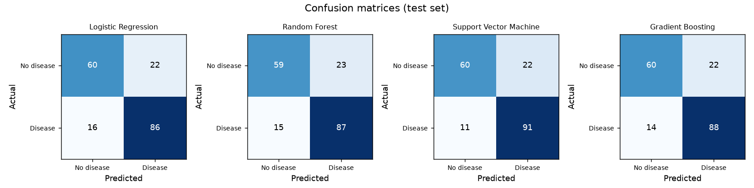
Figure 3. Confusion matrices for each model on the test set.
The ROC curves (Figure 4) plot the trade-off between sensitivity and the false-positive rate. All four curves lie well above the diagonal chance line, and the Random Forest curve dominates for most of its range, consistent with its leading ROC-AUC of 0.901.
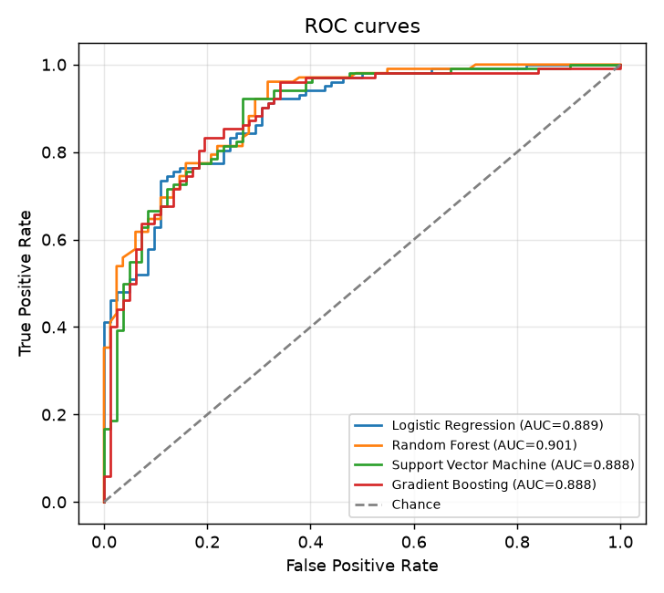
Figure 4. ROC curves for all models.

9. Comparison Analysis
Figure 5 compares all models side by side across the five core metrics. Several observations stand out. First, the models are close in overall quality — every model exceeds 0.79 accuracy and 0.88 ROC-AUC — which indicates that the signal in the data is captured well by all four approaches. Second, the choice of 'best' model depends on the metric one prioritises: the Support Vector Machine wins on accuracy, recall and F1-score, whereas the Random Forest wins on ROC-AUC. Third, training cost varies by more than an order of magnitude, from roughly 0.02 s for Logistic Regression to 0.49 s for the Random Forest.
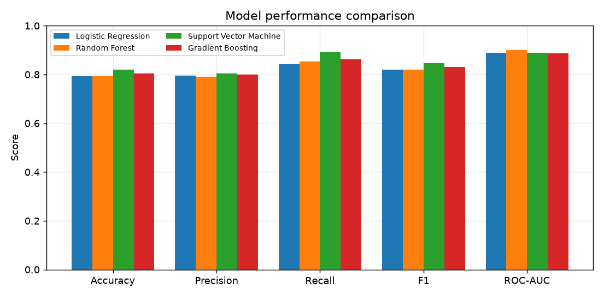
Figure 5. Grouped comparison of all models across the core metrics.
For a medical screening application, ROC-AUC and recall are the most relevant criteria because the cost of missing a sick patient (a false negative) is high. The Random Forest was therefore selected as the default model in the application for its best-in-class ROC-AUC and strong recall, while the Support Vector Machine remains an excellent alternative that a user can select for its higher raw accuracy and recall. The interactive dashboard lets users weigh these trade-offs themselves.

10. Web Application
The deliverable is a Streamlit web application that exposes the trained models through a browser interface. It is organised into four pages:
- Home — an overview of the project and a checklist of the requirements it satisfies.
- Predict — a form where the user enters the eleven clinical measurements and selects a model; the app returns a disease/no-disease prediction together with a probability gauge.
- Model Dashboard — the comparison dashboard, rendering Table 2 and Figures 3–5 interactively (performance table, grouped bar chart, ROC curves, confusion matrices and training time).
- Data Explorer — interactive inspection of the dataset, including distributions, disease rates per category and the correlation heatmap.
Because the trained pipelines are saved to disk and loaded at start-up, predictions are instantaneous and require no network access — satisfying the 'no external APIs' requirement. The same preprocessing pipeline used in training is applied to user input, guaranteeing consistency between training and inference.

11. Conclusion and Future Work
This project delivered a complete, self-contained machine-learning web application for heart-disease prediction. Four classifiers were trained and rigorously compared on the combined UCI Heart Disease dataset, with the Random Forest achieving the best ROC-AUC (0.901) and the Support Vector Machine the best accuracy (0.821). All mandatory requirements — a web interface, at least two algorithms on a common dataset, no external prediction APIs, user-driven prediction, and a model-comparison dashboard — were met.
Several avenues could extend the work:
- Hyperparameter tuning (e.g. grid or randomised search) to squeeze additional performance from each model.
- Adding explainability, such as SHAP values, so users can see which measurements drove a particular prediction.
- Incorporating the dropped 'ca' and 'thal' attributes via more sophisticated imputation, or sourcing a richer dataset.
- Calibrating decision thresholds to a clinically chosen sensitivity, and reporting confidence intervals.
- Deploying the application to a cloud host so it can be accessed without a local installation.
Disclaimer: this application was built for educational purposes and is not a medical device. It must not be used for actual diagnosis or treatment decisions.

References
1. World Health Organization. Cardiovascular diseases (CVDs) — Fact sheet. https://www.who.int/news-room/fact-sheets/detail/cardiovascular-diseases-(cvds)
2. Detrano, R., et al. (1989). International application of a new probability algorithm for the diagnosis of coronary artery disease. American Journal of Cardiology, 64(5), 304–310.
3. Dua, D. & Graff, C. (2019). UCI Machine Learning Repository — Heart Disease Data Set. University of California, Irvine. https://archive.ics.uci.edu/dataset/45/heart+disease
4. Pedregosa, F., et al. (2011). Scikit-learn: Machine Learning in Python. Journal of Machine Learning Research, 12, 2825–2830.
5. Streamlit Inc. Streamlit Documentation. https://docs.streamlit.io

