Assignment (POINTERS)

Task 01:

Write a program in C to demonstrate the use of &(address of) and *(value at address) operator using pointers

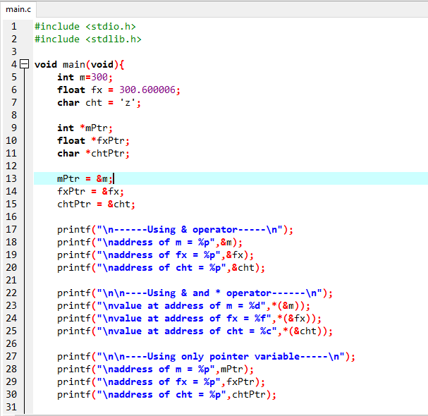Code:

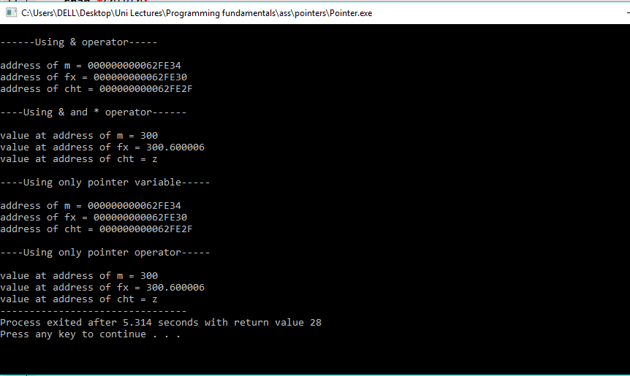Output:

Task 2:

Write a program in C to find the maximum number between two numbers using a pointer.

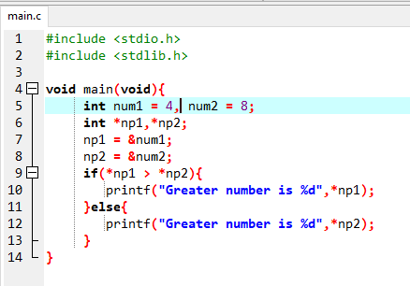Code:

Output:

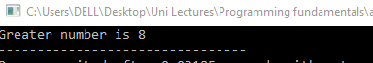

Task 3:

Write a program in C to add numbers using call by reference

Code:

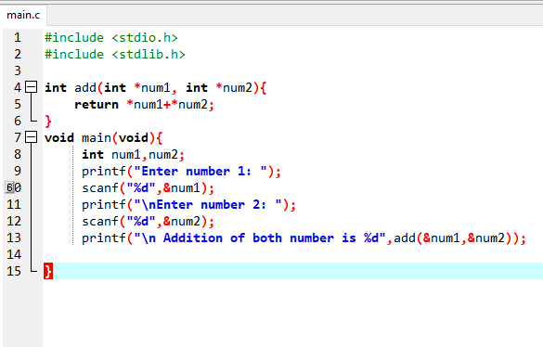

Output:

