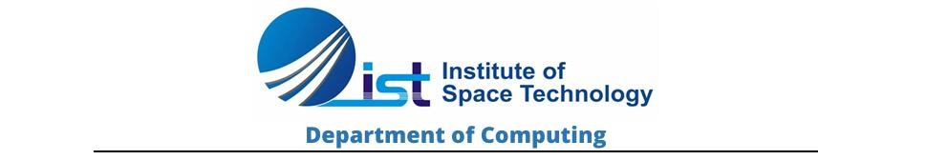
OOPS Lab Project
Hotel Management system
Submitted To: Ms. Fizza
Submitted By: M. Sahil Khan
Reg no: 250901032
Contents
Project title:- 2
Hotel Management System using C++ (Object Oriented Programming) 2
1. ABSTRACT 2
2. INTRODUCTION 2
3. OBJECTIVES 2
4. PROBLEM STATEMENT 3
5. FEATURES OF SYSTEM 3
6. OOP CONCEPTS USED 3
1. Encapsulation 3
2. Inheritance 3
3. Polymorphism 3
4. Abstraction 3
5. Dynamic Binding 4
6. Constructors & Destructors 4
7. SYSTEM MODULES 4
1. Room Management Module 4
2. Customer Management Module 4
3. Booking Module 4
4. Billing Module 4
5. Checkout Module 4
6. File Handling Module 4
7. CSV Export Module 4
8. UML DIAGRAM 5
9. FLOWCHART 5
10. CODE SECTION 6
11. SCREENSHOTS 12
12. ADVANTAGES 16
13. LIMITATIONS 16
14. FUTURE ENHANCEMENTS 16
15. CONCLUSION 16

Project title:-

Hotel Management System using C++ (Object Oriented Programming)

ABSTRACT
The Hotel Management System is a console-based application developed in C++ that automates hotel operations such as room booking, customer registration, billing, checkout, and data management.
The system replaces manual record-keeping with a computerized solution that improves efficiency, reduces errors, and enhances data accuracy. It uses Object-Oriented Programming (OOP) concepts including inheritance, polymorphism, abstraction, and encapsulation.
The system also supports file handling and CSV export to store data permanently and open it in Excel for reporting purposes.

INTRODUCTION
Hotels require efficient management of rooms, customers, and billing systems. Manual systems are slow and error-prone. To solve this, a C++ based Hotel Management System is developed.
This system helps:
- Manage room availability
- Store customer records
- Automate booking process
- Generate bills
- Perform checkout operations
- Store data permanently

OBJECTIVES
The main objectives of this project are:
- To develop a hotel management system using C++
- To apply Object-Oriented Programming concepts
- To automate hotel operations
- To manage customer and room records efficiently
- To generate accurate billing system
- To implement file handling for permanent storage
- To export data into CSV (Excel format)

PROBLEM STATEMENT
Manual hotel management has several issues:
- Data duplication
- Human errors in billing
- Difficult record tracking
- Slow processing
- No proper data storage system
This project solves these problems using a structured OOP-based system.

FEATURES OF SYSTEM
✔ Add Rooms
✔ Display Available Rooms
✔ Book Rooms
✔ Store Customer Data
✔ Search Customer/Room Data
✔ Generate Bills
✔ Checkout Customers
✔ File Handling (.txt storage)
✔ Export Data to CSV (Excel support)

OOP CONCEPTS USED

1. Encapsulation
Data is hidden inside classes using private variables.

2. Inheritance
- Customer inherits Person class
- StandardRoom & DeluxeRoom inherit Room class

3. Polymorphism
- Virtual functions used:
  - display()
  - bill()
  - getType()

4. Abstraction
Abstract classes:
- Person
- Room

5. Dynamic Binding
Achieved using virtual functions

6. Constructors & Destructors
Used for initialization and cleanup

SYSTEM MODULES

1. Room Management Module
- Add rooms
- Display rooms
- Check availability

2. Customer Management Module
- Add customer data
- Store records

3. Booking Module
- Assign rooms to customers
- Check availability

4. Billing Module
- Calculate total cost based on days

5. Checkout Module
- Free occupied rooms

6. File Handling Module
- Store data in text file
- Load previous records

7. CSV Export Module
- Export data to Excel format

UML DIAGRAM
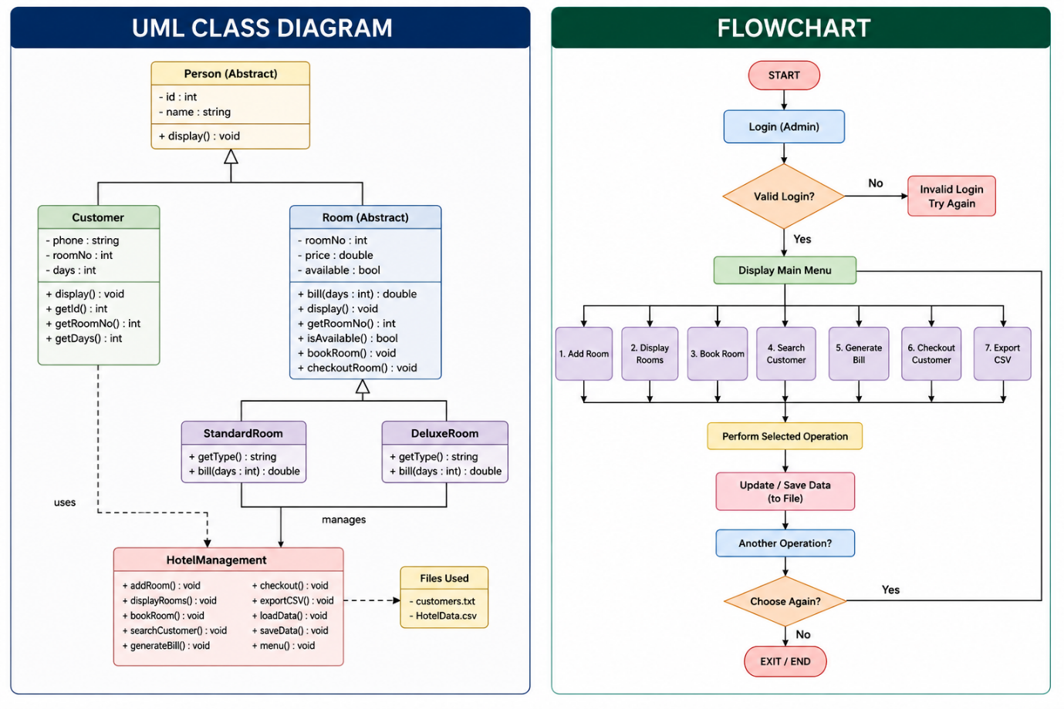

FLOWCHART



CODE SECTION

#include <iostream>
#include <fstream>
#include <vector>
#include <iomanip>
using namespace std;

/* =========================
ABSTRACT CLASS (OOP)
========================= */
class Person {
protected:
int id;
string name;

public:
Person(int i = 0, string n = "") {
id = i;
name = n;
}

virtual void display() = 0; // Abstraction
};

/* =========================
CUSTOMER CLASS (Inheritance)
========================= */
class Customer : public Person {
string phone;
int roomNo;
int days;

public:
Customer(int i = 0, string n = "", string p = "", int r = 0, int d = 0)
: Person(i, n) {
phone = p;
roomNo = r;
days = d;
}

int getId() { return id; }
int getRoomNo() { return roomNo; }
int getDays() { return days; }
string getName() { return name; }
string getPhone() { return phone; }

void setRoom(int r, int d) {
roomNo = r;
days = d;
}

void display() override {
cout << "\nID: " << id
<< "\nName: " << name
<< "\nPhone: " << phone
<< "\nRoom: " << roomNo
<< "\nDays: " << days << endl;
}
};

/* =========================
ROOM CLASS (Inheritance + Polymorphism)
========================= */
class Room {
protected:
int roomNo;
double price;
bool available;

public:
Room(int r, double p) {
roomNo = r;
price = p;
available = true;
}

virtual string getType() = 0;

int getRoomNo() { return roomNo; }
bool isAvailable() { return available; }

void bookRoom() { available = false; }
void checkoutRoom() { available = true; }

virtual double bill(int days) {
return price * days;
}

virtual void display() {
cout << "Room: " << roomNo
<< " | Price: " << price
<< " | Status: " << (available ? "Available" : "Booked")
<< endl;
}

virtual ~Room() {}
};

/* =========================
STANDARD ROOM
========================= */
class StandardRoom : public Room {
public:
StandardRoom(int r) : Room(r, 3000) {}

string getType() override {
return "Standard";
}
};

/* =========================
DELUXE ROOM
========================= */
class DeluxeRoom : public Room {
public:
DeluxeRoom(int r) : Room(r, 6000) {}

string getType() override {
return "Deluxe";
}
};

/* =========================
HOTEL MANAGEMENT SYSTEM
========================= */
class HotelManagement {
private:
vector<Customer> customers;
vector<Room*> rooms;

public:
HotelManagement() {
loadData();

// default rooms
if (rooms.empty()) {
rooms.push_back(new StandardRoom(101));
rooms.push_back(new StandardRoom(102));
rooms.push_back(new DeluxeRoom(201));
rooms.push_back(new DeluxeRoom(202));
}
}

/* ================= FILE LOAD ================= */
void loadData() {
ifstream file("customers.txt");
int id, room, days;
string name, phone;

while (file >> id >> name >> phone >> room >> days) {
customers.push_back(Customer(id, name, phone, room, days));
}
file.close();
}

/* ================= SAVE FILE ================= */
void saveData() {
ofstream file("customers.txt");

for (auto &c : customers) {
file << c.getId() << " "
<< c.getName() << " "
<< c.getPhone() << " "
<< c.getRoomNo() << " "
<< c.getDays() << endl;
}
file.close();
}

/* ================= ADD ROOM ================= */
void addRoom() {
int type, no;

cout << "\n1. Standard\n2. Deluxe\nEnter type: ";
cin >> type;

cout << "Enter Room Number: ";
cin >> no;

if (type == 1)
rooms.push_back(new StandardRoom(no));
else
rooms.push_back(new DeluxeRoom(no));

cout << "Room Added Successfully!\n";
}

/* ================= DISPLAY ROOMS ================= */
void displayRooms() {
cout << "\n===== ROOMS =====\n";
for (auto r : rooms) {
r->display();
}
}

/* ================= SEARCH CUSTOMER ================= */
void searchCustomer() {
int id;
cout << "Enter Customer ID: ";
cin >> id;

for (auto &c : customers) {
if (c.getId() == id) {
c.display();
return;
}
}
cout << "Customer Not Found!\n";
}

/* ================= BOOK ROOM ================= */
void bookRoom() {
int id, roomNo, days;
string name, phone;

cout << "Enter Customer ID: ";
cin >> id;

cout << "Enter Name: ";
cin >> name;

cout << "Enter Phone: ";
cin >> phone;

cout << "Enter Room No: ";
cin >> roomNo;

cout << "Enter Days: ";
cin >> days;

for (auto r : rooms) {
if (r->getRoomNo() == roomNo && r->isAvailable()) {

r->bookRoom();

customers.push_back(Customer(id, name, phone, roomNo, days));

cout << "\nRoom Booked Successfully!\n";
saveData();
return;
}
}

cout << "Room Not Available!\n";
}

/* ================= GENERATE BILL ================= */
void generateBill() {
int id;
cout << "Enter Customer ID: ";
cin >> id;

for (auto &c : customers) {
if (c.getId() == id) {

for (auto r : rooms) {
if (r->getRoomNo() == c.getRoomNo()) {

double total = r->bill(c.getDays());

cout << "\n===== BILL =====";
cout << "\nName: " << c.getName();
cout << "\nRoom: " << c.getRoomNo();
cout << "\nDays: " << c.getDays();
cout << "\nTotal Bill: " << total << endl;
return;
}
}
}
}

cout << "Customer Not Found!\n";
}

/* ================= CHECKOUT ================= */
void checkout() {
int id;
cout << "Enter Customer ID: ";
cin >> id;

for (int i = 0; i < customers.size(); i++) {
if (customers[i].getId() == id) {

for (auto r : rooms) {
if (r->getRoomNo() == customers[i].getRoomNo()) {
r->checkoutRoom();
}
}

customers.erase(customers.begin() + i);
cout << "Checkout Successful!\n";

saveData();
return;
}
}

cout << "Customer Not Found!\n";
}

/* ================= EXPORT CSV ================= */
void exportCSV() {
ofstream file("HotelData.csv");

file << "ID,Name,Phone,Room,Days\n";

for (auto &c : customers) {
file << c.getId() << ","
<< c.getName() << ","
<< c.getPhone() << ","
<< c.getRoomNo() << ","
<< c.getDays() << "\n";
}

file.close();

cout << "CSV Exported Successfully!\n";
}

/* ================= MENU ================= */
void menu() {
int choice;

do {
cout << "\n\n===== HOTEL MANAGEMENT SYSTEM =====";
cout << "\n1. Add Room";
cout << "\n2. Display Rooms";
cout << "\n3. Book Room";
cout << "\n4. Search Customer";
cout << "\n5. Generate Bill";
cout << "\n6. Checkout Customer";
cout << "\n7. Export CSV";
cout << "\n8. Exit";

cout << "\nEnter Choice: ";
cin >> choice;

switch (choice) {
case 1: addRoom(); break;
case 2: displayRooms(); break;
case 3: bookRoom(); break;
case 4: searchCustomer(); break;
case 5: generateBill(); break;
case 6: checkout(); break;
case 7: exportCSV(); break;
case 8: saveData(); break;
default: cout << "Invalid Choice!\n";
}

} while (choice != 8);
}

~HotelManagement() {
for (auto r : rooms)
delete r;
}
};

/* ================= MAIN ================= */
int main() {
HotelManagement h;
h.menu();
return 0;
}

SCREENSHOTS

Screenshot 1: Main Menu
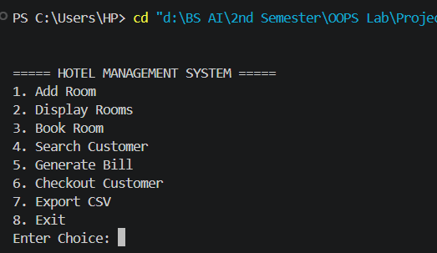

Screenshot 2: Add Room

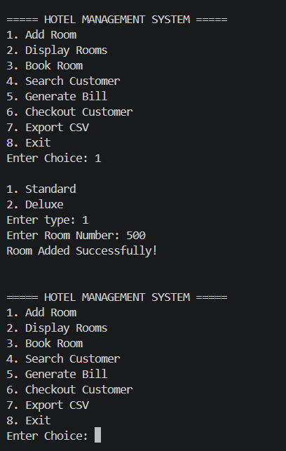

Screenshot 3: Display Rooms
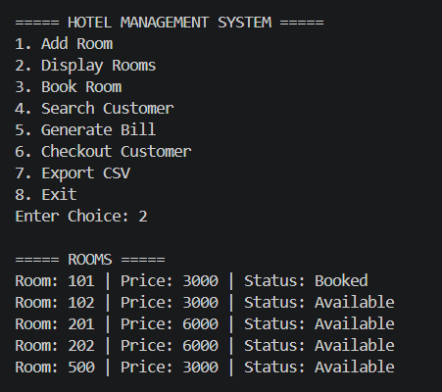

Screenshot 4: Book Room

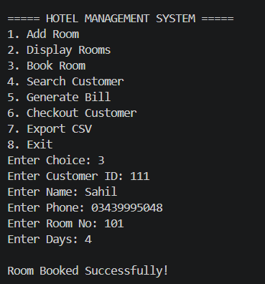

Screenshot 5: Search Customers
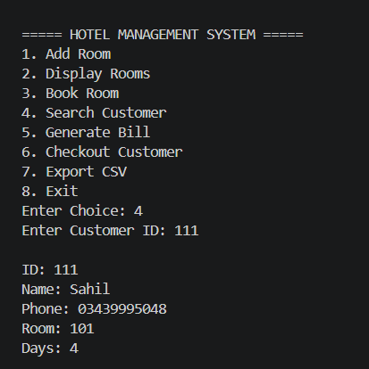

Screenshot 6: Billing Output
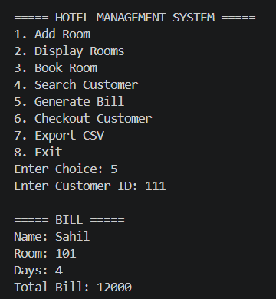

Screenshot 7: Checkout
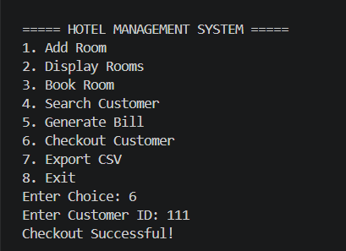

Screenshot 8: CSV Export
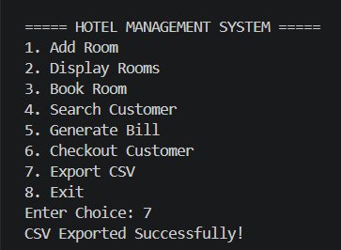

Screenshot 9: Records Save in Excel
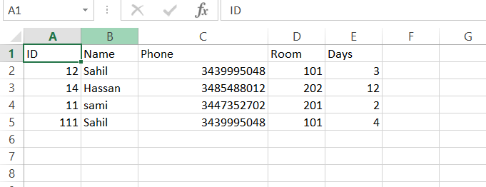

Screenshot 9: Records Save in txt format
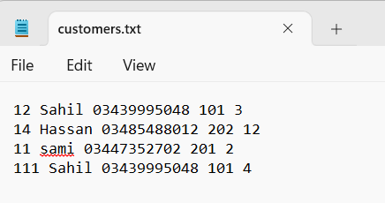

ADVANTAGES
✔ Easy to use
✔ Fast processing
✔ Reduces human errors
✔ Data stored permanently
✔ Excel support (CSV)
✔ Modular structure

LIMITATIONS
- Console-based interface only
- No GUI
- Limited security system
- No online booking

FUTURE ENHANCEMENTS
- GUI-based system (Qt / Windows App)
- Online booking system
- Database integration (MySQL)
- Payment gateway integration
- Multi-user system

CONCLUSION
The Hotel Management System successfully automates hotel operations using C++ and Object-Oriented Programming. It improves efficiency, reduces manual work, and provides a structured approach to managing hotel data.

