1. **Requirement**

* **Title**

Creating a restaurant website template

* **Project Details**

We are currently looking for the following people

Creating a restaurant website template(coding)

【Overview】

Our company operates a variety of businesses information technology ventures.

This time, we are looking for a "coder" who can create a template for our new business, "Products that can be created by using the restaurant system."

【Details】

This time, it is a "template production" involving the system, so it would be good if you had some understanding of the system."Ideally, you should be able to code by yourself. As for the design, we place importance on quality (only those who can produce in HTML, not WordPress templates).

This time, we will be using CMS like WordPress, so we are looking for people who can design templates.

【Request details】

There are two deliverables.

1. Basic page×1
2. block collection（For customization）×1

・commissioned process：coding、mobile responsive

・working volume：TOP page×2

※For more information, we will send you a sample page as soon as we have finished talking about it.

【Materials to be:】

・PSD design

【design image】

・reference site：I'll show you when we get to the point.

1. **Details**

It will be a little longer, but I will explain to you the background of my request!

<https://333-inc.com/>

Our company is Triple Three Co., Ltd. and has been in business for two years. For more information, please visit our website.

I'm the CEO. To briefly tell you my background, I had been working at Suntory for 12 years until two years ago, and I was a consultant for a restaurant (restaurant).We became independent two years ago, but this time we decided to develop a product for HP production with our fellow engineers, utilizing the connection with the restaurant and the nationwide network of Suntory salesmen.

This time, we would like to name the system "TRIPLE PAGE" and expand it into restaurants. What kind of website is...

■Our goal is to create an all-in-one website for attracting customers that includes all the marketing necessary for store-related businesses.

What I would like you to do this time is:

1. Basic Layout Page
2. block page

these 2 pages coding.

The image of another company is as follows.

1. Basic Layout Page＞

<https://hanjo-one.com/basic/>

1. block page＞

<https://hanjo-one.com/blocks/>

Using ① as a template, we would like to customize from ②'s block collection and create websites for various restaurants.

From now on, we would like to increase the number of templates such as Japanese food, Do Izakaya, restaurants, Italian...

That's what we've done so far.

This time, we are going to create a template, so we would appreciate it if you could put together various source codes in the block collection of ② and design it so that it can be customized.

1. Basic Layout Page＞

<https://hanjo-one.com/basic/>

1. block page＞

<https://hanjo-one.com/blocks/>

Finally, it will be OK if these two sites are completed!

Regarding the system to be created this time, we plan to create a simple MovableType-like CMS.

① Basic layout page

② Block page

The reason why we are asking you to create these two items is:

I would like to reuse HTML elements in blocks on the program and use them as a base for creating HP easily.That's how it works for.

For this reason, I would like you to make an estimate and create HTML so that it can be reused and customized on a block-by-block basis to some extent.I would like to explain this point, though it is not very rough.

·Mandatory points

→Use of grid system to increase layout freedom

→ I would like you to use the CSS framework to simplify element classification for convenience in reusing blocks.

→

< div class = " section 01 " >

< div > < / div >

< / div >

As in .section01 div{}, please do not specify css without class or id specification in div itself (just in case you use CSS framework).

·It is not necessary, but it would be helpful if you could consider it.

→Using bootstrap as a CSS framework

→ Systematically changing color schemes and fonts can be considered, so color schemes and font specifications for important parts are as easy to understand as possible.

That's all.

If you have any questions, please let me know.

Thank you for your confirmation.

"It is possible to change the color scheme or font systematically, so it is as easy to understand as possible to specify important parts."

This request is a basic part, so it's like preaching to Buddha, so I think it'll be all right.

Please leave comments at key points and arrange CSS by relevant elements or sections.

<https://hanjo-one.com/basic/>

Looking at this, is the black background bass very versatile?

By the way, the following is a list of websites made in this format.

＜Deployment Examples＞

Fujisawa Meat Shop

<https://fujisawa-nikuten.com>

feast

<https://gujo-usami.com>

fine

<https://haru-gifu.com>

sumi yoshi be-su sama

<https://sumiyoshi-base.com>

Western Cuisine Kikkou-sama

<https://yoshoku-kikkou.com>

I would be happy if I could make a "model" of the template well!

By the way, this system is managed by having Suntory salesmen all over the country carry it.

I would like to improve compatibility with Google My Business this time.Specifically, using the API connection function,

If you update the information on the website, it would be great if it could be automatically reflected in Google My Business.Therefore, I would appreciate it if you could create a design with the image of publishing all the information on Google My Business.

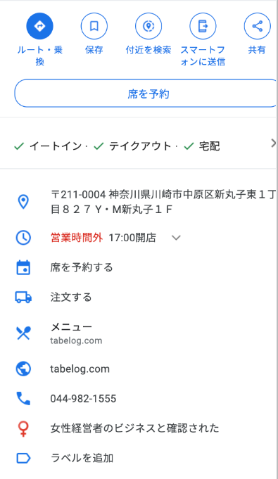

Here is the reference.

<https://goo.gl/maps/EtKH4CJaT8LYG1pm6>