Dataset: NHANES (2021-23):
- Dataset: NHANES 2021-2023 adult participants.
- Final modeling CSV: 5,552 rows x 25 columns.
- Final target: three-class kidney-risk screening label: Low / Moderate / High.
- Modeling split: Train 3,886 / Validation 833 / Test 833, stratified by class.
- Class distribution is highly imbalanced: Low 82.91%, Moderate 12.63%, High 4.47%.

Main dataset:
N = 5552
Features = 22
Numeric features = 15
Binary features = 7

Class | Count | Percent
Low | 4603 | 82.91%
Moderate | 701 | 12.63%
High | 248 | 4.47%

Split: 70-15-15(train-validation-test)
Split | Total | Low | Moderate | High
Train | 3886 | 3222 | 491 | 173
Validation | 833 | 691 | 105 | 37
Test | 833 | 690 | 105 | 38

In NHANES 2021–23 dataset, leakage-safe routine urine features are not available
In Public laboratory release- kidney-related urine variables are:
- urine albumin
- urine creatinine
- albumin–creatinine ratio or ACR/UACR

In NHANES, each participant has only a single eGFR and UACR measurement.

Target Construction:
UACR Calculation:
In the EDA notebook, UACR was calculated as:
uacr = (urine_albumin / urine_creatinine) * 100
The official NHANES documentation also uses the same formula:

CKD-EPI 2021 eGFR Calculation:
The notebook uses the following equation:
142
* min(Scr/k, 1)**alpha
* max(Scr/k, 1)**-1.200
* 0.9938**age
* 1.012 if female
This is consistent with the official race-free CKD-EPI 2021 creatinine equation.
KDIGO Category Boundaries:
The GFR categories used in the notebook are:
- G1: ≥90
- G2: 60–89
- G3a: 45–59
- G3b: 30–44
- G4: 15–29
- G5: <15
The albuminuria categories are:
- A1: <30
- A2: 30–300
- A3: >300
These category boundaries correctly match the KDIGO 2012 classification grid.
Three-Class Mapping:
The proposed mapping is:
- Low: G1/G2 with A1
- Moderate: G1/G2 with A2, or G3a with A1
- High: Combined KDIGO orange and red risk categories

# Low risk
if (g in ["G1", "G2"]) and (a == "A1"):
return "Low"

# Moderate risk
if ((g in ["G1", "G2"]) and (a == "A2")) or ((g == "G3a") and (a == "A1")):
return "Moderate"

# High risk: high + very high collapsed
return "High"

Part | What was done | purpose | findings
Dataset | NHANES 2021–2023 adult kidney-risk dataset, 5552 rows, 25 columns | Routine/non-invasive/common lab variables used for kidney-risk screening | Dataset imbalanced: Low 82.91%, Moderate 12.63%, High 4.47%. So, accuracy-only metric misleading.
Target | low / moderate / high kidney risk | Risk stratified screening target | It is not diagnosis, screening category.
Leakage control | eGFR, UACR, urine albumin, urine creatinine, serum creatinine were excluded | Target-defining variable were excluded due to m leakage issues | target generating variables were excluded from model training.
Feature setup | 15 numeric + 7 binary features | Routine lab/vital/history-based screening | Feature list clinically explainable.
Split | Train 3886, validation 833, test 833 | Train model, validation-for threshold/model choose, held-out test-used for final report | Test set was not used for tuning.

Validation threshold search:
Threshold | Validation Accuracy | Balanced Acc | Macro F1 | Moderate Recall | High Recall | High→Low Miss
0.425 | 0.6891 | 0.6835 | 0.5155 | 0.5333 | 0.8108 | 1
0.450 | 0.6903 | 0.6808 | 0.5204 | 0.5524 | 0.7838 | 1
0.500 | 0.6939 | 0.6787 | 0.5300 | 0.6000 | 0.7297 | 1

Test comparison:
Threshold | Test Accuracy | Balanced Acc | Macro F1 | Moderate Recall | High Recall | High→Low Miss
0.425 | 0.7119 | 0.6451 | 0.5322 | 0.4476 | 0.7368 | 2
0.500 | 0.7191 | 0.6641 | 0.5591 | 0.5048 | 0.7368 | 2

Final selected model:
Stage-1: RandomForest + RandomOverSampler, low vs at-risk gate
Stage-2: OBU-like resampling + TreeMedianSelector + GradientBoosting, moderate vs high classifier
Final thresholds: Stage-1 = 0.440, Stage-2 = 0.500

Final cascade architecture
Stage | Purpose | Model
Stage-1 | Low vs at-risk | RandomForest + RandomOverSampler
Stage-2 | Moderate vs high | OBU + TreeMedianSelector + GradientBoosting

ARCHITECTURE:
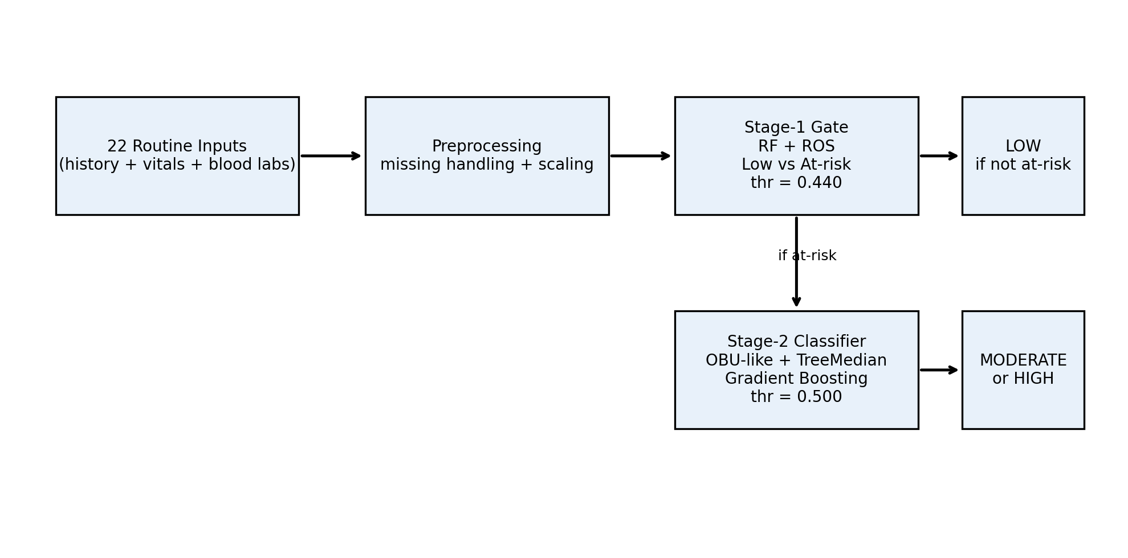

Metrics:

Final model | Value
Accuracy | 0.7191
Balanced accuracy | 0.6641
Macro F1 | 0.5591
Low recall | 0.7507
Moderate recall | 0.5048
High recall | 0.7368
High→Low miss | 2

Confusion matrix:
Test confusion matrix:
Actual / Predicted | Pred Low | Pred Moderate | Pred High
Actual Low | 518 | 147 | 25
Actual Moderate | 32 | 53 | 20
Actual High | 2 | 8 | 28

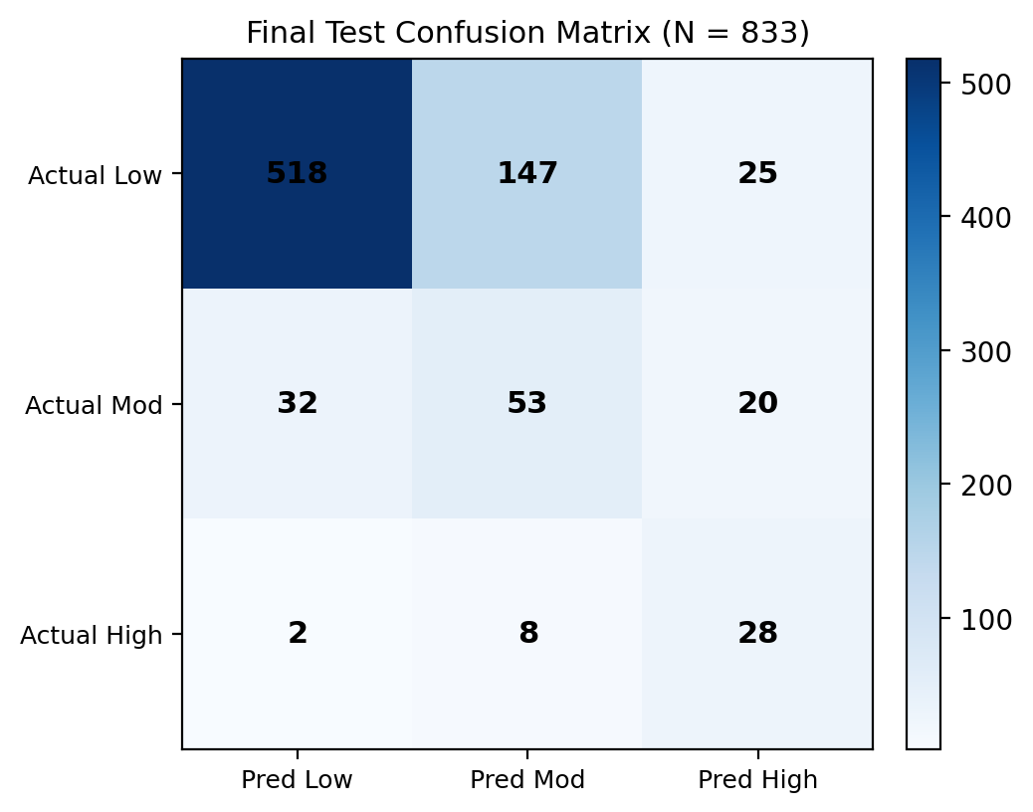

Stage-1 gate analysis
Stage-1 gate summary:
Actual | Sent to Stage-2? | Count
High | False | 2
High | True | 36
Low | False | 518
Low | True | 172
Moderate | False | 32
Moderate | True | 73

Error analysis
Test error decomposition:
Error group | Count
low_to_low | 518
low_to_moderate | 147
moderate_to_moderate | 53
moderate_to_low | 32
high_to_high | 28
low_to_high | 25
moderate_to_high | 20
high_to_moderate | 8
high_to_low | 2

Train/validation/test comparison
Split | Accuracy | Balanced Acc | Macro F1 | Low Recall | Moderate Recall | High Recall
Train | 0.7126 | 0.6718 | 0.5431 | 0.7377 | 0.5377 | 0.7399
Validation | 0.6939 | 0.6787 | 0.5300 | 0.7062 | 0.6000 | 0.7297
Test | 0.7191 | 0.6641 | 0.5591 | 0.7507 | 0.5048 | 0.7368

Repeated Split:
Metric (Low / Mod / High) | Validation | Test (once) | Repeated 25-split (mean ± SD)
Accuracy | 0.694 | 0.719 | 0.715 ± 0.015
Balanced accuracy | 0.679 | 0.664 | 0.601 ± 0.028
Macro-F1 | 0.530 | 0.559 | 0.535 ± 0.022
High recall | 0.730 | 0.737 | 0.540 ± 0.073
Moderate recall | 0.600 | 0.505 | 0.505 ± 0.053
Low recall | 0.706 | 0.751 | 0.757 ± 0.018
High → Low misses | 1 | 2 | 3.8 ± 2.1

External validation: NHANES 2017–2018
Target distribution:
Class | Count | Percent
Low | 3904 | 80.88%
Moderate | 698 | 14.46%
High | 225 | 4.66%

External result:
Metric | Value
Accuracy | 0.6677
Balanced accuracy | 0.6144
Macro F1 | 0.4890
Weighted F1 | 0.7126
Low recall | 0.7129
Moderate recall | 0.3926
High recall | 0.7378
High→Low miss count | 19
High→Low miss rate | 8.44%

NHANES 2015–2016
Target distribution:
Class | Count | Percent
Low | 4225 | 83.27%
Moderate | 610 | 12.02%
High | 239 | 4.71%

External result:
Metric | Value
Accuracy | 0.6947
Balanced accuracy | 0.6061
Macro F1 | 0.5186
Weighted F1 | 0.7398
Low recall | 0.7340
Moderate recall | 0.4443
High recall | 0.6402
High→Low miss count | 21
High→Low miss rate | 8.79%

Internal vs external comparison
Dataset | Accuracy | Balanced Acc | Macro F1 | Moderate Recall | High Recall | High→Low Miss Rate
Internal 2021–2023 test | 0.7191 | 0.6641 | 0.5591 | 0.5048 | 0.7368 | 5.26%
External 2017–2018 | 0.6677 | 0.6144 | 0.4890 | 0.3926 | 0.7378 | 8.44%
External 2015–2016 | 0.6947 | 0.6061 | 0.5186 | 0.4443 | 0.6402 | 8.79%

Now the final model is used to in the merge datasets.

Dataset (merged NHANES 2011–2023):
Cycle | n | Low | Moderate | High
2011–2012 | 5,098 | 4,233 | 581 | 284
2013–2014 | 5,540 | 4,628 | 645 | 267
2015–2016 | 5,309 | 4,446 | 578 | 285
2017–2018 | 5,063 | 4,124 | 656 | 283
2021–2023 | 5,552 | 4,603 | 701 | 248
Merged | 26,562 | 22,034 (83.0%) | 3,161 (11.9%) | 1,367 (5.1%)
Fresh stratified 70/15/15 split → test n = 3,985 (High = 205, vs 38 in the single-cycle design).
Repeated Split:
Metric | Repeated 10-split (mean ± SD) | Single canonical split
Accuracy | 0.673 ± 0.007 | 0.682
Balanced accuracy | 0.612 ± 0.016 | 0.597
Macro-F1 | 0.501 ± 0.008 | 0.501
Low recall | 0.705 ± 0.007 | 0.718
Moderate recall | 0.435 ± 0.018 | 0.460
High recall | 0.696 ± 0.052 | 0.615
High → Low miss rate | — | 17 / 205 = 8.3%

Confusion matrix (single canonical test split):
Actual \ Predicted | Low | Moderate | High
Low | 2,372 | 755 | 179
Moderate | 135 | 218 | 121
High | 17 | 62 | 126

