Software Development and Construction

Lab Final



SUBMITTED BY:

Muhammad Saleh Janjua (B22F0086SE017)

SUBMITTED TO:

Ms. Zainab

DEPARTMENT OF SOFTWARE ENGINEERING
PAK-AUSTRIA INSTITUTE OF APPLIED SCIENCE

Question 1: Secure Eureka Server with Basic Authentication
Objective
To configure a Eureka Server with basic authentication, ensuring only authorized services can register.
Implementation Steps
- Project Setup
  - Created a Spring Boot project via SpringInitializr with dependencies:
    - Eureka Server
    - Spring Security
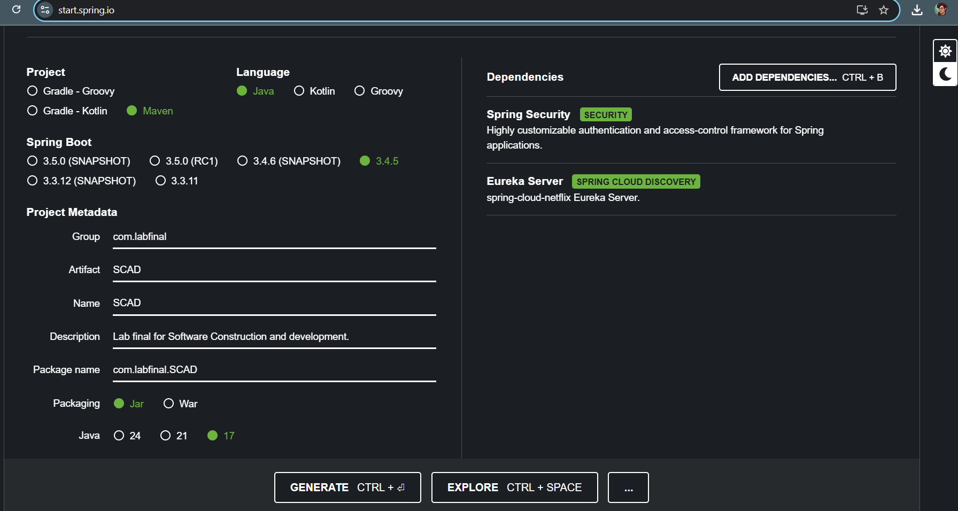

- Configuration
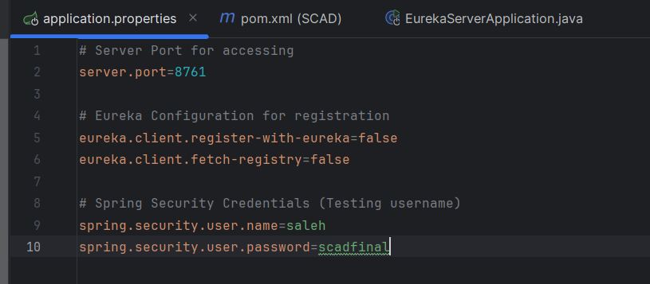
- Code Implementation
  - Added @EnableEurekaServer annotation to the main class:
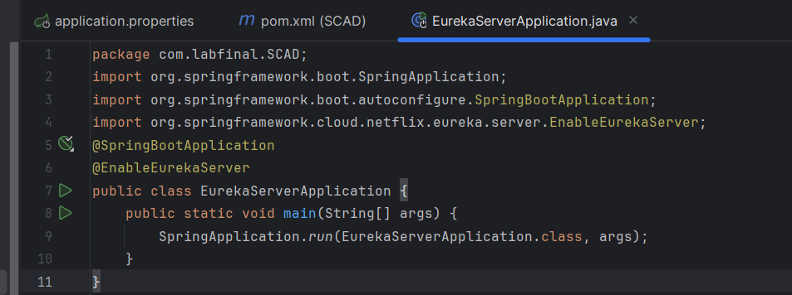

- Testing
  - Ran the server and accessed http://localhost:8761.
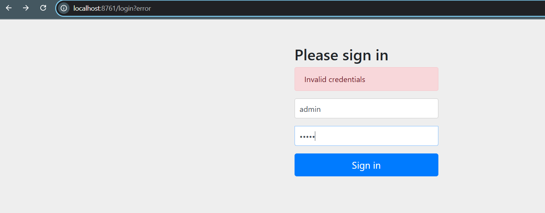
  - Logged in with credentials saleh/scadfinal.
  - Directs us to the Eureka Dashboard.
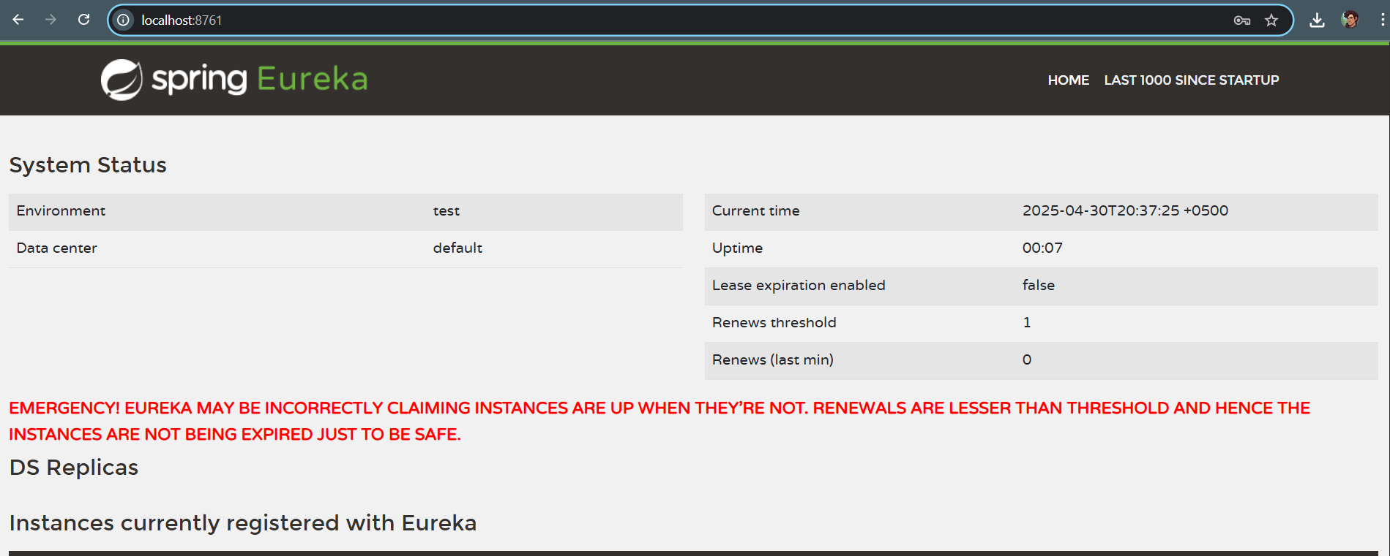

Question 2: JPA Application Registered with Eureka
Objective
To develop a Spring Boot JPA application that auto-registers with the secured Eureka Server and performs CRUD operations.
Implementation Steps
- Project Setup
  - Created a Spring Boot project with dependencies:
    - Eureka Client
    - Spring Web
    - Spring Data JPA
    - H2 Database
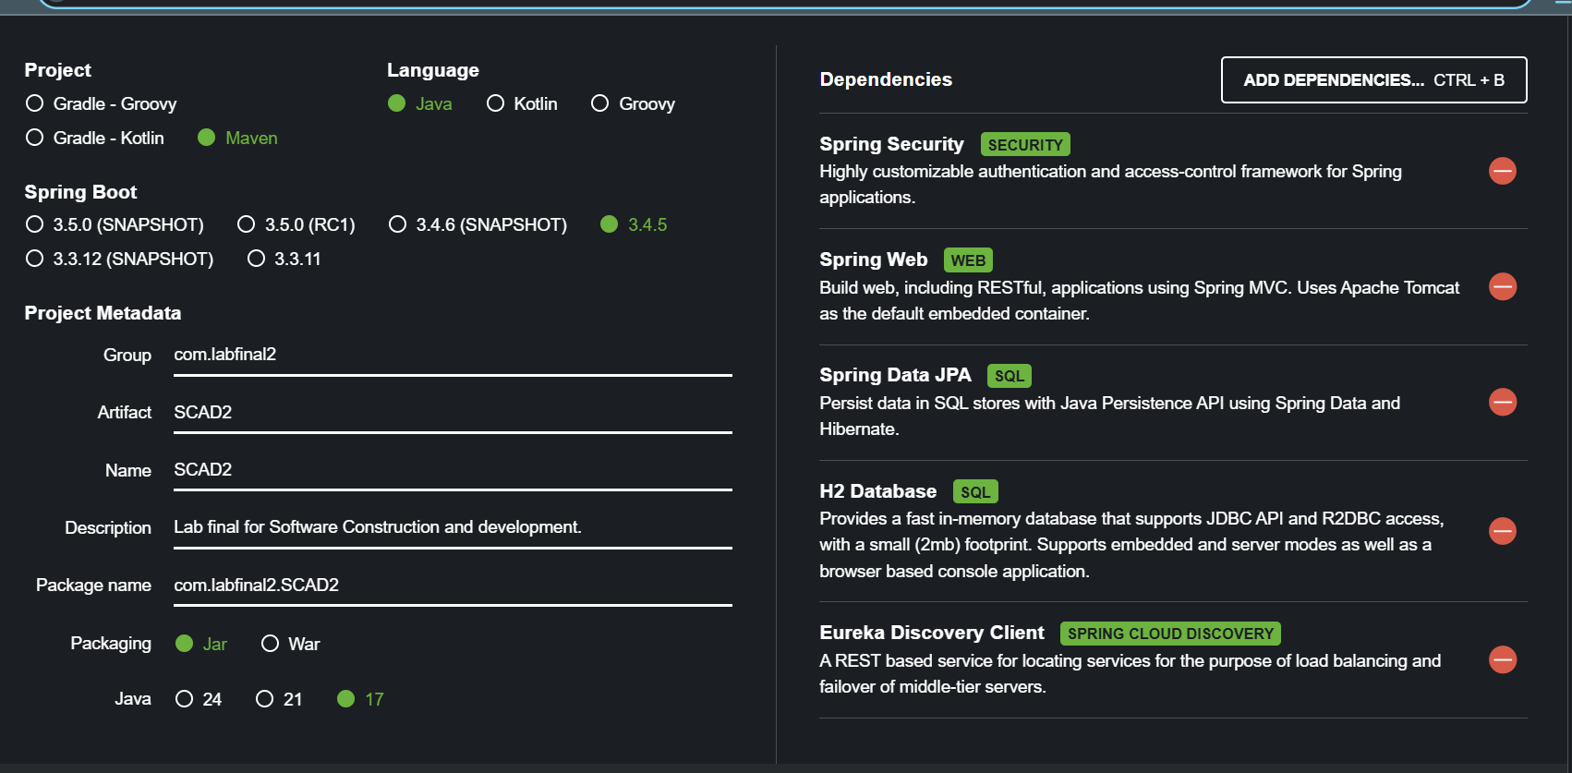
- Configuration
  - Configured application.properties:
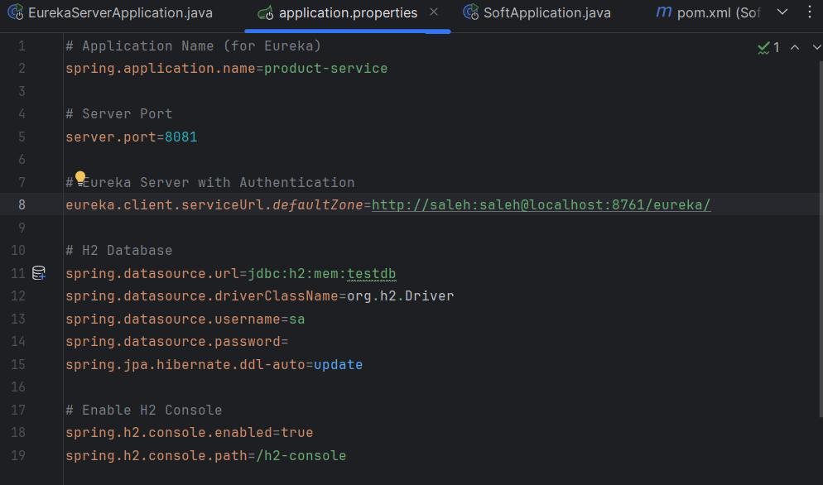
- Code Implementation
  - Entity Class:
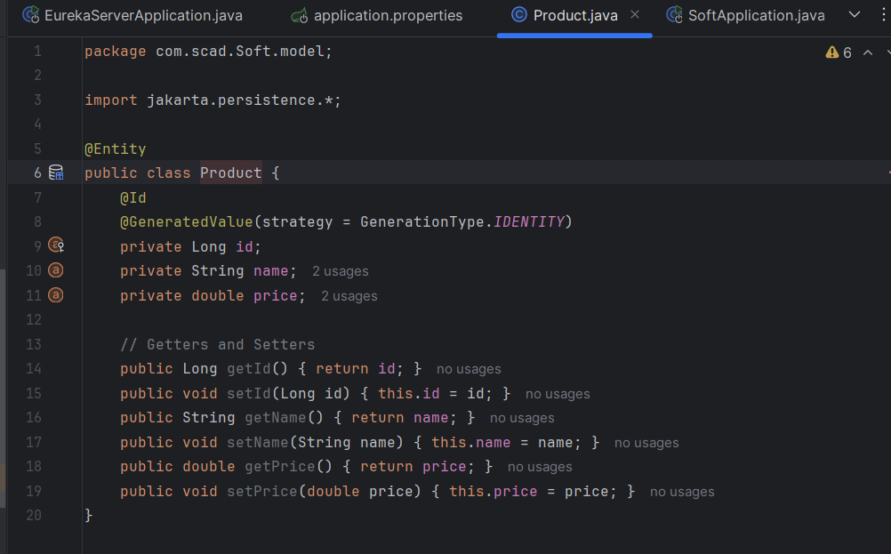
  - REST Controller:
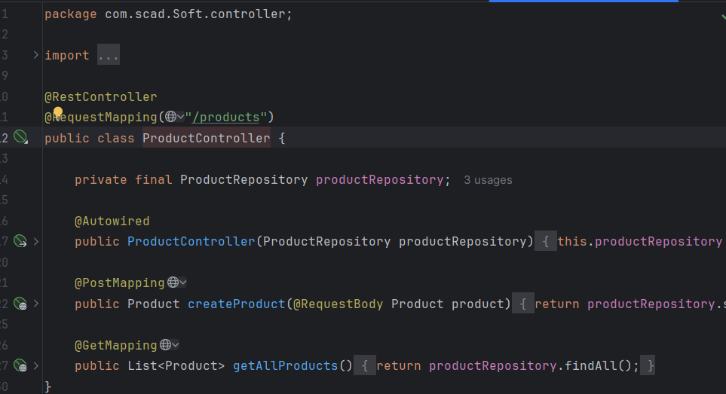
- Testing
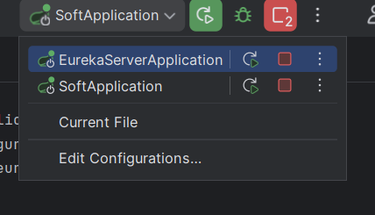
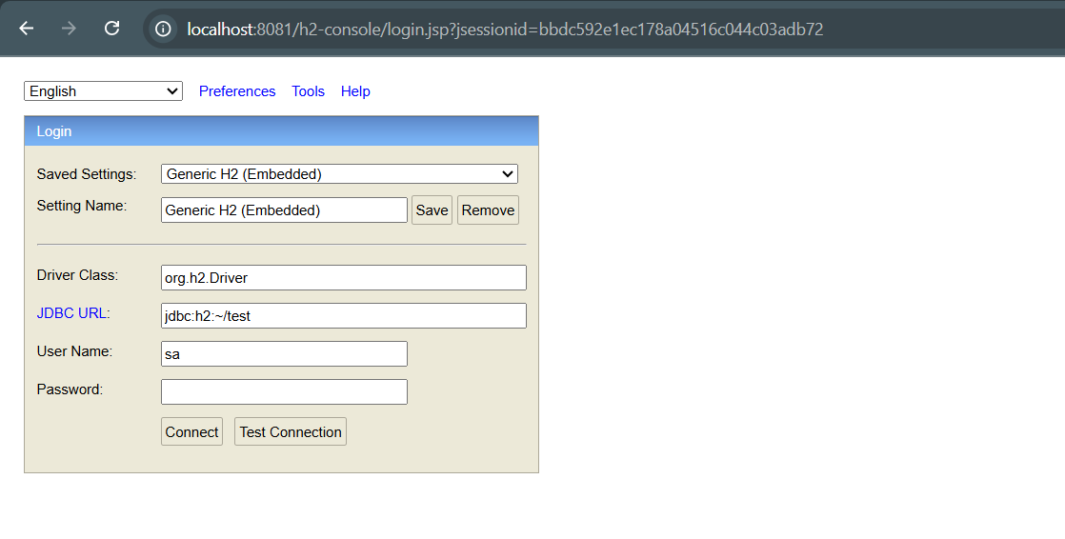
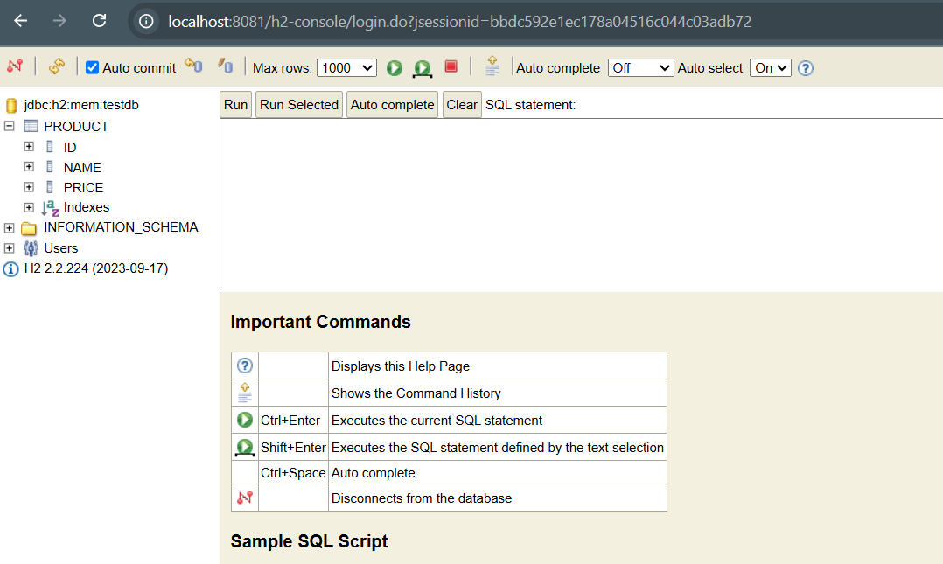

Conclusion
- Successfully implemented a secure Eureka Server with basic authentication.
- Developed a JPA-based microservice that registers with Eureka and performs CRUD operations.
- Resolved version compatibility issues between Spring Boot and Spring Cloud.

