

**Submitted by:**

Muhammad Salman Siddiqui 210920

Qurat ul Ain 210958

operating system

BSCS-4-C

**PROJECT TITLE:**

***Creating Virtual Environment and running apps on that Virtual environment***

**INTRODUCTION:**

A virtual environment is a networked application that allows a user to interact with both the computing environment and the work of other users. Email, chat, and web-based document sharing applications are all examples of virtual environments.

**What We Are Creating:**

We are going to create a virtual environment and run a flask python application with the python virtual environment

**Requirements:**

A virtual machine & ubuntu

**What Should Do:**

Creating virtual environment and running apps on virtual environment

**CREATION OF VIRTUAL ENVIRONMENT**

1. update your system packages

**sudo apt-get update**

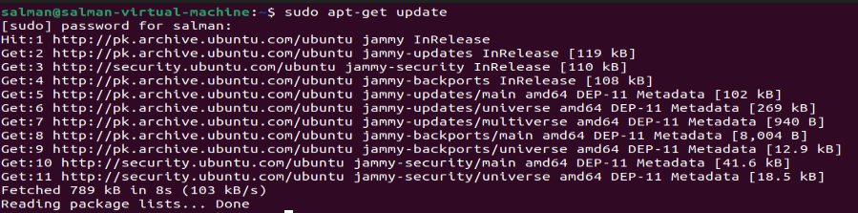

1. Next type the following command:

**sudo add-apt-repository ppa:fkrull/deadsnakes**

deadsnakes is basicaly a new python version so the statement above will add all deadsnakes repositoies to our system

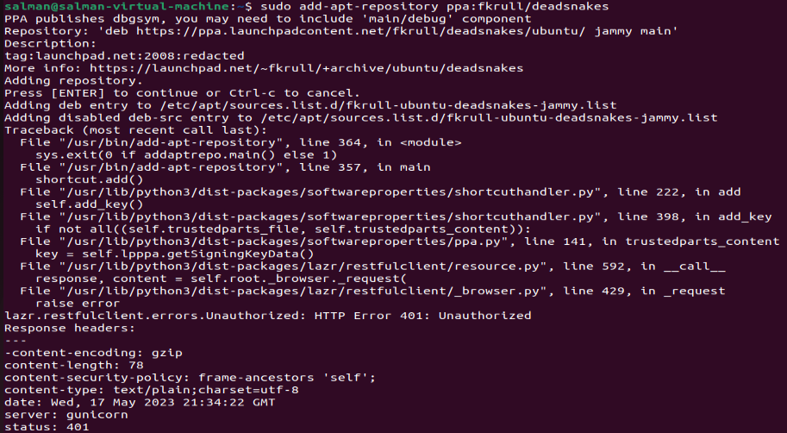

1. Then we install python 3

**sudo apt-get install python3**

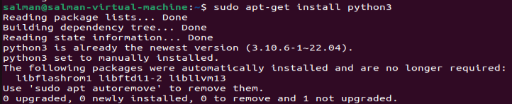

1. Then we install python 3

**sudo apt-get install python3-dev**

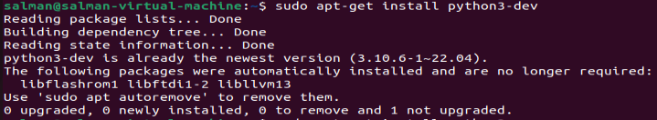

1. Then we install python 3

**sudo apt-get install python3-virtualenv**

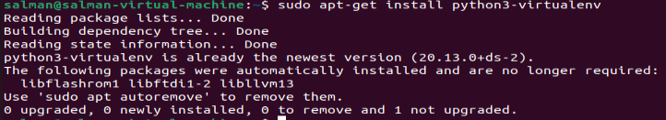

1. Then we install python 3

**sudo apt-get install python3-venv**

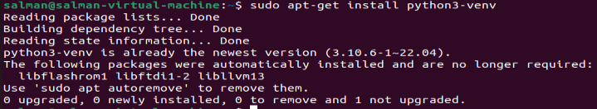

1. We than make a new directory

**mkdir apps**



1. We then go to this newly created directory

**cd apps**



1. We then create a python virtual environment

**python -m venv myvenv**



1. Then we activate our virtal machine

**source myvenv/bin/activate**

there will be (myvenv)written at the start of command line indicating that the vitual machine is activated



**Virtual environment is created.**

**RUNNING APPS ON VIRTUAL ENVIRONMENT**

1. The first step is to install the module, using the Python package manager, pip.

**pip install requests**

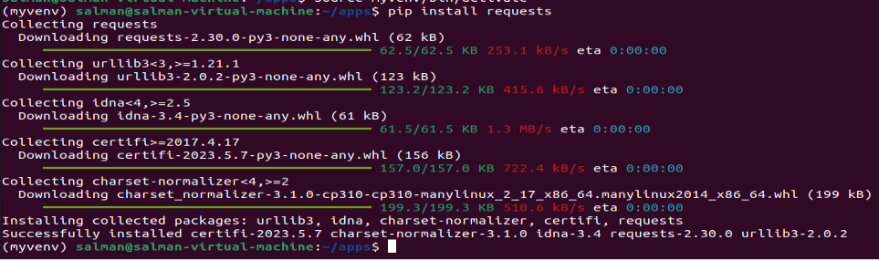

1. Create nano file and write code it in.



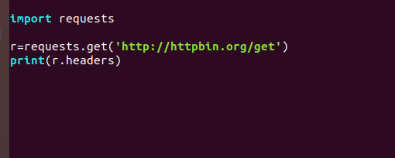

Now running the script:

**python testing.py**



1. Then install flask

**pip install flask**

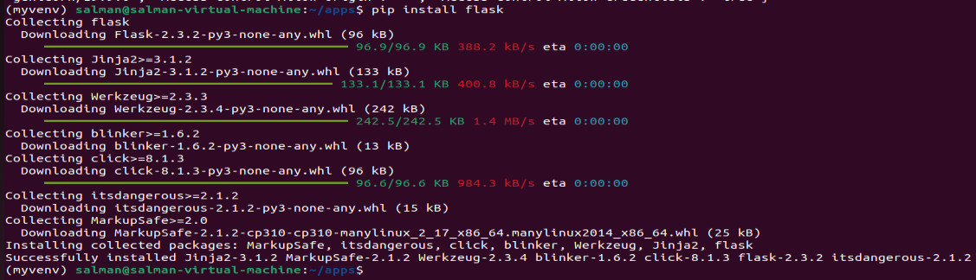

1. We then create a requirements text file

**pip freeze requirements.txt**

this requiremnts.txt file contains flask and its dependencies

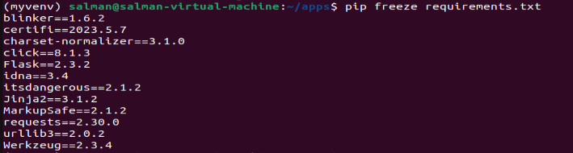

1. To write our code we create a python file

**Nano p.py**

p.py is my file name

We will write our code in this executable file



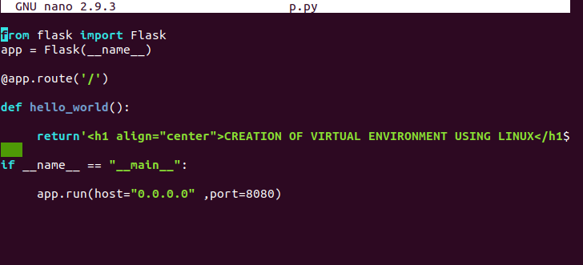

for this we have using python as well as html

1. we assign it some local hosting to run it on

I have assigned [**http://0.0.0.0:8080/**](http://0.0.0.0:8080/)

1. For running this application we type

**python p.py**

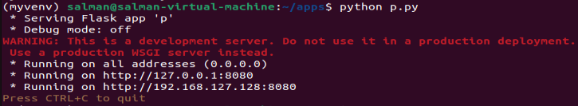

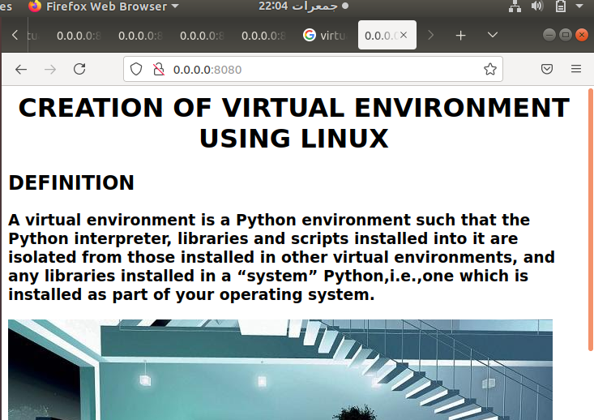 

1. After you are done running this app make sure you deactivate your vitual environment for that type

**deactivate**