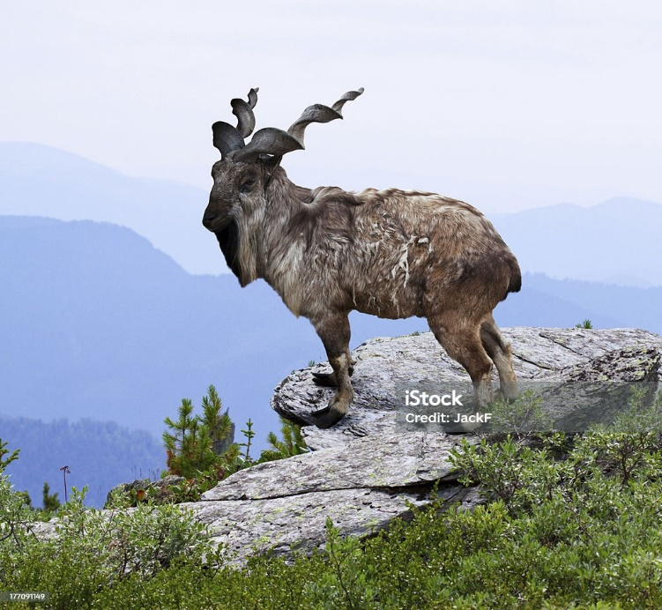

***MARKHOR***

The markhor is the largest of the wild goat species, with broad hooves and striking spiral horns that can grow to five feet long in mature males. These goats live in herds of 30-100 females, which are joined by males during the fall mating season. Markhor is a Persian word meaning “snake-eater” or “snake-killer,” which may refer to its spiral horns or how it easily kills snakes by stepping on them with its wide hooves. The coat of the markhor is of a grizzled, light brown to black color, and is smooth and short in summer; it grows longer and thicker in winter. The fur of the lower legs is black and white. Males have longer hair on the chin, throat, chest, and shanks. Females are redder in color, with shorter hair, a short black beard, and are maneless. Both sexes have tightly curled, corkscrew-like horns, which close together at the head but spread upwards toward the tips.