**Introduction to Computer Programming Lab**

**Lab Journal - 3**

Name: _________________________________

Enrollment #: _________________________________

Date: ________________________________

**Objective:**

1. Understanding of relational and equality operators
2. Understanding Control Structures
3. Using if, if/else, multiple ifs/else-if, switch statements and ternary operator

**Tools Required:**

* 1. PC with Windows 7 Professional or onwards
  2. Visual Studio 2013 onwards

Attempt the following tasks:

**Task 1 : Give output of the following piece of code:**

|  |  |  |
| --- | --- | --- |
| 1. | int a=5, b =10;  cout << (a > b) << endl; cout << (a < b) << endl; cout << (a == b) << endl; cout << (a != b) << endl; | **Output:** |
| 2. | Print the output of following expressions (each line of code) as 1 and 0 (1 for “True” and 0 for “False”). | **Output:** |
| **(5+ 4 < 3)**  **('a' != 'b' - 1)**  **(7 == 7)**  **(3%2 == 1)**  **('a' == 97)** |
| 3. | int a=5, b=10, c=15; ;    cout << ((a > b) && (c > b)) << endl;  cout << ((a > b) || (c > b))<< endl; | **Output:** |

|  |  |  |  |
| --- | --- | --- | --- |
|  | cout << (a || b) << endl; cout << (a && b) << endl; cout << !(a > b) << endl; | |  |
| 4. | Differentiate between = and ==. | |  |
| 5. | **int x = 25; if (x / 2 == 12)**  **{ cout << "I ”; cout << "like";**  **} else {**  **cout << "I ";**  **cout << "don’t like";**  **} cout << "apples";** | | **Output:** |
| 6. | **double Max =12.7; if(Max>=12) cout<<”French”; else**  **cout<<”Fries”;** | | **Output:** |
| 7. | int x = 12; if(x!=12) cout << “Yes”; else  cout << “No”; | | **Output:** |
| 8. | int x = 13; if(x>12) { if(x<15) cout<<”Blue”;  }  Else {  cout<<”Green”;  }  cout<<”Jeans”; | | **Output:** |
| 9. | int x = 20; if(x>10) { if(x<25)  cout<<”Happy ”;  }  Else {  cout<<”Not Happy ”;  }  cout<<” Day!”; | | **Output:** |
| 10. | Write C++ statement for following pseudocode: **if number is divisible by 2 print “even”** | | |
|  | **else print “odd”** |  | |
| **Using if/else statement:** | **Output:** | |
| 11. | **Cout<<”Hi there!\n”; Goto Label;**  **Cout<<”How are you?\n”;**  **Cout<<”Are you feeling**  **better?\n”; Label:**  **Cout<<”Hope you are good!”;** |  | |
| 12. | cout << "I'm at line 1\n"; goto Point1;  cout << "I'm at line 2\n"; cout << "I'm at line 3\n"; Point1: cout << "I'm at line 4\n"; |  | |
| 13. | int x = 10; cout<<x<<endl; x++;  cout<<x<<endl;  ++x; cout<<x<<endl; x--;  cout<<x<<endl;  --x;  cout<<x<<endl; |  | |
| 14 | int x = 10; cout<<x<<endl; cout<<x++<<endl; cout<<++x<<endl; cout<<x--<<endl; cout<<--x<<endl; cout<<x<<endl; |  | |

**Task 2** : Write a C++ program that reads an integer and determines and prints whether it is odd or even using if-else statements.

**Output & Code**:

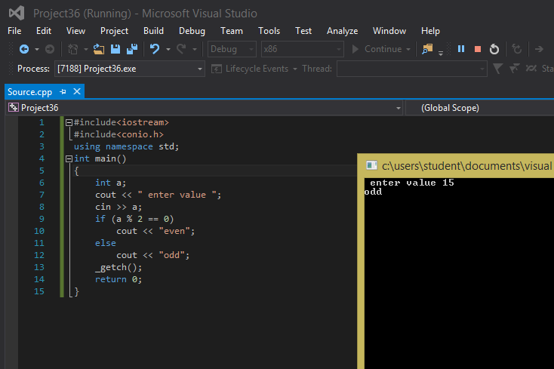

**Task 3 :** Write a program that reads three non zero integers and determines and prints whether they could be the sides of a right angle triangle. (Hint* : Pythagorus Theorem a2 + b2 = c2 )

So your program should take three variables a, b and c and check that the sum of square of a and square of b should be equal to the square of c.

**Output & Code :-**

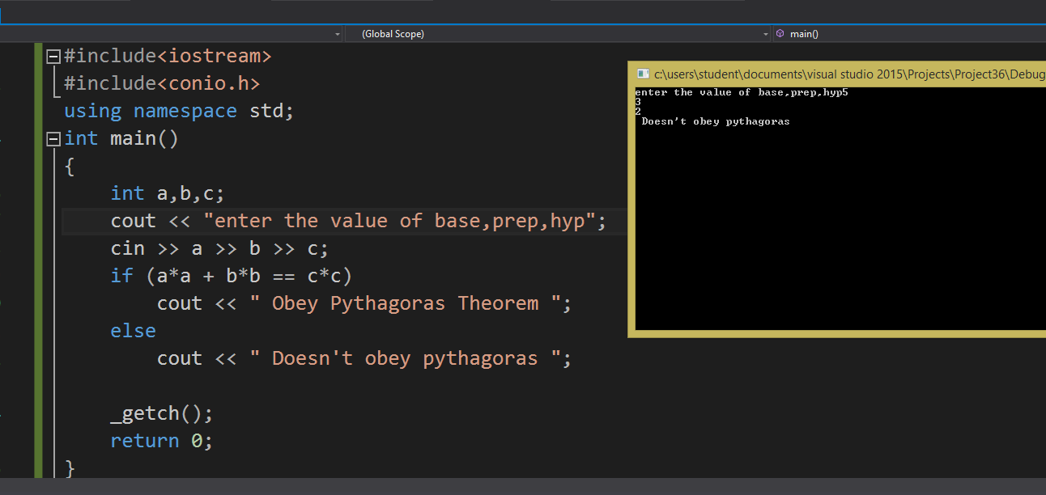

**Task 4:** Write a program for a basic calculator. Your calculator should take two integers. Then it should display options for different operations and then ask the user for choice. Based on user’s choice it will perform the operation. The options will be displayed as following

**Press 1 for addition**

**Press 2 for subtraction**

**Press 3 for multiplication**

**Press 4 for division**

**Press 5 for finding the remainder**

**Code:**

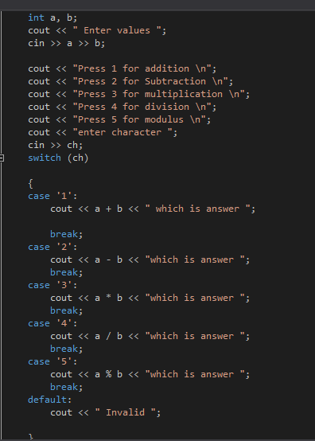

**Output**

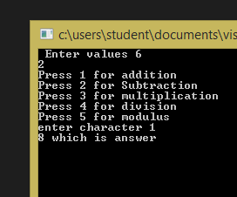

**Task 5 :** Write a C++ program (use if-else statement) to compute the telephone bill for the city consumers. The bill computed according to the number of calls.

* If numbers of calls are less than and equal to 100, then the rate per call is rs.0.80 and the meter charges is Rs. 250.
* If numbers of calls are greater than 100, then the rate per call is computed is Rs. 1.00 and the meter charges are minimum Rs.350.
* **Formula for bill calculation is:**

**Phone Bill = meter charges + (number of calls x rate per call)**

**CODE & OUTPUT :-**

#include<iostream>

#include<conio.h>

using namespace std;

int main()

{

// Phone Bill = meter charges + (number of calls x rate per call) //

double a, b, c,

float d; // a = phone bill, b = meter charges , c= no. of calls , d=rate per call //

cout << " enter number of calls";

cin >> c

if (c <= 100)

{

b = 250;

d = 0.80;

a = b + (c*d);

cout <<"bill is " << a;

}

else if( c> 100 )

{

b = 350;

d = 1.00;

a = b + (c*d);

cout << "phone bil is " << a;

}

_getch();

}

**\*\*\*\*\*\*\*\*\*\*\*\*\*\*\*\*\*\*\*\*\*\*\*\*\*\*\*\*\*\*\*\*\*\*\*\*\*\*\*\*\*\*\*\*\*\*\*\*\*\*\*\***