**Introduction to Computer Programming Lab**

**Lab Journal - 4**

Name: _________________________________

Enrollment #: _________________________________

Date: ________________________________

**Objective:**

1) Understanding Looping Statements

2) Practicing while repetition structures

3) Practicing do-while repetition structures

**Tools Required:**

1. PC with Windows 7 Professional or onwards
2. Visual Studio 2013 onwards

Attempt the following tasks:

**Task 1 : Give output of the following pieces of codes :**

|  |  |  |
| --- | --- | --- |
| 1. | #include<iostream>  #include<conio.h>  using namespace std;  void main()  {  int start=1,end = 10;  while(start<=end)  {  cout << start <<endl;  start++;  }  getch();  } | **Output:** |
| 2. | #include<iostream>  #include<conio.h>  using namespace std;  void main()  {  int start=10,end = 1;  do  {  cout << start<<endl;  start--;  }  while(start>=end);  getch();  } | **Output:** |
| 3. | //Is the condition of do-while true? Should the loop run? Why?  #include<iostream>  #include<conio.h>  using namespace std;  void main()  {  int n=6,i=7;  do  {  cout << i;  i++;  }  while (i <=n);  getch();  } | **Output and Answer:**    **In a do while loop ,,**  **The condition must be evaluated at least once tine also incase of fasle condition..** |
| 4. | Identify and correct the error in the following code:  **int x=0;**  **do**  **{**  **cout<<x<<endl;**  **x++;**  **}**  **while(x<=10)** | Identify and correct the error in the following code:  **while(i<10)**  **{**  **cout<<i;**  **i++;**  **}** |
|  | **Corrected Code:**  ; is missing ate the end | **Corrected Code:**  i is undeclared identifier |
| 5 | // Calculate the square of first 10 natural numbers.  int j=0;  while( j<10)  {  cout<< “ square is: “<< j*j;  j++; //same as j = j+1;  }  cout<<endl; | **Output:** |
| 6 | //Calculate the cube of all the natural numbers where the // cube is less than a four digit number.  int cube = 1;  int numb = 1;  while( cube < 999)  {  cube = numb * numb * numb;  cout<< “ Number is: “ <<numb;  cout<< “ Cube is: “<<cube;  numb++;  } | **Output:** |
| 7 | //A program to divide 2 numbers taken from user and display the quotient and remainder. Also continue to the next calculation again and again if the user says yes, and exit the program when the user says no.  int dividend, divisor, quotient, remainder;  char ch;  do{  cout<< “ Enter dividend : “;  cin>> dividend;  cout<<”Enter Divisor: “;  cin>>divisor;  quotient = dividend /divisor;  remainder = dividend % divisor;  cout<<” Quotient is: “<< quotient;  cout<<” Remainder is : ”<<remainder;  cout<<”\n Do another Division Calculation? “;  cout<<”\\n(Press y/n for yes/no) : “;  cin>>ch;  }while ( ch != ‘n’); | **Output:** |
| 8 | A program that will never end until the user asks to exit it.  char ch;  While(1)  {  cout<< “\n\n\n*************************** “;  cout<< “\nWelcome to my program “;  cout<<” \nIt will not exit “;  cout<<”\n Until you ask for it “;  cout<<”\n Press e if you want to exit”;  cout<<”\n And any other character if you want to continue“;  cin>>ch;  if(ch == ‘e’)  exit(0);  } | **Output:** |

**Task 2** : Using a do-while loop write a program that asks user to enter a temperature in Fahrenheit and convert it into Celsius. The program should ask the user if he/she wants to perform another conversion. In case the user enters an ‘N’ the program should terminate. This is similar to one of the practice tasks you have done. [Hint : Formula for conversion is: C = 5/9 (F-32)]

**Task 3 :** Write a program to find the average of natural numbers from 1 to N using do while loop. Value of N should be entered by user.

[Hint : Average = sum of all numbers / total number of natural numbers]

**Task 4:** Write a program that takes total number of students in a class. And then asks the user to enter marks for each student in the class and compute the class average. Use a while loop to compute the average. [Hint : Average = sum of marks of all students / total number of students]

**Task 5:** Write a program to calculate the factorial of a number using while loop

**Task 6:** Write a program for a basic calculator (Using Switch Only) Your calculator should take two integers. Then it should display options for different operations and then ask the user for choice. Based on user’s choice it will perform the operation. The options will be displayed as following

**Press 1 for addition**

**Press 2 for subtraction**

**Press 3 for multiplication**

**Press 4 for division**

**Press 5 for finding the remainder**

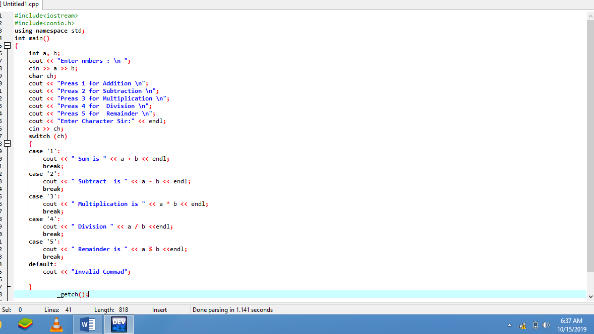

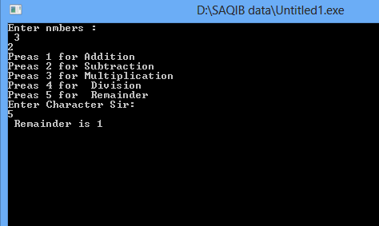

**Task 7:** Now make the menu of the previous program stay on the screen until the user asks to exit using an infinite loop. For that simply enclose the whole code in while(1) loop, as shown in one of the practice tasks above and add a case 6: for exiting.

**Hint: Enclose its code in the following while block, Except the declaration and initialization statements.**

**while (1)**

**{**

**system(“cls”);**

**//adjust that code here, and add a 6th case as shown below**

**case 6:**

**exit(0);**

**}**

**OUTPUT & CODE:**



