**CSC103 Programming Fundamentals Arrays**

**Muhammad Saqib**

**Sp20-BSE-069**

# LAB TASKS

1. Make arrays of different data types. Check what default values are stored in each of them.

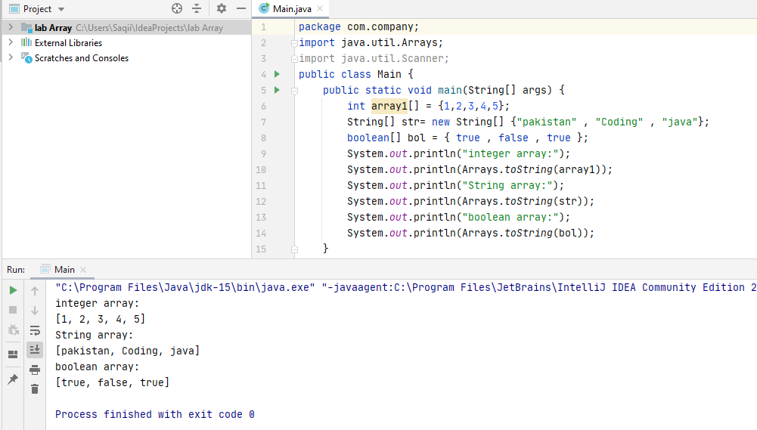

1. Create array, d_array. Store in it 15 int numbers, taken from user. Display its contents.

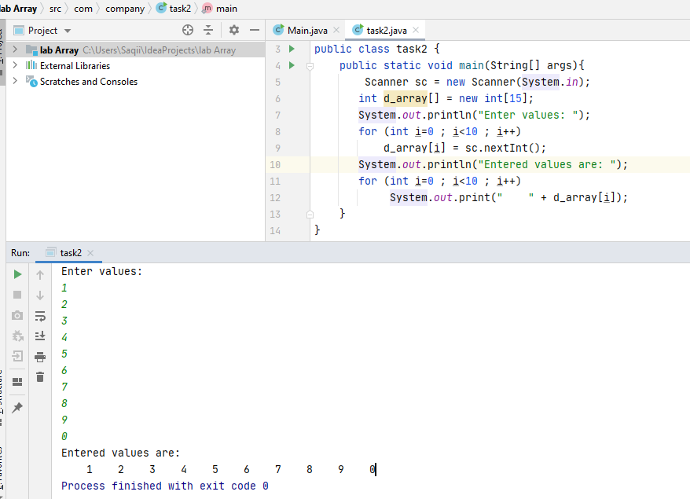

1. Create an array, ch_list. Read 7 characters from keyboard and store them in ch_list.

Read and display the contents of ch_list backwards.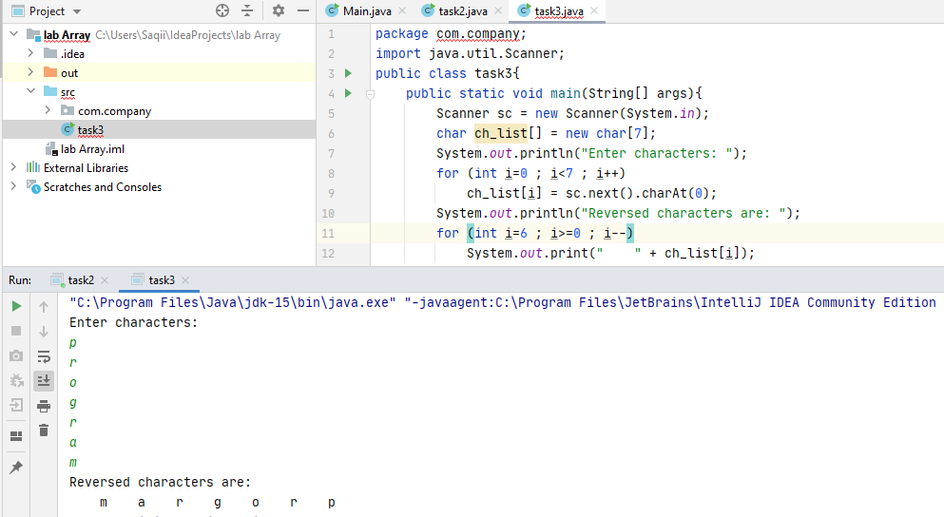

1. Create following array:

|  |  |  |  |  |  |
| --- | --- | --- | --- | --- | --- |
| 15 | 75 | 85.5 | 61 | 0 | 18 |

Shift the values one place ahead. Use loop. The last value will become the first value of array.

public class task4 {  
 public static void main(String[] args) {  
 //Initialize array  
 int [] arr = new int [] {1, 2, 3, 4, 5};  
 int n=1;  
 System.*out*.println("Original array: ");  
 for (int i = 0; i < arr.length; i++) {  
 System.*out*.print(arr[i] + " ");  
 }  
 for(int i = 0; i < n; i++){  
 int j, last;  
 last = arr[arr.length-1];  
  
 for(j = arr.length-1; j > 0; j--){  
 arr[j] = arr[j-1];  
 }  
 arr[0] = last;  
 }  
  
 System.*out*.println();  
 System.*out*.println("Array after right rotation: ");  
 for(int i = 0; i< arr.length; i++){  
 System.*out*.print(arr[i] + " ");  
 }  
 }  
}

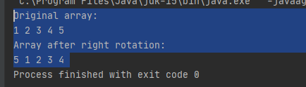

1. Using random number method, store 100 random values less than 100 in an array.
   1. Calculate sum of values
   2. Calculate average of values
   3. Count number of values:
      1. Greater than average
      2. Lesser than average iii. Equals to average
2. package com.company;  
   import java.util.Arrays;  
   import java.util.Random;  
   public class Task5 {  
    public static void main(String[] args) {  
    Random r = new Random();  
    int[] randomArray = new int[100];  
    int sum=0,equal=0,greater=0,smaller=0;  
    for (int i = 0; i < 100; i++){ randomArray[i] = 0; }  
    int count = 0;  
    int rand;  
    while(count<100)  
    {  
    rand = r.nextInt(101);  
    if(rand<100)  
    {  
    randomArray[count] = randomArray[count] + rand; count++;  
    }  
    }  
    System.*out*.println(" "+ Arrays.*toString*(randomArray) );  
     
    for (int i = 0; i < 100; i++)  
    {sum= sum + randomArray[i];}  
    System.*out*.println("Sum is "+ sum );  
    int Avg = sum/count;  
    System.*out*.println("Average is "+ Avg);  
     
    for (int i = 0; i < 100; i++)  
    {  
    if(randomArray[i]<Avg)  
    smaller++;  
    else if(randomArray[i]>Avg)  
    greater++;  
    else  
    equal++;  
    }  
    System.*out*.println("Equal number:"+equal+" Greater numbers: "+greater+" Smaller numbers: "+smaller);  
    }  
   }







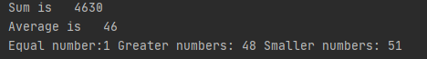

1. Create an array, list_1, with values: {‘h’, ‘e’, ‘l’, ‘l’, ‘o’}. Make another array, list_2, with same contents as of list_1 (copy the contents using both for loop and arraycopy() method). Declare list_3 that should refer to list_2.

package com.company;  
public class task6 {  
 public static void main(String[] args){  
 char[] list_1 = {'h', 'e' ,'l','l','o'} , list_2 = new char[list_1.length];  
  
 System.*arraycopy*(list_1, 0, list_2, 0, list_1.length); // array copy by using arraycopy  
  
 for(int i=0 ; i< list_1.length ; i++) //Manual array copy  
 list_2[i] = list_1[i];  
  
 char[] list_3 = list_2;  
 System.*out*.println("Address of list_2"+list_2);  
 System.*out*.println("Address of list_3"+list_3);  
 }  
}

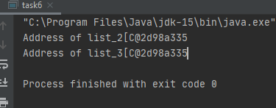

1. Create two arrays, list_1 and list_2, by inputting values from user. Check if they are of same size. If not, determine which one is bigger.

package com.company;  
  
import java.util.Scanner;  
  
public class tsk7 {  
 public static void main(String[] args) {  
 Scanner sc = new Scanner(System.*in*);  
  
 System.*out*.print(" Enter size of array1: " );  
 int size1 = sc.nextInt();  
 int[] list_1 = new int[size1] ;  
 System.*out*.print(" Enter values array1: " );  
 for (int i =0 ; i<list_1.length ;i++)  
 list_1[i]=sc.nextInt();  
  
 System.*out*.print(" Enter size of array2: " );  
 int size2 = sc.nextInt();  
 int[] list_2 = new int[size2] ;  
 System.*out*.print(" Enter values of array2: " );  
 for (int i =0 ; i<list_2.length ;i++)  
 list_2[i]=sc.nextInt();  
  
 if (size1>size2)  
 System.*out*.print("Array 1 is bigger");  
 else if(size2>size1)  
 System.*out*.print("Array 2 is bigger");  
 else  
 System.*out*.print("both arrays have same size");  
  
  
 }  
}

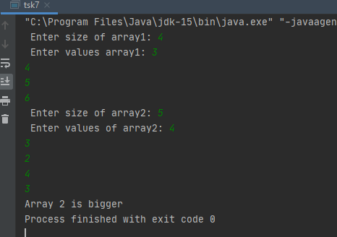

1. In task 7, if list_1 and list_2 are of same length, determine if they contain same contents or not. Use loop.
2. package com.company;  
     
   import java.util.Scanner;  
     
   public class task8 {  
    public static void main(String[] args) {  
    Scanner sc = new Scanner(System.*in*);  
     
    System.*out*.print(" Enter size of array1: ");  
    int size1 = sc.nextInt();  
    int[] list_1 = new int[size1];  
    System.*out*.print(" Enter values array1: ");  
    for (int i = 0; i < list_1.length; i++)  
    list_1[i] = sc.nextInt();  
     
    System.*out*.print(" Enter size of array2: ");  
    int size2 = sc.nextInt();  
    int[] list_2 = new int[size2];  
    System.*out*.print(" Enter values of array2: ");  
    for (int i = 0; i < list_2.length; i++)  
    list_2[i] = sc.nextInt();  
     
    if (size1 > size2)  
    System.*out*.print("Array 1 is bigger");  
    else if (size2 > size1)  
    System.*out*.print("Array 2 is bigger");  
    else {  
    System.*out*.println("Both arrays have same size");  
    for (int i = 0; i < size1 ; i++)  
    if (list_1[i] == list_2[i]) {  
    if (i == size1 - 1)  
    System.*out*.print("Arrays containing same content also");  
    }  
    else  
    break;  
    }  
    }  
   }

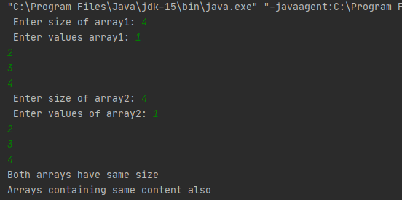

1. Redo Task 2. Use following methods:

public static void inputValues(double[] da) public static void display(double[] da)

10. Redo Task 4, using the method public static void shift(double[] a).

1. Redo task 5. You will make following methods:

public static int sum(int[] list)

public static double average(int[] list, int sum)

CSC103 Programming Fundamentals Arrays

public static int[] count(int[] list, double avg) This method will return three values, Task 5c.

1. Redo Task 6 by making a method that would copy the contents of list_1 to list_2.
2. Redo Task 8 with method: sameContents(). The method will take two arrays and return a Boolean value.
3. Make your own arraycopy() method, with same type and number of parameters/arguments.
4. Make Hangman game. Use String class, arrays, and methods. Avoid using a lot of built-in methods. Make user-defined methods as much as you can.