package com.company;  
import java.util.Scanner;  
public class homeTaskHANGMAN {  
 public static void main(String[] args){  
 Scanner sc = new Scanner(System.*in*);  
 System.*out*.println("Enter your secret word \n Than user will guess it." +  
 "\n enter your word: ");  
 String Word=sc.next();  
 String word = Word.toUpperCase();  
 String Status="";  
 String s="*";  
 String str = s.repeat(word.length());  
 char[] arr= str.toCharArray();  
 int wrongTurn=0;  
 boolean status;  
  
 do {  
 System.*out*.println("\n Enter your guess character: ");  
 char guess = sc.next().charAt(0);  
 char g = Character.*toUpperCase*(guess);  
 status=false;  
 for(int i=0 ;i<word.length(); i++)  
 if(g==word.charAt(i))  
 {  
 arr[i] = g;  
 status=true;  
 }  
 for(int i=0;i< word.length();i++)  
 System.*out*.print( arr[i]);  
 if (status){  
 System.*out*.println("\nYor guess is TRUE ....\n");}  
 else{  
 wrongTurn++;  
 System.*out*.println("\nYor guess is FALSE ....\n" +  
 "and Number of wrong guesses " + wrongTurn);  
 if (wrongTurn == 1) {  
 System.*out*.println("Wrong guess, try again");  
 System.*out*.println();  
 System.*out*.println();  
 System.*out*.println();  
 System.*out*.println();  
 System.*out*.println("___|___");  
 System.*out*.println();}  
 if (wrongTurn == 2) {  
 System.*out*.println("Wrong guess, try again");  
 System.*out*.println(" |");  
 System.*out*.println(" |");  
 System.*out*.println(" |");  
 System.*out*.println(" |");  
 System.*out*.println(" |");  
 System.*out*.println(" |");  
 System.*out*.println(" |");  
 System.*out*.println("___|___");}  
 if (wrongTurn == 3) {  
 System.*out*.println("Wrong guess, try again");  
 System.*out*.println(" ____________");  
 System.*out*.println(" |");  
 System.*out*.println(" |");  
 System.*out*.println(" |");  
 System.*out*.println(" |");  
 System.*out*.println(" |");  
 System.*out*.println(" |");  
 System.*out*.println(" | ");  
 System.*out*.println("___|___");  
 }  
 if (wrongTurn == 4) {  
 System.*out*.println("Wrong guess, try again");  
 System.*out*.println(" ____________");  
 System.*out*.println(" | _|_");  
 System.*out*.println(" | / \\");  
 System.*out*.println(" | | |");  
 System.*out*.println(" | \\_ _/");  
 System.*out*.println(" |");  
 System.*out*.println(" |");  
 System.*out*.println(" |");  
 System.*out*.println("___|___"); }  
 if (wrongTurn == 5) {  
 System.*out*.println("Wrong guess, try again");  
 System.*out*.println(" ____________");  
 System.*out*.println(" | _|_");  
 System.*out*.println(" | / \\");  
 System.*out*.println(" | | |");  
 System.*out*.println(" | \\_ _/");  
 System.*out*.println(" | |");  
 System.*out*.println(" | |");  
 System.*out*.println(" |");  
 System.*out*.println("___|___");  
 }  
 if (wrongTurn == 6) {  
 System.*out*.println("Wrong guess, try again");  
 System.*out*.println(" ____________");  
 System.*out*.println(" | _|_");  
 System.*out*.println(" | / \\");  
 System.*out*.println(" | | |");  
 System.*out*.println(" | \\_ _/");  
 System.*out*.println(" | |");  
 System.*out*.println(" | |");  
 System.*out*.println(" | / \\ ");  
 System.*out*.println("___|___ / \\");  
 }  
 if (wrongTurn == 7) {  
 System.*out*.println("GAME OVER!");  
 System.*out*.println(" ____________");  
 System.*out*.println(" | _|_");  
 System.*out*.println(" | / \\");  
 System.*out*.println(" | | |");  
 System.*out*.println(" | \\_ _/");  
 System.*out*.println(" | _|_");  
 System.*out*.println(" | / | \\");  
 System.*out*.println(" | / \\ ");  
 System.*out*.println("___|___ / \\");  
  
 System.*out*.println("GAME OVER! The word was " + word);  
 System.*exit*(1);  
 }  
 }  
  
 for(int i=0 ;i<word.length(); i++)  
 if (arr[i] == '*') {  
 Status = "not guessed";  
 break;  
 } else {  
 Status = "guessed";  
 }  
 } while (Status.equals("not guessed"));  
 System.*out*.println("Yes the secret word was \" " + word + "\" .... YOU WiN");  
 System.*out*.println("WELDONE! Talliyan honi chahiye.");  
 }  
}

**OUTPUT:-**

* **TRUE word:-**

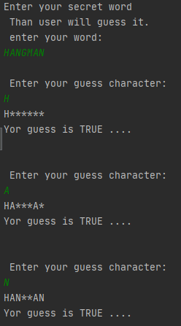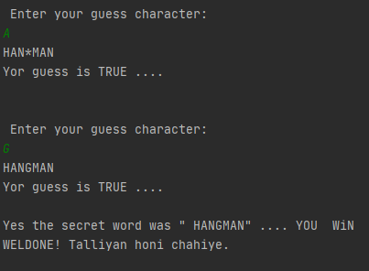

* **WRONG word:-**

