

**Setting Up the Development Environment**

Assignment No.1

Muhammad Shakeel

2024

Table of Contents

**Task 1: Download and Install Node.js 2**

**Task 2: Download and Install VS Code 2**

**Task 3: Download and Install Git and Signup to GitHub 3**

**Task 4: Research and Write a Short Answers 4**

# Task 1: Download and Install Node.js

I have already downloaded the setup file of node.js and installed it successfully on my laptop.

Running Node.js with following command:

node -v

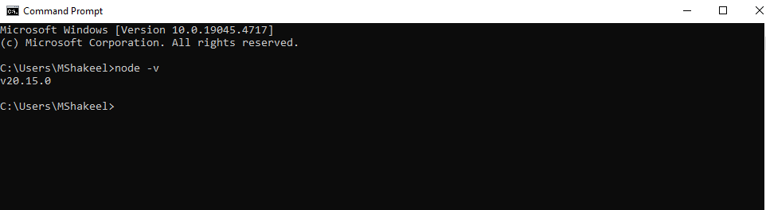

# Task 2: Download and Install VS Code

I have downloaded VS Code from <https://code.visualstudio.com/> and install on my laptop.

After installation this is the screenshot:

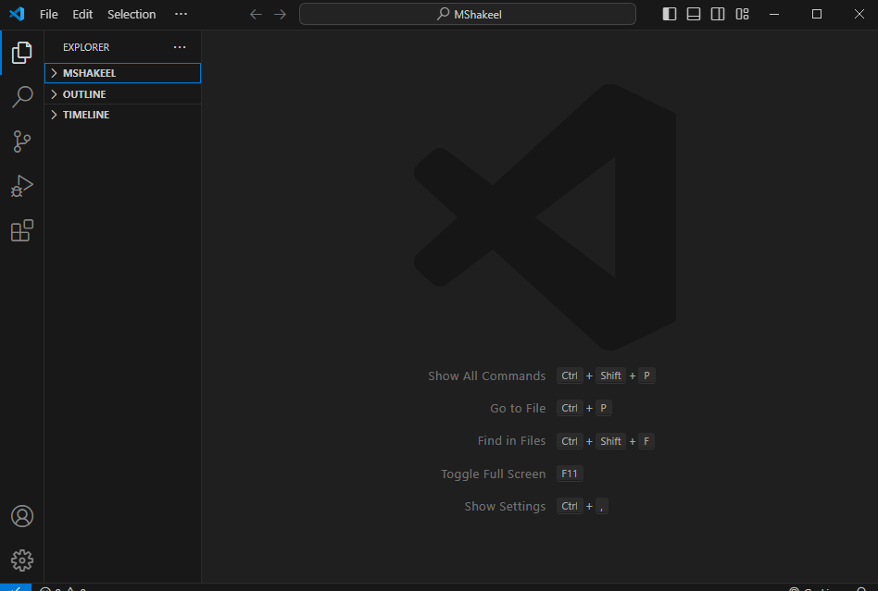

# Task 3: Download and Install Git and Signup to GitHub

Downloading and installing git from <https://git-scm.com/> and after installing the setup of git.

Checking the current installed version using **git -v**

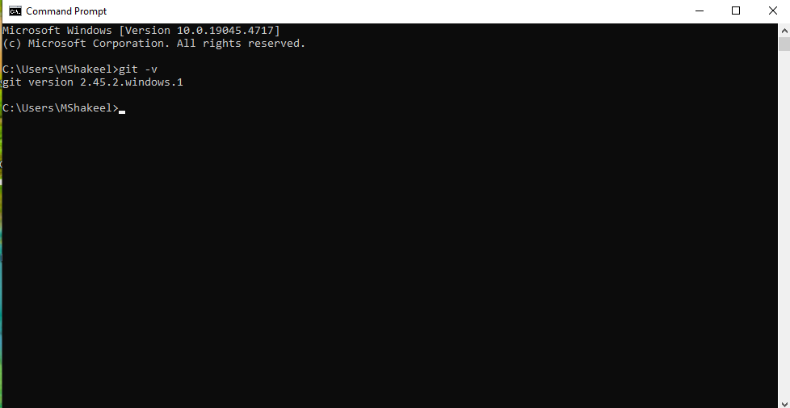

After Signing up at <https://github.com/>

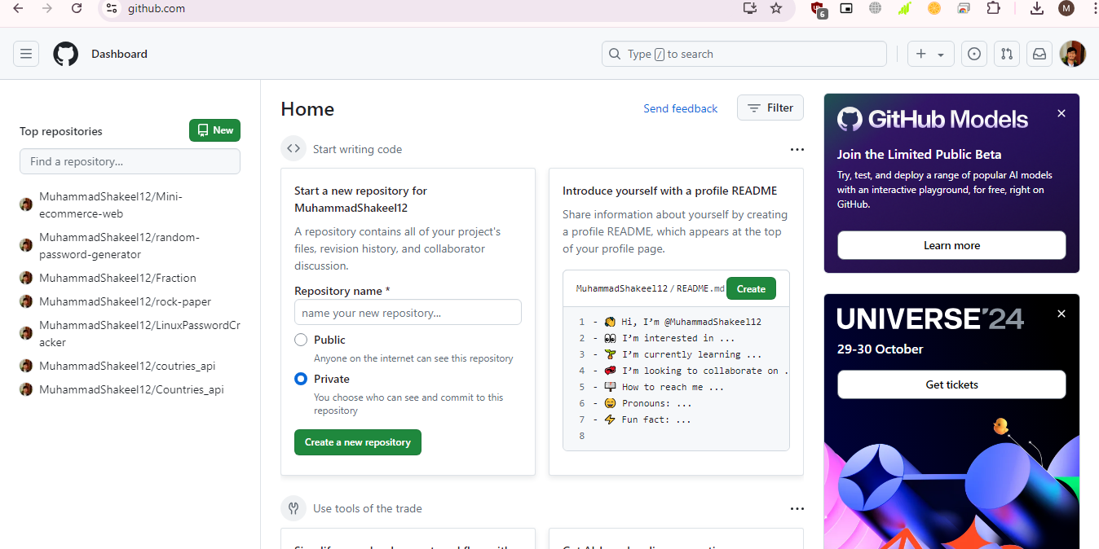

# Task 4: Research and Write a Short Answers

## 1. What is MongoDB, Express.js, React, and Node.js? Explain their purpose and role in the MERN Stack.

**MongoDB**: A NoSQL database that stores data in flexible, JSON-like documents. It’s used in the MERN stack to handle the database layer, allowing for easy data storage and retrieval.

**Express.js**: A minimal and flexible Node.js web application framework that provides robust features for building web and mobile applications. It handles the backend and server-side logic in the MERN stack.

**React**: A JavaScript library for building user interfaces, particularly single-page applications. In the MERN stack, React is used for the front-end, allowing developers to create dynamic and responsive user interfaces.

**Node.js**: A runtime environment that allows JavaScript to be run on the server side. It enables the development of scalable network applications and serves as the foundation of the MERN stack, providing the runtime for Express.js.

In the MERN stack, these four technologies work together to enable full-stack development using JavaScript across the entire application, from the client-side interface to the server-side logic and database management.

## 2. Briefly compare the MERN Stack with other popular stacks (e.g., LAMP, MEAN). What are the key differences? Why might a developer choose MERN over another stack?

**MERN vs. LAMP**:

* **LAMP** (Linux, Apache, MySQL, PHP): A traditional stack that uses Linux as the operating system, Apache as the web server, MySQL as the database, and PHP for server-side scripting. It’s known for its stability and widespread use but requires knowledge of multiple languages (PHP, SQL) and different environments (Linux).
* **MERN** (MongoDB, Express.js, React, Node.js): A modern stack that uses JavaScript throughout, making it easier for developers to work with a consistent language across the entire application. It’s ideal for developing single-page applications and real-time features.

**MERN vs. MEAN**:

* **MEAN** (MongoDB, Express.js, Angular, Node.js): Similar to MERN but uses Angular instead of React. Angular is a full-fledged framework, offering a more structured and opinionated approach, while React is a library, giving developers more flexibility in how they build their applications.
* Developers might choose **MERN** if they prefer React’s flexibility and its component-based architecture, which can make it easier to manage and scale large applications.

**3. Real-World Applications or Companies Built Using the MERN Stack**

1. **Netflix**: Netflix uses the MERN stack, particularly for some of its internal tools and user interfaces. React’s component-based architecture helps in building dynamic and fast-loading UIs, while Node.js ensures efficient server-side performance.
2. **Instagram**: Instagram uses parts of the MERN stack, particularly React, for its web application. React helps Instagram handle complex and dynamic user interfaces, offering a smooth and responsive user experience. The stack’s ability to handle high loads and real-time updates is crucial for a platform like Instagram.